Journal

Table of Contents

Personal Development 2

Master Planning v3.0 (2020): Plan Your Week, Month and Year 2

Resources 3

**Udemy Courses** 3

Building a state-of-the-art card fraud detection system in 9 months 6

Books 7

Bangalore Jobs 8

Big Companies 8

Walmart 8

Startups 8

Programming Languages 9

Clojure 9

Rust 10

JavaScript 10

TypeScript 10

Dart 11

Kotlin 11

Web Development 11

CSS 11

Content Management 11

GraphQL 11

PWA 11

JAM Stack 11

Serverless 12

API- first 12

Web Assembly 12

Speech Recognition 12

Emmet, NPM/Yarn, Axios, Webpack/Parcel 12

Basic Deployment 12

Svelte, React, Vue, Angular 12

State management 12

TypeScript 12

JavaScript 13

Data Engineering 13

Apache Flink 13

Autonomous Driving Solution 14

# Personal Development

## Master Planning v3.0 (2020): Plan Your Week, Month and Year

<https://www.udemy.com/course/master-planning/>

Plan-Act-measure-Learn

Areas of Your Life

1. Professional
2. Personal
3. Relationships
4. Health

Review these 1-hr per week

## Random stuff

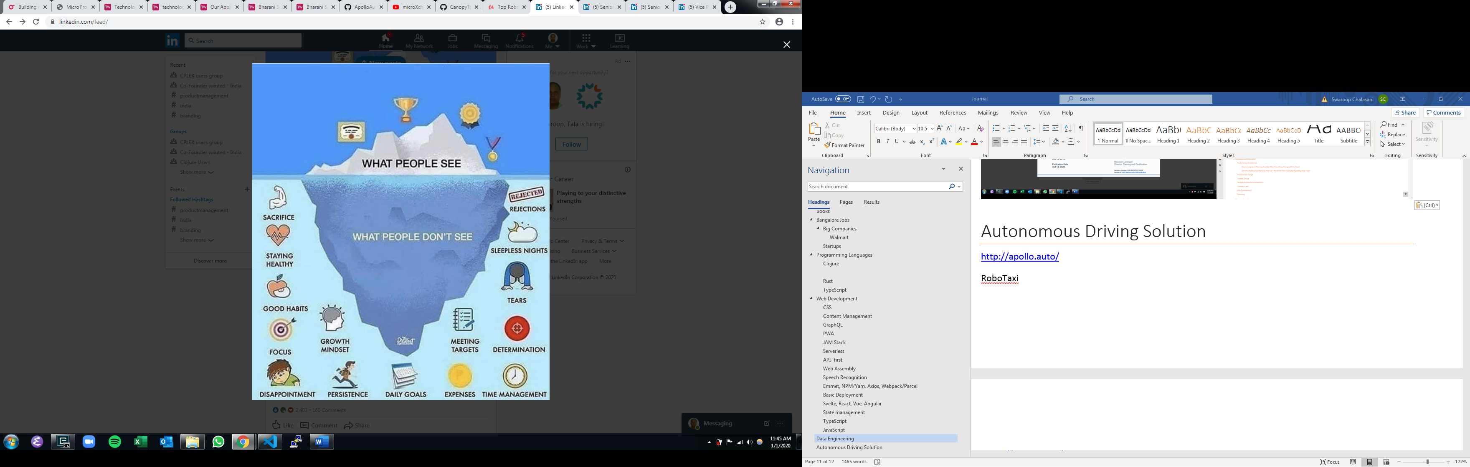

1. Google CEO is an Indian 2. Microsoft CEO is an Indian 3. Citigroup CEO was an Indian 4. SoftBank Vision Fund CEO is an Indian 5. Adobe CEO is an Indian 6. NetApp CEO is an Indian 7. PepsiCo CEO was an Indian 8. Nokia CEO is an Indian 9. MasterCard CEO is an Indian 10. DBS CEO is an Indian 11. Cognizant CEO was an Indian 12. Novartis CEO is an Indian 13. Conduent CEO was an Indian 14. Diageo CEO is an Indian 15. SanDisk CEO was an Indian 16. Motorola CEO was an Indian 17. Harman CEO is an Indian 18. Micron CEO is an Indian 19. Palo Alto Networks CEO is an Indian 20. Reckitt Benckiser CEO is an Indian

Here are few simple principles I have adopted to run my business, and I have found them helpful: 1) Speak less - listen more (perhaps why we have two ears) 2) Why use harsh words when the same message can be communicated with soft and pleasant words 3) Being kind, caring and reasonable in business does not imply weakness. To the contrary it reflects strength! 4) Being firm is not same as being aggressive. Former reflects confidence while the latter reflects insecurity 5) Being respectful to all, irrespective of where she/he stands in the corporate/societal hierarchy is a basic 6) You reap as you sow. If your dominant thoughts are generosity, love, health, kindness and goodwill these blessings come back to you multiplied many times over. 7) Nothing great ever got achieved without cart loads of positivity and child-like enthusiasm 8) Lastly, eat only when you are hungry - with liberal servings of fruits and raw vegetables I take this opportunity to wish you all a terrific 2020!

## Books

1. Atomic Habits

2. Metamorphosis

3. So Good They Can't Ignore You

<https://twitter.com/kunalb11/status/1210969949742743552>

# Jobs

## Big Companies

|  |  |  |  |  |  |  |  |  |  |
| --- | --- | --- | --- | --- | --- | --- | --- | --- | --- |
| Product Development | Consulting | Banks/Financial | Manufacturing |  |  |  |  |  |  |
| Twitter |  |  |  |  |  |  |  |  |  |
|  |  |  |  |  |  |  |  |  |  |
|  |  |  |  |  |  |  |  |  |  |
|  |  |  |  |  |  |  |  |  |  |

Twitter Staff Software Engineer – Data Platform

<https://www.linkedin.com/jobs/view/1662183721/?alternateChannel=paview>

Intuit Staff Software Engineer

<https://www.linkedin.com/jobs/view/1662631567/?alternateChannel=paview>

Visa Staff Software – Data

<https://www.linkedin.com/jobs/view/1663140721/?alternateChannel=paview>

### Walmart

Distinguished Software Engineer - Data Foundation

<https://www.linkedin.com/jobs/view/1609086782/>

## Startups

|  |  |  |
| --- | --- | --- |
| B2C | B2B | Technology |
| LendingKart |  | Hasura.io |
| Navi Technologies (BACQ) |  |  |
| OYO |  |  |
| OLA |  |  |
|  |  |  |
|  |  |  |
|  |  |  |

# Software System Design and Development

## Resources

<https://www.thoughtworks.com/radar>

## Building a state-of-the-art card fraud detection system in 9 months

<https://medium.com/revolut/building-a-state-of-the-art-card-fraud-detection-system-in-9-months-96463d7f652d>

XGBoost <https://xgboost.readthedocs.io/en/latest/>

VowpalWabbit <https://github.com/VowpalWabbit/vowpal_wabbit/wiki>

Catboost <https://catboost.ai/>

# Programming Languages

Can programming languages give leverage? What kind of leverage do they provide for consultant, self-employed, indie developer, entrepreneur?

Inhouse Development

|  |  |  |  |  |  |  |  |  |  |  |  |  |  |  |  |  |
| --- | --- | --- | --- | --- | --- | --- | --- | --- | --- | --- | --- | --- | --- | --- | --- | --- |
| Application Area | HTML5/CSS3 | JavaScript | Python | Java | Go | Rust | C/C++ | PHP | Ruby | Clojure | Scala | Kotlin | Dart | Swift | C# | SQL |
| Web Application Frontend |  | React  Angular  Vue |  |  |  |  |  |  |  |  |  |  |  |  |  |  |
| Web Application Backend |  | Express, Koa  Adonis  Feathers.js  Nest.js |  | Spring MVC  Grails | Revel |  |  | Laravel | Rails  Sinatra | Luminus | Play |  |  |  |  |  |
| Mobile Development |  | ReactNative  NativeScript  Ionic |  | Android |  |  |  |  |  |  |  |  | Flutter |  | Xamarin |  |
| Desktop Applications |  | Electron |  | Swing, Eclipse RCP |  |  |  |  |  |  |  |  |  |  |  |  |
| Data Engineering & Analytics |  |  |  | Hadoop, Spark |  |  |  |  |  |  |  |  |  |  |  |  |
| Data Science | D3, Chart | Brain.js  TensorflowJS |  |  |  |  |  |  |  |  |  |  |  |  |  |  |
| Game Development |  |  |  |  |  |  | Unreal |  |  |  |  |  |  |  | Unity |  |
| Systems Development |  |  |  |  |  | Yes |  |  |  |  |  |  |  |  |  |  |
| Cloud Development |  |  |  |  |  |  |  |  |  |  |  |  |  |  |  |  |
| DevOps Development |  |  | Jenkins | Spinnaker |  |  |  |  | GitLab |  |  |  |  |  |  |  |
| QA |  |  |  |  |  |  |  |  |  |  |  |  |  |  |  |  |

Cloud Development

|  |  |  |  |  |
| --- | --- | --- | --- | --- |
|  | Heroku | AWS | Azure | GCP |
|  |  |  |  |  |
|  |  |  |  |  |
|  |  |  |  |  |
|  |  |  |  |  |
|  |  |  |  |  |
|  |  |  |  |  |
|  |  |  |  |  |

Cloud Native applications

Cloud agnostic applications? (on-prem?)

## Clojure

<https://github.com/pdsouza/chloe>

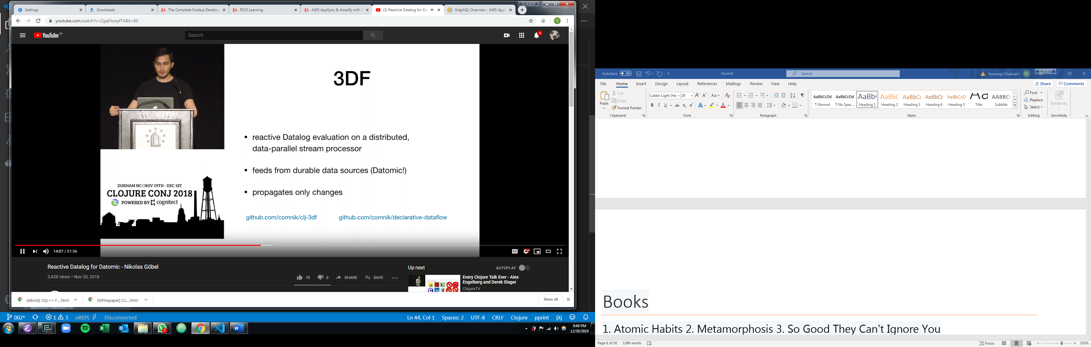

<https://docs.datomic.com/on-prem/query.html>

## Rust

<https://github.com/frankmcsherry?tab=repositories>

## JavaScript

## TypeScript

## Dart

## Kotlin

# Web Development

<https://www.youtube.com/watch?v=0pThnRneDjw>

## CSS

Bootstrap

Bulma

Materialize

Tailwind CSS

## Content Management

Headless CMS – Contentful, Prismic.io, Sanity, Strapi

Full CMS – **Wordpress**, Drupal, Keystone, Enduro

## GraphQL

<https://www.prisma.io/docs/1.10/quickstart/>

<https://hasura.io/> <https://github.com/hasura/graphql-engine>

<https://www.graphile.org/postgraphile/>

<https://github.com/remorses/mongoke>

<https://supergraph.dev/>

Get started on Hasura and Heroku

<https://riccardogiorato.com/blog/2019/2019-11-18_Create-a-GraphQL-API-in-60-Seconds---With-No-Code---Using-Hasura-fba06c8159c0/>

## PWA

With Vue.js

## JAM Stack

JavaScript, Apis and Market with Gatsby

## Serverless

## API- first

Machine Learning in JavaScript Brain.js

## Web Assembly

Generated by C/C++/Rust

## Speech Recognition

Html5 Web Speech API

Google Speech to Text

Dialog Flow

## Emmet, NPM/Yarn, Axios, Webpack/Parcel

## Basic Deployment

Cpanel, netlify

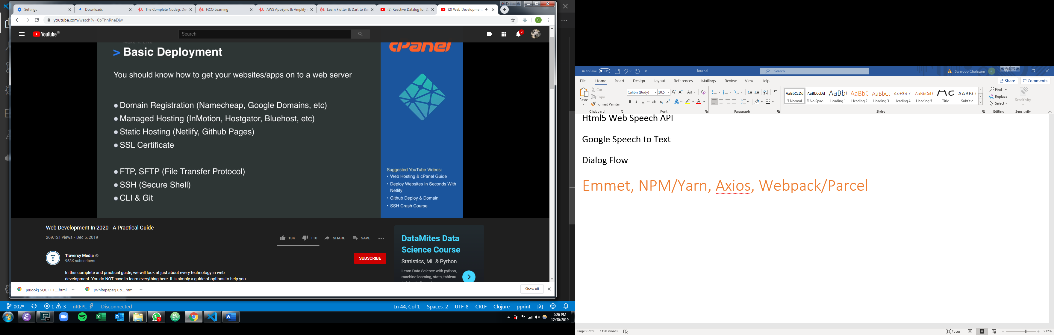

## Svelte, React, Vue, Angular

## State management

React – Redux, Context API with Hooks

Vue – Vuex

Apollo Client

## TypeScript

## JavaScript

Old

Functions, conditionals, loops

Es6 – arrow functions, promiss, async/await, destructuring, template strings

AI/chatbots (Python, TensorFlow)

Python is king of AI

Tensorflow

Zurb motion ui

# Data Engineering

Apache Flink

has seen increasing adoption since our initial assessment in 2016. Flink is recognized as the leading streamprocessing engine and also gradually matured in the fields of batch processing and machine learning. One of Flink’s key differentiator from other streamprocessing engines is its use of consistent checkpoints of an application’s state. In the event of failure, the application is restarted and its state is loaded from the latest checkpoint — so that the application can continue processing as if the failure had never happened. This helps us to reduce the complexity of building and operating external systems for fault tolerance. We see more and more companies using Flink to build their data-processing platform

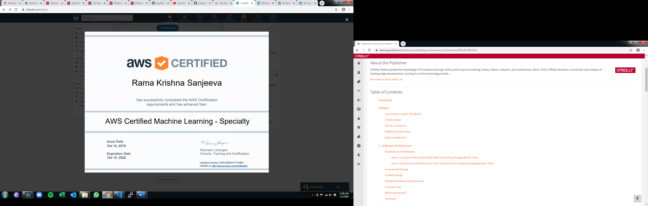

## Udemy Courses

[AWS CloudFormation MasterClass](https://links.datacumulus.com/aws-cloudformation-coupon): Enhance your AWS Learning with over 3 hours of content, that will fully teach you how to use AWS CloudFormation to deploy your AWS Infrastructure stacks. This class rocks and any AWS professional should master CloudFormation

[AWS Lambda and the Serverless Framework](https://links.datacumulus.com/aws-lambda-coupon): Must do course if you want to learn how to become a Serverless and AWS Lambda developer. Serverless is revolutionizing IT very quickly and becoming a highly valuable skill to land a job!

[AWS EC2 Master Class (with Auto Scaling and Load Balancer)](https://links.datacumulus.com/aws-ec2-coupon): Must have course for any AWS professional. You will learn how to properly use and setup your EC2 Instances, AWS Security Groups, New types of Load Balancers, AutoScaling groups and new types of policies, and choose the perfect EC2 instance type for your application

[Amazon EKS Starter: Kubernetes on AWS](https://links.datacumulus.com/aws-eks-coupon): Learn how to use and deploy Kubernetes clusters on AWS

**Apache Kafka Series:**

[Kafka for Beginners v2](https://links.datacumulus.com/apache-kafka-coupon): The must-know technology for all your streaming needs. Kafka is a quickly rising technology any engineer should know!

[Kafka Connect](https://links.datacumulus.com/kafka-connect-coupon): Advanced course in the series to learn about the Kafka Connect frameworks, with hands-on exercise to source data from Twitter, and Sink it into ElasticSearch and PostgreSQL!

[Kafka Streams for Data Processing](https://links.datacumulus.com/kafka-streams-coupon): The new fantastic Kafka library that will make all your data streaming and processing look so easy

[KSQL Hands On!](https://links.datacumulus.com/kafka-ksql-coupon): Do SQL on Kafka using Confluent KSQL. Write a taxi booking application easily, do stream processing like a boss!

[Kafka Setup and Administration](https://links.datacumulus.com/kafka-cluster-setup-coupon): The only tutorial that will teach you how to setup Kafka on multiple machines in the AWS cloud. This course is for experts and you will become an Apache Kafka master

[Confluent Schema Registry & Kafka REST Proxy](https://links.datacumulus.com/confluent-schema-registry-coupon): The only online course that will teach you all you need to know about Apache Avro, the Confluent Schema Registry and the Kafka REST Proxy

[Kafka Security](https://links.datacumulus.com/kafka-security-coupon): The only online course that will teach you about Kafka Security, including SSL for Encryption, SSL and SASL for authentication, and ACL for authorization.

[Kafka Monitoring and Operations](https://links.datacumulus.com/kafka-monitoring-operations-coupon): Learn how to properly setup Kafka monitoring. Practice the most important Kafka Operations. Upgrade a Cluster from 1.1 to 2.0!

[NEW! Confluent Certified Developer for Apache Kafka (CCDAK) - Practice Tests](https://links.datacumulus.com/confluent-certified-ccdak-coupon): 3 Practice exams to ensure you're ready before passing the certification exam CCDAK

**AWS Certifications:**

[NEW! AWS Certified Solutions Architect Associate](https://links.datacumulus.com/aws-certified-sa-associate-coupon): Study AWS in-depth with **18 hours of content** and become a great solutions architect today! More than 3 hours of solution architecture discussions to make sure you fully understand all the various subtleties on Solutions Architecture in AWS.

[Ultimate AWS Certified Developer Associate 2019](https://links.datacumulus.com/aws-certified-dev-coupon): Study AWS in-depth with **18 hours of content** and become a great cloud engineer today! Learn over 25 services including Beanstalk, Lambda, Serverless, CICD, CloudFormation, IAM, Security, EC2, SQS, Kinesis & more!

[AWS Certified Developer Associate [Practice Exams]](https://links.datacumulus.com/aws-certified-dev-pt-coupon): Complete your learning and ace your exam with **four practice exams of 65 questions each**.

[NEW! AWS Certified SysOps Administrator Associate](https://links.datacumulus.com/aws-certified-sysops-coupon): Study AWS in-depth with **15 hours of content** and become a great cloud engineer today! Learn over 25 services including Beanstalk, Lambda, Serverless, CICD, CloudFormation, IAM, Security, EC2, SQS, Kinesis & more!

[NEW! AWS Certified Big Data Specialty](https://links.datacumulus.com/aws-certified-big-data-coupon): Learn how to do Big Data on AWS and pass the Specialty exam. Use technologies such as EMR, Kinesis and Redshift. Over 11 hours of content!

[AWS Certified DevOps Engineer Professional - Hands On!](https://links.datacumulus.com/aws-certified-devops-pro-coupon): Pass the AWS Certified DevOps Engineer Professional Certification (DOP-C01) with this brand new course, ALL HANDS ON ! **20+ hours of video content**

[AWS Certified DevOps Engineer Professional [Practice Exam]](https://links.datacumulus.com/aws-certified-devops-pro-pt-coupon): One high-fidelity 75-questions practice test for the AWS Certified DevOps Engineer Professional certification (DOP-C01).

[AWS Certified Machine Learning Specialty 2019 - Hands On!](https://links.datacumulus.com/aws-certified-machine-learning-coupon): Learn how to pass the AWS Certified Machine Learning Specialty exam. Over **9 hours of video** to help you pass with confidence!

**Data Engineering & API:**

[Complete Guide to Protocol Buffers 3](https://links.datacumulus.com/protocol-buffers-coupon): Say goodbye to JSON and XML. Protocol Buffers is a new data format from Google that will allow you to create safe objects with a strong schema. It is the future of data formats and you should learn about it today. Don't wait!

[gRPC Java Master Class: Build Modern API & Microservices](https://links.datacumulus.com/grpc-java-coupon): Say goodbye to REST API & JSON. gRPC is a new framework from Google that will allow you to quickly create powerful strongly typed API. Thanks to Protocol Buffers all the server and client code is generated for you. It's the future of APIs!

[gRPC Golang Master Class: Build Modern API & Microservices](https://links.datacumulus.com/grpc-golang-coupon): Say goodbye to REST API & JSON. gRPC is a new framework from Google that will allow you to quickly create powerful strongly typed API. Thanks to Protocol Buffers all the server and client code is generated for you. It's the future of APIs!

[gRPC [C#] Master Class: Build Modern API & Microservices](https://links.datacumulus.com/grpc-csharp-coupon): Say goodbye to REST API & JSON. gRPC is a new framework from Google that will allow you to quickly create powerful strongly typed API. Thanks to Protocol Buffers all the server and client code is generated for you. It's the future of APIs!

[gRPC Node.js Master Class: Build Modern API & Microservices](https://links.datacumulus.com/grpc-nodejs-coupon): Say goodbye to REST API & JSON. gRPC is a new framework from Google that will allow you to quickly create powerful strongly typed API. Thanks to Protocol Buffers all the server and client code is generated for you. It's the future of APIs!

[Introduction to Apache NiFi](https://links.datacumulus.com/apache-nifi-coupon): NiFi is really useful in the streaming world to build data pipelines in no-time! It has support for many databases and even Apache Kafka. This revolutionary technology has made it a lot easier to move data in the big data world

<https://fico.udemy.com/course/aws-appsync-amplify-with-react-graphql-course/learn/lecture/16335692#overview>

<https://www.linkedin.com/jobs/view/1637579260/>

## Apache Flink

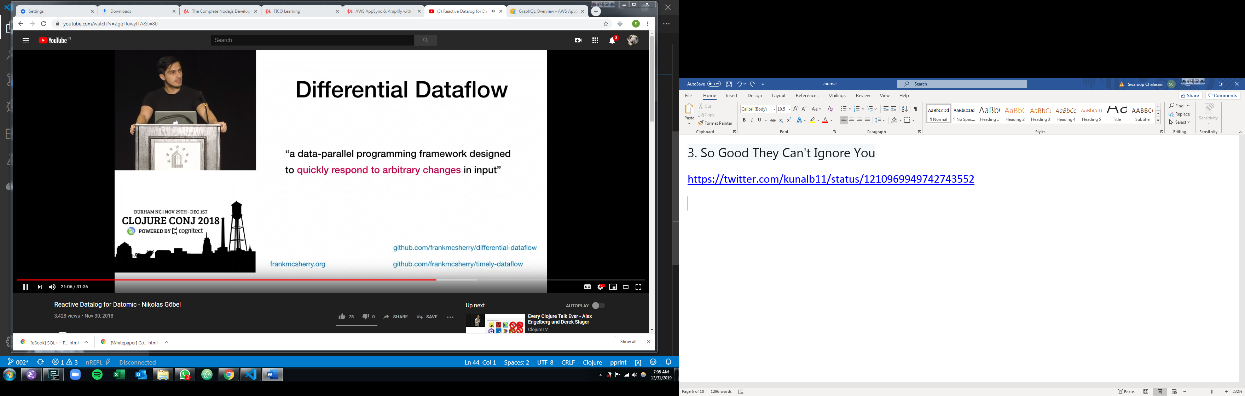

# Autonomous Driving Solution

<http://apollo.auto/>

RoboTaxi

<https://github.com/apolloauto>

<https://github.com/ros/ros>