**Conor Sweeney – cjs2201**

**COMS W3134 Spring 2016 (Sections 1 and 2)**

**Homework 4**

**Due: 4:00pm on Friday, April 1st**

**Written (35 pts)**

For the written section of this assignment, type up your answers and submit a computer based document to us. You can submit MS Word doc files, pdf files, or txt files.

1. (7 pts): Weiss, Exercise 5.1 - it is possible that some of the numbers in parts of the problems will not be insertable into the table.  Indicate when a number cannot be inserted in your answer.

Given input {4371, 1323, 6173, 4199, 4344, 9679, 1989} and a hash function h(x) = xmod 10, show the resulting:

* 1. Separate chaining hash table.
  2. Hash table using linear probing.
  3. Hash table using quadratic probing.
  4. Hash table with second hash function h2(x) = 7 – (x mod 7)

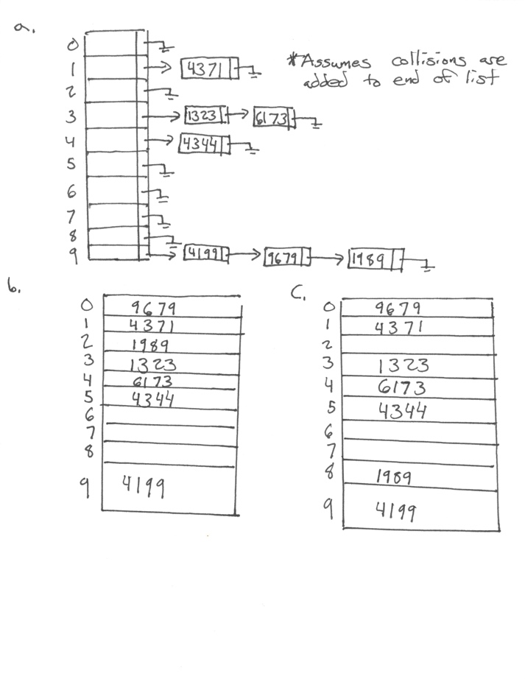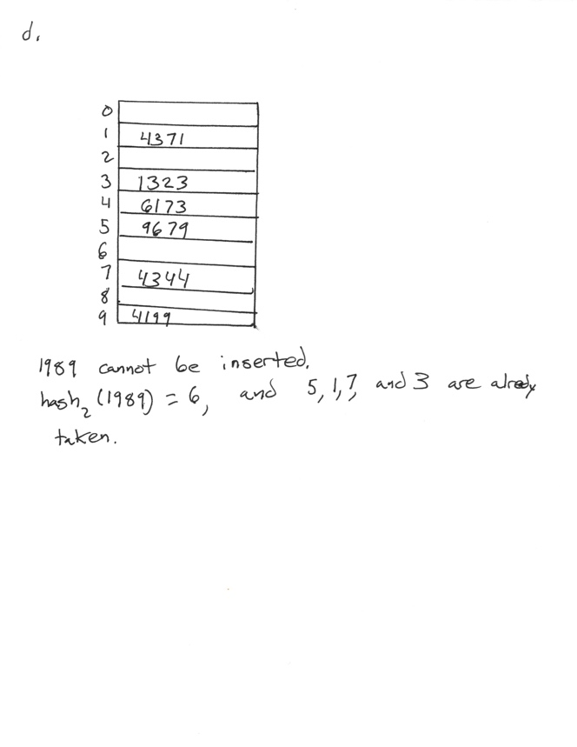

1. (7 pts): Weiss, Exercise 5.2 - You are rehashing each table that you built in the four parts of exercise 5.1. Use a new table size of 19, adjust the hash function accordingly.

Show the resulting hash tables in exercise 5.1

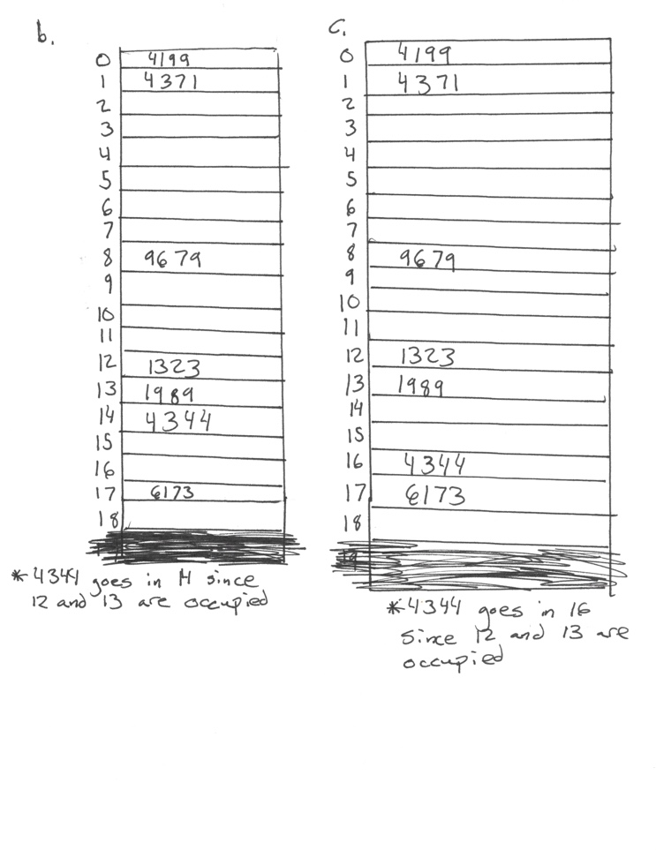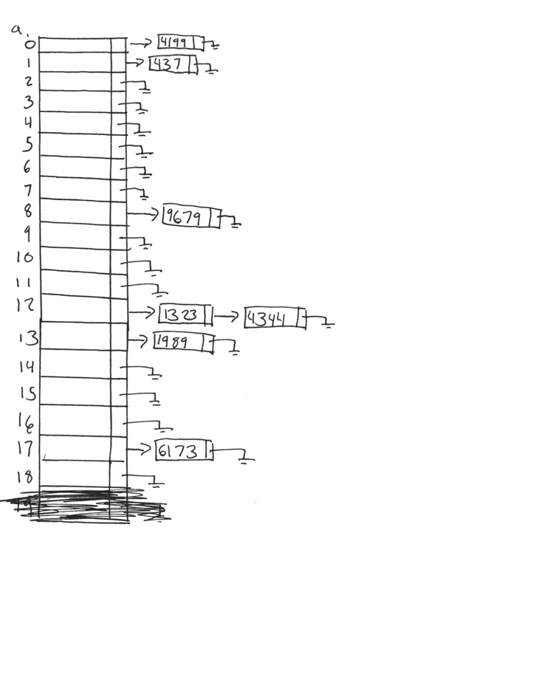The new hash function is: h(x) = x mod 19

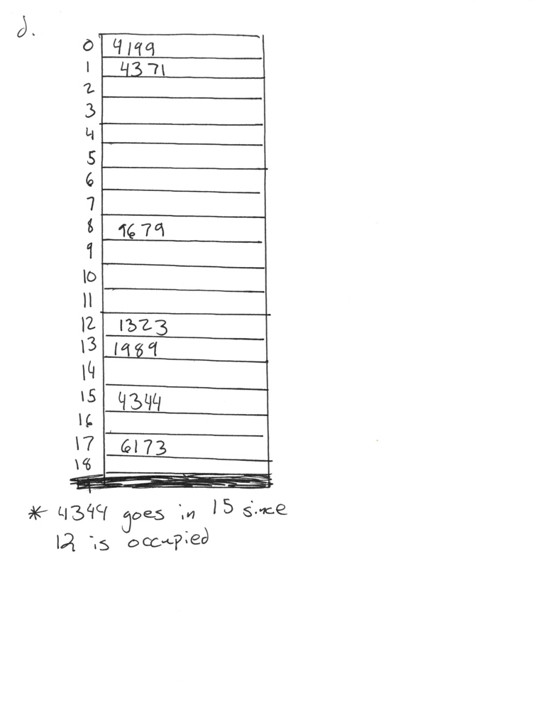

*I apologize. I realized after making the illustrations that the tables should end with 18 and not 19. I forgot to count 0. I hope that it is okay that I crossed 19 out and re scanned the images.

1. (7 pts): Weiss, Exercise 6.2 (show the contents of the heap after each step either as a tree or in binary heap array format)
   1. Show the result of inserting 10, 12, 1, 14, 6, 5, 8, 15, 3, 9, 7, 4, 11, 13, and 2, one at a time, into an initially empty binary heap

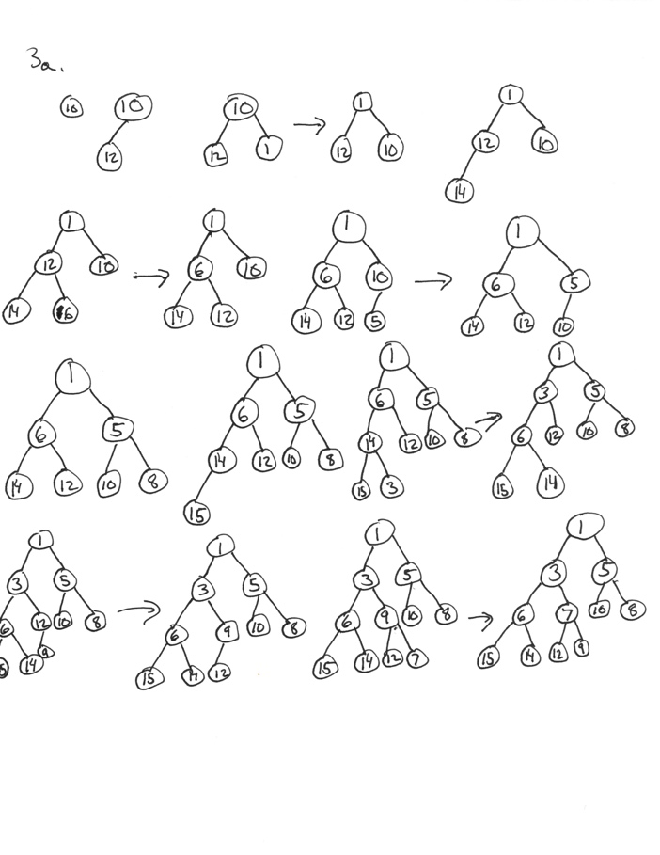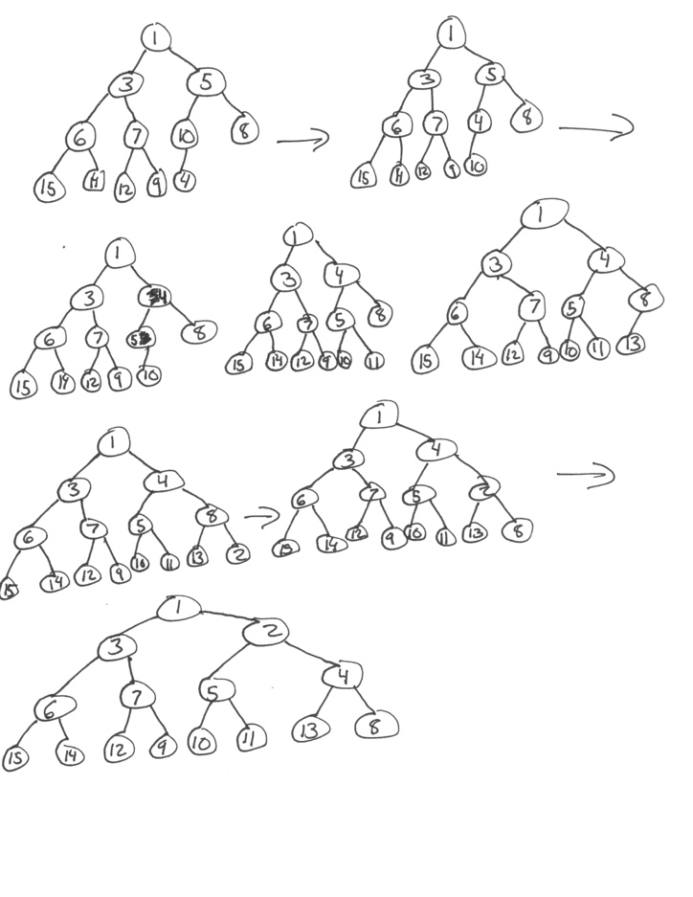

* 1. Show the result of using the linear-time algorithm to build a binary heap using the same input

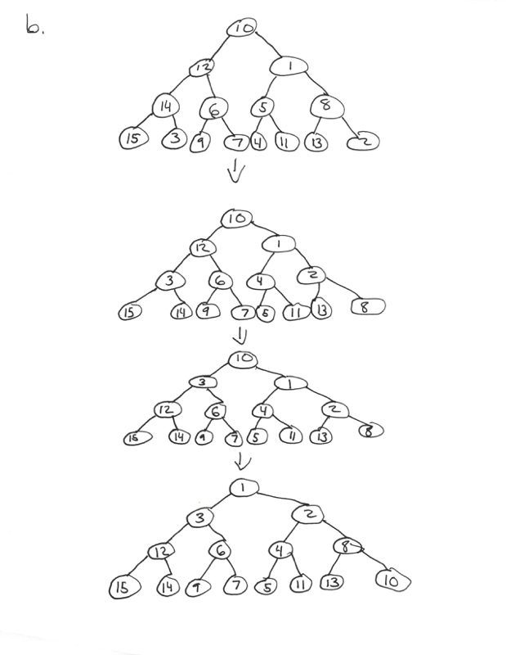

1. (7 pts): Weiss, Exercise 6.3 (again, show the contents of the heap after each step either as a tree or binary heap array format)

Show the result of performing three deleteMin operations in the heap of the previous exercise.

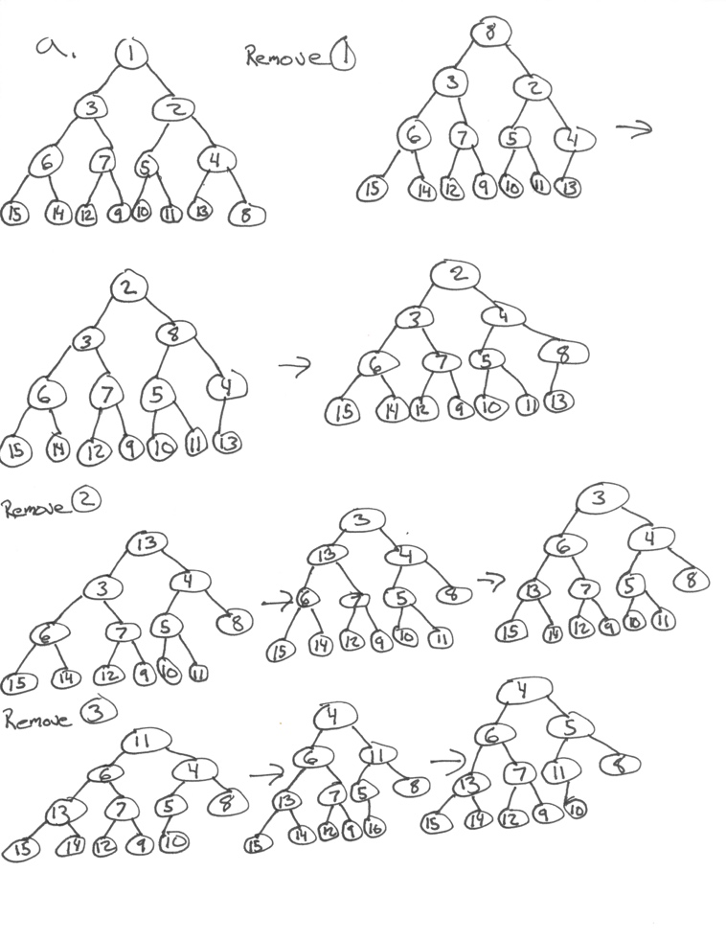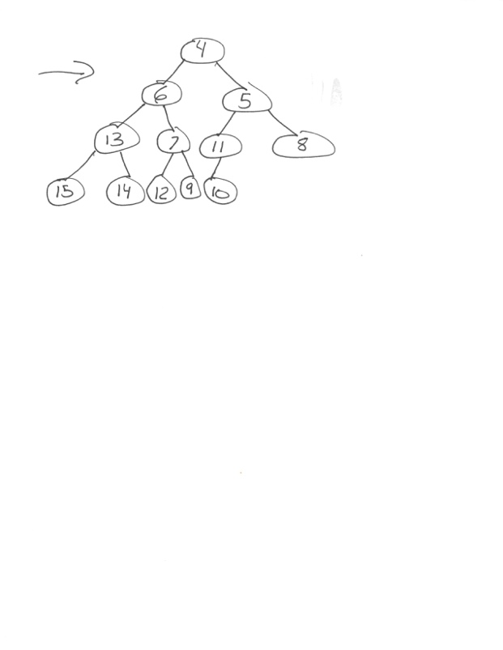

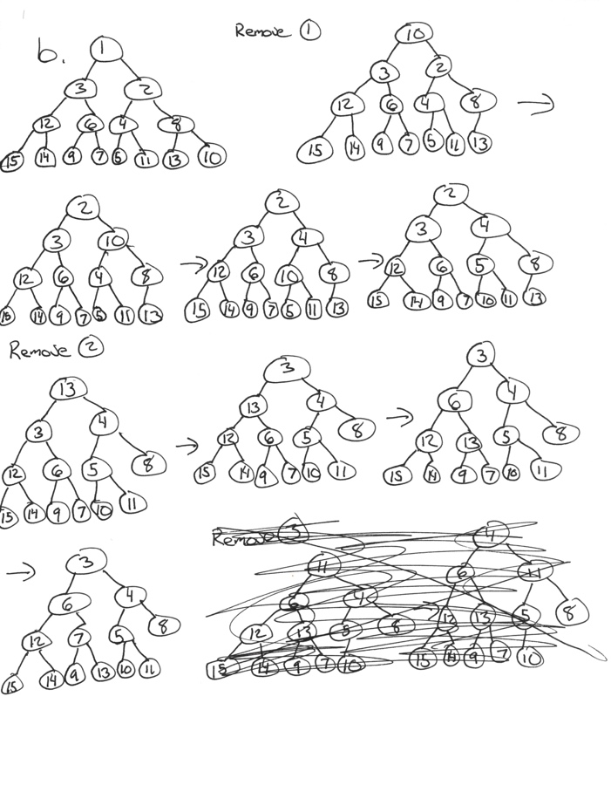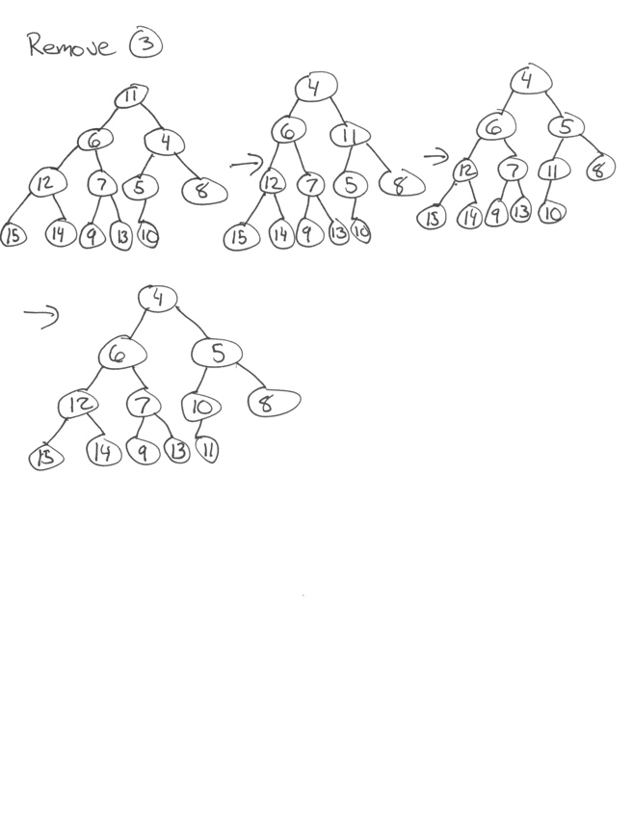

1. (7 pts): Weiss Exercise 6.8 (just an explanation is good enough)

Show the following regarding the maximum item in the heap:

* 1. It must be at one of the leaves

Proof by contradiction: If we assume that the maximum item is not a leaf, then it therefore must have at least one child. If the maximum item has a child, then it must be greater than its child and this violates the heap order property. Therefore, the maximum value of a heap must always be a leaf or else it will contradict heap order structure, and therefore cannot be a heap structure.

* 1. There are exactly ⎡N/2⎤ leaves
* A perfect tree with a depth k must have 2^(k+1) – 1 nodes
* Assuming that the heap reaches depth k thus:
  + Up to level k-1 it is a perfect tree with 2^k – 1 nodes
  + The last level has exactly n – 2^k + 1 nodes and they are all leaves
* Each leaf on the last level (at depth k) has a parent and two consecutive nodes has the same father with the exception of possibly the last node
* Therefore out of 2^(k-1) nodes at level k-1, ⎡(n – 2^k + 1)/2⎤ are parents and the rest are leaves
* Therefore, the total amount of leaves is:
  + n – 2^k + 1 + 2^(k-1) - ⎡(n – 2^k + 1)/2⎤
  1. Every leaf must be examined to find it

If it is assumed that the heap is a perfect tree with N nodes and its maximum element is m. If N+1 nodes are added to the heap that are all greater than m then these values will end up in the leaves in the order in which they are inserted and any of them can be the greatest node. This means that the maximum element can be any leaf in the heap.