**Conor Sweeney – cjs2201**

**COMS W3134 Spring 2016 (Sections 1 and 2)**

**Homework 6**

**Due: 11:59pm on Tuesday, May 3**

**Written (30 pts)**

For the written section of this assignment, type up your answers and submit a computer based document to us. You can submit MS Word doc files, pdf files, or txt files.

1. (10 pts): Weiss, Exercise 9.15

a. Find a minimum spanning tree for graph in Figure 9.84 using both Prim’s and Kruskal’s algorithms.

Vertices:

(A,B) 3 Accepted

(B,C) 10 Rejected

(D,A) 4 Accepted

(A,E) 4 Rejected

(E,B) 2 Accepted

(B,F) 3 Accepted

(F,C) 6 Rejected

(C,G) 1 Accepted

(D,E) 5 Rejected

(E,F) 11 Rejected

(F,G) 2 Accepted

(D,H) 6 Rejected

(H,E) 2 Accepted

(E,I) 1 Accepted

(I,F) 3 Rejected

(F,J) 11 Rejected

(J,G) 8 Rejected

(H,I) 4 Rejected

(I,J) 7 Accepted

A - B C

/ / \ \

D E F - G

/ \

H I - J

b. Is this minimum spanning tree unique?

No. This is not unique. The vertices can be connected into more than one configuration.

1. (10 pts): Weiss, Exercise 9.21

Find all the articulation points in the graph in Figure 9.85. Show the depth-first spanning tree and the values of *Num* and *Low* for each vertex.

The articulation points in the graph are E, F, And C. The figure below shows the the depth-first spanning tree. Each vertex has its Num, and Low values written next to it. Tree edges are solid arrows and back edges are dashed arrows.

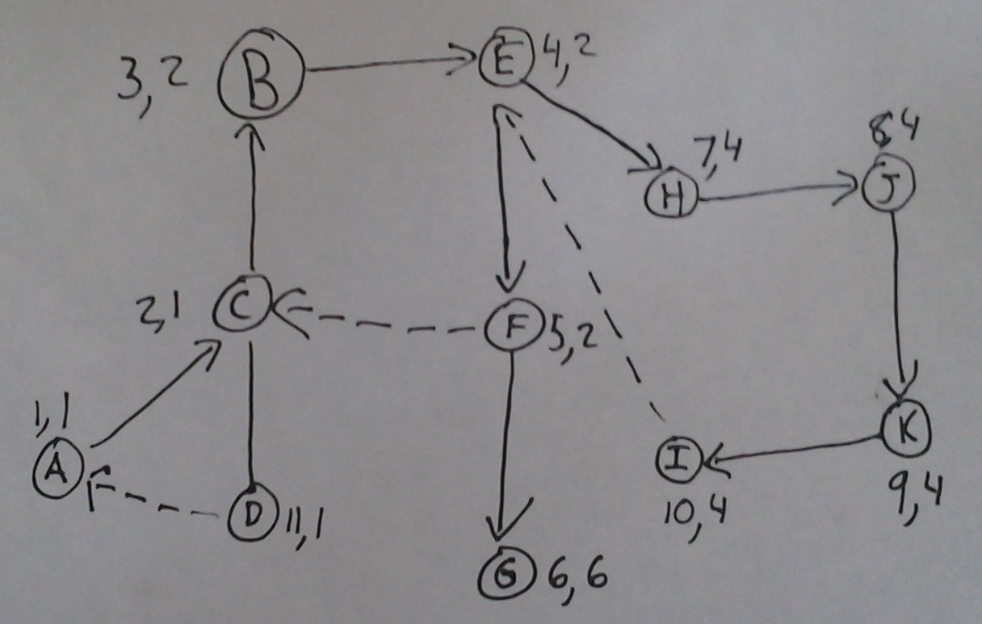

1. (10 pts): Weiss, Exercise 9.53

The object of the Kevin Bacon Game is to link a movie actor to Kevin Bacon via shared movie roles. The minimum number of links is an actor’s Bacon number. For instance, Tom Hanks has a Bacon number of 1; he was in Apollo 13 with Kevin Bacon. Sally Field has a Bacon number of 2, because she was in Forrest Gump with Tom Hanks, who was in Apollo 13 with Kevin Bacon. Almost all well-known actors have a Bacon number of 1 or 2. Assume that you have a comprehensive list of actors, with roles, and do the following:

a. Explain how to find an actor’s Bacon number.

Build a graph that has a vertex corresponding to each actor so that there is an edge between two actors if they were in the same movie. Then to find an actors Bacon number is to simply find the shortest path from the actor’s vertex to the Bacon’s vertex.

b. Explain how to find the actor with the highest Bacon number.

Find the shortest path between every single actor’s vertex to Bacon’s vertex. Then the actor’s vertex with the longest “shortest path” has the highest Bacon number.

c. Explain how to find the minimum number of links between two arbitrary actors.

Find the shortest path between them.