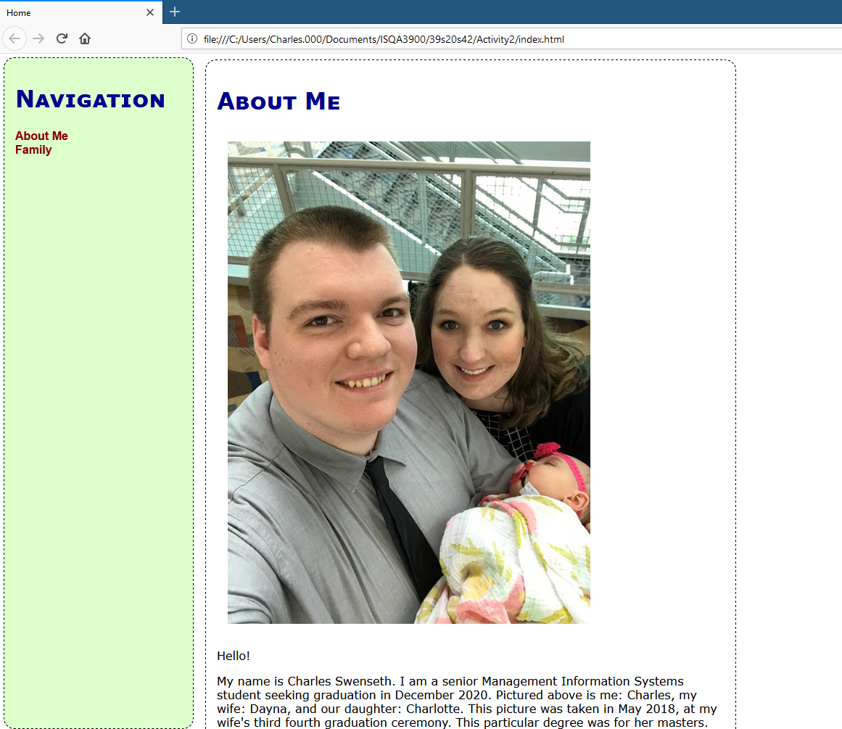

<https://github.com/ISQA-Classes/39s20s42>

1. What is the value of having a CSS in one page HTML in other pages? Why not simply embed the CSS in each web page?
   1. One CSS document centralizes the styling for an organization’s website. When a color or other design change is desired, the change only needs to be made once – instead of thousands of times (depending on the size of the website).
2. There are many cloud based document replication facilities such as DropBox, Box, Microsoft OneDrive. What is the advantage of using a tool like Git and GitHub over simply using something like Box to manage code?
   1. Git’s tracking system allows changes to be more easily added or removed from a project. Each change can also be documented with comments appearing next to each filename/directory. A