Get Event Log

A typical user interaction with the State of Florida’s Unemployment Insurance website.

Grey Box Testing of Fl UI Page

SQA of https://connect.myflorida.com

# Introduction

This document will highlight a typical user experience with the state of Florida’s “Reemployment Insurance” site (hereon referred to as UI). https://connect.myflorida.com

# Test Objectives

This will be a Blackbox test of the UI and point out any problems encountered with a user’s interaction of the UI.

# Scope

Deliverables: report of UI experiences.

Timeline: a standard business workday.

Reports: captured screen shots from UI interactions.

# Test types Identified

Black box testing. Functional testing without reference to the internal structure of the component or system.

# Architecture

# Assumptions

User has an active account on the UI.

<https://connect.myflorida.com>

Step 1

1. Navigate to <https://connect.myflorida.com>.
2. Click “acknowledge” check box.
3. Click “Next” button.

Step 2

1. Navigated back to initial page.
2. Click the “acknowledge” button once more.
3. Click the “Next” button once more.

Step 3

1. Finally get to verification page.
2. Enter SSN.
3. Enter PIN.
4. Click “Login” tab.

Step 4

1. Taken back to initial login page.
2. This behavior of being thrown back to the initial login page can and does occur throughout the entire process of logging, data entry and conclusion.

Step 5

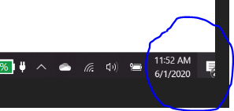

Entered the que @ 11:52. Was able to logon @ 13:42. Wait time: 1 hour 50 minutes.

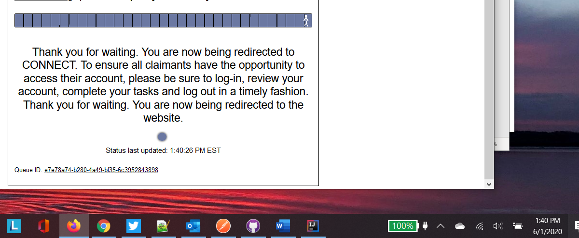

## New Behavior

As of June 1, 2020, the UI is now rationing access to the site. I am unable to see how many concurrent users they are allowing. After using this new option it is evident that the State of Florida is trying to superficially correct the poor performance of the UI, but are just making things worse.

Here is a copy of the JavaScript/page source. 

Some initial observations looking at the JavaScript:

<div id="BodyTop_nojavascriptenabled" class="nojavascript alert alert-error">

**The site requires JavaScript to be enabled! The browser you're using doesn't support JavaScript, or has JavaScript turned off.** <br>Try again with a browser that has JavaScript turned on. <a href="https://www.enable-javascript.com/" target="_blank">Learn More</a>

</div>

<div id="main-top-message">

<p class="item">

<span id="lbCookieInfo" title="**Your browser does not allow us to save cookies.** To keep your place in line, copy the web address of this page and save it for later.">You will lose your place in line if you close this page!</span>

</p>

</div>

**Test Note: Do not have the option to use the site without tracking.**

<div id="MainPart_frmReminder2" name="Notify me" class="reminder-form queueElement" style="display: none;" data-bind="visible: layout.reminderVisible">

<h2><span id="MainPart_lbNotyfyMeText">**Please notify me when it is my turn**:</span></h2>

<div id="MainPart_divEmailInput" class="row" style="display: none;" data-bind="visible: layout.reminderEmailVisible">

<form id="MainPart_FormEmailInput" name="Email notification form">

<input name="ctl00$MainPart$inpEmailAddress" type="text" id="MainPart_inpEmailAddress" title="Enter email address" class="item-input" placeholder="Enter email address" data-bind="value: emailAddress" />

<button type="submit" class="btn" id="aUpdateEmail" data-bind="click: updateNotify"><span class="l">Notify me by e-mail</span><span class="r">&nbsp;</span></button>

**Test Note: I was never presented with this option.**

# Site Information

## Traceroute

Doing a **traceroute** on the IP address shows that the path is going from JAX to Miami to Houston to Los Angeles. Where I time out on the Comcast network.

C:\>tracert 35.162.101.205

Tracing route to ec2-35-162-101-205.us-west-2.compute.amazonaws.com [35.162.101.205]

over a maximum of 30 hops:

1 45 ms 1 ms 3 ms 10.0.0.1

2 12 ms 12 ms 12 ms 96.120.21.153

3 12 ms 12 ms 17 ms 96.110.108.5

4 15 ms 15 ms 18 ms ae-29-ar02.southside.fl.jacksvil.comcast.net [68.85.225.125]

5 22 ms 24 ms 31 ms be-33489-cr02.miami.fl.ibone.comcast.net [68.86.95.45]

6 48 ms 136 ms 151 ms be-12223-cr01.houston.tx.ibone.comcast.net [68.86.86.142]

7 71 ms 70 ms 70 ms be-11523-cr02.losangeles.ca.ibone.comcast.net [68.86.87.173]

8 70 ms 69 ms 71 ms be-11580-pe02.losangeles.ca.ibone.comcast.net [68.86.82.34]

9 72 ms 69 ms 97 ms 50.242.149.102

10 * * * Request timed out.

11 * * * Request timed out.

…

26 * * * Request timed out.

27 * * * Request timed out.

28 * * * Request timed out.

29 * * * Request timed out.

30 * * * Request timed out.

Trace complete.

Why would the state of Florida send traffic to their site across the country?

## Whois Information

Raw Whois Data

Domain Name: MYFLORIDA.COM

Registry Domain ID: 9758247_DOMAIN_COM-VRSN

Registrar WHOIS Server: whois.networksolutions.com

Registrar URL: http://networksolutions.com

Updated Date: 2019-09-03T04:24:37Z

Creation Date: 1999-09-03T02:24:04Z

Registrar Registration Expiration Date: 2029-09-03T02:24:04Z

Registrar: Network Solutions, LLC

Registrar IANA ID: 2

Reseller:

Domain Status: clientTransferProhibited https://icann.org/epp#clientTransferProhibited

Registry Registrant ID:

Registrant Name: Department of Management Services

Registrant Organization: Department of Management Services

Registrant Street: 4030 ESPLANADE WAY

Registrant City: TALLAHASSEE

Registrant State/Province: FL

Registrant Postal Code: 32399-7016

Registrant Country: US

Registrant Phone: +1.8504873394

Registrant Phone Ext:

Registrant Fax:

Registrant Fax Ext:

Registrant Email: email@dms.myflorida.com

Registry Admin ID:

Admin Name: Majid, Abdul

Admin Organization: Department of Management Services

Admin Street: 4030 Esplanade Way

Admin City: Tallahassee

Admin State/Province: FL

Admin Postal Code: 32399-0001

Admin Country: US

Admin Phone: +1.8504873394

Admin Phone Ext:

Admin Fax:

Admin Fax Ext:

Admin Email: email@dms.myflorida.com

Registry Tech ID:

Tech Name: Department of Management Services

Tech Organization: Department of Management Services

Tech Street: 4030 ESPLANADE WAY

Tech City: TALLAHASSEE

Tech State/Province: FL

Tech Postal Code: 32399-7016

Tech Country: US

Tech Phone: +1.8504873394

Tech Phone Ext:

Tech Fax:

Tech Fax Ext:

Tech Email: email@dms.myflorida.com

Name Server: NS1.STATE.FL.US

Name Server: NS4.STATE.FL.US

Name Server: MFNORL-NS2.MFN.MYFLORIDA.COM

Name Server: MFNTAL-NS2.MFN.MYFLORIDA.COM

Name Server: MFNTEX-NS1.MFN.MYFLORIDA.COM

DNSSEC: unsigned

Registrar Abuse Contact Email: email@web.com

Registrar Abuse Contact Phone: +1.8003337680

URL of the ICANN WHOIS Data Problem Reporting System: http://wdprs.internic.net/

>>> Last update of WHOIS database: 2020-05-28T22:32:58Z <<<

