1.

t=0:0.1:400;

y= sawtooth(0.1*t,0.5);%T=2pi/a

x=1.5*y+1.5;

Fs=50;

N=length(x);

y0 = abs(fft(x));

f = (0:N-1)*Fs/N;

plot(f,y0);

xlabel('Frequency');

ylabel('Amplitude');

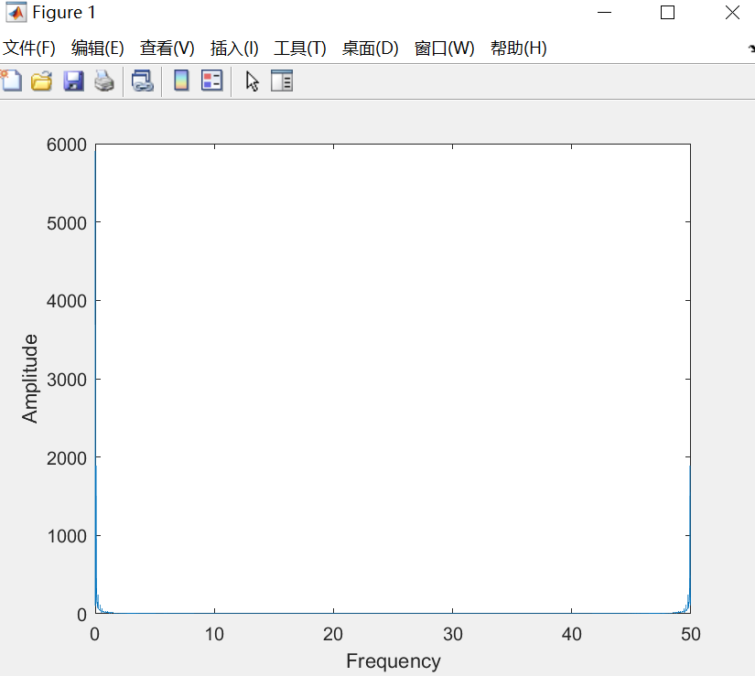

2.

Uw=10;

Wc=300000*2*pi;Ww=1;

t=0:1:500;

y= sawtooth(0.1*t,0.5);%T=2pi/a

x=1.5*y+1.5;

uw=x;%调制信号

uc=cos(Wc.*t);%载波信号

uDSB=uw.*uc;%DSB已调信号

subplot(2,1,1);plot(t,uDSB);xlabel('t');ylabel('uDSB');title('已调信号');

Fs=50;

N=length(x);

y0 = abs(fft(x));

f = (0:N-1)*Fs/N;

subplot(2,1,2);

plot(f,y0);

xlabel('Frequency');

ylabel('Amplitude');

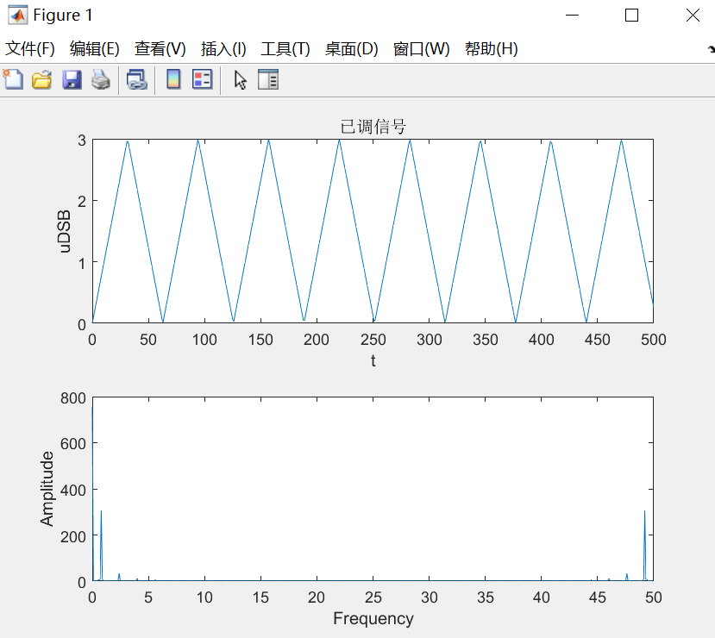

3.

t=0:0.1:400;

y= sawtooth(0.1*t,0.5);%T=2pi/a

x=1.5*y+1.5;

y=x;

yh = hilbert(y); % matlab函数得到信号是合成的复信号

yi = imag (yh); % 虚部为书上定义的Hilbert变换

figure

subplot (211)

plot (t, yi)

title ( 'Hilbert变换信号' )

ylim ([-1,1])

y1 = abs(fft(yi));

subplot (212)

plot(t,y1);

title ( '频域' )

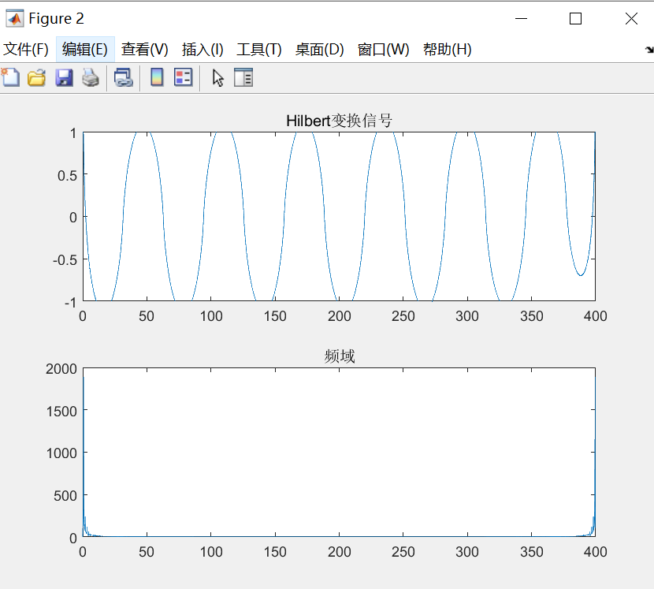

4.

dt=0.005; %设定步长

t=0:dt:3;

am=5;

%调制信号幅度

fm=5;

%调制信号频率

y= sawtooth(0.1*t,0.5);%T=2pi/a

x=1.5*y+1.5;

mt=1.5*y+1.5;

%生成调制信号

j_mt(1)=0;

for i=1:length(t)-1

%对调制信号求积分

j_mt(i+1)=j_mt(i)+mt(i)*dt;

end

fc=25;

ct=cos(2*pi*fc*t) ;

%生成载波

kf=10;

%调频灵敏度

sft=cos(2*pi*fc*t+kf*j_mt) ;

subplot(211);

plot(t,sft) ;

title('已调信号时域图');

Fs=50;

N=length(x);

y2 = abs(fft(x));

f = (0:N-1)*Fs/N;

subplot(212);

plot(f,y2);

title('已调信号频域图');

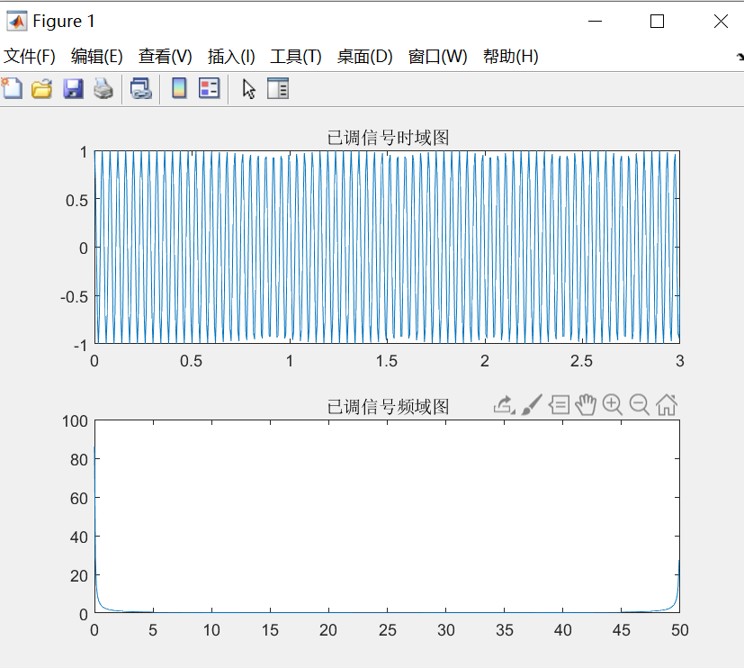

2.

(a)

If H(ω) is aliked with a period of K2pi/T and the resulting spectrum is constant (a straight line), then H(ω) is intersymbol crosstalk free

(b)