Backend REST End Points

1) setupTables:

METHOD : POST
- Header : “api-key” : BACKEND_API_KEY
- Response:
- {"result": 1, "msg": "Tables Created Successfully"}

4 Tables are created:
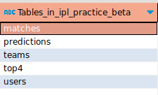

2) populateTeamsTable
METHOD : POST
1. Header : “api-key” : BACKEND_API_KEY
2. form-data: execl-file : <Team_excel_file> (Refer to teams.ods present in the repo)
3. Response:
{"result": 1, "msg": "Teams table"}
In postman:
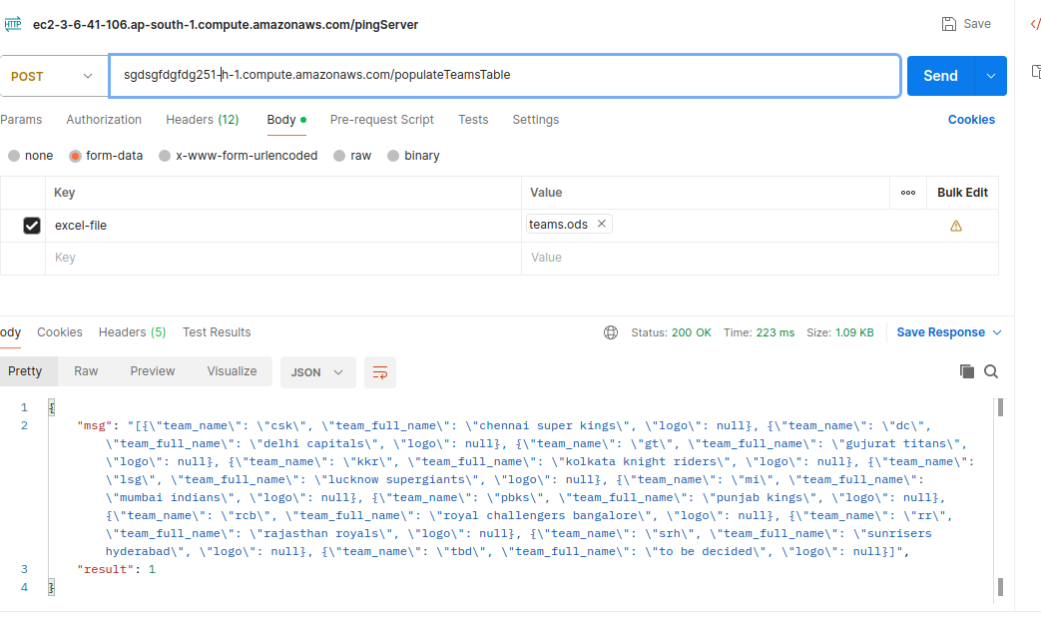

3) populateMatchesTable
METHOD : POST
1. Header : “api-key” : BACKEND_API_KEY
2. form-data: execl-file : <matches_excel_file> (Refer to matches.ods present in the repo)
3. Response:
{"result": 1, "msg": "matches table"}

4) updateTeamWon:
METHOD : POST
1. Header : “api-key” : BACKEND_API_KEY, Contet-type: application/json
2. Body: {“match_id”:<match_number>,”team_won”:”<team_initlais>”}
3. Response:
{"result": 1, "msg": "”}

