
UNIVERSITI TUNKU ABDUL RAHMAN
Faculty of Information and Communication Technology
UCCD1203
DATABASE DEVELOPMENT AND APPLICATIONS

ACADEMIC YEAR: 2025/2026
2025 February Trimester

Group Members:

No. | Name | Student ID | Program | Lecture Group
1. | AEDAN LOH YI CHENG |  | CS | 2
2. | CHUAH SHIN YEE |  | CS | 2
3. | KENDREW LIM YAN ZHE |  | CS | 2
4. | WONG LOONG JIE |  | CS | 2

Marking Section:
Section | Marks
Part A
Part B
TOTAL | /100

MARKING SCHEME

Case Study: Museum Artifact Management System
Check list for Part A – Database Design (3.5%)
1. Introduction (5 marks)
Describe the business background of the database system including the user of the system and discuss 3 main objectives of this project.
2. ER model (15 marks)
You are required to design an ER diagram for the case study given, identify entities, identify relationships, identify associate attribute and determine keys. Check the ERD with the requirements stated in the case. Resolve all the many-many relationships.
3. Business Rule Requirements (10 marks)
Identify the business rule involve based on the ERD. Please include any assumptions that you make.
4. Report (5 marks)
Submit your report with proper technical report writing skills (cover page, headers & footers, page numbering, headings, sections numbering, proper fonts, spell checked, proper alignments, spacing, marking scheme, table of contents etc).
SUBTOTAL: | /35

Check list for Part B – The Implementation of database using Microsoft Access (6.5%)
1. Tables and records (15 marks)
Create all the relations in the ERD and insert the necessary records. (at least 10 records per table except Lookup/composite tables)
2. Queries (15 marks)
Create 3 relevant queries based on the given case study and include the corresponding SQL command. Explain the purpose of each query.
3. Forms (15 marks)
Create 3 useful forms based on the given case study. You may use subform(s). Explain the purpose of each form. Include colors/images to make your form look interesting.
4. Reports (15 marks)
Create 3 useful reports based on the given case study. Explain the purpose of each form. Design your reports so that it will look proper and easy to understand.
5. Switchboard (5 marks)
Create a switchboard that includes all the tables, forms, queries and reports. Make sure the switchboard can start automatically when the database is open and include the exit button to exclude the user from the database.
SUBTOTAL: | /65
TABLE OF CONTENTS

MARKING SCHEME | i
TABLE OF CONTENTS | ii
LIST OF FIGURES | iii
CHAPTER 1 PROJECT BACKGROUND | 1 - 3
1.1 System Overview | 1
1.2 Project Objectives | 2
1.3 Target Database User | 3
CHAPTER 2 DATABASE DESIGN | 4 - 11
2.1 List of Entities and Attributes | 4 – 5
2.2 Entity Relationship Diagram (ERD) | 6
2.3 Assumptions and Business Rules | 7 - 11
CHAPTER 3 DATABASE DEVELOPMENT | 12 - 24
3.1 List of Tables | 12 - 22
3.1.1 Data Dictionary and Table Records | 12 - 22
3.2 Switchboard | 23 - 24
CHAPTER 4 DATABASE OBJECTS | 25 - 36
4.1 Queries | 25 - 28
4.2 Forms | 29 - 32
4.3 Reports | 33 - 36
CHAPTER 5 CONCLUSION | 37
5.1 System Weaknesses | 37
5.2 Future Improvements | 37
REFERENCE | 38

LIST OF FIGURES

Figure Number | Title | Page
Figure 3.1.1.1 | Data dictionary of ARTIFACT entity | 13
Figure 3.1.1.2 | Table Records of ARTIFACT entity | 13
Figure 3.1.2.1 | Data dictionary of COLLECTION entity | 14
Figure 3.1.2.2 | Table Records of COLELCTION entity | 14
Figure 3.1.3.1 | Data dictionary of CURATION entity | 15
Figure 3.1.3.2 | Table Records of CURATION entity | 15
Figure 3.1.4.1 | Data dictionary of EXHIBITION entity | 16
Figure 3.1.4.2 | Table Records of EXHIBITION entity | 16
Figure 3.1.5.1 | Data dictionary of FEATURE entity | 17
Figure 3.1.5.2 | Table Records of FEATURE entity | 17
Figure 3.1.6.1 | Data dictionary of MAINTENANCE entity | 18
Figure 3.1.6.2 | Table Records of MAINTENANCE entity | 18
Figure 3.1.7.1 | Data dictionary of PROVENANCE entity | 19
Figure 3.1.7.2 | Table Records of PROVENANCE entity | 19
Figure 3.1.8.1 | Data dictionary of REPOSITORY entity | 20
Figure 3.1.8.2 | Table Records of REPOSITORY entity | 20
Figure 3.1.9.1 | Data dictionary of STAFF entity | 21
Figure 3.1.9.2 | Table Records of STAFF entity | 21
Figure 3.1.10.1 | Data dictionary of STORAGE entity | 22
Figure 3.1.10.2 | Table Records of STORAGE entity | 22
Figure 3.2.1 | Main Switchboard | 23
Figure 3.2.2 | Form Switchboard | 23
Figure 3.2.3 | Query Switchboard | 24
Figure 3.2.4 | Table Switchboard | 24
Figure 3.2.5 | Report Switchboard | 24
Figure 4.1.1.1 | “Renaissance Art Collection” query | 26
Figure 4.1.2.1 | “Artifact Maintenance Detail” query | 27
Figure 4.1.3.1 | “Artifact Exhibition and Storing” query | 28
Figure 4.2.1.1 | Artifact Record Navigation and Management Interface | 29
Figure 4.2.1.2 | New Artifact Registration Form | 30
Figure 4.2.2.1 | Artifact Condition Update and Maintenance History Form | 31
Figure 4.2.3.1 | Exhibition Details and Management Form | 32
Figure 4.3.1.1 | Collection Report | 34
Figure 4.3.2.1 | Exhibition Report | 35
Figure 4.3.3.1 | Maintenance Report | 36

CHAPTER 1 PROJECT BACKGROUND
Project Background
In this chapter, we present the system overview and details about the business background of the Heritage Museum’s Museum Artifact Management System. The database system is designed to efficiently manage the collection of artifact information, and the details of targeted users of the database will also be included in this chapter.

The goal of this project is to develop a centralized database system that is user-friendly for the museum administrators to access, store, update, retrieve data and navigate across it.

1.1 System Overview
The Museum Artifact Management System is a centralized database solution designed for the Heritage Museum to streamline the management of artifacts and related operations. The system supports a comprehensive set of functionalities, including storing detailed information about artifacts, tracking their provenance, maintenance history, storage locations, and exhibition records. It also allows users to monitor artifact conditions and manage staff assignments related to conservation, exhibition planning, and curation tasks.

This database system enhances efficiency by enabling museum staff to retrieve and update information quickly, ensure artifact security, and maintain accurate historical records. The system incorporates various entities such as Artifact, Staff, Exhibit, Maintenance, Storage, and Provenance, with clear relationships to facilitate data consistency and integrity. With role-based access and organized data flows, the system aims to support the daily operations of the museum while safeguarding valuable cultural assets.

1.2 Project Objectives
Objective 1:
To develop a structured database system that store artifact information with proper categorization and easy retrieval.

Objective 2:
To allow user to track and monitor the artifacts, including its current location, condition, maintenance record, and exhibition status, to improve artifact data management and security.

Objective 3:
To design an effective resource management sub-system that tracks and optimizes artifact-related resource allocation by integrating staff roles and maintenance workflows, ensuring real-time monitoring of storage facilities

1.3 Target Database User
The targeted users for this database system are archivist, curator, museum conservator, exhibit designer, museum educator, and the human resource department.
An archivist holds a critical role in the museum, as they were required to have exceptional organizational skills as they are responsible for maintaining the data collection of each artifact [1]. Their primary duties allow them to be a user of the database system so that they can catalog each artifact, ensure that the data recorded are organized and have accurate documentation, and provide updates for each record.
A curator holds the highest position among the museum hierarchy, is responsible for acquiring new artifacts. Specifically, this involves conducting research to identify the significant artifacts that are related to the museum’s theme, negotiate acquisition with collectors and donors, and seek funding for artifact acquisition [1]. In addition, curators are proficient in using the database system to update and manage the provenance records of each artifact.
A museum conservator is responsible for making preventative conservation measures, such as environmental and climate control, pest management, and retain the aesthetic appeal of artifacts [1]. They need to use the database system to update the condition and maintenance history of each artifact.
An exhibit designer plays a crucial role in planning, design, and executes the layout of museum displays, ensuring that artifacts are presented in a way that is both educational and aesthetically pleasing to enhance the visitors’ experience [1]. They need to use the database system to plan and organize future exhibitions features of an artifact.
A museum educator engages with the public and educates visitors as they are responsible for providing guided tours, creating educational materials, and contributing to the museum's educational programs [1]. Educators use the database system to access information on artifacts and exhibits, ensuring they have accurate and up-to-date knowledge to share with visitors.
Lastly, the museum’s human resource department also requires access to the database system to record and manage information related to every museum staff member, including their roles and responsibilities.

CHAPTER 2 DATABASE DESIGN
2.1 List of Entities and Attributes
Entity | Attributes
ARTIFACT | - PK artifact_id  - artifact_name  - artifact_desc  - artifact_type  - acqui_date  - artifact_value  - current_condition
PROVENANCE | - PK provenance_id  - FK artifact_id reference ARTIFACT (artifact_id)  - owner_fname  - owner_lname  - previous_country  - acqui_method
COLLECTION | - PK collection_id  - FK staff_id reference STAFF (staff_id)  - collection_theme
CURATION | - PK, FK collection_id reference COLLECTION (collection_id)  - PK, FK artifact_id reference ARTIFACT (artifact_id)  - curation_date
MAINTENANCE | - PK, FK staff_id reference STAFF (staff_id)  - PK, FK artifact_id reference ARTIFACT (artifact_id)  - PK maintenance_id  - maintenance_date  - maintenance_type
STAFF | - PK staff_id  - staff_fname  - staff_lname  - staff_dob  - staff_role  - FK supervisor_id reference STAFF
EXHIBITION | - PK exhibit_id  - FK staff_id reference STAFF (staff_id)  - exhibit_name  - exhibit_sdate  - exhibit_edate
STORAGE | - PK storage_id  - storage_location  - climate_control
FEATURE | - PK, FK exhibit_id reference EXHIBITION  - PK, FK artifact_id reference ARTIFACT
REPOSITORY | - PK, FK artifact_id reference ARTIFACT  - PK, FK storage_id reference STORAGE  - placement  - storing_desc

2.2 Entity Relationship Diagram (ERD)
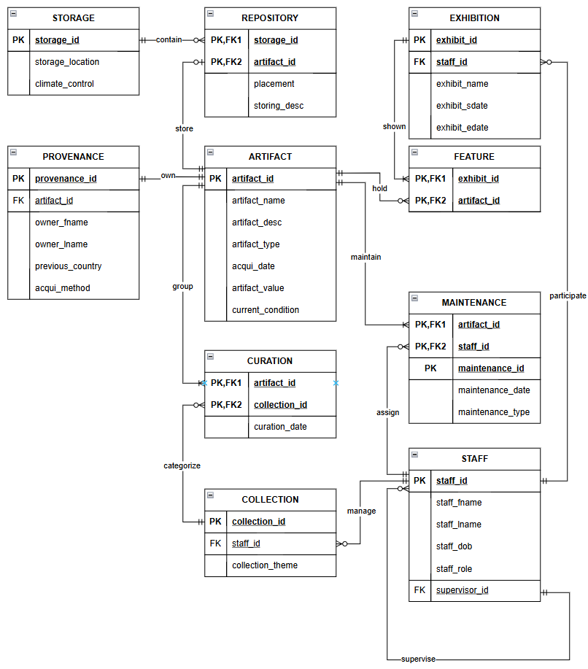

2.3 Assumptions and Business Rules
List of Assumptions
1. Storage
Assume that each storage is uniquely identified.
Assume that a storage can contain multiple repositories.
Assume that climate control and storage capacity are managed per storage unit.
Assume that storage locations do not overlap.
Assume that each artifact is indirectly linked to storage through repositories.

2. Repository
Assume that a repository is stored in exactly one storage.
Assume that each repository stores only one artifact.
Assume that repositories cannot be empty if they exist.
Assume that no repository stores multiple artifacts.
Assume that a repository cannot belong to more than one storage.

3. Artifact
Assume that every artifact may or may not be stored in a repository.
Assume that each artifact has a unique provenance.
Assume that an artifact can have multiple curations and features.
Assume that each artifact may appear in multiple maintenance records.
Assume that artifact location, condition, and related activities are consistently tracked.

4. Provenance
Assume that each provenance is linked to exactly one artifact.
Assume that provenance information is accurate and verified during acquisition.
Assume that provenance data includes acquisition method and previous ownership.
Assume that no artifact can have more than one provenance.
Assume that provenance records are immutable once entered.

5. Curation
Assume that each curation is related to one and only one artifact.
Assume that curations must belong to a valid collection.
Assume that an artifact can have multiple curations over time.
Assume that curation activities are periodically reviewed.
Assume that curation information is necessary for categorizing artifacts.

6. Collection
Assume that a collection manages one or many curations.
Assume that each collection is assigned to exactly one staff member.
Assume that collections do not share artifacts.
Assume that collection themes or categories are clearly defined.
Assume that collections are not auto generated and require staff input.

7. Feature
Assume that a feature is related to exactly one artifact.
Assume that an artifact can have zero or more features.
Assume that features are used to represent artifacts in exhibitions.
Assume that each feature is only linked to one exhibition at a time.
Assume that features provide display and descriptive information about artifacts.

8. Exhibition
Assume that each exhibition displays one or many features.
Assume that an exhibition is managed by a staff member.
Assume that exhibitions are uniquely identified by exhibit_id.
Assume that artifacts can appear in multiple exhibitions through different features.
Assume that exhibitions follow a structured schedule and theme.

9. Staff
Assume that every staff has a unique supervisor except those at the top level (who supervise themselves).
Assume that a staff can be assigned to multiple collections and exhibitions.
Assume that roles include curator, conservator, exhibition manager, and archivist.
Assume that supervisor relationships form a tree hierarchy without cycles.
Assume that a staff may perform maintenance if assigned the conservator role.

10. Maintenance
Assume that maintenance is done by one staff member per record.
Assume that an artifact can have multiple maintenance records over time.
Assume that each maintenance event includes a date and type (e.g., cleaning, repair).
Assume that only staff with the proper role can perform maintenance.
Assume that maintenance records help track artifact condition history.

List of Business Rules (According to ERD)
1. STORAGE AND REPOSIROTY
Each Storage contains one or many repository.
Each Repository contained one and only one Storage.

2. REPOSITORY AND ARTIFACT
Each Repository stores one and only one Artifact.
Each Artifact stored by one or zero Repository.

3. ARTIFACT AND PROVENANCE
Each Artifact owns one and only one Provenance.
Each Provenance owned by one and only one Artifact.

4. ARTIFACT AND CURATION AND COLLECTION
4.1 ARTIFACT AND CURATION
Each Artifact group one or many Curation.
Each Curation grouped by one and only one Artifact.

4.2 CURATION AND COLLECTION
Each Curation categorized by one and only one Collection.
Each Collection categorize to zero or many Curation.

5. ARTIFACT AND FEATURE AND EXHIBITION
5.1 ARTIFACT AND FEATURE
Each Artifact is held by zero or many Features.
Each Feature hold one and only one Artifact.
5.2 FEATURE AND EXHIBITION
Each Feature shown by one and only one Exhibition.
Each Exhibition shows one or many Features .

6. COLLECTION AND STAFF
Each Collection managed by one and only one Staff.
Each Staff manage zero or many Collection .

7. EXHIBITION AND STAFF
Each Exhibition participated by one and only one Staff.
Each Staff participates in zero or many Exhibition.

8. STAFF
Each Staff supervised by one and only one Staff which is a Supervisor.
Each Supervisor that is a staff and supervises zero or many Staff.

9. STAFF AND MAINTENANCE
Each Staff get assigned to zero or many Maintenance
Each Maintenance assigned by one and only one staff

10. MAINTENANCE AND ARTIFACT
Each Maintenance will maintain one and only one Artifact
Each Artifact will be maintained by one or many times of maintenance.

CHAPTER 3 DATABASE DEVELOPMENT
3.1 List of Tables
In this project, the patient, guardian, doctor, duty slot, diagnosis, treatment, medication, and treatment receipt are among the tables that were used. There are a total of 8 tables in the project, each of which contains a collection of named columns and an unspecified number of rows to store data and information. Each column has a set data type, and the values that can be entered into each field are restricted by domain constraints such as check constraints, not null constraints, unique constraints, and default constraints.

3.1.1 Data Dictionary and Table Record
a) ARTIFACT
- Data Dictionary
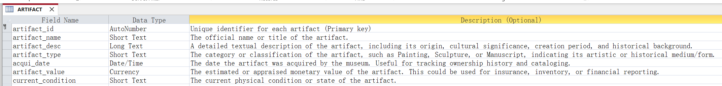
Figure 3.1.1.1: Data dictionary of ARTIFACT entity

- Table Records
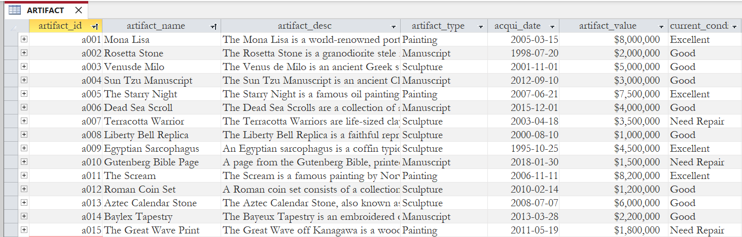
Figure 3.1.1.2: Table Records of ARTIFACT entity

b) COLLECTION
- Data Dictionary
Figure 3.1.2.1: Data dictionary of COLLECTION entity

- Table Records
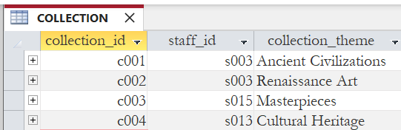
Figure 3.1.2.2: Table Records of COLLECTION entity

c) CURATION
- Data Dictionary
Figure 3.1.3.1: Data dictionary of CURATION entity
- Table Records
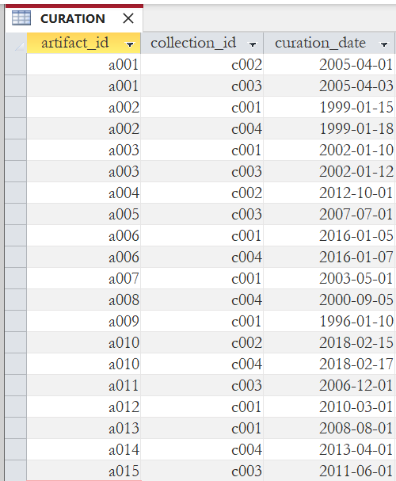
Figure 3.1.3.2: Table Records of CURATION entity

d) EXHIBITION
- Data Dictionary
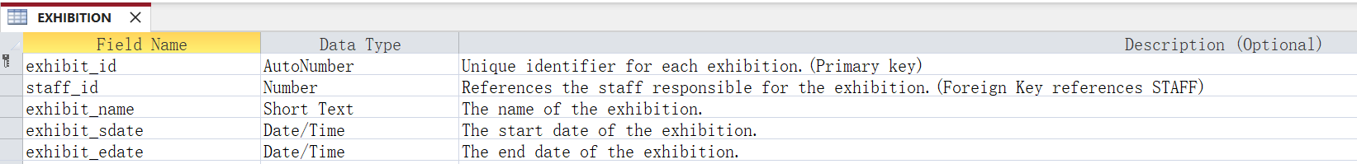
Figure 3.1.4.1: Data dictionary of EXHIBITION entity

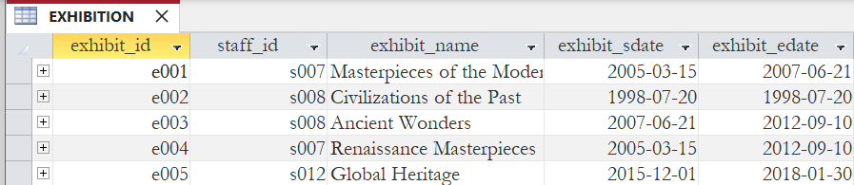
Figure 3.1.4.2: Table Records of EXHIBITION entity

e) FEATURE
- Data Dictionary
Figure 3.1.5.1: Data dictionary of FEATURE entity

- Table Records
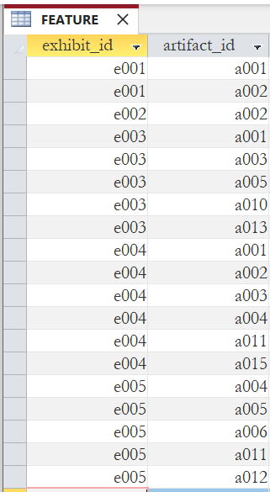
Figure 3.1.5.2: Table Records of FEATURE entity

f) MAINTENANCE
- Data Dictionary
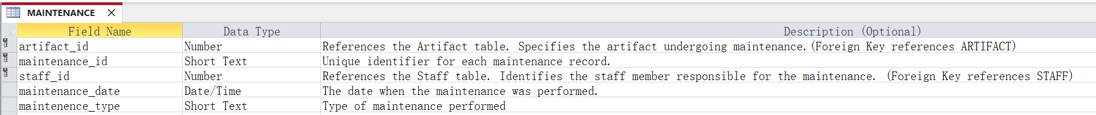
Figure 3.1.6.1: Data dictionary of MAINTENANCE entity

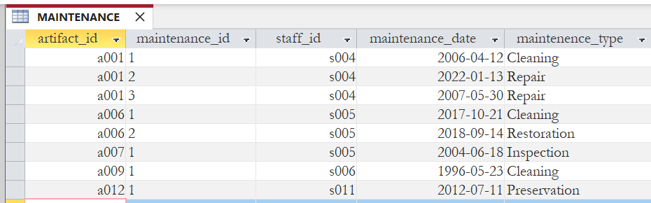
Figure 3.1.6.2: Table Records of MAINTENANCE entity

g) PROVENANCE
- Data Dictionary
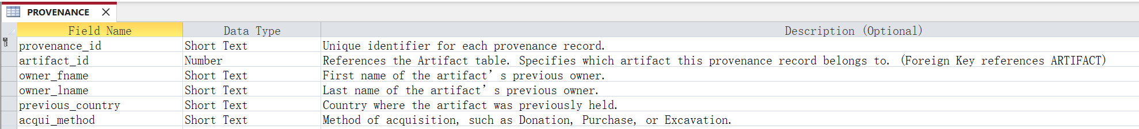
Figure 3.1.7.1: Data dictionary of PROVENANCE entity

- Table Records
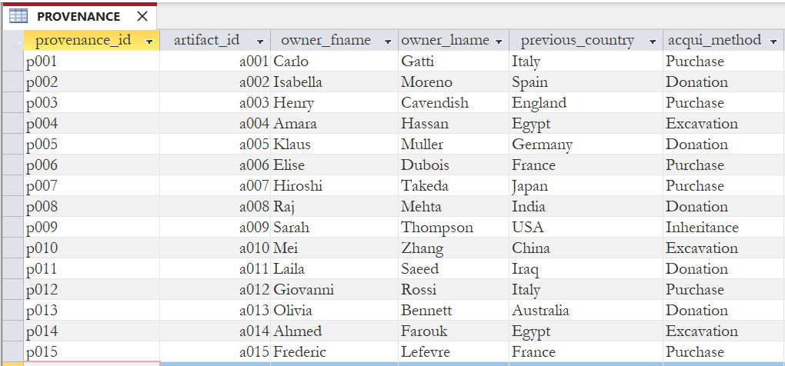
Figure 3.1.7.2: Table Records of PROVENANCE entity

h) REPOSITORY
- Data Dictionary
Figure 3.1.8.1: Data dictionary of REPOSITORY entity

- Table Records
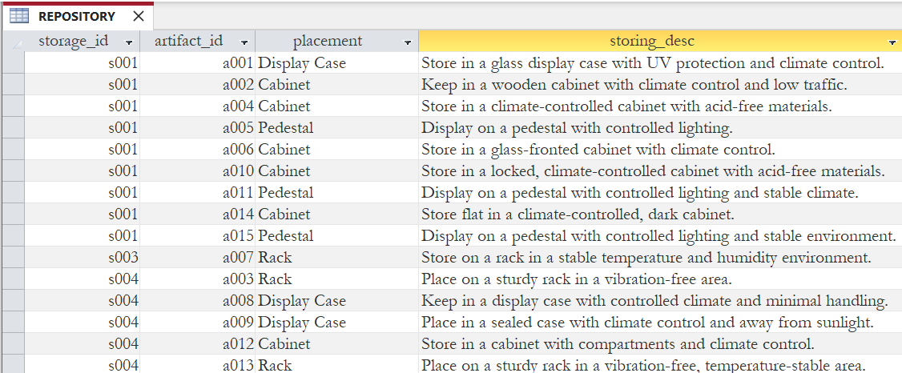
Figure 3.1.8.2: Table Records of REPOSITORY entity

i) STAFF
- Data Dictionary
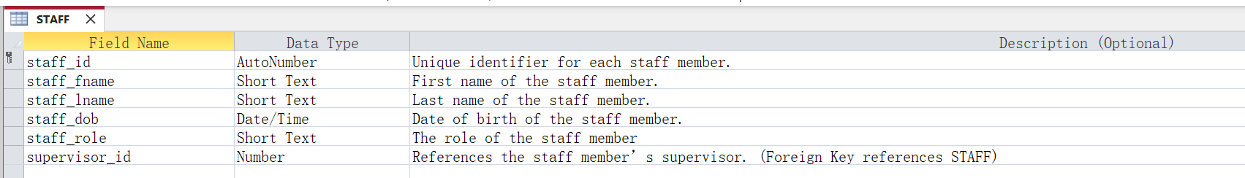
Figure 3.1.9.1: Data dictionary of STAFF entity

- Table Records
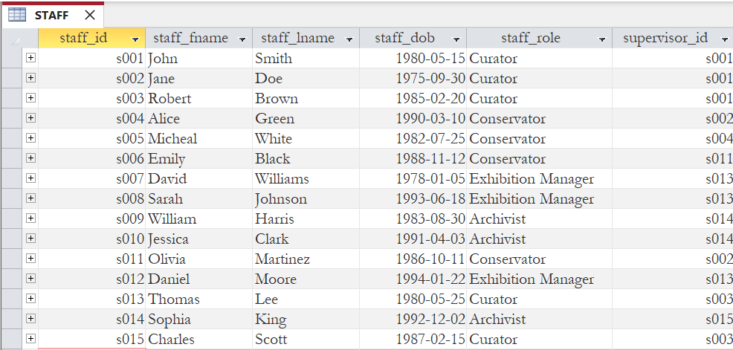
Figure 3.1.9.2: Table Records of STAFF entity

j) STORAGE
- Data Dictionary
Figure 3.1.10.1: Data dictionary of STORAGE entity

- Table Records
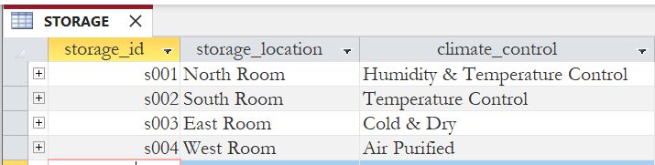
Figure 3.1.10.2: Table Records of STORAGE entity

3.2 Switchboard
The Switchboard in Microsoft Access is a user-friendly interface that serves as a central navigation hub for users to access various forms, reports, and queries within the database system. It simplifies navigation by organizing and linking key functions into a single, easy-to-use interface, allowing users to quickly perform tasks without needing to navigate through multiple menus or objects. This feature enhances efficiency, especially for non-technical users, by providing a clear and straightforward way to interact with the database. In this project, we use a switchboard to case the navigation process for the staff members in The Heritage Museum houses.

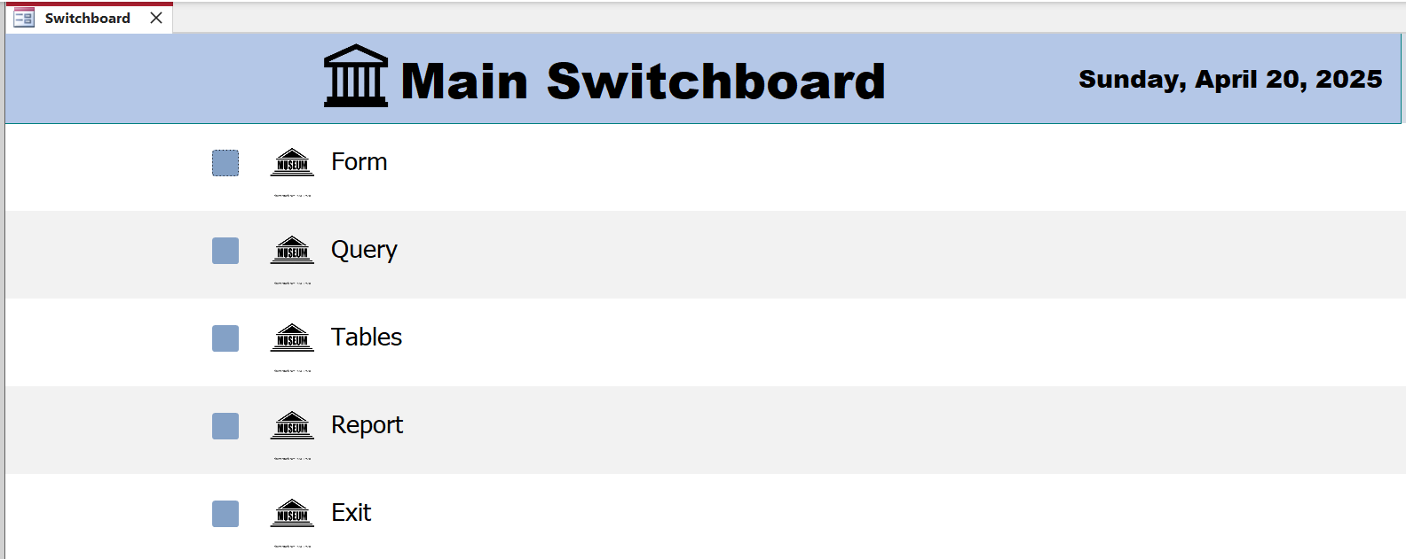
Figure 3.2.1: Main Switchboard

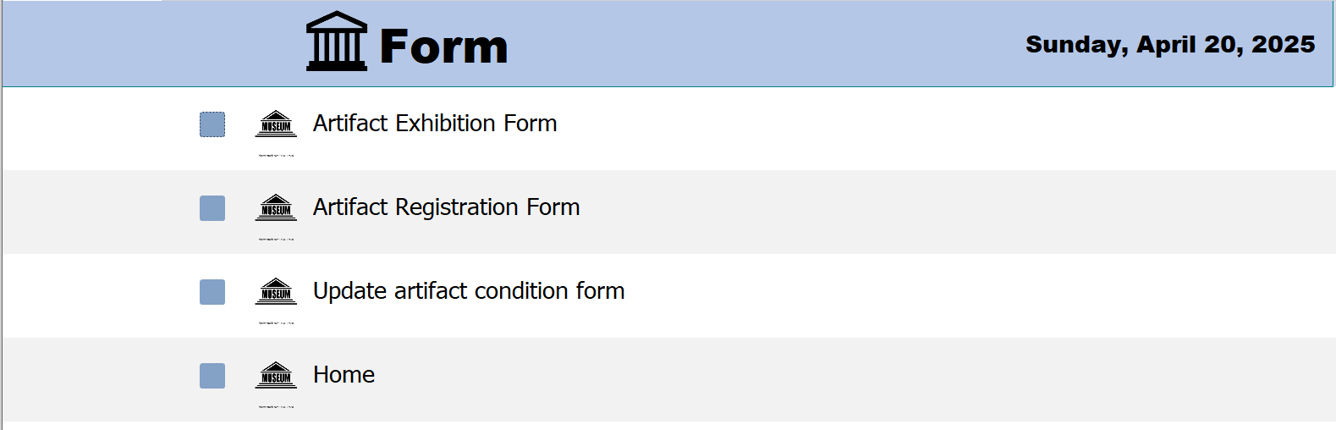
Figure 3.2.2: Form Switchboard

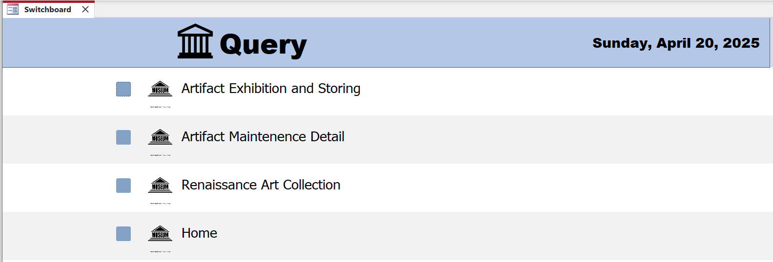
Figure 3.2.3: Query Switchboard

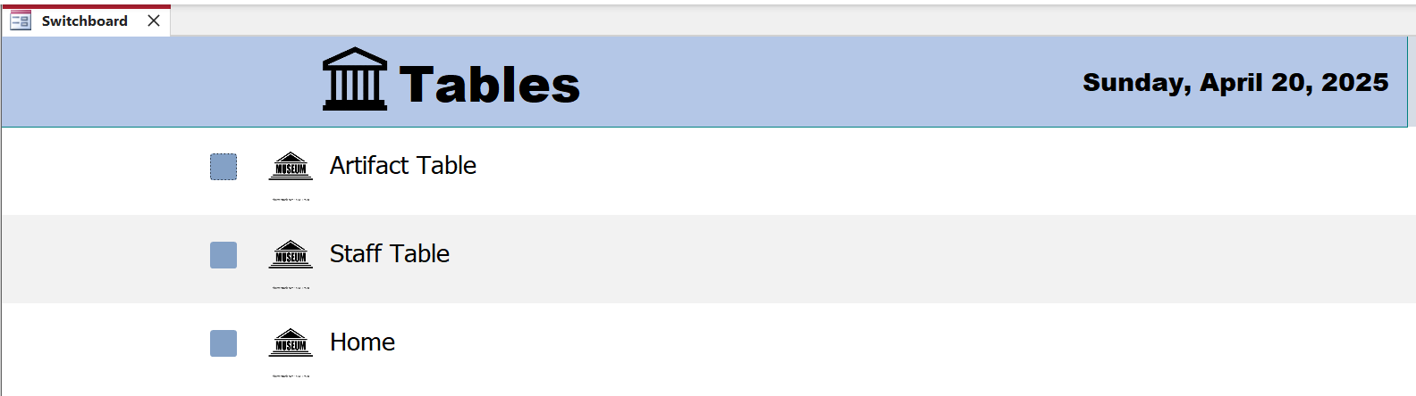
Figure 3.2.4: Table Switchboard

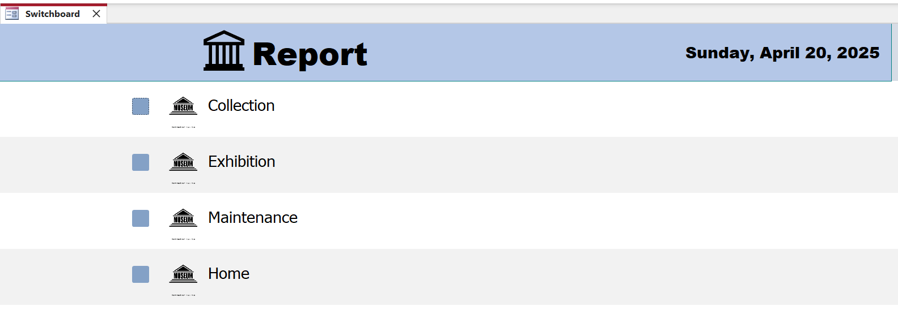
Figure 3.2.5: Report Switchboard

CHAPTER 4 DATABASE OBJECTS

Database Objects
A database object is a structured component within a database that serves a specific function. Examples of database objects include tables, queries, forms, reports, macros, and modules. Each object plays a distinct role and contributes to the overall design, functionality, and integrity of the database system.

4.1 Queries
Queries are used to extract, filter, and analyze data from one or more tables within a database. They allow users to retrieve specific information based on defined criteria, making it easier to focus on relevant data. By streamlining data retrieval, queries help users save time and enhance productivity in database management.

4.1.1 Query 1
Explanation:
The “Renaissance Art Collection” query is created to search for all artifacts that belong to the ‘Renaissance Art’ collection. Information such as the artifact’s ID, name, and type will be displayed if the artifact is part of the specified collection. Since an artifact may belong to more than one collection, the query filters to show only those related to ‘Renaissance Art’. It serves to help museum staff efficiently access and organize specific artifacts for exhibition planning, inventory review, or thematic research purposes.

SQL command:
SELECT COLLECTION.collection_id, COLLECTION.collection_theme,
ARTIFACT.artifact_id, ARTIFACT.artifact_name, ARTIFACT.artifact_type,
CURATION.curation_date
FROM (COLLECTION INNER JOIN CURATION ON COLLECTION.collection_id = CURATION.collection_id) INNER JOIN ARTIFACT ON CURATION.artifact_id = ARTIFACT.artifact_id
WHERE COLLECTION.collection_theme = "Renaissance Art";

Sample query 1:
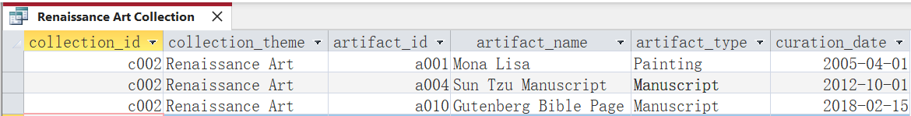
Figure 4.1.1.1: “Renaissance Art Collection” query

4.1.2 Query 2
Explanation:
The “Artifact Maintenance Detail” query is created to retrieve all artifacts along with their maintenance records and the name of the staff member responsible for each task. The information displayed includes the artifact’s details, maintenance type, maintenance date, and staff name. An artifact may undergo multiple maintenance activities over time, so all related records are shown together. This query enables the museum staff to track artifact care history and assign responsibility, promoting preservation efforts and ensuring long-term artifact integrity.

SQL command:
SELECT ARTIFACT.artifact_id, ARTIFACT.artifact_name,
ARTIFACT.artifact_type, MAINTENANCE.maintenance_id,
MAINTENANCE.maintenance_date, MAINTENANCE.maintenance_type,
STAFF.staff_id, STAFF.staff_fname, STAFF.staff_lname
FROM (ARTIFACT INNER JOIN MAINTENANCE ON ARTIFACT.artifact_id = MAINTENANCE.artifact_id) INNER JOIN STAFF ON MAINTENANCE.staff_id = STAFF.staff_id;

Sample query 2:
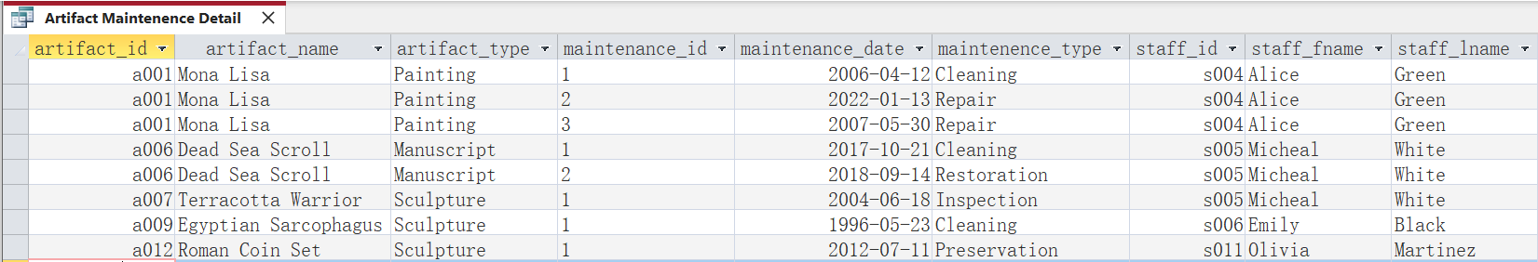
Figure 4.1.2.1: “Artifact Maintenance Detail” query

4.1.3 Query 3
Explanation:
The “Artifact Exhibition and Storing” query is created to display all artifacts together with their exhibition and storage details. The information includes artifact names, associated exhibitions (if any), and storage locations. Some artifacts may not currently be part of any exhibition, and in such cases, the exhibition fields will display a dash instead of being left blank. This query helps museum staff to gain a comprehensive overview of the location and display status of each artifact, supporting space planning and effective collection management.

SQL command:
SELECT ARTIFACT.artifact_id, ARTIFACT.artifact_name,
ARTIFACT.artifact_type, EXHIBIT.exhibit_id, EXHIBIT.exhibit_name,
STORAGE.storage_id, STORAGE.storage_location
FROM ARTIFACT LEFT JOIN EXHIBIT_ARTIFACT ON ARTIFACT.artifact_id = EXHIBIT_ARTIFACT.artifact_id
LEFT JOIN EXHIBIT ON EXHIBIT_ARTIFACT.exhibit_id = EXHIBIT.exhibit_id
LEFT JOIN STORAGE ON ARTIFACT.artifact_id = STORAGE.artifact_id;

Sample query 3:
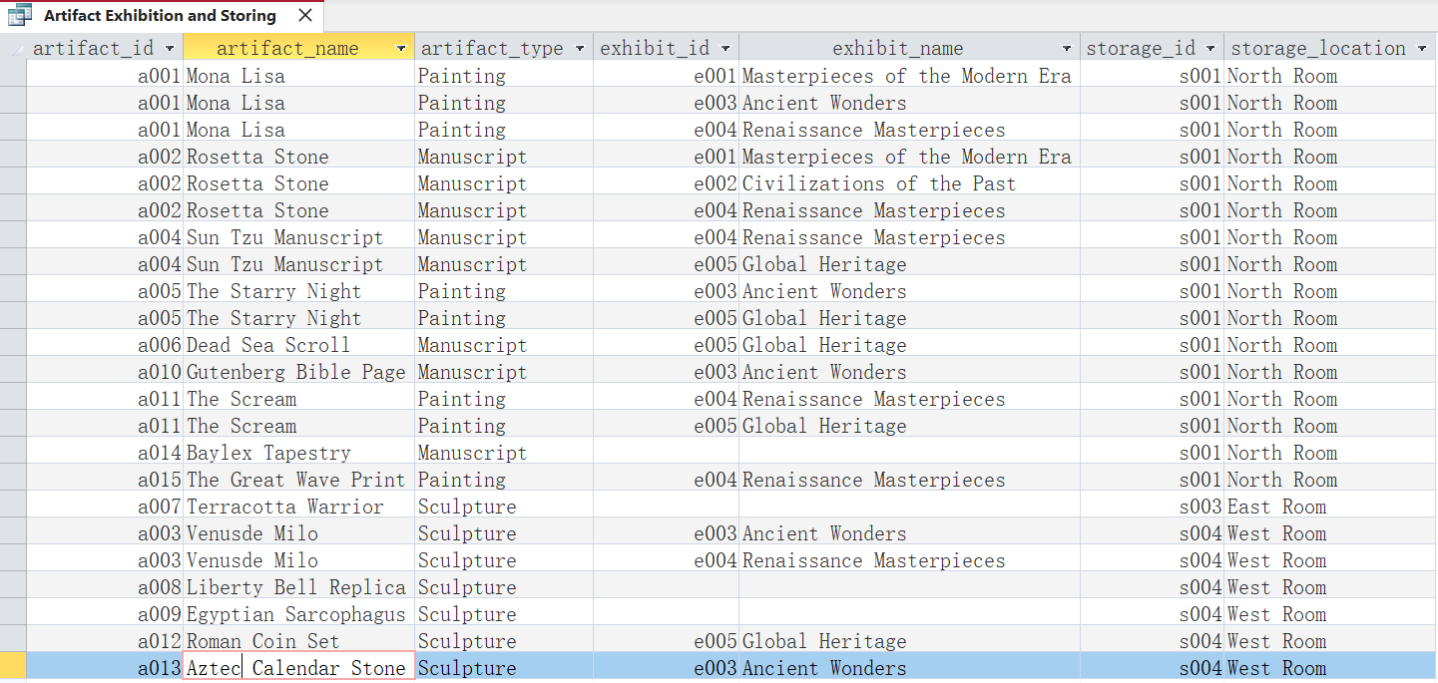
Figure 4.1.3.1: “Artifact Exhibition and Storing” query

4.2 Forms
A form is a customized window or screen that allows users to interact with the data in an Access database without directly opening the tables. It can display one or multiple records simultaneously and often includes text boxes, combo boxes, buttons, and other controls.
4.2.1 Form 1
The Artifact Registration Form contains all the detailed information about each artefact, including the artifact ID, artifact name, artifact description, acquisition date, and artifact value. Users can navigate through the records using the Previous and Next buttons, as shown in Figure 4.2.1.1. Additionally, users can also edit and delete the existing records using the respective Delete and Register buttons. Besides, users can also add new artifacts by filling out the form as shown in Figure 4.2.1.2 and clicking the Register button to save the new entry. The data will automatically update to the artifact table after clicking the Register button.
Sample Form 1:
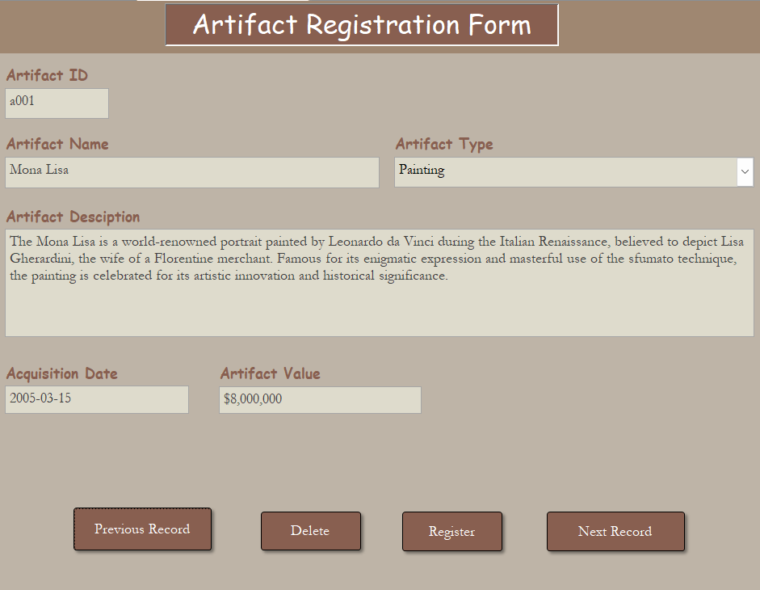Figure 4.2.1.1 Artifact Record Navigation and Management Interface 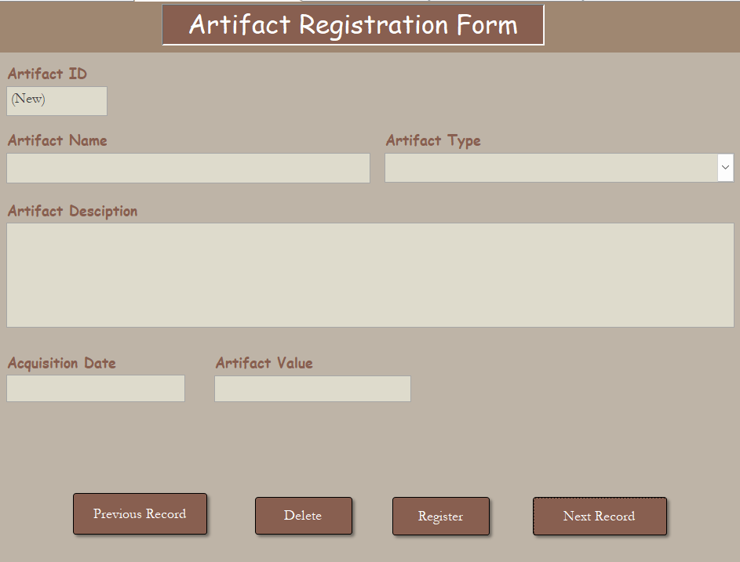Figure 4.2.1.3 New Artifact Registration Form

4.2.2 Form 2
The Update Artifact Condition Form allows users to view the maintenance history and update the current condition for each artifact. The artifact ID and artifact name fields are locked and cannot be edited. Users are only allowed to change the current condition by selecting one of the three predefined options from the combo box, as shown in Figure 4.2.2.1.
Sample Form 2:
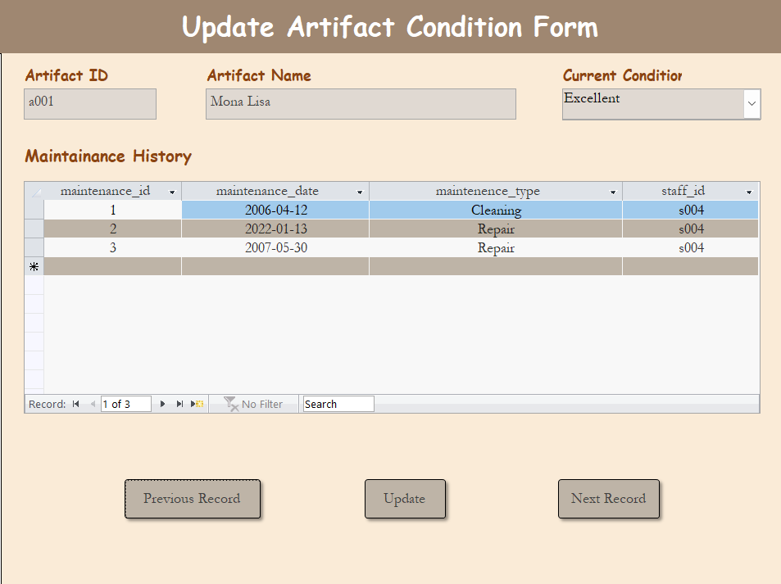Figure 4.2.2.1 Artifact Condition Update and Maintenance History Form

4.2.3 Form 3
The Artifact Exhibition Form shows details information of each exhibition, including exhibition ID, exhibition name, start and end date, the artifact involved, and the staff involved. Users can view all exhibition details and create new records, as shown in Figure 4.2.3.1.
Sample Form 3:
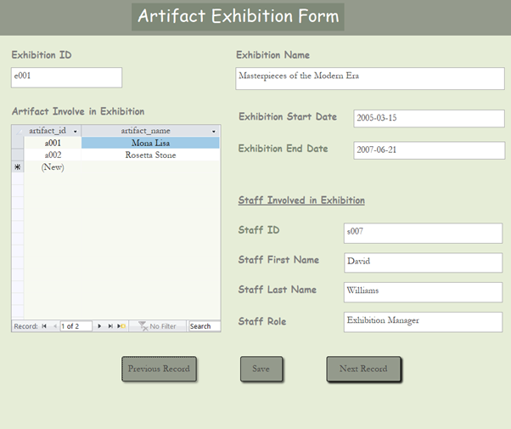Figure 4.2.3.1 Exhibition Details and Management Form

4.3 Report
Reports are used for presenting summarized and structured information stored in a database. For The Heritage Museum, reports enable staff members to extract essential details about artifacts, their origins, and maintenance history in a clear, concise, and meaningful format. These reports are especially valuable for museum curators and management, as they provide a comprehensive overview of the collection, aiding in preservation planning, historical research, and decision-making regarding exhibitions. Reports can be generated for specific categories of artifacts or for the entire collection and can be customized to present data in a format that is easy to interpret and use.

4.3.1 Report 1
Explanation:
The Artifact Collection Report below demonstrates the organization and status of the museum’s holdings by grouping each item under its respective collection theme. By categorizing artifacts such as the Egyptian Sarcophagus and the Gutenberg Bible Page under themes like Ancient Civilizations and Renaissance Art, the report makes it easy to track acquisition dates and monitor the growth of each collection over time. It presents essential fields like Collection Theme, Artifact Name, and Acquisition Date in a clear, tabular layout, allowing curators and managers to quickly assess when key pieces entered the collection and to identify gaps or recent additions. This report is a vital tool for the museum’s leadership, supporting informed decision about preservation scheduling, exhibition planning, and future acquisitions. Reports can be generated for individual themes or for the entire collection and customized to highlight specific date ranges or artifacts categories in a format that is straightforward to interpret and act upon.

Sample Report 1: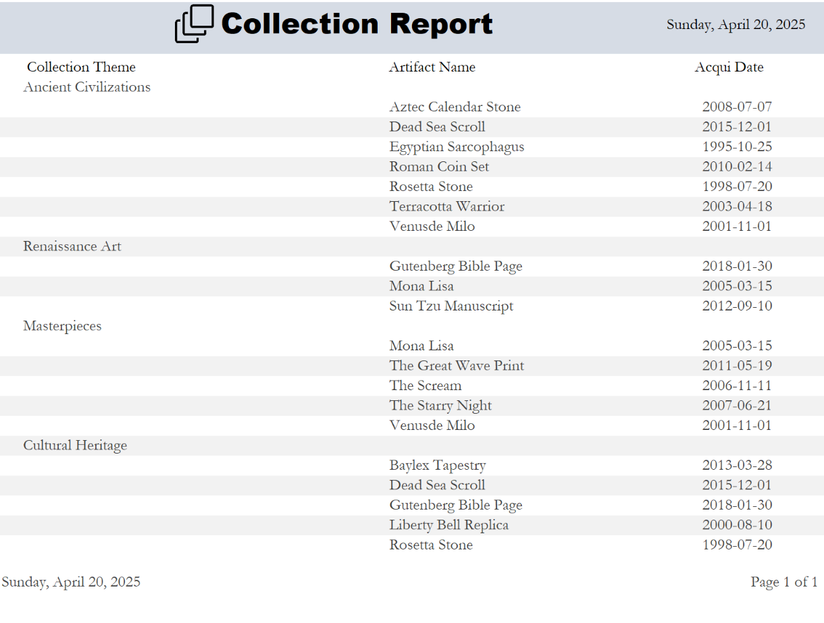
Figure 4.3.1.1: Collection Report
4.3.2 Report 2
Explanation:
The Exhibition Report provides a comprehensive overview of museum or gallery exhibitions by tracking essential details such as exhibit names, dates, and associated artifacts. Structured to manage the logistics of artifact display, this report ensures efficient scheduling by documenting the start and end dates of each exhibit alongside the specific artifacts included. In Microsoft Access, this report is crucial for preventing conflicts where the same artifact might be double-booked across overlapping exhibits, while also aiding in historical analysis and future planning. By centralizing data on artifact utilization and exhibit timelines, administrators can optimize resource allocation, assess artifact popularity, and streamline exhibit rotations. This structured approach supports informed decision-making for curators and managers, enhancing operational efficiency and ensuring seamless coordination of exhibitions.

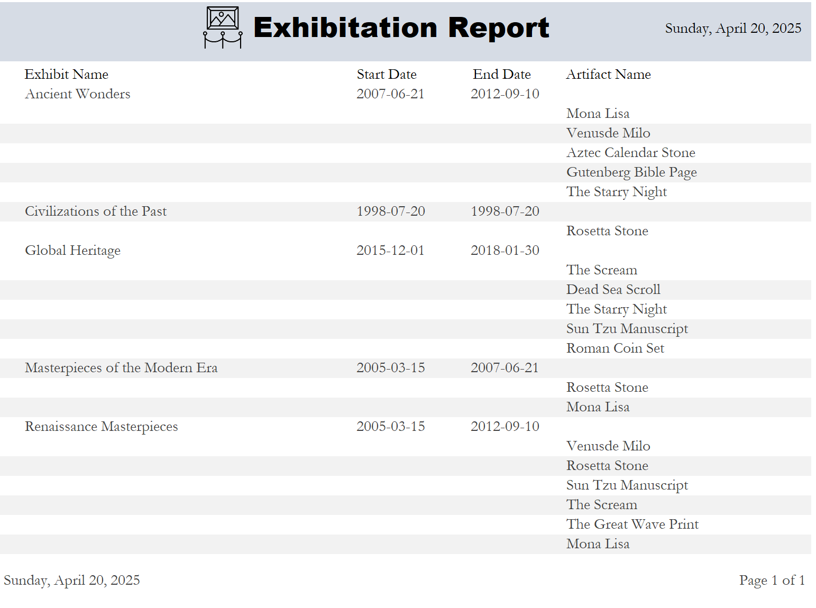
Sample Report 2
Figure 4.3.2.1: Exhibition Report
4.3.3 Report 3
Explanation:
The Maintenance Report systematically tracks the preservation activities and condition status of museum artifacts, categorizing them by type (e.g., Manuscript, Painting, Sculpture) and documenting critical details such as maintenance type, artifact condition, and maintenance dates. For example, it records repeated repairs and cleanings for the Mona Lisa and highlights artifacts requiring urgent attention, like the Terracotta Warrior marked as "Need Repair." In Microsoft Access, this report is vital for ensuring artifact longevity by scheduling timely interventions, avoiding maintenance overlaps with exhibitions and maintaining historical longevity efforts. It aids in resource allocation, budgeting for repairs, and preventing deterioration by flagging recurring issues. By centralizing maintenance data, curators can prioritize tasks, comply with preservation standards, and coordinate seamlessly with exhibition planning, ensuring artifacts remain display-ready while safeguarding their historical value. This integration enhances operational efficiency and supports data-driven conservation strategies.

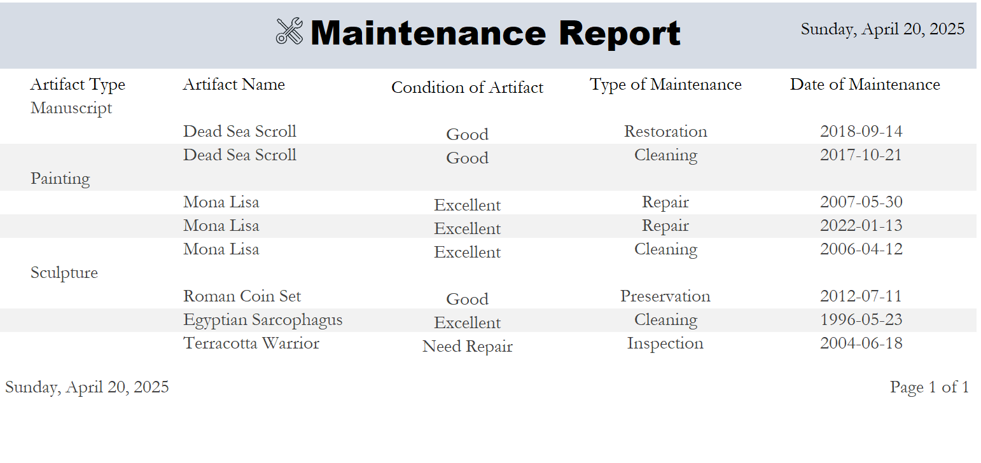
Sample Report 3
Figure 4.3.3.1: Maintenance Report

CHAPTER 5 CONCLUSION
5.1 System Weaknesses
The current system has several weaknesses, including limited scalability and difficulty in handling large volumes of data. Performance issues may arise as the database grows, especially when running complex queries or generating reports. Additionally, the system lacks sufficient user role management, leading to potential access control issues. Some features may also be unintuitive for less technical users, requiring additional training or support.
Another weakness is the absence of automated data backup and recovery processes, which increases the risk of data loss in case of system failures. Furthermore, the current interface could be improved for better user experience, as navigation between different forms and reports could be made more seamless. These limitations hinder the system's overall effectiveness in handling larger, more dynamic datasets.

5.2 Future Improvements
Future improvements should focus on enhancing system scalability by optimizing database structure and improving query performance. Implementing role-based access controls will help better manage user permissions and prevent unauthorized access to sensitive data. Additionally, introducing automated data backup and recovery mechanisms will increase data security and minimize downtime in case of system failure.
The user interface could also benefit from an overhaul to make it more intuitive and user-friendly, reducing the need for extensive training. A more dynamic and responsive design would enhance the overall experience. Finally, integrating new features such as data analytics or visualization tools could provide users with better insights and decision-making capabilities, improving the system's overall functionality and utility.

REFERENCE
[1] K. Rapp, “List of Museum Jobs Their Roles, Responsibilities, and More.,” ACME Ticketing, Jul. 03, 2019. https://acmeticketing.com/list-of-museum-jobs/
‌

