Code is in code directory. Whole project is in wc1

start task1
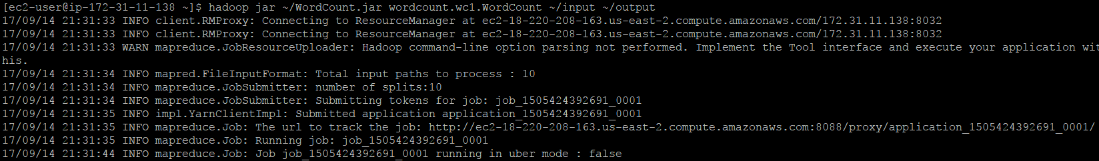
task1 information
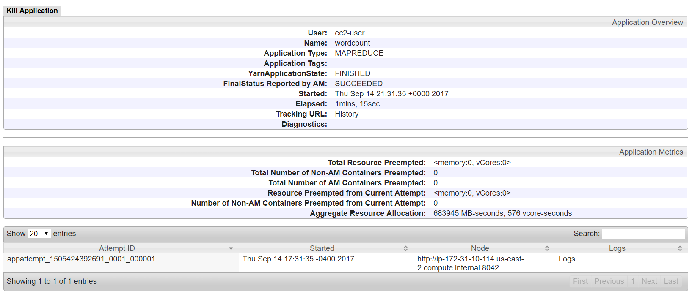
task result: please see result/result1.txt or
https://github.com/csymicc/Cloud_Computing_Assignments/blob/master/Assignment1/results/result1.txt

start task2
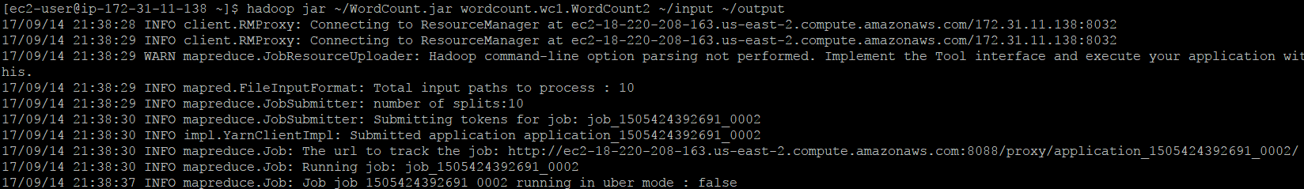
task2 information
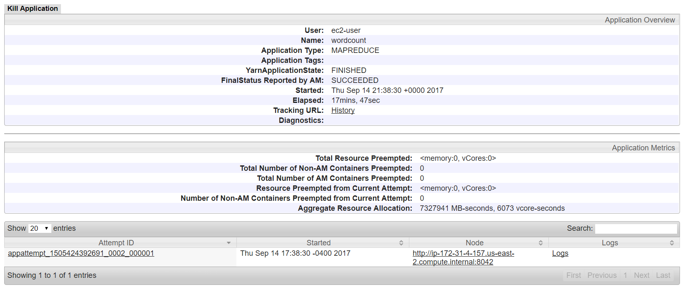
task result: please see result/result2.txt or
https://github.com/csymicc/Cloud_Computing_Assignments/blob/master/Assignment1/results/result2.txt

start task3
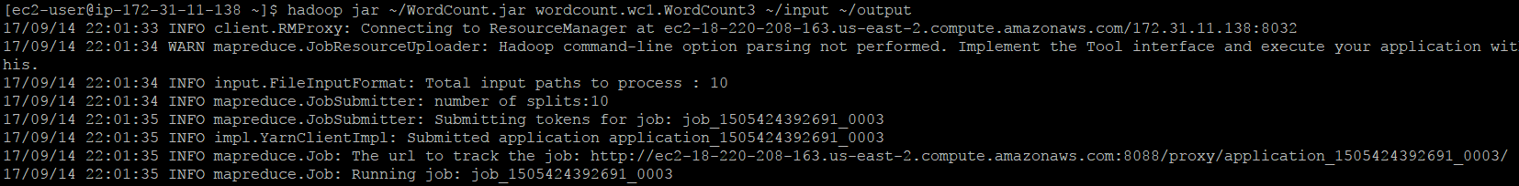
task3 information
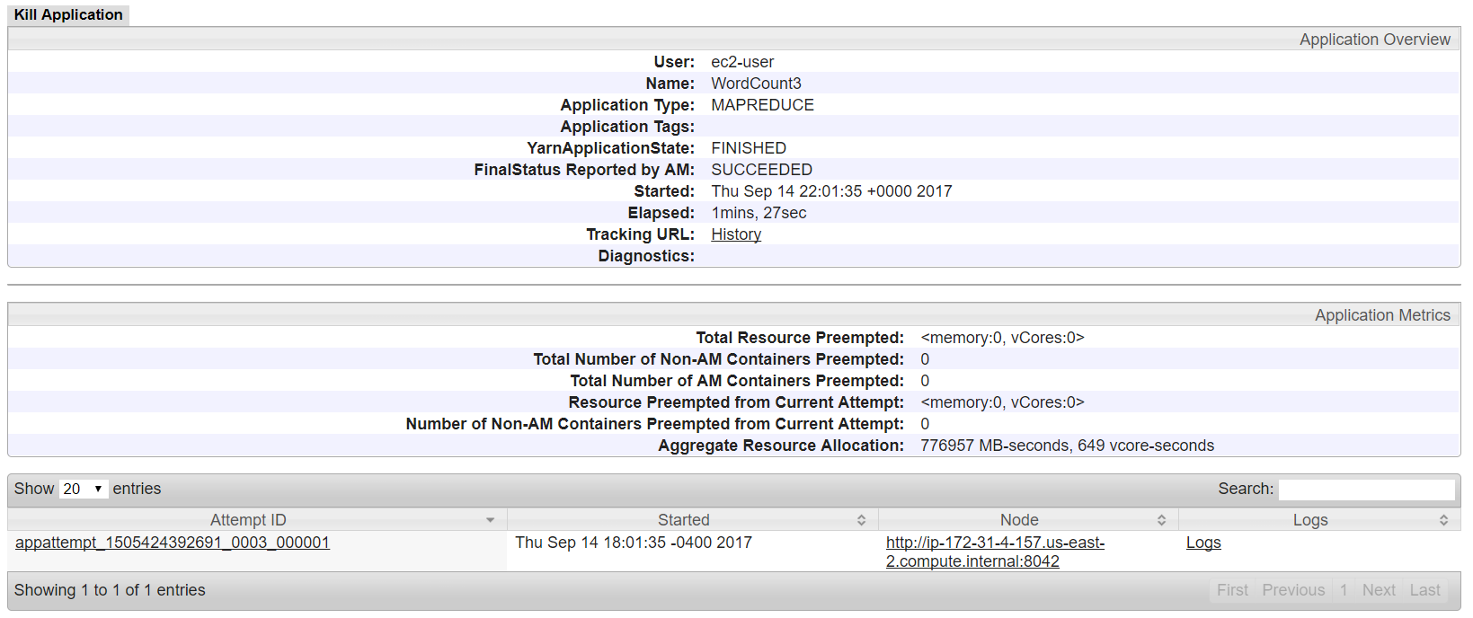
task result: please see result/result2.txt or
https://github.com/csymicc/Cloud_Computing_Assignments/blob/master/Assignment1/results/result2.txt

