Hw1 Report

1, Generate 10 samples and y = sin(x), noise is Gaussian distribution of mu = 0, Sigma = 0.1

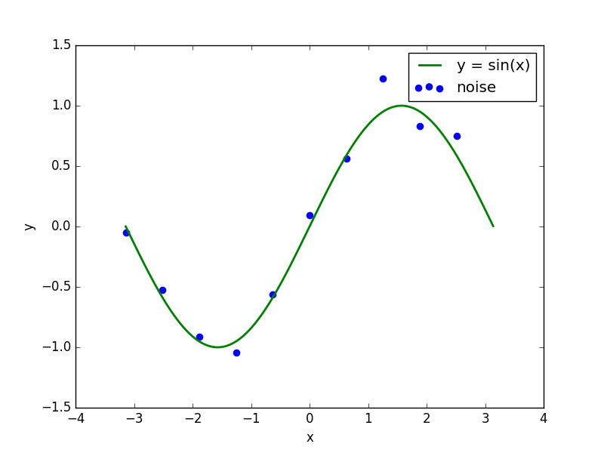

2, Fit degree 3 in 10 samples

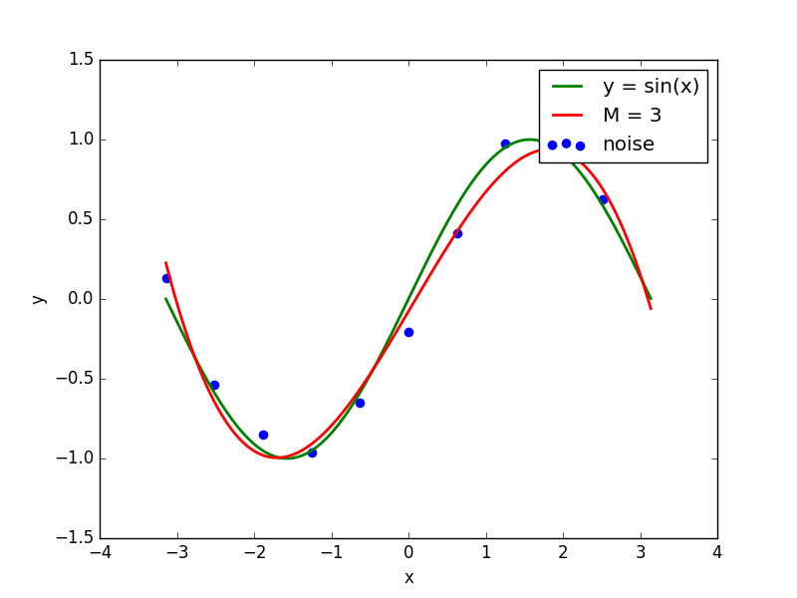

3, Fit degree 9 in 10 samples

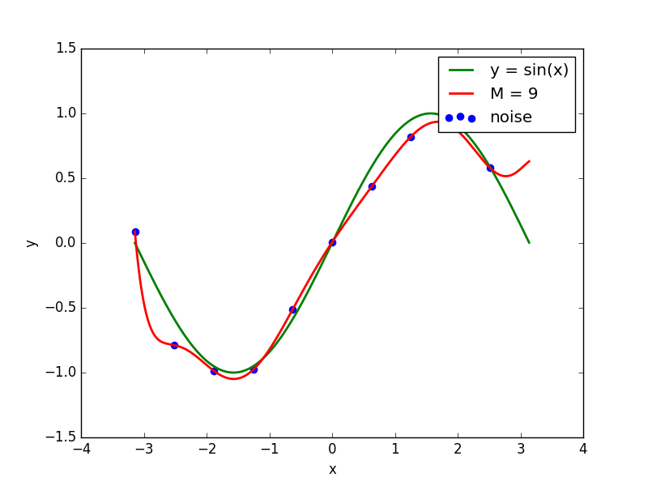

4, Fit degree 9 in 15 samples

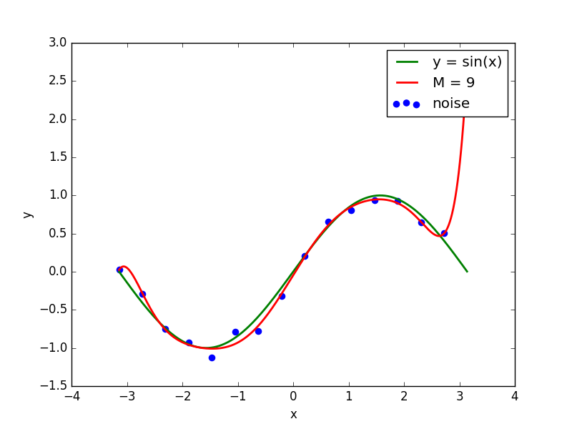

5, Fit degree 9 in 100 samples

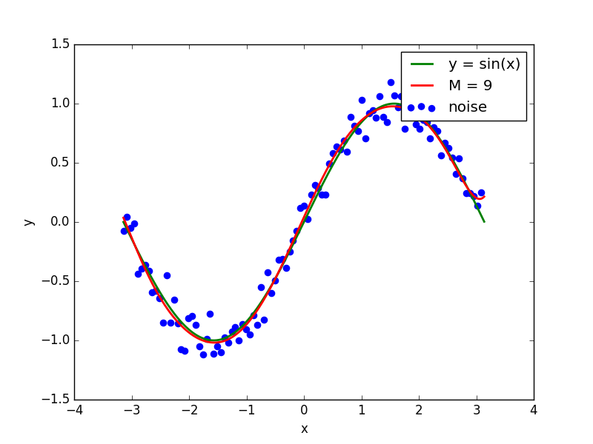

6, Fit degree 9 curve in 10 samples but with regularization term

