Hw2 Report

1, Perform PCA over all digit 3 with 2 components

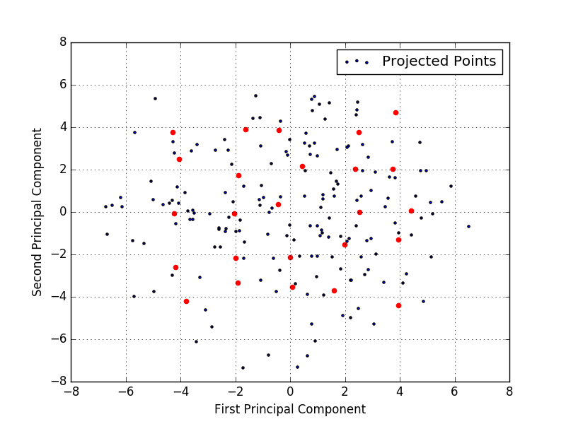

2, Plot the PCA result

