Hw3 Report

1, Implement K-means in N-dimension.

Here I take 2D as example. The process is as below.

Here I generate 3 Gaussian distribution.

(x1, y1) ~ N([10,-15], [[20,0],[10,15]])

(x2, y2) ~ N([0,5], [[1,0],[0,1]])

(x3, y3) ~ N([10,-5], [[2,0],[0,2]])

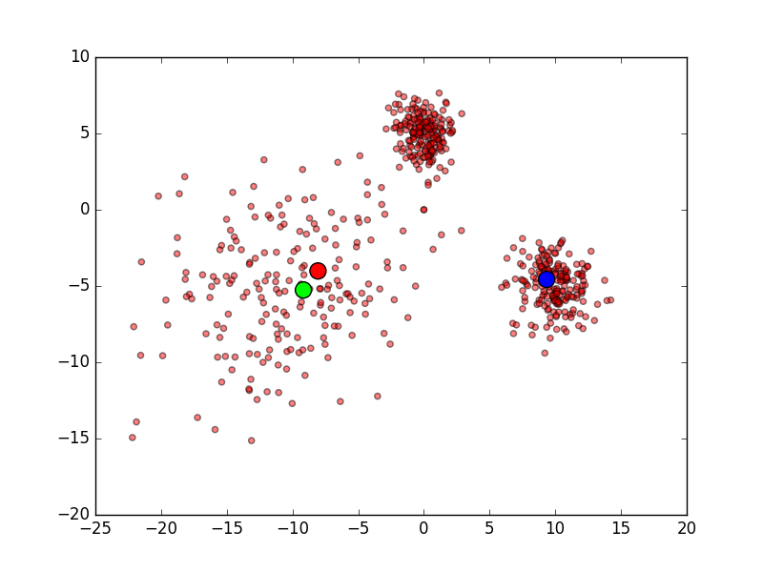

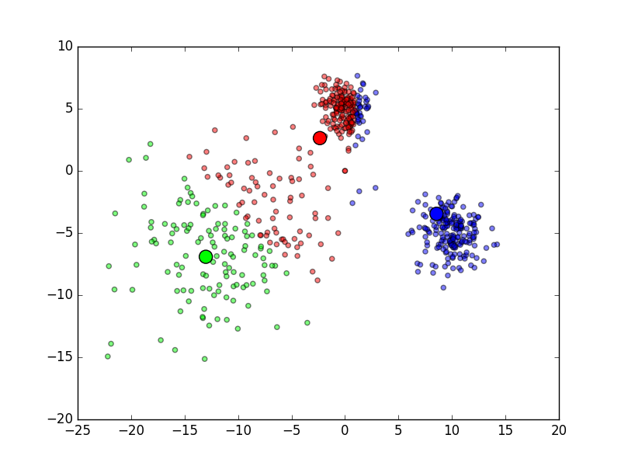

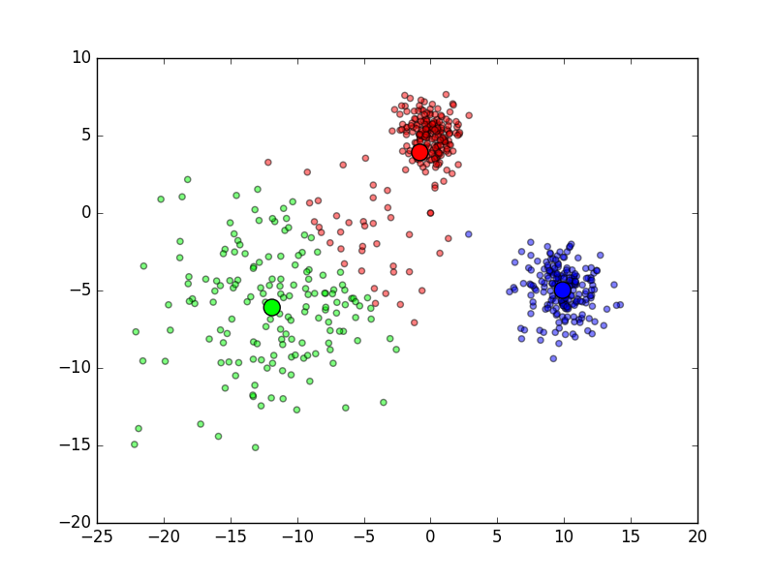

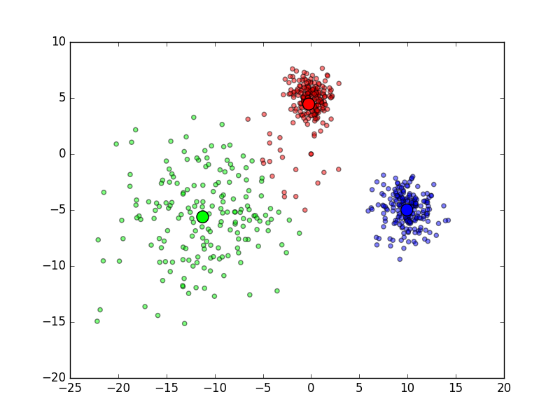

2, Implement MOG in N-dimension.

The data is same with K-means data.

Here I take 2D as example. The process is as below.

A little bit slower than K-means.

