Hw5 Report

1, Generate linear separable data.

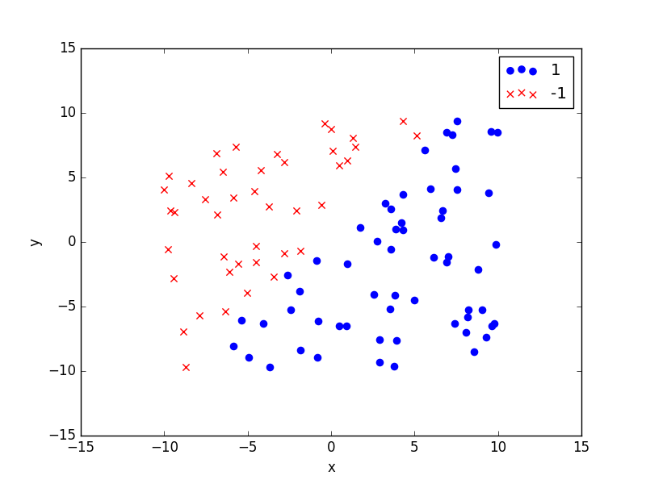

2, Train SVM classifier and show result

