1 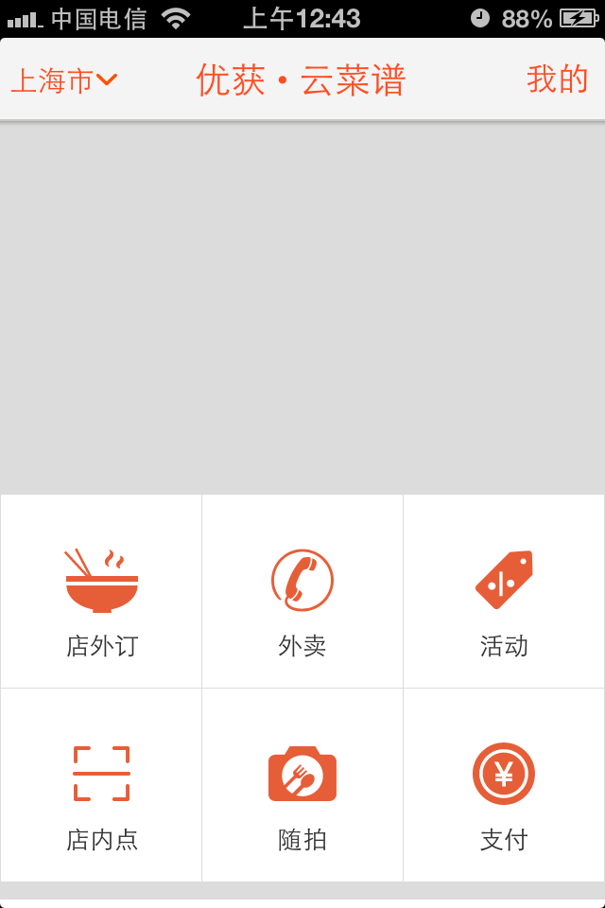txt (251,53,29)

2toobar(241,241,241)

3 background (212,212,212)