Team 20 Business Thesis

Based on the results, it is recommended to invest in **Synchrony** because of [REASON1], [REASON2], and [REASON3].

Looking at data going back five years from January 1st, 2019, the standard devastation for the four companies can be seen below in the table, along with their means and how much the variance weights over the mean. From this table, Synchrony is seen to have the least volatility over the past five years as the variance around the average value of the stock was about 12%.

|  |  |  |  |
| --- | --- | --- | --- |
| Company | Mean | Variance | Variance/Mean*100 |
| 3M | 176.79 | 30.02 | 16.98% |
| **Synchrony** | **30.99** | **3.66** | **11.81%** |
| Honeywell | 113.73 | 21.66 | 19.05% |
| Bayer | 23.35 | 4.34 | 18.87% |

Looking at data from all four of companies for the closing rate between 2014 and 2019 and plotting the closings that were greater than 1% from the previous closings, the Honeywell stock is seen to be the one that grew the most over the past four years. However, this implies that it is too late to invest into the Honeywell company. Instead, it would be better to invest in **Synchrony** as the company is cycling regularly between the highs and lows of their stock. For Synchrony, the company is at a valley or peak every 100 changes greater than 1%. With 500 being the next low, a peak is expected to occur at around 100 more changes. The tables are below.

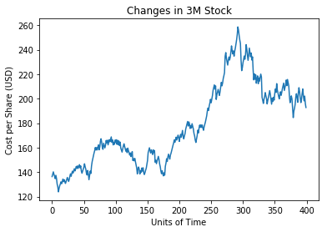 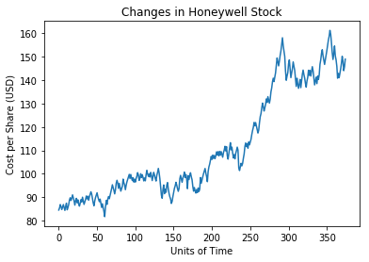 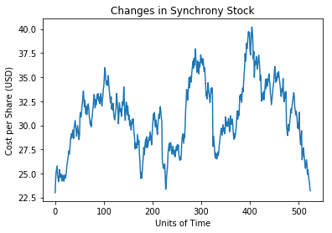 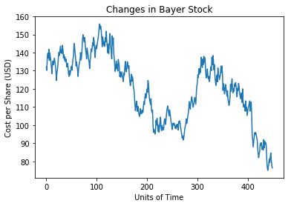

After training a Geometric Brownian Motion model on data from the past four years, the model was used to extrapolate on what is expected to occur in the first six weeks of 2019.