**1. Default_LSTM:** The Model detail

(model = {"use_lstm": True,

"max_seq_len": 32,

"lstm_cell_size": 256,

"fcnet_hiddens": [256, 256],

"fcnet_activation": "relu"

})

**Results:**

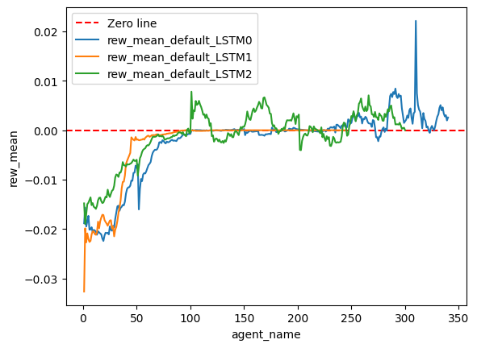

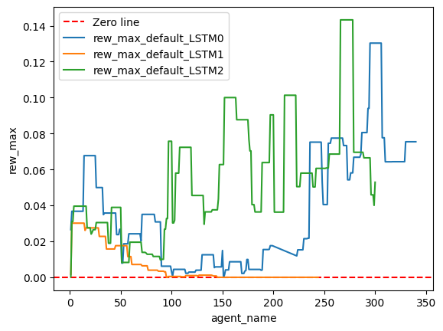

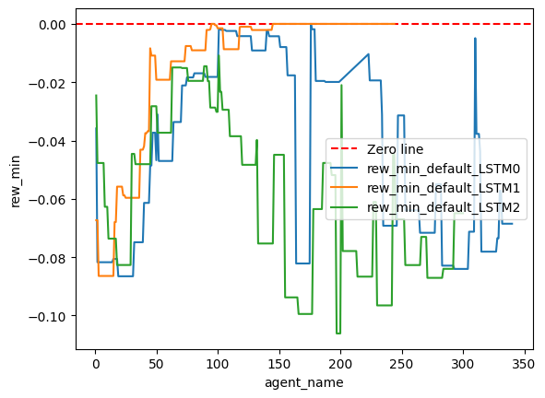

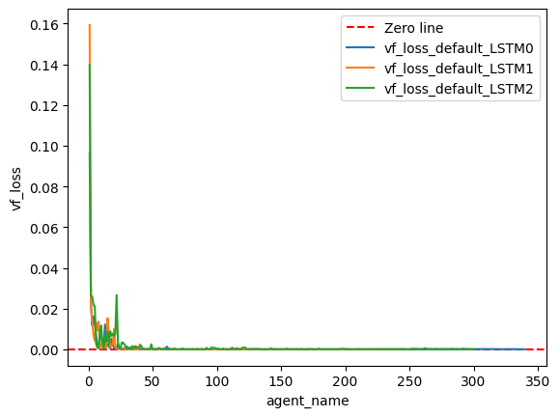

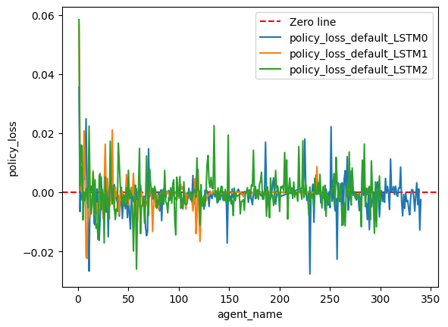

**2. Default_LSTM_v2:** A small modification is done over Default_LSTM as follows

(model = {"use_lstm": True,

"lstm_use_prev_action": True,

"lstm_use_prev_reward": True,

"max_seq_len": 32,

"lstm_cell_size": 256,

"fcnet_hiddens": [256, 256],

"fcnet_activation": "relu"

})

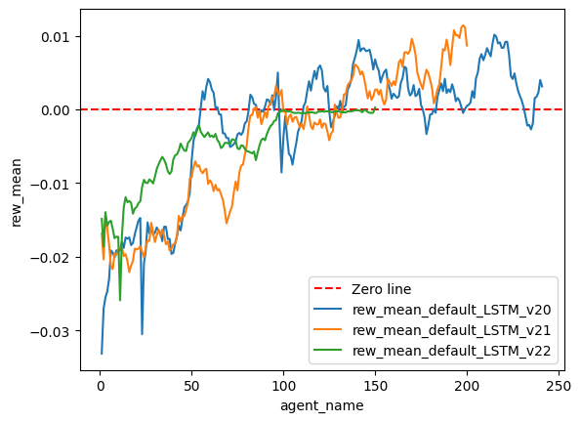

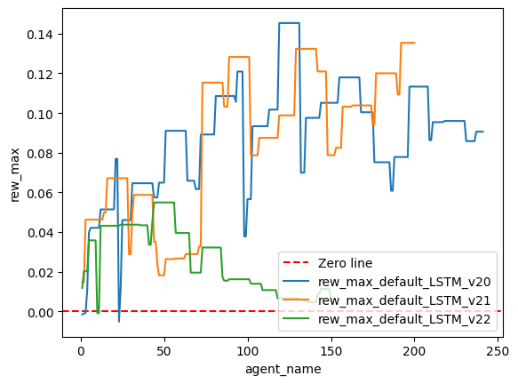

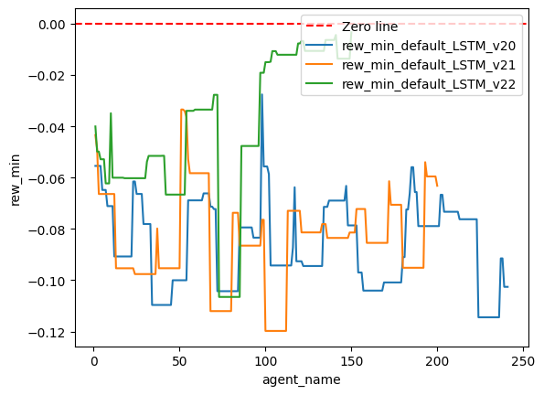

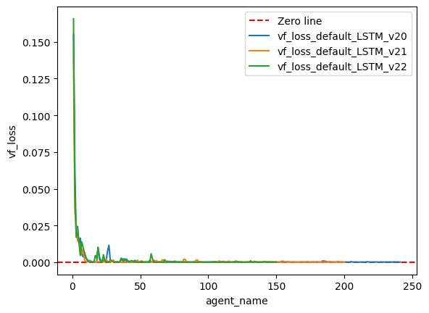

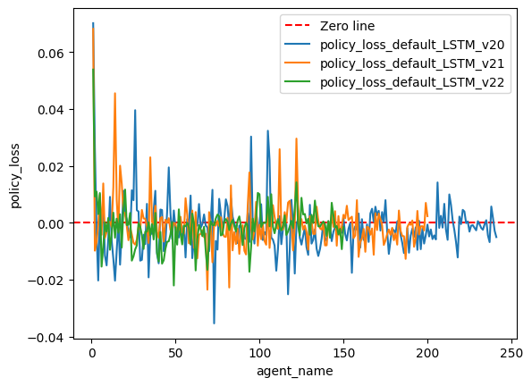

**3. Default_LSTM_v3:** A small modification is done over Default_LSTM as follows

(model = {"use_lstm": True,

"lstm_use_prev_action": True,

"lstm_use_prev_reward": True,

"max_seq_len": 128,

"lstm_cell_size": 256,

"fcnet_hiddens": [256, 256],

"fcnet_activation": "relu"

})

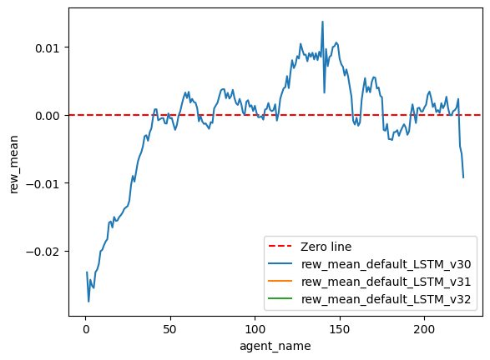

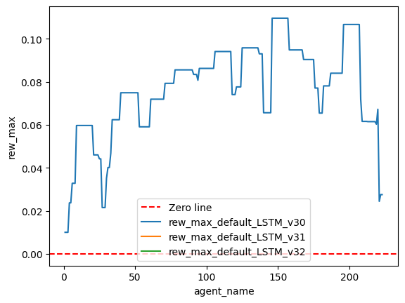

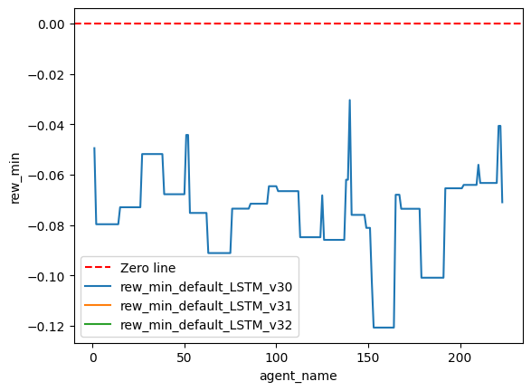

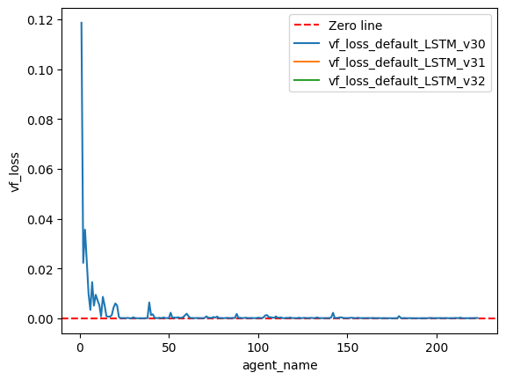

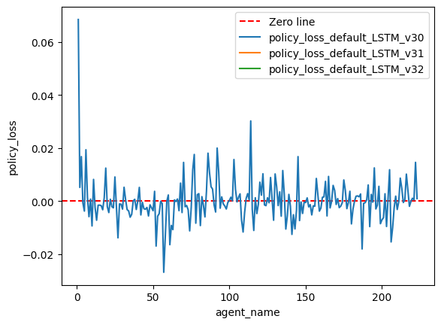

**4. Default_LSTM_v4:**

(model = "use_lstm": True,

"lstm_use_prev_action": True,

"lstm_use_prev_reward": True,

"max_seq_len": 128,

"lstm_cell_size": 512,

"fcnet_hiddens": [],

"fcnet_activation": "relu"

})

The Agent is not getting trained at all. The training is getting hanged every time while other agents are getting trained fined.