Project Name: Exploratour
Team: Sixth Sense
6th Sense Board | Trello
Exploratour Github

Members
# | Name
` 1 | Christian Torphy
2 | Andrew Sperano
3 | Maria Shamasna

Content Inventory
Christian
-Map
-Booking flights portion
-Hotel booking portion
-Price comparisons
-Country information page
-Activities list

Andrew
- Book a Trip
- Destinations Page (a list of all places)
- Destination Information (for each destination)
- Hidden Gems (for each destination)
- Activities list (for each destination)
- Hotel price comparison
- Flight price comparison
- Travel Checklist
- Account
  - Trips
  - Payments

Maria
- Travel Budget Planner
- Visa Information
- Travel Safety Tips
- Transportation Guides
- Restaurant Recommendations
- Local Culture Guides
- Travel Reviews
- Saved Destinations
- Trip History
- Customer Support

Final list of content inventory
- Book a Trip
- Destinations Page
  - Map (For visual search on the map (able to click the location))
    - Destination Information (for each destination)
    - Hidden gems
    - Activities list
    - Hotel price comparison
    - Flight price comparison
    - Budget Planner for the entire trip!
  - List of Destinations (Ordered by Continent and Country, then alphabetical)
    - Destination Information (for each destination)
    - Hidden gems
    - Activities list
    - Hotel price comparison
    - Flight price comparison
    - Budget Planner for the entire trip!
- Travel Checklist
- Account
  - Trips
  - Payments

Final Sitemap
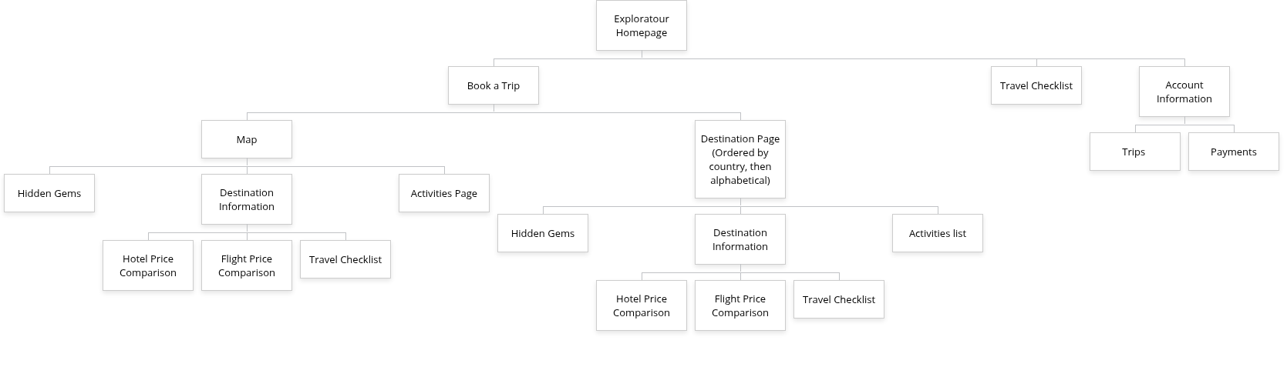

Tree test tasks
- Find information about a country and the hidden gems
- Access the Trips page
- Compare flight prices for a destination
- Find the payments page
- Access the travel checklist

Tree test results

Christian
- Start at homepage, Book Trip, Destinations, Hidden Gems (about 10sec)
- Start at homepage, Account Information, Trips (about 5 secs)
- Start at homepage, Book Trip, Destinations Page, Destination Information, Flight Price Comparison (about 12 secs)
- Start at homepage, Account, Payments (about 5 secs)
- Start at homepage, Travel Checklist (about 3 secs)
Andrew
- Home Page -> Book a Trip -> Destinations Page -> Hidden Gems -> Go back -> Destination Information
- This took approximately 10 seconds to access
- Home Page -> Account -> Trips
- This took approximately 6 seconds to access
- Home Page -> Book a Trip -> Destinations Page -> Destination Information -> Flight Price Comparison
- This took approximately 12 seconds to access
- Home Page -> Account -> Payments
- This took approximately 6 seconds
- Home Page -> Travel Checklist
- This took approximately 2 seconds

Maria
- Home Page → Book a Trip → Destinations → Hidden Gems (11 seconds)
- Finding information about a country and its hidden gems.
- Home Page → Account → Trips (7 seconds)
- Accessing the trips page.
- Home Page → Book a Trip → Destinations → Destination Information → Flight Price Comparison (14 seconds)
- Comparing flight prices for a destination.
- Home Page → Account → Payments (6 seconds)
- Finding the payment page.
- Home Page → Travel Checklist
- Accessing the travel checklist.

Tree test interview questions and answers

Christian
Questions | Answers
Did you find the pages where you thought they should? If not, which pages were not where you expected them to be in the menu hierarchy? | Yes, I feel like all the pages are in a pretty good spot. Although I think the destination page should just take the highlights of each location so there is a good amount of information about it
Did it take more time than you thought it would take? If so, why do you think it took longer? | Not really, I feel that each time is accurate to how complex the task is.
Were menu items labeled properly to indicate relevant resources? If not, what was mislabeled and how would you correct it? | I feel that they were. Each one was labeled as what it did.
Do you have any suggestions to make the site navigation easier? | Overall, I feel that the site is relatively easy to traverse. Maybe have the destinations page easier to access, rather than going through “Book a Trip”

Andrew
Questions | Answers
Did you find the pages where you thought they should? If not, which pages were not where you expected them to be in the menu hierarchy? | “Yes, the placement of each page was pretty accurate. It seemed very easy to find which direction i needed to go. Although, I think all of the information for each country should be on one page. Id like to be able to see everything in one spot so I’m not having to go back and forth from pages. If I had to say which to place it under, I would put it under the ‘Destination Information’ section as that seems the most relevant.”
Did it take more time than you thought it would take? If so, why do you think it took longer? | “I think i could have done it faster if I was actually looking at the website and able to click. But i feel as if the time I took was relatively fast”
Were menu items labeled properly to indicate relevant resources? If not, what was mislabeled and how would you correct it? | “I think the labeling was pretty good. It basically told me where each thing was, which I liked”
Do you have any suggestions to make the site navigation easier? | “Maybe adding a section for the locations you have information on instead of having to go through “Book a Trip.”

Maria
Questions | Answers
Did you find the pages where you thought they should? If not, which pages were not where you expected them to be in the menu hierarchy? | I was able to ask one of my classmates studying in the same room as me to be the user for this, and I feel as if they were able to find most of the pages where they expected them to be. The “Trips” and “Payments” pages made sense under the Account section. However, the user expected some travel planning resources such as the Travel Checklist, Travel Budget Planner, and Visa Information to be grouped together under the “Book a Trip” section rather than appearing separately. They felt that these tools were all part of the trip planning process.
Did it take more time than you thought it would take? If so, why do you think it took longer? | Most tasks were completed fairly quickly, but finding the flight price comparison took slightly longer because the user had to navigate through the Destinations page and then the Destination Information page first. The user also mentioned that if additional planning resources such as Transportation Guides or Travel Safety Tips were included, they would expect them to be located in the same planning section to reduce navigation time.
Were menu items labeled properly to indicate relevant resources? If not, what was mislabeled and how would you correct it? | The user felt that most labels were clear, but suggested that “Book a Trip” could be renamed to something like “Plan Your Trip” because it would better represent resources such as travel budgeting, transportation guides, and travel checklists. The user also suggested that cultural resources like Local Culture Guides, Restaurant Recommendations, and Travel Reviews should be clearly grouped under destination information so users can easily explore what to do at each location.
Do you have any suggestions to make the site navigation easier? | The user suggested grouping related tools and information together. For example, travel planning resources such as Travel Budget Planner, Visa Information, and Travel Safety Tips could be grouped under a “Travel Planning” section. They also suggested adding a section within user accounts where features like Saved Destinations and Trip History are stored so users can easily revisit places they are interested in. Additionally, having a visible Customer Support page would help users quickly find assistance if they encounter issues while planning their trip.

Assessment of the sitemap
Overall, the sitemap flows really well, and users were able to find most pages easily during the tree testing. Pages such as Trips, Payments, and Travel Checklist were located quickly, which shows that the general navigation structure is good and thoughtful of its users. One suggestion from the testing was to combine most destination-related information into a single destination page. It could include a variety of items, such as destination information, hidden gems, activities, restaurant recommendations, and travel reviews. Another improvement could be grouping travel planning resources together, such as a travel budget planner, visa info, travel safety tips, and transportation guides, so users can easily find tools that help them prepare for their trips. Overall, the sitemap works well but organizing related resources together could help make navigation even clearer!

Labels/titles
- Homepage
- Plan a Trip
- Travel Checklist
- Account Information
- Trips
- Payments
- Map
- Destination Page
- Hidden Gems
- Destination Information
- Activities list
- Hotel Price Comparison
- Flight Price Comparison

