My ICT171 Learning Journey
From a Linux beginner to getting hands-on with servers, cloud and automation
Lai Kah Peng • ICT171 – Introduction to Server Environment & Architecture

1. Starting the Journey
When I first saw this module, I did not realise it would involve Linux. VMware, Ubuntu and server commands were completely new to me. I started with almost no practical Linux experience.
The few days of class were challenging, but each lab earned me a small win. I slowly became more comfortable with the terminal and began to understand how server skills are used in real work.

2. Getting Comfortable with Linux
My first step was setting up Ubuntu inside VMware. I am skeptical about the idea of running another operating system safely on my Windows laptop. However, I knew that if I made a mistake, I could recover without affecting my main system.
The biggest change for me was using the command line. Commands such as ls, cd, sudo and nano looked confusing at first. With the lecture notes, Google and AI explanations, they slowly started to make sense.
My takeaway: The terminal looked difficult at first, but practice made it much less intimidating.

I also used GitHub to keep my work organised and track my progress. It gave me a simple introduction to version control and a more structured way of working.

3. Learning by Doing: Services, Permissions and Scripts
Installing Apache2 was one of my first real server tasks. Seeing the Apache default page appear in my browser was a simple but satisfying moment because I knew the server was working.
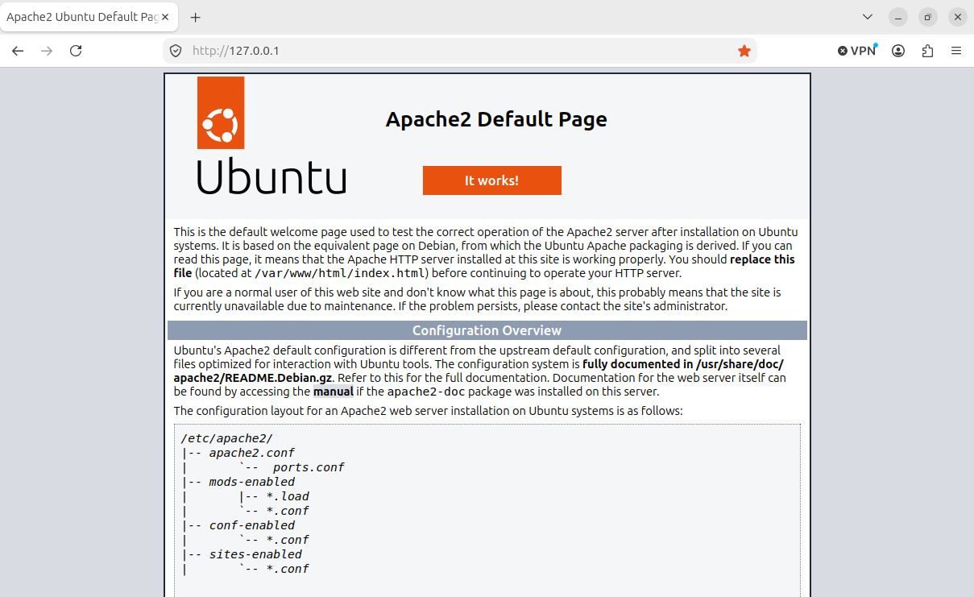
Apache2 running successfully on Ubuntu
I then practised downloading files, creating folders, moving files and compressing them. These commands were unfamiliar, but repeating them helped me remember the basic Linux workflow.
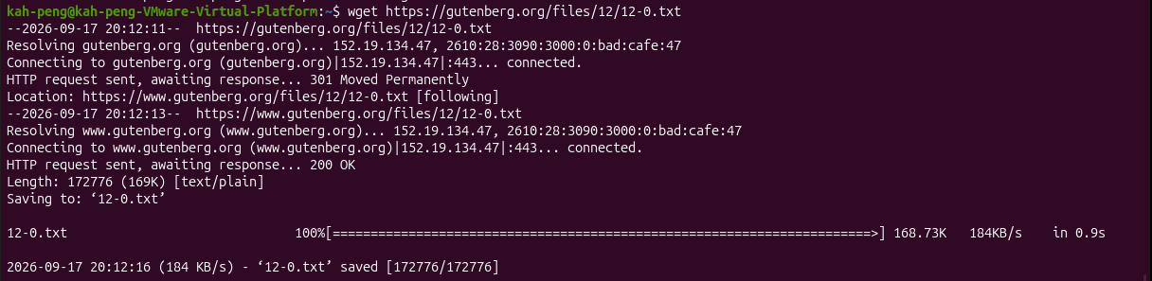
Downloading files from the terminal
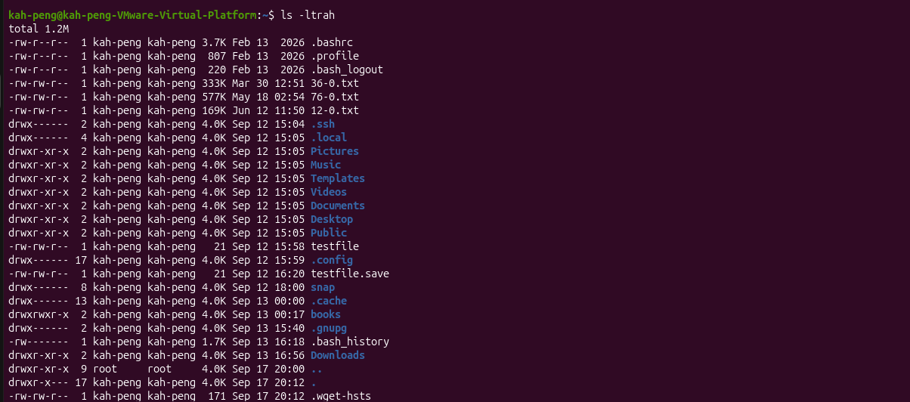
Files successfully downloaded
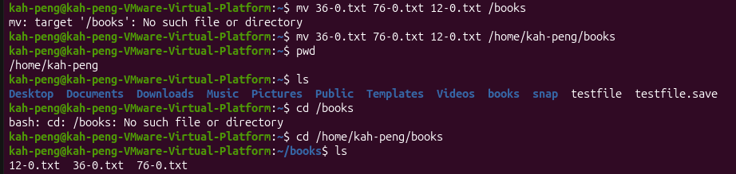
Moving the files into the books folder

The books folder in Ubuntu
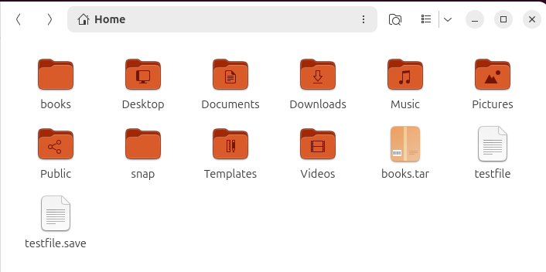
Compressing the files
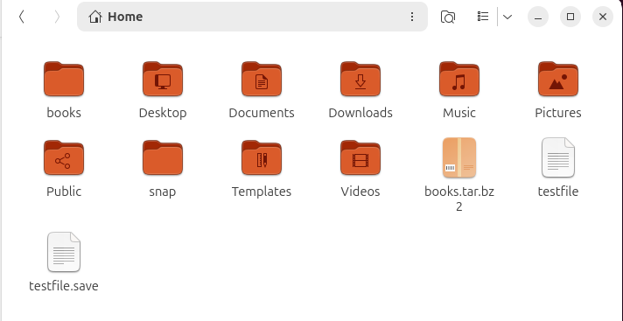
Creating the compressed archive
Permissions were another important lesson. I learned that 770 gives full access to the owner and group, while all others have no access. This showed me why least privilege is important for server security, in fact this logic applies to all other security aspects, including physical security.
Creating users and assigning group access
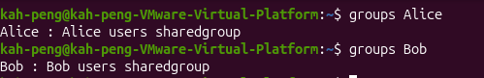
Checking user group membership
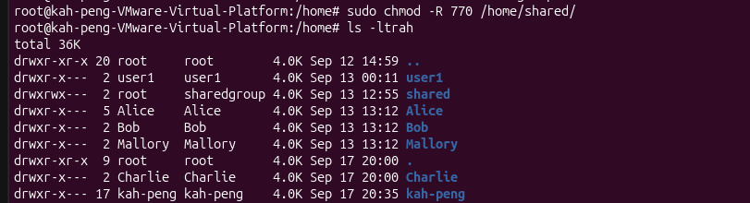
Checking files and permissions
I also used grep, find, du, sort, sed, uniq and pipelines. These tools helped me search files, check changes, compare file sizes and organise information. I began to see how small commands can be combined to automate tasks.
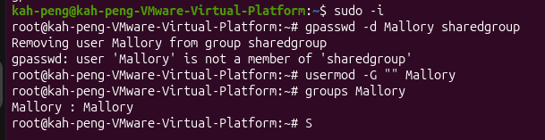
Searching for a user who is not in the group
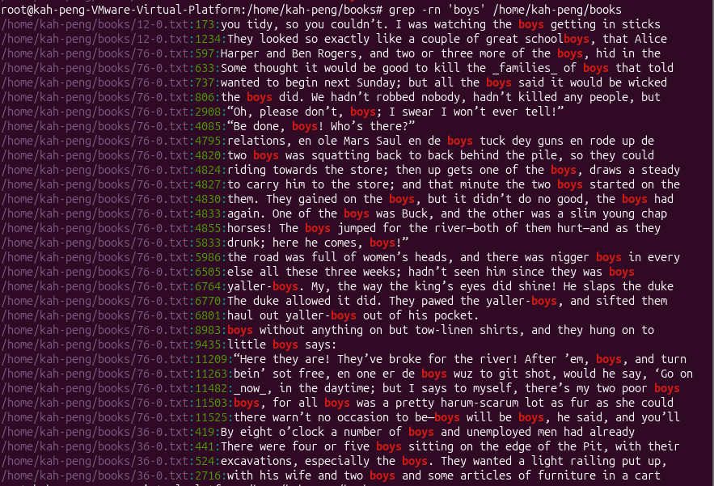
Searching for a word in multiple files
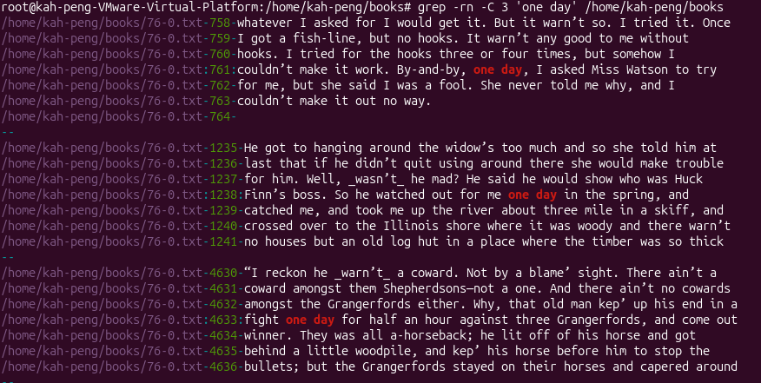
Searching with surrounding context
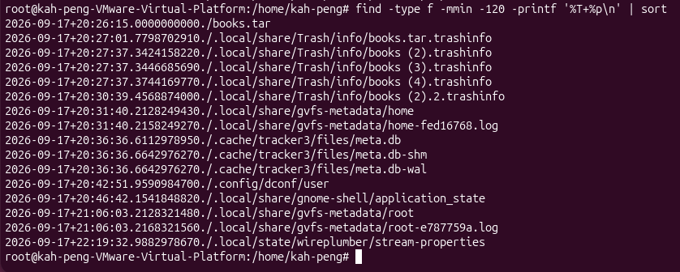
Checking file dates and times
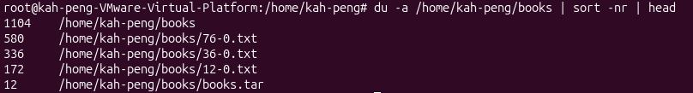
Finding and sorting files
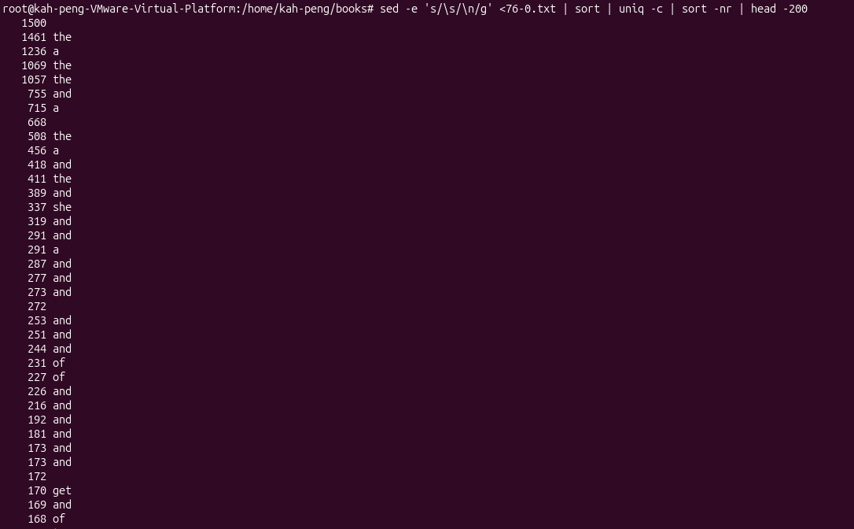
Checking word frequency

4. Moving into the Cloud
AWS was my first hands-on experience with cloud deployment. I created an EC2 instance and configured the security settings through SSH, HTTP and HTTPS.
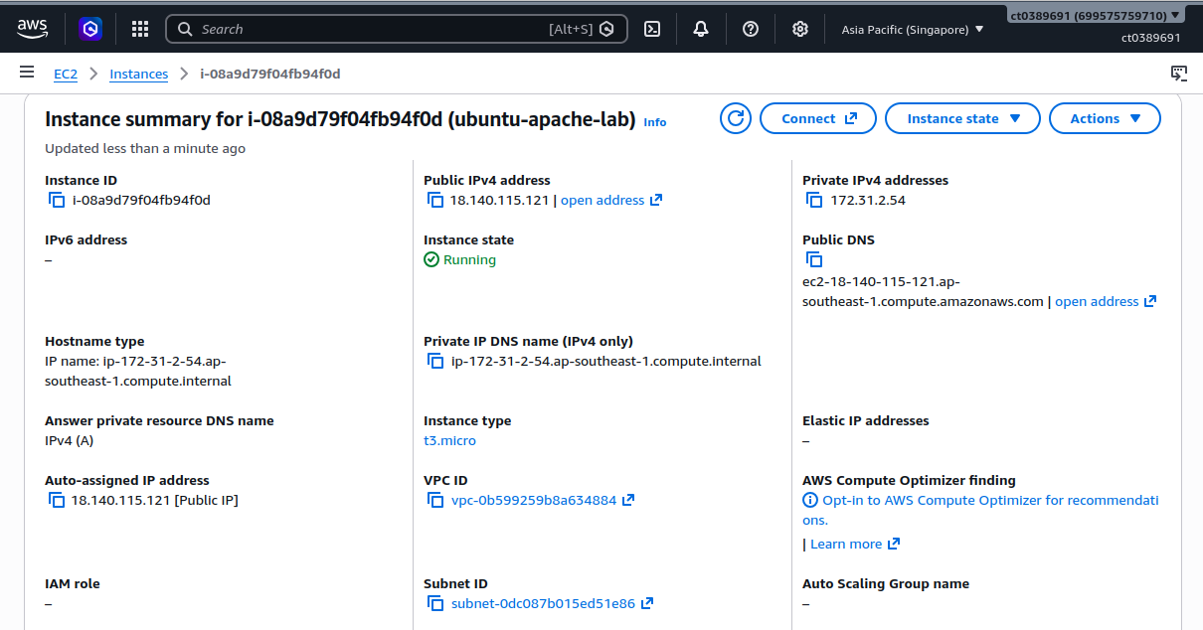
My AWS EC2 instance
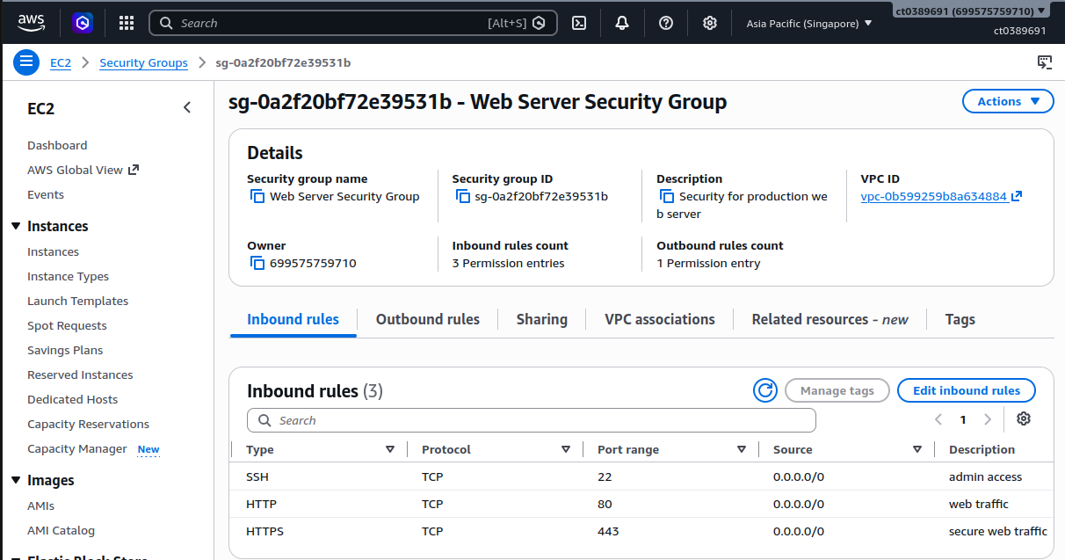
Inbound security rules
This made me realise that cloud services are not just about making a server available. Security matters too. Opening ports makes a service accessible, but unnecessary access can also create risk.

I also compared a physical hard drive with cloud storage over five years. In my calculation, the hard drive cost about $355.60, while the cloud option was about $205 under the given assumptions.
Option | 5-year cost | Main point
External hard drive | $355.60 | Offline access and physical control
Cloud storage | $205 | Easy access and scalability

5. DNS and SSL: Making the Server Reachable and Safer
Next, I connected my server to a DuckDNS domain. Using nslookup helped me check whether the domain was pointing to the correct public IP.
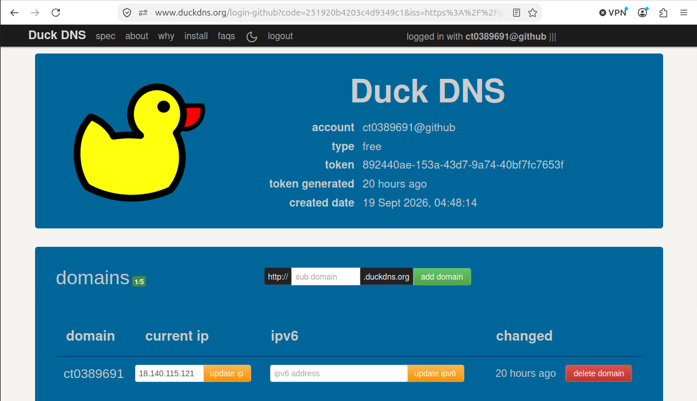
DuckDNS domain configuration
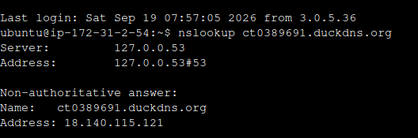
Checking DNS propagation
After DNS, I set up an SSL certificate using Let’s Encrypt and Certbot. The main reason to do so is simple, besides having a working website, communication should also be protected.
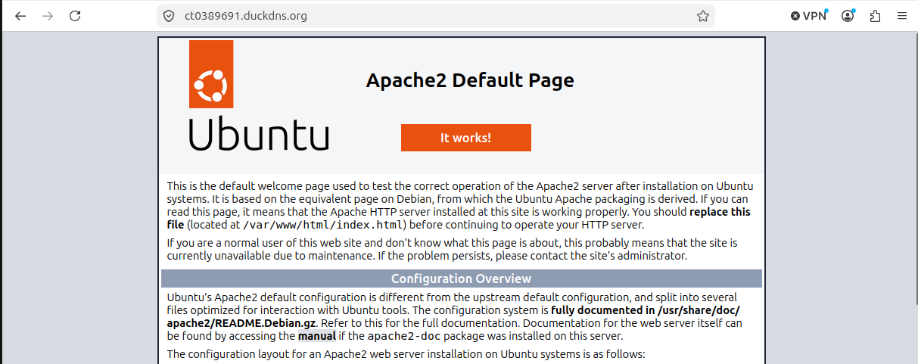
Server page after SSL configuration
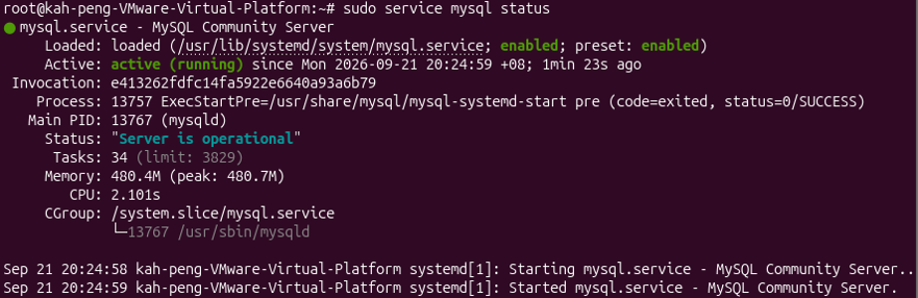
SSL-related command output
Certificate verification

6. Letting Linux Work for Me
Cron jobs introduced me to automation. Instead of doing the same task manually every day, a scheduled command can run it automatically.
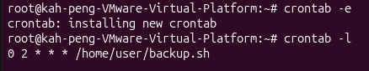
Creating a cron job
This was a useful reminder that automation can save time, reduce human error and keep routine tasks consistent.

7. My Extra Challenge: MySQL
For my additional server service, I chose MySQL because it was not covered in the main module. I wanted to learn something extra and see how a database could run within a Linux server.
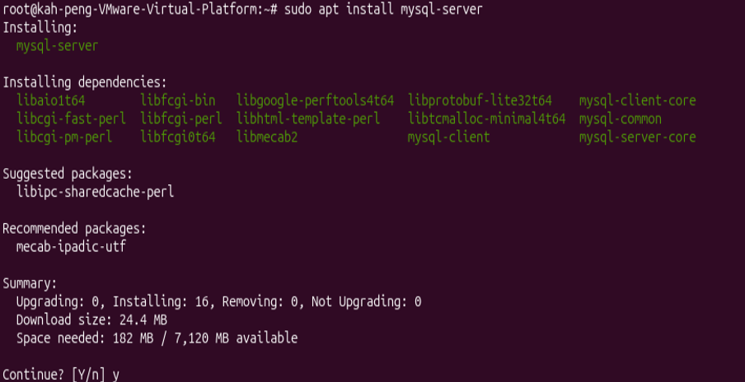
Installing MySQL
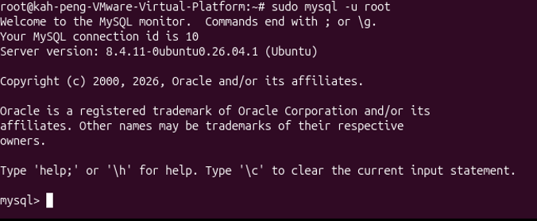
Checking the MySQL service
I created a database, made a table and inserted a student record. This helped me understand how Linux can support applications that need structured data.
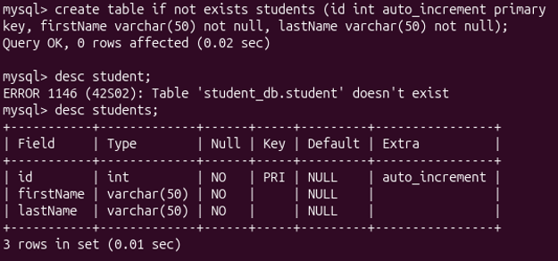
Working with the MySQL database
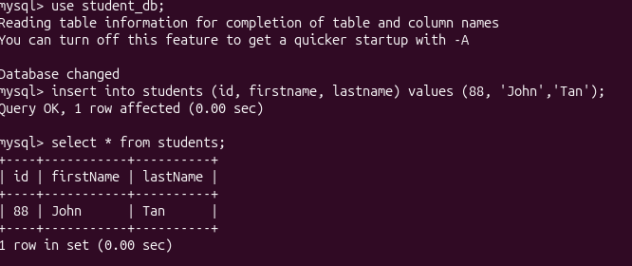
Creating and displaying a student record
I also learned that database security matters. Strong passwords, limited access and proper user management are important when handling data.

8. Problems I Faced Along the Way
Not everything worked on the first try. I encountered various problems along the way. Here are a few;
Problem | What I did
SSH connection failed | Checked port 22, the key file and its permissions.
Permission denied | Used sudo and corrected ownership with chown.
DNS did not resolve | Updated the A record and checked with nslookup.
MySQL would not start | Checked logs, fixed the configuration and restarted it.
Cron did not run | Checked and corrected the crontab syntax.

These problems taught me not to panic when something fails. Check the error, understand the cause and test the fix step by step.

9. What This Means for the Real World
The labs gave me a small taste of work done by systems administrators and DevOps engineers. I practised cloud deployment, permissions, DNS, SSL and automation.
I also started to see how security ideas such as least privilege and secure communication connect classroom learning with real server environments.

10. Final Reflection
Looking back, I started this module with no Linux experience. I can now use basic Linux commands, configure services, deploy a cloud server and create simple automation.
The biggest change was not just learning commands. I became more comfortable with troubleshooting and problem-solving on my own. The lecture notes, Mr Yatim and friends with IT experience all helped me along the way.
If I were to work on another server project, I will plan first, document my steps, think about security from the beginning and test changes in a safe environment.
My final thought: I came into ICT171 as a Linux beginner. I am leaving with more confidence, more practical skills and a better idea of how servers work in the real world.

