**FINAL PROJECT**

**GROUP 8**

**Team Members List:**

Varshitha Inaganti (11637772)

Chathurya Thimmapuram (11590479)

Shashank Jha (11634967)

Sujith Kumar Jonnadula (11599424)

**Table of Contents**

**1.** **Introduction** 3

**2.** **List of variables** 4

**3.** **Summary of Descriptive Statistics of Numerical Variables using EXCEL** 6

**4.** **Descriptive statistics of one or more categorical variable** 8

**4.1 Frequency Distribution of Personality Categorical Variables** 8

**4. 2 Frequency Distribution of Personality, Business and Female Variable** 9

**5. Descriptive statistics of one or more quantitative variables** 13

**5.1 Frequency Distribution of Customer Satisfaction Score of Discrete Variable and Age, Feedback of Continuous Variables** 13

**5.2 Frequency Distribution of Personality by Age** 18

**6. Simpson’s Paradox** 20

**7. Research Questions** 22

**8. Analysis and Results** 22

**8.1 Research Question 1** 22

**8.2 Research Question 2** 23

**8.3 Research Question 3** 25

**8.4 Research Question 4** 26

**8.5 Research Question 5** 27

**8.6** **Research Question 6** 28

**8.7** **Research Question 7** 30

**8.8 Research Question 8** 30

**9. Discussion** 32

**10. Conclusion** 33

**Reference** 34

# **1. Introduction**

Human resources are essential in managing and maximizing employees’ potential in each organization. Understanding the factors influencing employee performance, satisfaction, and success is crucial for businesses to optimize their human capital (Akdere & Egan, 2020). In this research paper, we delve into HR data analysis to explore the relationship between various variables and their impact on sales representatives' performance and satisfaction. Murphy (2020) argues that traditional performance evaluation methods are and suggests alternative approaches to evaluating employee performance. This study raises critical questions about the effectiveness of performance evaluation in the context of HR practices.

Kurdi, Alshurideh, and Alnaser (2020) explore the link between employee and customer experience, emphasizing the interconnectedness of these two factors. This research is built on a theoretical and empirical foundation of appreciating the impact of employee satisfaction on customer satisfaction, which serves as a crucial backdrop to our research questions and provides the basis for this research's findings. In addition, Elrehail et al. (2019) investigate the connection between satisfied employees, effective human resource management techniques, and a company's ability to gain a competitive edge. Their study analyzes how effective HR practices can lead to increased levels of employee satisfaction, leading to increased levels of competitive advantage. This research highlights the significance of employee satisfaction as a driving force behind organizational success. The research answers the following questions;

1. Is there a relationship between the age of sales representatives and their salary?
2. Is there a significant difference in the levels of customer satisfaction reported by sales representatives who work in the Hardware business as opposed to those who work in the Software sector?
3. Is there a discernible gap in the levels of client satisfaction between male and female sales personnel?
4. Do having a degree determine the salary of the sales representative?
5. Can the years of experience be used to predict customers’ satisfaction scores?
6. Are there differences in customer satisfaction scores among sales representatives with different numbers of certificates?
7. Does the feedback given to sales representatives have a significant relationship with their years of experience?
8. Does client satisfaction differ significantly among salesperson personality types?

# **2. List of variables**

The two basic categories are the qualitative and quantitative groupings of variables in data analysis. Although they cannot be mathematically operated on, qualitative variables reflect traits or categories. Gender, college and personality are a few examples of qualitative factors. Alternatively, quantitative variables are made up of numerical values that can be measured and quantitatively examined. Age, height, and length are some illustrations of quantitative variables. There are two further classifications of quantitative variables: discrete and continuous variables. Discrete variables can only take on a limited or countable number of values. Consider discrete variables as "dogs" that can give birth to 1, 2, or 10 pups, depending on the value. The variable's acceptable range of values is defined and constrained. Continuous variables, on the other hand, are capable of an endless variety of values.

|  |  |
| --- | --- |
| **Variable** | **Description** |
| Sales_Rep | It is a nominal variable, it shows the unique ID of sales representatives |
| Business | This is a categorical variable, describes about the two types of business the sales representatives working in such as Hardware, Software |
| Age | This is a quantitative variable of type discrete, |
|  | it describes about the particular age group representatives involved in this data, we can observe that the people involved in this data having age in between 21 and 65 |
| Female | This is considered as a categorical variable as it describes whether the person is female or not, ‘1’ indicates as ‘true’ and ‘ 0’ indicates as ‘false’ |
| Years | It is a discrete/numerical variable, indicates the years of experience individual is having |
| College | It is a categorical variable, describes about the individual having college degree or not, indicates ‘Yes’ or ‘No’ |
| Personality | This variable comes under a categorical, describes the type of personality the individuals are having such as Analyst, Diplomat, Explorer, Sentinel |
| Certificates | This is a discrete/numerical data, describes about how many certificates individual having in the industry |
| Feedback | This is a continuous variable, describes the feedback of the individual |
| Salary | This is a discrete/numerical variable, indicates the salary of the sales representative, from observation the minimum salary is 21000 and maximum salary is 197000 |
| Customer-Satisfaction-Score | This is a discrete variable, describes about the rating given by the customer to an individual sales representative it ranges from 1-10 |

# **3. Summary of Descriptive Statistics of Numerical Variables using EXCEL**

A thorough overview of the most important statistical metrics and features of a dataset is provided by a summary of descriptive statistics using Excel. To get a general picture of the dataset, a summary of descriptive statistics on quantitative variables, both discrete and continuous, was performed.

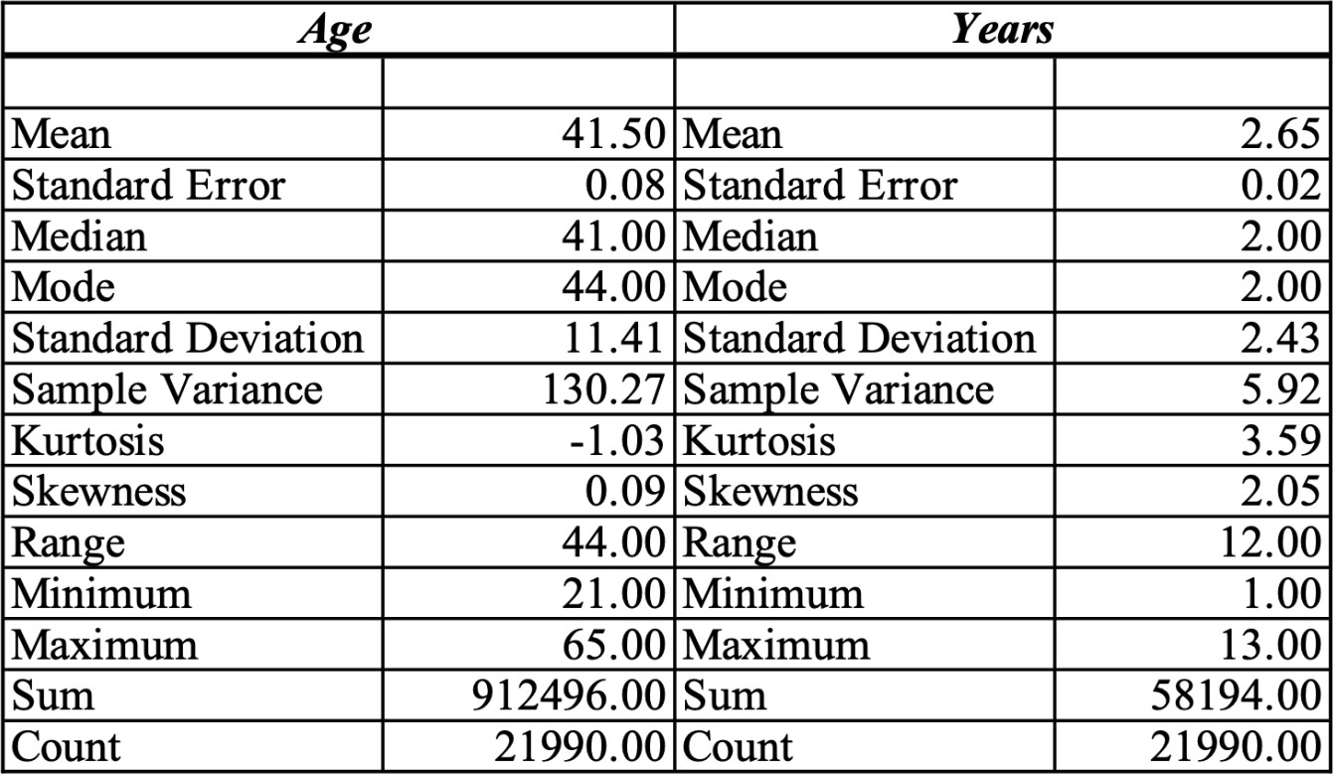

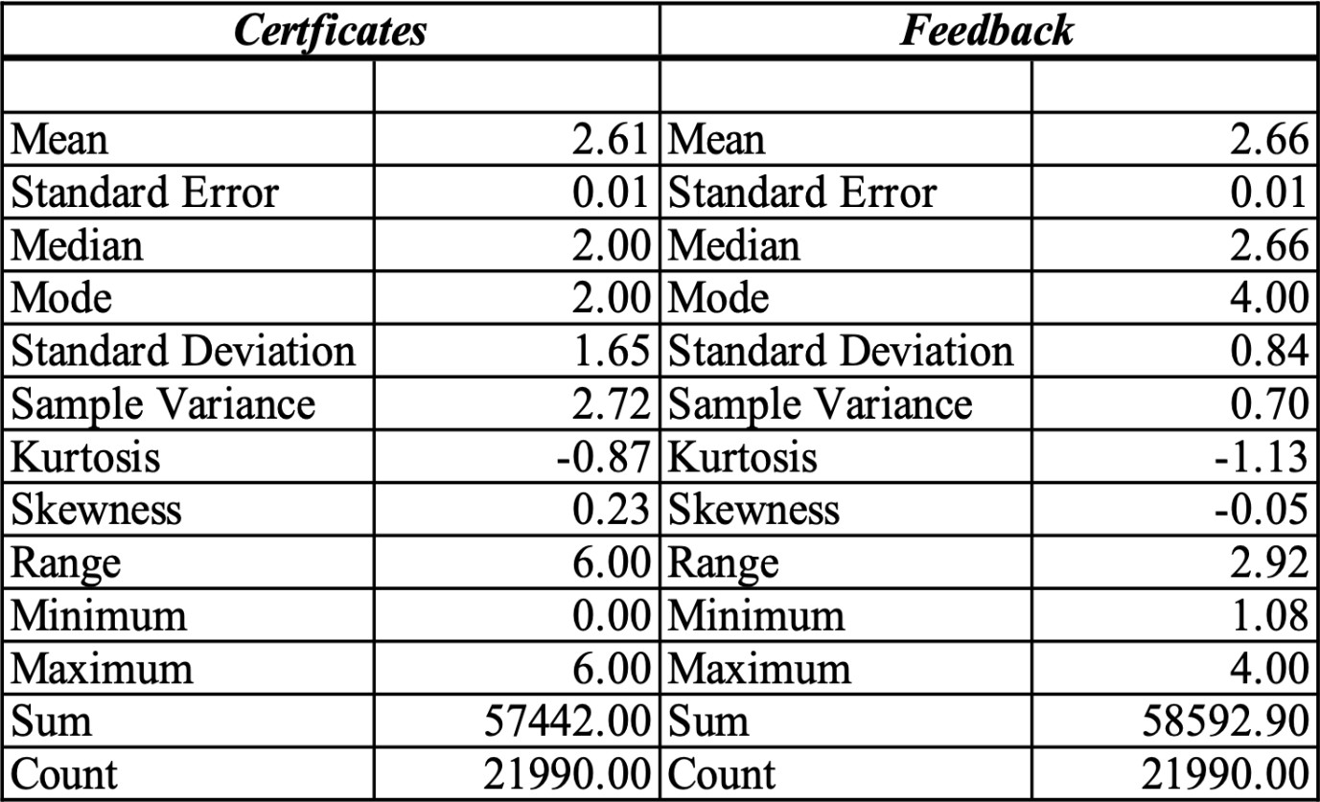

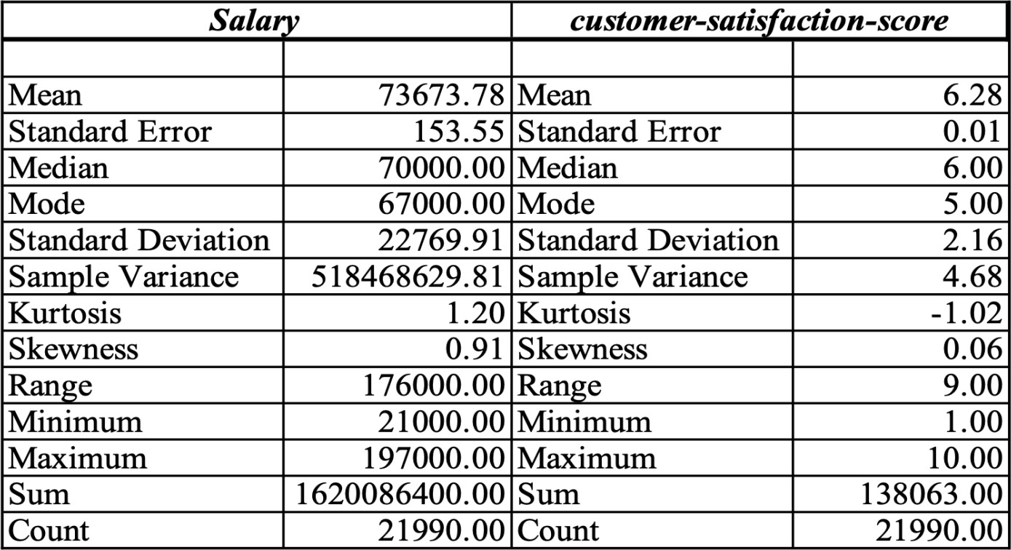

# **4. Descriptive statistics of one or more categorical variable**

Performing the descriptive statistics by considering one or more categorical variables by using excel we are calculating the frequency, percentage frequency and relative frequency of the variables.

## **4.1 Frequency Distribution of Personality Categorical Variables:**

|  |  |  |  |
| --- | --- | --- | --- |
| **Personality** | **Frequency** | **% Frequency** | **Relative Frequency** |
| Analyst | 2659 | 12.09% | 0.121 |
| Diplomat | 7849 | 35.69% | 0.357 |
| Explorer | 8200 | 37.29% | 0.373 |
| Sentinel | 3282 | 14.92% | 0.149 |
| **Grand Total** | **21990** | **100.00%** | **1.000** |

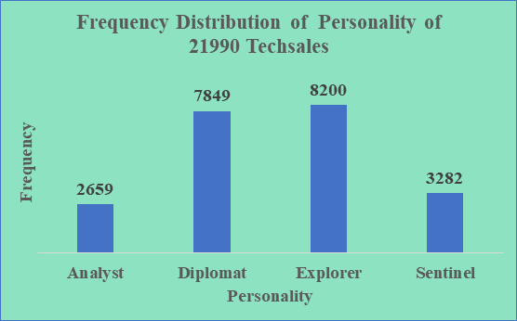

The distribution of personality types among sales reps is shown in the bar chart. Businesses can use this information to better identify the personality qualities that are most prevalent within its salesforce. If Explorer personalities, for instance, are more prevalent, it implies that the sales team may be made up of individuals who are daring, inquisitive, and eager to explore new chances. Companies can modify their management and training practices to take full advantage of these traits by recognizing the dominant personalities. For instance, diplomats, who are renowned for their diplomatic and compassionate disposition, can be particularly adept at developing lasting relationships with clients. Companies can allocate suitable sales reps to particular consumer segments by analyzing the personality mix, boosting the likelihood of successful sales outcomes.

## **4.** **2 Frequency Distribution of Personality, Business and Female Variable:**

|  |  |  |  |
| --- | --- | --- | --- |
| **Frequency** | **Business** |  |  |
| **Personality** | **Hardware** | **Software** | **Grand Total** |
| Analyst | 406 | 620 | 1026 |
| Diplomat | 1180 | 1792 | 2972 |
| Explorer | 1255 | 1907 | 3162 |
| Sentinel | 495 | 768 | 1263 |
| **Grand Total** | **3336** | **5087** | **8423** |

Businesses can detect possible alignment or mismatch between personality types and business requirements by understanding how personalities are distributed throughout various industries. For instance, because personality traits are more prevalent in the software sector than in hardware, there are chances for businesses to target and grow within the software market segment. As a result, businesses can access specialized skill sets, market knowledge, and customer insight unique to the software domain (Gurcan & Cagiltay, 2019). This knowledge can help firms assign salespeople with the right personality types to different company areas for the best success.

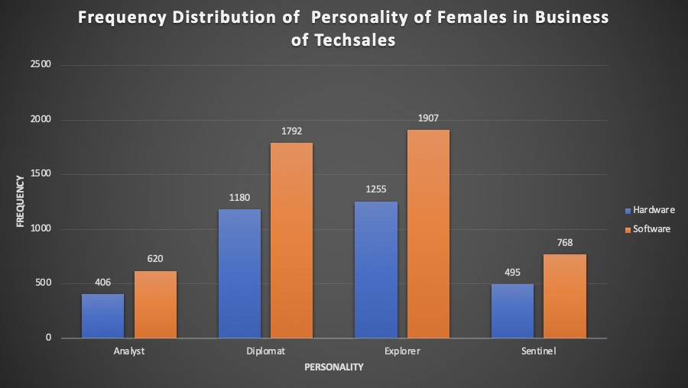

Percentage of Frequency Distribution of Female of Sales Representatives

|  |  |
| --- | --- |
| **Female** | **% Frequency** |
| 0 | 61.70% |
| 1 | 38.30% |
| **Grand Total** | **100.00%** |

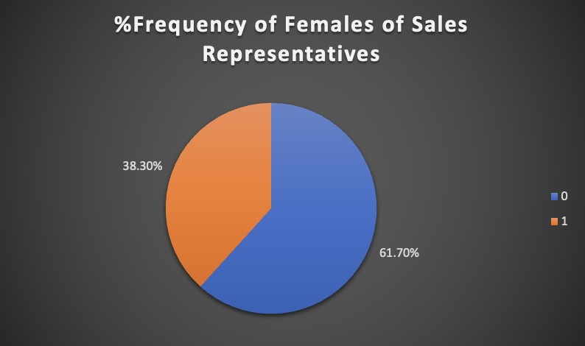

The representation of women among the salespeople is shown in the pie chart. This information implies that the company is doing a better job of encouraging inclusion and gender diversity among its sales staff. In a sales force that is dominated by males, there may be a concentration of abilities or attributes if men are thought to perform well as sales representatives. This can suggest that certain traits, such aggressiveness or negotiation skill, are more common in men in a particular corporate setting (Hernandez et al., 2019) Utilizing these findings, companies may build a more diverse and inclusive sales team, improving performance, customer satisfaction, and brand perception.

|  |  |
| --- | --- |
| **College** | **% Frequency** |
| No | 20.33% |
| Yes | 79.67% |
| **Grand Total** | **100.00%** |

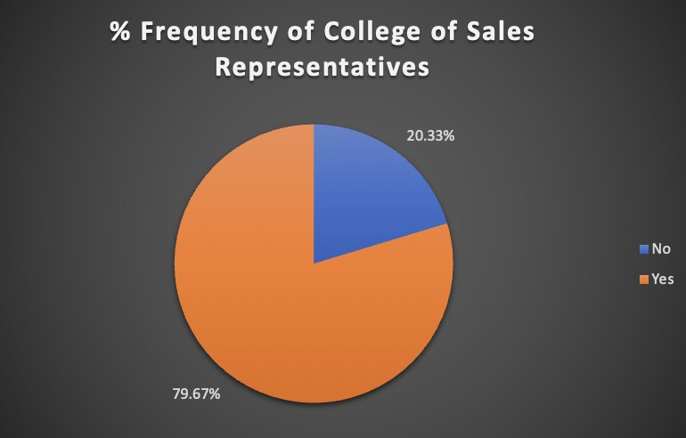

The pie chart shows that, of the sales representatives in the dataset, a sizable majority, or 79.67%, had a college degree. This suggests that the company employs a staff with more formal education, which provides several advantages such as a greater knowledge base, critical thinking abilities, and the capacity to adapt to challenging assignments. The increased proportion of salespeople with college degrees shows that they may have picked up a wide range of skills and knowledge during their educational experience. These qualities may include aptitudes for communication, problem-solving, research, and analysis. Businesses may fully use their sales team possible and make use of their educational backgrounds to boost sales effectiveness by identifying and utilizing these skills.

# **5. Descriptive statistics of one or more quantitative variables**

## **5.1 Frequency Distribution of Customer Satisfaction Score of Discrete Variable and Age, Feedback of Continuous Variables:**

|  |  |  |
| --- | --- | --- |
| **customer-satisfaction-score** | **Frequency** | **% Frequency** |
| 1 | 12 | 0% |
| 2 | 426 | 2% |
| 3 | 1817 | 8% |
| 4 | 3085 | 14% |
| 5 | 3593 | 16% |
| 6 | 3188 | 14% |
| 7 | 2765 | 13% |
| 8 | 2659 | 12% |
| 9 | 2762 | 13% |
| 10 | 1683 | 8% |
| **Grand Total** | **21990** | **100%** |

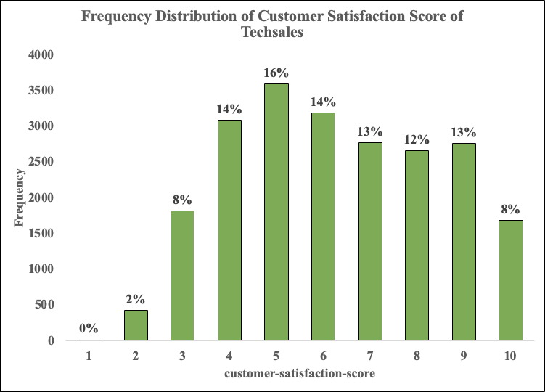

The above visualization shows the frequency distribution of customer satisfaction scores of TechSales. The bar graph is plotted between customer satisfaction scores ranging from 1 to 10 with the frequency of occurrences of each score. Most frequently rated score is 5 with the frequency of 3593 i.e, it is 16% of the total frequency and the lowest frequency being 12 i.e, 0% of the total with the customer score of 1. You can also observe the customer score with 3,10 having the same 8% of frequency. Setting objectives and monitoring advancement over time might be aided by using the distribution of customer satisfaction scores as a benchmark. Businesses can set reasonable goals and gauge their effectiveness in raising customer satisfaction by comparing current ratings to planned ones. This enables businesses to keep track of their progress, take appropriate action, and constantly improve their customer-centric strategies.

|  |  |
| --- | --- |
| **Feedback** | **Frequency** |
| 1-1.5 | 2177 |
| 1.5-2 | 3398 |
| 2-2.5 | 4078 |
| 2.5-3 | 3934 |
| 3-3.5 | 3648 |
| 3.5-4 | 4755 |
| **Grand Total** | **21990** |

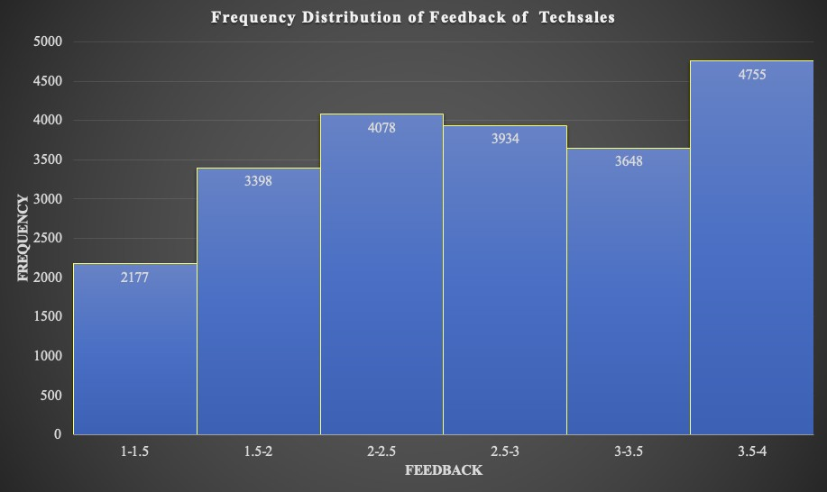

The values in the feedback variable are grouped together with the interval of 0.5. The above histogram represents the frequency distribution of a feedback for a TechSales company. Where we can see the feedback within the range of 3.5-4 has the highest frequency of 4755 and the lowest being the range of 1-1.5 with the frequency of 2177.Overall, this histogram offers valuable insights into the distribution of feedback scores received by the tech sales company highlighting the areas of improvement and focusing on the most common feedback range. According to the frequency distribution of the feedback scores, the majority of the scores are clustered at the upper end of the scale, which suggests that positive feedback is more common. This may indicate that consumers are typically happy with the company. There is still space for progress, though, by addressing the feedback from the lower ranges and using the positive feedback to fuel corporate expansion.

|  |  |
| --- | --- |
| **Age** | **Frequecy** |
| 20-29 | 4189 |
| 30-39 | 5732 |
| 40-49 | 5823 |
| 50-59 | 4878 |
| 60-70 | 1368 |
| **Grand Total** | **21990** |

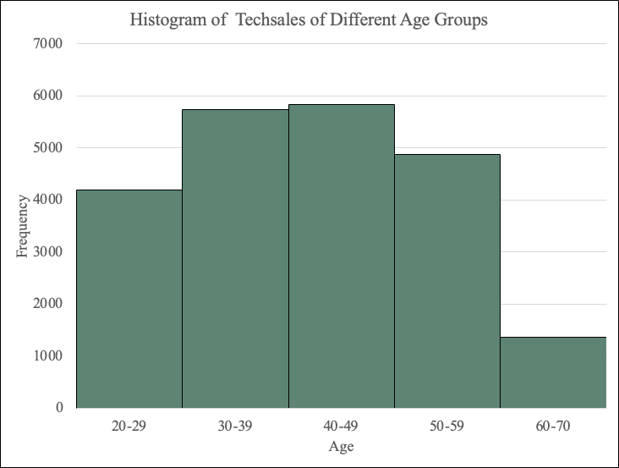

The above histogram represents the distribution of tech sales across various age groups. The highest frequency is observed in the age group of 40-49, indicating a significant number of tech sales from customers with the frequency of 5823. The age groups of 30-39 and 50-59 also exhibit relatively high frequencies, suggesting a substantial customer base in those demographics. Overall, this histogram provides a concise overview of the distribution of tech sales among different age groups, emphasizing the dominant age range of 40-49 for sales and highlighting potential opportunities for targeted marketing or growth in specific demographics.

|  |  |  |
| --- | --- | --- |
| **Age** | **Frequency** | **Cumulative Frequency** |
| 20-29 | 4189 | 19% |
| 30-39 | 5732 | 45% |
| 40-49 | 5823 | 72% |
| 50-59 | 4878 | 94% |
| 60-70 | 1368 | 100% |
| **Grand Total** | **21990** |  |

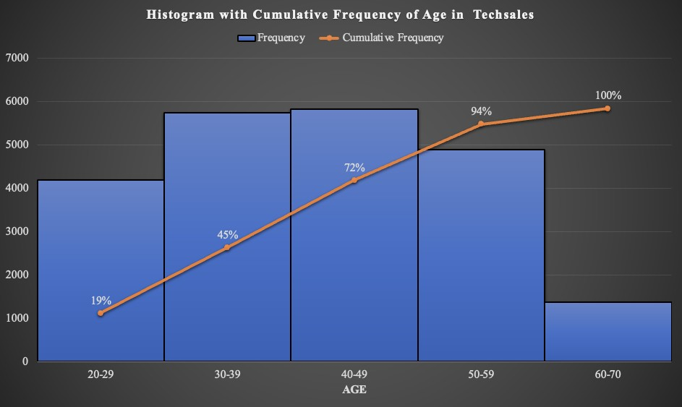

The above histogram illustrates the cumulative frequency distribution of age in the Tech Sales field, indicating the total number of individuals falling within various age groups. The age group of 40-49 exhibits the highest cumulative frequency of 72%. Overall, the histogram demonstrates a progressive rise in cumulative frequency from the youngest age groups to the high-aged category, reaching its peak at 60-70, followed by a gradual decline for the younger age groups. This data can be used by businesses to plan their workforce, find talent, and manage their operations. For instance, if the 40–49 age group predominates, it may be a sign that the organization needs to concentrate on finding and keeping talent in this age group, understanding their career ambitions, and offering opportunities for their professional progress.To show how frequencies gradually increase as you move through the age groupings, cumulative frequency for the age variable was provided. It is not essential or appropriate for all variables in every dataset, though. Depending on the features of the variables and the type of analysis being done, distinct variables may need various statistical measurements or presentation techniques.

## **5.2 Frequency Distribution of Personality by Age:**

|  |  |  |  |  |  |
| --- | --- | --- | --- | --- | --- |
| **Frequency** | **Personality** |  |  |  |  |
| **Customer Age** | **Analyst** | **Diplomat** | **Explorer** | **Sentinel** | **Grand Total** |
| 20-23 | 85 | 315 | 301 | 152 | 853 |
| 24-27 | 259 | 782 | 807 | 321 | 2169 |
| 28-31 | 271 | 815 | 833 | 365 | 2284 |
| 32-35 | 270 | 844 | 867 | 322 | 2303 |
| 36-39 | 300 | 835 | 859 | 318 | 2312 |
| 40-43 | 281 | 805 | 890 | 344 | 2320 |
| 44-47 | 283 | 841 | 855 | 346 | 2325 |
| 48-51 | 278 | 865 | 858 | 339 | 2340 |
| 52-55 | 277 | 780 | 824 | 364 | 2245 |
| 56-59 | 188 | 510 | 560 | 213 | 1471 |
| 60-63 | 117 | 339 | 404 | 144 | 1004 |
| 64-67 | 50 | 118 | 142 | 54 | 364 |
| **Grand Total** | **2659** | **7849** | **8200** | **3282** | **21990** |

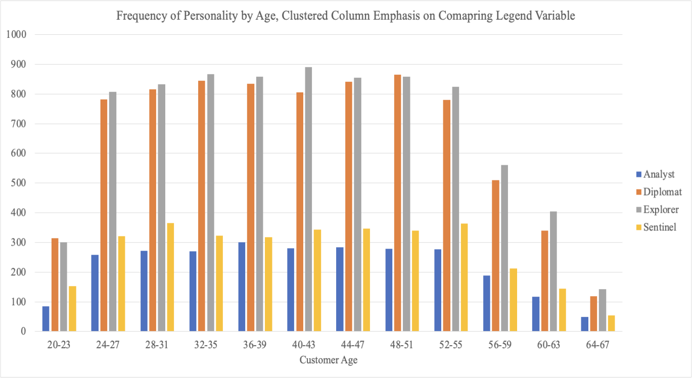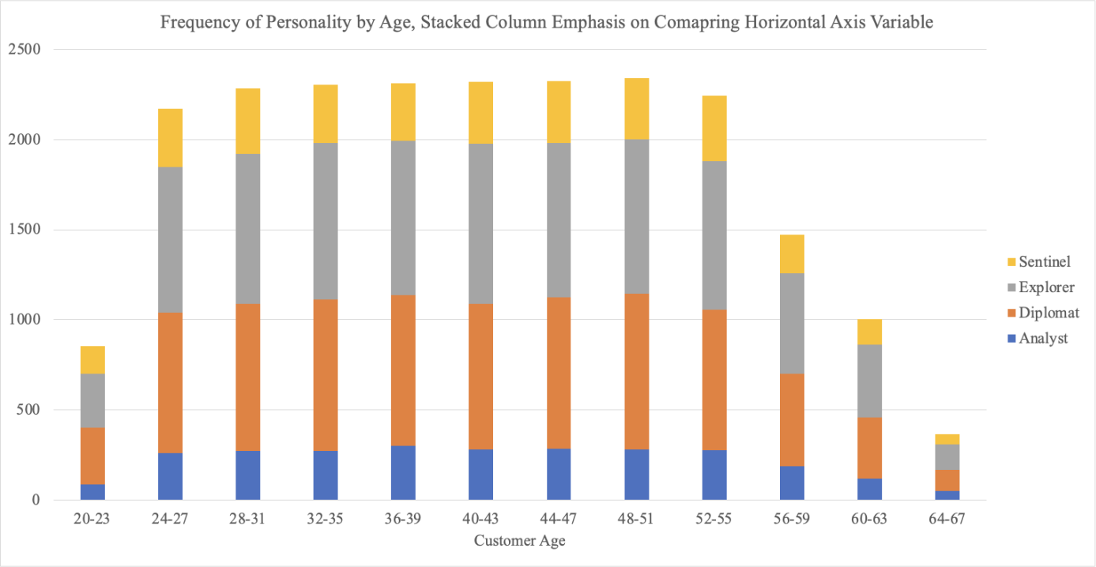

Both the above clustered and stacked charts convey similar meanings regarding the frequency distribution of personality types among customers of different age groups. However, the clustered chart provides better insights into the individual personality types of each age group compared to the stacked chart. In the clustered chart, the data is divided into separate clusters, allowing for a clearer view of the higher and lower frequencies within different age groups. Conversely, in the stacked chart, it is more challenging to compare the frequency distributions of the various age groups since the data is organized in a single stack. From both the graphs, the highest frequency for each personality type among age groups was 890 for Explorers in the 40-43 age group, while the lowest frequency was 50 for Analysts in the 64-67 age group, with overall decreasing trends observed for most personality types.By analyzing the frequencies and trends of personality types, businesses can develop targeted approaches to engage and cater to specific customer segments, ultimately improving customer satisfaction and driving business growth.

**6. Simpson’s Paradox**

A statistical phenomenon known as Simpson's Paradox happens when a pattern or connection shows up in various groups of data but reverses or vanishes when the groups are merged. It is a paradoxical finding that calls into question our preconceived notions about the facts. It develops when a hidden or confusing variable exists in the data. This variable affects both the independent and dependent variables, which might result in conclusions that are incorrect or inconsistent.

The below tables represent the Simpson’s paradox phenomenon, in this dataset, there is a hidden variable associated with the "female" field. This variable has values of '0' and '1'. When the value is '0', it indicates that the sales representatives are male. This hidden variable influences other variables in the dataset, both independent and dependent variables, and should be taken into consideration when analyzing the data.

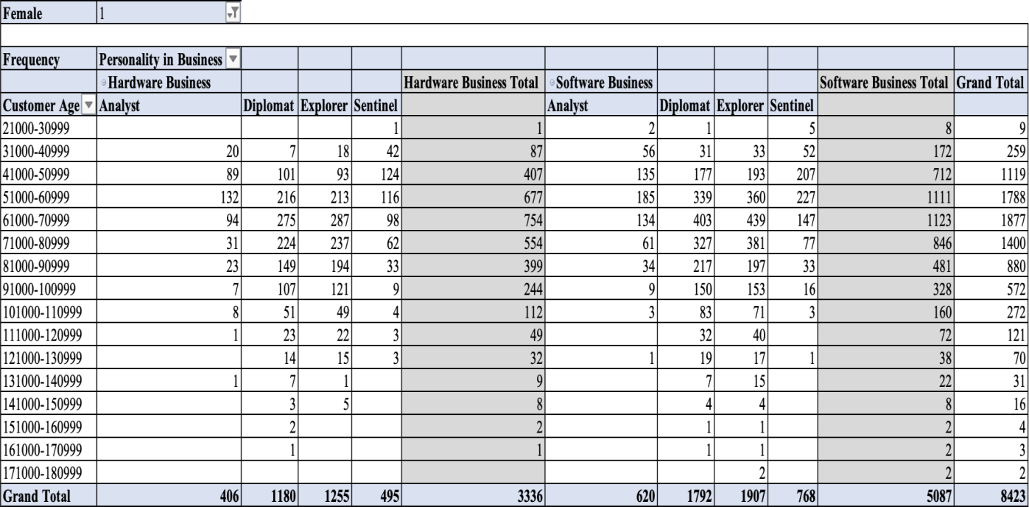

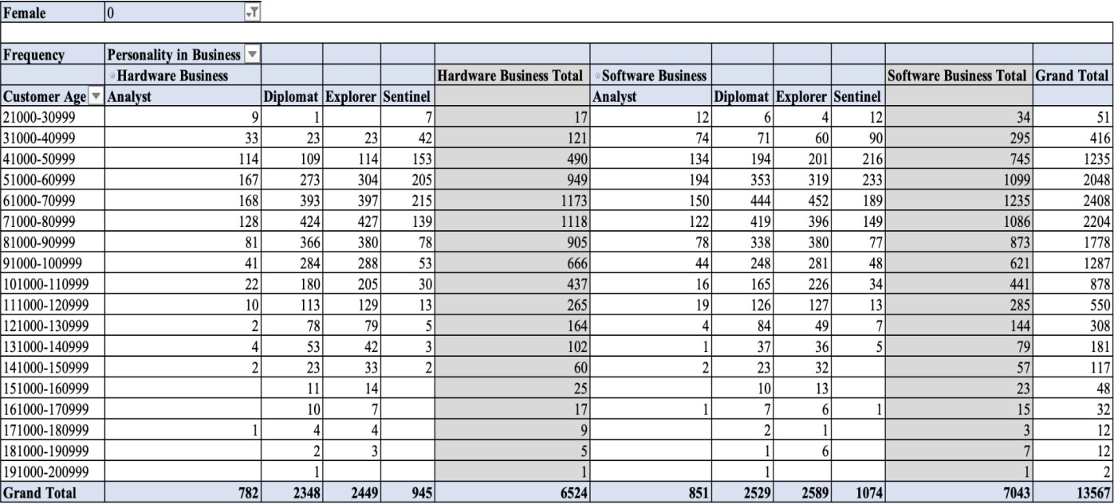

The tables show how various personality traits, separated by gender, affect sales effectiveness in the hardware and software industries. By evaluating the frequency distribution, businesses can determine which personality types—male or female—are more frequent in each business sector. To increase overall sales effectiveness, this study can be used to pinpoint efficient sales tactics, pinpoint the advantages of personality types, and optimize team composition. The excessive representation of male salespeople may hamper the business's ability to attract and engage female clients. Different genders may have different purchasing patterns, opinions, and requirements (Bigne, Ruiz & Sanz, 2005). A more diverse sales force, with a balanced representation of men and women, offers a larger range of viewpoints, experiences, and ideas.

# **7. Research Questions**

1. Is there a significant difference in the levels of customer satisfaction reported by sales representatives who work in the Hardware business as opposed to those who work in the Software sector?
2. Does the age of sales representatives have a significant impact on their salary?
3. Is there a difference in customer satisfaction scores based on the gender of sales representatives?
4. Do sales representatives with college degrees receive higher salaries than those without degrees?
5. Can the years of experience be used to predict customers’ satisfaction scores?
6. Are there differences in customer satisfaction scores among sales representatives with different numbers of certificates?
7. Does the feedback given to sales representatives have a significant relationship with their years of experience?
8. Is there a difference in customer satisfaction scores due to the sales representative personality?

# **8. Analysis and Results**

## **8.1 Research Question 1:**

Is there a significant difference in the levels of customer satisfaction reported by sales representatives who work in the Hardware business as opposed to those who work in the Software sector?

Statistical Analysis: Independent samples t-test.

|  |  |  |  |  |  |
| --- | --- | --- | --- | --- | --- |
| **Group Statistics** | | | | | |
|  | Business | N | Mean | Std. Deviation | Std. Error Mean |
| customer-satisfaction-score | Hardware | 9860 | 6.253 | 2.1450 | .0216 |
| Software | 12130 | 6.299 | 2.1776 | .0198 |

|  |  |  |  |  |  |  |  |  |
| --- | --- | --- | --- | --- | --- | --- | --- | --- |
| Independent Samples Test | | |  |  |  |  |  |  |
|  |  | Levene's Test for Equality of Variances | | t-test for Equality of Means | | |  |  |
|  |  | F | Sig. | t | df | Sig. (2-tailed) | Mean Difference | Std. Error Difference |
|  |  |  |  |  |  |  |  |  |
| customer-satisfaction-score | Equal variances assumed | 7.797 | 0.005 | -1.595 | 21988 | 0.111 | -0.0468 | 0.0293 |
|  | Equal variances not assumed | | | -1.598 | 21201.91 | 0.11 | -0.0468 | 0.0293 |

The descriptive statistics for customer satisfaction scores in the Hardware and Software businesses indicated that score for hardware sales representatives (M = 6.253, SD = 2.1450). On the contrary contrast, software (M = 6.299, SD = 2.1776). The results indicated a violation of the hypothesis (p = .005), suggesting that the conflicts of the two groups were not equal.

The t-test results revealed no statistically significant difference in customer satisfaction scores between sales representatives in the Hardware and Software businesses (t(21,201.910) = -1.598, p = .110). In conclusion, there was no valid difference in customer satisfaction scores between sales representatives working in the Hardware business compared to those in the Software business.

## **8.2 Research Question 2:**

Is there a relationship between the age of sales representatives and their salary?

Statistical Analysis: Simple linear regression.

|  |  |  |  |  |
| --- | --- | --- | --- | --- |
| **Model Summary** | | | | |
| Model | R | R Square | Adjusted R Square | Std. The error in the Estimate |
| 1 | .264a | .070 | .070 | 21963.1293 |
| a. Predictors: (Constant), Age | | | | |

|  |  |  |  |  |  |  |
| --- | --- | --- | --- | --- | --- | --- |
| **ANOVAa** | | | | | | |
| Model | | Sum of Squares | df | Mean Square | F | Sig. |
| 1 | Regression | 794056140135.018 | 1 | 794056140135.018 | 1646.125 | .000b |
| Residual | 10606550560830.830 | 21988 | 482379050.429 |  |  |
| Total | 11400606700965.848 | 21989 |  |  |  |
| a. Dependent Variable: Salary | | | | | | |
| b. Predictors: (Constant), Age | | | | | | |

|  |  |  |  |  |  |  |
| --- | --- | --- | --- | --- | --- | --- |
| **Coefficients** | | | | | | |
| Model | | Unstandardized Coefficients | | Standardized Coefficients | t | Sig. |
| B | Std. Error | Beta |
| 1 | (Constant) | 51826.351 | 558.477 |  | 92.799 | .000 |
| Age | 526.495 | 12.977 | .264 | 40.572 | .000 |
| a. Dependent Variable: Salary | | | | | | |

The regression model shows a positive relationship between age and salary, with an R2= 0.070, indicating that age can explain 7% of the salary variation. The statistical significance of the age coefficient is confirmed by the t-test, with a t=40.572, p =0, indicating that the relationship between age and salary is highly significant.

## **8.3 Research Question 3:**

Is there a discernible gap in the levels of client satisfaction between male and female sales personnel?

Statistical Analysis: Independent samples t-test

|  |  |  |  |  |  |
| --- | --- | --- | --- | --- | --- |
| **Group Statistics** | | | | | |
|  | Female | N | Mean | Std. Deviation | Std. Error Mean |
| customer-satisfaction-score | Male | 13567 | 6.251 | 2.1610 | .0186 |
| Female | 8423 | 6.323 | 2.1658 | .0236 |

|  |  |  |  |  |  |  |  |  |
| --- | --- | --- | --- | --- | --- | --- | --- | --- |
| Independent Samples Test | | |  |  |  |  |  |  |
|  |  | Levene's Test for Equality of Variances | | t-test for Equality of Means | | |  |  |
|  |  | F | Sig. | t | df | Sig. (2-tailed) | Mean Difference | Std. Error Difference |
|  |  |  |  |  |  |  |  |  |
| customer-satisfaction-score | Equal variances assumed | 0.371 | 0.542 | -2.384 | 21988 | 0.017 | -0.0715 | 0.03 |
|  | Equal variances not assumed | | | -2.382 | 17823.03 | 0.017 | -0.0715 | 0.03 |

The group statistics indicate that male sales representatives' average customer satisfaction is 6.251, SD = 2.1610. On the other hand, the average customer satisfaction score for female sales representatives is 6.323, with a standard deviation of 2.1658. The t-test shows a significant difference in customer satisfaction scores based on gender, with a t () = -2.384, p = 0.017. This outcome indicates that the average customer satisfaction scores are different due to gender. In conclusion, Female sales representatives have slightly higher customer satisfaction scores than their males.

## 

## **8.4 Research Question 4:**

Do having a degree determine the salary of the sales representative?

Statistical Analysis: Independent samples t-test

|  |  |  |  |  |  |
| --- | --- | --- | --- | --- | --- |
| **Group Statistics** | | | | | |
|  | College | N | Mean | Std. Deviation | Std. Error Mean |
| Salary | No | 4470 | 64220.268 | 19250.6723 | 287.9335 |
| Yes | 17520 | 76085.719 | 22969.5726 | 173.5345 |

|  |  |  |  |  |  |  |  |  |
| --- | --- | --- | --- | --- | --- | --- | --- | --- |
| Independent Samples Test | | |  |  |  |  |  |  |
|  |  | Levene's Test for Equality of Variances | | t-test for Equality of Means | | |  |  |
|  |  | F | Sig. | t | df | Sig. (2-tailed) | Mean Difference | Std. Error Difference |
|  |  |  |  |  |  |  |  |  |
| Salary | Equal variances assumed | 163.881 | 0 | -31.804 | 21988 | 0 | -11865.5 | 373.0752 |
|  | Equal variances not assumed | | | -35.294 | 8034.803 | 0 | -11865.5 | 336.1843 |

The statistical analysis results suggest that sales representatives with college degrees receive significantly higher salaries than those without degrees. The independent samples t-test was carried out so that a comparison could be made between the mean salary of sales representatives with college degrees and those without. The group statistics indicate that the mean salary for sales representatives without college degrees is $64,220.268, with a standard deviation of $19,250.6723. On the other hand, the mean salary for sales representatives with college degrees is $76,085.719, with a standard deviation of $22,969.5726. The t-test assuming unequal variances shows a significant wage difference between sales representatives with and without college degrees, with a t-value of -35.294 and a p-value of 0.000 (two-tailed). This outcome indicates that the mean salaries of these two groups are significantly different. In addition, the mean salary difference is estimated at -$11,865.4507, with a standard error of $336.1843. The 95% confidence interval of the difference (-$12,524.4592 to -$11,206.4423) does not include zero, further supporting the conclusion that sales representatives with college degrees receive significantly higher salaries than those without degrees.

## **8.5 Research Question 5:**

Can the years of experience be used to predict customers’ satisfaction scores?

Statistical Analysis: Analysis of variance

|  |  |  |  |  |
| --- | --- | --- | --- | --- |
| **Model Summary** | | | | |
| Model | R | R Square | Adjusted R Square | Std. The error in the Estimate |
| 1 | .203a | .041 | .041 | 2.1180 |
| a. Predictors: (Constant), Years | | | | |

|  |  |  |  |  |  |  |
| --- | --- | --- | --- | --- | --- | --- |
| **ANOVAa** | | | | | | |
| Model | | Sum of Squares | df | Mean Square | F | Sig. |
| 1 | Regression | 4245.075 | 1 | 4245.075 | 946.286 | .000b |
| Residual | 98639.008 | 21988 | 4.486 |  |  |
| Total | 102884.083 | 21989 |  |  |  |
| a. Dependent Variable: customer-satisfaction-score | | | | | | |
| b. Predictors: (Constant), Years | | | | | | |

|  |  |  |  |  |  |  |
| --- | --- | --- | --- | --- | --- | --- |
| Coefficients | | | | | | |
| Model | | Unstandardised Coefficients | | Standardised Coefficients | t | Sig. |
| B | Std. Error | Beta |
| 1 | (Constant) | 5.801 | .021 |  | 274.935 | .000 |
| Years | .181 | .006 | .203 | 30.762 | .000 |
| 1. Dependent Variable: customer-satisfaction-score | | | | | | |

According to the statistical research findings, the number of years of experience may predict the satisfaction scores received from consumers. The linear regression was carried out so that the association between the number of years of experience and the customer satisfaction scores could be investigated while other parameters were held constant. According to the model summary, the model has an R-squared value of 0.041, which implies that years of experience may explain around 4.1% of the variance in customer satisfaction scores; this variation is minimal for a model to be significant. The ANOVA results show that the regression model is significant, with a regression sum of 4245.075, a mean square of 4245.075, and an F-value of 946.286 (p < 0.001). This outcome suggests that including years of experience as a predictor significantly improves the prediction of customer satisfaction scores but does not fully explain the overall variation in satisfaction.

The coefficients table reveals that the constant term (intercept) is 5.801, indicating the estimated customer satisfaction score when the years of experience are zero (which is not practically meaningful in this context). The coefficient for years of experience is 0.181, indicating that the predicted customer satisfaction score increases by 0.181 units for each extra year of experience beyond the initial amount. The statistical significance of the years of experience coefficient is confirmed by the t-test, with a t-value of 30.762 and a p-value of <0.001. This outcome indicates a highly significant relationship between years of experience and customer satisfaction scores.

## **8.6 Research Question 6:**

Are there differences in customer satisfaction scores among sales representatives with different numbers of certificates?

Statistical Analysis: Simple linear regression.

|  |  |  |  |  |  |
| --- | --- | --- | --- | --- | --- |
| **ANOVA** | | | | | |
| customer-satisfaction-score | | | | | |
|  | Sum of Squares | df | Mean Square | F | Sig. |
| Between Groups | 21393.272 | 6 | 3565.545 | 961.843 | .000 |
| Within Groups | 81490.811 | 21983 | 3.707 |  |  |
| Total | 102884.083 | 21989 |  |  |  |

The statistical analysis results suggest significant differences in customer satisfaction scores among sales representatives with different numbers of certificates. A one-way ANOVA compared the mean customer satisfaction scores between other certificate groups. The ANOVA results indicate that the differences between groups are statistically significant, as evidenced by a considerable F-value of 961.843 (p < 0.001). This outcome suggests that the number of certificates sales representatives hold significantly impacts their customer satisfaction scores.

The results on differences include sales representatives with no certificates (-.5337) have significantly lower mean customer satisfaction scores compared to those with one diploma (.5337) and two certificates (-1.1840), and so on for other certificate groups. Sales representatives with one certificate (.5337) have significantly higher mean customer satisfaction scores compared to those with two certificates (-.6503), three certificates (-1.2361), and so on. Sales representatives with five credentials (-2.9756) have significantly lower mean customer satisfaction scores than those with six credentials (-3.4001). In conclusion, the statistical analysis suggests significant differences in customer satisfaction scores among sales representatives with different numbers of certificates. The specific mean differences depend on the pairs of certificate groups being compared. The results indicate that holding more certificates is associated with higher customer satisfaction scores.

## **8.7 Research Question 7:**

Does the feedback given to sales representatives have a significant relationship with their years of experience?

Statistical Analysis: Simple linear regression

|  |  |  |  |  |
| --- | --- | --- | --- | --- |
| **Model Summary** | | | | |
| Model | R | R Square | Adjusted R Square | Std. The error in the Estimate |
| 1 | .002a | .000 | .000 | .836788035648276 |
| a. Predictors: (Constant), Years | | | | |

|  |  |  |  |  |  |  |
| --- | --- | --- | --- | --- | --- | --- |
| **ANOVAa** | | | | | | |
| Model | | Sum of Squares | df | Mean Square | F | Sig. |
| 1 | Regression | .047 | 1 | .047 | .068 | .795b |
| Residual | 15396.310 | 21988 | .700 |  |  |
| Total | 15396.358 | 21989 |  |  |  |
| a. Dependent Variable: Feedback | | | | | | |
| b. Predictors: (Constant), Years | | | | | | |

The simple linear regression analysis indicates no significant relationship between the feedback given to sales representatives and their years of experience. The meagre R-squared value (0%) suggests that the model needs to provide meaningful information to explain the variation in the feedback variable based on years of experience. Additionally, the non-significant F-statistic (p > .05) further supports that the regression model is not statistically significant in predicting feedback based on years of experience.

## **8.8 Research Question 8:**

Does client satisfaction differ significantly among salesperson personality types?

Statistical Analysis: ANOVA

|  |  |  |  |  |
| --- | --- | --- | --- | --- |
| **Model Summary** | | | | |
| Model | R | R Square | Adjusted R Square | StdThe error of the Estimate |
| 1 | .002a | .000 | .000 | .83679 |
| a. Predictors: (Constant), Years | | | | |

|  |  |  |  |  |  |
| --- | --- | --- | --- | --- | --- |
| **ANOVA** | | | | | |
| customer-satisfaction-score | | | | | |
|  | Sum of Squares | df | Mean Square | F | Sig. |
| Between Groups | 15190.386 | 3 | 5063.462 | 1269.479 | .000 |
| Within Groups | 87693.697 | 21986 | 3.989 |  |  |
| Total | 102884.083 | 21989 |  |  |  |

|  |  |  |  |  |  |  |
| --- | --- | --- | --- | --- | --- | --- |
| **Multiple Comparisons** | | | | | | |
| Dependent Variable: customer-satisfaction-score | | | | | | |
| Tukey HSD | | | | | | |
| (I) Personality | (J) Personality | Mean Difference (I-J) | Std. Error | Sig. | 95% Confidence Interval | |
| Lower Bound | Upper Bound |
| 1.0 | 2.0 | -1.8667* | .0448 | .000 | -1.982 | -1.752 |
| 3.0 | -1.8515* | .0446 | .000 | -1.966 | -1.737 |
| 4.0 | .0230 | .0521 | .971 | -.111 | .157 |
| 2.0 | 1.0 | 1.8667* | .0448 | .000 | 1.752 | 1.982 |
| 3.0 | .0151 | .0315 | .964 | -.066 | .096 |
| 4.0 | 1.8896* | .0415 | .000 | 1.783 | 1.996 |
| 3.0 | 1.0 | 1.8515* | .0446 | .000 | 1.737 | 1.966 |
| 2.0 | -.0151 | .0315 | .964 | -.096 | .066 |
| 4.0 | 1.8745* | .0413 | .000 | 1.769 | 1.980 |
| 4.0 | 1.0 | -.0230 | .0521 | .971 | -.157 | .111 |
| 2.0 | -1.8896* | .0415 | .000 | -1.996 | -1.783 |
| 3.0 | -1.8745* | .0413 | .000 | -1.980 | -1.769 |
| *. The mean difference is significant at the 0.05 level. | | | | | | |

According to the findings of the statistical study, there is a discernible gap between the levels of customer satisfaction attained by different sales representatives' personalities. A multiple regression or correlation analysis examined the relationship between sales usual personality and customer satisfaction scores. The ANOVA results show that the differences between personality groups are statistically significant, as evidenced by a substantial F-value of 1269.479 (p < 0.001). This outcome suggests that sales representative personality come as a considerable impact on customer satisfaction scores.

# **9. Discussion**

This study investigated the link between various background information of sales representatives and their impact on their performance and customer satisfaction. The literature review highlighted the importance of HR in managing and optimising an organisation’s workforce. It referenced previous studies by Murphy (2020), Kurdi et al. (2020), and Elrehail et al. (2019) to establish a theoretical and empirical foundation for the research questions. These studies emphasised the significance of employee satisfaction, performance evaluation methods, and HR practices in achieving competitive advantage and improving customer satisfaction. The current study aimed to contribute to this existing body of knowledge and provide practical implications for HR professionals and organisations in the sales industry. This study agrees with most of the other research in the following ways.

This finding suggests that the type of business has little impact on customer satisfaction scores, whether hardware or software. The age of sales representatives significantly affected their salary, with older representatives generally receiving higher wages. This finding aligns with expectations that experience and seniority contribute to higher earnings primarily due to the experience level. There was a significant difference in customer satisfaction scores based on the gender of sales representatives, with female sales representatives tending to have slightly higher customer satisfaction scores than their male counterparts. This may be assumed that females are gentle and communicate with customers humbly. Thus their customers end up being satisfied. Furthermore, sales representatives with college degrees received significantly higher salaries than those without degrees.

This finding supports the notion that higher education qualifications are associated with higher earning potential. Years of experience were found to be a predictor of customer satisfaction scores. As sales representatives gained more experience, customer satisfaction scores tended to increase. In addition, the number of certificates held by sales representatives was associated with differences in customer satisfaction scores. More credentials tended to be associated with higher customer satisfaction scores because education provided the critical foundation for handling customers. This outcome indicates that years of experience did not significantly influence the input received by sales representatives. Furthermore, sales representative personality had a significant impact on customer satisfaction scores. Different personality traits were associated with variations in customer satisfaction scores, making it essential to identify the nature of the sales representative before employing them for customer maintenance.

# **10. Conclusion**

As a result, the descriptive statistics analysis offers important details and insights regarding the dataset under examination. We now have a crystal-clear understanding of the conventional or average values in the dataset according to the summary statistics, which include calculations for the mean, median, and mode. These measurements serve as a point of comparison and aid in comprehending the data's primary tendency. Variability measurements like range, variance, and standard deviation have illuminated how evenly distributed the data is. Graphical representations, such as histograms, bar charts and line charts have visually represented the distribution patterns between the variables. Cross-tabulation has also helped examine the connections between categorical variables and determine their relationships or dependencies.

The study reveals important insights into the factors that influence the performance of sales agents and their level of satisfaction. The findings contribute to the knowledge of human resource practices, performance evaluation, and customer satisfaction. The results suggest that organisations should consider age, gender, education, experience, certificates, and personality traits when managing their sales workforce. These findings can guide HR professionals in designing effective strategies for improving sales representatives' performance and maximising customer satisfaction.

There are some limitations to consider in this study. The research relied on a specific dataset and variables, which does not give a more comprehensive view of essential factors influencing sales representatives' performance and satisfaction. In addition, the study only looks at the sales industry, while many other sectors deal with customer satisfaction.

# **References:**

* Akdere, M., & Egan, T. (2020). Transformational leadership and human resource development: Linking employee learning, job satisfaction, and organisational performance. Human Resource Development Quarterly, 31(4), 393-421.
* Bigne, E., Ruiz, C., & Sanz, S. (2005). The impact of Internet user shopping patterns and demographics on consumer mobile buying behaviour. Journal of Electronic Commerce Research, 6(3), 193.
* Elrehail, H., Al-Lozi, M., & Aqqad, N. (2019). Employee satisfaction, human resource management practices, and competitive advantage: The case of Northern Cyprus. European Journal of Management and Business Economics, 28(1), 49-64.
* Gurcan, F., & Cagiltay, N. E. (2019). Big data software engineering: Analysis of knowledge domains and skill sets using LDA-based topic modelling. IEEE Access, 7, 82541-82552.
* Hernandez-Arenaz, I., & Iriberri, N. (2019). A review of gender differences in negotiation. Oxford Research Encyclopedia of Economics and Finance.
* Kurdi, S. M., Alshurideh, M. T., & Alnaser, W. E. (2020). The impact of employee satisfaction on customer satisfaction: Theoretical and empirical underpinning. Management Science Letters, 10(7), 1545-1554.
* Murphy, K. R. (2020). Performance evaluation will not die, but it should. Journal of Business and Psychology, 35(2), 125-130.