# Baron Institute Addiction Study

## Population Sample

*Segments studied:

-Male, White -Male, Other -Female, White -Female, Other

*Sustances reviewed:

-Alcohol -Cigarettes -Marijuana

library(vcdExtra)

## Warning: package 'vcdExtra' was built under R version 3.1.2

## Loading required package: vcd

## Warning: package 'vcd' was built under R version 3.1.2

## Loading required package: grid  
## Loading required package: gnm

## Warning: package 'gnm' was built under R version 3.1.2

head(DaytonSurvey)

## cigarette alcohol marijuana sex race Freq  
## 1 Yes Yes Yes female white 405  
## 2 No Yes Yes female white 13  
## 3 Yes No Yes female white 1  
## 4 No No Yes female white 1  
## 5 Yes Yes No female white 268  
## 6 No Yes No female white 218

We took a sampling of the world population and examined thier use of specific controlled substances over the course of a month.

plot(DaytonSurvey$Freq)

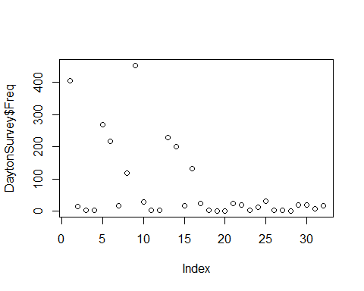

As the graphs above and below show - the majority of the population kept contraolled substance use below 50. This is great news because we have programs in place to handle the outliers

hist(DaytonSurvey$Freq)

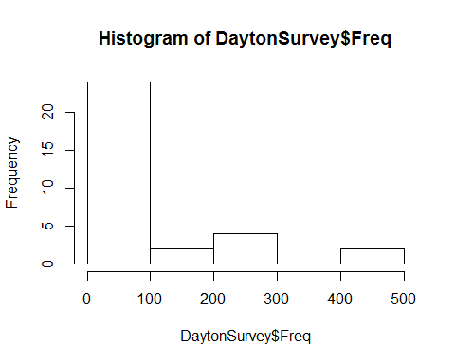

Here is a summary of the landscape in Dayton:

## Warning: package 'psych' was built under R version 3.1.2

## vars n mean sd median trimmed mad min max range skew  
## cigarette* 1 32 1.50 0.51 1.5 1.50 0.74 1 2 1 0.00  
## alcohol* 2 32 1.50 0.51 1.5 1.50 0.74 1 2 1 0.00  
## marijuana* 3 32 1.50 0.51 1.5 1.50 0.74 1 2 1 0.00  
## sex* 4 32 1.50 0.51 1.5 1.50 0.74 1 2 1 0.00  
## race* 5 32 1.50 0.51 1.5 1.50 0.74 1 2 1 0.00  
## Freq 6 32 71.12 121.22 17.0 44.23 23.72 0 453 453 1.83  
## kurtosis se  
## cigarette* -2.06 0.09  
## alcohol* -2.06 0.09  
## marijuana* -2.06 0.09  
## sex* -2.06 0.09  
## race* -2.06 0.09  
## Freq 2.35 21.43

As you can see from the summary of our findings, the statics on usage has drasticly fallen compared to last year. My recommendation is to maintain our programs and revisit our participants next year to determine if this is a trend.