


Nutrition Trends and Changing Dietary Patterns
in the Caribbean

Lead Paper
presented at

CTA/CCST/NCST WORKSHOP
Adding Value to Local Foods for Food and Nutrition Security: Myth or Strategic Option
November 26 - 29, 2012, Wyndham Kingston Hotel, Jamaica

by
Patricia Thompson M.Sc.
Health Promotion Consultant/Registered Nutritionist

December 15, 2012

Commissioned by
Technical Centre for Agricultural and Rural Cooperation ACP-EU (CTA)

TABLE OF CONTENTS

Page
Executive Summary 3
1. Introduction 4
2. Relationship of Diet and Disease 6
3. Trends in Nutrition Status and Food Relationships 9
3.1 Nutrition status determining dietary priorities 9
3.2 Double burden of disease 12
4. Dietary Resources for Healthy Eating 14
4.1. Nutrition food facts labels 14
4.2 Dietary guidelines and food guides 15
5. Trends in Food Availability and Dietary Consumption Patterns 17
5.1 Nutrient availability 17
5.2 Use of foods and food categories 20
5.3 Meal patterns and food choices for meals 27
6. Eating Influences 32
6.1 Why people eat the way they do 33
7. Food and Nutrition Security Policies 39
8 Conclusion and Key Recommendations 40
References 41

Executive Summary
The rise in chronic non-communicable nutrition related diseases in the Caribbean accompanied by spiraling health care costs has occurred parallel with changing dietary patterns. For example, the total direct and indirect costs of treating obesity related diseases in five countries in 2003 was estimated to be US$1,000 million. Coming from an era of protein-energy malnutrition (PEM) when food choices favoured energy density (high fat, sugar and protein), coupled with many external influences, Caribbean people have become conditioned to a diet not considered to be healthy. We are now faced with the double burden of under-nutrition (pockets of PEM and iron deficiency anaemia persist) and over-nutrition (cancers, diabetes, hypertension) which threatens to erode all efforts at achieving food and nutrition security.
A second concern is the over dependence on a predominantly imported food supply and the need to develop the local food and agriculture industry so as to provide more nutritious and value-added alternatives. Caribbean consumers have always been attuned to imported foods and perceive local foods to be expensive. On a cost nutrient basis, several imported foods e.g. whole dried milk powder and wheat flour, give ‘the best food value for money’. Food security through increased local food production must have a clear goal; that is to improve the nutrition status of our people thereby leading to increased productivity, prosperity and socio-economic development. Dietary guidelines should favour low sodium and low fat criteria for food products, beverages and snacks with reduced sugar content and high fibre and possibly organic alternatives.
Food availability and food consumption trends reveal that dietary practices are probably more to blame for the existing poor health situation than are the food products themselves. People make choices based on inherent personal factors such as taste, experience and environmental influences. The food choices and meal patterns of adolescents are as much a factor of availability and accessibility as it is personal choices. Changing lifestyles account for one of the main influences on why people eat the way they do. However, environmental conditions strongly influenced by trade policies, globalisation and declining agricultural outputs also play a role. Much opportunity exists for farmers and agro-processors to target the needs of different market segments with differentiated value-added products, given better knowledge of how people make food choices.
To achieve food and nutrition security requires more insight into the causes of the problem through further research, and more collaborative multi-sectoral efforts. Only by working together will the various sectors (agriculture, health and nutrition, trade, education, science and innovation) achieve the collective objective of improved agricultural and nutrition outcomes. Collaboration will surpass the achievement of any sector working alone. Caribbean populations must also be made aware of the challenges and their role in creating and alleviating the problems. While governments can be called on to pass legislation, the impetus for change must originate from the people. Renewed efforts at educating the public on nutrition and employing social marketing strategies utilising modern technology will provide the impetus for change.
1.0 Introduction
Over the past 30-50 years, Caribbean countries have experienced a steady increase in chronic non-communicable diseases (NCD). Much of this has been attributed to changing dietary patterns and the nutritional content of foods eaten and those made available on our local markets. This paper presents a review of trends in nutrition and dietary patterns of Caribbean people to examine these relationships and the role for value-added food products in meeting the dietary needs and impacting nutrition status.
As background to the discourse, we need a common understanding of terms such as nutrition status, food, nutrition needs, diet, dietary patterns, dietary needs and dietary culture, in relation to the topic of food and nutrition security. It is generally accepted that our intake of food will impact health outcomes so that nutrition status is defined as the condition of one’s health as it is related to the intake and use of food by the body. It reflects the degree to which the body’s physiological need for nourishment is met (Thompson 2012). Food must maintain life, promote growth and keep us healthy. Indeed food is of value because it not only provides nutrients but because it is a source of energy. Minerals and vitamins by themselves cannot maintain life and promote growth so that all foods must contain the energy nutrients (carbohydrate, fat, protein) whether singly or in combination. Nutrition needs must then reflect the calories the body requires on a daily basis in addition to the various levels of nutrients. This is usually expressed as the Recommended Dietary Allowance (RDA) applied at an individual level or as population nutrition goals at the macro level.
Foods by themselves do not impact health but rather it is the ways in which we combine, use and consume food i.e. our diet is what modifies the nutrition impact. For instance, Table 1 illustrates how food combinations impact the amount of fibre available for physiological use. Although whole wheat bread is promoted for its fibre content, the traditional combination of Jamaican bulla and avocado pear provides the body with more fibre than the bread with butter.
Table 1 Comparison of nutritional values for bread items with spread
Food Items | Calories | Fat | Crude Fibre
*w/w bread (4 slices – 100g)  ‘buttered’- 40g  Total | 243  267  510 | 3.0  29.0  32.0 | 1.6  -  1.6
Bulla** – 1 medium (100g)  ½ small avocado pear (100g)  Total | 362  162  524 | 1.9  16.0  17.9 | 0.2  2.0  2.2
* w/w is whole wheat
*Bulla is a hard sweet pastry made in Jamaica
Source: Nutrition and Diet Services

The way we eat therefore is the real determinant of health and the variety of ways can be very numerous resulting in many varied dietary patterns. It is this diversity that influences dietary needs or the food choices we make based on the total environment. The study of nutrition covers an analysis of the food and nutrition situation of individuals, groups of persons and populations whereby food and the chemicals in food interact with the environment (both externally and internally) to support and promote health or result in disease (Thompson 2012). To understand food and nutrition security, we must consider all the environmental factors that affect the accessibility of food through to the personal factors that affect how food is selected and used by the body to promote health benefits, and finally why we eat the way we do.
Diet and lifestyles, are never static and the Caribbean lifestyle and dietary culture have been radically modified especially since the middle of the last century. Following the independence of many Caribbean countries from Great Britain, education became more widely available to the population and there was expansion of the workforce. Taking advantage of labour saving modern equipment and convenient processed foods being more widely available and affordable to the consumer for home use, more women were able to enter the formal workforce. Children were no longer schooled in local districts but parents sought the best schools which sometimes required travelling far distances, resulting in long hours outside the home and necessitated more eating at school and away from home. Changing lifestyles meant time was now at a premium for meal preparation and to balance home and work responsibilities therefore resulting in changing eating patterns and diets. Moreover, many external influences of one kind or another have brought about changes which have affected the eating patterns of our people.
Health and industrial development are not the only considerations however affecting the need for value-added foods. Despite the similarities in disease patterns and food consumption trends in the Caribbean, brought about by our common heritage, we have a great diversity of cultural influences, which has resulted in a variety of dietary patterns. There are differences in ethnicity, religious practices, socio-economic factors, environmental factors, and individual preferences. Various flavours using oil, sugar, curry powder and coconut milk along with pungent and hot spices and sauces create what is referred to as ‘creole’ cooking (Thompson 2012).
The impact of food choice extends to cooking methods and a large part of dietary culture is the way we prepare the food. The use of curry powder with meat or oil for frying can radically change the nutritional content of foods from animals for instance, as illustrated in Table 2. Curry powder is very rich in iron but its non-haem nature means it is not readily available to the body. Meat protein however, as with ‘curry goat’, will enhance the availability thereby greatly increasing the iron content of the combination relative to fish or even to red meat prepared in other ways. For vegans, the use of a source of vitamin C as with juice will have a similar enhancing effect as when currying plant foods such as channa or curried stringbeans. In addition, frying fish increases the total fat content comparatively to red meat even though fresh fish by itself has negligible fat (Thompson 2012).
Table 2 Comparison of fat, calorie and iron levels for three typical meal choices
Menu Item | Total Fat (g) | Total Calories | Iron (mg)
I Fried snapper fish (6 ozs whole-90g flesh)  ½ medium bammy fried  Total | 15.5  10.0  25.5 | 214  273  487 | 0.7  2.6  3.3
II Curried Goat (90g flesh)  2 large green bananas  Total | 14.2  0  14.2 | 236  107  343 | 7.0  0.2  7.2
III Grilled tenderloin steak (90g)  2 boiled medium white potatoes  Total | 11.3  0.2  11.5 | 202  134  336 | 3.6  0.7  4.3
Source: Nutrition and Diet Services

Further to these traditional influences, a growing awareness of the environmental and ecological factors governing food production has led to a demand for ‘natural’, ‘organic’ and ‘health’ foods. Hence the opening of health food stores in the region. In some cases, there is cause for concern about pesticide and herbicide residues on foods and the use of hormones and antibiotics. There are even concerns about some products from natural origins because of the awareness of biotechnology and the far reaching effects of genetically (GMO) foods.

2.0 Relationship of Diet and Disease

Sinha (1995) demonstrated changing food patterns in the Caribbean as reflected by the availability of foods locally and the possible effects on our health status. Presenting data from food balance sheets, he indicated that Caribbean people have developed a dietary pattern which suggests that consumption of food from animals, sugar and salt has been steadily increasing over a 20-30 year time span. At the same time consumption of complex carbohydrate sources such as roots, tubers and legumes, vegetables, and fruits, has remained low or has declined. He illustrated this by plotting calorie availability of food categories over the 1940’s to the 1990’s period, against the recommended population goal suggested by FAO of 2250 calories per person per day.

Calorie contribution of different foods were quite varied with patterns showing an increase in intake of fat and animal food products, and cereal grains (primarily processed products), in some Caribbean countries, and a decline in availability of roots and tubers and legumes (Figure 1).

Figure 1 Food availability patterns in the Caribbean

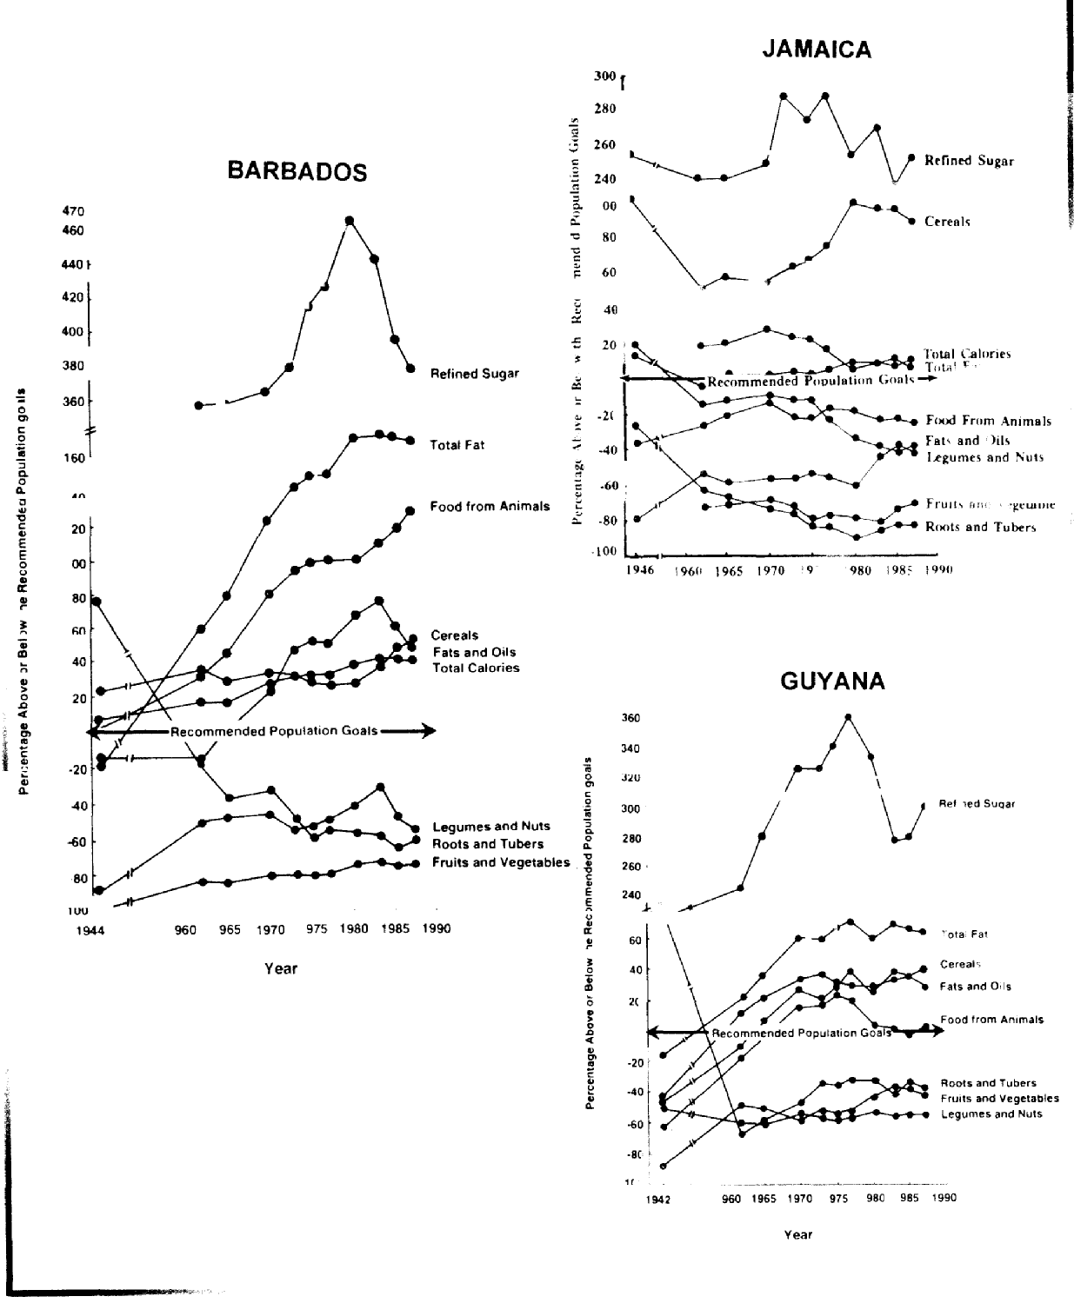
Source: Dinesh P. Sinha (1995) “Food, Nutrition and Health in the Caribbean” – Caribbean Food and Nutrition Institute.
The evidence to date shows that people consuming diets characteristically low in fruits, vegetables, roots and tubers, relatively low in other complex carbohydrates (starch and fibre containing foods) but high in saturated fat from animal sources, processed vegetable fats, red meats and excess of refined sugar and salt, are particularly vulnerable to chronic diseases.
Over the same time period, there has been a change in the nutritional status of Caribbean people which, it is argued, matches the changing dietary patterns and, consequently, the shift in mortality and morbidity factors has been attributed to this. The more pronounced these patterns, the greater the incidence of chronic diseases in the region such that comparatively, Barbados shows the highest incidence of high blood pressure, diabetes and heart attack followed by Trinidad then Jamaica and lastly Guyana. Except for colon cancer, the incidence of the main chronic diseases even outstripped the North American countries once there was adjustment for population size (Figure 2).

Figure 2 Comparative incidences of select chronic diseases in the Caribbean and North America

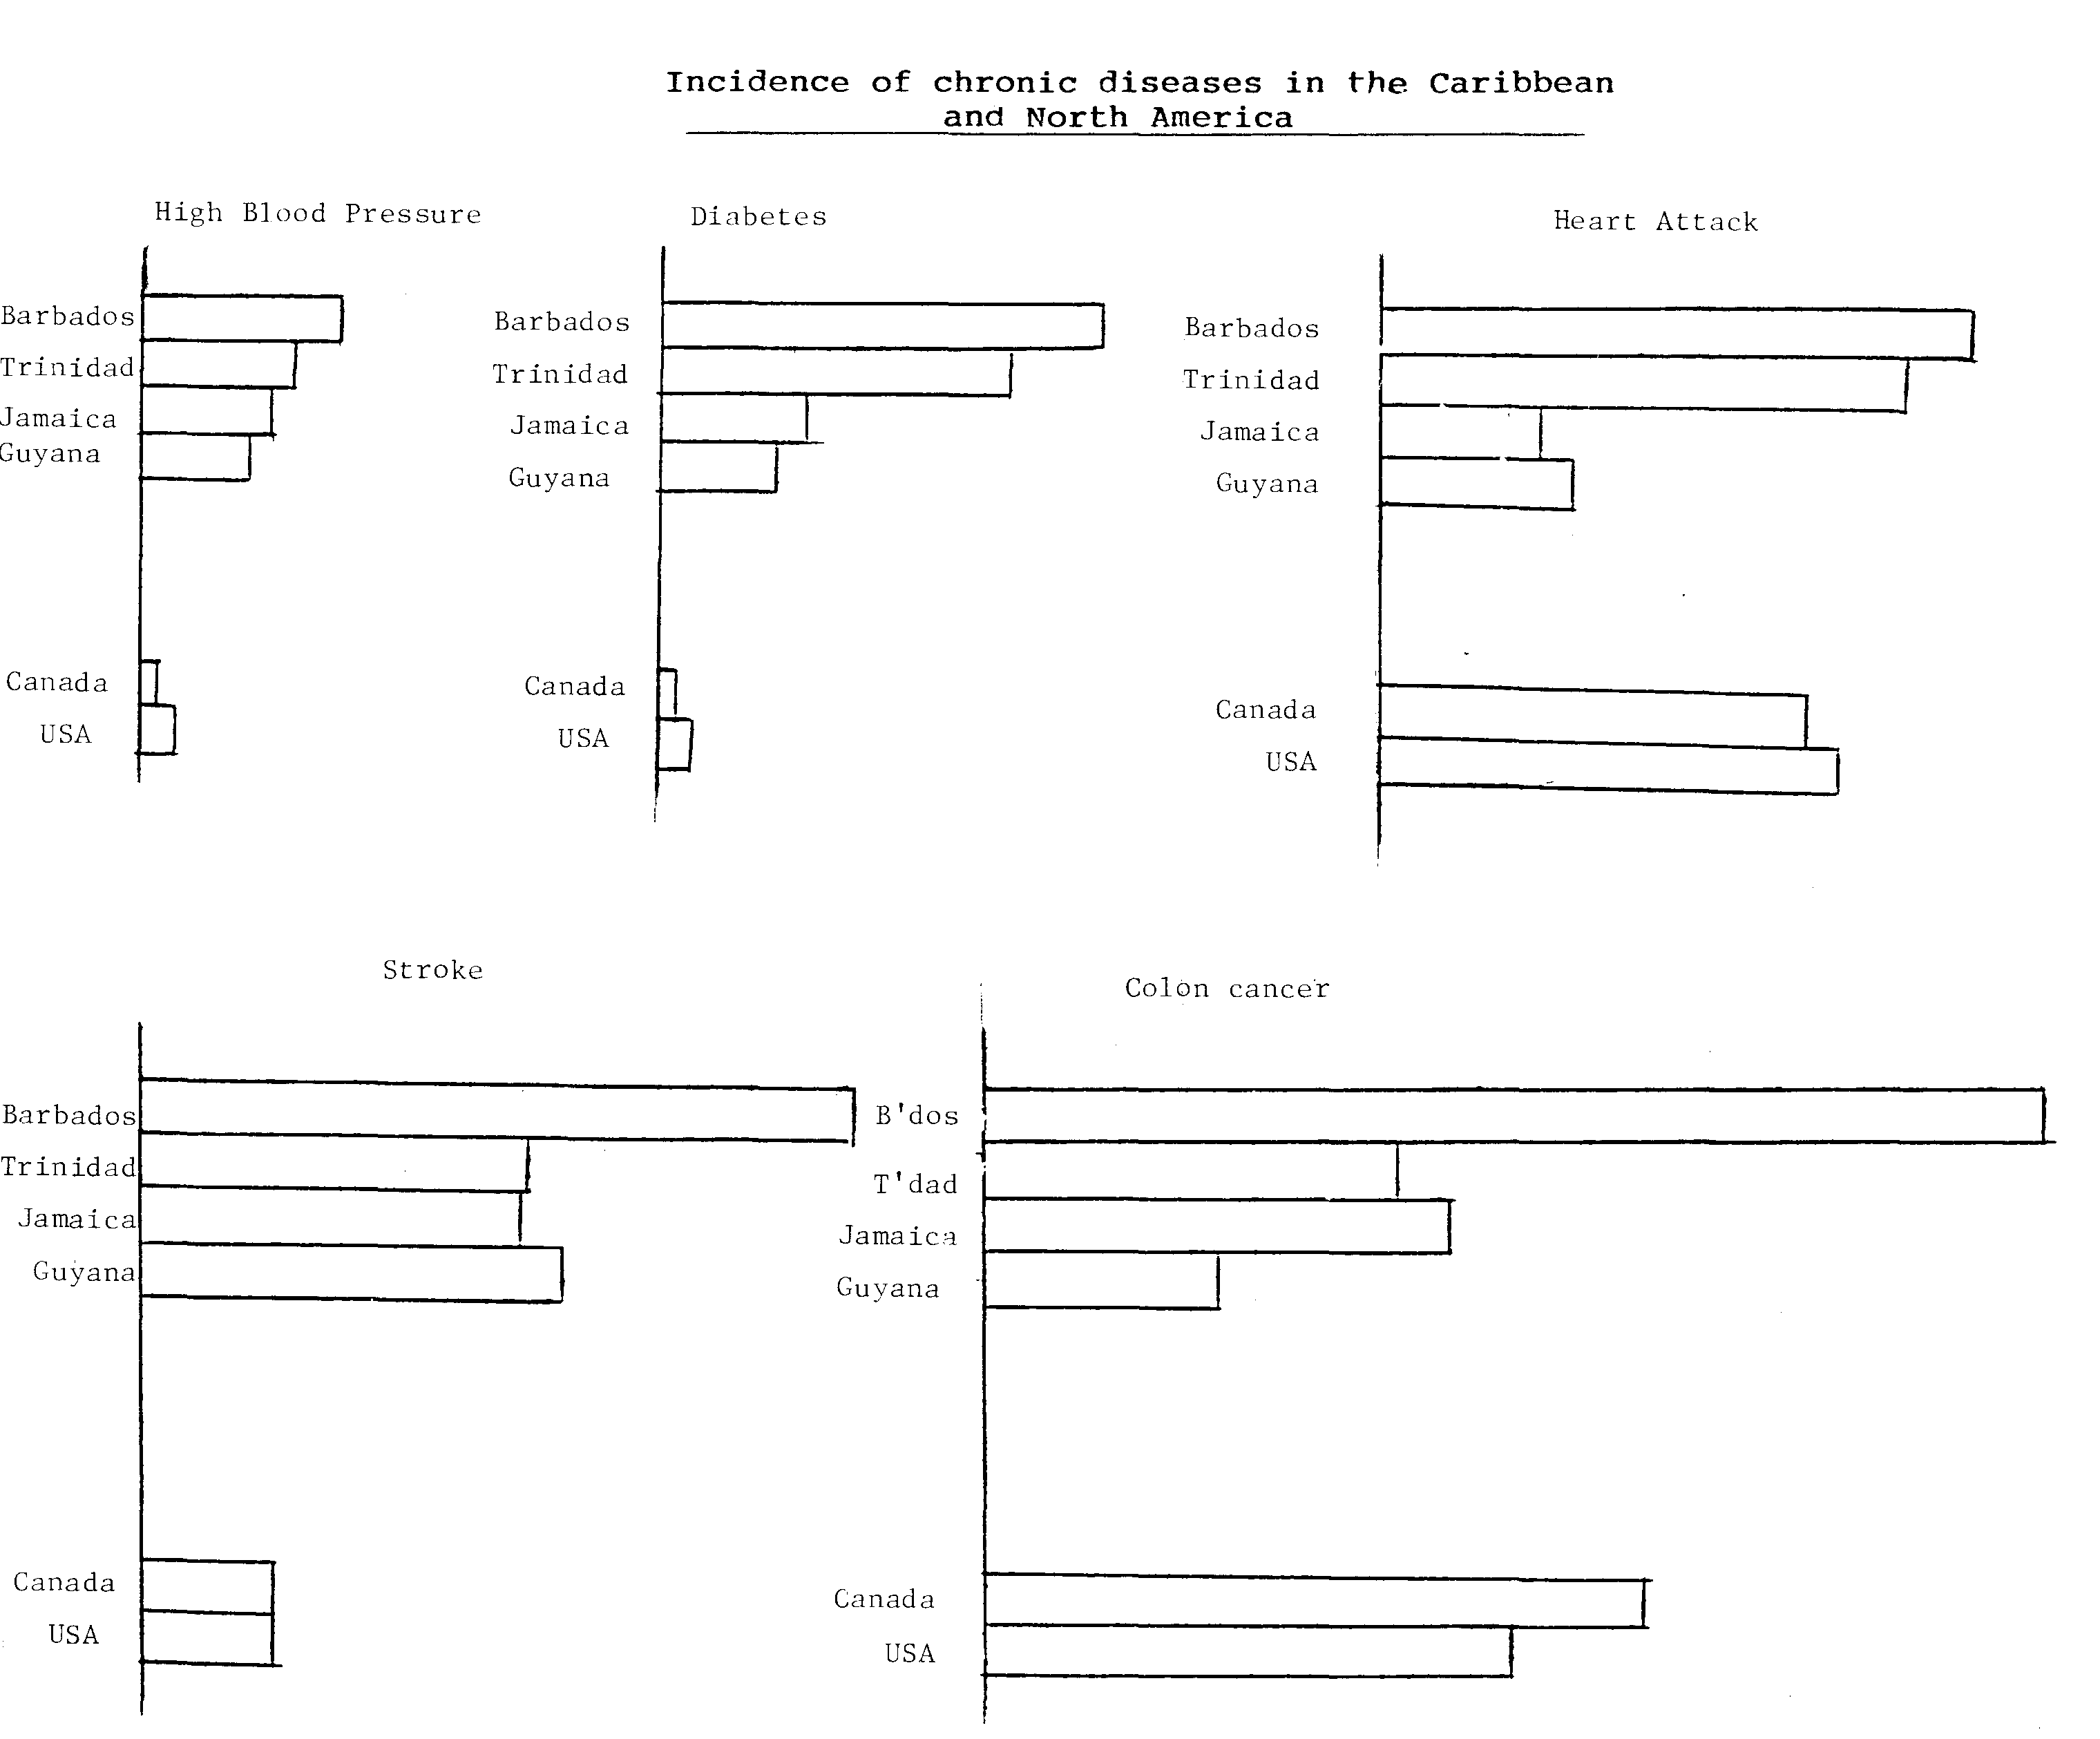

Source: Adapted from Dinesh P. Sinha (1995) “Food, Nutrition and Health in the Caribbean”.
3.0 Trends in Nutrition Status and Food Relationships

3.1 Nutrition status determining dietary priorities
Nutrition has played a significant role in the development of nations. The developmental status of a country can be measured by its infant mortality rate (IMR) and in the past, protein energy malnutrition (PEM) was recognised as a major factor in its determination. The role of nutrition in alleviating PEM has resulted in reducing the IMR, so increasing human potential and enhancing gross national product (GNP) of our countries. This relationship is demonstrated for instance by Jamaica. Over the past half century Jamaica’s infant mortality rate (IMR) has fallen from 57.4 to 20.2 per 1000 live births due, in large part, to declining levels of childhood malnutrition from over 20% to under 5% today (Sinha D.P. 1988).
Dietary priorities in the last century reflected the nutrition needs of the population. Formerly emphasis was placed on energy density of foods to alleviate PEM. During the 1950’s and 1960’s, a large proportion of children in the region were reported to be malnourished. Assessment of the prevalence of protein-energy malnutrition (PEM) in the region during the 60s and 70s, based on weight for age deficit, showed that between 25-50% of children under the age of 5 years could be described as malnourished. In the early 1980s, it was reported that between 2 and 19% of pre-school children were moderately or severely malnourished. By the late 1980s, the prevalence of under-nutrition declined to less than 5% in nine counties of the Caribbean, with rates of 5%-10% reported in six countries. Guyana was an exception at 10% of pre-school children affected with malnutrition. Grenadian data showed a decline in malnutrition among children 3-5 years old from 39.6% in 1985 to 8% in 1990 (Sinha 1995).
There has been a transition in the region towards a lowering of PEM levels while, over the same period, our incidence of obesity and chronic diseases has increased as illustrated in Figure 3 on Dominica (Sinha 1995). Obesity (defined as accumulation of excess body fat) is on the rise, but there is paucity of up-to-date data on obesity from Caribbean countries. However, national nutrition surveys of representative samples of the population since 1971 have consistently shown a high prevalence of obesity with 7–21% of Caribbean men and 22-48% of Caribbean women greater than 15 years, being obese (Sinha, 1995). Barbados showed increases in the prevalence of obesity between 1968 and 1987, from 7 to 17% in males and 32 to 46% in females (Henry, 2001). Undoubtedly, sedentary lifestyles contribute to our obesity problem but this is coupled with a continuing trend of preferentially eating calorie dense foods and diets. Dietary priorities have changed over the past 30 years as a result of the changing pattern of disease but food and dietary choices have not kept pace with changes in nutrition needs.

Figure 3 Changing patterns of deaths from infectious diseases/malnutrition and chronic diseases in Dominica between 1950 and 1990
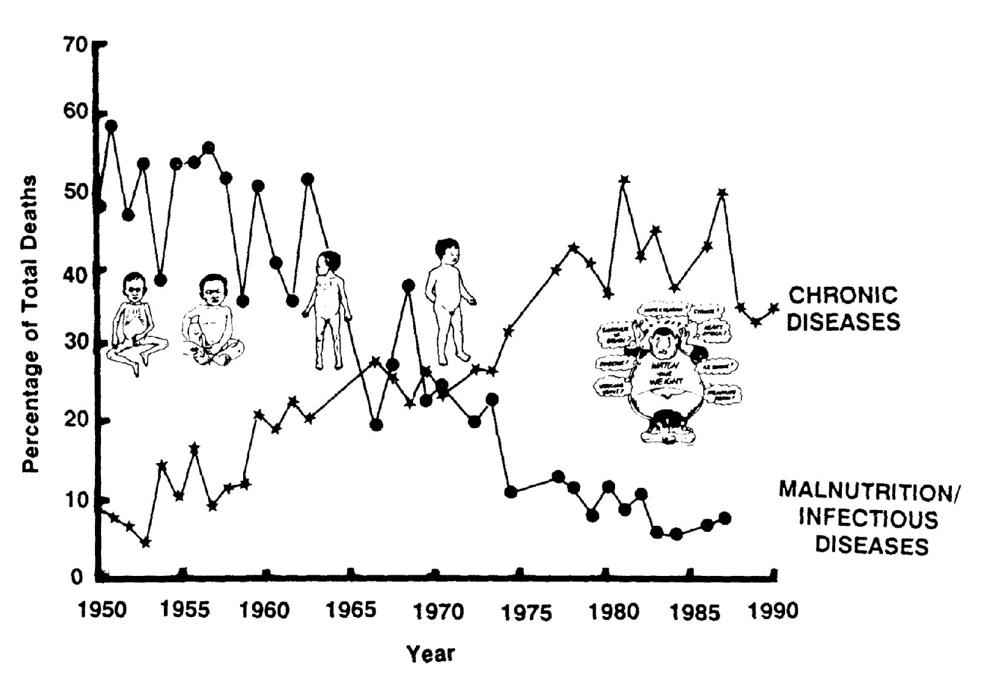
Source: Dinesh P. Sinha “Food, Nutrition and Health in the Caribbean” – Caribbean Food and Nutrition Institute.

Already the incidence of overweight is seen in preschool children (aged three to six years) with child obesity defined as >85th percentile. On average, 3-6% of preschool children in the Caribbean were reported as obese compared with the global prevalence of 3.3% (Xuereb et al, 2001). The prevalence in Jamaica was higher than the rest of the region and has since increased from 6% in 2000 (Henry, 2002) to 14% in 2007 (Henry 2011). Research has shown that adult men most vulnerable to developing obesity were those who had been ‘light’ at birth or who had thin or ‘light’ mothers (Parsons, 2001). Babies born prematurely and of low birth weight are most at risk when growing up in a society with low levels of activity and high levels of dietary fat and sugar. In the Caribbean, we have a persistence of high prevalence of low birth weight (Henry, 2006). A priority has always been to make widely available appropriate baby food products based on local foods to meet the needs of this market segment.

Obesity continues into adolescence. Table 3 illustrates the increase in obesity in select Caribbean countries. The increase in obesity in Guyanese adolescence was 6.7% in 1998 to 12.9% in 2000. This is another market segment that has not been adequately provided for in order to improve the dietary intakes. Despite school feeding programmes in many countries, several criticisms have been levelled at the nutritional appropriateness of the meals.

Table 3 Obesity prevalence in adolescents in select Caribbean countries

Countries | Baseline | Follow-up
Dominica | 6% (1990) | 9.7% (1999)
St. Kitts | 7.1% (1990) | 10.6% (1999)
St. Vincent | 6.9% (1991) | 7.2% (1998)
Guyana | 6.7% (1998)  15-19 years | 12.9% (2000)
Source: Cajanus 2001, Vol 34 (3) p 120

Obesity is the single most implicated factor in the causation of other chronic disorders. This predisposal risk factor manifests in adulthood and results show that, in 2002, cerebrovascular disease, heart disease, diabetes, hypertension, and nutrition related cancers were among the top ten causes of death in the region. Between 1984 and 1989, 24 to 57% of all deaths in the Commonwealth Caribbean region were due to these chronic NCD (Henry, 2001).
The incidence of NCDs continues to increase. Population studies in various countries indicate that an average prevalence for diabetes of 10-15% among adults 40 years and over is a realistic figure (Sinha, 1995). Figures for Trinidad and Tobago have been given as 1.4% of the total population in 1968, 2.04 % in 1969 and 2.9% in 1980 with the prevalence of non-insulin-dependent diabetes (NIDDM) found to be 11.5% in adults in 1985. Figures for Jamaica in 1995 for Type 2 diabetes mellitus was 17.9% and 1993 prevalence for Barbados was 18% in women and 15% in men (Xuereb and Ragoobirsingh, 2006). At least 60% of the diabetic population in the region is overweight. Studies have shown that about 30 of every 100 adults over 35 years old have hypertension. The current estimated prevalence of hypertension in the region is 18-22% of the adult population.
Throughout the Caribbean, deaths due to malignant neoplasms or cancer are an important cause of mortality ranging from 6% in Suriname to 16% in Barbados and Guyana. In Trinidad and Tobago, it is the third major cause of death. Dietary factors are increasingly recognised as significant contributors to the development of cancers arising in a variety of tissues. It is estimated that 1/3 of all cancer deaths may be related to food choices (Henry, 2001). The stomach is the most common site for cancer in most Caribbean countries and this could be related to high salt and nitrite intake. Next common cancers are lung, breast, cervix and prostate cancers (Henry, 2006). The latter three cancers have been attributed to high fat intake diets. Critical care of patients from varied causes involves diet therapy requiring modified diets and this has seen an increase in the use of liquid meal supplements some of which are calorie dense and most being nutrient dense. This is another big market opportunity for value-added products since persons even on enteral (tube) feeds have been demanding products based on natural local products in their mixtures.
The nutritional concerns for the modern diet in relation to disease can therefore be summarised as follows:
- Excess calories leading to obesity
- High fat (saturated fat and cholesterol of animal foods)
- Low fibre
- High sodium
- Insufficient micronutrients notably the antioxidant vitamins and minerals e.g. iron, calcium, vitamins A and C.

3.2 Double burden of nutrition concerns
While grappling with the emerging challenges of NCDs, the problem of childhood malnutrition has not fully disappeared. PEM still appears in pockets in the region and even more of a concern is the persistent problem of micronutrient deficiencies most notably iron deficiency anaemia. This is termed the double burden of nutritional concerns. Iron deficiency anaemia is a nutritional anaemia of great concern since it causes ill health that threatens the wellbeing of women and children. Even mild anaemia in pregnant women has been shown to be associated with pregnancy complications, premature delivery and low birth-weight infants and maternal mortality. In children, iron deficiency anaemia can result in impaired growth, reduced cognition and school performance, as well as poor development and fatigue. These children have been characterised with impaired neuro-development, less attentive to instructions, display functional isolation and with more severe attention deficit hyperactivity disorder symptoms (Gordon et al, 2002).

Results of surveys throughout the region show that nutritional anaemia occurs in all the countries of the Caribbean and remains a public health problem. Using the WHO standards for defining anaemia of 11g/decilitre (dl), it was found in 15-80% of young children and in 27-75% of pregnant and lactating women of five countries (Table 4) in a 1996-98 study. Severe anaemia (haemoglobin level below 8g/dl), was found in about 11% of pre-school children and about 6% of pregnant and lactating women in some of the countries (Gordon et al, 2002). Among a group of 13-15 year old students in Antigua and Barbuda, the prevalence of anaemia was 17.2% in male students, 29.3% in female students and 24.8% overall. Iron fortification of foods and education programmes could account for reduction in these levels. Supplementation programmes suffer from low compliance and low clinic coverage although, in Montserrat, supplementation was believed to account for the fall from 82.3% in 1980 to 23.2% in 1985 and 18.5% in 1990 (CFNI 2010).

Table 4 Figures from the five country study for anaemia prevalence
Countries | Anaemia Prevalence using tests indicated
 | Pregnant Women | Children 1-4 years | 5-15 years  (or older)
Guyana | 52% (Hb) | 48.2% | 56.7%
Jamaica | 51.3% (Hb) | 48.2% | 23.5%
St. Vincent & the Grenadines | 41.7% (ferritin) |  | 18.8% (ferritin)
Antigua |  | 49.4% (Hb)
Dominica | 35.1% (Hb) | 34.4% | 30.7%
Source: CAJANUS 2002, Vol 35 no. 1 p 13 - Micronutrient Deficiencies in the Caribbean.

There is little evidence of other micronutrient deficiencies in the region. The 1996-98 study of five countries gave specific figures for frank vitamin A deficiency varying from zero to 1.1% however marginal deficiency was as high as 33.6% of pregnant women and 58.1% of children 1-4 years old in Jamaica.

A small number of school children do present with wasting and underweight because of inadequate food intake. While acute hunger and starvation are not a problem in the region, school children do experience short-term hunger from not eating an adequate breakfast. A survey in Jamaican primary schools in 1999 showed that approximately 40% of primary school students received inadequate breakfast and experienced short-term hunger at school, thus compromising their ability to learn. This cohort showed an overall prevalence of underweight children at 7.3% (Thompson 2003). Numerous studies have shown a relationship of undernourishment and missing breakfast as related to underperformance in school (Brown et al 2008).

Other nutritional challenges with school children are increased dental caries and threat of osteoporosis indicating an increased need for calcium intake. Providing foods of high nutritional quality with enhanced availability of iron and calcium is most desirable for the use of these vulnerable groups. Foods rich in vitamins C and A would also be of benefit. Traditional breakfast items are often rich sources of iron, calcium and Vitamin A in the form of canned fish (sardines, mackerel), callaloo (with saltfish) while liver provides vitamin A and iron and milk with porridge or other cereal provides calcium and vitamin A. Red meat is a reliable source of iron and dried legumes will provide much calcium and iron.

The double burden of nutritional concerns can then be summarised as follows:
- Iron deficiency anaemia and lethargy
- Hunger – transient or short term
- Nutritional imbalances
- Underweight especially in school children and adolescents
- Sick or tired children who lack appetite and perform poorly
- Inappropriate food intake
- Poor calcium intake increasing risk for poor skeletal formation, tooth decay and osteoporosis
- Obesity from sedentary lifestyle.
- Overweight and obesity especially in adolescence and adulthood
- Risk for chronic disorders
- Ulcers, gas, heartburn
- Irregular eating leading to eating disorders

4.0 Dietary Resources for Healthy Eating
Every country seeks to educate its people on healthy eating to meet nutrition needs through providing guidelines. These were originally stated in terms of appropriate levels of nutrient intake and based on WHO standards for healthy eating. These values have been modified for food labelling purposes.

4.1 Nutrition food facts labels

Despite widespread awareness of the value of reading food labels, many people do not understand how to do this and are especially ignorant of the interpretation of food facts on labels. Two terms that need explaining for accurate interpretation are Daily Value and serving size.

The Daily Value (DV) is a reference standard by which processed products can be compared and it is not meant to reflect personal needs for calories and nutrients. The nutrition values are generally stated per serving size, which is intended to reflect usual amounts recognised by the population rather than a standard amount of 100g, generally used in food composition tables. These servings do not prescribe intake but merely inform, since each individual through self selection will determine the final quantities eaten. Nutrition values that appear on food labels generally reflect consumer interest in values for calories, fat, protein carbohydrate (sugar), and sodium. The main minerals are calcium and iron and the vitamins mainly A and C.

4.2 Dietary guidelines and food guides

More recently, the Food and Agriculture Organization (FAO) has called for food based dietary guidelines (Samuda, 2007) rather than nutrient based ones, in order to simplify information for use by the general public. While each country in the region has its own depiction, all Caribbean countries have statements in common such as:
1. Eat a variety of foods from all the food groups
2. Attain and maintain a reasonable weight
3. Choose foods and cooking methods low in fat, saturated fat and cholesterol
4. Use less sugar, sugary foods and drinks.
5. Eat more vegetables, fruits, ground provision, cereals and legumes but less meat
6. Use less salt, salty food and seasonings, packaged food such as salty snacks
7. If you drink alcohol, do so in moderation.
8. Drink water several times daily
9. Make physical activity a daily part of your life.

Many of these guidelines would appear contrary to using processed foods and general terms like ‘eat more’ or ‘eat less’ results in much misinterpretation. An adaptation of these guidelines for practical purposes is the use of food guides by the Caribbean Food and Nutrition Institute (CFNI). These guides imply primarily foods in the whole form and this presents opportunities for processors as with frozen or dried provisions that can be easily reconstituted. The food guides all use the Caribbean six food groups and these can be depicted in different ways to illustrate the relative proportion of foods to be selected from each food group (CFNI Posters).

Figure 4a depicts the traditional distribution where the bulk of intake (50-60%) is provided from staple foods (hence the name) such as locally grown produce (root crops e.g. yam, cassava, sweet potato and starchy fruits e.g. breadfruit and green bananas) and cereal grains (usually imported). These guides suggest the complementation of cereal protein with legume protein and to a lesser extent animal protein, as depicted by the size of each allotment. Smaller segments are given to fruits, vegetables, and fats and oils have been given the least status. Because of the pre-occupation with the heath challenges of NCD, food guides have been revised to give greater prominence to fruits and vegetables and less status to other food groups (Figure 4b). The latter for many is not a practical solution as traditional patterns and other influences still apply.

Figures 4a Caribbean food guides using traditional food group distributions

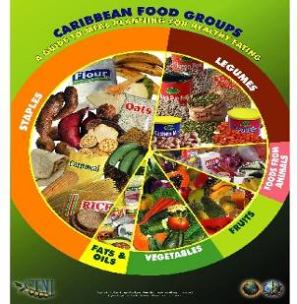

Figures 4b Caribbean food guides using revised food group distributions
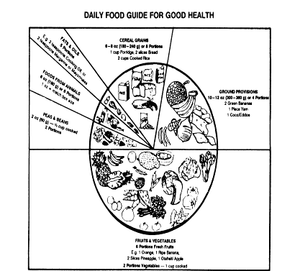

5.0 Trends in Food Availability and Dietary Consumption Patterns
Examination of these trends will illustrate the extent to which food choices reflect the dietary guidelines and the opportunities to be explored for value-added products.

5.1 Nutrient availability
Food consumption data are not available on a regular basis in the region so crude estimates have been based on food availability data. The excess availability of calories which characterised the period of high levels of PEM and under-nutrition left us a legacy of indiscriminate use of high energy diets. From the 1970s and onwards, the average availability of calories per person has increased rapidly and has always exceeded the recommended population goal of 2250 kilo calories in 12 Caribbean countries (Henry, 2004). The two major nutrients contributing to this are fat and sugar. Fat availability in the region exceeds 160% of average population requirement/goal and sugars are at 250% in excess. Protein availability has also been in excess although many still speak of the outdated concept of the ‘protein gap’ popular in the 1960-70s. These concepts are illustrated in Figures 5-8 below.
Figures 5-8 Trends in availability of energy, fat, sugar and protein by decade in the Caribbean (Reference: Henry 2004 and Ballayram 2007)

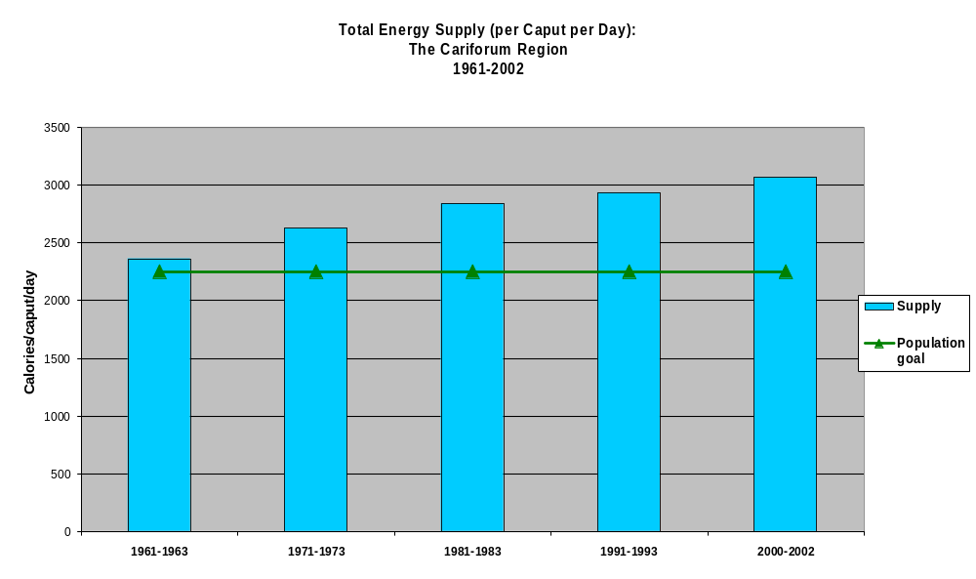
Figure 5 Per caput per day total energy supply in the Cariforum region 1961-2002

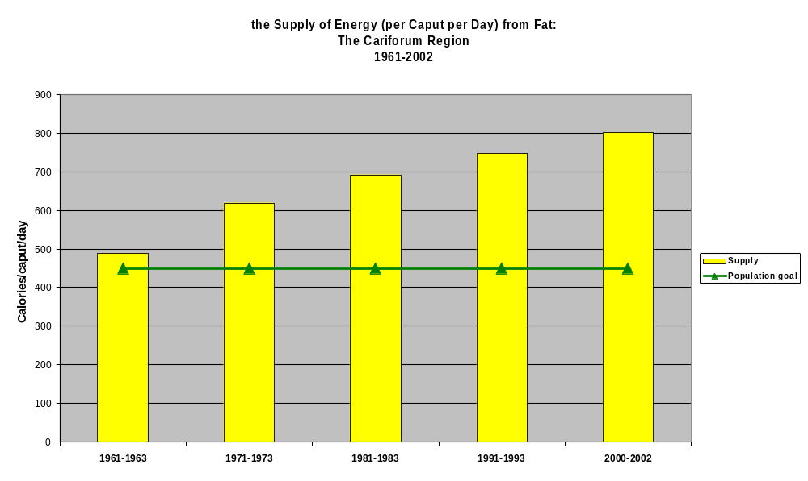
Figure 6 Per caput per day total energy supply from fat in the Cariforum region 1961- 2002

Figure 7 Per caput per day total energy supply from sweeteners in the Cariforum region 1961-2002
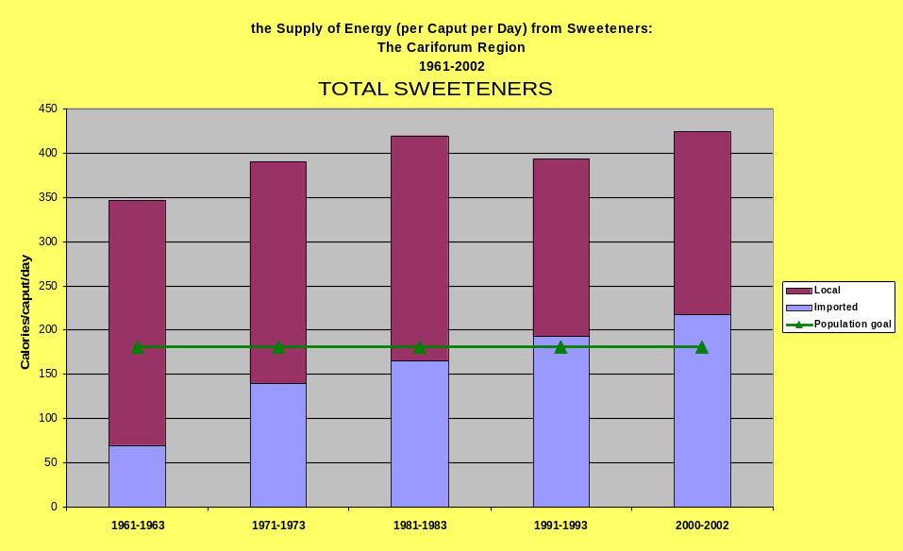

Figure 8 Per caput per day total energy supply from protein in the Cariforum region 1961-2002
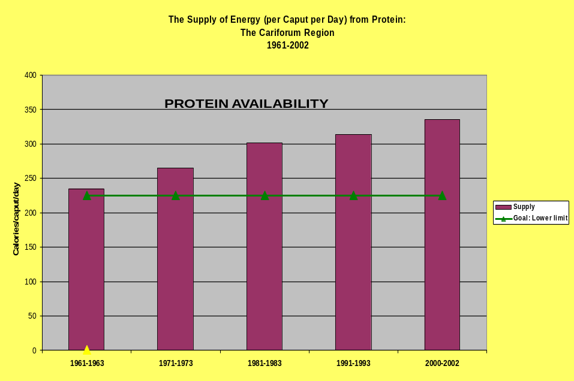

In practical terms, diets with excess sugars and fats contribute to high energy consumption. This has implications for the main value-added products in the region being syrups, drinks/juices, sweets, pastries, jam, jellies, snacks such as guava cheese, chocolates, dried fruit, chips and similar snacks. Processed products are likely to add to the nutritional challenges if industry does not consider health factors in manufacturing of value-added products as with fat and sugar modified choices.
However, as said before, it is the dietary use and consumption and not just food availability that determine nutrition status. Moreover, not everyone who eats a high fat or a high sugar diet will become obese (Blundell 2000). Minimal insight can be gleaned from Jamaican data on consumption patterns of adults aged 25-74 years (Jackson, 1999) which showed that obese women consumed less energy and fewer calories from carbohydrate food sources but a higher proportion of energy from fat sources when compared with non-obese women but neither energy, fats and carbohydrates predicted obesity in Jamaican females (Jackson, 1999). We do know however, that obesity is an outcome of energy intake consistently exceeding energy needs irrespective of the source of the calories.

5.2 Use of foods and food categories
More recent surveys have been trying to determine actual food consumption patterns and these have been reported as use of actual foods or food categories. This information may be more useful for the positioning of value-added products than nutrient consumption. One survey in 1999 in Dominica (Maglorie and Prevost, 2000) reported by the Dominica Food and Nutrition Council (DFNC) described consumption patterns as traditional especially in rural areas and amongst older residents at lower income levels. The practices were summarised as follows:
High intake of and status assigned to meats, especially pork products, chicken and fish
High salt intake levels, and consumption of salted, preserved and/or otherwise cured meats
High consumption of oils especially as in condiments at point of consumption
Relatively high levels of snacking between meals.
Jamaican studies reporting on consumption according to food categories are the Jamaica Healthy Lifestyle Survey (JHLSII) between 2007 and 2008 among individuals 15-74 years (Wilks et al, 2009), the Jamaica Youth Risk and Resiliency Behaviour Survey (JYRRBS) in 2006 for 15-19 year olds (Wilks et al, 2007). Smaller surveys have occurred especially among adolescents in select countries throughout the region from 1996 namely Antigua and Barbuda, St Kitts and Nevis and Montserrat (CFNI, 2010). These findings are summarised below.

5.2.1 Use of fats and oils

According to the JHLSII, only 10% of people report that they use no oil in cooking and 28% report not using any fat on their bread with men exceeding women 32% to 25% but 60% of people use soft margarine on bread. The majority (74%) of the population use vegetable oil in cooking with more women reporting use of vegetable oil than men while more men reported using coconut oil (Table 5). From personal experience, most persons are not aware of what constitutes vegetable oil but the perception is that it is healthy because it is from plant sources and no consideration is given to the quantity used.

Similar results were reported from the Jamaica Youth Risk and Resiliency Behaviour Survey (JYRRBS), where the most frequently used oil for cooking in the households of 15-19 year old (79.8%) was vegetable oil. The majority reported using fat on bread with most reporting soft margarine as the spread (69.7%). There were no sex differences in the use of oils and fats. Given the widespread use of soft fat on bread, a possible value-added opportunity could be an avocado spread, providing high fibre and antioxidant benefits not attained by other vegetable sourced margarines.

Table 5: Reported usage (%) of fats and oils by Jamaicans 15-74 years by sex, JHLSII 2008
Oil & Fat Usage | Males | Females | Total
Type of oil for cooking  None  Vegetable  Coconut  Butter/margarine  Oil from animals  Bulk | 10.0  70.4  13.9  7.9  0.2  6.1 | 8.2  76.8  11.1  8.2  0.8  6.4 | 9.1  73.7  12.5  8.0  0.5  6.2
Type of fat on bread  None  Soft margarine  Hard margarine  Butter  Other fats* | 31.9  55.6  4.9  4.3  0.9 | 24.6  64.0  5.8  5.2  1.1 | 28.2  60.4  5.3  4.7  1.0
*Bulk fat & condiments such as peanut butter and jellies

5.2.2. Animal flesh as a protein source
Chicken was the preferred protein source reported by the two Jamaican surveys respectively for JHLSII (90%) as well as Jamaican youth (91.9%). Fish/seafood was reportedly eaten by 61% and peas/beans 33% of the JHLSII sample while 50% of the youth survey respondents ate fish or seafood regularly and 25% of the 15-19 year olds consumed pork or beef regularly (Table 6). Chicken was also the overwhelming favourite in an Antiguan study (Figure 11).
Table 6 Protein choice and method of preparation (%) of Jamaicans 15-74 years by sex, JHLSII 2008

Protein Intake | Males | Females | Total
Type of protein rich foods  Poultry  Meat  Fish/Seafood  Milk Products  Soy products  Peas/Beans  Vegetables | 85.8  35.9  62.0  24.6  7.8  32.8  0.4 | 93.0  38.0  59.0  26.5  6.0  32.9  0.1 | 89.5  37.0  60.5  25.5  6.9  32.9  0.2
Preparation of protein source  Fry  Stew  Bake  Steam | 31.7  41.4  8.2  18.7 | 35.9  41.0  11.9  11.2 | 33.9  41.2  10.1  14.9
Addition of salt to food  Salt added at table | 5.8 | 6.3 | 6.1
Fat removal from protein source  Does not remove fat  Remove small portion of fat  Remove most visible fat  Remove all visible fat | 6.3  7.2  34.9  51.6 | 4.7  7  31.5  56.8 | 5.5  7.1  33.2  54.2

The youth resiliency survey reported frying in 55.% of households while the preferred cooking methods of the JHLSII sample were stewing (41%), frying (34%), whichboth require fat in cooking, while baking and steaming were reported by only 10% of the population. Most of the population (87.4%) reported that they removed most or all the visible fat from their protein source and this did not differ by sex while 6% of the population reported that they added salt at the dining table (Table 6).
Although the data indicates high use of fish it does not reveal the specific form although fresh fish is implied. Jamaicans use much salted fish as cod, herring and mackerel – as the fish of choice. Figures are not known, but general knowledge suggests that this is all imported. Is there an opportunity here for processors of local fish and fish products?

5.2.3. Other ources of protein
The JHLSII reported milk/milk products usage among 26% of respondents and among 40% of respondents in the JYRRBS survey. This compares with surveys in Montserrat with 13-15 year olds where 39.4% consumed milk and milk products daily and 55% on some days. In a similar sample in St. Kitts and Nevis, milk was the food with the highest daily consumption (36%). The term milk assumes cow’s milk but a wide variety of plant sourced ‘milks’ are now available and popular ones include soy, almond and rice. Surveys do not usually specify the types of milk or milk products and this information could guide manufacturers as to where the demand really lies so as to facilitate the production of local value-added products to displace the imported ones..
Legumes are the most readily available protein alternative to animal products. Among the Antiguan youth, 39.7% reported having these 1-2 times per week, while another 23.3% reported having legumes 3-4 days per week. This compared to the youth in Montserrat aged 12-17 years where 41.2% had legumes at least once in the past week and in St Kitts and Nevis where peas and beans were consumed by 54% of 13-15 year olds weekly. About 40% of the Jamaican youth reported consumption of peas and beans weekly. Again, can local production meet this demand and frozen dried peas be offered as an alternative to canned peas and beans to reduce salt intake?

5.2.4 Food sources of complex carbohydrate, vegetables and fruits
In excess of 60% of individuals in the JHLSII reported that they consumed 6-12 servings (3-6 times/day) of staple foods per day and a higher proportion of rural males and females compared to urban counterparts consuming the larger quantities of staples and legumes. Vegetables were however less popular. Only 19.6% of students in the twin islands of Antigua and Barbuda reported having vegetables daily or on most days of the week and almost half of students (45.1%) had vegetables only 1 to 2 days per week. Students in St. Kitts and Nevis (27%) reported consuming vegetables on a daily basis in the month prior to the survey and 32.1% of Montserrat students consumed vegetables daily. The JHLSII survey reported that the vast majority (99%) of Jamaicans currently consumed below two servings of vegetables (Figure 9) and the Jamaican youth survey found that less than one-fifth of youth consumed vegetables at or above the same recommended levels with no sex difference.

Figure 9 Vegetable consumption of Jamaicans 15-74 years, JHLSII 2008

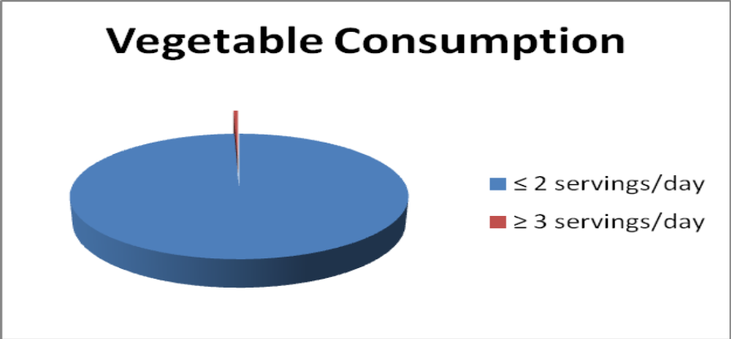

In Montserrat, fruit consumption was not very common, with 18.5% reporting that they consumed fruit daily and a similar proportion in St Kitts and Nevis (16%). Likewise in Antigua, only 23.1% of students had fruits on a daily basis. 10% of students had no fruits in the previous 30 days, and most students reported only having fruits 1-2 times per week. Over one third of the sample however had fruit juices and drinks daily. The consumption pattern for fruits was similar to vegetables for the JHLSII survey with less than 2% meeting the recommended daily intake (Figure 10), while optimal fruit intake was achieved by 38.1% and 44.2% of females and males respectively in the Youth Risk survey.

Figure 10 Fruit consumption of Jamaicans 15-74 years, JHLSII 2008
- < 1 serving/day
- ≥ 2 serving/day
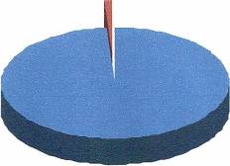

Further the Youth Risk survey found that compared to youth who failed to meet the recommended levels of vegetable consumption, optimal vegetable consumption was associated with lower prevalence of overweight in males (7.2 % vs. 11.9%) and obesity in females (4.7 % vs. 8.0%) but these differences were not statistically significant. More males who report not meeting recommended fruit intake were obese (5.1% vs. 2.7% p = 0.09) compared with those who had optimal consumption.

The specific types of staple foods, vegetables and fruits that are mostly consumed would be of value to agriculturists and marketers in determining need for value-added foods. Some information is provided from focus group discussions with students in Antigua (Benjamin et al, 2004) and Grenada (Samuda et al 2004). Both countries reported similar responses and Antigua is presented below. The most frequently mentioned staple foods were rice, pasta and bread (eaten on a daily basis) but yams and sweet potatoes were primarily mentioned by rural participants. Legumes were mainly used in combination dishes, such as soup and rice and peas. Imported fruits were more commonly consumed than local fruits, of which the ones mentioned were pineapples, mango and watermelon. Carrot was the favourite vegetable or salads (cucumbers, lettuce) with salad dressing. Reasons for liking were taste, smell, appearance and method of preparation.
Figure 11 Preferred types of foods across the food groups in Antigua

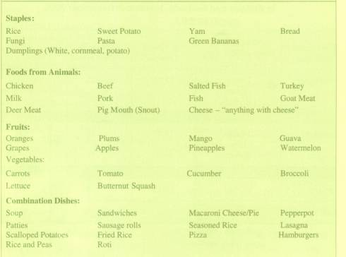
Source: Cajanus 2004, Vol 37, No. 2 p 86

The perishable nature of local fruits would be a factor in giving preference to imported fruits that are hardier. Is there a market opportunity for dried fruits that could replace raisins, cherries, dates and similar - even for baking purposes? Certainly, local fruits have been used to produce snack foods such as guava cheese and tamarind balls. How do these compare with imported favourites and what features can be highlighted? From Table 7, we note that sweets from local fruits contribute fibre to the diet, have no fat and are a source of iron with some calcium. Weight for weight, they provide less calories than imported milk chocolate.

Table 7 Comparing nutrition facts on snacks
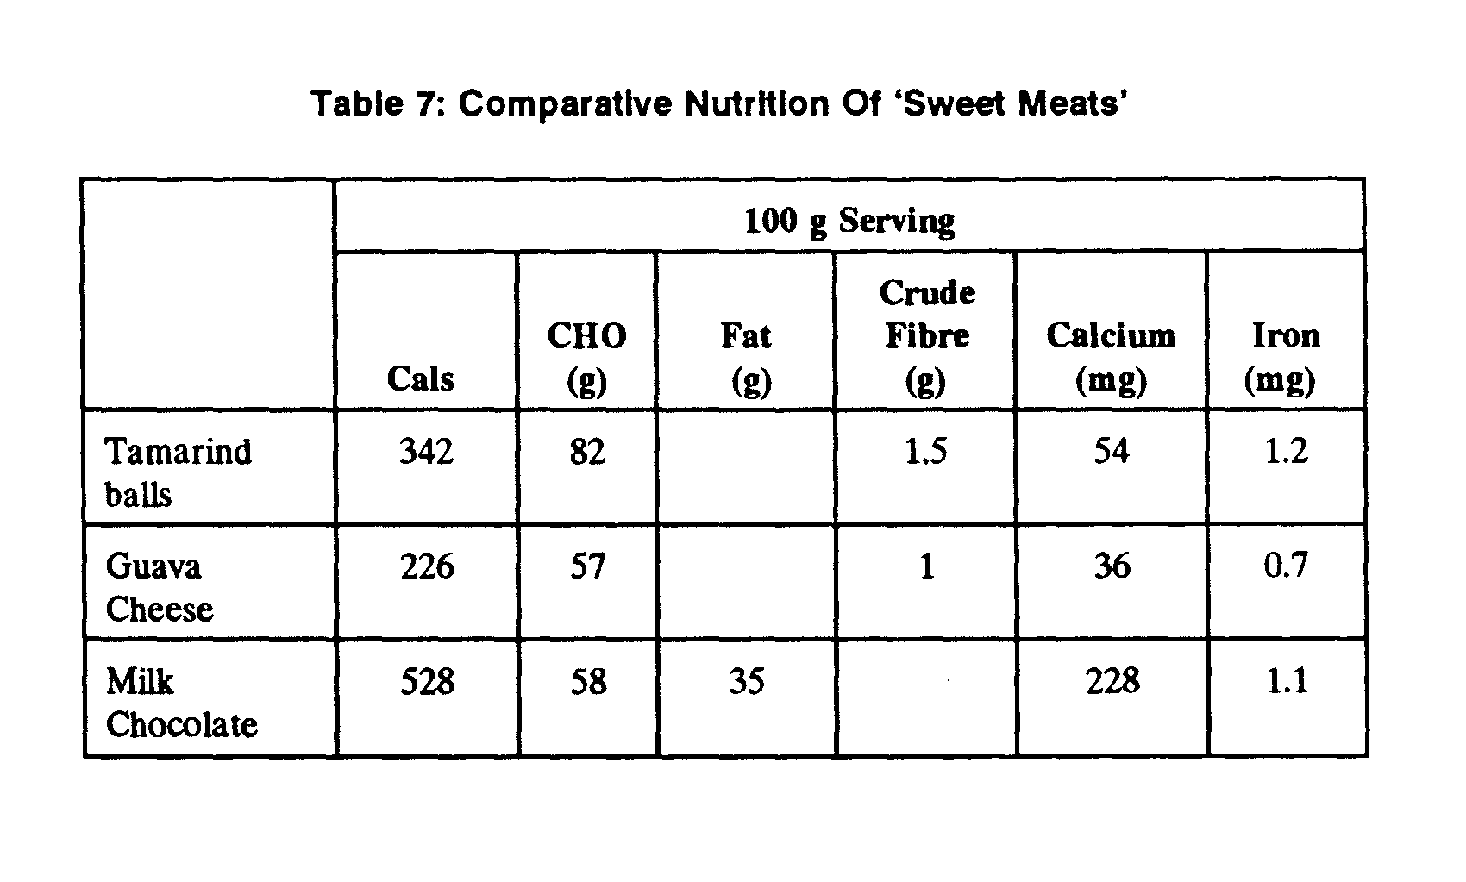
Source: Nutrition and Diet Services

    - Food sources of sugars, pastries and fast foods
The significance of this category of foods is that they are a source of ‘hidden’ fat and sugar and may not even have been included in Sinha’s and Ballayram’s computations of calories from fat and sugar. Yet they contribute a sizable portion to the population’s intake as will be seen from survey data presented below available from the select countries, notably Antigua and Barbuda, St. Kitts and Nevis and Montserrat (CFNI, 2010). These surveys were primarily done with adolescents in secondary schools, aged 13-19 years old except for the JHLSII survey (Wilks et al, 2009).
The following data are reported by countries:
Antigua and Barbuda
- Soft drinks were most commonly consumed, 1-2 days per week by 35.8% of the students, but at least a quarter of students (25.4%) had soft drinks daily, and another 12.7% had these 5 – 6 days per week.
- 18.4% reported having coffee or tea (which can inhibit iron absorption) daily but 35.8% reported not having these in the previous 30 days.
- Snack items such as pastries, candy, corn curls or fries were taken at least once daily by one third (37.7%) of students

St Kitts and Nevis
- Fatty snacks and fizzy drinks were consumed daily by 20% of the children while 70% consumed these less frequently.
- A little over 50% of children consumed coffee or tea

Montserrat
- One in four students reported that they drank soft drinks daily and 61% reported having these items some days.
- The majority had eaten high sugar snacks (90.9%) and high fat snacks (86.9%) daily, with a slightly higher proportion having fatty snacks (22.8%) compared to sugar snacks (17.5%). Significantly more females reported consuming snack items than males.
- Half of the students indicated that they drank coffee or tea with 18.3% stating that it was on a daily basis.

Jamaica HLSII survey (Wilks et al, 2009)
- Three quarters or more of Jamaicans aged 15-74 consumed one or more bottle/glass of sweetened beverage per day with more rural than urban dwellers consuming these amounts.
- A higher proportion of rural males compared to urban males (13.2% vs. 9%) and urban women compared to rural women (15.2% vs. 13.1%) consumed pastry one or more times per day.
- Frequent fast-food consumption (> 2 times /week) was higher among urban residents compared to rural dwellers (14.1% vs. 7.4%). However, more than 80% of individuals reported consuming fast-food less than once per week or none at all.

Jamaica Youth Resiliency Survey (Wilks et al, 2007)
- Excessive/frequent sweetened beverage consumption was reported by more than 90% of males and females.
- Frequent or excessive consumption of pastries was reported by 39.5% of youth with a significantly larger proportion of males (45.5% vs. 33.5% for females; p<0.002)
- Fast-food consumption was reported as 15.2%, with females reporting a higher frequency than males (17.2% vs. 13%; p<0.05).

Interestingly, this survey reported that there were no significant associations of pastry consumption with overweight measured by body mass index (BMI). Fast-food and sweetened drink consumption appeared not to be associated with BMI in all but one category where adolescent males who reported consuming fast-food or sweetened drink “often or excessive” had a lower prevalence of obesity than those whose consumption was seldom (2.2% vs. 4.4%; 3.4% vs. 9.1% respectively).

5.3 Meal patterns and food choices for meals

Probably a large market segment for local added value foods would be school children since our regional governments have invested in school feeding programmes. The options appear to be freshly cooked food at meal sites except for the Jamaican ‘nutribun’ programme offering a solid sweet pastry (bulla, bun, rock cake) and a drink. How can products be positioned for the various meals? Certainly many factors could be exploited for convenience and value-added products, especially considering the reasons given by school children for missing meals described below.

5.3.1. Breakfast

Antigua
- Just under half of students (45.7%) had consumed breakfast daily and only 4.7% reported not having breakfast in the past 30 days.
- The main reasons for not eating breakfast were not having enough time to eat (64.9%) and not being able to eat early (20.3%).

Montserrat
- Almost a quarter of students (24.2%) said they rarely or never had breakfast. 55.2% ate breakfast daily or on most days.
- The two main reasons for not eating breakfast was not having enough time to eat (65.9%) and not being able to eat early in the morning (24.8%).

St Kitts and Nevis
- Just above half (56%) students had breakfast daily
- 23% of students in St. Kitts and 18% from Nevis reported having no time for breakfast. Other reasons were; not liking what was available, inability to eat early, and others.
- Not having enough money or food was the reason given by only 3% of students for not having breakfast

Jamaica – study at 16 rural primary schools in 1995 (Powell, 2001).
- Most of the children reported eating breakfast at home. 67% had a sandwich, porridge or cooked meal, 27% had bread or crackers, and 6% had nothing to eat.
- Similarly 66% had a milk-based drink such as cocoa, 29% had herbal tea with sugar but no milk and 5% did not have anything to drink.

5.3.2 Lunch

Antigua
- 59.6% of students had eaten lunch daily and only 1.5% reported not having lunch in the past 30 days.
- 47% of students reported not having lunch because they were not hungry, 27.1% said they did not like what was available and 10.6% reported not having enough money.
- Most students bought lunch from vendors (35.5%) while 34.7% brought lunch from their home. 17.4% purchased lunch from the school canteen while 5.2% purchased lunch from shops or snackettes and 7% from other sources

Montserrat
- Lunch was more commonly consumed than breakfast among students. 91.3% said they ate lunch either daily or on most days.
- 29.8% of students said they did not eat lunch because they did not like what was available, 21.3% did not have enough money to purchase and 48.9% gave another reason.
- 38.1% of students obtained lunch from the school vendor, 34.8% from home, 22.7% had school lunch, and 4.8% had lunch from another place.

St Kitts and Nevis
- 73% of children were having lunch daily. Not having enough money or food was the reason given by only 2% of students for not having lunch.
- Not liking what was available was the reason given by 10% of students for not eating lunch. More children from Nevis (17%) than St. Kitts (7%) gave this reason.
- 52% of children took their lunches from home, 29% from a shop or snackette, 9% from the school canteen, and 4% from school vendors.

Jamaica – study at 16 rural primary schools in 1995 (Powell, 2001).
- At lunch time vendors (47%) was the most common source for items eaten at lunch, 31% of lunch items were obtained from the canteen
- Snacks and sweets were the most common type of lunch followed by Jamaican patties and sandwiches
- 10% had Nutribun and milk/drink for lunch, while 10% had a cooked meal
- Few children brought lunch from home, while 18% went home for lunch
- 7% had nothing to eat and 6% had a drink only
- The children obtained between 17-20% of their energy requirements and about one-third of their protein requirements at lunchtime. On average lunch should provide 15% of their daily requirements for iron.

A small survey conducted among 32 secondary school students in Jamaica by their teachers (who were nutrition students at the University of Technology (Utech) for a semester course), revealed the preferred choices for protein source and starch sources for lunch, as well as the preferred preparation methods and the amounts they wished to be served. It is noted that traditional foods of soup and liver are not desired for lunch at school. The majority selected fried chicken to be served with rice and peas indicated in Table 9 below. Note also that the traditional provisions were not selected as lunch choices and neither was bread - assumed to be used for sandwiches.

Table 8 Students’ preferred protein sources for lunch

Protein source for lunch | Selection as first choice (N=32) | Preferred preparation method (N=32) | Amount preferred to be served
- Chicken | 18 (56%) | Fried – 9  Curried – 3  Stewed – 1 | 2 pieces  5 pieces  8 pieces
- Pork | 7 | Baked – 3  Barbeque – 1  Stewed – 2  Jerked – 1 | 6 pieces  ½ pound
- Fish | 5 | Fried – 0  Steamed – 3  Grilled – 1  Stewed – 1 | 1 large  1 medium
- Oxtail | 2 | Stewed – 2
- Stewed peas | 1 | Stewed – 1
- Fast Foods | 3 | KFC – 1  Patties – 2 | 2 pieces  2 patties
- Soup – one pot | 0 | 0 | 0
- Liver | 0 | 0 | 0
Source: Utech Year 2 Nutrition Class 2012, Faculty of Education and Liberal Studies

Table 9 Students’ preferred starch sources for lunch

Starch source | First choice selection (N=32) | Preparation preferred | Serving size
- Rice and peas | 19 (59%) | Steamed - 19 | 1 cup  2 cups  4 cups
- Rice | 6 | Pumpkin rice steamed – 3  Plain rice - 3 | 3 cups  1 cup  1 ½ cups
- Bammy | 4 | Fried | 2 pieces  4 pieces
- Yam | 1 | Boiled | 0
- Green bananas | 0 | 0 | 0
- Other provisions | 0 | 0 | 0
- Bread | 0 | 0 | 0
Source: Utech Year 2 Nutrition Class 2012, Faculty of Education and Liberal Studies

5.3.3 Break

This is a most important eating period for many school children in Jamaica and a variety of snacks are eaten.

Jamaica – study at 16 rural primary schools in 1995. – (Powell, 2001)
- Sweets, syrup drinks, and snacks such as Cheese trix, crackers, popcorn and biscuits were the most commonly consumed items at mid morning break
- 26% of the children did not have anything to eat or drink
- 73% of items consumed at break were bought from vendors, 9% from home, 8% from the school canteen

The University of Technology (Utech) study above revealed preferred snack choices as follows:

Table 10 Students preferred snack choices

 | Examples of preferred snack choices | No. of students selecting choices (N=32) | Percentage %
a. | Potato, Banana, Lays*, Plantain, Cheese Trix | 9 | 28.13
b. | Sugar Bun, Donut, Cup cakes, Cakes | 6 | 18.75
c. | KFC, Chicken and Chips, Patty and Coco bread | 5 | 15.63
d. | Mango, Orange, Pineapple, Banana, Melon, grapes | 5 | 15.63
e. | Coconut water, Orange juice | 2 | 6.25
f. | Tea, Peanut butter, snackables | 3 | 9.38
g. | Chocolate, Bun-bun | 2 | 6.25
* Brand name for imported potato chips
Source: Utech Year 2 Nutrition Class 2012, Faculty of Education and Liberal Studies

Snack and drink choices for Antiguan students are shown in Figures 12 and 13 below. As with the quantitative surveys, sodas and fruit ‘juices’ were widely drunk.

Figure 12: Snack choices for Antiguan students

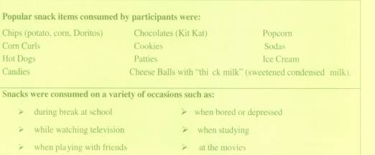
Source: Cajanus 2004, Vol 37, No. 2 p 87

Figure 13: Drink choices for Antiguan students

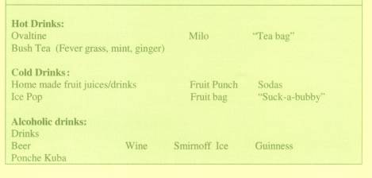
Source: Cajanus 2004, Vol 37, No. 2 p 88

6.0. Eating Influences
Although the factors already considered may have scientific credence, these are generally at the lower end of priorities when making dietary choices. The typical consumer rarely considers nutrient need or food labelling information when making food choices. Higher level influences are food culture and habits such as how and where persons eat, eating habits such as when and how much is normally eaten. When assessing diets, most critical is to determine why persons eat the way they do. The hierarchy is depicted as follows:

Figure 14 Assessing characteristics of a diet

Dietary patterns – WHY?
Eating habits – WHEN & HOW MUCH?
Food culture and habits - HOW & WHERE?
Food choice – WHAT?
Nutrient needs – WHO?

Source: Nutrition and Diet Services

6.1 Why people eat the way they do
Food choice among the adolescent study groups in four countries outlined above indicated that social and lifestyle changes seem the most influential. The St. Kitts study stated, for example, that food choice did not indicate that they were made based on nutrition knowledge, but rather on availability and what the parents provided. Choices were said to be also linked to convenience.

Generally, the following summary of reasons for making specific food choices would apply:
- Social and lifestyle changes leading to high fat diets
- No time to eat
- Not hungry at typical times to eat
- Eating outside the home – school, work, vendors
- Female-headed households
- Females working outside the home
- Sedentary lifestyle – favours snacking in front of TV and using computer/studying
- Socioeconomic influences – no money or too much money
- Personal preferences – taste (salt, fat, sugar)
- Cultural influences – food perceptions e.g. status foods (snacks)
- Psychological factors leading to habitual behaviours learnt from a lifetime of conditioning
- Knowledge of food value and nutrition needs
- Choices in the market place – What industry makes available.

6.1.1 Social and lifestyle changes

Where and how people eat

Most people in the formal workforce in Jamaica depend on the food provided at work for breakfast and lunch. The caterers are the ones who determine how people eat. The food selected, how cooked and served depend on the menus offered. It is almost impossible to introduce portion control at the workplace since meals are seen as an employee benefit and, as such, the tendency is to eat as much as possible to avoid having to cook at home. This is especially so when management policy dictates that food cannot be taken home or sometimes not even out of the work area as with food manufacturers. Likewise, children are becoming more dependent on school meals – breakfast and lunch.

Figure 15 Tuckshop offerings at Junior High School

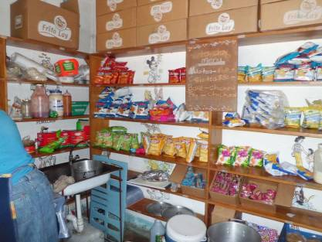
Source: Nutrition and Diet Services

There is widespread concern about meals being eaten in fast food or quick service restaurants but there is little available data to shed some light on the frequency of eating in these places. One study in Jamaica (Magnus 1994) looked at frequency of patronising of fast food chain restaurants. Only 20% of the respondents aged 15-45 years (both urban and rural) had visited such eating establishments once in the three months prior to the interview. The frequencies were listed as follows:

Table 11 Frequency of visits to fast food restaurants

Frequency over previous three months | Percentage
Once  2-5 times  6-9 times  10-13 times  14-16 times  17-20 times  More than 20 times  None | 20.2  29.2  12.2  6.8  3.8  1.7  6.3  19.8

Source: Cajanus, 1994: 27 (2) 80

The trend is towards more eating out and it can be assumed from the proliferation of fast food outlets in the island, that these places are far more patronised today than in the past. Fast foods however, are not the sole culprit. Much of the frying of foods takes place right in the home. Typical home-fried chicken may be just as fatty and salty than that purchased from the fast food outlet as seen from the following values for chicken.
Table 12 Comparing calories, fat and sodium of ‘fast food’ with home-cooked fried chicken
Food item  Chicken leg – 1 drumstick | Calories | Fat (gm) | % Fat calories | Sodium (mg)
Fast food outlet I (2.9 oz) | 147 | 9 | 55 | 286
Fast food outlet II (2 oz) | 173 | 11 | 57 | 346
Home fried chicken (2 oz) | 176 | 12 | 61 | 333
Fast food outlet III  Chicken tenders (6 pieces) | 204 | 10 | 44 | 636
Source: Nutrition and Diet Services

When and how much is eaten?

Meal frequency and scheduling is often not a personal choice but depends on lunchtime at work or work start time. Certainly there is an opportunity here for food processors to target people working long hours and those on shift schedules. Parents get home late at night and dinner/supper is sometimes eaten as late as 10 p.m. It is small wonder that so many children give as a reason for not eating breakfast - ‘not hungry in the morning’, another opportunity for healthy value-added food products. Otherwise, children will be forced to select the typical snack options.

Figure 16 Children at Primary School – 7.30 a.m. purchasing ‘breakfast’ from vendor


Source: Nutrition and Diet Services

Typical eating times and meals are outdated and instead, snacking has become the norm. As young as in Basic school, lunch kits are packed with snacks rather than cooked foods. Fresh fruits and vegetables are not seen because of packing challenges and this affects how much snacks are eaten since most of the day is spent at school or work.

Figure 17 Child’s lunch kit contents – Basic School

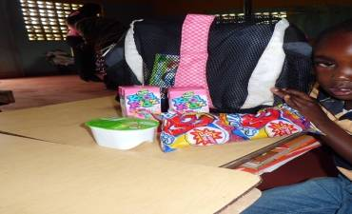

In the Youth Resiliency Survey, approximately 23% of 15-19 year olds (20% males and 25% females) interviewed had gone hungry in a usual week because of lack of food in the home and in approximately 8% of those reporting hunger these episodes occurred most of the time. Two-thirds of Jamaican youth in this age group had been hungry sometimes.

6.1.2 Socio-economic factors

Often it is what is available and accessible (affordable) that determines a person’s food choices.
The most frequent argument against local foods is that they are too expensive. A common example is the comparison of purchasing an American apple versus a luxury type mango like the East Indian variety. It can be argued that actual cost does not reflect quality and that persons will pay for quality once they can afford it. This means of course that the diets of the poor will continually be inferior to those more socially advantaged hence the perception that the ‘status’ foods are more desirable. The poor in most Caribbean countries include the primary producers (small farmers) and they often cannot consume the food they produce because it is not economical. It is a known fact, that they and other poor select the cheaper imported foods that are rich in fats, salt, sugars and refined carbohydrate (Braithwaite and Noble, 2001). Coupled with the fact that Caribbean people have always been attuned to imported foods, this puts local products to a disadvantage. Increasing production is expected to lower prices of locally produced goods (supply exceeding demand) and consequently making products more affordable, but this has been a continuing challenge.
From a nutrition perspective, it is often the cheaper foods that have the nutritional advantage like callaloo, dried skim milk. A concept applied in nutrition is the cost nutrient value of foods. This can be expressed in more than one way but the most common is the amount of calories and protein (or other nutrient in question) that a single dollar will purchase given the market price of the food. Over the years, the same foods generally give ‘the best food value for money’ profiles and unfortunately, most of these are imported, such as dried skim milk among the protein sources choices (Table 13). Among the staple foods, the cereal grains (mostly imported) are always the most economic buy nutritionally compared to local provisions in terms of calories and protein (Table 14). Some imported food items, however, like luxury cereals such as cornflakes and bran flakes are not economical and this is where local manufacturers could probably achieve the competitive edge.
Table 13 Comparative food value for money of foods from animals

Best buy foods from animals | Cost – dollars  $ | Calories per dollar spent | Protein (g) per dollar spent
Whole dried milk  Imported beef liver  Chicken (whole)  Fish, fresh | 6.68/kg (3.03/lb)  5.25/kg (2.38.lb)  7.70/kg (3.50/lb)  11.00/kg (4.99.lb) | 757  255  150  56 | 39  38  16  8
Source: Nutrition and Diet Services

Table 14 Comparative food value for money of cereals and provisions

Best buy staple foods | Cost – dollars  $ | Calories per dollar spent | Protein (g) per dollar spent
Wheat flour (counter) | 1.30/kg (0.59/lb) | 2839 | 82
Cornmeal | 1.74/kg (0.79/lb) | 2092 | 45
Green banana | 0.77/kg (0.35/lb) | 913 | 12
Cornflakes | 11.92 /kg (5.42/lb) | 323 | 7
Source: Nutrition and Diet Services

6.1.3 Personal factors

While cheaply produced food may be an incentive to purchase local foods, repeat purchases have to do with personal choices such as taste, packaging, appearance perception of status and similar factors. Marketing research suggests that consumers mostly care about taste, cost, convenience, health and then variety (Drewnowski, 2002). Taste is the main reported influence on food selection. Innovative products already appearing on the shelves, such as dried green bananas and packaged breadfruit, have quickly disappeared because the taste did not meet up to expectations.

Our taste preferences have evolved based on the interaction of biological determinants and environmental influences and the two most prominent taste biases are sweet tastes and fatty textures. Another powerful influence on food choice is experience which is a factor of cultural and psychological conditioning (Rozin, 2002). It is argued that the French are thinner than Americans because their portion sizes (even in restaurants) are smaller in size than American portioning where the modern trend is for ‘super-sizing’. Despite the efforts of nutrition education to promote ‘healthy eating’, marketers are faced with the challenge in Caribbean society that personal preferences based on taste, cultural and psychological preferences are just the opposite of what is promoted as healthy.
A sample of Jamaican students was asked to rate their criteria for selecting snacks and the following were the results. As is seen in Table 15, after price and taste, nutrients were considered important but not so calories. This is probably a factor that could be exploited as a value-added attribute for local producers.
Table 15: Student criteria for selecting snacks

Categories | No. of students selecting categories (N=32) | Percentage
- Price | 22 | 68.75
- Taste | 21 | 65.63
- Nutrients | 9 | 28.13
- Packaging | 8 | 25
- Calories | 3 | 9.38
- Texture | 2 | 6.25
Source: Utech Year 2 Nutrition Class 2012, Faculty of Education and Liberal Studies

7.0 Food and Nutrition Security Policies
The Caribbean region in post independence is unfortunately afflicted with malnutrition in another form – obesity and chronic non-communicable diseases. Food security issues are not only related to under-nutrition but also to these conditions which threaten to destroy the gains made in health, productivity and national development of Caribbean people over the past half century. The cost of treating obesity-related diabetes was studied in five Caribbean countries (Bahamas, Barbados, Guyana, Jamaica and Trinidad and Tobago) by Barcelo in 2003 and reported (Henry, 2004) as over US$200 million in direct cost and over US$800 million in indirect cost. The cost of all obesity-related diseases in general would therefore be enormous.
Obesity and its related diseases are not solely products of poor dietary quality and sedentary lifestyles. Henry (2004) suggests that the environment in which we live facilitates weight gain and obesity and strategies should focus on curbing the environment. These conditions are strongly influenced by trade and environmental policies, globalisation, and declining agricultural outputs. This alarming trend will continue unless efforts are made at the national rather than individual level to arrest the tsunami of obesity and its related ailments and nutritional concerns and to integrate these nutritional concerns into our national developmental plans and food security policies.
Eating local has been promoted for improved health and nutrition as well as improved economy but in reality is this really achievable or will it achieve food security? Henry suggests three levels of policies (Henry, 2004). Among these are the following with my comments relative to value-added products on the local market:
- Establish regulations requiring food service establishments to provide information about calories and fat content on menus or menu boards;
Comment: This would of course affect food in any form whether fresh or processed and may reflect more the preparation methods rather than actual foods.
- Provide incentives (subsidies) for low-calorie nutritious foods (grains and other cereals) and disincentives (taxes) on high-calorie and fatty foods (milk, meat, soft drinks) whether produced locally or imported.
Comment: As seen from food choice discussion above, calories is low on the list of criteria for adolescent snack selection. High on the list is price and taste. If competition from imported goods is given equal access to our markets as local products, there is the likelihood that our local manufacturers could not compete on price.
- Discontinue the excessive use of sugar- and fat-containing foods offered at school cafeterias, lunch programmes or school vendors.
Comment: As discussed, many students cannot afford to purchase the quantum of food needed to become obese from eating at school and the data do not support that there is a relationship between high sugar and high fat intake with obesity (BMI). It is personal and cultural preferences that dictate portion sizes and this cannot be legislated. Also the evidence shows that frquently, the home cooking and eating practices are at fault and not the products themselves. Such changes may indeed result in children receiving a more balanced intake of nutrients if more nutrient dense foods are offered from vendors but this by itself will not guarantee reduction in the obesity epidemic.

8. Conclusion and Key Recommendations
The givens are that there is a reduction in PEM but the challenges of malnutrition are still increasing and these range from under-nutrition to over-nutrition in specific forms. The aetiology and consequently the solutions are very complex. It is agreed that we need to support our local agriculture and that value-added processing enterprises will be needed to aid in the process of national development. It is also critical, as has happened through this workshop, that nutrition considerations be included in discussions on food security, agricultural and agro-industry development as well as overall socio-economic development.
Certainly there are many information gaps and more research is needed before concrete recommendations can be made to create a path for adding value to local foods for Food and Nutrition Security. Some key points are as follows:
- More concrete data on how Caribbean people make food/dietary choices and the factors that motivate them to change consumption patterns are needed. Research on the nutritional composition of local foods is also necessary.
- Strategies require all sectors working together cooperatively so each will understand the many perspectives of the multiple challenges rather than creating new problems as old problems are fixed.
- This collaborative conference is only the beginning and it will be a long road ahead with many pot holes. Positions should be created for Nutrition Specialists/Nutritionists in key ministries starting with agriculture and trade/marketing.
- Other countries have succeeded in adding value to local foods and improving the food and nutrition security situation and perhaps models they used could be studied and workable solutions adapted to our local situations. Most notable is the Fome Zero programme in Brazil.
- Change will come about when people demand change. The population should therefore be empowered through renewed efforts at nutrition education and social marketing to reach a broad cross section of the population. Without this, food and nutrition security will elude us and the Caribbean agriculture and food sectors will remain uncompetitive.

References
Ballayram. (2007). The Importance of Nutrition in the Right to Food Covenant - Presentation by Food Economist, Caribbean Food & Nutrition Institute/Pan American Health Organization
at World Food Day, October 16, 2007, Knutsford Court Hotel, Kingston, Jamaica.

Benjamin, C., Jackson, V., Isaac, E., Scotland, J., Samuel-Christian, V., Gordor, E., James, J., Barnes, C. and Samuda, P. (2004). Food Consumption in Antigua and Barbuda: Qualitative Analysis of Dietary Patterns in Adolescents. Cajanus: the Caribbean Food and Nutrition Institute quarterly, 37(2):82-100.

Blundell, J.E. (2000). What Foods do People Habitually Eat? Cajanus: the Caribbean Food and Nutrition Institute quarterly, 33(1):23-29. Reprinted from Am. J. Clin. Nutri. 71:3-5.
Braithwaite, C.W.D. and Noble, B. (2001). Are Local foods Too Expensive for a Healthy Diet? Cajanus: the Caribbean Food and Nutrition Institute quarterly, 34(2):97-112.
Brown, L.J., Beardslee, W.H. and Prothrow-Stith, D. (2008). Impact of School Breakfast on Children’s Health and Learning – An Analysis of the Scientific Research, Commissioned by the Sodexo Foundation. [online] www:SodexoFoundation.org.

CFNI. (2010). Nutrition in Adolescents in the Caribbean - Cajanus: the Caribbean Food and Nutrition Institute quarterly, 43(3):99-154

Drewnowski, A. (2002). Taste, Genetics and Food Choices in Food Selection – From Genes to Culture. In: Anderson, H., Blundell, H. and Chiva, M (eds.). Danone Institute, France.

Gordon, G., Johnson, P., Morris, A. and Henry, F. (2002). Iron and Vitamin A Status in Five Caribbean Countries in Micronutrient Deficiencies in the Caribbean. Cajanus: the Caribbean Food and Nutrition Institute quarterly, 35(1):4-49.

Henry, F. (2011). Presentation for Consumer International - Monitoring Food Marketing to Children at Jamaican High School in Kingston, Jamaica.

Henry, F.. (2006). Opportunities to Tackle Chronic Diseases in the Caribbean. Cajanus: the Caribbean Food and Nutrition Institute quarterly, 39(4):175-197.

Henry, F. (2004). The Obesity Epidemic – A Major Threat to Caribbean Development: The Case for Public Policies. Cajanus: the Caribbean Food and Nutrition Institute quarterly, 37(1):3-21.

Henry, F. (2004). The Public Policy Approach to Combat Obesity. Cajanus: the Caribbean Food and Nutrition Institute quarterly, 37(1):22-33.

Henry, F.. (2004). Food Consumption Information - Critical to Health Planning and Development. Cajanus: the Caribbean Food and Nutrition Institute quarterly, 37(2):55-56.

Henry, F. (2001). Obesity – Related Mortality, Morbidity and Behaviour in the Caribbean Cajanus: the Caribbean Food and Nutrition Institute quarterly, 34(2):62-76.

Isaacs Greene, P. (2001). Can Food Offered by Quick Service Restaurants be Healthier yet Profitable? Cajanus: the Caribbean Food and Nutrition Institute quarterly, 34(2):77-79.

Jackson, M. (2001). Risk Factors for Obesity in Caribbean Women and Children. Cajanus: the Caribbean Food and Nutrition Institute quarterly, 34(2):88-96.
Maglorie, W. and Prevost, J. (2000) Studying Food Consumption Patterns in Dominica. Cajanus: the Caribbean Food and Nutrition Institute quarterly, 33(1):5-10.
Magnus, M. (1994). Jamaican Fast Food Consumption Patterns. Cajanus: the Caribbean Food and Nutrition Institute quarterly, 27(2):80-95.
Parsons (2001). Adult Obesity and Growth in Childhood. Cajanus: the Caribbean Food and Nutrition Institute quarterly, 34(3):159-161. Reprinted with permission from BMJ International, 2001, 323:1320-1321, December 8.
Powell, C. (2001). Food Consumption Patterns of Children in Rural Jamaican Primary Schools. In: Report of the Proceedings of Technical Working Groups Meeting on Food Choice and Eating Behaviour: Relationship to the Development of Obesity, Ministry of Health.
Rozin, P. (2002). Human Food Intake and Choice: Biological, Psychological and Cultural Perspectives in Food Selection – From Genes to Culture. In:Anderson, H., Blundell, J. and Matty, C (eds.). Danone Institute, France.
Samuda, P. (2007). Background to the Development of FBDG in the Caribbean. Cajanus: the Caribbean Food and Nutrition Institute quarterly, 40(4):194204.
Samuda, P., Findlay, B., Wilson, A. and Purcell, N. (2004) Food Consumption in Grenada: Qualitative Analysis of Dietary Patterns in Adolescents. Cajanus: the Caribbean Food and Nutrition Institute quarterly, 37(2):101-114.

Sinha, D.P. (1995). Food, Nutrition and Health in the Caribbean ….A Time for Re-examination. Caribbean Food and Nutrition Institute. Sections 1 and 2.
Sinha, D.P. (1988). Children of the Caribbean 1945-1984: Progress in Child Survival, its Determinants and Implications. Pan American Health Organization.

Thompson, P. (June 2003, June 2005) Final Report on Health and Nutrition Intervention – New Horizons for Primary Schools Project - Contract No. 532-C-00-98-12345-00 United States Agency for International Development.

Thompson, P. (2012). In Integrated food and nutrition sciences – Book 1 (in process of publication).
Chapter 1 Nutrition Basics
Chapter 3 Nutrition Standards and Dietary Tools
Chapter 8 The Benefits of foods – Plant Based Food Groups
Chapter 9 The Benefits of foods – Animal Foods, Fats and Others
Chapter 12 Dietary patterns and Cultural Habits
Chapter 14 Nutritional Status and Assessment

Thompson, P. (2004). Fast Food Mania. Published in the Jamaica Daily Gleaner April 30, 2004.
University of Technology. (2012) - Students in Technical Education course - Nutrition in World Perspective, Year 2 – Project submitted in partial fulfilment of the requirements for the Bachelor of Education in Family and Consumer Studies: Food & Health in Faculty of Education and Liberal Studies.
Wilks, R., Younger, N., Tulloch-Reid, M., McFarlane, S. and Francis, D. (2009). Jamaica Health and Lifestyle Survey 2007–8, Technical Report. Epidemiology Research Unit, Tropical Medicine Research Institute, University of the West Indies, Mona, Jamaica. Reprinted from [online] http://mona.uwi.edu/reports/heatlh/JHLSII_final_May09.pdf.

Wilks, R., Younger, N., McFarlane, S., Francis, D. and Van Den Broeck, J. (2007). Physical Activity, Dietary Practices and Self Perception in Jamaica: Youth Risk and Resiliency Behaviour Survey 2006 - Community Based Survey on Risk and Resiliency Behaviours of 15-19 year olds.

Xuereb, G., Johnson, P., Morris, A., Bocage, C., Trotter, P. and Henry, F. (2001). Obesity in Caribbean Children: Its Magnitude and Current Control Efforts. Cajanus: the Caribbean Food and Nutrition Institute quarterly, 34(3):120 – 126.

Xuereb, G. and Ragoobirsingh, D. (2006). The Prevalence of Diabetes in the Caribbean. Cajanus: the Caribbean Food and Nutrition Institute quarterly, 39(3):119–124.

Published by CTA, http://knowledge.cta.int/
Edited by J.A. Francis, CTA

Citation: CTA 2013. http://knowledge.cta.int/, “author” accessed on “date.”

Copyright CTA 2013. Articles and material published on Knowledge for Development http://knowledge.cta.int/ can be freely reproduced, provided that authors and source are fully acknowledged.

