Adding value to Jamaican herbs and spices: reducing postharvest losses and expanding market opportunities
Dr Audia Barnett, Scientific Research Council, Jamaica
Introduction
Jamaica has a rich history of utilizing herbs and spices in the preservation of food, a tradition of both its native Tainos and its African slaves. In addition to improving the shelf-life of meat, fruits and vegetables, the unique flavours and aromas that resulted endeared the island to the people from cooler climates. Spices were also very valuable items that for millennia formed an integral part of the trade regime. Early Europeans were enamoured with the pungent and fragrant flavours. Christopher Columbus, for example, is credited with having taken back allspice (pimento) to Europe from the Caribbean. The spice trade was lucrative, resulting in aromatics such as nutmeg, ginger and black pepper being plied between the West Indies and Europe by early traders and settlers. While most important spices originated in Asia and Africa, the Caribbean islands have been said to have more potent flavours than their counterparts.
Spices can be defined as pungent or aromatic seasonings obtained from the bark, buds, fruit, roots, seeds or stems of various plants and trees. Popular spices include allspice, cardamom, clove, ginger, nutmeg, mace, black pepper, paprika, saffron and turmeric. Herbs are small, non-woody, seed-bearing plants in which all the aerial parts die at the end of each growing season. They are also valued for their medicinal, savoury or aromatic properties. Herbs are usually grown in temperate climates while spices generally originate in the tropics. Aromatic plants are part of a more general class of plants which produce a variety of secondary substances. These odorous, volatile chemical compounds occur as essential oils, gum exudates, balsam and oleoresin in one or more parts. Nutraceuticals are considered as foods or food products, extracts that provide health and medical benefits, including the prevention and treatment of disease.
World demand
The USA remains the world's largest spice importer, meeting 60% of its needs from some fifty countries. The recent trend towards wellness and healthy eating habits has seen the promotion of the use of spices to compensate for less salt and lower fat levels in foods. This, with the explosion and fusion of ethnic cuisine from Asia and Latin America and the Caribbean, has served to not only sustain the herbs and spice trade but incrementally increase it.
According to FAOSTAT data (2007), the EU market for spices and herbs increased from 221,000 tonnes in 2000 to 310,000 tonnes in 2004, representing an average annual increase of 9%. The leading consuming EU member country is Hungary, accounting for about one fifth of total EU spice consumption, followed by Germany, the Netherlands and the UK. The leading spices consumed are pepper, paprika and allspice (pimento), while leading herbs include thyme and oregano.
Spices and herbs are sold to three main end-users: the industrial, retail and catering sectors (CBI, 2007). In addition to the culinary market sector, there is also the medicinal (including supplements) and the essential oils market (Export Centre and Business Information Point and the Jamaica Exporters Association, 2008). In almost all EU countries, the industrial sector consumes the largest proportion, accounting for 55-60% of the total usage of spices and herbs. The retail sector consumes 35-40% and the catering sector 10-15%. Market demand is highest in the EU for chillis, paprika and allspice (Fig. 1).
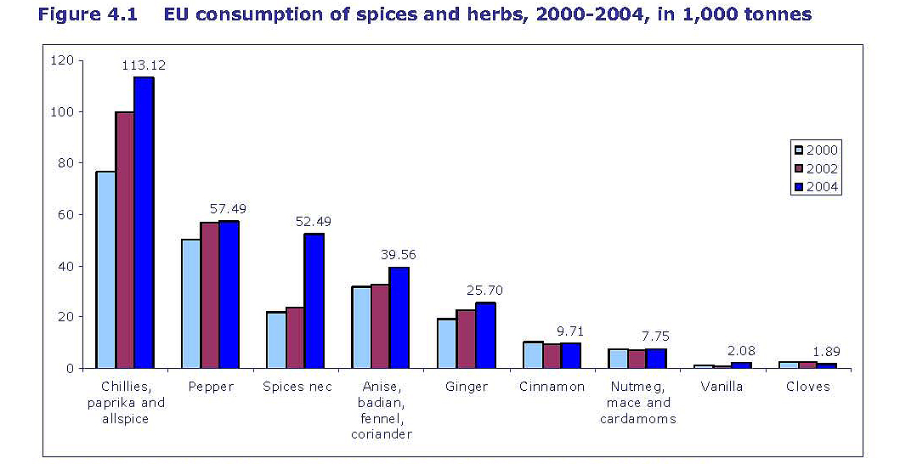
Fig. 1. EU consumption of spices and herbs, 2000-2004, in 1000 tonnes (FAOSTAT, 2007),
Developing countries supplied more than 60% of total 2005 EU imports (in value) of products such as cinnamon, cloves, ginger, saffron and turmeric directly to the EU member countries, indicating a vibrant niche (FAOSTAT, 2007).
Nutraceuticals and functional foods emerged almost two decades ago as lucrative options for tapping the healthy lifestyle niche market. Steady growth in the global market for nutraceuticals which includes foods, beverages and supplements worth US$117.3 billion in 2007 is expected to increase to $176.7 billion in 2013 (BCC Research, 2008). The markets for nutraceuticals and dried spices and herbs present excellent opportunities for product diversification in ACP countries such as Jamaica.
Local production & trade
There has been a steady decline in the contribution of agriculture to GDP in Jamaica, from 9.2% in 1996 to 4.8% in 2008. There was also a 30% decline in production and a 17% decline in productivity from 1996 to 2007, respectively. Factors such as poor quality planting material and soil conditions, inappropriate postharvest techniques and increasing incidence of hurricanes and floods contributed to the ailing agricultural performance. Consequently, Jamaica has become a net importer of food, placing a strain on the limited foreign exchange resources and increasing the country’s vulnerability to external shocks.
It was against this background that the National Agriculture Sector Plan (Vision 2030-National Development Plan), National Food Security Strategy and Jamaica’s Agriculture Sub-Sector Strategy for Roots & Tubers, Fruits & Vegetables, Herbs & Spices were elaborated to improve productivity and effect import substitution where possible. Data revealed a 318% increase in ginger imports between 1997 and 2001 (Data Bank and Evaluation Division, MOA http://www.moa.gov.jm/about/departments/databank.php). Priority crops identified for Jamaica have therefore included inter alia, sorrel, ginger and hot peppers. Initiatives by the Ginger Farmers Association, SRC, Greenhouse Growers’ Association, Bodles Research Station, Ministry of Agriculture, Export Division and the University of the West Indies are in train to re-establish Jamaican ginger in the international marketplace.
In addressing the myriad of factors contributing to the decline in ginger and other priority crops, value-addition was recognized as a key strategy to improve the contribution of agriculture to GDP (Table 1). Interventions have already resulted in favourable outcomes, with steady increases in domestic crop production volumes and a decline in food imported in 2009 and 2008 over 2007. Ginger production and sorrel production for example increased by 23% and 26%, respectively, in 2009 over 2008 levels.
Table 1. National Agriculture Sector Plan – First Goal
Goal 1: Efficient competitive diversified value-added agricultural production
- Increased productivity and cost efficiency of agricultural enterprises
- Diversified range of agricultural production including higher value-added production
- Strengthened application of technology, innovation, research and development to agricultural production
- Development of key sub-sectors
The Sub-Sector Strategy (2010) for Roots & Tubers, Fruits & Vegetables, Herbs & Spices also is predicated on exploiting the value-added lines of primary products. “Pepper Mash”, “Concentrates and Pulps” and “Convenience Foods” inclusive of roots and tubers and ginger, both fresh and processed were all identified to have varying levels of market appeal.
Current market opportunities exist in the area of bulk spices, herbs and essential oils for repacking or as ingredients for the food service industry (International Trade Center, 2006). Cosmetics also appear as the most promising sector for development of organic essential oils and extracts. For such products, the microbiological quality and chemical profiles are important indicators for gaining and retaining market share.
Going up the value chain
The Scientific Research Council (SRC) has a mandate for using science, technology and innovation for economic growth and development. The main area of focus has been the agro-industrial sector, wherein research and development activities resulted in value-addition on primary agricultural commodities. Since herbs and spices have been identified as a key sub-sector for development, the SRC has undertaken activities to complement the production base. As such, exotic products ranging from chutneys and sauces to beverages have been developed for the local and export markets. This has served to stimulate backward linkages, resulting in increased supply of raw material. Export data (Table 2) illustrate the instability in the supply of fresh and processed spices for export.
Table 2. Jamaica’s domestic exports of selected spices and herbs
Spice/herb 2005 2006 2007 2008 2009
(000 kg)
Pimento (allspice) 418.5 264.5 452.7 502 526.5
Ginger¹ 30.4 27.7 32.8 16.2 12.1
Sorrel² 52.7 50.8 20 43.7 37.3
Sarsaparilla 1.3 0.65 2.8 0.96 3.5
Pepper – fresh 134 180 124 98.5 173.8
Pepper - processed³ 567.3 674.1 537.3 816 n.a.
Source: Data Bank and Evaluation Division, Ministry of Agriculture & Fisheries, Jamaica http://www.moa.gov.jm/about/departments/databank.php
¹Dry Ginger; ² Fresh sorrel exports, representing 3–8% total production; ³ Includes crushed, ground pepper and sauces; n.a. - not available
Quality parameters
The quality-control regime of herbs and spices is quite rigid, beginning with the planting material. Tissue culture, while useful in the micropropagation of other crops, has been found to be difficult for aromatic plants, the exception to date being ginger. In addition to good agricultural practices (GAP), care in harvesting and in post-harvest handling was critical in maintaining desirable flavour profiles in the products. The SRC conducted trials to determine the best time for harvesting ginger for its nutraceutical properties as opposed to its flavour notes.
The most common method used to process the herbs and spices is drying. As the products are often exposed to the elements, strict quality assurance measures are taken in order to prevent microbiological contamination with Escherichia coli and Salmonella. Herbs which are produced for the growing herbal tea market are subject to additional post-harvest steps such as washing. Processing also involves drying, milling and screening. A regimen consistent with the hazard analysis critical control point (HACCP) system is applied for assuring food safety.

Processing Methods

Drying & Milling
Concentrating (Sauces, Drinks)
Steam Distillation (Essential Oils)
Spice Blends (Jerk)

Expanding product range and marketability
Spices such as pimento are exported as whole dried grains and also utilized in the country’s now world-renowned “jerk seasoning” and sauces. These products are made as dry blends and wet blends. The wet blends are usually acidified and pasteurized for flavour and extending the shelf life. “Jerk” has now been mainstreamed in culinary preparations and is to be found on menus worldwide. Recent changes in the US Food and Drug Administration (US FDA) regulations for acidified foods require additional testing of Jamaica’s jerk seasoning and sauces.
The blend of herbs and spices determines the organoleptic quality of the jerk seasoning. As hot pepper (capsicum) is integral to the jerk seasoning, blends range from mild to very spicy. The range of sauces marketed has increased from the table jerk sauce to include barbeque-jerk, honey-jerk as well as a range of fruit-based jerk sauces. Markets have also been developed for ingredients in jerk seasoning, such as pepper mash. Scotch Bonnet, a Jamaican hot pepper with a distinctive flavour profile and pungency, is used in the pepper mash. However, the West Indies Red has grown in popularity among farmers and processors because of its resilience in the field and also the attractive red colour conferred in the mash and sauces. This is an example of the work of the R&D community impacting on market diversification.
Extraction of essential oils
In optimizing the value of herbs, spices and aromatics, the extraction of their essential oils has been promoted. Steam distillation, a simple technology, has been employed to extract essential oil from pimento for decades. The production of essential oils from other aromatic plants is being explored as an income-generating activity to meet the attractive market demand in the EU and the USA.
Over the past decade, the local scientific fraternity has converged on opportunities inherent in the country’s genetic resources in an effort to capitalize on the world demand for nutraceuticals and functional foods. Lemongrass, also known as “fever grass” in Jamaica, owing to folklore regarding its healing properties, was one such plant, earmarked for capitalizing on its nutraceutical as well as essential oil value.
Agronomical studies conducted by CARDI and Bodles Research Station supported the notion that lemongrass was a relatively easy crop to cultivate, requiring minimal post-harvest treatment, and with a potential to provide attractive returns (Johnson and Simpson, 2009).
The postharvest treatment of the lemongrass is determined by its intended end-use. For example, if intended for the tea industry, careful harvesting and washing should ensure that contamination with food poisoning micro-organisms such as E. coli and Salmonella is minimized. Drying in a drying house is recommended to ensure that the grass is not exposed to birds, bats, etc. that can contaminate the grass with droppings after washing. The grass utilized for extraction of its essential oil should also be handled to avoid postharvest contamination, although this is a less rigorous process.

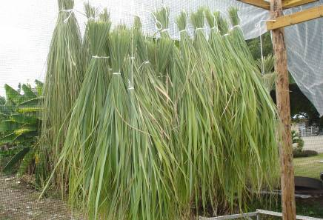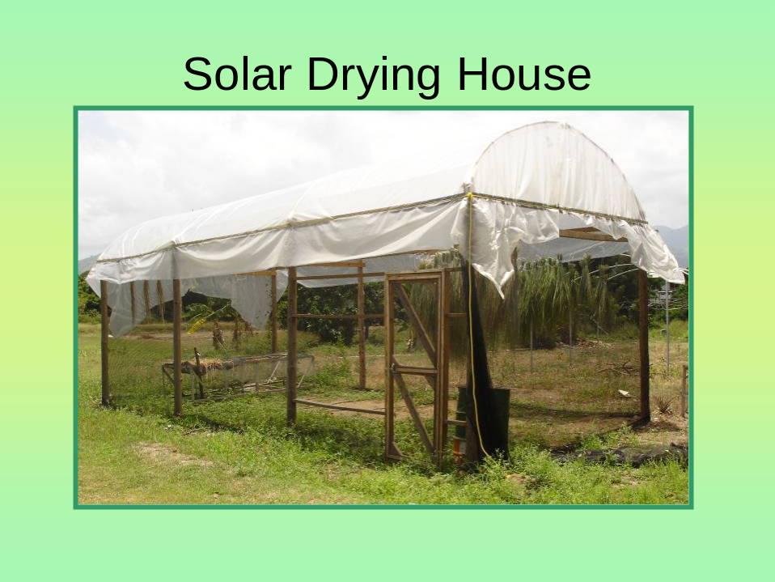
The SRC conducted chemical characterization studies as well as extraction by steam distillation and the spinning cone column technology. Results indicated that Jamaican lemongrass oil is rich in citral (geranial and neral) and geraniol: important components in aromatherapy, personal care and other wellness products (Table 3). Certificates of analysis have been developed for the budding industry as well as a suite of product formulations (Table 4) . Targeting the organic market has also been encouraged for advancing the value of products.
Table 3. Properties of lemongrass oil
Chemical components | %
Chemical components | C. flexuosus | C. citratus
- Citral | 20.93 | 66.81
- Geranial | 13.11 | 37.76
- Neral | 7.82 | 29.05
- Geraniol | 61.98 | 6.27
- Citronellal | 2.00 | 0.11
- Others | 15.09 | 26.81

In addition to the very appealing essential oil, value-added products were produced to include personal care products and beverages. These provide additional entry levels for entrepreneurs. According to Marketech, the marketing subsidiary of SRC, the lemongrass market is still at the introductory stage of the product life cycle, opening up opportunities for several players to get involved.

Table 4. Characteristics of lemongrass essential oil

Characteristics of lemongrass essential oil
Appearance | Clear mobile liquid
Odour - | Strong, lemon-like
Colour - | Pale yellow
Relative gravity - | 0.872 – 0.905
Refractive index | 1.483-1.489
Optical rotation - | -3◦-+1◦

Responding to challenges
Given the extremely competitive marketplace, developing small states such as Jamaica, having identified specific niche areas, need to ensure sustainability in supply and quality. There are several hurdles that remain to be addressed in order to ensure sustainability. These include addressing strain selection, soil productivity, effective plant protection and postharvest measures. Furthermore, recognizing the increasing onslaught of natural disasters resulting from climate change, protected agriculture is also being actively pursued.
The programme of Certification Marks embarked on by the Jamaican Agricultural Society and the Bureau of Standards, Jamaica, addresses the issue of consistency in quality, while the SRC’s Certificates of Analysis for herbs and spices provide a valuable aid for accessing and maintaining international market share.
The susceptibility of herbs and spices to microbial contamination makes the postharvest treatment an important step in managing the supply chain. With the promotion of the food safety regimen: HACCP, enterprises have become more aware of the importance of traceability and controlling the “hazards”. The delicate flavours that are important in herbs and spices are susceptible to loss and change if not properly handled. A fine balance is required to ensure safety and organoleptic quality of these products. Policy interventions may become necessary to investigate the use of irradiation in this regard.
International regulatory regime
The European Partnership Agreement between CARIFORUM and the European Union provides the framework for accommodating imports of spices, herbs and aromatics, among other commodities. HACCP certification is becoming a standard requirement for products but is expensive to implement.
Regulatory measures for nutraceuticals are pending in the USA and the EU, and as such, the thorough screening and evaluation of products being promoted as nutraceuticals are necessary prerequisites. Data are available from SRC and the University of the West Indies on selected plants to assist in responding to the regulatory requirements.
Conclusion
Adding value to herbs and spices extends the shelf-life and provides new market opportunities for Jamaica. However, enabling policies, adequate regulatory framework and supportive science, technology and innovative infrastructure can contribute to sustainability.

References
BCC Research. 2008. Nutraceuticals: Global Markets and Processing Technologies.
http://www.bccresearch.com/report/FOD013C.html
Borget, M. 1993. Spice Plants. CTA. Wageningen, Netherlands. 120 pp.
Buzzanell, P.J., Dull, R. and Gray, F. 1995. The Spice Market in the United States: Recent Developments and Prospects. US Agriculture Information Bulletin No. (AIB709) 60 pp. http://www.ers.usda.gov/Publications/AIB709/
CBI, 2007. The Spices and Herbs Market in the EU, 2007.
http://cbi.nl/marketinfo/cbi/docs/the_spices_and_herbs_market_in_the_eu
Data Bank and Evaluation Division, Ministry of Agriculture & Fisheries, Jamaica http://www.moa.gov.jm/about/departments/databank.php
Export Centre and Business Information Point and the Jamaica Exporters Association, 2008. Market Brief on Essential Oils.
http://ecbip.com/download_pdf.php?filename=documents/sections/document_Essential_Oils_110809172.pdf
Food and Agriculture Organization, 2007. FAOSTAT data - http://faostat.fao.org/default.aspx
International Trade Centre. 2006. Marketing Manual and Web Directory for Organic Spices, Culinary Herbs and Essential Oils by International Trade Centre.
http://www.intracen.org/organics/documents/Marketing_Manual_for_Organic_Spices_Culinary_Herbs_Essential_Oils.pdf
Johnson, A. and Simpson, L. 2009. Agronomy of Lemon Grass (Cymbopogon sp.) Caribbean Agricultural Research and Development Institute.

