Validating Traditional Medicines: Adding Value to Indigenous Resources

Ermias Dagne
African Laboratory for Natural Products (ALANP), Department of Chemistry, Addis Ababa University, PO Box 30270, Addis Ababa Ethiopia. E-mail: edagne@gmail.com

Introduction

Many unique plants, some of which are now used and known worldwide, originate from Ethiopia and its neighboring countries. The most famous among these is coffee (Coffea arabica), which is now so much part of modern living. If indigenous knowledge (IK) is examined using the powerful tool of science, we will be in a better position to validate IK and also derive from it innovative products. This concept is elaborated using six important natural products.

- Coffee

The energizing effect of the coffee bean is believed to have been discovered in Ethiopia many centuries ago. From Ethiopia, the beverage was introduced into the Arab world through Egypt and Yemen. Coffee is now a commodity of crucial economic importance to more than 60 developing countries. In recent years revenues from coffee exports and retail run into billions of dollars. At least 14 countries are dependent on coffee for 10% of their export earnings and three (Burundi, Ethiopia and Uganda) depend on coffee for more than 50% of their export earnings.

The wide popularity of some of the very well known modern soft drinks such as Coca Cola, Pepsi and Red Bull, depends to a considerable extent on caffeine, the most decisive additive in these drinks, which is obtained by extracting it from coffee beans.

Credit for the discovery of the preparation of a mild stimulant beverage from coffee goes to the indigenous knowledge of Africa. Thus coffee is an excellent example of an indigenous resource from which enormous value has been created benefiting in one way or another millions of people all over the world.

2. Khat: Coffee’s number one rival

Catha edulis Forsk (Celastraceae) is another example of a unique plant from Ethiopia and its neighboring countries. It is a shrub or tree, 1-25 m high, widely cultivated at altitudes ranging from 1100 to 2100 m in East Africa, from Ethiopia to Madagascar and beyond the Red Sea in Yemen and parts of Saudi Arabia. The custom of chewing fresh leaves of Khat is mainly because of its stimulating and euphoric effects. The first major breakthrough in research on this plant came about in the middle of the 1970’s when the simple compound cathinone [α-aminopropiophenone] (1) was established to be the most important active chemical constituent of the fresh plant (Szendrei, 1980). This compound eluded the attention of chemists of earlier times because they limited their research to dried material, in which the concentration of the active principle is too low for isolation or detection. This finding was consistent with the fact that Khat users prefer fresh material to the dried one.
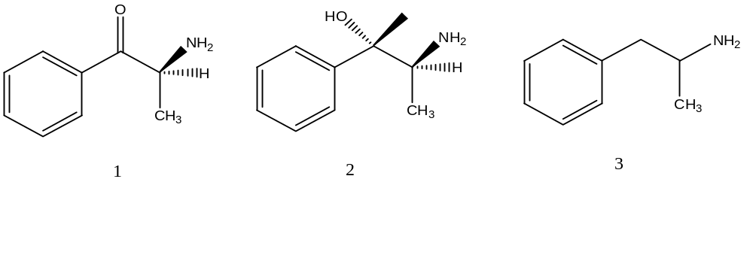
Cathinone (1) and Cathine (2) and the synthetic compound Amphetamine (3)
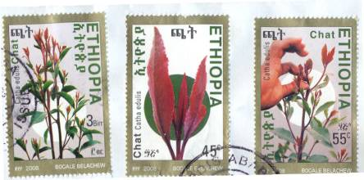
Khat is now openly used, traded, imported and exported in the countries of the region. Ethiopia is most likely the number one grower and exporter of this plant. The livelihood and daily income of millions of people is dependent on it, while nationally it is the second most important foreign exchange earner for the country after coffee. The Ethiopian Post-al Authority issued on September 9, 2008 three Khat stamps in order to herald open discussion and debate on the use and abuse of this plant. Although at the moment Khat is consumed only by chewing the tender twigs, the dried leaves could also find in the future use as green tea due to the presence of the mild stimulant cathine (Dagne, et al. 2010).

3. Civet: A unique natural product from an animal

An interesting example of a commercially significant natural product that is derived from an animal is civet (locally known as ‘Zibad’), which is secretion from the odoriferous glands of the civet cat (Civettictis civetta, locally ‘Tirin’)). Civet is one of the most expensive natural products known. It is used as fixative in the making of perfumes. Ethiopia is the world's most important supplier of civet since ancient times. Trade in civet was well established even before the time of Queen of Sheba. The main constituent of civet is a simple compound commonly known as civetone (9-cycloheptadecen-1-one). Also present are a wide range of saturated and unsaturated cyclic ketones and alcohols.

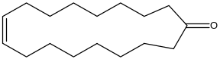

Structure of civetone

One of the most serious challenges in civet trade is monitoring the quality of civet. This is because civet may be adulterated with greasy materials such as butter or Vaseline. Existing quality control methods are roundabout, cumbersome and inconclusive. We have developed in our laboratory a quick proton NMR method that helps one establish the percentage of civetone present in civet.

Fig. 1 shows ¹H NMR spectrum of pure civetone in CDCl₃. 100 mg of civet was extracted with hexane to yield 80 mg of hexane soluble fraction. Fig 2 shows the partial ¹H NMR spectrum of 4 mg of this extract to which 1 mg of reference caffeine was added. The ratio of the olefinic proton of civetone that appears at 5.3 ppm (Signal A) with one of the methyl signals (B) of caffeine gives the molar proportion of civetone to the reference caffeine. When the concentration of the reference caffeine is known, it is possible to deduce the concentration of civetone in the civet, which in this experiment turned out to be 2%.


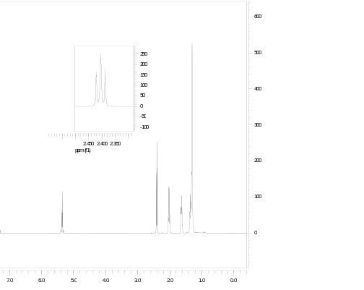
B
A
A

Fig. 1: 1H NMR spectrum of civetone Fig. 2 Civet sample with caffeine

4. Smoke brings bioactive substances to a desired site

‘Kebericho’ or Echinops kebericho (Asteraceae), a species known only in Ethiopia, is among the most important medicinal plants of the country. The roots are used to fumigate homes; also women smoke affected parts of their body to combat diseases. It is common knowledge that smokes of selected plants are used in traditional medicine of many African societies to prevent or cure diseases. It is therefore pertinent to ask whether the smoke of such plants indeed serves as a vehicle for bringing biologically active natural products to desired parts of the body or other desired targets such as holes and crevices when fumigating houses and other locations. Chemical studies on the roots of Kebericho by Abegaz et al. (1991) revealed the presence of two highly bioactive compounds known as dehydrocostus lactone (DHCL) and costunolide. Subsequently, we set out to determine if these compounds are present in the smoke. By condensing the smoke and analyzing it by TLC and spectroscopic methods we have established that the smoke contains significant amounts of the above two substances. This result validates the traditional method of resorting to smoke in order to bring out bioactive compounds from plant parts and deliver them to the site where they are required to elicit response. Frankincense and myrrh are among other examples of plants that yield medicinal and aromatic smoke.

5. Managing spasm with roots of a Taverniera abyssinica
Roots of a plant are wrapped into small bundles and sold at markets in Ethiopia. The common name of this plant drug is Dingetegna, indicating its use to treat sudden spasms in particular of the stomach. At the beginning it was not clear what the botanical identity of the source plant was. This required going backwards through the supply chain of the medicinal plant, which led to the identification of the plant as Taverniera abyssinica, an endemic plant of Ethiopia. We then embarked on a study to find out if the traditional use of the plant can be supported by scientific evidence.
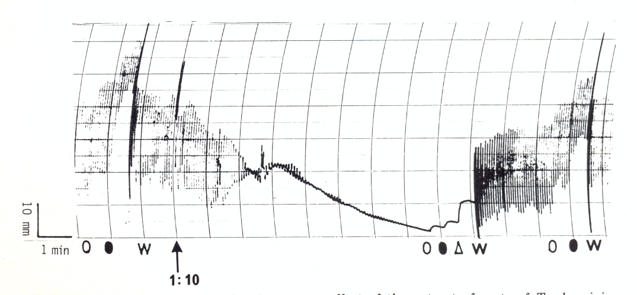
We showed (Noamesi et al., 1990) that a room temperature aqueous extract of the root antagonized the contractile responses of the guinea-pig ileum to acetyl choline (AcCh) and histamine. The extract also relaxed the smooth muscle of the rabbit duodenum by abolishing its pendular contractions. The mechanism of action is due to antagonism of the effects of acetylcholine and histamine on the tissue.
The above figure shows the time-course effect of the extract (1:10 dilution) on pendular contraction on isolated rabbit duodenum. (O) 5 ng and (O) 10 ng acetylcholine spasmogenic response. The Arrow indicates the time when the extract was injected. After a short while, the spontaneous contraction disappears. In the presence of the extract the tissue did not respond to addition of AcCh, and it is only restored after washing with water (W).

6. Is black cumin, panacea for all diseases?

According to traditional Islamic belief, ‘black seed’, Habesuda (Arabic), Tikur azmud (Amharic), is a panacea, a remedy for all ailments, but which cannot prevent ageing or death. The plant, known in botany as Nigella sativa L. (Ranunculaceae), is an erect, usually profusely branched herb growing up to 0.7 m tall. It is cultivated as a crop for its black seeds in Ethiopia, Kenya, Sudan, Afghanistan, central and southern Europe, India, Iran, Syria, Russia etc. The seeds can be physically pressed to give 36-38% Nigella sativa fixed oil (NSFO), which is rich in unsaturated fatty acids, while steam distillation gives 0.4% - 2.5% volatile oil (NSVO) (Ali and Blunden, 2003). The major compound present in NSVO is thymoquinone.

In folk medicine of many countries black cumin seeds and its expressed oils are used as medicines to treat various types of ailments. As a result extensive studies have been undertaken by research groups in different parts of the world to establish the scientific basis for these traditional experiences and observations. The seeds and expressed oil have been found to have very low degree of toxicity (Zaoui et al., 2002). Some biological studies on black cumin corroborated by scientific studies include: analgesic and anti-inflammatory (Hajhashemi et al., 2004), antifungal (Khan et al., 2003), antiasthmatic (Boskabady et al., 2010), improving allergic complaints (Klaus et al., 2003), anticonvulsant (Hosseinzadeh and Parvardeh, 2004), blood glucose lowering (El-Dakhakhny et al., 2002), and antioxidant (Mariod et al., 2009).

The above studies clearly indicate that there are sound scientific bases for many of the traditional claims of this wondrous plant. Many simple formulations based on NSPO and powdered seeds are now available on sale in many parts of the world including the Middle East, Africa and Europe. N. sativa can therefore be considered as an excellent example of an indigenous remedy from which added value has been created.

Conclusion

The above six examples clearly show the importance of following up leads from indigenous knowledge using systematic scientific investigation.

References

Abegaz, B.M., Tadesse, M., Majinda, R. Distrbution of Sesquiterpene Lactones and Polyacetylenic Thiophenes in Echinops. Biochemical Systematics and Ecology, 19, 323-328. 1991.

Ali, B.H., Blunden, G. Pharmacological and Toxicological Properties
Boskabady, M.H., Mohsenpoor, N., Takaloo, L. Antiasthmatic effectof Nigella sativa in airways of asthmatic patients. Phytomedicine, 17, 707–713 (2010).
Dagne, E., Adugna, Y., Kebede, E. Determination of Levels of Cathine in Khat (Catha edulis) Leaves and its Detection in Urine of Khat Chewers: A Preliminary Report. In Press (2010).
El-Dakhakhny M, Mady N, Lembert, N., Ammon, H.P.T. Hypoglycemic Effect of Nigella sativa Oil is Mediated by Extrapancreatic Actions. Planta Medica, 68, 465-466 (2002.
Hajhashemi, V., Ghannadi, A, Jafarabadi, H. Black Cumin Seed Essential Oil, as a Potent Analgesic and Antiinflammatory Drug, Phytotherapy Research, 18, 195–199 (2004).

Hosseinzadeh, H. and Parvardeh, S. Anticonvulsant effects of thymoquinone, the major constituent of Nigella sativa seeds, in mice. Phytomedicine, 11, 56–64 (2004).

Khan, M.A.U., Ashfaq, M.K., Zuberi, H. S., Mahmood, M. S., Gilani, A.H. The In Vivo Antifungal Activity of the Aqueous Extract from Nigella sativa Seeds. Phytotherapy Research\, 17, 183–186 (2003).

Mariod A. A., Ibrahim, R. M., Ismail, M., Ismail, N. Antioxidant activity and phenolic content of phenolic rich fractions obtained from black cumin (Nigella sativa) seedcake, Food Chemistry, 116, 306–312, (2009).

Noamesi, B.K., Bogale, M., Dagne, E. Smooth Muscle Spasmolytic Actions of the Aqueous Extract of the Roots of Taverniera abyssinica. Journal of Ethnopharmacology, 30, 107-113 (1990).
Szendrei, K. The Chemistry of Khat. Bulletin on Narcotics, 22, 5–35 (1980).

Zaoui, A., Cherrah, Y., Mahassini, N., Alaoui, K., Amarouch, H., and Hassar, M. Acute and chronic toxicity of Nigella sativa fixed oil, Phytomedicine, 9, 69–74, (2002).

