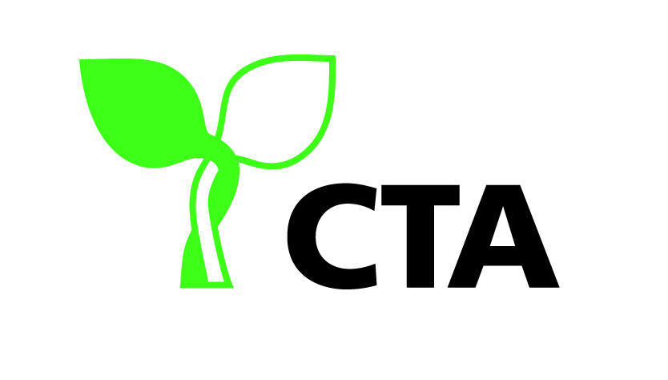
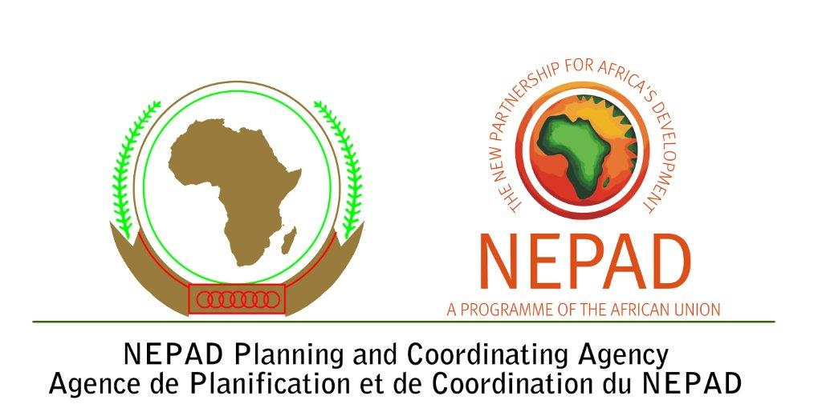

ADVISORY COMMITTEE COMMUNIQUÉ
on

“Science, Indigenous Knowledge and Innovation: Implications for ACP Agriculture”

Issued at the 9th Meeting of the Advisory Committee on
Science and Technology for ACP Agricultural & Rural Development
Johannesburg, South Africa, November 22-26, 2010

Background

The members of the Advisory Committee on Science and Technology for ACP Agricultural and Rural Development held their 9th meeting in South Africa from 22 – 26 November 2010. The theme of the meeting was, “Science, Indigenous Knowledge and Innovation: Implications for ACP Agriculture”. The objectives and expected outcomes are provided in Annex 1.

This year’s meeting built on the deliberations and outcomes of 2009 where-in the Advisory committee (AC) identified; the mega challenges, most important commodities for trade and consumption, major scientific disciplines and technologies (including bio and nano-technology, ICTs) that will shape the future of ACP agricultural science and innovation. The AC had also proposed future strategic options for intervention. Building ACP scientific and technological capacities was seen as essential and the AC recommended that consideration be given to incorporating indigenous knowledge (IK) and skills in the ACP science, technology and innovation (ST&I) agenda; for the development of new technologies and products, for responding to mega challenges in support of agricultural and rural development and for economic prosperity.

At its 9th meeting, the AC members reflected on: (i) the history of knowledge and the need to make science more inclusive; (ii) the convergence of the two knowledge domains, namely formal science and indigenous knowledge which is seen as the new frontier for science and innovation in agriculture; and (iii) best practices in the development of traditional medicine for policy learning and programme implementation to further the integration of IK with science. Presentations were made on a range of key issues which provided opportunity for further discussion during group work. Sessions on the integration of IK, science, biodiversity and sustainable development covered: (i) aquatic resources and traditional knowledge with women as the custodians; (ii) fisheries, featuring science, art and local knowledge with the engagement of youth; (iii) mainstreaming IK in education and research with a focus on neo-tropical animals (indigenous breeds) and adding value throughout the chain starting with the engagement of the IK holders to finished packaged products for sale; and (iv) plant biodiversity for food and the environment. Domestication of indigenous breeds requires years of investments in research as well as public and private investments in getting the product to market.

Presentations on traditional medicines provided lessons on: (i) application of advanced scientific tools and methods to validate the efficacy of active ingredients - although it was noted that some principles lose their efficacy when isolated; (ii) policy and governance structures for integrating the two knowledge systems including documentation, policy advocacy and protection of intellectual property rights (IPR); and (iii) requirements for building strategic partnerships with IK holders while at the same time acknowledging that there are some aspects of indigenous knowledge which cannot be validated by science and that this may not always be feasible or necessary.

The AC also visited Centres of Excellence in South Africa which are harnessing IK through the application of science and innovation and deriving benefits for scientists and their organizations, industry, IK holders and government. The field trip to the selected facilities provided an opportunity to observe firsthand the strides made by the Council for Scientific Research, the Phytomedicine Programme at the University of Pretoria and Biomox Pharmaceutical Company, in harnessing and commercializing indigenous knowledge through the application of science and the financial and social benefits derived from these investments. The field trip also reinforced the critical role that a strong partnership between government, private sector and institutions of higher learning can play in sustaining investments for fostering research, entrepreneurship and capacity/skills development which benefit researchers, IK holders, industry and government.

AC members acknowledged and recognized the value of indigenous knowledge as a richly diverse resource and upheld the principle that holders of this knowledge must be able to share in any benefits derived by adding value through scientific pursuits. The AC also reviewed, updated and approved its revised Terms of Reference during the 9th AC meeting (see Annex II), based on amendments proposed at the 8th meeting in Montpellier in 2009, and identified its priority areas for intra ACP and ACP/EU partnerships for 2011(see Annex III).

The AC noted, acknowledged and endorsed the following:
- The need for shared understanding on indigenous knowledge
Indigenous knowledge, also known as local/traditional knowledge, is a broad term that refers to several types of knowledge including: cultural practices, beliefs, taboos, technical skills and technology that enable communities/societies to overcome constraints, conserve biodiversity, and support sustainable livelihoods. It evolves through experience accumulated over years of use and learning and is passed on from one generation to the other through informal means e.g. tales, songs, dances, traditional ceremonies. It is not usually documented or published but preserved and valued by the people who use it. It is also location and culture specific and rooted in tradition.

- Ethical standards governing documentation of indigenous knowledge
There are ethical concerns on the documentation of indigenous knowledge. These are linked to the possible loss of control of the knowledge, need for cultural sensitivity, IPR and confidentiality, piracy and lack of clarity governing laws and regulations for sharing of benefits when indigenous knowledge is put in the public domain. The current structures for scientific publications, patents etc. do not presently accommodate indigenous knowledge.

The AC members reiterated the need to protect the interest of the individual IK holder(s) and communities and advocated for creative ways to address these concerns. The scientific community needs to recognize indigenous knowledge to be a knowledge domain in its own right and show sensitivity and consideration when working collaboratively with IK holders.

- Integration of Indigenous Knowledge into Research & Training
Integration of indigenous knowledge into the ACP research and training agenda has potential benefits for all stakeholders. Scientists need to give due recognition to the fact that indigenous knowledge existed before modern science and acknowledge IK systems in their own right. There is much to be done in the ACP region on capturing and validating indigenous knowledge for advancing science and agriculture. The AC noted the need for more inter-disciplinary and collaborative research and training to validate promising indigenous knowledge that can be up-scaled while following ethical principles.

- Reform of policies for making science more inclusive
The policy and legislative framework must be in place if the integration of indigenous and scientific knowledge is to serve as a platform for generating solutions to pressing challenges e.g. biodiversity loss, climate change, generating income and addressing food, nutrition, and energy insecurity. A value chain approach is proposed for commercialization of promising leads. Public and private incentives should be provided to ensure that indigenous knowledge holders share in the benefits.

The AC further noted the need to strengthen the voice of indigenous knowledge holders in policy debates and to provide institutional support to the process. There is also need to build institutional and legal frameworks that support the recognition and protection of indigenous knowledge at national and regional level and address all pertinent IPR issues.

- Advisory Committee’s Revised Terms of Reference and 2011 Work Programme
The amendments to the revised Terms of Reference and indicative work programme for 2011 were approved (see Annex 2). The AC proposed that its 10th meeting be held in the Caribbean and further proposed that climate change research, value chain and post harvest losses be included in its 2011 work progamme. The AC members also agreed on four major impact areas for its future activities namely: (i) mobilization of key actors to influence policy processes; (ii) increased collaboration and joint programme implementation to improve quality and relevance of S&T for ARD; (iii) increased investments for research, tertiary education, and extension; and (iv) increased participation of marginalized actors especially women and youth.

Conclusion and recommendations
In conclusion the AC learned valuable lessons for advancing the integration of IK in the science and innovation agenda in ACP countries. These included the need for: adequate funding for research and development; integration of IK holders in scientific studies from a very early stage; avoiding pitfalls by gaining buy-in from academic heads, policy makers and IK holders and; recognizing that the process of integration and knowledge transfer is difficult.

The AC recommended that:

- ACP countries should invest in IK as an integral part of their science and innovation agendas in the search for new technologies and other solutions to spur agricultural innovation, address multiple challenges of food, nutrition and energy insecurity, environmental sustainability, income generation and economic development. Empirical multi-disciplinary research should be promoted and higher education curricula should be reformed to include Inventories of IK in the first year and analytical work at postgraduate level.

2. Ethical standards must be developed and adhered to for the integration of indigenous knowledge into formal science.

- ACP countries should continue to lobby for increased funding for R&D. Partnerships with the private sector are crucial to increase funding for carrying out research to up-scale and commercialize promising indigenous knowledge.

- ACP countries should institute relevant policies and legislative frameworks which are consistent with international agreements to support harnessing of indigenous knowledge and to protect the rights of all stakeholders including the IK holder(s). Clear benefit sharing mechanisms should also be put in place to ensure that all stakeholders along the value chain benefit. There should be coherence between national, regional and international frameworks and support should be provided to strengthen the voice of IK holders in policy debates. Lessons can be learned from South Africa.

- ACP countries should focus on strengthening research, training and extension and mainstream indigenous knowledge into these programmes for sustainable development.

- CTA should take steps to: (i) involve IK holders in agricultural science technology and innovation platforms; (ii) support capacity building of research and higher education organizations on the legal issues governing IK; (iii) support a publication series of case studies on IK - in agricultural production systems, in agro-biodiversity conservation and in soil and land management practices, for example, to identify and analyze success factors and; (iv) convene an international symposium on IK systems in 2012.

Meeting Objectives:
The main objectives of the 9th AC meeting were as follows:
- To achieve shared understanding and consensus on the definition of indigenous/local/traditional knowledge and its relevance to transforming the formal science agenda and innovation systems for addressing the mega challenges facing ACP agricultural and rural development.

- To share knowledge, experiences and best practices and identify opportunities and constraints for systematically integrating indigenous knowledge in the ACP agricultural science, research, education and training agenda in support of agricultural innovation.

- To reflect on ethical issues concerning the documentation, publication and exploitation of indigenous knowledge for science, education, innovation and development.

- To identify and prioritize policies, strategies and programmes at organizational, national, regional and international levels for making science more inclusive and valorizing indigenous knowledge through its integration in science, research and tertiary education programmes for spurring ACP agricultural innovation and economic development.

- To reflect on proposals for the CTA ST&I strategies 2011 programme including the Advisory Committee, determine the future impact and propose methods for evaluation.
Expected Outcomes:

The expected outcomes were:

- Consensus reached among AC member on policies, strategies and options for making science more inclusive and integrating indigenous knowledge in the ACP science and innovation agenda.
- AC members committed to deepening and promoting linkages between traditional/indigenous and formal knowledge systems (science) and mobilizing resources for ACP agricultural science, research, education and training in collaboration with CTA and other partners to further advance the ACP science and innovation agenda for achieving economic and ecological sustainability

Terms of Reference of the Advisory Committee on
Science, Technology and Innovation for ACP Agricultural and Rural Development

Name and Goal
- The Advisory Committee on Science, Technology & Innovation for ACP Agricultural and Rural Development (herein after called the AC) has been established as a think tank to contribute to enhancing food security and rural prosperity and the sustainable development of ACP countries in general.

- The AC in the conduct of its work, may develop policy proposals / recommendations for consideration by stakeholders, national governments and regional organizations

Membership
The AC’s membership shall be comprised of key national, regional and supra-regional (S&T and policy) and stakeholder organizations of the six ACP regions, the EU and CTA. The organizations shall be represented by competent professionals who shall have a two-year term of office with a maximum of four (4) years.

Meetings
The AC shall meet annually or as deemed necessary.

Roles & Responsibilities
- The AC shall serve as a knowledge platform on Science, Technology and Innovation (ST&I), identify and deliberate on priority emerging issues and trends impacting on ACP agriculture (including fisheries and forestry).

- The AC shall propose ST&I policy options and interventions, facilitate inter and intra regional and ACP-EU cooperation and dialogue and encourage greater integration of ST&I in national, regional and international agendas in support of ACP agricultural and rural development.

- The AC shall provide timely alerts and information on key ST&I issues and contribute to developing policy guidelines / positions and strategies for; achieving sustainable development, the attainment of food security goals and enhanced agricultural performance and national, regional and international competitiveness. Policy briefs shall be prepared and finalized through a consultative process and published and disseminated to ACP and EU stakeholders, governments and international organizations.

- The AC shall identify suitable organizations and institutions for building knowledge platforms at the national and regional levels in support of ST&I policy formulation and strategic decision making for improving the performance of ACP agriculture.

- The AC shall provide guidance to inform the CTA ST&I work programme.

- The AC shall continually review its composition, internal and external communication mechanisms and performance and adjust where necessary.

It should be noted that the AC recognizes that policy formulation is a national responsibility and that policies give a country its competitive advantage. Hence, any policy proposals will be provided only as a guide to support more informed decision making.

Composition
- National organizations
  - Central Africa (3)
  - East Africa (3)
  - Southern Africa (3)
  - Western Africa (3)
  - Caribbean (2)
  - Pacific (2)
- Regional, Supra-regional ACP and EU organizations
  - Sub-regional R&D organizations, universities & networks – Africa (4)
  - Regional R&D and policy organizations, universities & networks (9)
  - Pan-African organizations (2)
  - ACP Youth representatives (3)
  - Young Professionals Platform for Agricultural Research for Development (1)
  - Gender specialist (1)
  - EU S&T organizations & networks (5)
Observers (international professional & R&D organizations, EC and ACP Secretariat)

Funding
Funding – Supported by CTA and co-financing by key strategic partners

Impact
- Impact 1 – ACP ST&I actors mobilized and influencing the ACP ST&I policy agenda and processes in support of agricultural and rural development (ARD).
- Impact 2 – ACP-EU ST&I collaboration strengthened and joint programmes implemented that improve the quality and relevance of ST&I for ARD.
- Impact 3 – Investments for agricultural research & development, tertiary education and extension increased.
- Impact 4 – Women, young professionals and other marginalized actors actively participating in ACP ST&I policy and programme processes from formulation to implementation and evaluation.

Activities
- Annual Meeting & e-consultations
- Policy Briefs
- Advocacy
- National and regional consultations/meetings/dialogues
- Capacity building

Approved by Members represented at 9th AC Meeting in South Africa in 2010

Central Africa
African Centre for Research on Bananas and Plantains, Cameroon
University of Kinshasa, DR Congo

East Africa
Afican Network for Agriculture, AgroForestry and Natural Resources Education, Kenya (regional)
Alliance for a Green Revolution in Africa, Kenya (regional)
Kenya Agricultural Research Institute, Kenya
Uganda Oilseed Producers & Processors Association (Ag. Bus), Uganda
University of Nairobi, Kenya

West Africa
Agricultural Research Council of Nigeria, Nigeria
CORAF/WECARD, Senegal (sub-regional)
Council for Scientific & Industrial Research, Ghana
University of Nigeria, Nsukka, Nigeria
Polytechnic University of Bobo Dioulasso, Burkina Faso

Southern Africa
Bunda College, Malawi
National Centre of Applied Research for Rural Development, Madagascar
National Unviersity of Science & Technology (NUST), Zimbabwe
NEPAD Planning & Coordinating Agency, South Africa (Pan-African)
University of Zambia

Caribbean Region
Bahamas Agricultural & Industrial Corporation (Agri business), Bahamas
Caribbean Agricultural Research & Development Institute (regional)
Caribbean Council for Science & Technology (regional)
CARICOM Secretariat, Guyana (regional)
Scientific Research Council, Jamaica
University of the West Indies, St Augustine Campus, Trinidad (regional)

Pacific Region
National Agricultural Research Institute, Papua New Guinea
University of the South Pacific, Fiji (regional)

Youth Representative
Young Professionals Platform for Agricultural Research for Development

EU
AGRINATURA, France
Catholic University Leuven, Belgium
CIRAD/AGREENIUM, France
University of Hohenheim, Germany
Wageningen UR, The Netherlands

Observers
ISHS / Globalhort

Apologies
Forum for Agricultural Research in Africa, Ghana (Pan-African)
Regional Universities Forum for Capacity Building in Agriculture, Uganda (sub-regional)
Senegal Institute for Agricultural Research, Senegal (national)

Proposals for Advisory Committee for 2011

Thematic Focus

- Expert Meetings and Policy Briefs
  - Reducing post harvest losses
  - Mainstreaming IK in the ACP STI agenda
  - Climate change research priorities
  - Food security
- Tertiary education
  - Biotechnology, biodiversity & plant genetic resource management (Caribbean & Pacific)
  - West & central Africa (Francophone) – Mainstreaming CAADP into the university agenda
  - Capacity Building on Foresighting
- Women & Young professionals
  - Caribbean film & video finals
  - Africa wide science competitions

Strategic Partnerships for responding to FP7, FSTP and EDULINK calls

Venue and Theme for 10th Meeting of the Advisory Committee (AC) 2011

The AC proposed that the 10th AC meeting carded for 2011 be held in the Caribbean and recommended that the theme be centred on Postharvest Issues. Dates of the meeting are to be determined.

