Cassava Stem Multiplication Technology: a Viable Option for Industry Development?
Ekwe Kenneth Chikwado, Research Scientist, National Root Crops Research Institute (NRCRI) Umudike, Nigeria.

Abstract
The strategic position of cassava in the food and farming systems of millions of rural households, especially in Africa, is highlighted. Key issues in cassava agronomy, especially regarding planting materials and productivity per unit area are discussed. The development of improved varieties as well as status and constraints in the cassava seed distribution system in Nigeria are emphasised. Also, development of the technology of rapid multiplication of improved cassava varieties is discussed with special regard to reasons for and processes of the technology’s use by farmers. A case study of the adoption and competence of use among farmers in a cassava-growing location in Southern Nigeria is reported. Essentially, the opportunities and constraints associated with the technology in the agricultural innovation processes of cassava are examined and questions raised as to its suitability for up-scaling, given the challenges in obtaining substantial quantities of roots.

Introduction
Cassava (Manihot esculenta Crantz) is the fifth most important food crop in the world. Since its emergence in Africa in the 16th and 17th centuries, the crop has replaced several traditional staples and has been successfully incorporated into many farming and food systems on the continent. Cassava, which was initially adopted as a popular famine reserve crop as it provided a more reliable source of food during drought and hunger periods, has in recent times emerged to be both a staple food and profitable cash crop of industrial significance in the world economy (Aerni, 2006). Cassava produces large amounts of energy per unit land area, much more than most cereals (Achinewhu and Owamanam, 2001). Its high productivity under adverse conditions, all-year-round availability as well as its wide adaptability to various farming and food systems make it an ideal food security crop and resourceful industrial raw material (Awa and Tumanteh, 2001).
Cassava propagation
Cassava is propagated by stem cuttings and the main sources of the planting materials are the farmers' fields, farmers’ neighbours and sometimes rural markets. High-quality cassava cuttings for planting are often in short supply, especially during dry seasons and or dry zones of producing environment. This implies that farmers require the supply of healthy stem cuttings as planting materials (COSCA, 1996). Cassava plant density has a large effect on fresh root yield, and thus a plant density of 10 000 stands per ha is often recommended (IITA, 1990). Its flexible planting schedule, wide interspacing and slow rate of growth make it suitable for intercropping. Cassava production is indeed all year round as it lasts an average of 12 months in the field. In most areas, only minimal efforts are made to preserve cassava stem cuttings after harvest of the roots (Eke-okoro et al., 2005). In Nigeria, cassava production has been characterized by dominant use of poor-quality planting materials of disease-prone local varieties with long maturation period and low yield potentials of 9-12 tons/ha (Fresco, 1986).
In response to the situation in Nigeria, the International Institute for Tropical Agriculture, (IITA), Ibadan, in collaboration with the National Root Crops Research Institute (NRCRI), Umudike, have developed 40 high-yielding, disease-resistant improved cassava varieties. These varieties have the potential to raise the low cassava productivity on farmers’ farms by up to 30-40 ton/ha (NRCRI, 2010). Thus the introduction of improved varieties and agronomic practices into cassava production system consequently can increase yields per unit area by 40% (Nweke et al. 2001). A survey conducted in Nigeria in 2003 indicated that a lack of clean planting material (clean stakes) was by far the most important problem in cassava production systems, followed by low yields of fresh roots (Dickson, 2003). Moreover, rates of adoption and diffusion of the new varieties are slow because one cassava plant can only generate about 10 stem cuttings (IITA, 1998). Also, accounting for low adoptability of the new varieties among farmers were the issues of a weak extension system, insufficient quantity of recommended planting materials and the lack of an efficient seed system.
In Nigeria, the government monopoly in the seed industry has caused undue delays in distributing approved planting materials to farmers. As a result, demand is quite high. Several bureaucratic bottlenecks in the seed system have become entrenched to the disservice of farmers, thereby rendering the system inefficient and unproductive. In a bid to revitalize the ailing seed system, successive Nigerian governments have encouraged active participation of the private sector in the production, distribution and marketing of the improved seeds/varieties. As a result, various improvements have been recorded in distribution and marketing of vegetable and grain seeds.

Most private companies seem not to be interested in the multiplication, distribution and marketing of cassava varieties. Cassava, being vegetatively propagated, has a relatively low multiplication ratio and thus cannot compete vigorously with grain crops, which have very high multiplication ratios. Also, the one-year-long period of producing cassava planting materials has a comparative cost disadvantage over that of the grain seeds, which are produced in 3-5 months. Furthermore, the large hectarages required to produce substantial quantities of cassava stems as well as the bulkiness of the planting materials usually require significant sums of money for transportation which often discourage private companies from investing in production, distribution and marketing of cassava stem cuttings to rural farmers.
Cassava rapid multiplication
Considering that adoption of improved cassava varieties can be facilitated if they are readily available to farmers, IITA and NRCRI developed a technology for rapid multiplication of cassava stem cuttings as planting materials. This involves producing cassava stems using 2- and 3-node cassava stakes. Use of the 2-nodes stakes requires selecting stems of improved varieties of choice; cutting the stems into 2-node stakes; administering some preventive agrochemical treatment (a mixture of insecticide and fungicide) on the stakes against pests and diseases; pre-nursery handling; then nursery care; transplanting of sprouted stakes and management of the field. Planting the 3-nodes stakes follows the same processes, except that the stems are cut into 3 nodes, treated with agrochemicals and then planted direct into the already-prepared field. These stakes are planted at shorter interspaces than when roots are produced. With efficient field management, the cassava stems are ready for initial harvest 6 months after planting. The roots are not harvested with the stems; rather, they are left underground to decay and nourish the ratoons that will soon emerge from the stumps of the harvested stems. The ratoons, which sprout in multiples, are allowed to grow and yield even more stems than the initial stakes planted the next 6 months after first harvest. In all, using about 30 bundles of cassava stems to plant up a hectare, about 1600 bundles of cassava stems can be obtained from the same unit area within a farming year.
Several opportunities are linked to this stem multiplication technology. Research institutes can use the technique to multiply breeder and foundation stocks of newly developed varieties rapidly for easy availability to farmers. On the other hand, farmers can multiply cassava varieties of their choice rapidly using only a few stems of such varieties.
Adequate quantity of choice cassava varieties can also easily be obtained for commercial production of cassava. This is particularly important, especially when specific cassava products are desired, considering that some varieties are bred for industrial uses. In the event of outbreak of diseases, the technology plays very important roles in making available to farmers new varieties bred to address the disease problem in the field. Training of farmers in rapid multiplication of cassava stems has facilitated acceptance and adoption of the new varieties among cassava farmers in remote rural areas in Nigeria. The training also provided opportunities for further improving the farmers’ capacity for cassava production, because many other essential rudiments for enhancing productivity are taught in the process.
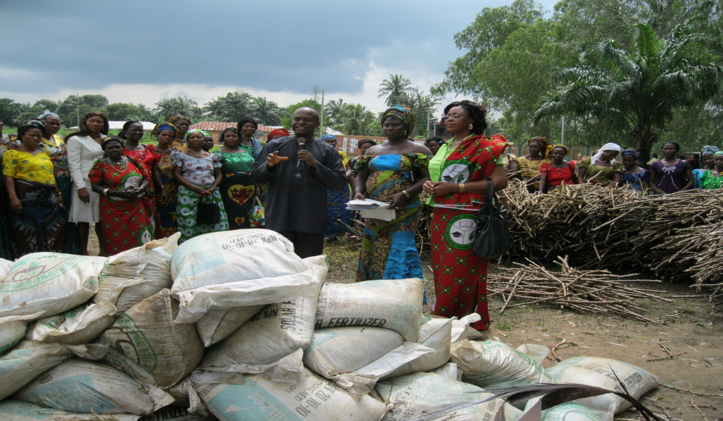
Figure 1. Cassava stems of improved varieties and inorganic fertilizers being handed over by a Government Research Agency in Nigeria to farmers to encourage them to kick-start the use of both improved varieties and stems multiplication technologies after training.

Socioeconomic benefits
Some socioeconomic benefits are derivable from the technology. Currently, in Nigeria, some farmers engage in the enterprise of multiplying stems of popular improved cassava varieties such as TMS30572, TMS 89/0505, TME 419 and NR8082, etc. Stem multiplication has opened opportunities for employment, income generation and improved livelihoods for the cassava farmers concerned. Some enterprising small-scale farmers in South-eastern Nigeria who adopted the technology have engaged themselves in the business of cassava stem multiplication and marketing, thereby providing employment and income to several of their community members.
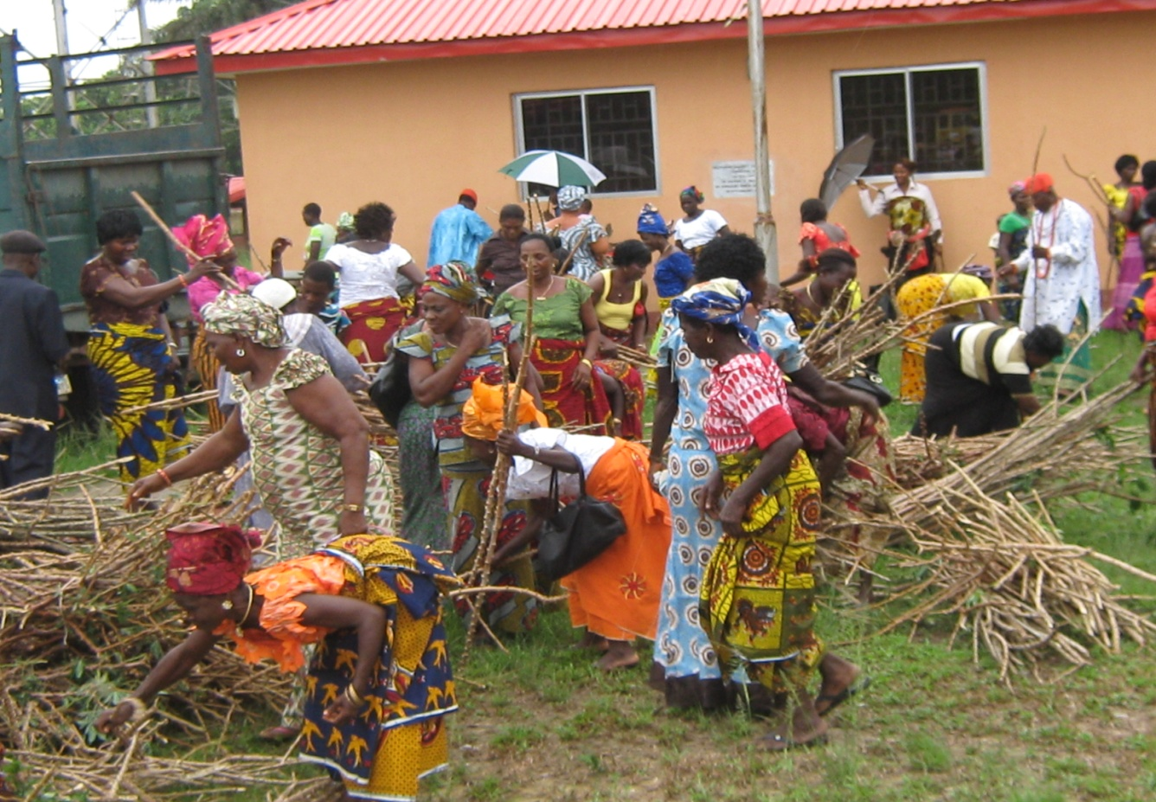
Figure 2. Cassava farmers in South-eastern Nigeria scrambling for improved cassava varieties multiplied through the stem multiplication technology and distributed by National Root Crops Research Institute, Umudike, Nigeria.
A study conducted in Akwa Ibom State, Nigeria in 2010 indicated that 54% of cassava farmers in the state have adopted the rapid stem multiplication technology. Also, 33% of the farmers indicated they use knowledge of the technology to multiply stems of improved varieties, which they sell to other farmers during farming seasons. The study also showed that the farmers make an average annual income of N120,313 (equivalent of US$752) from the enterprise. The farmers were emphatic that use of the technology made significant impacts on their households, especially in such issues as hunger wedging, income generation, paying children’s school fees as well as attainment of higher socio-economic status (CEDP, 2010).
Constraints
A number of constraints limit the use of the technology, especially among farmers growing cassava for the roots. Optimal yields of roots are not achieved as the emphasis is usually on enhancing yields of stems instead of fresh roots. As a result, a substantial quantity of fresh roots is lost in the process. It also requires high usage of external inputs such as inorganic fertilizers and agrochemicals, which are scarce, costly and inaccessible to some farmers. The challenges associated with procurement of such inputs also cause farmers to shun the technology. A number of cassava varieties also do not respond very favourably to the technology, possibly because of the size of the 2- or 3-nodes stakes. In such cases, the multiplied stems usually have low vigour and may not be ready for harvest after the initial 6 months after planting.
Conclusion
Despite the introduction of improved varieties and agronomic practices which can increase yields per unit area, adoption rate by Nigerian farmers remain low. Lack of an efficient seed system and insufficient quantities of planting material were identified as problems. The stem multiplication technology was developed to increase the availability of clean planting material to address the shortcomings in the cassava production system. It was anticipated that yield of roots would improve. However, optimal yields of root and substantial losses of fresh roots in the process have been identified as major constraints.

Cassava is important as a food security crop and varieties are needed that will feed the specific value chains of cassava commodities such as starch, high-quality cassava flour, chips, sweeteners (high-fructose syrup) and fuel ethanol. A sound cassava seed system that will provide for these chains is required.

Policy decisions need to be taken at the operational level of research institutes to determine the relevance of future investments of research on this technology for rapid multiplication of cassava stems or for exploring other options for ensuring that yields of roots can be increased and loss of fresh roots minimized. The technical and economic viability of the stem multiplication technology need further research. African, Caribbean and Pacific countries need cassava research to provide tangible results given the importance of this commodity for food and livelihoods security and its strategic importance for responding to the climate change challenge and for industrial development.

References
Achinewhu, S.C. and Owuamanam, C.I. 2001. Garification of five improved cassava cultivars in Nigeria and physico chemical and sensory properties of gari yield. African Journal of Root and Tuber Crops 4 (2): 18-21.
Aerni, P. 2006. Mobilizing science and technology for development: the case of the Cassava Biotechnology Network. AgBioForum 9 (1): 1-14.
Awah, E.T. and Tumanteh, A. 2001. Cassava based cropping systems and use of inputs in different ecological zones of central Africa. African Journal of Root and Tuber Crops 4 (2): 20-27.
CEDP. 2010. Impact Assessment Evaluation of Cassava Enterprise Development Project (CEDP) Implemented in Akwa Ibom, Cross River and River States, Nigeria. Technical Report submitted to IITA Ibadan, Nigeria, May 2010.
Collaborative Study of Cassava in Africa (COSCA) 1996. COSCA Working Paper No. 20, IITA, Ibadan, Nigeria.
Dickson, D. 2003. South-South collaboration picks up steam. Editorial. Science and Development Network. 17 November.
http://www.scidev.net/en/editorials/southsouth-collaboration-picks-up-steam.html
Eke-okoro, O.N., Ekwe, K.C. and Nwosu, K.I. 2005. Cassava Stem and Root Production: A Practical Manual. National Root Crops Research Institute (NRCRI) Press, Umudike, Nigeria. pp. 54.
Fresco, L. 1986. Cassava in shifting cultivation: a systems approach to agricultural technology development in Africa: Royal Tropical Institute, Amsterdam, Netherlands.
IITA (International Institute of Tropical Agriculture). 1998. IITA (International Institute of Tropical Agriculture) Annual Report and Research Highlights for 1987–88. IITA, Ibadan, Nigeria.
IITA, 1990. Cassava in Tropical Africa, International Institute of Tropical Agriculture (IITA), Ibadan, Nigeria.
National Root Crops Research Institute (NRCRI). 2010. Annual Report of NRCRI, Umudike, Nigeria.
Nweke, F.I., Spencer, D.S. and Lynam, J.K. 2001. The Cassava Transformation: Africa's Best Kept Secret. Michigan State University Press, East Lansing, USA.

