Sustainable Small-Scale Poultry Production: Are Local Feeds a Viable Option for the Pacific Region?

P.C. Glatz, Science Leader, Pigs and Poultry, South Australian Research and Development Institute, Roseworthy Campus, University of Adelaide, South Australia 5371, Australia

Summary

There has been a 500% and 300% increase in per capita consumption of eggs and meat, respectively, over the last 50 years, linked to the rapid increase in poultry production in developing countries worldwide. Poultry products are popular sources of high-quality protein, reflecting their high efficiency and relatively low cost of production. The greatest increase in livestock production in developing countries in the future is expected to be in poultry, eggs, pork and milk (Delgado et al., 1999).

A significant proportion of poultry meat and eggs produced in some developing countries comes from small-scale family units, either from small semi-scavenging flocks of indigenous birds or from small commercial flocks of broilers or layers reared in confinement and provided with commercial feeds. One of the major impediments to the efficiency and profitability of production is a lack of knowledge on poultry nutrition, health and management. The major constraint is often the feed supply. Commercial feed may not be available or must be imported or transported over long distances in-country. It is also very expensive and accounts for about 70% of the total cost of production. The viability of small-scale producer operations has been threatened by rising costs of imported feeds.

Effective rations for poultry can be developed from local sources. Four feeding strategies could be adopted by smallholder farmers depending on feed resources available in the region; (a) complete ration formulation using local feed ingredients; (b) free choice of feed ingredients; (c) mixing a concentrated diet with local feed ingredients and (d) dilution of a commercial diet with locally available food products. Adoption of such feeding systems is considered a solution for ensuring the viability of poultry farming.

Mini-mill equipment is becoming progressively more available and these could be established where appropriate local feed ingredients are readily available and cost-competitive. The establishment of small-scale regional feed manufacturing centres (producing 5-10 tonne/week) in areas where local feed supply is plentiful has the potential to achieve feed cost savings of up to 30%.

Introduction

Smallholder poultry farming makes an important contribution to the livelihoods of rural households in Pacific countries (Daghir, 1995). In the traditional rural setting dominated by smallholder farms, poultry have little shelter, are allowed to scavenge for feed, and are free to wander. This system is cheap as little husbandry and few management skills are required. There are considerable problems with this system, including slow growth and poor productivity because of energy and protein deficiencies, poor bird genetics, losses because of predators and theft and damage to gardens. However, many smallholders have changed from producing poultry solely for household purposes to farming meat birds and layers to produce eggs for sale in local markets. They have adopted improved housing and nutrition and use modern genetic strains fed on commercial feeds. The viability of these semi-commercial operations has been threatened by the rising costs of imported ingredients and feeds. When transport problems are added (and these are also made worse by the rising real cost of fuel), the smallholder poultry industries that rely on imported ingredients struggle financially. Smallholder operations will be substantially improved if feeding regimes based at least in part on local ingredients can be developed as an alternative to imported complete feed or feed ingredients from overseas.

Feed Resources

It is widely recognised that Pacific countries have feed resources that are either unutilised and wasted or used inefficiently. Most of these alternate feedstuffs have potential, but their use has been limited by variability in nutrient quality, high fibre content and anti-nutritional properties and unreliable supply. Nevertheless, the local feed resources that are available in the Pacific countries (ALFID, 2002; FAO, 2012) could be utilized more effectively for feeding poultry. Farmers could also introduce new crops for humans and livestock (Latham, 1997) and use pasture species with higher nutritional value. Energy sources include cereals, cereal milling co-products, roots and tubers, fruits and fruit co-products (Ravindran and Blair, 1991). Protein sources include oilseed meals, grain legumes, green meals, distillery co-products, fish silage, fish meal, copra meal, feather meal, poultry by-product meal plus alternative resources such as insects, maggots, earthworms, termites and snails (Ravindran and Blair, 1992 & 1993). The immediate prospect for the use of alternative feedstuffs is in the semi-commercial poultry units, which employ some degree of on-farm feed mixing and in family poultry units. In these sectors, where profitability rather than maximum production is the objective, alternative feedstuffs can make a useful contribution in poultry feeding.

Rations for poultry using local feed resources

Effective rations for poultry can be developed based on feed resources available. Four feeding strategies for poultry could be adopted by smallholder farmers; (a) complete ration formulation using local feed ingredients; (b) free choice of feed ingredients; (c) mixing a concentrated diet with local feed ingredients and (d) dilution of a commercial diet with locally available food products.

(a) Development of poultry rations for village farmers in the Solomon Islands

There is a wide variety of local feed resources available that could be utilized more effectively such as root crops, fruit, forages, bush plants and vines. Farmers in remote areas can introduce new crops (sorghum, mung bean, pigeon pea, sunflower, amaranth and others) with higher nutritional value for poultry and provided they have the appropriate tools and growing technologies. For example, in the Solomon Islands, three feeding trials with village hens were conducted using local feed resources.

Composition of diet 1: Corn (45%), cassava (6.31%), ripe paw paw (5%), mung beans (30%), fishmeal (5%), lime (8%), premix (0.25%), lysine (0.09%), methionine (0.05%) and salt (0.3%). Specifications of diet; AME 10.8 MJ/kg; CP 147 g/kg; fat 26 g/kg; fibre 22g/kg, Ca 30 g/kg and P 5 g/kg (calculated values). Where additives are not available, the birds foraging outdoors obtain some minerals and vitamins by pecking from the environment.

Composition of diet 2: Corn (25%), pigeon pea (15%), ripe paw paw (5%), mung beans (30%), fresh grated coconut (5.81%), cassava (10%), lime (8%), dicalcium phosphate (0.5%), premix (0.25%), lysine (0.09%), methionine (0.05%) and salt (0.3%). Specifications of diet; AME 9.3 MJ/kg; CP 136 g/kg; fat 33 g/kg; fibre 30g/kg, Ca 30 g/kg and P 5.2 g/kg (calculated values).

Composition of diet 3: Pigeon pea (25), sorghum (45%), ripe paw paw (8%), cassava (8.31%), fishmeal (5%), lime (8%), premix (0.25%), lysine (0.09%), methionine (0.05%) and salt (0.3%). Specifications of diet; AME 10.2 MJ/kg; CP 125 g/kg; fat 27 g/kg; fibre 36g/kg, Ca 30 g/kg and P 5.5 g/kg (calculated values).

The trials compared the performance of birds fed the local home mix layer ration with an imported commercial layer feed. The feeding trials were conducted in a naturally ventilated barn at the Solomon Islands College of Higher Education comprising 16 pens (1.5 × 1.5m) each with perches, nest boxes, drinkers and feeders. A total of 64 local hens were used for each trial which included 4 replicates of a control commercial layer diet (as the gold standard) and 4 replicates of the local feed diet. The birds were of a mixed age and obtained from local farmers. Corn and mung beans were included as whole grain in the rations. Cassava and paw paw were chopped, weighed, mixed and fed fresh twice daily. Numbers of eggs laid were recorded daily. Egg production was significantly lower in birds fed the local mix ration compared to the commercial ration (Figure 1). However, the cost of using the imported commercial feed is too expensive for village farmers to consider purchasing (Glatz et al., 2009).

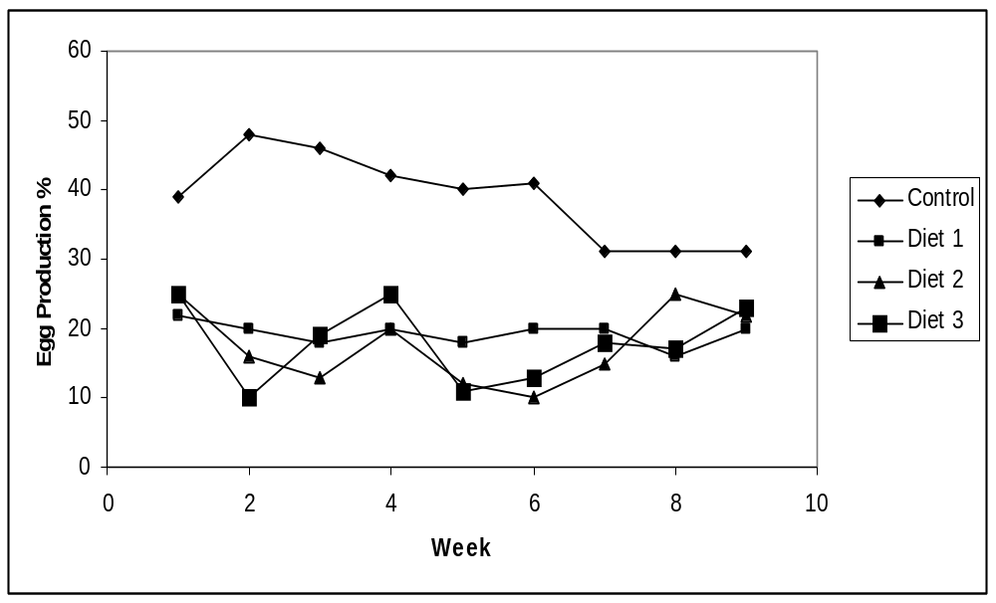
Figure 1. Egg production % of village hens in the Solomon Islands fed a commercial ration vs three local diets.

(b) Free-choice feeding

There is evidence that both wild and domesticated poultry are able to adjust their nutrient intake by selecting from a range of feedstuffs a diet that matches their physiological requirements (Pousga et al., 2005). In village layers, Grayson and Campbell (2004) reported that free-choice feeding system can be used successfully for village poultry in the Solomon Islands. Feed from the three food groups; protein, carbohydrate and minerals and vitamins are provided separately every day so the birds can choose feed according to their requirements. Provided with choice, birds have a capacity to regulate their separate intakes of energy, protein, minerals and vitamins to meet requirements. If feed from the three food groups are provided in separate containers, the birds will choose feed according to their requirements. If one of the food groups is eaten quickly, then more of that food should be provided.

(c) Development of a concentrated diet that can be blended with local feed ingredients

Glatz (2006) reported on a feeding strategy where high-energy and low-energy concentrates were supplemented with local ingredients (e.g. sweet potato) to make up the whole ration. The composition and calculated nutrient specifications of high-energy and low-energy concentrate were as follows:

(a) High-energy concentrate (11.6MJ/kg); Composition (g/kg), sorghum 118; soya 485.9; meat & bone meal 286; tallow 65; l-lysine 12.5; dl-methionine 11.8; l-threonine 1.3; salt 5; mycocurb 1; choline cloride 4.5; boiler premix 9; Specification (g/kg); Protein (419.75), Arg (28.59), Isoleu (15.95), Lys (32.89), Meth (17.41), M+C (23.25), Threo (16.58), Fibre (23.62), Ca (27.56), Ptot (16.73), AvP (9.4), NA (3.58), K (10.48), CI (6.08).

(b) Low-energy concentrate (9.4MJ/kg); Composition (g/kg) mill run 246; soya 389.45; meat & bone meal 309; + tallow 8; l-lysine 13.8; dl-methionine 12.4; l-threonine 1.7; salt 5; mycocurb 1; choline chloride 4.5; ronozyme phytase 0.15; broiler premix 9; Specification (g/kg); Protein (417.87), Arg (28.19), Isoleu (14.91), Lys (33.01), Meth (18.01), M+C (24.03), Threo (16.45), Fibre (38.47), Ca (30.29), P tot (20.18), AvP (11.44), Na (3.7), K (10.5), CI (6.43).

The diets tested were; (1) 50% sweet potato plus 50% low-energy concentrate; (2) 70% sweet potato plus 30% low-energy concentrate; (3) 50% cassava plus 50% high-energy concentrate and (4) 70% cassava plus 30% low-energy concentrate. The feeding demonstration activity was undertaken at 3 different sites in Papua New Guinea (PNG); Christian Leaders Training Centre (CLTC) in the highlands, Lutheran Development Service (LDS) in the lowlands and OK Tedi Development Foundation (OTDF) in the remote Western Province. The grow out facilities at each of these sites comprised 8 floor pens in a naturally ventilated shed with two replicates of each diet.
Figure 2 demonstrates the simple method of preparing the sweet potato and mixing with the concentrate.

Figure 2. Preparing sweet potato based diet for meat chickens

Collect and wash tubers
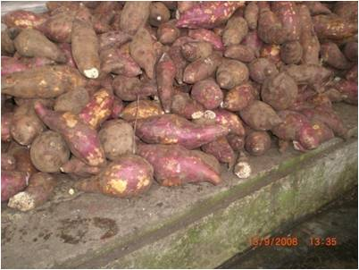

Boil
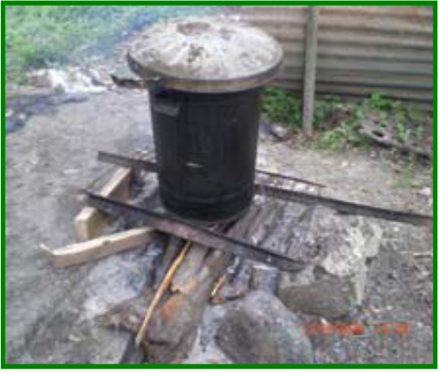

Drain and Cool
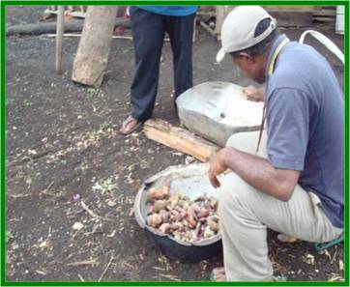

Mash the boiled tubers
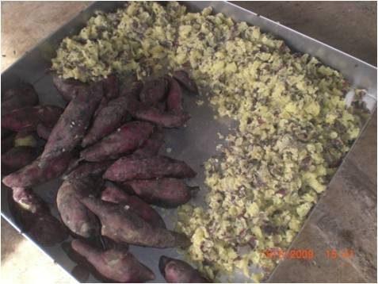

Mix one part of concentrate with 3 parts of sweet potato
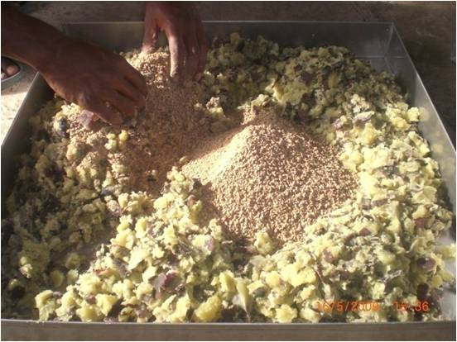

Table 1a CLTC site; weekly body weights of meat chickens fed on combinations of concentrate, sweet potato and cassava.

Experimental Diet | Day 21 | Day 28 | Day 35 | Day 42
Commercial finisher | 0.810 | 1.371ª | 1.988ª | 2.724ª
50SP + 50 LEC | 0.813 | 1.276ª | 1.735^{b} | 2.283^{b}
50C + 50 HEC | 0.813 | 1.221ª | 1.566^{b} | 2.082^{c}
70SP + 30 LEC | 0.810 | 0.906^{b} | 1.157^{c} | 1.514^{d}
P-value | 0.803 | 0.004 | <0.001 | <0.001
LSD | 0.009 | 0.147 | 0.174 | 0.151
SP50=50% sweet potato; SP70=70% sweet potato; C50=50% Cassava; LEC=low-energy concentrate; HEC=high-energy concentrate. Means with a common letter within a row are not significantly different (P > 0.05)

Table 1b LDS site; weekly body weights of meat chickens fed on combinations of concentrate, sweet potato and cassava.

Experimental diets | Day 21 | Day 28 | Day 35 | Day 42
Commercial finisher | 0.801 | 1.477ª | 2.011ª | 2.724ª
50SP + 50 LEC | 0.800 | 1.318^{b} | 1.802^{b} | 2.342^{b}
50C + 50 HEC | 0.801 | 1.327^{b} | 1.860^{b} | 2.377^{b}
70SP + 30 LEC | 0.801 | 1.154^{c} | 1.454^{c} | 1.785^{c}
P-value | 0.651 | <0.001 | <0.001 | <0.001
LSD | 0.002 | 0.067 | 0.099 | 0.200

SP50=50% sweet potato; SP70=70% sweet potato; C50=50% Cassava; LEC=low-energy concentrate; HEC=high-energy concentrate. Means with a common letter within a row are not significantly different (P > 0.05)

Table 1c OTDF site; weekly body weights of meat chickens fed on combinations of a concentrate, sweet potato, potato and cassava.

Experimental diets | Day 21 | Day 28 | Day 35 | Day 42
Commercial finisher | 0.870 | 1.536ª | 2.181ª | 2.570ª
50SP + 50 LEC | 0.878 | 1.365^{b} | 1.916^{b} | 2.463ª
50C + 50 HEC | 0.870 | 1.339^{b} | 1.919^{b} | 2.457ª
70SP + 30 LEC | 0.880 | 1.174^{c} | 1.627^{c} | 2.010^{b}
P-value | 0.598 | 0.012 | <.001 | 0.008
LSD | 0.024 | 0.149 | 0.111 | 0.224
SP50=50% sweet potato; SP70=70% sweet potato; C50=50% Cassava; LEC=low-energy concentrate; HEC=high-energy concentrate. Means with a common letter within a row are not significantly different (P > 0.05)

The results (Tables 1a, 1b, 1c) from the three climatic zones in PNG showed that birds fed the 50% sweet potato with 50% low-energy concentrate and 50% cassava with 50% high-energy concentrate diets were able to reach market weight of 2 kg or more at 42 days of age. However, birds fed the 70% sweet potato with 30% low-energy concentrate did not reach market weight for both the CLTC and LDS sites. At the OTDF site, birds achieved market weight when fed higher amounts of sweet potato, possibly because of a more suitable environment for the birds.

(d) Dilution of a commercial diet with locally available food products

In some Pacific countries, copra meal is available for use in poultry feeds. Pandi (2005) examined the growth rate of village broilers that were fed with a commercial finisher feed diluted with 20-80% of copra meal. In Figure 3, diet 1 was 100% broiler finisher (BF); diet 2, 80% BF + 20% copra meal (CM); diet 3, 60% BF + 40% CM; diet 4, 40% BF + 60% CM; diet 5, 20% BF + 80% CM and diet 6, 100% CM. Diluting a broiler finisher diet with 20-40% copra meal resulted in similar growth as the control diet and inclusion of 60% copra meal resulted in acceptable growth. The extent of dilution that is practiced depends on the availability and cost of copra meal.
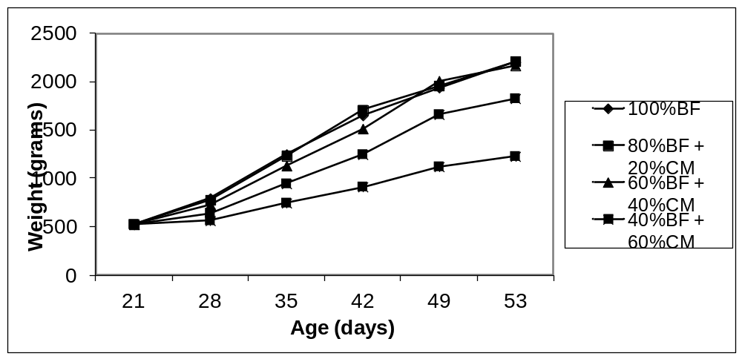

Figure 3. Dilution of commercial broiler finisher over the period 21-53 days (from Pandi, 2005).

Cost of imported feed

The major issue restraining the development of the smallholder poultry sector in some Pacific countries is the lack of regional small-scale feed manufacturing plants and the high cost of imported feed as well as cheap imports. Despite this, there are adequate supplies in some regional areas of fishmeal, cassava, sweet potato, fresh coconut and maize, which could form the basis of the feed industry. Poultry production is an important smallholder industry. The growth and expansion of this smallholder industry is dependent on reducing the reliance on imported complete feed or feed ingredients from overseas. Smallholder poultry production has been hampered or abandoned due to increased feed costs. Cheap diets based on locally available ingredients and agricultural by-products will encourage new poultry farmers into the industry and encourage others back to poultry production. Use of local feeds will provide an opportunity to develop a sustainable system that will support smallholders who have not benefited from such production systems. Knowledge and skills in poultry feed diet formulation based on locally available ingredients and agricultural by-products have improved. Smallholder poultry farmers in several locations, particularly in the Pacific, appear to have demonstrated that they can make a profit from these farming systems using imported complete feeds supplemented with local feed ingredients or in some cases, using only local formulated diets.

Milling equipment

Where feed mills have been established, they have relied on the use of imported feed ingredients, but many commercial mills have closed as a result of the escalating costs of imports. Currently, only small amounts of local feed resources are used in commercial rations by the larger feed mills, owing to the high cost of transport, storage difficulties, reliability of supply and constraints in feed formulation because of variable quality. However, the establishment of small-scale regional feed manufacturing centres (producing 5-10 tonne/week) in areas where local feed supply is plentiful may overcome some of these issues. The lack of suitable feed-making equipment is the major constraint limiting the development of the small-scale feed industry. However, such equipment is becoming more available. In the Pacific, progress is being made in establishing small-scale feed manufacturing centres that use local feed ingredients to produce lower-cost pig and poultry feed.

Cost benefits of small-scale feed mills

Smallholder broiler farmers in PNG purchase day-old broilers usually in lots of 52 and grow them out for 6 weeks using commercial feed and then sell them as live birds in local markets. The cheapest carbohydrate source to feed broilers in the highlands is sweet potato, while in the lowlands cassava is preferred. Comparisons were made of the costs of the following feeding options; (a) lowlands mini-mill HEC (50%) supplemented with cassava (50%); (b) lowlands commercial HEC (50%) supplemented with cassava (50%); (c) lowlands commercial feed (50%) diluted with copra meal (50%) and (d) lowlands commercial feed. In the highlands, the costs of the same feeding options were determined except sweet potato was used instead of cassava. The lowland broiler farmers are close to the commercial mills, while the highland farmers have extra costs associated with transport of commercial feed. The feeding costs in both the highlands and lowlands show advantages when concentrates (HEC and LEC) are fed with sweet potato or cassava compared to use of commercial finisher broiler feed based on imported ingredients (Black and Yalu, 2010) – Table 2.

Table 2 PNG village feeding costs in Kina per batch of 52 meat chickens grown to 6 weeks of age

PNG feeding system | Kina
Lowlands mini-mill HEC + cassava | 276
Lowlands commercial concentrate + cassava | 318
Lowlands diluted commercial feed | 334
Lowlands commercial feed | 431
Highlands mini-mill LEC + sweet potato | 311
Highlands commercial concentrate + sweet potato | 350
Highlands diluted commercial feed | 359
Highlands commercial feed | 481

The proportion of the costs of the concentrate and dilution feeding system relative to using commercial feeds alone show that there is a strong cost reduction incentive at the village level to adopt alternative feeding strategies based partly or wholly on local feed ingredients (Table 3) .

Table 3 Alternative PNG village feeding systems costs as a proportion of the commercial feeding costs

PNG Feeding system | Proportion
Lowlands mini-mill HEC + cassava/lowlands commercial feed | 0.64
Lowlands commercial concentrate + cassava/lowlands commercial feed | 0.74
Lowlands diluted commercial feed/lowlands commercial feed | 0.77
Highlands mini-mill LEC + sweet potato/highlands commercial feed | 0.65
Highlands commercial concentrate + sweet potato/highlands commercial feed | 0.73
Highlands diluted commercial feed/highlands commercial feed | 0.75

It may be possible to achieve feed cost savings of up to 35%, with the mini-mill concept being the most advantageous. The mini-mill concentrate was based on costs of local copra, fishmeal, coconut oil and mill run.

Conclusion

Local feed resources are available that could be utilized more effectively for feeding poultry in Pacific countries. To further develop cheap balanced diets and save the industry, technical and financial assistance are needed to encourage the establishment of small-scale feed mills to make cheaper concentrate diets based mainly on locally available feed resources and reduce dependence on costly imported ingredients. Economic modelling suggests there is a significant reduction in costs when poultry diets are manufactured by mini-mills using local feed ingredients. Ensuring the quality, cost competitiveness, and reliability and efficiency in supply of locally produced feed can contribute to improving the profitability and sustainability of the small-scale poultry sector. The use of locally available feed resources should be considered a high priority in most Pacific countries.

Acknowledgement

These studies were supported by the Australian Centre for International Agriculture Research.

References

ALFID. 2002. Australian Livestock Feed Ingredient Database. SARDI, Roseworthy, South Australia.

Black, I.D and Yalu, M. 2010. An ex-ante benefit-cost analysis of the impact of the research, development and extension programme that provided feeding strategies to improve the profitability of village broiler production in Papua New Guinea. Journal of South Pacific Agriculture 14: (1&2): 23-27.

Daghir, N.J. 1995. Poultry Production in Hot Climates. CAB International, Wallingford, UK.

Delgado, C., Rosegrant, M., Steinfeld, H., Ehui, S. and Courbois, C. 1999. Livestock to 2020: the next food revolution. IFPRI, Food, Agriculture, and the Environment Discussion paper 28. Washington, D.C.,USA: IFPRI.
http://www.ifpri.org/sites/default/files/publications/vb61.pdf

FAO. 2012. Feed Resources Information System, Animal Health and Production Division, FAO, Rome.
http://www.fao.org/ag/AGA/AGAP/FRG/afris/default.htm

Glatz, P.C. 2006. Poultry feeding systems in PNG. Final report to Australian Centre for International Agriculture Research.
http://aciar.gov.au/project/LPS/2001/077

Glatz, P.; Miao, Z., Hughes, R., Jansen; T., Aleve, H. and Sandakabatu, C. 2009. Feeding village poultry in Solomon Islands. Publication Code: FR2009-21, ISBN: 978 1 921615 07 8 Australian Centre for International Agricultural Research. Canberra, ACT, Australia.

Grayson, R. and Campbell, F. 2004. Improved Kokorako keeping. Kastom Gaden Association and
TerraCircle Association Inc., Honiara, Solomon Islands.

Latham, M.C. 1997. Human nutrition in the developing world. FAO Food and Nutrition Series No. 29; FAO, Rome, Italy.
http://www.fao.org/DOCREP/W0073e/w0073e00.htm

Pandi, J. 2005. Dilution of broiler finisher feed with copra meal. PNG Journal of Agriculture, Forest and Fisheries 48: (1 & 2).

Pousga, S., Boly, H. and Ogle, B. 2005. Choice feeding of poultry: a review. Livestock Research for Rural Development 17: No. 45.
http://www.lrrd.org/lrrd17/4/pous17045.htm

Ravindran, V. and Blair, R. 1991. Feed resources for poultry production in Asia and the Pacific. I. Energy sources. World's Poultry Science Journal 47: 213-231.
Ravindran, V. and Blair, R. 1992. Feed resources for poultry production in Asia and the Pacific. II. Plant protein sources. World's Poultry Science Journal 48: 205-231.
Ravindran, V. and Blair, R. 1993. Feed resources for poultry production in Asia and the Pacific. III. Animal protein sources. World's Poultry Science Journal 49: 219-235.

