
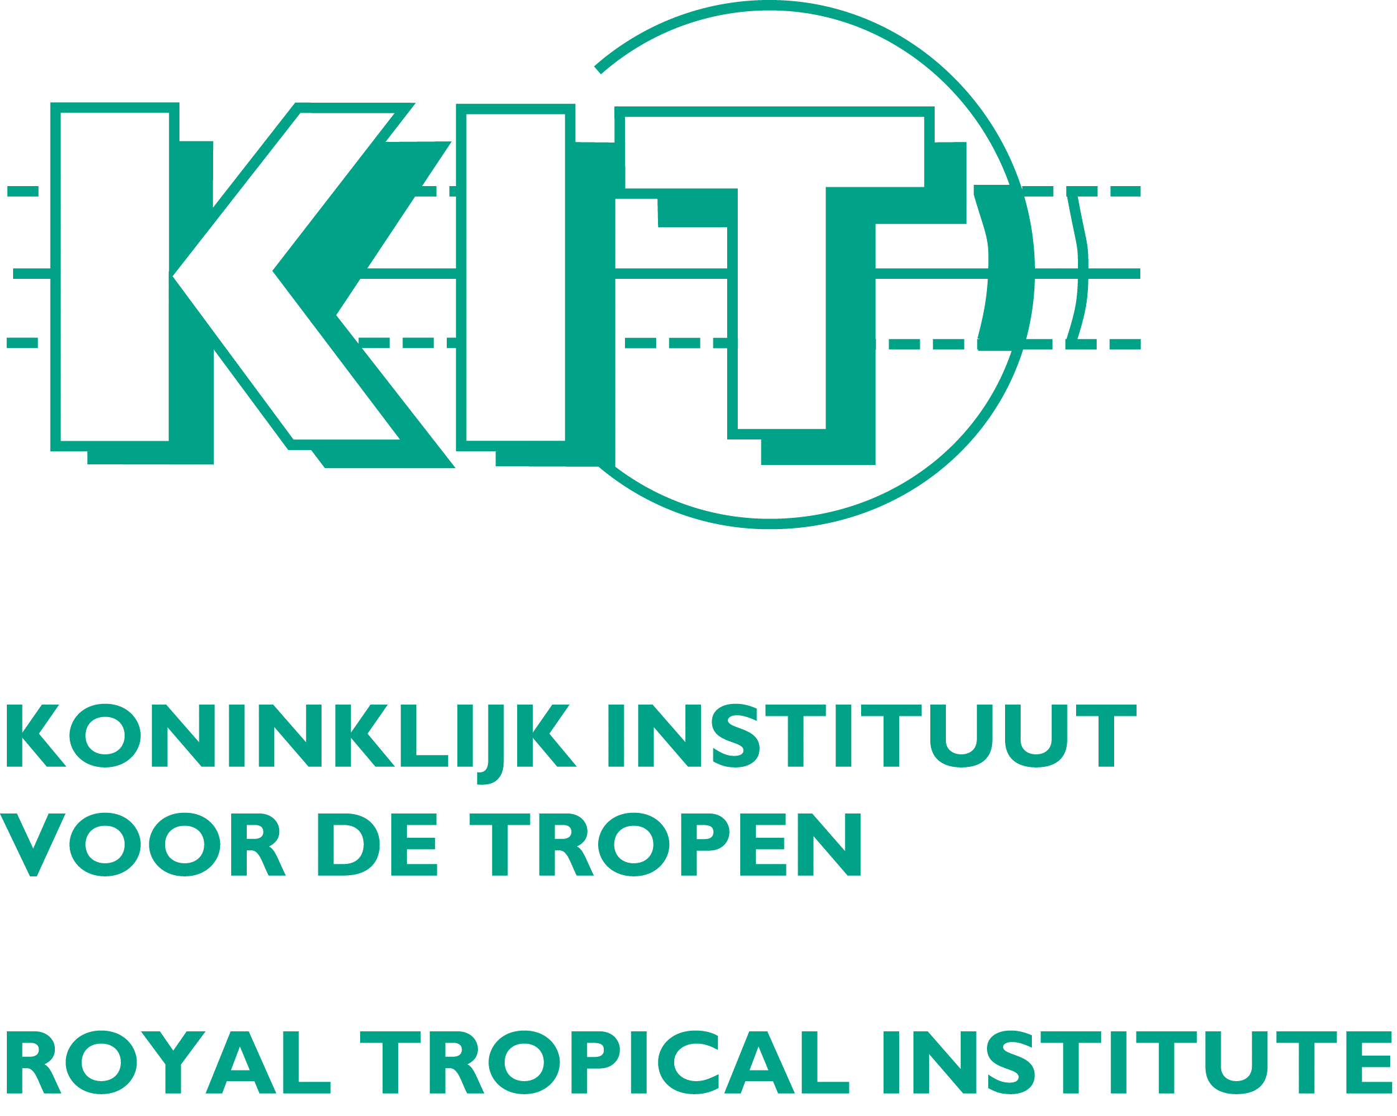



ASTI TOT Programme

Day 0 Arrival of Participants

Day 1 Innovation Concepts & Relevance to ACP Agriculture
08.00 - 08.30 | Registration | Logistics Team
08.30 - 08.40 | Welcome Remarks | Senior Official Host Institute
08.40 – 09.00 | Feature/ Key Note Address – ST&I Relevance for Development | CTA or Host Institution
09.00 – 09.45 | Introductions, Fears and Expectations, Self Evaluation | CTA/KIT
09.45 – 10.15 | Course Overview  - Training objectives  - Evaluation methods  - Reading assignments  - House-rules | CTA
10.15 – 10.30 | Discussion | CTA/KIT
10.30 - 11.00 | Coffee/Tea Break
11.00 - 13.00 | Module 1: Knowledge economy, economic development and innovation  - Interactive presentation  - Group brainstorm  - Plenary discussion | KIT
13.00 - 14.00 | Lunch
14.00 -15.30 | Module 2: National systems of innovation | CTA
15.30 - 15.45 | Coffee/Tea Break
15.45 - 16.45 | Module 3: Applying the innovation system to agriculture | KIT
16.45 – 17.30 | Understanding innovation concepts  - Working Group Session | CTA/KIT
17.30 - 17.45 | Daily evaluation  Workshop Evaluation  Self Evaluation | CTA/KIT
18.00 - 19.00 | Group Cocktail

Day 2 Analyzing the ASTI System
08.30 - 09.00 | Reiteration Day 1
9.00 - 10.30 | Module 4: Analysing the ASTI system and assessing its performance. | KIT
10.30 - 11.00 | Coffee/Tea Break
11.00 – 13.00 | Module 5: Review of the ASTI Analytical Framework  Working Group Session | KIT/CTA
13.00 - 14.00 | Lunch
14.00 - 15.30 | Module 6: Applying the Methodological Framework  - Working Group Session | KIT/CTA
15.30 - 16.00 | Coffee/Tea Break
16.00 - 17.30 | Module 6 (Continued): Applying the Methodological Framework  - Continuation of Working Group session and Presentation & Discussion of Working Group Reports | KIT/CTA
17.30 - 17.45 | Daily evaluation  Workshop Evaluation  Self Evaluation | KIT/CTA

Day 3 Strengthening the ASTI System
08.30 - 09.00 | Reiteration Day 2
09.00 – 9.45 | Module 7: Farmer Experimentation & Innovation – Theory, methodology & case study (part 1) | Vrije - CIS
9.45 – 10.30 | Module 7 (Continued): Farmer Experimentation & Innovation  Working Group Session | Vrije - CIS
10.30 - 11.00 | Coffee/Tea Break
11.00 - 11.45 | Module 7 (Continued): Farmer Experimentation & Innovation – Theory, methodology & case study (part 2) | Vrije - CIS
11:45 – 12:30 | Module 7 (Continued): Farmer Experimentation & Innovation – Working Group Session | Vrije - CIS
12:30 – 13:00 | Video on Promoting Farmer Innovation | Vrije - CIS
13.00 - 14.00 | Lunch
14.00 - 14.30 | Module 8: Demand led research : Bridging the Gap in the ASTI System / Research Priority Setting | CABI
14:30 – 15:30 | Module 8 (Continued): Demand led research : Bridging the Gap in the ASTI System  Working Group Session | CABI
15.30 - 16.00 | Coffee/Tea Break
16.00 - 17.30 | Module 8 (Continued): Demand led research : Bridging the Gap in the ASTI System  Presentation and Discussion of Working Group Reports | CABI
17.30 - 17.45 | Daily evaluation  Workshop Evaluation  Self Evaluation

Day 4 Strengthening the ASTI System
08.30 - 09.00 | Reiteration Day 3
09.00 - 10.30 | Module 9: Multi-stakeholder Processes & Institutional Change | KIT/CTA
10.30 - 11.00 | Coffee/Tea Break
11:00 – 12:00 | Module 10: Conflict management | CABI
12:00 – 13:00 | Module 11: Facilitating information and knowledge flows | KIT
13:00 – 14:00 | Lunch
14.00 - 14.30 | Module 11 (Continued): Facilitating information and knowledge flows | KIT
14.30 - 15.30 | Module 12: Influencing policy change | CABI
15.30 – 16.00 | Coffee / Tea Break
16.00 – 17.30 | Module 12 (Continued): Influencing policy change | CABI
17.30 - 17.45 | Daily evaluation  Workshop Evaluation  Self Evaluation | CTA/KIT

Day 5 The Way Forward
08.30 - 09.00 | Reiteration Day 4
09.00 - 10.00 | Module 13: Participatory Monitoring & Evaluation | KIT
10.00 - 11.00 | Module 14: ACP Biotechnology Policy Brief  - Presentation and group discussion | National Expert
11.00 - 11.30 | Coffee/Tea Break
11:30 - 12:30 | Module 15: ACP Biodiversity Policy Brief  - Presentation and group discussion | National Expert
12:30 - 13:30 | Lunch
13.30 - 14.30 | Module 16: Remote Sensing  - Presentation and group discussion | National Expert
14.30- 15.30 | Module 17: Training of Trainers – Lessons Learned | CTA / KIT
15:30 – 16.00 | Coffee Break
16.00 – 16.30 | Presentation of Banana case study action plan | Lead agency / CTA
16.30 – 17.15 | Workshop Evaluation  - Plenary discussion  - Submission of individual draft action plans
17.15 - 17.30 | Closing Ceremony | Host Institution / CTA

