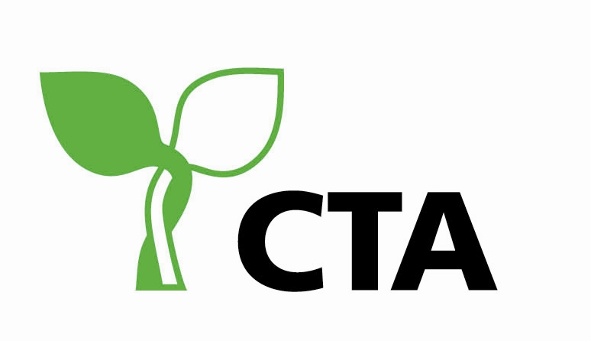
Key Messages
from the
10th Meeting of the Advisory Committee on
Science & Technology for ACP Agricultural and Rural Development
Judith Ann Francis, Senior Programme Coordinator, Science, Technology & Innovation Strategies, CTA, The Netherlands
The10th meeting of the Advisory Committee (AC) on Science and Technology for ACP Agricultural and Rural Development on “Safeguarding the ACP Food System through Science, Technology & Innovation” coincided with the 10th meeting of the Caribbean Week of Agriculture which was held in Dominica from 09-14, October. The Caribbean is represented on the AC by the CARICOM Secretariat, the Caribbean Agricultural Research and Development Institute (CARDI), the University of the West Indies (UWI), the Caribbean Council for Science and Technology (CCST), and the Scientific Research Council – Jamaica.
From Sunday October 09, when Professor Bongani Ndimba, a young scientist from the Agricultural Research Council, South Africa, presented the future of science for food and nutrition security and wealth creation at the Joint Opening Ceremony of the climate change and 10th AC meetings and continuing; AC members reflected on the following:
- what has been achieved through the enhanced ACP/EU scientific cooperation and;
- what impact has this cooperation had on improving agricultural performance and reducing poverty in Africa, Caribbean and Pacific?
The AC agreed that inter and intraregional and international cooperation on Science, Technology and Innovation has been strengthened. However, while there have been advances in agricultural productivity, the enhanced cooperation has not made a significant dent on mobilizing more national resources for research (1% GDP), or on increased agricultural performance and wealth creation in the ACP region. ACP scientists are still not sufficiently engaged in national, regional and international policy processes. The AC also concurred that the ACP scientific community needs to provide more evidence to support policy and decision-making to convince governments to make adequate resources available for agricultural research, teaching and training.
The AC presented the following key messages to the Alliance comprising of Ministers of Agriculture for the Caribbean and other key stakeholders:
- There is a problem not only of ageing farmers and technocrats but also of ageing scientists. There are not enough scientists and not enough science is being done to respond to the common challenges impacting on agriculture in the ACP region and the Caribbean in particular. There is need to invest in the production of new knowledge by undertaking ground breaking research and by building on existing knowledge including indigenous (traditional) knowledge to support innovations in the agricultural sector for food and nutrition security and wealth creation.
- There is need to improve the postharvest knowledge system to reduce food losses and maximize economic returns and for enhancing value addition, commercialization and business opportunities through SME development. In the absence of adequate and reliable data on the extent of postharvest losses in the ACP region; postgraduate research should be encouraged and supported to build the evidence base e.g. through mapping and researching postharvest losses (the extent in terms of volume and monetary value, at various stages of the chain and the reasons, including constraints to market access) and developing an inventory of existing technologies which can contribute to finding solutions. Exploring new technologies and new product options from the rich biodiversity should also be actively pursued. Three criteria should be used for determining the priority commodities for research on postharvest issues; importance for food and nutrition security, economic potential – linked to market demand, wealth creation and fair tax collection and employment opportunities. In the Caribbean, attempts should be made to link efforts at providing the evidence base on postharvest losses with the priorities identified for gathering reliable data on climate change and studies aimed at mapping of vulnerable groups under the implementation of the regional food and nutrition security plan. The AC further noted that reducing post harvest losses also has a positive effect on the carbon footprint related to crop and livestock production and trade. Reducing food waste was not considered a priority at this time for the ACP region.
- The ACP scientific community needs to provide governments with the evidence for investing in research and tertiary education and for convincing them that this is a long term investment which will provide high returns. Scientific cooperation is key and governments should be encouraged to make national investments which can allow national experts to use the resources to leverage the best scientific and technical expertise available in the North and in the South. South Africa provides a good model, their scientific community is able to leverage the best expertise available from the funds allocated by the government to support research. Strengthening the link between science and policy for responding to societal challenges remains a priority and a key strategic goal for the AC. The ACP scientific community wishes to remain engaged and connected with the policy processes and policy and decision-makers at the national, regional and international levels.
In conclusion, the Advisory Committee, a team of senior level scientists/researchers/academics/policy and decision-makers, representing national, regional, continental and international organizations from Africa, the Caribbean, the Pacific and Europe, took the decision to build on the work started in 2009 in Montpellier and which continued in 2010 in South Africa in realigning its modus operandi, endorsed its new Terms of Reference and updated its composition and membership to ensure its continued relevance.

