Science and Technology for Livestock Value Chain Development: A Focus on Artificial Insemination
P.H. Bayemi
Institute of Agricultural Research for Development, Cameroon
hbayemi@yahoo.fr
An estimated 1.29 billion people in 2008 lived on below $1.25 a day, equivalent to 22% of the population of the developing world (World Bank, 2012). Among these, 925 million do not have enough to eat, and 98% of them live in developing countries (FAO, 2010). Profound changes in agricultural markets are giving rise to new and promising opportunities for the developing world’s smallholder farmers to significantly boost their productivity, which will be necessary to ensure enough food for an increasingly urbanized global population, estimated to reach at least 9 billion by 2050.
Delgado et al. (1999) predicted a livestock revolution by the year 2020, suggesting that there are prospects for major livestock improvement for developing countries. Population growth, urbanization, and income growth in developing countries are fuelling a global increase in demand for food of animal origin. The resulting demand comes from changes in diets of billions of people and provides income growth opportunities for many of the rural poor. Over the last 20 years, meat consumption in developing countries has increased three times as fast as in developed countries. In order to benefit from the demand, farmers in developing countries should adapt to the new environment, which demands dissemination of technologies and changes of production systems to eliminate low productivity.
The efficiency of a livestock value chain is largely dependent on reproduction (Figure 1). Reproductive efficiency affects the milk and meat production yields because of its influence on the calving-to-service interval, calving pattern, length of lactation and culling rate.
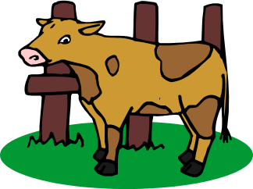
Cloning
Multiple ovulation and embryo transfer
Offsprings
Feeding, Health
Management

Purchase of semen straws or embryos
More suitable for developed countries or specialized centres
Semen collection, processing and storage
Artificial Insemination
Synchronization of ovulation
Genetic selection
Marker-assisted selection and detection of quantitative traits loci
Maps of genetic linkage
Marketing
Processing
Transport
Transport
Pregnancy diagnosis
Figure 1: Livestock value chain with focus on artificial insemination
Artificial insemination
Artificial insemination (AI) was the first major biotechnology technique to be applied to improve reproduction and genetics of farm animals. It has had an enormous impact worldwide in many species, particularly in dairy cattle. The acceptance of AI technology worldwide provided the impetus for developing other technologies, such as cryopreservation and sexing of sperm, oestrous cycle regulation, embryo harvesting, freezing, culture and transfer and cloning. New, highly effective methods of sire evaluation were also developed (Foote, 2002).
AI allows the transfer of genes from a “superior” male to a large number of offspring and breed improvement takes place much more quickly than with natural mating. With AI, since there is no direct contact between bull and cow the risk of transfer of diseases and injuries from natural mating is reduced. One portion of semen (ejaculate) from a bull can be divided into enough doses to inseminate hundreds of cows rather than a few dozen cows per year. AI technicians use semen from different bulls in the same herd (even in small herds). This allows the farmer to choose his own breeding policy. Semen of a proven bull can still be used even though the bull might be weak or dead.
For over 60 years, AI has been practiced in developing countries, mainly on commercial dairy herds, especially India, where growing milk demand has made it economical (Chupin and Schuh, 1993; Chupin and Thibier, 1995). South Africa, Northern Africa and countries such as Kenya, Uganda and Sudan have also developed their AI systems. If animal production is to be further improved in less advanced countries, AI is one of the key technologies to be encouraged. The practice of AI in African countries has often relied (at least in its beginning) on imported semen for crossbreeding with local breeds, and considerable gains in productivity have been obtained. The negative side effect of this system has been the need for improved management, and therefore additional costs in health and nutrition of the crossbreds. A population of Brangus (Bos taurus) × Gudali (B. indicus) F₁ crossbreeds was entirely decimated in Cameroon by tick-borne diseases. Indiscriminate and wide crossbreeding of native breeds may put the local population in jeopardy. Therefore, guidelines and breeding policies should be put in place to guide AI usage in ACP countries.

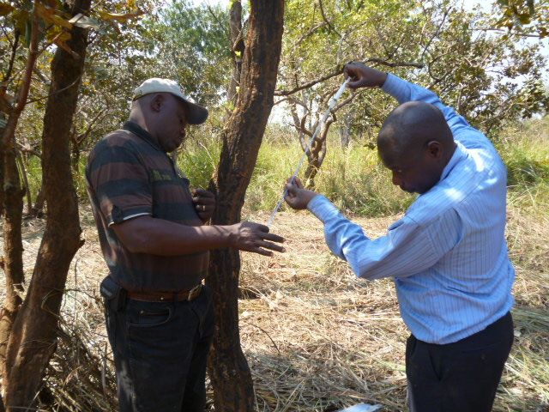
Loading of AI pipette with chilled semen (Photo: Bayemi)

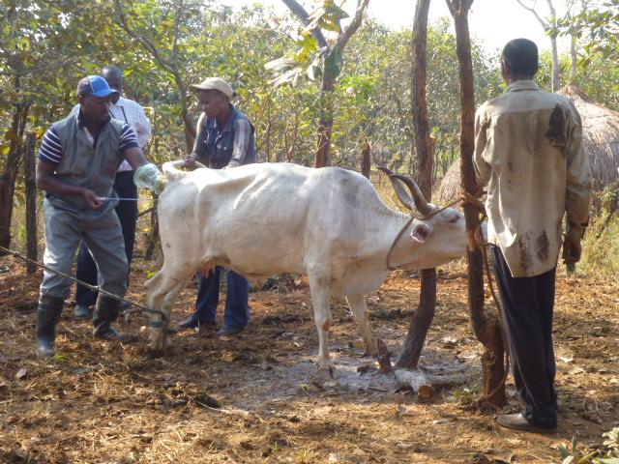
AI using chilled semen in a smallholder farm in the Central African Republic (Photo: Bayemi)

Semen collection and storage
Many countries using AI have established local centres for semen collection, where bulls are selected and trained. Semen is collected, processed and stored for further use. The establishment of AI centres is to be encouraged as technologies adapted to difficult conditions under similar circumstances facing other countries can be exploited, such as the use of coconut water for room-temperature storage of semen, use of chilled semen, fruits and vegetables extenders, etc.
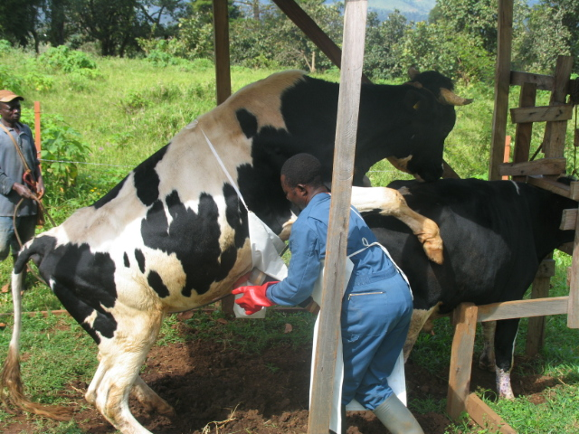
Semen collection at IRAD CENTRE, Cameroon (Photo Bayemi)

Oestrus and ovulation synchronization

The success of AI in the field depends on the proper detection of oestrus and skilful insemination. The classic rule referred to as the A.M. to P.M. and P.M. to A.M. system for insemination is based on observation, palpation of the ovaries and breeding data. This rule established that for best fertility, cows first seen in oestrus in the morning should be inseminated during the afternoon of the same day. Cows first seen in oestrus in the afternoon should be inseminated before noon the next day.

In many developing countries, the intercalving interval has been long, often reaching 24 months both in native and typical dairy cows. This long period is caused by many factors, in particular the unavailability of breeding bulls when cows come to oestrus. Though artificial insemination can greatly contribute to solving this problem, farms in the remote areas are often quite isolated from each other and from AI centres that would provide inseminators. In peri-urban areas, many zero-grazing dairy farms only have one to three dairy cows. In order to reduce costs of travelling long distances to farms for an insemination of only one cow and reducing mistakes associated with incorrect oestrus detection, synchronization of ovulation is of great help, as detection of oestrus is even more difficult in tropical breeds (Muruvi et al, 2005). These breeds tend to exhibit silent heats or to have short periods of oestrus that are easily missed (Mukasa-Mugerwa, 1989). Moreover, pastoralists are often on the move in search of pastures. Synchronization can also be used in selected cows of transhumant herds as permanent detection of oestrus and insemination will be difficult to apply in these herds. Calving can be planned for seasons when forage is more available. Given that hormonal applications are relatively costly for many farmers, it is advisable that, at least in the beginning of the programme, governments should prove support for such a scheme to facilitate industry development.

Multiple ovulation and embryo transfer

The use of multiple ovulation and embryo transfer (MOET), allows cows of high genetic potential to produce a much larger number of calves than with normal reproduction. Most MOET schemes require one or a few large nucleus herds. The resulting genetic improvement would be disseminated to the general population by embryo transfer, artificial insemination, or by young bulls to be used in natural breeding. There are both practical and theoretical advantages to MOET; identification of genetically valuable animals accurately so that the best can be used as parents of the next generation; use of high selection intensity so that only the best animals genetically are selected as parents; minimisation of the generation interval. Although some people thought this technology was unsuitable for developing countries, experience from South Africa shows that MOET can be practiced in specialized centres and embryos transferred to other countries (http://www.embryoplus.com). This allows selected native breeds to be exported in other regions while shortening the generation interval compared to simple artificial insemination. Because of ‘mad cow disease’ (bovine spongiform encephalopathy (BSE), some Africans countries have banned importation of live animals from Europe. Even so, highly productive parents can have their embryos transferred in these countries for faster genetic gains. Similarly, more productive breeds in one ACP country can be transferred to another if the environment is similar (e.g. Boran embryos to Cameroon). However, even if MOET can be done in some developing countries, collection and storage of embryos may be much more difficult to do because of frequent power shortages and poor water quality. Justifying the high costs of embryos assumes that scientists are well trained so that efficiency is ensured when transfers are done.

Artificial insemination in Cameroon

The steady increase in the demand for milk and dairy products in Cameroon, especially in the rising urban and high-income populations, has prompted the government to import significant amounts of dairy products, a strategy that is usually very expensive. The majority of milk producers are indigenous breeds that include amongst others; Gudali, Red and White Fulani (all zebu cattle), and because of their poor genetic potential for milk production (about 500 kg of milk/lactation on the average), they have been termed poor milkers when compared to exotic breeds such as Holstein and Jersey, which under the same environmental conditions produce about 12 litres/cow/day (Bayemi et al., 2005a and 2005b).
The need for alternative methods to increase milk production led to the establishment of dairy research at the Bambui and Wakwa Centres of the Institute of Agricultural Research for Development (IRAD), with the financial and technical support of the International Atomic Energy Agency (IAEA), as reported by Bayemi and Mbanya (2007). The IRAD Bambui Regional Centre has been applying interventions aimed at improving the milk production potential of cattle in Cameroon and artificial insemination has been shown to be an effective means of attaining this goal. Presently, this centre is the only functional AI centre in the Central Africa Region; Republic of Chad, Republic of Central Africa, Gabon, Equatorial Guinea and the Congo Republic, that harbour the same cattle breeds as Cameroon. The ongoing AI work in IRAD Bambui uses semen from Holstein Friesian bulls to crossbreed with local cows so as to improve the dairy potential of the resulting crossbreds and increase heterosis. Semen collected from the bulls is evaluated, processed and chilled for subsequent use in selected local cattle farms for breed improvement aimed at increasing milk production.
This is the first step to introducing the intensive use of frozen semen in the country, as previous attempts were not sustainable because of the high cost of liquid nitrogen of nearly $30 per litre. There is a need for government to strongly support such a scheme by making it possible for the AI centre to acquire nitrogen plants and means to distribute nitrogen throughout the country, although the reality of the situation might be different. Other aspects necessary for the successful breeding scheme include: organization of breeding societies for traditional and imported breeds; empowering of research institutions in the short term, to multiply valuable offspring for milk production to be available to farmers, in the long term, to carry out research in stabilizing Cameroonian dairy breeds well adapted to local conditions; in subsidizing pregnancy diagnosis to be done by the AI centre. The extensive systems use AI in selected cows while the zero-grazing system is advised to rely entirely on AI.

Conclusion

There are many factors to be considered in the livestock value chain, including production of offspring, processing and marketing. In the production process, reproduction is of primary importance as it is the only way to obtain high-quality stock which is essential for providing the main ingredient in sufficient quantity that is needed by the dairy or meat industry. AI technologies to improve reproduction have proven to be very effective. Safeguarding indigenous breeds and improving their genetic potential remain research priorities. Too many local breeds, such as the Ndamas, are now low producers, because adequate investments were not made. Though it is argued that selection for higher production is usually done at the expense of adaptation to challenging environments, an index combining these traits can be considered in selections of indigenous breeds.

REFERENCES

Bayemi, P.H., Bryant, M.J., Perera, B.M.A.O., Mbanya, N.J., Cavestany, D. and Webb, E.C. 2005a. Milk production in Cameroon: a review. Livestock Research for Rural Development 17 (6).
http://www.lrrd.org/lrrd17/6/baye17060.htm
Bayemi, P.H., Bryant, M.J., Pingpoh, D., Imele, H., Mbanya, J., Tanya, V. et al. 2005b. Participatory rural appraisal of dairy farms in the North West Province of Cameroon. Livestock Research for Rural Development 17 (6).
http://www.lrrd.org/lrrd17/6/baye17059.htm
Bayemi, P.H. and Mbanya, N.C. 2007. The first cattle artificial insemination centre in Cameroon. IRAD Scientific Review Conference, Yaoundé, 3-5 July 2007.
http://www-naweb.iaea.org/nafa/aph/stories/conf-jul07-presentation3.pdf
Chupin, D. and Schuh H. 1993. Survey of present status of the use of artificial insemination in developing countries. World Animal Review 74/75: 26-35.
Chupin, D. and Thibier M. 1995. Survey of the present status of the use of artificial insemination in developed countries. World Animal Review 82: 58-68.
Delgado, C., Rosegrant, M., Steinfeld, H., Ehui, S. and Courbois, C. 1999. Livestock to 2020: the next food revolution. Food, Agriculture, and the Environment Discussion Paper 28. International Food Policy Research Institute, Washington, USA.
http://www.nzdl.org/gsdlmod?e=d-00000-00---off-0fnl2.2--00-0----0-10-0---0---0direct-10---4-------0-1l--11-en-50---20-about---00-0-1-00-0--4----0-0-11-10-0utfZz-8-00&a=d&cl=CL1.3&d=HASH0174efca4b2a9d0959bb3064.4
FAO. 2010. Global hunger declining, but still unacceptably high: International hunger targets difficult to reach. News Release, 14 September 2010.
http://www.fao.org/docrep/012/al390e/al390e00.pdf
Foote, R.H. 2002. The history of artificial insemination: Selected notes and notables. Journal of Animal Science 80:1-10
Mukasa-Mugerwa, E. 1989. A review of reproductive performance of female Bos indicus (zebu) cattle. ILCA Monograph 6. ILCA, Addis Ababa, Ethiopia.
http://www.ilri.org/InfoServ/Webpub/fulldocs/X5442E/X5442E00.HTM
Muruvi, W., Hamudikuwanda, H., Chakoma, C. and Kusina, N.T. 2001. Evaluation of synchronization of oestrus based on gonadotrophin-releasing hormone and its potential use for fixed-time breeding in Tuli beef cows. Tropical Animal Health and Production 33(5):431-40.
Staal, S.J., Pratt, A.N. and Jabbar, M. 2008. Dairy Development for the Resource Poor Part 2: A Comparison of Dairy Policies and Development in South Asia and East Africa. PPLPI Working Paper No. 44-2.
http://www.fao.org/ag/againfo/projects/en/pplpi/docarc/wp44_2.pdf
World Bank. 2012. World Bank Sees Progress Against Extreme Poverty, But Flags Vulnerabilities. Press Release No:2012/297/DEC, Washington, D.C., USA, February 29, 2012. http://web.worldbank.org/WBSITE/EXTERNAL/NEWS/0,,contentMDK:23130032~pagePK:64257043~piPK:437376~theSitePK:4607,00.html

