
STATE OF ISRAEL

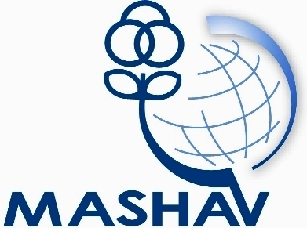

srael’s Agency for International Development Cooperation
Ministry of Foreign Affairs


CINADCO
Center for International Agricultural Development Cooperation
Ministry of Agriculture and Rural Development

ARO
Agricultural Research Organization

R&D Division
Course On:
Postharvest Physiology, Pathology and Handling of Fresh Commodities
February 11th –March 7th, 2013
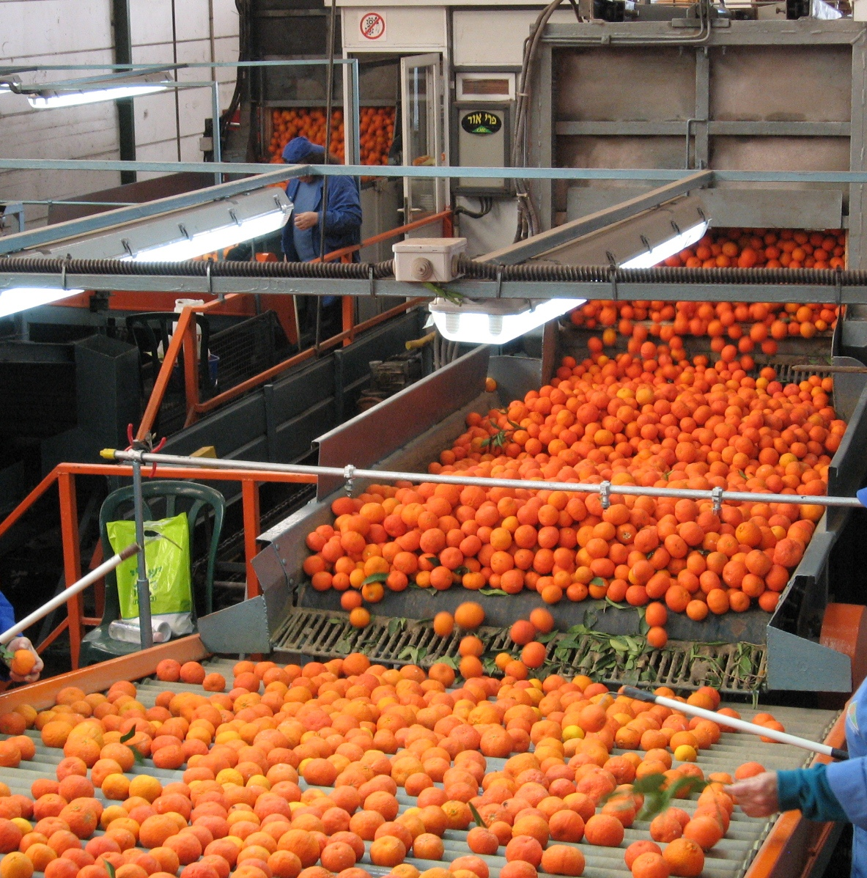

MASHAV – Israel’s Agency for International Development
Cooperation, and CINADCO - Center for International Agricultural
Development Cooperation, in cooperation with the ARO – Agricultural Research Organization, the Institute for Technology and Storage of Agricultural Products, Postharvest Science of Fresh Produce Department,
invites professionals to participate in the course on:
Postharvest Physiology, Pathology and Handling of Fresh Commodities
which will take place in CINADCO's Training Centre,
Volcani Agricultural Complex, Israel
February 11th –March 7th, 2013

About the course
Background
Despite the remarkable progress made in increasing food production world wide, approximately half of the population in the developing countries does not have access to adequate food supplies; thus the food security problem is worsening.
There are many reasons for this, one of which is food losses occurring throughout the supply chain from production, post-harvest, processing and marketing.
In its recent report “Global food losses and food waste” the FAO suggests that roughly one-third of food production for human consumption is lost or wasted globally, which amounts of about 1.3 billion tons per year.
Evidence suggests that these losses tend to be highest in those countries where the need for food is greatest.
Pre-harvest conditions and events in the fields such as cultivar, soil type, fertilization and irrigation practices, weather conditions, pest control programs etc. have a significant influence on achievement of the best potential postharvest quality and shelf-life of fresh fruits and vegetables.
Plants or plant parts continue to function metabolically after harvest and are subjected to physiological and pathological deterioration and loss. “Loss” means any change in the quality of the food that prevents it from being consumed by people. Postharvest loss in fresh fruits and vegetables is estimated at 5-25% in developed countries and 20-50% in developing countries.
Causes of this loss are varied with microbiological, mechanical and physiological factors being the main cause in perishable crops. Other causes are in-adequate harvesting, packaging, handling skills and refrigerated storage, as well as inadequate transportation.
Storage and shelf life are defined as the period from harvest to consumption, while a food product remains safe and wholesome. There is a wide range of postharvest technologies that can be adopted to reduce losses throughout the process from field to fork. Both quantitative and qualitative food losses of extremely variable magnitude occur at all stages in the post-harvest system from harvesting, through handling, storage, processing and marketing to final delivery to the consumer.
Appropriate storage can minimize moisture loss, slow down respiration rate and inhibit development of decay-causing pathogens. Wilting, re-growth, ripening, senescence and decay can be postponed. Temperature is the most important determination of fresh produce deterioration rate. An important supplement to temperature and relative humidity management is the use of controlled atmosphere (CA) or modified atmosphere (MA) and other technologies.
Postharvest loss results not only in the loss of the actual crop, but also have an impact on the environment, resources, labor needed to produce the crop and livelihood of individuals involved in the production process. The implementation of appropriate storage and postharvest techniques will add value to the produce and will increase the farmer’s income.

Aims
To understand the Physiological, pathological & environmental factors involved in the deterioration of fresh agricultural produce. To learn postharvest technologies and best practices associated with the postharvest handling of fresh fruits and vegetables, to assist in the delay of senescence, reduce loss and maintain the best possible quality of the produce. To initiate, research, teach and transfer knowledge to extension workers and farmers.

Main Subjects
Physiological and pathological factors affecting storage and shelf life; Cause and site of loss; Standardization and inspection of fresh produce; Quality factors and analysis; Prolonging shelf life; Post-harvest technologies.

Qualifications
This course is designed for research and extension workers, quality control personnel in the produce industry, and business, government or academic professionals interested in current advances in the postharvest technology of frits, vegetables & horticultural crops.
It is particularly of interest to technical professionals responsible for quality assurance, research and extension activities related to fresh produce quality, safety and marketability under the aegis of national or international organizations, institutions, universities, research institutes, civil society and the private sector. Course participants must have a relevant academic degree and at least three (3) years of practical work experience in related fields. A very good command of the English language is essential.

Application forms
Application forms and other information may be obtained at the nearest Israeli mission and at Israel's Ministry of Foreign Affairs website: http://mashav.mfa.gov.il (in Contact Us → Information and Registration), or at Volcani website at www.agri.gov.il (Administration → International R&D Courses). Completed application forms, including the medical form should be sent to the Israeli mission in your area and also faxed or e-mailed to CINADCO Training Center in Israel: Fax no: +972 3 9485771 / e-mail: sigalp@moag.gov.il .

MASHAV will award scholarships covering tuition fees, full board accommodation (two participants share a room), basic medical insurance and transportation to and from the airport.
Scholarships do not include international airfare and per diem.

General Information

Location and accommodation
The course will be held at the Volcani Agricultural Complex, situated 10 km east of Tel Aviv, Israel.

Transportation
Participants will be transported from and to Ben Gurion airport, without charge, by Tal Limousine Company, which is located on the mezzanine level at the Arrivals Hall. Participants are requested not to take any other transport company.

Clothing
The course will be held in the winter. Temperatures may vary between 10°C and 20°C with probabilities of rainfall. It is therefore recommended to bring warm clothing, suitable footwear for field trips and swimwear.

Insurance
Participants are medically insured by a health insurance policy. This policy does not cover the treatment of chronic or serious diseases, dental care, eyeglasses, pregnancy and specific medication taken by the participant on a regular basis. Participants are required to bring with them their usual medication. No insurance of personal belongings like money, video cameras, laptops or jewelry will be provided.

About MASHAV
Israel's Agency for International Development Cooperation (MASHAV) was founded in 1958 as part of Israel’s Ministry of Foreign Affairs. MASHAV is responsible for initiating and implementing Israel's development cooperation programs worldwide. MASHAV aims at transferring to developing countries the expertise and technologies that have assisted Israel on its own path to development. Today, Israel cooperates with over 140 countries, providing training in Israel and abroad, and operates on-site long-term demonstration projects. MASHAV is active in fields ranging from agriculture to health and from community development to entrepreneurship. http://mashav.mfa.gov.il

About CINADCO
The Center for International Agricultural Development Cooperation (CINADCO) is a part of the Israel Ministry of Agriculture and Rural Development. Since 1958, CINADCO has been in charge of the International Agricultural program conducted by MASHAV in Israel and abroad. CINADCO's activities consist of: International and country “tailor-made” courses in Israel, on-the-spot courses, long- and short-term projects and advisory missions. Israeli experts have also been sent to different locations around the world to conduct projects and to share their expertise in various aspects of agricultural production, extension and project planning. http://www.cinadco.moag.gov.il/cinadco

About ARO
The Agricultural Research Organization (ARO) is the research arm of the Ministry of Agriculture and Rural Development and is responsible for most of the agricultural research conducted in Israel. The scientists of the ARO collaborate with the regional R&D Stations and with the Agricultural Extension Service of the Ministry of Agriculture. Research at the ARO aims to improve existing agricultural production systems and introduce new products, processes and equipment on which Israel's future agricultural efforts will be based. ARO website: http://www.agri.gov.il

For further information please contact:
International R&D courses ARO/CINADCO
P.O.Box 30 Bet Dagan 50250, Israel
Tel: 972-3-9485770
Fax: 972-3-9785771
E-mail: sigalp@moag.gov.il
http://www.cinadco.moag.gov.il

