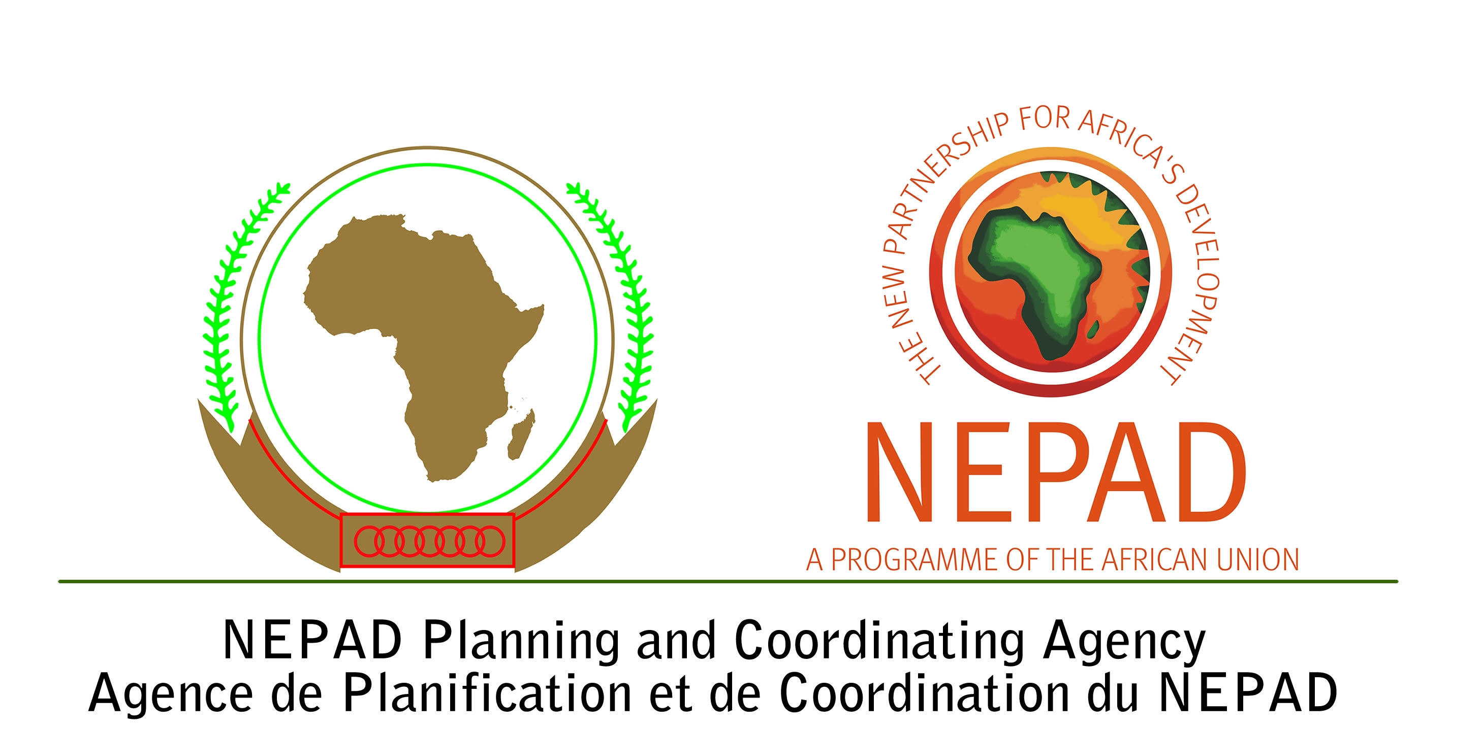
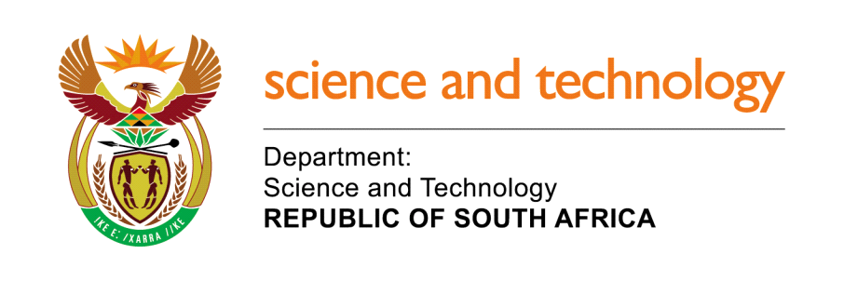


INTERNATION STUDENT CONFERENCE ON CLIMATE CHANGE AND INDIGENOUS KNOWLEDGE SYSTEMS (IKS) Johannesburg, 15-17 August 2011
CALL FOR PAPERS
The New Partnership for Africa’s Development (NEPAD) Agency, in collaboration with the IKS Centre of Excellence at the North-West University (South Africa), the National Indigenous Knowledge Systems Office in the Department of Science and Technology, the University of Hohenheim (Germany), the University of Kwazulu-Natal (South Africa), University of Namibia (Namibia) and Hanseo University (South Korea) are organizing an International Student Conference on Climate Change and Indigenous Knowledge Systems . The conference will be held in Johannesburg, 15-17 August 2011.

The initiative to organize this conference is based on the realization that climate change is one of the major challenges that the world is facing in the 21st century that is adversely affecting sustainable development and community livelihoods. Climate change and variability has been the centre of discussion during major international conferences on the environment and sustainable livelihoods. Further to this, there has also been renewed interest among leaders in solving the climate change challenge as a means for promoting sustainable development and environmental management. This is meant to achieve Millennium Development Goal (MDG) number 7 which seeks to promote the integration of the principles of sustainable development into country policies and programmes; reverse loss of environmental resources; and reduce biodiversity loss. The achievement of such targets with regard to environmental issues and climate change is very significant for Africa because it is the most vulnerable continent in spite of its rich biodiversity.
Despite being the most vulnerable continent to climate change, African countries are not effectively participating in the search for sustainable solutions against its adverse effects and their contribution to the global pool of knowledge is very minimal. Research on climate change adaptation and mitigation has not been informed by the existing wealth of indigenous knowledge nor has it focused much on validating/affirming indigenous knowledge systems. There have also been very limited concerted efforts to solicit the opinions and initiatives of students and the youth, especially from the south, as an important sector of the global academic community.
It is in this recognition that the New Partnership for Africa’s Development (NEPAD) Agency, in collaboration with its partners have organized an International Student Conference on Climate Change and Indigenous Knowledge Systems. The objectives of the conference are : to create an international platform for students and youth to exchange ideas and experiences in the field of climate change research and the role of indigenous knowledge systems in climate change adaptation and mitigation; to facilitate the building of a sustainable young African Scientists network on climate change research; and to inform the formulation of the African Young Scientists Initiative on Climate Change (AYSICC) that will also focus on the role of African indigenous knowledge systems in adaptation and mitigation.

The themes for the conference are:
- The Role of Indigenous Knowledge Systems in Climate Change Adaptation and Mitigation
- Climate change and vulnerable groups (women, children, disabled, etc,)
- Climate change, food security and health
- Climate change, Migration and social conflicts
- Climate change, land , water and other natural resources management
- Climate change and biodiversity management and conservation

Interested students and youth should submit an abstract of not more than 300 words by
31 May 2010 to the following address:

The Secretariat:
African Young Scientists Initiative on Climate Change (AYSICC)
IKS Centre of Excellence, North-West University
P/Bag X2046, Mmabatho 2735, SOUTH AFRICA
Fax: +27- 866975797
Tel/Fax: + 27-18- 3892294
E-mail: kayah.kaya@nwu.ac.za
Albert. Materechera@nwu.ac.za

