Press release – Noumea, April 6th 2012

The Pacific - A region of innovative people with a high natural resource potential - facing global and climate challenges: PACE-Net Conference strengthens research, development and innovation partnership between Europe & the Pacific.
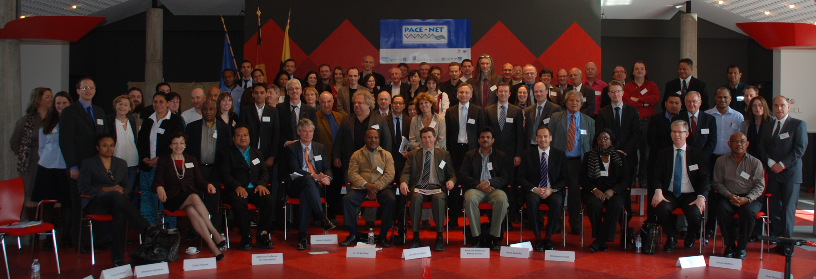
The Pacific is too important for Europe and the world to be left out. This was one of the main conclusions of the PACE-Net Conference held in Brussels, from March 20th to 23rd 2012. PACE-Net stands for “Pacific-European Network” (http://www.pacenet.eu/), three-year cooperation project between the two regions and is financially supported by the European Commission. This PACE-Net conference brought together more than a hundred senior researchers and officials from Europe, Australia, New Zealand, and the Pacific Island States such as Fiji, Samoa, Papua New Guinea (PNG), Tuvalu, Kiribati, French Polynesia, and New Caledonia.
The Pacific islands are the home to more than 10 Mio. people who live on some of the ca. 20.000 individual islands varying from large countries such as PNG (ca. 460.000 km²) to small ones such Tuvalu (ca. 26 km²). Prof. Teatulohi Matainaho, University of Papua New Guinea, pointed out that his country by itself contains over 5 % of the world's biodiversity in less than 1 % of the world's total land area. It boasts, for example 3,000 species of orchids, 800 species of coral, 600 species of fish, 250 species of mammals, 760 species of birds, and 8 species of tree-kangaroos. Similar wealth of coral, tuna fish, or unique agricultural products such as giant swamp taro (rich in calcium), are found throughout islands such as Samoa, Nauru or Tonga. Large deposits of nobel metals are available in PNG and New Caledonia and just recently rare-earth elements and the metal yttrium—which are crucial for green-energy technologies were found in the deep seafloor sediments of the South-Pacific. Pacific Island peoples have been sustainably using many of the region’s resources for centuries and have adapted themselves to changing environmental, societal and economic conditions by innovating new resource management strategies. Still, much of the Pacific’s natural resource diversity and richness - especially in the sea - is not yet known.
All of this – both humans and nature - is under threat. Ongoing climate change may have impacts on regional climate phenomena such as El Nino which – as Patrick De Dekker, Professor of Earth Sciences at the Australian National University pointed out – may cause extreme weather conditions such as floods and droughts. Climate change and rising sea levels may make entire islands uninhabitable, cause coral bleaching and rising water temperatures. Marine pollution, over-fishing, and exploitation of the remaining tropical forests are rapidly reducing existing bio-diversity, while rapid urbanization and changing cultural habits are also leading to the loss of precious traditional, for example medical, knowledge. These processes in some cases may even threaten to people to leave their home country, their natural resources, resulting in the loss of identity and culture.
In their dialogue with the scientists, representatives of the European Commission (EC) such as Dr. Laurent Bochereau, head of Unit in the Directorate General for Research and Innovation as well as Mr. Ranieri Sabatucci, head of Division in the European External Action Service (EEAS), emphasized therefore the need for still creating more awareness on the importance to Europe of the South Pacific.
These issues were central to the PACE-NET conference, organized by the International Bureau of the German Federal Ministry of Education and Research (IB-BMBF) together with the other PACE-Net partners, the EC –especially Mr. Armand Beuf (PACE-Net project officer)-, LISODE (a French company), and the Ministry of Sciences and Economic Affairs of Saxony–Anhalt. Dr. Gerd Rücker (IB-BMBF), the conference coordinator, highlighted: “For the first time this conference brought together a critical mass of Pacific key stakeholders to meet European counterparts in the field of research, development and innovation in a structured dialogue towards a common goal”.
Crucial high-level representatives participated in the conference from regional and national organisations in the Pacific (USP, SPC, SPREP, NARI, UPNG, IRD, Ministry of Environment, Lands and Agriculture Development of Kiribati, Tuvalu National Private Sector Organisation, Australian (ANU) and New Zealand (MSI) research and policy organisations, as well as and European research, development, innovation policy and investment sectors (EC, EEAS, EIB, UNESCO, UNIDO, IB-BMBF).
As input to the conference, high-level representatives from the EEAS, EIB, EC DG DEVCO, UNIDO, UNESCO, USP, SPREP, CTA as well as from Germany, presented their organisations in detail along with options for strengthening the Pacific-European collaboration in research, development and innovation.
Central to the event was two days of interactive workshops relating to 1) water, 2) agriculture & forestry, 3) natural hazards, 4) fisheries and 5) mid-term research, development and innovation policies. Each workshop developed integrated research, development and innovation framework drafts for equitable Pacific–EU partnerships. These drafts address the sectors and cross-cutting theme from their significance for both the EU and the Pacific, existing and required policies, a strategic needs assessment for research, development, and innovation, as well as the required actions and corresponding funding strategies. On the final day, the framework drafts, presentations and feedback from the high-level panel were discussed with the workshop participants. Prof. Claude Payri, coordinator of the PACE-Net project was delighted with the interactive nature of the event which helped to integrate the contributions of all involved: “We have seen a lively debate between the high-level panel and the workshop participants. They managed to identify some links between knowledge gaps and available funding opportunities in order to bridge future policy and investments decision making with research, development and innovation actions.”
During 2012, these collaboration frameworks will be further developed to policy brief white papers by the thematic and cross-sectoral work groups and policy and investment representatives from the ACP-Pacific countries, OCTs, EU, UN, Australia and New Zealand. The frameworks will be consolidated at the PACE-Net 3rd bi-regional key stakeholder conference in Suva, Fiji, in March 2013. This conference will be organized by the Pacific partner (USP) of the PACE-Net consortium with support of all other PACE-Net partners.

While many open questions remain from Brussels with regard to how best support and influence changes in the South Pacific, three clear ideas became prominent during the conference dialogues and will be taken into account for the third conference in Suva, Fiji in 2013:
1) The importance of involving policy makers in a science-policy dialogue as much and as early as possible because these are the people who set the framework conditions;
2) The importance of interdisciplinary research in an equitable partnership that acknowledges local and indigenous knowledge systems – while engaging with communities, scientists, innovators, development partners & policy makers;
3) Involving organisations – whether relating to funding, development and innovation - in the dialogue as they play a crucial role both for sponsoring the research, but also in the implementation of research results. Given the complexity of actors and issues, the clear need for the development of a Pacific Science Technology and Innovation (STI) policy framework emerged during the discussion. Such a framework would facilitate the Pacific’s STI collaboration with Europe as pointed out by Hans Thulstrup from UNESCO.

For further information about the PACE-Net project and PACE-Net´s conferences, please contact:
Prof. Claude Payri, PACE-Net Project Coordinator (claude.payri@ird.fr)
Dr. Gerd Rücker, Coordinator - PACE-Net Key Stakeholder Conferences (gerd.ruecker@dlr.de)
More on the PACE-Net project and the outcomes of this conference can be found at http://www.pacenet.eu/ and http://brussels-conference.pacenet.eu/, respectively.

LISODE (Lien social et décision) http://www.lisode.com/index.php/english/Accueil.html
USP (University of the South Pacific) http://www.usp.ac.fj/
SPC (Secretariat of the Pacific Community) http://www.spc.int/
SPREP (South Pacific Regional Environmental Programme) http://www.sprep.org/
NARI (National Agricultural Research Institute), Papua New Guinea http://www.nari.org.pg/
UPNG (University of Papua New Guinea) http://www.upng.ac.pg/
IRD (Institut de Recherche pour le Développement), French public research institute for development, http://en.ird.fr/
ANU (Australian National University) http://www.anu.edu.au/
MSI (Ministry of Science and Innovation) http://www.msi.govt.nz/
EIB (European Investment Bank) http://www.eib.org/?lang=en
UNESCO (the United Nations Educational Scientific and Cultural Organisation) http://www.unesco.org/new/en/
UNIDO (United Nations Industrial Development Organisation) http://www.unido.org/
DG DEVCO (Development and Cooperation – EuropeAid) http://ec.europa.eu/europeaid/index_en.htm
CTA (Technical Centre for Agricultural and Rural Cooperation) http://www.cta.int/

