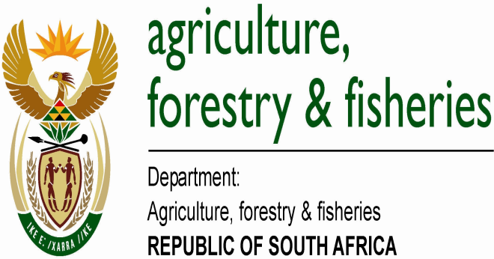

**FIRST ANNOUNCEMENT**

**3rd GLOBAL CONFERENCE ON AGRICULTURE, FOOD SECURITY AND CLIMATE CHANGE**

**VENUE: REPUBLIC OF SOUTH AFRICA,**

**DATES: 3 TO 5 DECEMBER 2013**

**PURPOSE:**

The 3rd Global Conference on Agriculture, Food Security and Climate Change is convened to deliberate on scientific solutions, information, policies and most importantly, build on partnerships in agriculture that will contribute towards increased yields, productivity and sustainable development. Agriculture responses to climate change, in particular conservation agriculture, new technological approaches, and, low carbon farming practices, will be explored along with mechanisms to enhance climate change resilience in the sector, including in forestry and fisheries.

Decisions of the conference will be based on scientific information, solutions and decisions emanating from conference. This will enable the development of policies and climate smart practices that should address goals of food and nutrition security, poverty alleviation, increased productivity and reduced inequality

**ENQUIRIES:**

**FURTHER DETAILED INFORMATION OF THE CONFERENCE WILL BE PUBLISHED ON 1 AUGUST 2013 AT THE FOLLOWING WEBSITE:** [**WWW.ARC.AGRIC.ZA**](http://WWW.ARC.AGRIC.ZA)

**EMAIL:** [**ceosec@arc.agric.za**](mailto:ceosec@arc.agric.za)

**PHONE: +27 12 427 9702**