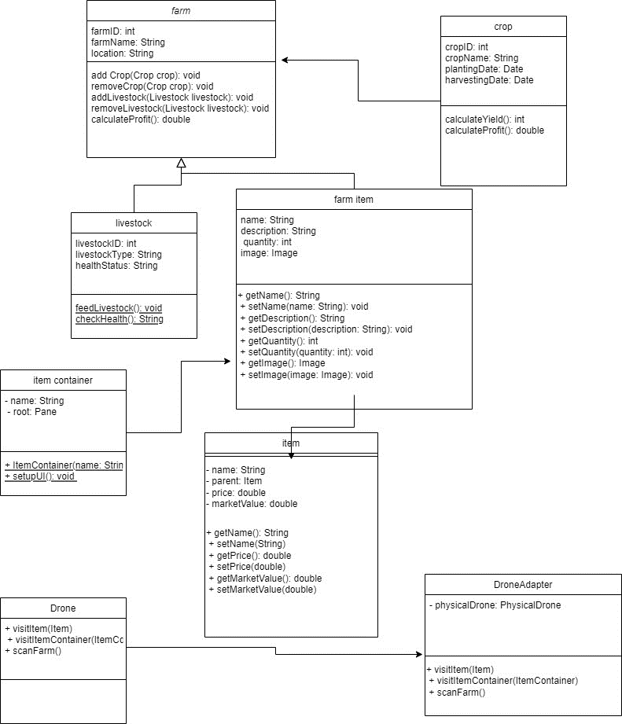

The primary class responsible for overseeing the farm dashboard is called FarmDashboard. It includes a way to choose an item and a list of Item objects. It is also capable of drone launch.

things on the farm are represented by individual things. Its properties are name, price, marketValue, and parent (which indicates its parent container). It offers ways to get and modify these characteristics.

Items are grouped using ItemContainer. A list of Item objects is contained in it. It permits item additions and deletions.

An interface Drone specifies the procedures a drone should follow in order to visit objects and item containers or survey the farm.

The class DroneAdapter is an adapter that modifies the Drone interface to operate with a particular physical drone, denoted as ActualDrone