PROJECT DOCUMENTATION
OneTownCity
A Hyperlocal Community Platform for Kuppam

Prepared for: Client Review
Prepared by: CraftLanee
Document date: September 11, 2026
Version: 2.0 (Expanded Edition)

Table of Contents
Right-click here and choose "Update Field" (or press F9) to generate the table of contents.

1. Executive Summary
OneTownCity is a hyperlocal community platform built for the town of Kuppam. It brings local businesses, real estate, jobs, events, news, and civic/infrastructure projects together in one place — giving residents a single trusted destination to discover what is happening locally, and giving local businesses and organizations a simple way to list themselves and reach the community they already live and work in.
The platform combines a public-facing directory and discovery experience with a self-service content submission system. Local businesses and residents submit their own listings, while a structured admin and moderation hierarchy — Super Admin, City Admin, Sub Admin, and Content Provider — reviews and approves everything before it goes live, keeping the information on the platform accurate and trustworthy without slowing down the people contributing it.
This document expands on the original project overview to give a complete picture of the platform: the problem it was built to solve, the reasoning behind its design decisions, every role and its exact responsibilities, every listing type, every major screen in the product with a full explanation of what it does and why it exists, and the technology it runs on.
6 | 5 | 5 | 100%
LISTING TYPES | USER ROLES | LANGUAGES | MODERATED CONTENT

2. Problem Statement
Before describing what OneTownCity does, it is worth spending time on why it needs to exist at all. The problem is not that Kuppam lacks businesses, jobs, events, or civic activity — it is that none of that information lives anywhere a resident, a visitor, or a local business owner can reliably find it. This section lays out that problem in detail before the rest of the document turns to the solution.

2.1 The Fragmented Local Information Landscape
In a town the size of Kuppam, the information that residents need day to day — which restaurants are open, which shops carry what, which houses or plots are for rent, who is hiring, what is happening this weekend, what the municipality is currently building — does not live in one place. It is scattered across dozens of disconnected channels: a handful of WhatsApp groups that most residents are not members of, a few business Facebook pages that are rarely updated, printed pamphlets and banners that go out of date the day they are put up, and a very large amount of information that exists only as word of mouth.
None of these channels are searchable, none of them are comprehensive, and none of them are structured. A resident who wants to know “which pharmacies near me are open right now” or “what 2BHK rentals are available under Rs.10,000” has no single place to ask that question. They have to already know who to ask, and the answer they get is only as good as that one person’s knowledge.

2.2 The Cost to Residents
For residents, this fragmentation is not just an inconvenience — it has a real cost. Job seekers rely on a small personal network to hear about openings, which means the best-connected residents get first access to opportunities and everyone else finds out late, if at all. People searching for a rental property or a service provider (an electrician, a tutor, a repair shop) fall back on asking around, which is slow and frequently produces outdated or incorrect contact details. Newcomers to the town — students, transferred employees, new families — are at the biggest disadvantage of all, since they have no existing network to draw on and no map of the town’s services to consult.
Even for long-time residents, there is no reliable way to discover things they did not already know to look for: a new restaurant that opened last month, a civic project that is about to start construction nearby, or an event happening across town this weekend. Discovery, in other words, simply does not happen unless someone already in the loop happens to mention it.

2.3 The Cost to Local Businesses and Service Providers
The same fragmentation hurts the other side of the market just as much. A small business in Kuppam — a restaurant, a repair shop, a tuition centre, a clinic — has no affordable, structured way to be found by people who are not already their customers. Building and maintaining an independent website is out of reach for most small, owner-operated businesses, both in cost and in technical know-how. Being listed on large, generic national directories rarely helps either, since those platforms are not built around a specific town and a business posting there competes for attention with listings from an entire state or country.
The result is that visibility ends up correlating with how long a business has existed and how much word-of-mouth reputation it has accumulated, rather than with the quality of what it actually offers. A new business, however good, starts from zero and has no fast way to reach the community it is trying to serve.

2.4 The Civic Transparency Gap
Civic and infrastructure information faces its own, slightly different version of this problem. Residents typically learn about local government projects — road work, drainage upgrades, public building construction — only when the work physically starts disrupting their street, not when it is planned, approved, or scheduled. There is no simple public record a resident can check to see what is planned for their neighbourhood, what stage it is at, or which department is responsible for it. That gap makes it harder for residents to plan around disruptions and harder for them to hold anyone accountable for delays.

2.5 Language, Access, and Trust Barriers
Finally, any solution to the above has to survive contact with how the town actually communicates. Kuppam’s residents are not uniformly comfortable in English, and a platform that only works in English immediately excludes a large part of the population it is meant to serve. Most residents primarily browse the internet on a phone, not a desktop, so a solution that is not built mobile-first will not reach them. And because so much local information today travels by word of mouth, trust is tied to the messenger — people believe a listing because a neighbour told them about it, not because of anything on the page itself. A digital platform starting from zero has none of that inherited trust and has to earn it structurally, through visible moderation and accountability, rather than assume it.
Taken together — fragmentation, poor discoverability for both sides of the market, a civic transparency gap, and language/trust barriers — these are the problems OneTownCity was designed to solve, and they directly shaped almost every product decision described in the rest of this document.

3. Why We Built OneTownCity
OneTownCity exists to replace that scattered, word-of-mouth information landscape with a single, structured, trusted destination — without recreating the trust and quality problems that plague open, unmoderated listing sites.

3.1 One Destination Instead of Many Channels
Rather than asking residents to check five different WhatsApp groups and two Facebook pages, OneTownCity puts businesses, properties, jobs, events, news, and civic projects behind one search bar and one set of category pages. A single “near me” search or category browse replaces the need to already know who to ask.

3.2 Self-Service, but Never Unmoderated
The platform deliberately does not require an admin to manually create every listing. Local businesses and residents submit their own content directly, which is the only way the platform can scale to hundreds of listings without needing a large in-house content team. But self-service alone tends to produce spam, duplicate entries, and outdated information over time — which is exactly the trust problem described in the previous section. OneTownCity’s answer is a review-and-approval layer that sits between submission and publication (detailed in Section 7), so every listing that is public has been seen by a real, accountable person before it went live.

3.3 Delegation Instead of a Single Bottleneck
A single administrator reviewing every submission for an entire town would quickly become a bottleneck. OneTownCity instead spreads that responsibility across a role hierarchy — Super Admin, City Admin, Sub Admin, Content Provider — so that authority over a category or a listing type can be delegated to whoever is best placed to review it, without ever losing the audit trail of who approved what.

3.4 Built to Grow Beyond One Town
Even though the first deployment is for Kuppam alone, the platform is structured around a city concept from day one — City Admins are scoped to a specific city, and every listing carries a city association. That means bringing a second or third town onto the platform is a matter of configuration, not a rewrite — a deliberate choice made early, since the same fragmentation problem described in Section 2 is not unique to Kuppam.

3.5 Meeting Residents Where They Are
Because the biggest barrier for many residents is language and device, not technology in the abstract, OneTownCity was built mobile-first and multi-lingual from the start (English plus Hindi, Tamil, Telugu, and Kannada) instead of adding those as an afterthought once the English, desktop version was already finished.

4. Project Overview
OneTownCity is a hyperlocal community platform built for the town of Kuppam. It brings local businesses, real estate, jobs, events, news, and civic/infrastructure projects together in one place, combining a public-facing directory and discovery experience with a self-service content submission system backed by a structured review workflow.
The home page is the platform’s front door: it establishes what the platform covers, surfaces live platform-wide counters, and routes visitors straight into the category or search flow that matches what they came looking for.
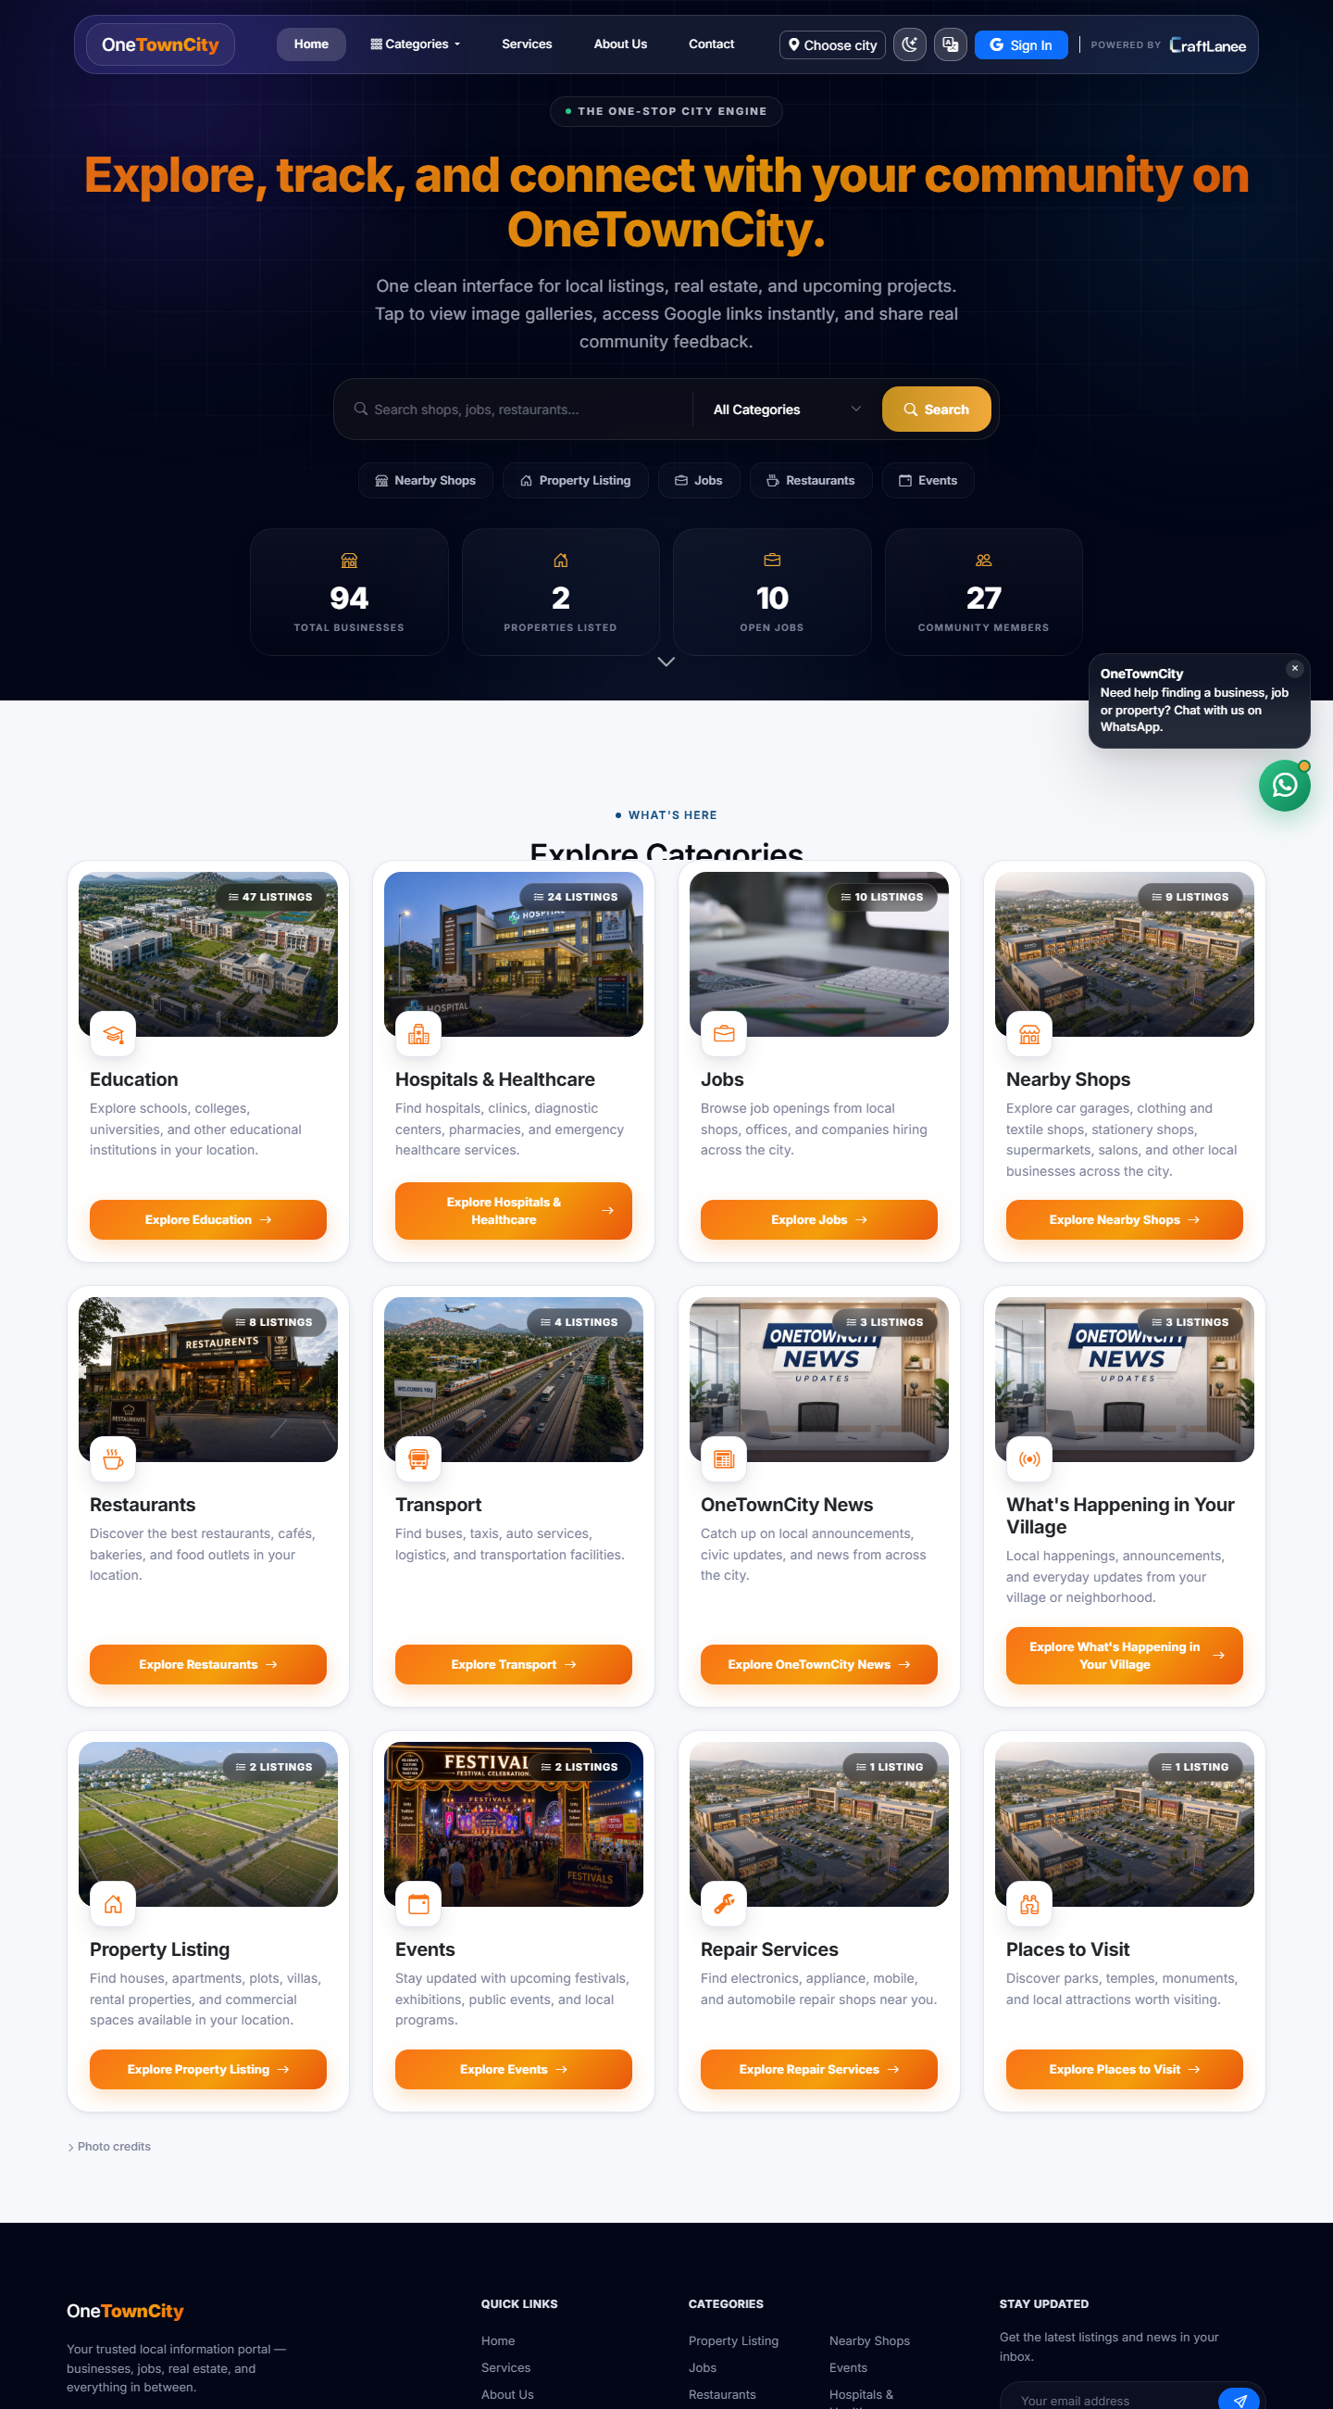
Figure 1: The OneTownCity home page — hero search, live stats, and category grid.
The home page opens with a full-width hero (“Explore, track, and connect with your community on OneTownCity”) and a single combined search bar with a category dropdown, so a first-time visitor can search across every listing type without first deciding which section of the site to go to. Directly below it, four live counters (Total Businesses, Properties Listed, Open Jobs, Community Members) pull real numbers from the database rather than showing static marketing copy, which signals to a new visitor that the platform is actually active. The “Explore Categories” grid beneath that is the platform’s main navigation surface: sixteen categories — Education, Hospitals & Healthcare, Jobs, Nearby Shops, Restaurants, Transport, OneTownCity News, What’s Happening in Your Village, Property Listing, Events, Repair Services, and Places to Visit among them — each shown with a representative photo and a live listing count, so residents can browse by the kind of thing they need rather than having to already know a search term. A floating WhatsApp button in the corner gives visitors a fallback channel to CraftLanee’s support if they cannot find what they are looking for through search or browsing.

5. Who Uses the Platform — Roles & Responsibilities
OneTownCity is built around five distinct roles. Each one has a clearly bounded scope of authority, and each sits at a specific point in the content-review chain described in Section 7. This section covers each role in full — what it can do, what it explicitly cannot do, and how it fits against the other four.

5.1 Super Admin
The Super Admin has unrestricted, platform-wide access and sits above the city-scoping that applies to every other role. There is exactly one practical ceiling on authority in the system, and this is it.
- Oversees the entire platform across every city the platform is deployed to, not just Kuppam.
- Creates and manages City Admin accounts, and assigns which city or cities each one is responsible for.
- Has final approve/reject/changes-requested authority over any submission from any role, in any city.
- Manages the platform-wide category tree, including which categories exist, which model they publish into, and whether they appear on the homepage.
- Views and moderates every registered user account, including suspending or blocking accounts that violate platform rules.
- Is the only role that can edit the Roles & Permissions capability matrix itself — i.e. the only role that can change what every other role is allowed to do.
- Has visibility into platform-wide analytics: total listings, users, pending approvals, and engagement, through the Super Admin dashboard (Section 10).

5.2 City Admin
The City Admin has full authority over one assigned city. Within that city, a City Admin operates with almost the same authority as a Super Admin — the scoping is geographic, not a reduction in capability.
- Publishes their own submissions instantly, with no review queue, since they carry full authority over their city.
- Reviews, approves, rejects, or requests changes to every submission from Sub Admins and Content Providers within their city.
- Creates and manages Sub Admin accounts for their city, and delegates a specific, fine-grained set of permissions to each one.
- Creates and manages Content Provider accounts and approves or rejects their category access requests.
- Manages which platform modules (listing types) are enabled for their city.
- Cannot see or act on another City Admin’s city, and cannot alter the platform-wide Roles & Permissions matrix.

5.3 Sub Admin
The Sub Admin exists specifically so that a City Admin does not have to personally review every single submission. A Sub Admin is given a scoped set of responsibilities by a City Admin — for example, authority over Business listings only, or Events only — through the same fine-grained permission matrix described in Section 11.
- Reviews and approves, rejects, or requests changes to submissions only within the listing types they have been delegated authority over.
- Cannot grant themselves additional permissions, create other Sub Admins, or manage Content Provider accounts unless a City Admin explicitly grants that specific permission.
- Operates entirely within a single city — the same one as the City Admin who created them.
- Their permission scope is visible to the City Admin at all times through a per-user capability toggle grid, so delegation is never a black box.

5.4 Content Provider (Business / Resident Admin)
A Content Provider is a business owner or resident who has applied for, and been approved for, the right to manage listings within one or more specific categories — the process described in Section 8.1.
- Creates, edits, and manages listings only within the categories they were explicitly approved for.
- Every submission enters the review queue and is published only after a City Admin or the relevant Sub Admin approves it — a Content Provider can never publish directly.
- Can apply to expand into additional categories at any time from their own dashboard, without needing to re-apply from scratch.
- Sees the status and review history of every listing they have submitted, including any rejection reason or requested change.
- Cannot see or moderate other users’ listings, and cannot access any administration tooling outside their own content.

5.5 Public Visitor
The Public Visitor is anyone browsing the platform without — or before — signing in, and remains the largest audience the platform serves, since discovery is the platform’s core value proposition.
- Browses and searches every public listing type without needing an account.
- Once signed in (via Google Sign-In), can like, comment on, review, and favourite listings.
- Can share any listing directly to WhatsApp, Facebook, Telegram, or X.
- Can report a listing that appears inappropriate, fraudulent, or outdated for moderator review.
- Can apply to become a Content Provider directly from the site, starting the category-request workflow in Section 8.1.

5.6 Roles at a Glance
Role | Scope | Can Publish Instantly? | Reviewed By
Super Admin | Entire platform, all cities | Yes | — (top of chain)
City Admin | One assigned city | Yes | Super Admin (oversight only)
Sub Admin | Delegated listing types, one city | No — own submissions still reviewed | City Admin
Content Provider | Approved categories only | No | City Admin or delegated Sub Admin
Public Visitor | Read + social actions only | N/A — no listing authority | N/A

6. What Can Be Listed
The platform supports six listing types, each tailored to the kind of information that matters most for it. Every listing, regardless of type, supports a multi-image photo gallery, a “featured” flag for highlighted placement, and an active/inactive visibility toggle that lets an admin hide a listing without deleting its history.

6.1 Business
Business is the largest and most active listing type on the platform, spanning 19 categories — restaurants, pharmacies, hospitals, schools, tourism, repair services, and more. Each business listing captures its name, category, address, phone number, GPS location for “near me” search, a photo gallery, description, website, a Google Maps link, and structured working days and hours.
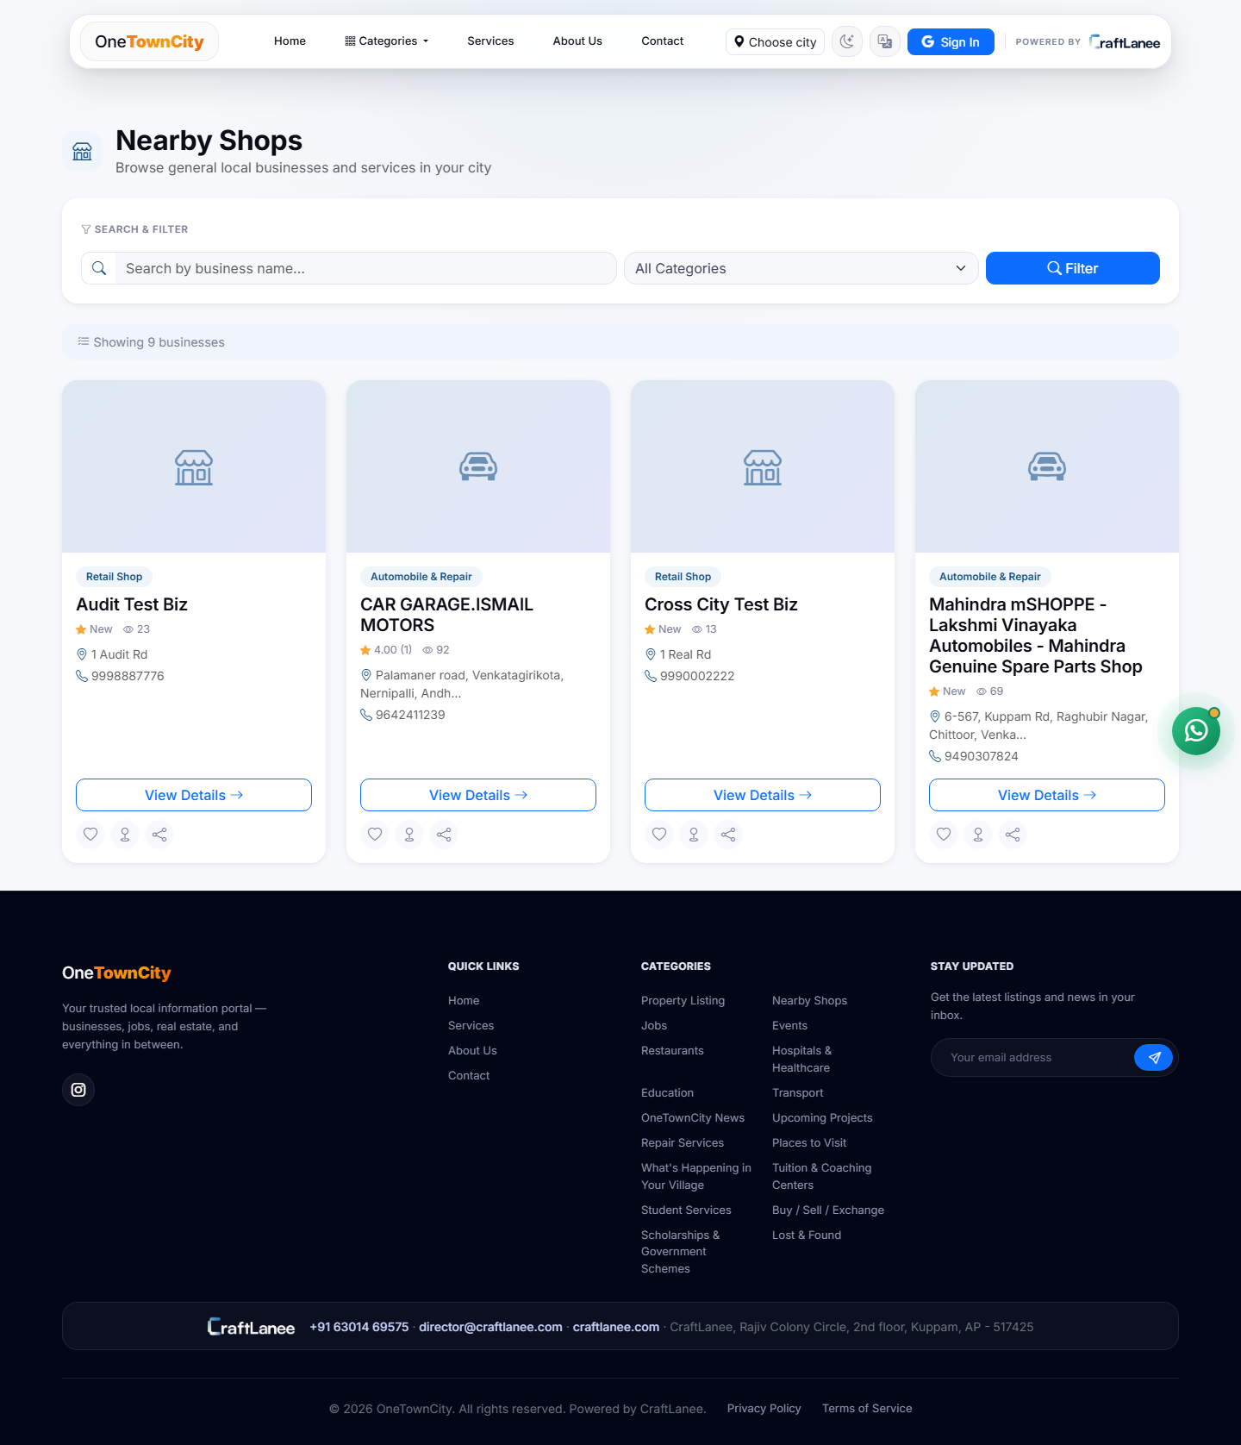
Figure 2: Business directory — filterable grid (shown here as the Nearby Shops category).
Every business category shares the same directory layout: a search-by-name box, a category filter, and a responsive grid of cards, each showing a category badge, business name, star rating (or “New” if it has none yet), view count, address, and phone number, with quick-action icons for save, share, and viewing full details. This consistent layout means a resident who has learned to browse one category (say, Restaurants) already knows how to browse every other one.
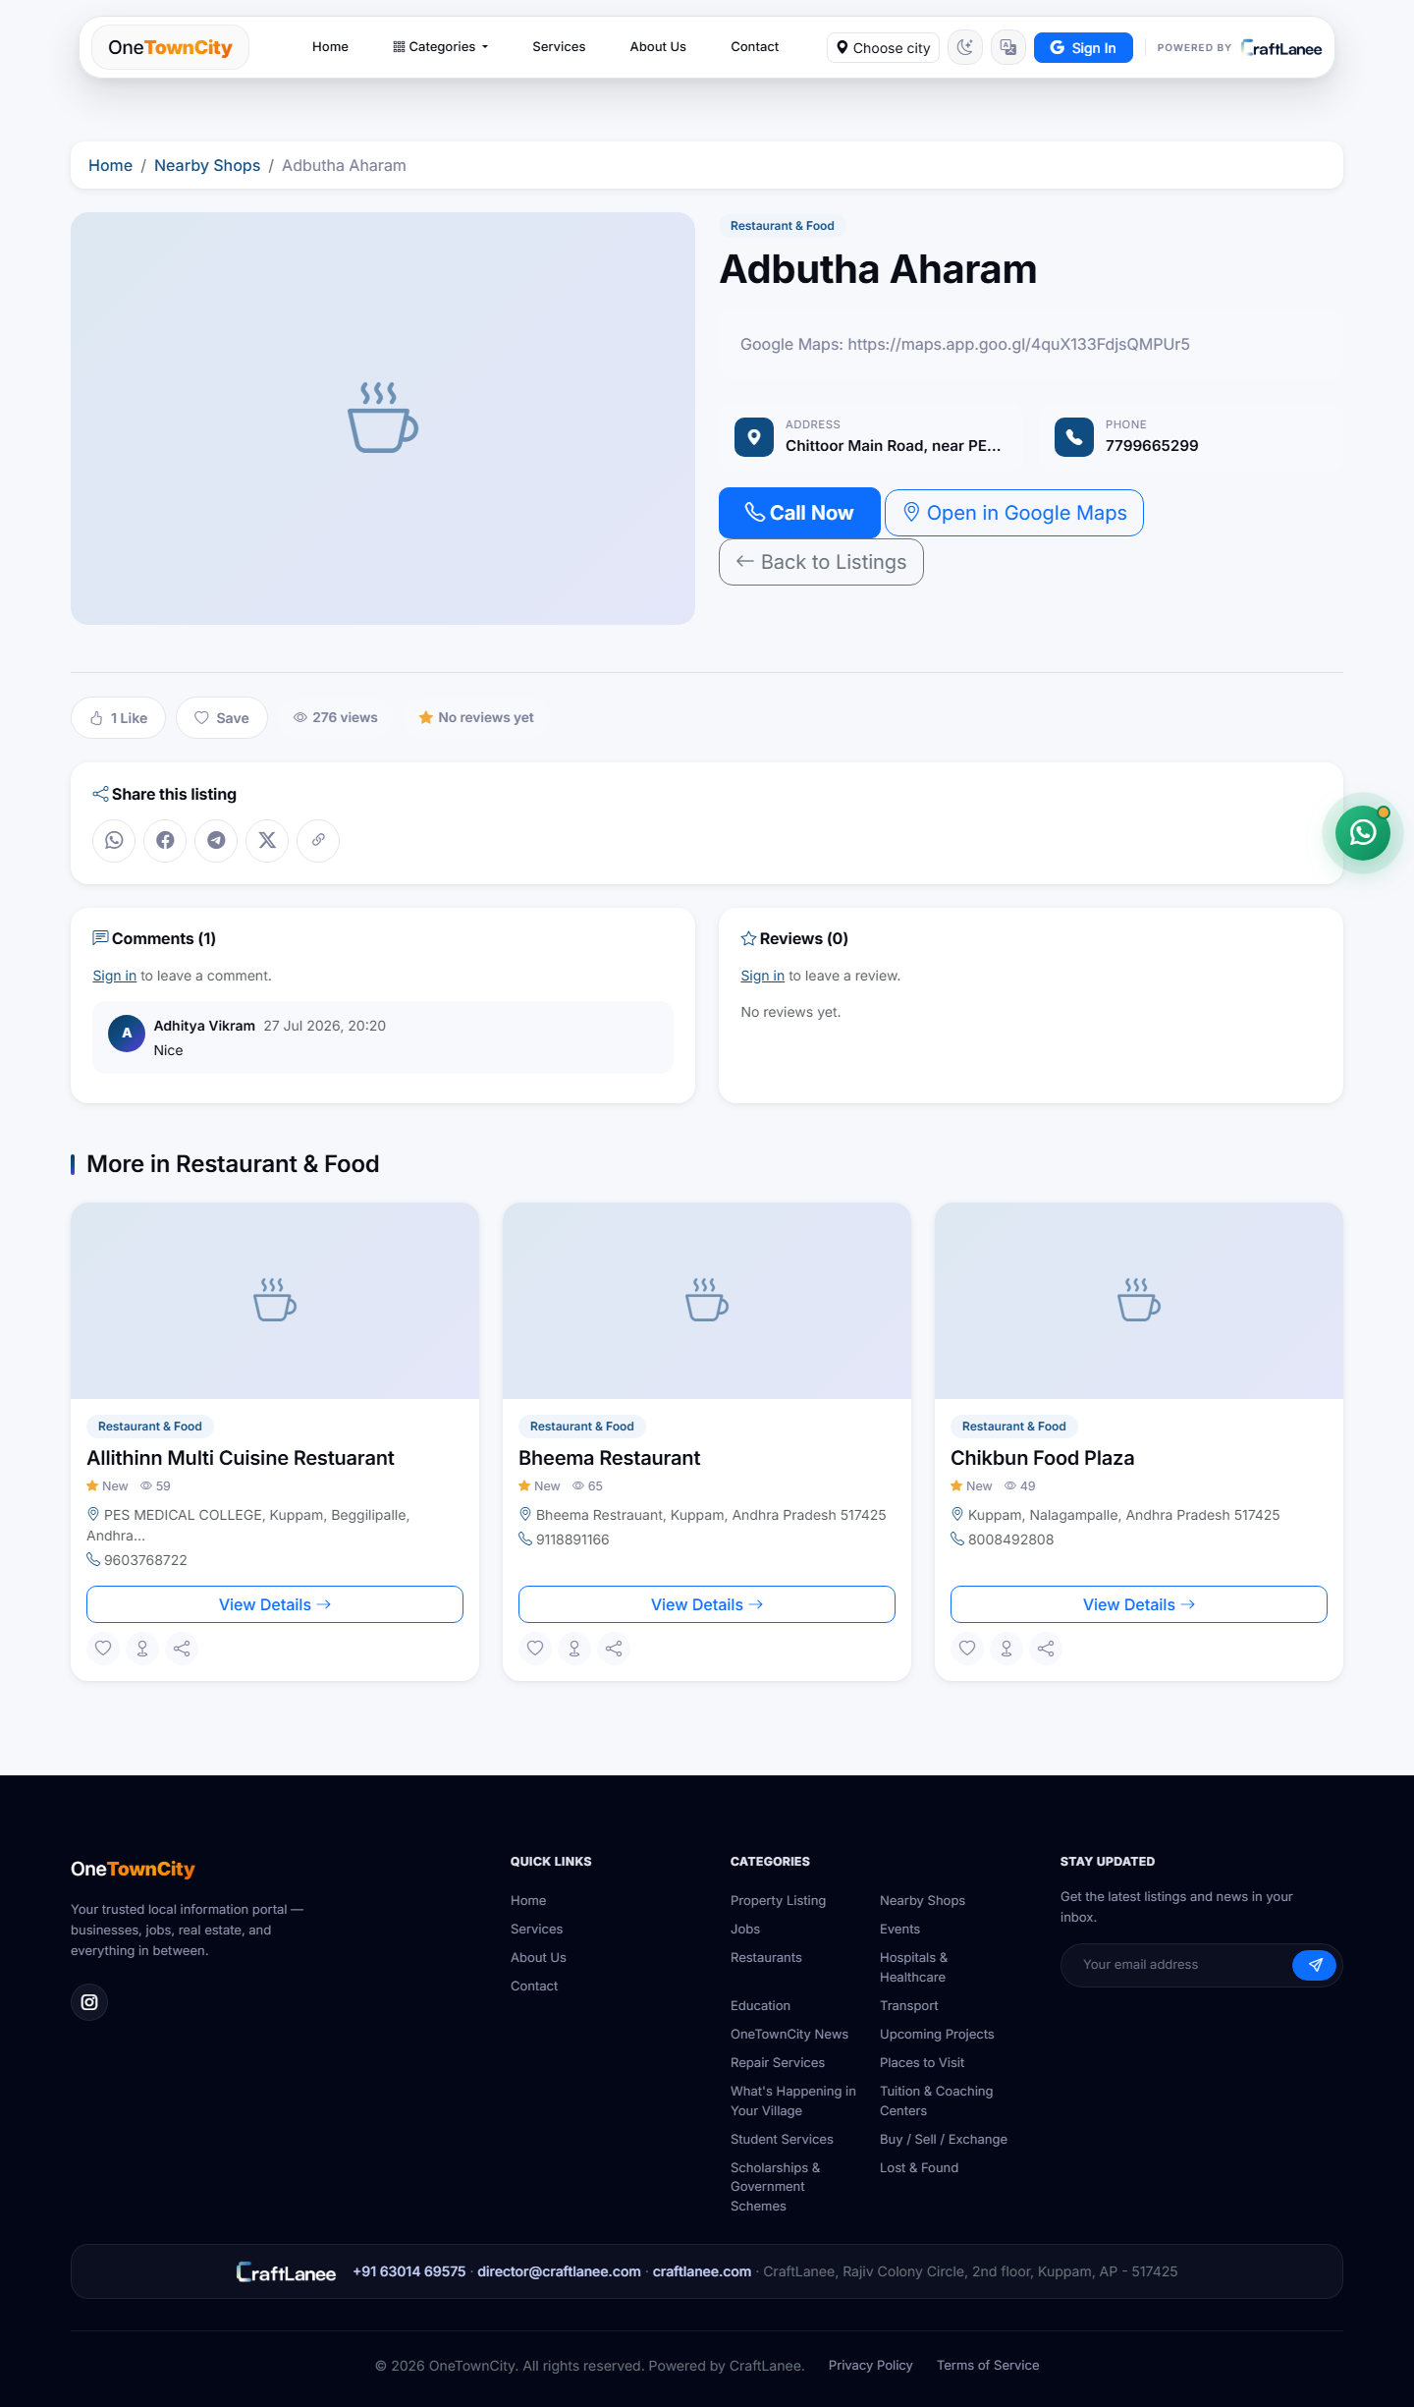
Figure 3: Business detail page — contact, map, likes, comments, and related listings.
The detail page is where a browsing visitor turns into an actual customer contact. It surfaces a direct “Call Now” button and an “Open in Google Maps” button above the fold, alongside the raw address and phone number, so no extra taps are needed to act on the listing. Below that, likes, saves, view count, and a star-rating summary build social proof, and a comments section lets residents leave public feedback directly on the listing — shown here with a genuine comment (“Nice”) from a signed-in user. A “Share this listing” row with one-tap icons for WhatsApp, Facebook, Telegram, and X turns every visitor into a potential distribution channel for the business. A “More in [Category]” strip at the bottom keeps visitors on the platform by surfacing similar listings instead of ending the browsing session.

6.2 Property
Property listings cover sale, rent, apartments, villas, plots, commercial space, and PG (paying-guest) accommodation — each captured with a title, property type, price, location, contact details, a GPS/Maps link, and photos.
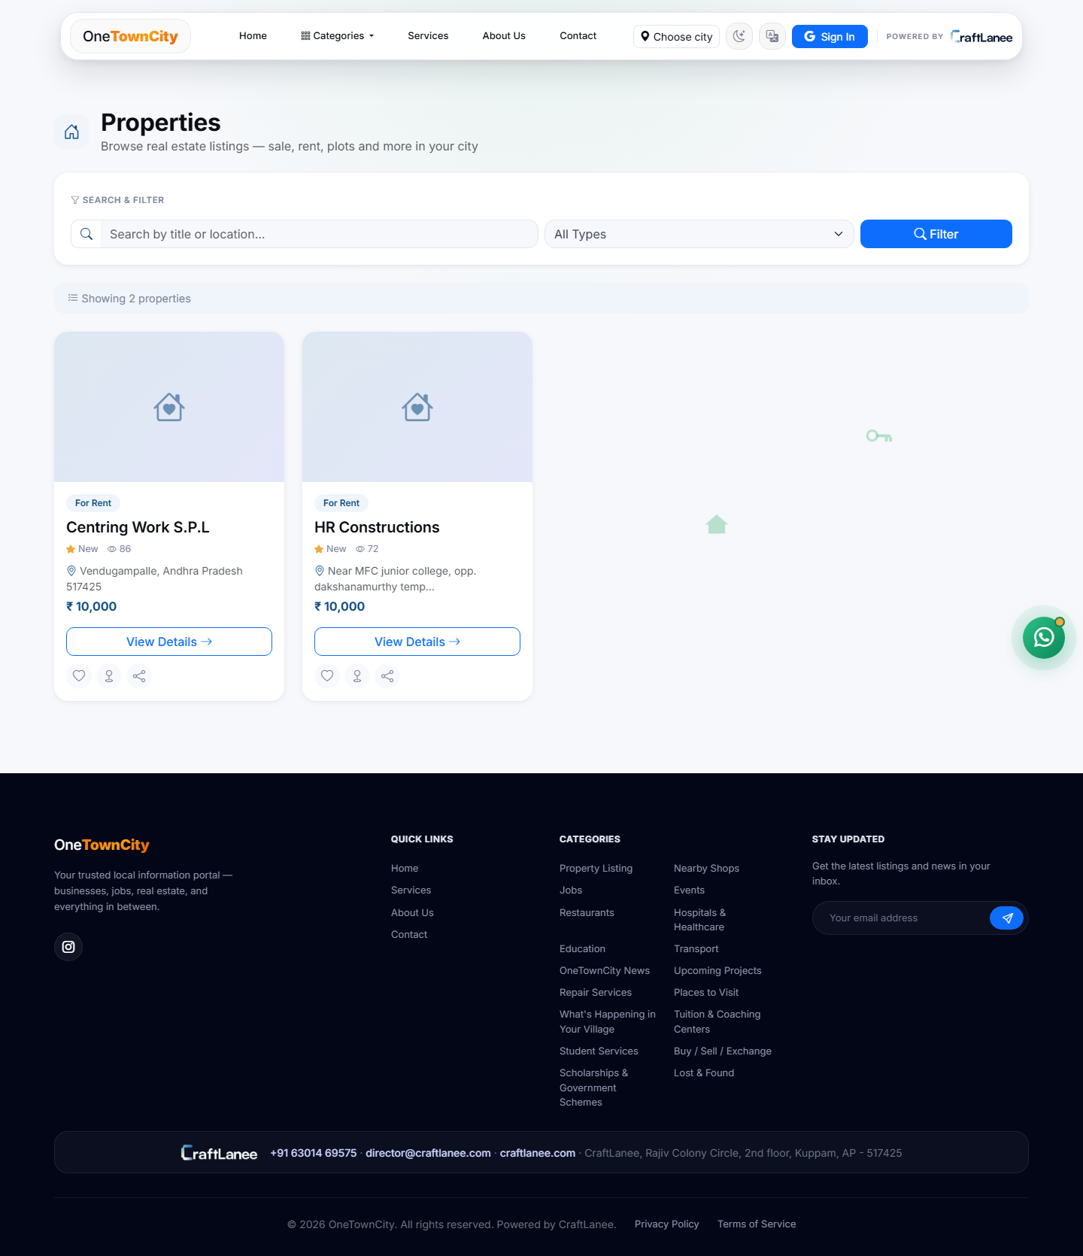
Figure 4: Property directory — grid of for-sale and for-rent listings.
The Properties page mirrors the Business directory’s search-and-filter pattern (title/location search plus a type filter) but swaps the business-card layout for one built around price and listing type — each card leads with a “For Rent” / “For Sale” badge and the monthly rent or asking price, since that is almost always the first thing a property seeker filters on.
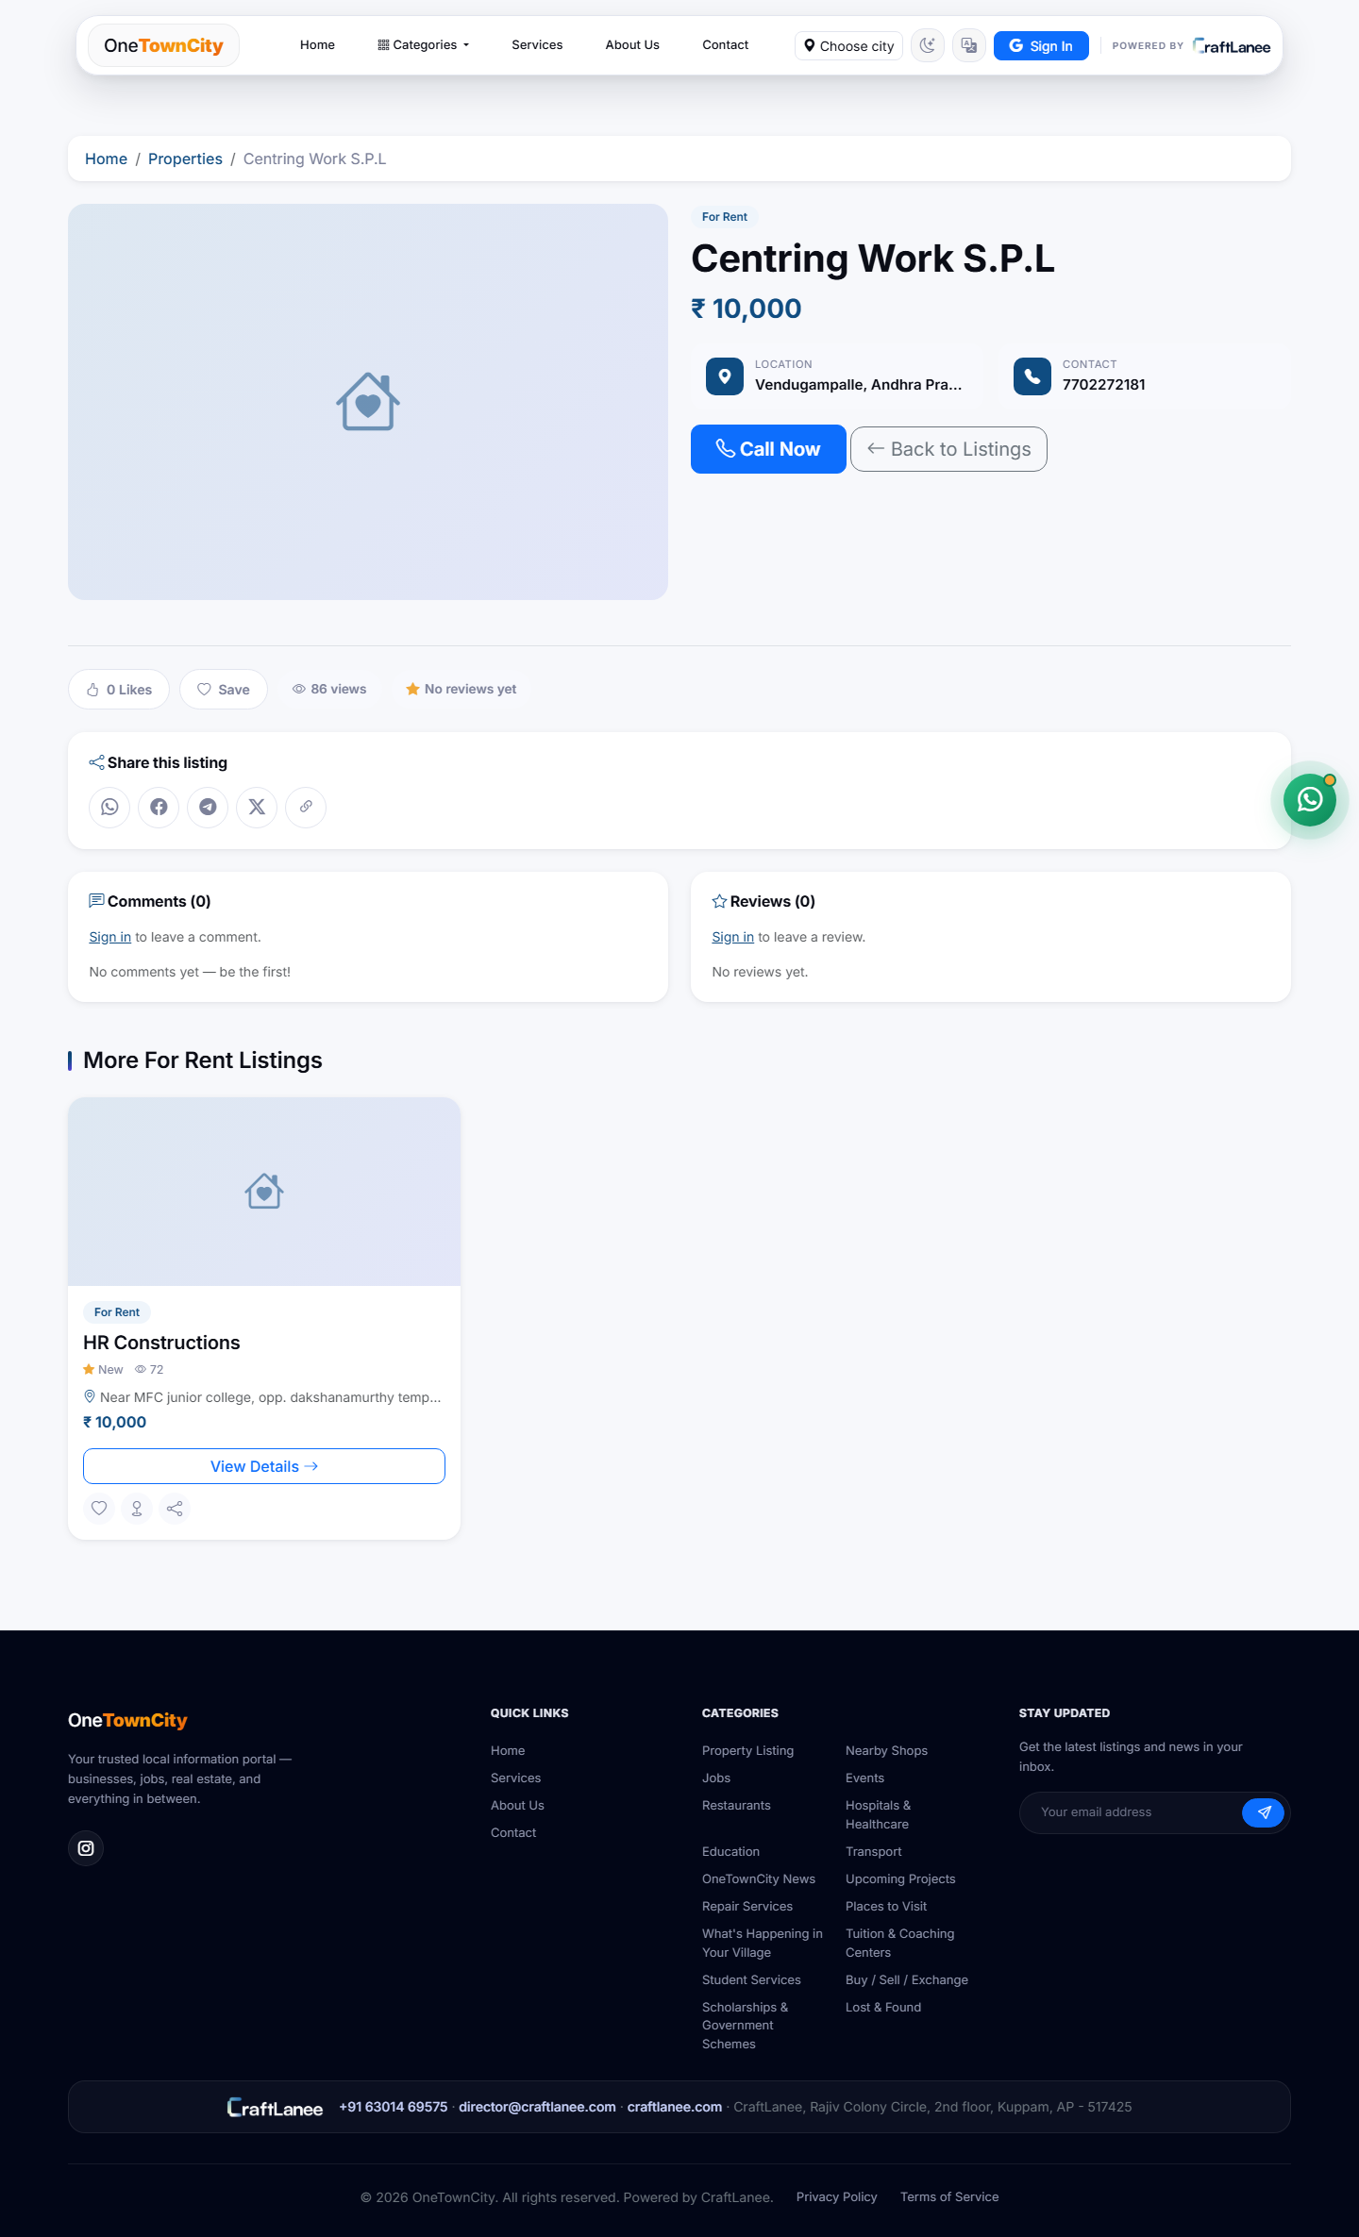
Figure 5: Property detail page — price, location, and direct contact.
As with businesses, the property detail page puts “Call Now” front and centre next to the price and location, on the reasoning that a property enquiry is time-sensitive — a listing that is still available today may not be tomorrow, so the platform minimises the number of steps between finding a listing and actually calling about it.

6.3 Job
The Job listing type covers both regular, ongoing positions and one-off hourly gigs, capturing company name, job title, job type (regular or hourly), location, salary, contact details, GPS location, and — for hourly gigs specifically — an exact shift date and time.
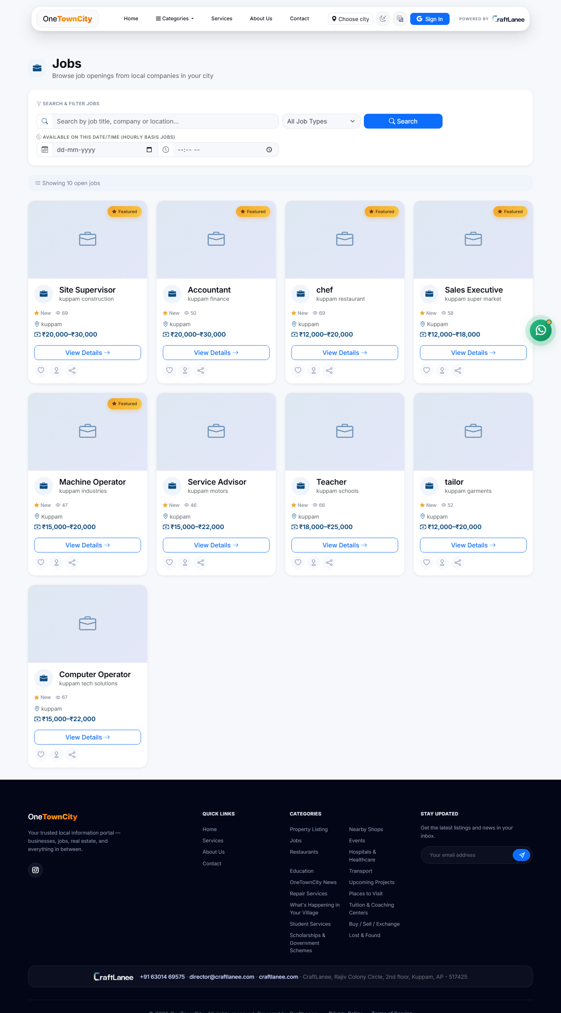
Figure 6: Job board — open positions with salary ranges and featured placement.
The job board lists every open position as a card with a salary band, location, and a “Featured” badge for promoted postings, alongside a filter for job type and a date/time picker specifically for finding hourly work available on a given day — a filter general-purpose job boards do not offer, and one that matters in a local, informal-economy job market where a large share of demand is short-term or gig work (a one-day event needing extra staff, a shift covering for someone) rather than a permanent role.

6.4 Event
Event listings capture a title, date and time, venue, description, contact details, and a Google Maps link — covering everything from religious festivals to civic gatherings.
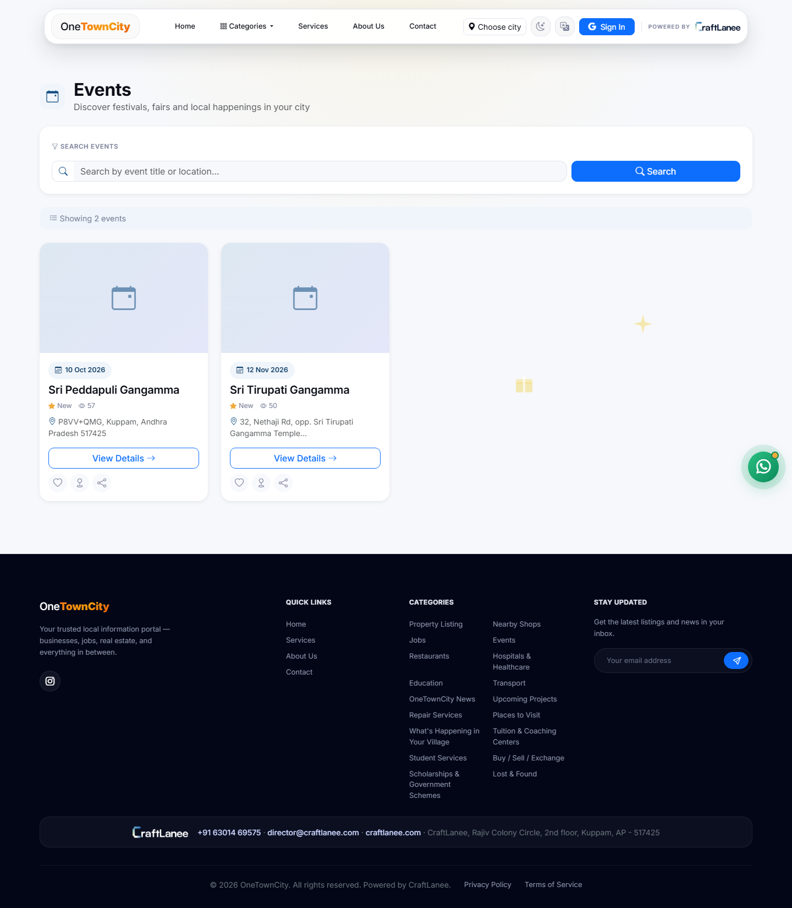
Figure 7: Events listing — upcoming local festivals and gatherings.
Each event card leads with its date, since that is the first filter a visitor applies mentally (“is this happening before or after the date I care about”), followed by the event name, location, and a view count that doubles as a rough popularity signal for undecided visitors.

6.5 News
News listings carry a title, article content, publish date, source attribution, and an optional photo, and are used for local announcements and civic updates.
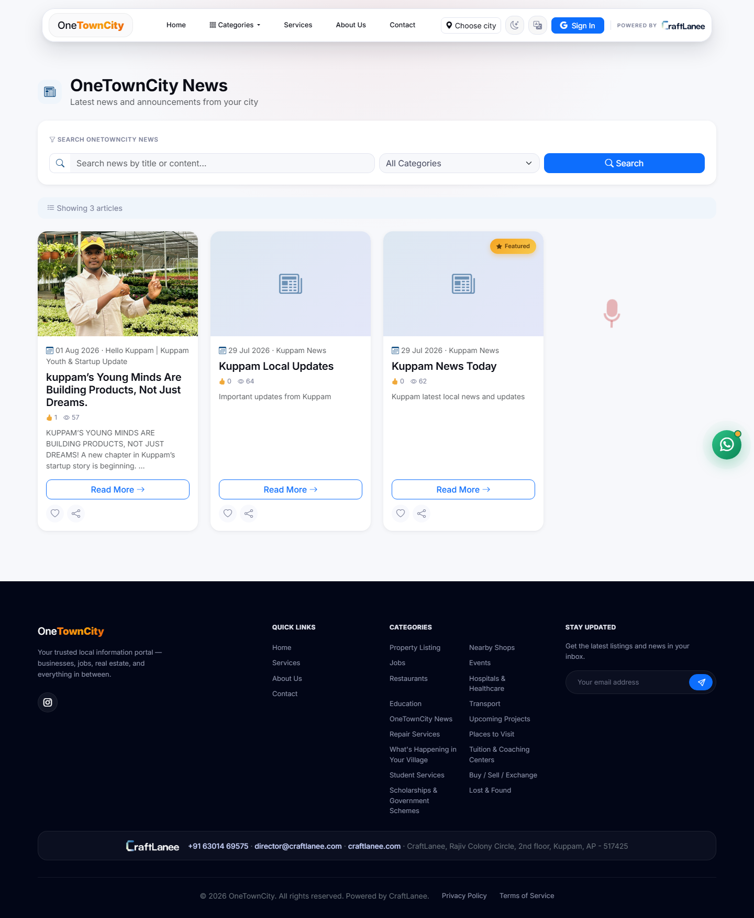
Figure 8: OneTownCity News — local announcements with likes and view counts.
The News section mixes staff-written civic updates with community-submitted stories — the featured article shown here, about young entrepreneurs in Kuppam building products locally, carries a genuine photograph rather than a placeholder icon, which is what a News listing looks like once a Content Provider has actually uploaded imagery. Each article shows a like count and a view count directly on its card, the same lightweight engagement signals used across every other listing type, so residents get a consistent way to judge what is worth reading before clicking through.

6.6 Civic Project
Civic Project listings are the platform’s answer to the transparency gap described in Section 2.4. Each one captures a title, status (planned, ongoing, or completed), location, expected completion date, and the executing department — turning “work suddenly started on my street” into something a resident could have looked up in advance. The category is fully built and wired into the same review workflow as every other listing type; it currently shows zero live entries in the Kuppam deployment simply because no civic project has been submitted into it yet, not because the feature is incomplete.

7. Content Review & Approval Workflow
To keep the platform accurate and trustworthy — the core problem identified in Section 2 — every submission moves through a clear, auditable approval process rather than going live the moment it is submitted.
Draft → Pending Approval → Approved / Rejected / Changes Requested
- Instant publish — City Admin submissions are published instantly, since they carry full authority over their city.
- Review queue — Sub Admin and Content Provider submissions enter a review queue for the responsible admin.
- Full control — Reviewers can approve, reject with a reason, or request changes before resubmission.
- Accountability — Every listing keeps a permanent record of who reviewed it and when.
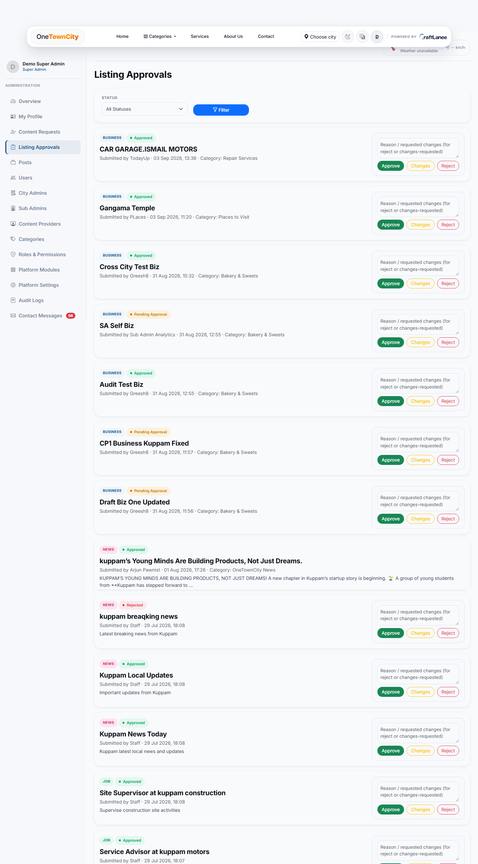
Figure 9: Listing Approvals queue — Super Admin view, spanning every listing type.
This is the operational heart of the trust model: every pending, approved, and rejected submission across every listing type — Business, News, Job, and the rest — lands in one reviewable queue, each entry showing who submitted it, when, and which category it targets, with Approve, Changes, and Reject actions (plus a free-text reason field for the latter two) directly inline. A reviewer never has to leave this screen to act on a submission, and because the queue mixes listing types rather than splitting them into separate screens, a City Admin can clear a backlog across the entire city in one pass instead of switching context six times.

8. Category & Access Management

8.1 Becoming a Content Provider
- Residents and businesses apply to list content in one or more categories directly from the site.
- Applications are reviewed and approved or rejected by the responsible City Admin, with an optional note explaining the decision.
- Approved requests grant access scoped to exactly those categories — nothing broader.
- Existing Content Providers can request additional categories at any time from their own dashboard, without starting over.
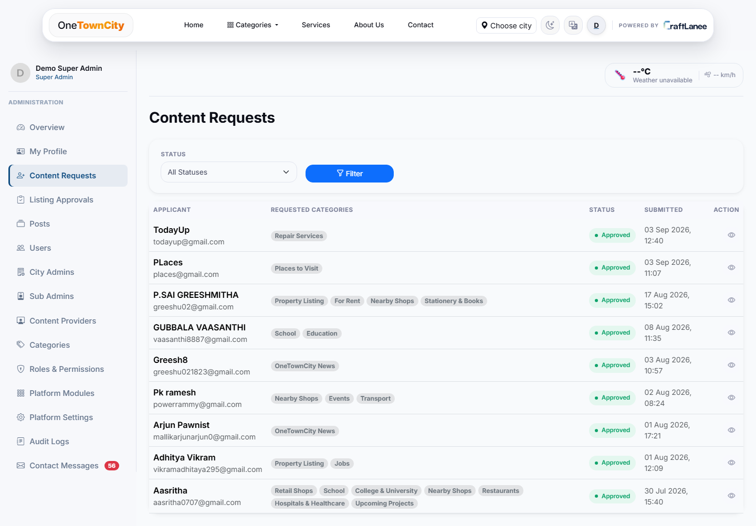
Figure 10: Content Requests — every category application, reviewed and tracked.
Every application to become a Content Provider, or to expand into new categories, is logged here with the applicant’s name and email, the specific categories they requested, current status, and submission date. Nothing about category access is implicit or undocumented — an admin (or, later, an auditor) can see exactly who asked for what and when, which matters because category access is the mechanism that controls who is allowed to publish content on the platform at all.

8.2 Category Structure
Categories are the backbone of the platform’s navigation, search filters, and listing forms — every category maps to one of the six underlying listing models (Business, Property, Job, Event, News, or Civic Project), can be marked active or hidden, can be toggled on or off the homepage per city, and can be nested so that a parent category automatically grants access to its subcategories.
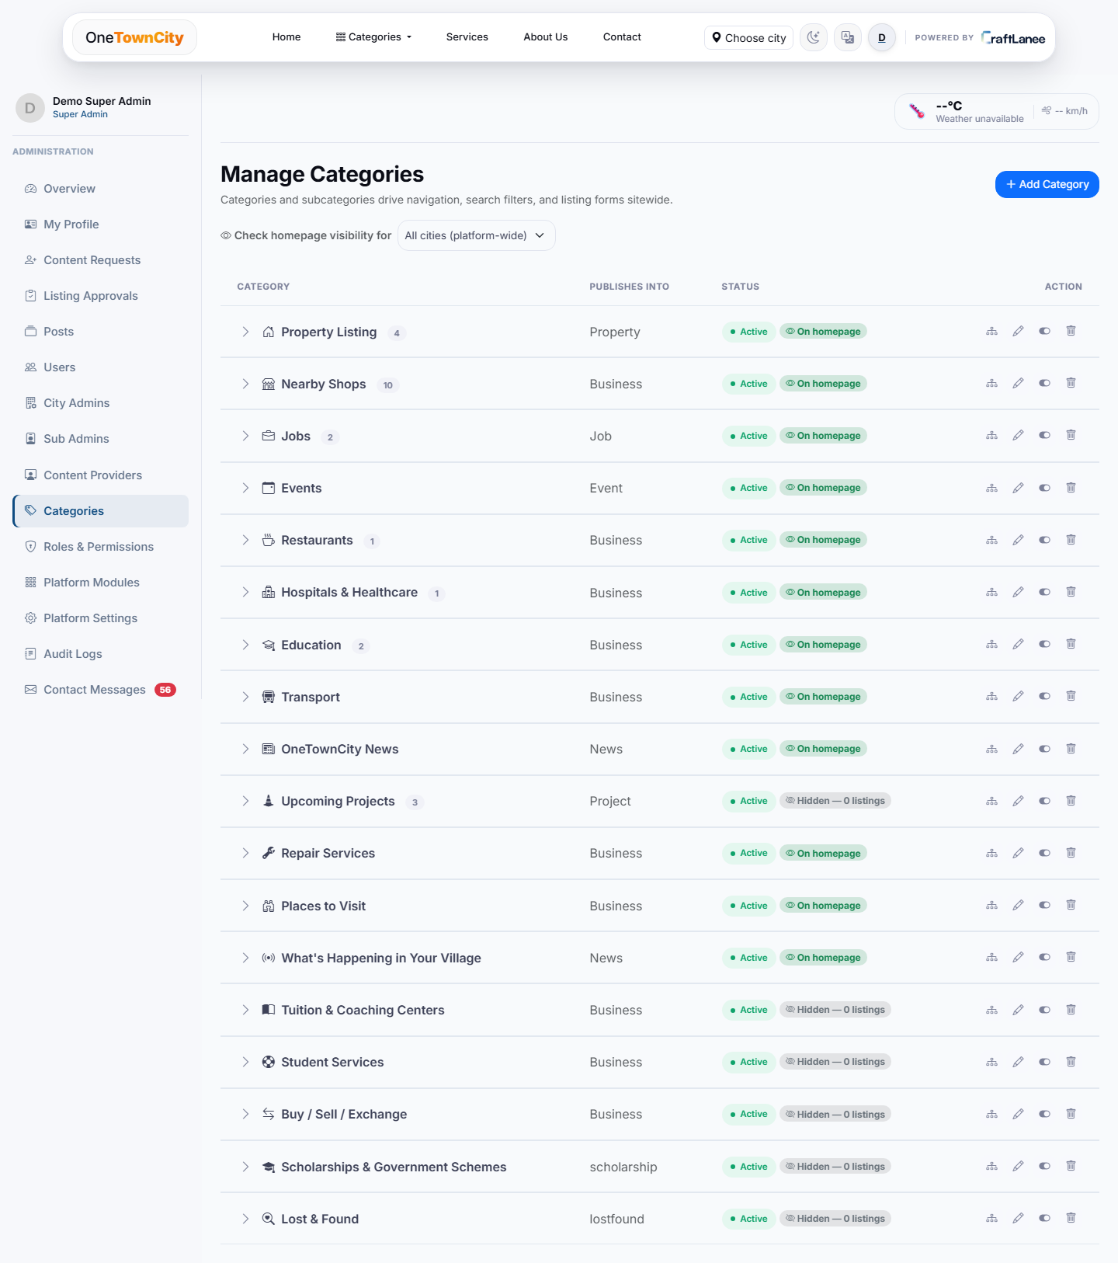
Figure 11: Category management — the full category tree with homepage visibility controls.
Each row shows which underlying model a category publishes into, its live listing count, whether it is active, and whether it currently appears on the homepage — with that homepage visibility checkable per city rather than globally, so a category that makes sense in one city does not have to be forced onto every other city’s homepage once the platform expands. Categories with zero listings so far (Tuition & Coaching Centers, Student Services, Buy/Sell/Exchange, and others visible here) are already fully wired up and simply waiting for their first Content Provider submission — adding a category to the platform is a configuration action here, not a development task.

8.3 Delegated Admin Control
- City Admins can delegate view, add, edit, delete, and approve rights per listing type to Sub Admins.
- City-level scoping is built into every account and every listing, ready to support additional towns without any structural change.
- A parent category can grant access to its subcategories automatically, so delegation does not have to be repeated one subcategory at a time.
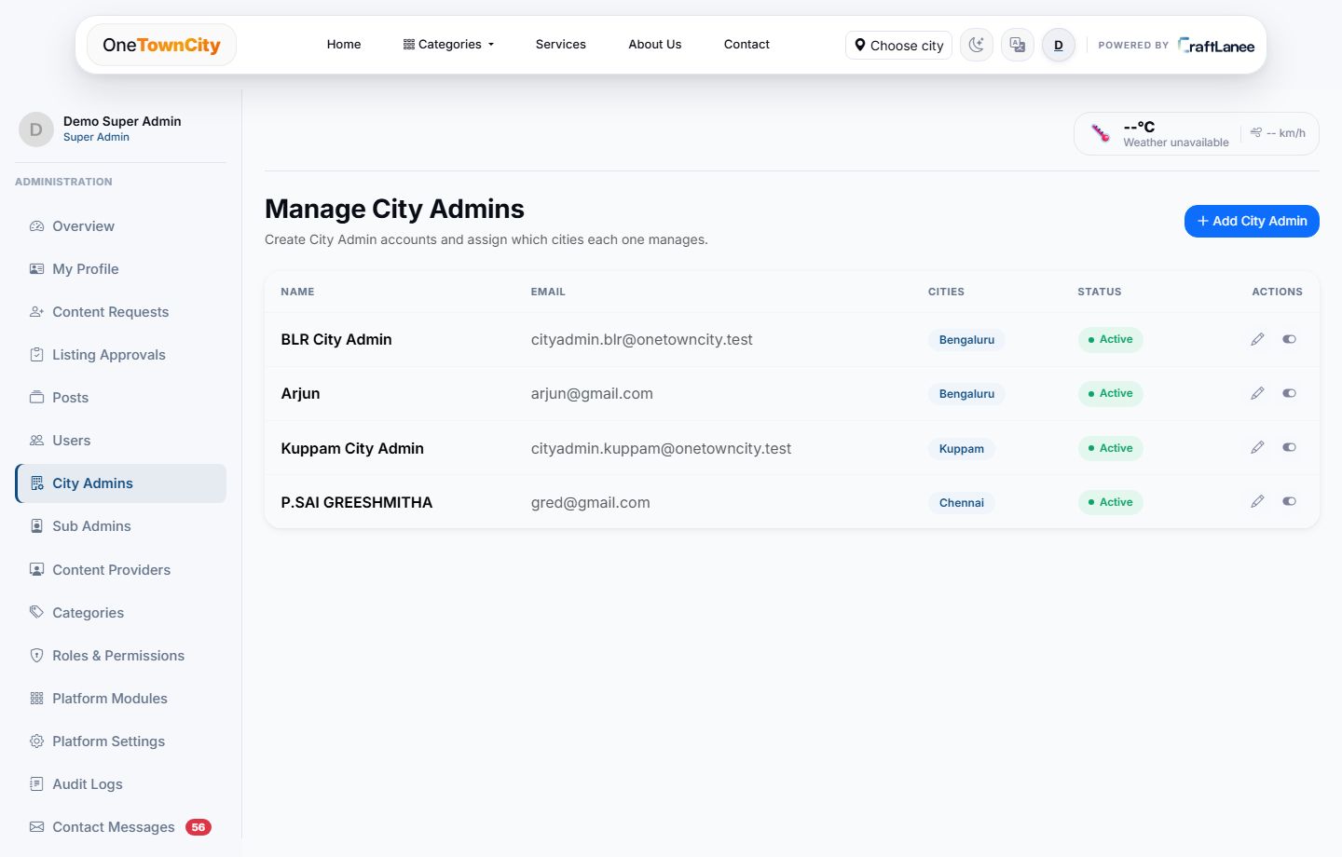
Figure 12: Manage City Admins — Super Admin's view of every City Admin and their assigned city.
Only the Super Admin can create a City Admin account, and every account is bound to a specific city at creation time (Bengaluru, Kuppam, and Chennai are shown here as configured cities in this environment, demonstrating the multi-city scaffolding described in Section 3.4 already functioning end to end, not just designed for on paper).
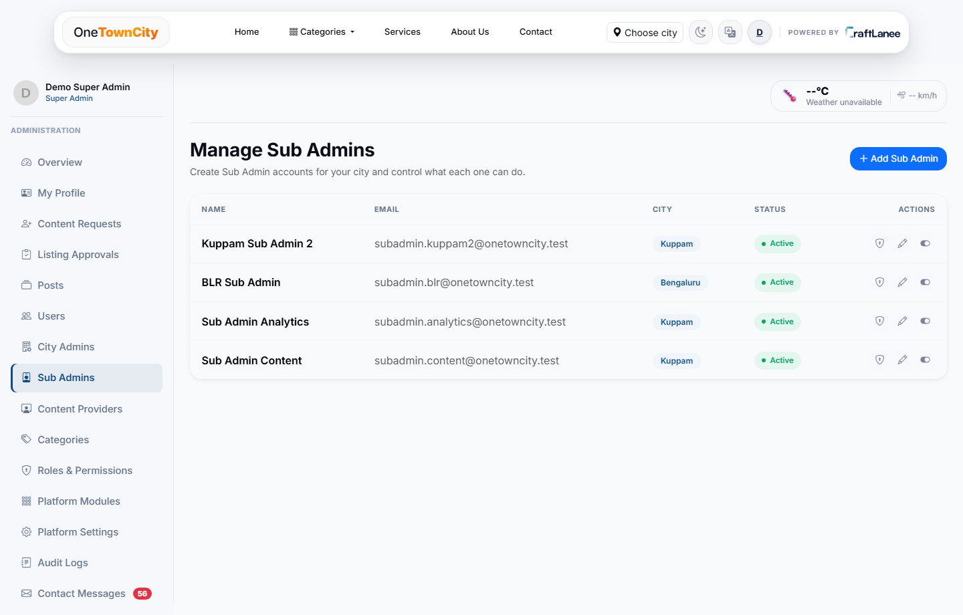
Figure 13: Manage Sub Admins — City Admin's view of their delegated team.
A City Admin creates Sub Admin accounts from this screen and, via the shield icon on each row, opens the per-user permission matrix that defines exactly which listing types and actions that Sub Admin can touch — the mechanism that lets a City Admin split moderation work by category (one Sub Admin for Events, another for Businesses) instead of reviewing everything personally.
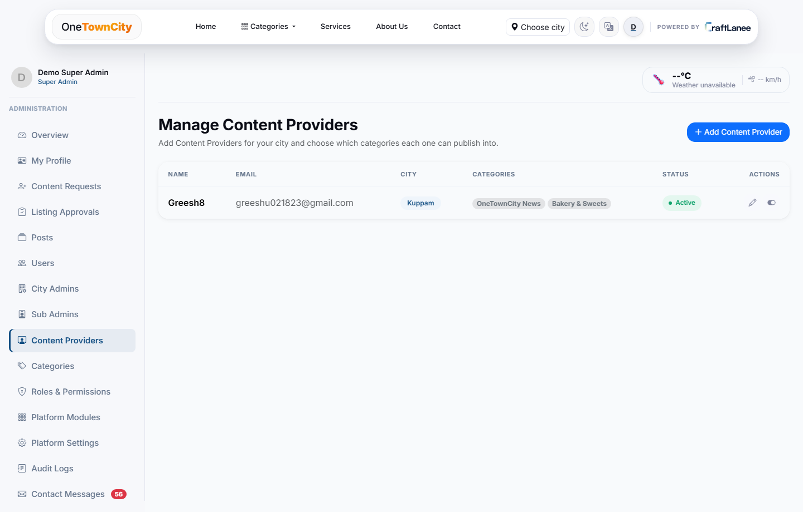
Figure 14: Manage Content Providers — City Admin's view of approved publishers and their categories.
Every approved Content Provider and the exact categories they can publish into is listed here in one place, giving a City Admin a single screen to audit who has publishing rights across their entire city at any given time.

9. Key Platform Features

9.1 Discovery & Search
- Site-wide search with category and listing-type filters, from a single search bar.
- “Near me” GPS-based search that surfaces nearby shops and services based on live location.
- Precise location pinning, with a Google Maps link auto-derived from GPS or entered manually.
- Structured, auto-formatted business working hours, shown day by day.
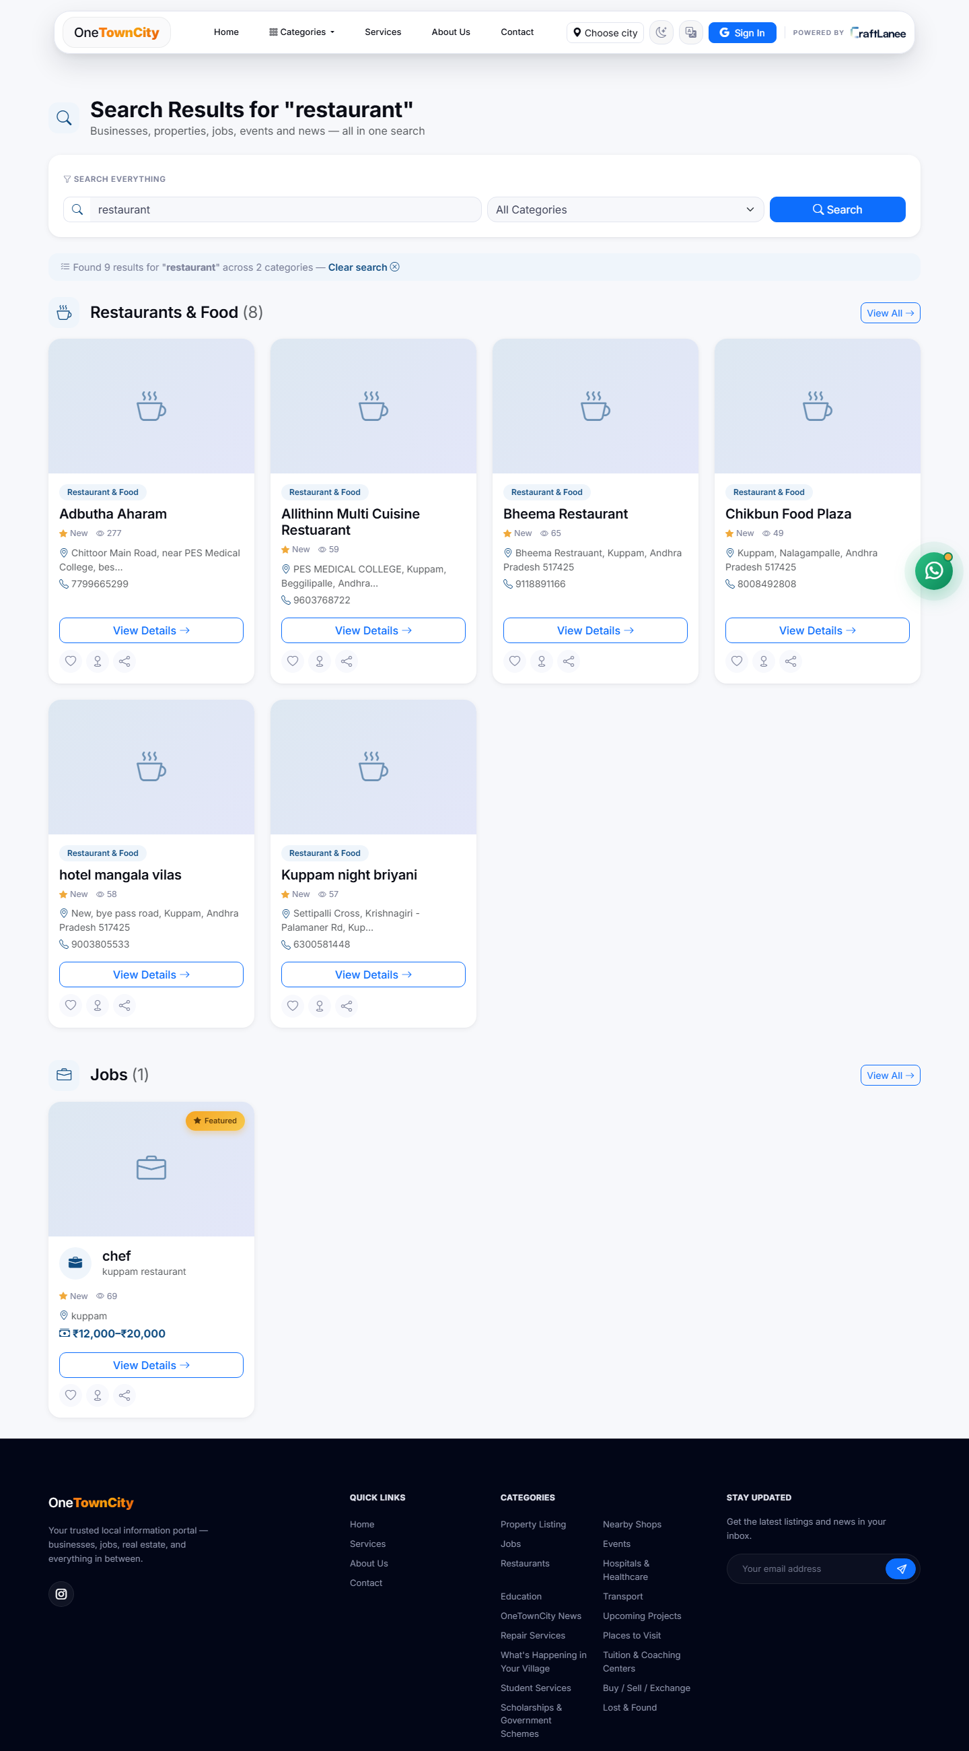
Figure 15: Site-wide search results — one query spanning every listing type.
Search does not stay confined to one listing type: a query for “restaurant” shown here returns results grouped by category — eight matches under Restaurants & Food and, in the same results page, one match under Jobs (a “chef” posting) — because the same keyword can be relevant across different kinds of listings. This cross-model search is what makes the single combined search bar on the home page meaningful rather than cosmetic; a visitor never has to guess which section of the site to search within.

9.2 Community Engagement
- Likes, comments, and star ratings/reviews on every listing.
- Favourites and one-tap social sharing to WhatsApp, Facebook, Telegram, and X.
- Content reporting, so any visitor can flag an inappropriate or outdated listing for moderator review.
- Newsletter subscription and a direct contact form.
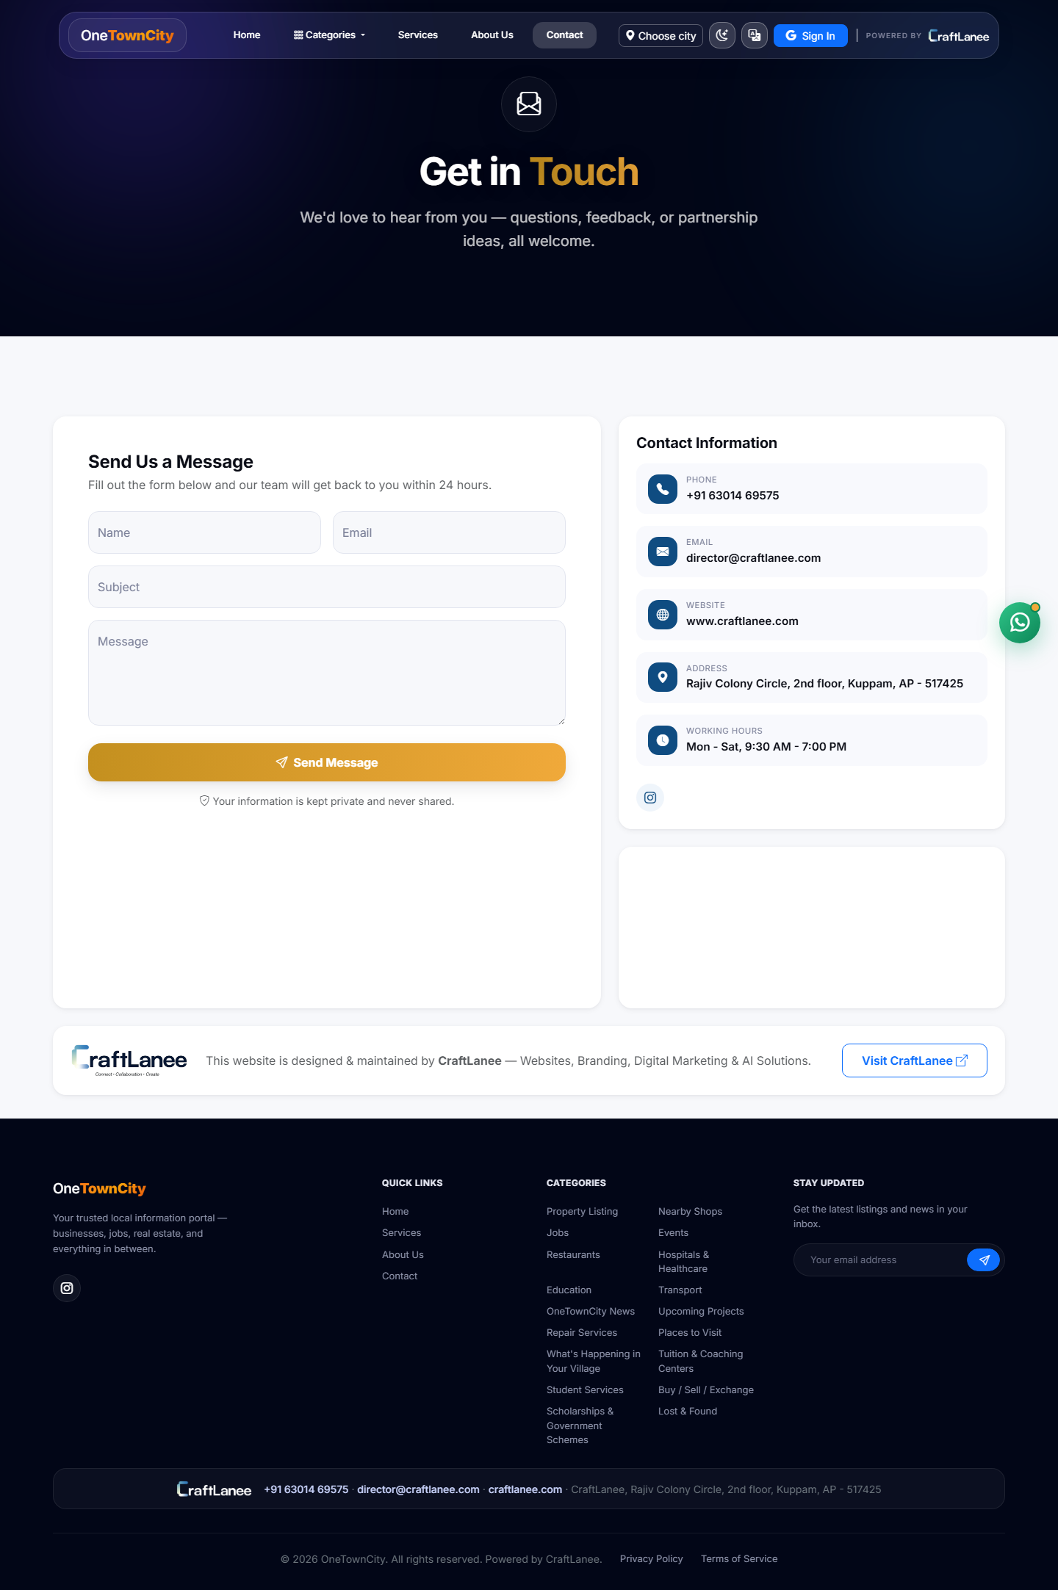
Figure 16: Contact page — direct enquiry form and full contact information.
Beyond listing-level engagement, the platform keeps one always-available channel for anything that does not fit a listing — a general enquiry, feedback, or a partnership question — through a structured contact form (name, email, subject, message) that lands directly in the admin's Contact Messages inbox (Section 9.6), next to the operator's phone number, email, and physical address for anyone who prefers to reach out directly.

9.3 Notifications
[NEW]
- An in-app notification bell for every signed-in user, with unread counts.
- Browser and OS-level web push notifications, so alerts reach users even when the site is not open.
- Admin dashboard alerts the moment a new category request or listing needs review.
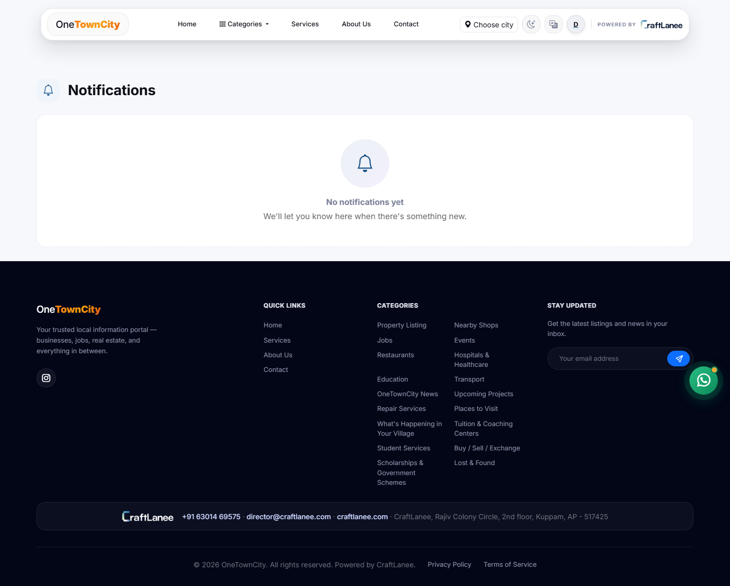
Figure 17: In-app notifications — shown here in its empty state.
The notification centre is shown here in its default empty state (“No notifications yet”), which is the correct state for a freshly-created or lightly-used account — once a user's listing is approved, rejected, commented on, or a category request they submitted is actioned, this is the panel that alerts them, both here in-app and, if the browser permission is granted, as an OS-level push notification even if the OneTownCity tab is closed. This closes a real gap the platform had before: previously, a Content Provider had no way to know their submission had been reviewed except by checking back manually.

9.4 Accessibility & Reach
- Multi-language interface — Hindi, Tamil, Telugu, and Kannada, alongside English.
- Google Sign-In for quick, secure access with nothing to remember.
- Mobile-friendly, responsive design, built for the phone-first way most residents actually use the internet.

9.5 Admin Tools
- Excel bulk import/export for fast content seeding across any listing type.
- A cross-model content operations screen covering every listing type from one table.
- Login history tracking for security auditing.
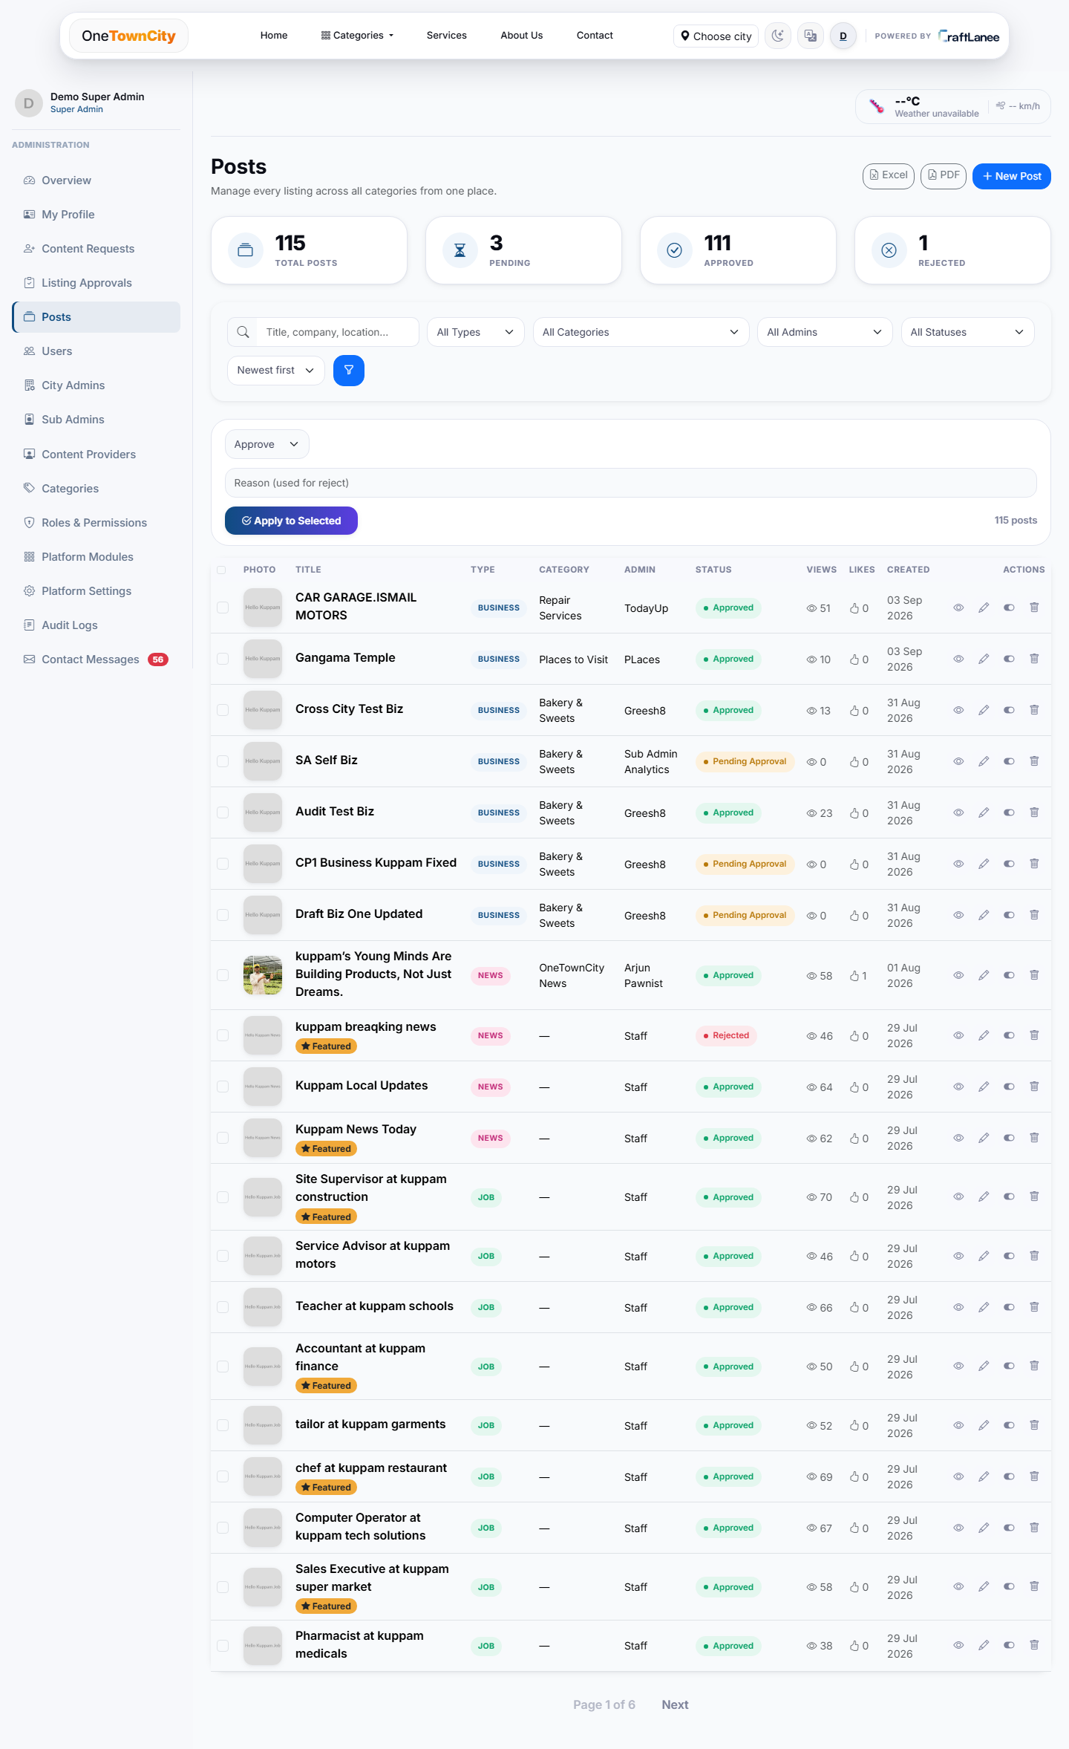
Figure 18: Posts — every listing type unified into one operations table.
Rather than giving an admin six separate screens (one per listing type), Posts unifies Business, Property, Job, Event, News, and Civic Project rows into a single searchable, filterable table — 115 total posts in this environment, with live counts for pending, approved, and rejected. Bulk actions (approve, reject, activate, feature, or delete a batch at once) and Excel/PDF export sit directly above the table, and each row exposes view, edit, visibility-toggle, and delete actions inline, so day-to-day moderation rarely requires leaving this one screen.
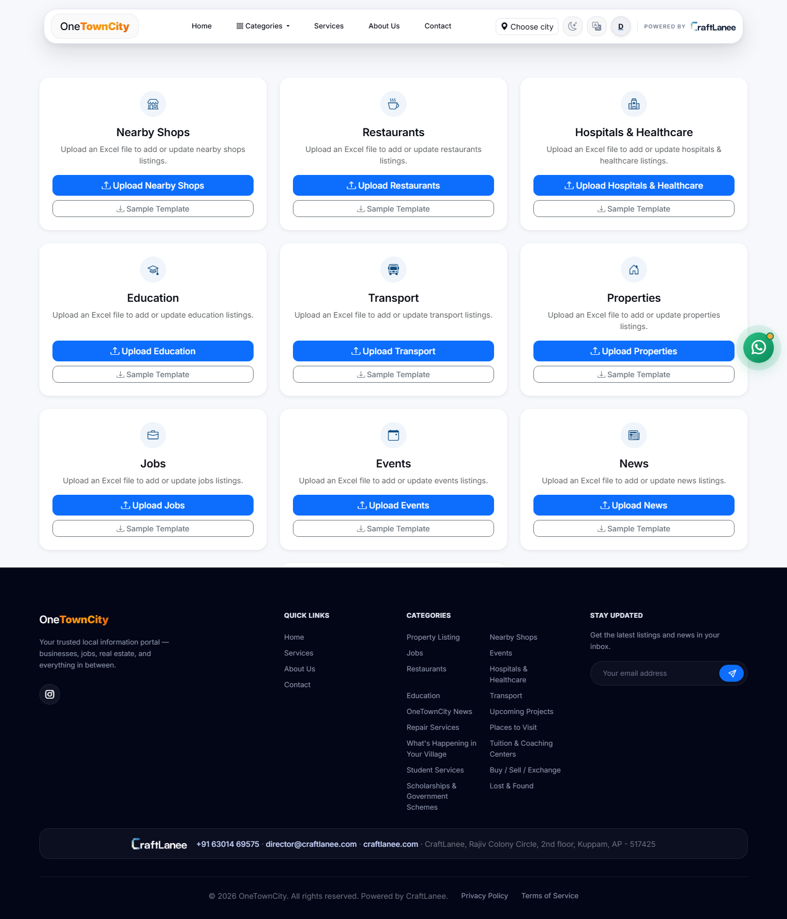
Figure 19: Excel Upload Center — bulk-seed any listing type from a spreadsheet.
Every listing type gets its own upload card with a dedicated Upload button and a downloadable Sample Template that shows the exact expected column layout, built on pandas/openpyxl with clear per-row error feedback on failure. This exists specifically to make onboarding fast: a City Admin bringing in an existing spreadsheet of, say, forty local businesses can seed all of them in one upload instead of typing each one into the listing form by hand. Uploads made by a Content Provider are attributed to them and enter the normal approval queue exactly like a manual submission; uploads made by staff publish directly, consistent with the same instant-publish rule that applies to every other City-Admin-level action.

9.6 Trust & Safety
- Per-user suspension and blocking controls.
- A full approval trail retained on every listing, permanently.
- Role-based access enforced at every level of the platform, not just in the UI.
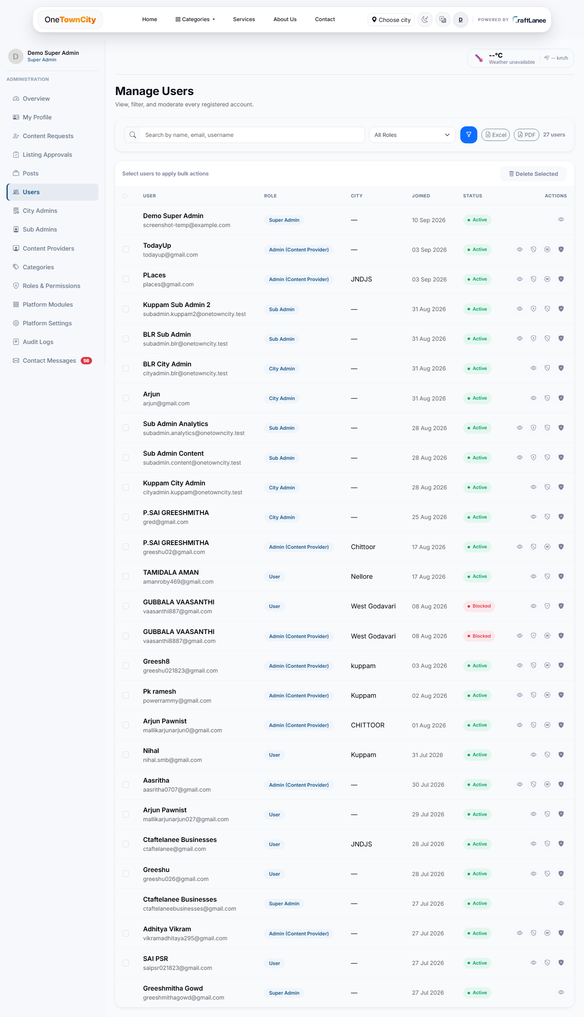
Figure 20: Manage Users — search, filter, export, and moderate every registered account.
Every account on the platform — 27 in this environment — is visible here with its role, assigned city, join date, and current status (Active or Blocked), searchable by name, email, or username and filterable by role, with Excel and PDF export for offline reporting and bulk-delete for cleanup. The per-row action icons let an admin view, adjust permissions, block, or manage an account without leaving the list — including the two “Blocked” accounts visible here, demonstrating the suspension control in active use rather than as a theoretical feature.
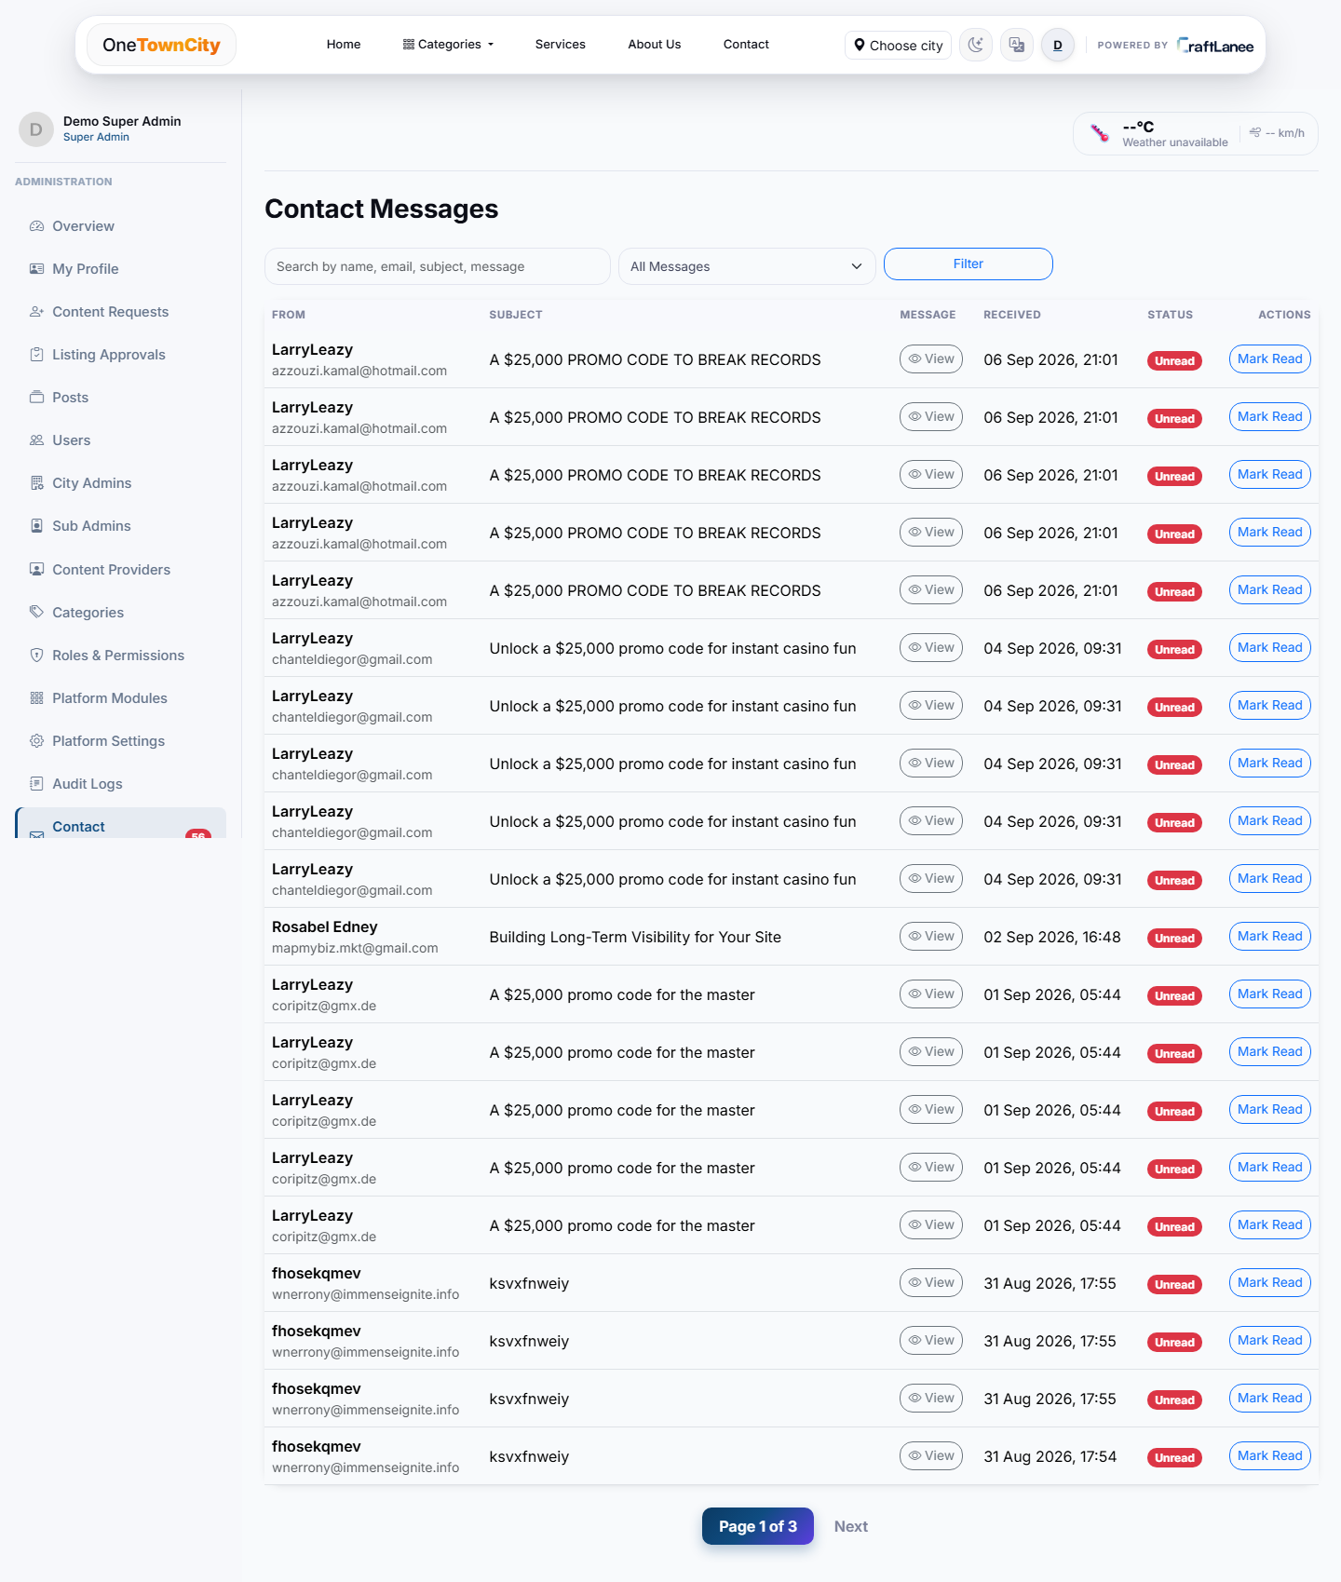
Figure 21: Contact Messages — every inbound enquiry from the public contact form, in one inbox.
Every submission from the Contact page (Section 9.2) lands here, unread by default, with search and a status filter. In an active, publicly-reachable inbox like this one, a meaningful share of the traffic is automated spam rather than genuine resident enquiries — visible here as repeated promotional messages from the same handful of senders — which is a normal consequence of exposing any public form to the open internet. The value of centralising every message in one filterable, mark-as-read inbox is precisely that it makes triaging that mix fast: a City Admin can work through Mark Read in bulk and still be confident a genuine enquiry has not been missed underneath the noise.

10. Administration & Analytics
The Super Admin dashboard is the platform's command centre — a single screen that answers “what is the state of the whole platform right now” without requiring a separate reporting tool.
- At-a-glance metrics — total listings, users, pending approvals, and activity, live.
- Role-aware views — Super Admin, City Admin, Sub Admin, and Content Provider each see a dashboard scoped to their own authority.
- Engagement analytics — views, likes, comments, and shares per listing over time, built from real event logs rather than estimates.
- City-ready — the same scoping used everywhere else in the platform, so onboarding another town is structural, not a rewrite.
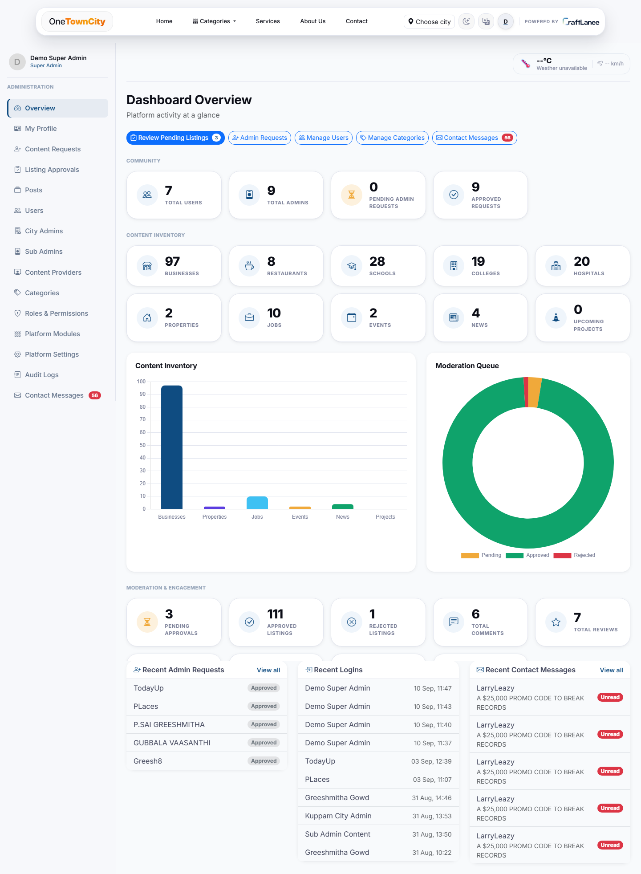
Figure 22: Super Admin Dashboard Overview — live platform metrics, content inventory, and moderation queue.
The dashboard is organised into four bands. Community (top) shows total users, total admins, and pending vs. approved admin requests. Content Inventory (middle) breaks every listing type down by category — 97 businesses further split into 8 restaurants, 28 schools, 19 colleges, and 20 hospitals, alongside 2 properties, 10 jobs, 2 events, and 4 news articles — visualised as a bar chart so an admin can immediately see which categories are actually active. The Moderation Queue donut chart shows the approved/pending/rejected split for content review at a glance (overwhelmingly approved here, which is the healthy state to be in). Moderation & Engagement (bottom) surfaces 3 pending approvals, 111 approved listings, 1 rejected listing, 6 total comments, and 7 total reviews, followed by three live activity feeds — Recent Admin Requests, Recent Logins, and Recent Contact Messages — so an admin starting their day can see exactly what changed since they last checked, without hunting through separate screens.

11. Roles & Permissions Capability Matrix
Every capability in the system — not just broad role descriptions, but individual actions like “Approve Businesses” or “Manage Sub Admins” — is controlled by an explicit, per-role toggle rather than hard-coded logic. The Super Admin always has unrestricted access; every other role's capabilities can be granted or revoked here, and changes take effect immediately on that role's own dashboard.
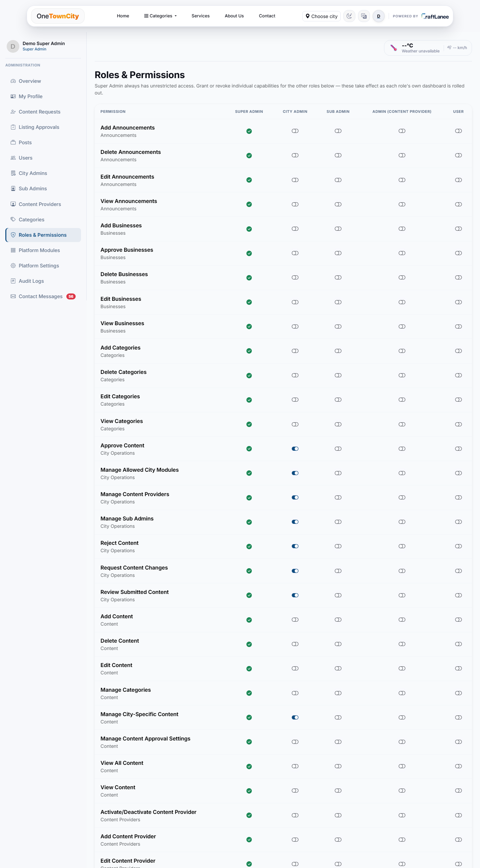
Figure 23: Roles & Permissions — the platform's full capability matrix.
The matrix lists permissions down the left — grouped by area, such as Announcements, Businesses, Categories, City Operations (Approve Content, Manage Allowed City Modules, Manage Content Providers, Manage Sub Admins, Reject Content, Request Content Changes, Review Submitted Content), and Content (Add/Delete/Edit Content, Manage Categories, Manage City-Specific Content, Manage Content Approval Settings, View All Content) — with a column per role (Super Admin, City Admin, Sub Admin, Admin/Content Provider, User) and a live toggle at each intersection. The same pattern of Add/Delete/Edit/View/Approve rows repeats for every other content area not shown in this excerpt — Properties, Jobs, Events, News, Civic Projects, Content Providers, Sub Admins, and City Admins each have their own equivalent block — so the entire access model for the platform is visible and editable from this one screen, rather than living in code that only a developer could change.

11.1 Why a Live Matrix Instead of Fixed Roles
Most small platforms hard-code what each role can do, which means any change to that logic requires a developer and a deployment. OneTownCity instead treats permissions as configuration: a City Admin who decides a particular Sub Admin should also be able to manage Categories, not just approve content, can grant that from this screen in seconds — and just as importantly, can revoke it just as fast if that turns out to be the wrong call, with the change visible to everyone with access to this page.

12. Technology Overview
OneTownCity is built on a modern, reliable, and widely-supported technology stack, chosen for long-term maintainability over novelty:
- Django 5.1 (Python) — the web application framework handling routing, business logic, and the admin tooling described throughout this document.
- PostgreSQL Database, hosted on Supabase — the platform's single source of truth for every listing, user, and permission.
- Supabase Cloud Storage — stores every uploaded photo across every listing type.
- Bootstrap 5.3 — the responsive frontend framework behind the mobile-first design referenced in Section 9.4.
- Google Sign-In Authentication, bridged through Supabase Auth — gives residents secure access with no new password to remember.
- Web Push Notifications — powers the browser/OS-level alerts described in Section 9.3.
- Excel Import/Export (pandas / openpyxl) — powers the bulk-seeding tooling described in Section 9.5.
- Gunicorn — the production WSGI server the application runs behind in every deployed environment.
The application is deployment-ready for standard cloud hosting platforms (currently running on Railway), with static assets served directly by WhiteNoise — removing the need for a separate CDN — and all configuration kept out of the codebase so the same application can be deployed securely to any environment without code changes.

13. Local Employment & Economic Impact
Beyond the product itself, OneTownCity has a direct answer to a question CraftLanee gets asked about every local platform it builds: what opportunity does this actually create for people, beyond the residents who use it to browse? There are three distinct layers to that answer, and it matters to keep them separate rather than blur them into one number — one is a community side-effect of the product, one is income enabled for local business owners, and only one is employment CraftLanee itself creates.

13.1 Jobs Discovered Through the Platform (Community Side-Effect)
The Job listing type (Section 6.3) already carries real, live postings from local employers — kuppam construction, kuppam finance, kuppam restaurant, kuppam schools, kuppam motors, and others — ten open positions at the time of writing, spanning roles such as Site Supervisor, Accountant, Chef, Sales Executive, Machine Operator, Service Advisor, Teacher, Tailor, and Computer Operator. It is important to be precise here: these are not jobs CraftLanee creates or hires for. They are openings posted by other local employers who, before OneTownCity existed, had no channel to advertise beyond word of mouth (Section 2.2). What the platform contributes is the matching itself — a public, searchable board instead of a personal network — which is a genuine community benefit, but a different thing from CraftLanee employment.

13.2 Income Opportunity for Local Business Owners (Content Providers)
Every approved Content Provider (Section 5.4) is a resident or business owner who gains a new, essentially free distribution channel the moment their category application is approved (Section 8.1). For a repair shop, a tuition centre, or a restaurant that previously had no online presence at all (Section 2.3), that is a real increase in how many potential customers can find them — an income opportunity the platform enables, though again not a CraftLanee payroll role. This is the layer where the platform's value is closest to the businesses themselves, rather than to CraftLanee's own operations.

13.3 Operational Roles the Platform Itself Requires (Direct CraftLanee Opportunity)
This is the direct answer to what CraftLanee itself can offer. Running OneTownCity for even a single town is not a fire-and-forget deployment — it requires real people sitting in the City Admin and Sub Admin roles described in Section 5, actively reviewing submissions, managing categories, and moderating users. The Kuppam deployment alone already sustains 9 staffed admin accounts today (visible on the dashboard in Section 10) — concrete proof that a single city deployment already carries close to ten working roles, before counting Content Providers at all.
Beyond the roles already built into the permission system, operating the platform well in practice calls for local, human roles the software cannot automate:
- Field onboarding agents — visit local businesses in person to sign them up and photograph their storefronts for the directory (Section 6.1), since many owner-operated businesses will never fill in an online form unassisted.
- A local WhatsApp / customer support contact — staffs the WhatsApp button visible on the home page (Section 4) and answers resident questions directly, in the resident's own language.
- Local translators and reviewers — keep the Hindi, Tamil, Telugu, and Kannada versions of the platform (Section 9.4) accurate as new categories and listings are added, since machine translation alone will not carry the tone of a genuinely hyperlocal directory.
- Category-specific Sub Admins — paid or part-time moderators delegated authority (Section 5.3) over a single listing type such as Events or Jobs, so review work can be split across several people instead of bottlenecking on one City Admin.

13.4 A Repeatable, Town-by-Town Employment Model
Role | Who Creates / Fills It | Nature of the Opportunity | How It Scales
City Admin | CraftLanee / local operator | Paid local coordination and final content authority for one city | +1 per new city onboarded
Sub Admin(s) | CraftLanee / local operator | Delegated, category-specific moderation work | 1—3 per city, by content volume
Field Onboarding Agent | CraftLanee (paid / commission) | Signs up and photographs local businesses in person | Scales with unlisted businesses per town
Local Translator / Reviewer | CraftLanee (freelance / part-time) | Keeps regional-language content accurate | One per language, shareable across towns
WhatsApp / Support Contact | CraftLanee | Answers resident queries via the homepage support channel | +1 per city or shared regionally
Content Provider | Local business owner (self) | New customer-reach / income channel, not a CraftLanee hire | Grows with approved category requests (8.1)
Job Seeker (community benefit) | Local resident | Finds work posted by third-party local employers | Grows with employer adoption of Jobs (6.3)

Because the entire access model is city-scoped by design (Section 3.4), this same small local team — one City Admin, one or two Sub Admins, a handful of field onboarding agents, a support contact, and a translator per language — is the unit that repeats every time OneTownCity launches in a new town. Scaling to five towns does not mean building one large central team five times over; it means standing up five of these small, town-rooted teams, each drawing its Sub Admins, field agents, and support contact from that town's own residents wherever possible. That is the direct, honest shape of the opportunity CraftLanee is positioned to create through this platform: not a fixed headcount, but a distributed, repeatable set of local roles that grows one-for-one with every new town the platform reaches.

14. Conclusion & Roadmap
OneTownCity was built to close a specific, well-understood gap: Kuppam's residents and businesses had no single, trusted, searchable place to find or be found, and the town's civic activity had no visible public record. Every design decision in this document — the self-service-plus-review content model, the five-role delegation hierarchy, the city-scoped architecture, the multi-language and mobile-first approach — traces back to one of the specific problems laid out in Section 2.
The platform today is fully functional across all six listing types, all five roles, and the complete review-and-approval workflow, with real content already live — 97 businesses, 10 open jobs, 2 properties, 2 events, and 4 news articles at the time of writing, moderated by a working admin hierarchy of 9 admin accounts.
Natural next steps, several of which the underlying architecture already supports without structural change, include: onboarding a second city to validate the multi-city scaffolding in production; populating the Civic Project category with the town's first tracked infrastructure work, closing the transparency gap described in Section 2.4; and extending the analytics dashboard in Section 10 with longer-term trend views now that real usage data has started to accumulate.
OneTownCity — Project Document — Prepared by CraftLanee — September 2026

