The Book of Cereal

Maintained by Christopher [ctag] Bero

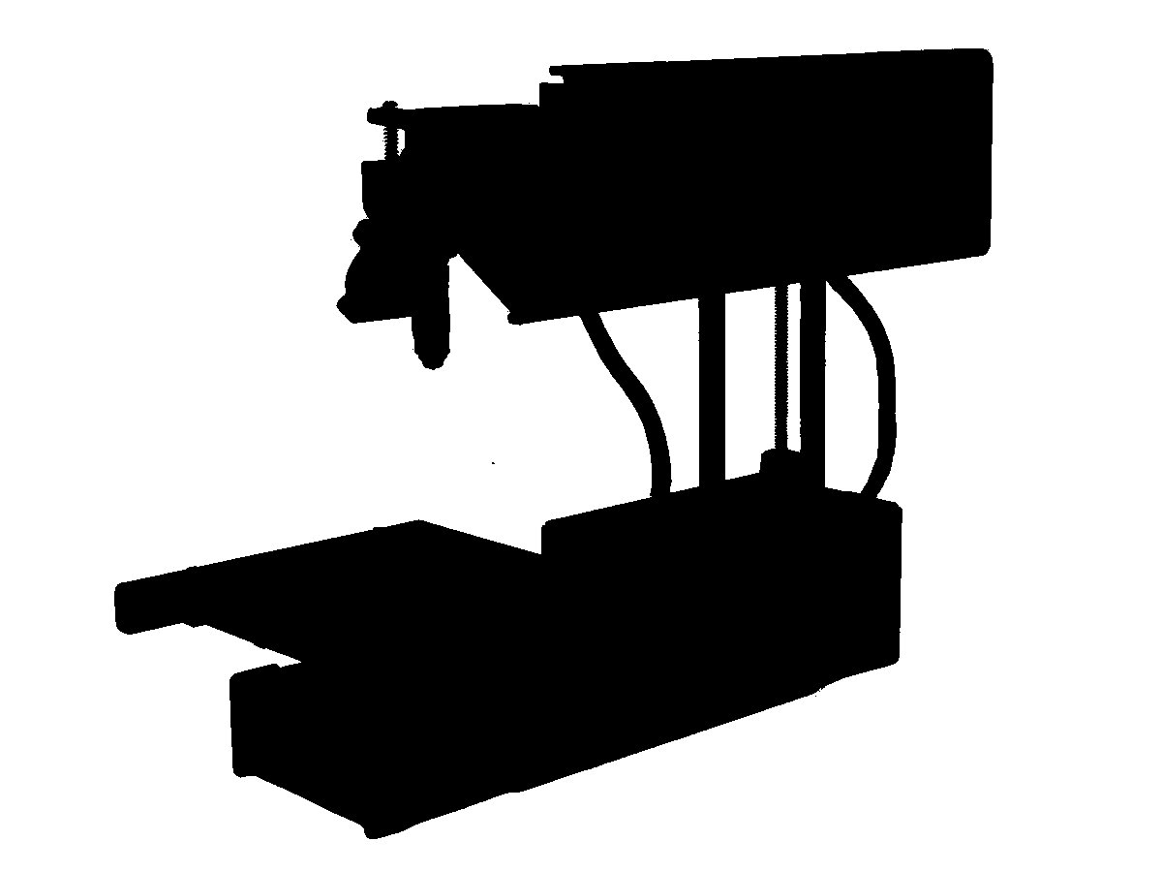
PRINTING

Even if you're comfortable working with 3D printers, I ask that you follow this procedure every time. This is because I'm still working on making this printer serialized and testing procedures helps with conceptual designs. If you wish to make an adjustment to the process please let me know!

To Print
- Use the configuration files in the 'cereal' git project. If there are no files for your software, I ask that you contact me and we'll set them up.
- Slice your part and upload it to Octoprint. Do not unplug the printer from the Raspberry Pi.
- The print bed should already be cleared before a print. If the “After Print” procedure hasn't been completed in a while, scrub the print bed again to clear away dust.
- If you're printing while at the shop, make sure the AC/Dehumidifier is turned on and the timer is set for a few hours. Humidity makes a difference!
- Start your print. Make sure to enter it in the logbook!
- Don't use errata plastic with this printer. If the printer runs out of plastic, use a spare roll from either on top of the toolbox or under the desk. Any roll labeled “CTAG” may be used with the printer.

- There's currently no charge for printing. If you wish to help with the cost of plastic, you can find the volume of a part in the “State” window of Octoprint. The plastic currently in use is $0.03 per cm³ OR $0.07 per meter.

After Printing
- After completion of a print, the stepper motors should turn off so that you can move them manually. If the print head is in the way, just push it backwards.
- There should be a knife in top level of the printer's toolbox. Use it to gently scrape the finished part off of the print bed.
- If the part doesn't belong to you, place it with the toolbox and contact the owner via irc, email.
- If the part is damaged or didn't turn out, make sure to describe the outcome in the 'notes' section of the logbook!
- If the tape is worn/torn, remove it and use the blue roll with the printer to re-apply. Tape goes horizontally across the print bed as close together as possible without overlap.
- Take the microfiber cloth and scrub the print bed while holding it to keep from torquing the mount. This is to remove dust and other contaminates which keep the part from adhering well. If you're concerned about extra adhesion, put a few drops of water/isopropyl from the toolbox on the cloth first, then scrub.

