Additive Manufacturing

(A Few) Methodologies
via 3dprintingfromscratch.com

Fused Deposition Modeling (FDM)

Developed and implemented at first time by Scott Crump, Stratasys Ltd. founder, in 1980s. Other 3D printing companies have adopted similar technologies but under different names. A well-known nowadays company MakerBot coined a nearly identical technology known as Fused Filament Fabrication (FFF).
With help of FDM you can print not only functional prototypes, but also concept models and final end-use products. What is good about this technology that all parts printed with FDM can go in high-performance and engineering-grade thermoplastic, which is very beneficial for mechanic engineers and manufactures. FDM is the only 3D printing technology that builds parts with production-grade thermoplastics, so things printed are of excellent mechanical, thermal and chemical qualities.
FDM technology is widely spread nowadays in variety of industries such as automobile companies like Hyundai and BMW or food companies like Nestle and Dial. FDM is used for new product development, model concept and prototyping and even in manufacturing development. This technology is considered to be simple-to-use and environment-friendly. With use of this 3d printing method it became possible to build objects with complex geometries and cavities.
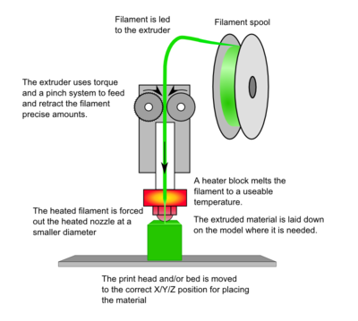

Stereolithography (SLA)

A 3d printing method that can be used to implement your projects that involve 3D printing of objects. Although this method is the oldest one in history of 3D printing it’s still being used nowadays. The idea and application of this method are amazing. Whether you are a mechanical engineer, who needs to verify if the part can fit to your design, or creative person who wants to make a plastic prototype of new coming project, Stereolithography can help you to turn your models into a real 3D printed object.
This method was patented by Charles Hull, co-founder of 3D Systems, Inc in 1986. The process of printing involves a uniquely designed 3D printing machine called a stereolithograph apparatus (SLA), which converts liquid plastic into solid 3D objects.
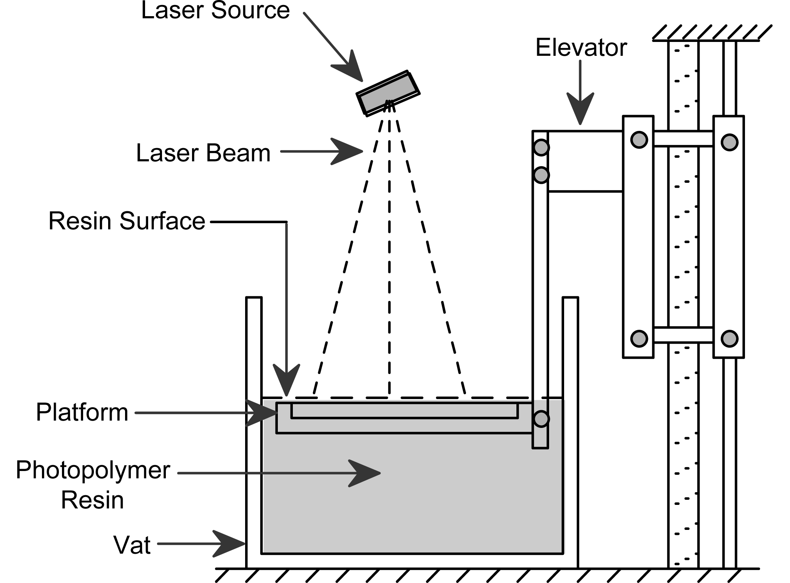

Selective Laser Sintering (SLS)

A technique that uses laser as power source to form solid 3D objects. This technique was developed by Carl Deckard, a student of Texas University, and his professor Joe Beaman in 1980s. Later on they took part in foundation of Desk Top Manufacturing (DTM) Corp., that was sold to its big competitor 3D Systems in 2001. As was stated previously, 3D systems Inc. developed stereolithography, which in some way is very similar to Selective Laser Sintering. The main difference between SLS and SLA is that it uses powdered material in the vat instead of liquid resin as stereolithography does.

Unlike some other additive manufacturing processes, such as stereolithography (SLA) and fused deposition modeling (FDM), SLS doesn’t need to use any support structures as the object being printed is constantly surrounded by unsintered powder.

SLS is more spread among manufactures rather than 3D amateurs at home as this technology requires the use of high-powered lasers, which makes the printer to be very expensive.

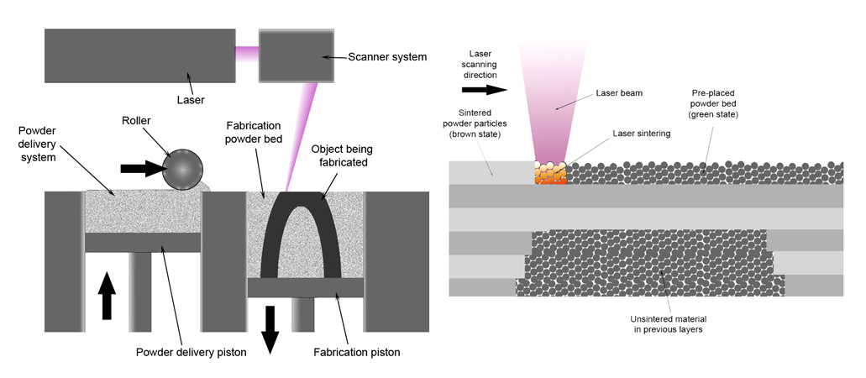

(A Few) Common Materials

Acrylonitrile Butadiene Styrene (ABS)

Used in: FDM, SLS
Melting point: 220-240 C

One of the oldest and most common FDM substrates. ABS is the type of plastic used in Lego bricks, and is one of the most common industrial/commercial plastics.

With FDM, ABS requires a heated print bed, otherwise thermal shock will cause most printed parts to curl and warp as they are printed. Ventilation should be taken into account while printing with ABS, as it produces a typical “burning plastic” smell, and has recently been linked to various health problems (unconfirmed studies).

Polylactic Acid (PLA)

Used in: FDM, SLS
Melting point: 160-180 C

The second most popular printing substrate for FDM. A bioplastic, PLA is made from various food product components; most commercial compost facilities are able to handle the material after it is discarded. While printing, the molten plastic smells neutral or slightly sweet, like pancakes. PLA is more likely to crack or shatter under stress than ABS.

Photopolymers (UV curable)

Used in: SLA
Melting point: N/A

A set of materials that transition from a watery liquid to a strong plastic-like solid nearly instantaneously when light of the correct wavelength is present. This material is more common than its description would lead you to believe, many inks and glues involve photopolymers, and a very obvious example is the binding agent used by an orthodontist when you have braces installed on your teeth.

