**Adaptive H.I.D.**   
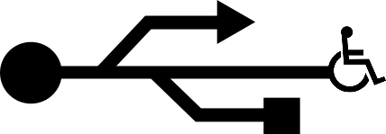  
<https://github.com/ctag/cpe495>

CPE 495 Interim Report

Fall 2015

University of alabama in huntsville

301 Sparkman Dr. NW, Huntsville, Alabama 35899

Christopher Bero

Bryant Johnson

Michael Baldwin  
John Gould

**Project Summary**

Design a set of adaptive interface devices for modern computers with readily available consumer machinery and products. The product will have a focus on affordability, iterative design, and easy operation. Construct and test the devices for viability in general use; then generate a case study on the effectiveness of this approach to bringing adaptive technology to a larger audience.

**Team Description**

The Adaptive H.I.D. project was envisioned to develop affordable computer interface devices and bring adaptive technology to more people around the world. Each team member was selected based on how their personal expertise would benefit the project.

**Chris Bero** is the Hardware Lead for the project with the subtask of community outreach. He originally conceptualized the project after noticing the many shortfalls of adaptive technology in his free time and drafted multiple designs that could benefit the disabled community. He is very knowledgeable in microcontrollers, 3D printers, and collaborative software development.

**Michael Baldwin** is the Software Lead for the project. He leads the pursuit in either upgrading an existing package or creating our own custom keyboard interface which uses predictive text to lessen the number of characters required to complete a word. Michael has a very strong programming background and implements professional modern style when developing code.

**Bryant Johnson** is the Testing Lead with the subtask of technical writer. He is responsible for creating the unit tests and maintaining the documentation of the entire project. He excels in strategizing the project and rationalizing each process while paying attention to fine details. His interest include cybersecurity and reverse engineering.

**John Gould** is the Systems Lead for this project. He is responsible for integration of the hardware and software that will be developed for this project and will ensure that the mechanical elements will work together in the finished product. His strengths include microcontroller based projects and software development.

In the event that one of our team members will not be able to complete their assigned duties, the responsibility of the lost member will be divided among the remaining members for the rest of the course. Additionally, all members assist and aid in other duties when available.

**Introduction**

Our team is researching and building Adaptive Technology human interface devices to help people living with disabilities interact with computers. Adaptive technology (AT) is a device or component which is specifically designed for persons with disabilities. Human Interface Devices (H.I.D) is a method by which a human interacts with an electronic information system either by input or output. Computers have dropped in price, grown in capability, and leapt into consumer markets in the past few years. Adaptive Technologies which help persons living with disability interface with a computer have been left behind in this regard. Solutions available are expensive and difficult to obtain. There is a distinct need for human interface devices which meet many AT requirements and are available to wider audiences for more reasonable cost. This project is going to be a student lead and noncommercial in nature. We wish to make clear that our design decision to present the project as open source incurs additional work for us to have a clean operating environment that others can approach and utilize in separate projects, not a sidestepping of features we do not intend to implement. We are developing two keyboard interfaces that include a Sliding Keyboard, and a Brailling Keyboard. The sliding keyboard will require no finger movement to type characters, instead utilizing shoulder and elbow ranges. Our brailling keyboard will consist of the standard eight button brailling interface, but made with consumer level material at a lower price. We are interfacing with local disability service groups United Cerebral Palsy (UCP) of Huntsville and National Federation of the Blind (NFB) of Huntsville.

We established our marketing and engineering requirements based upon UNICEF’s World Report on Disability. UNICEF states, “Manufacturing or assembling [AT] products locally, using local materials, can reduce cost and ensure that devices are suitable for the context.” Priority of the design was for cheap and readily available materials and techniques—allowing for the product to be easy to build and modify. Consumers should be able to with relative ease assemble the device themselves. Additionally we wanted to build a product with equivalent or better functionality without increasing complexity of user interaction. The design should be durable and adhere to the standards of current AT marketable solutions. The Marketing Requirements are as follows:

* Open Source Design
  + Require only items available to common makerspaces
  + Easy to iterate and customize
  + Low cost requirements for parts and machinery
* Easy to Operate
  + Must provide as good or better functionality than existing solutions
* Reliable
  + Must accept improper input and have a robust mechanical design.

The Engineering Requirements were based upon current mechanical keyboard design standards. We needed the hardware to react to changes under 6 milliseconds while in use. Each switch will need to last at least 10 Million cycles while supporting at least 30 words per minute operation at 90% accuracy. The device should be operational from -10 Degrees Celsius up to 70 Degrees Celsius. These requirements are typically found on the product speciation section of modern mechanical keyboards by various brands on the marketplace. Research was conducted by browsing and comparing specifications of listed items in retail stores.

**Background**

There are many shortfalls when it comes to AT. The main issue is that there is high development costs to a low volume market. Existing products include a Large Switch Keyboard which is aimed towards people with motor disabilities and lack of precision. It is less costly but does not necessarily solve the problem just lessens the possibility of error. Maltron created a Braille embossed keyboards have the same complexity of a regular keyboard, just using a simple mapping to the existing format, however it is very costly and less efficient. Additionally, there have been various projects that aimed to solve some challenges that disabled people may face when using technology. The Audrey Braille Display was an attempt to create a low cost braille refreshable display however the concept was abandoned in 2012. Ferrofluid Braille Displays were conceptualized to use electromagnetics however it was found to be very expensive. The most significant differences between competing products versus our product is the low price and iterative design. We strive to create and publish an open source product that will allow people develop custom, low cost AT wherever a makerspace is available.

**Trade-off Analysis of Design Alternatives**

Various alternative products were considered in the design of this project. We have reviewed the possibility of creating four different systems to be part of our suite of low cost AT devices that we will deliver as the outcome of our project. With our trade-off analysis we investigate the options available for our project and the design decisions which lead to our chosen systems.

**Products**

Within the project of creating AT HID, our team generates several product ideas and needs to decide which are worth pursuing and how to go about designing the results.

**Sliding keyboard.** Our first product is a keyboard to limit the required dexterity of typing. Targeted at users with conditions commonly associated with amyotrophic lateral sclerosis or cerebral palsy, this keyboard removes keys from the user’s path and instead places two horizontal “pucks” down as control surfaces. Pucks can be a custom design from a handle to a joystick, anything that the user can operate to slide the base of the puck around an inset hexagon that it resides on. At each corner of the hexagon are mechanical switches, totaling twelve between the two pucks. If each puck is moved to contact a switch, then depending on the key map a range of either 36 or 72 characters can be represented.

**RFB.** The next product we discuss is a braille refreshable display. Targeted at users with low or no eyesight, this system has two design proposals, one which uses a rack and gearing system to exchange templates of braille, and one which uses electro-cutaneous feedback to represent raised braille dots. The geared system would be based on a concept design named [‘Audrey’](http://www.utopiamechanicus.com/article/open-source-hardware-braille-display/) from David Pankhurst. This approach uses a rack with one half of a braille character enumerated along it from a single dot to all four; several racks are placed side by side to create braille characters. A stepper motor is then rotated beneath the racks and slides them to spell braille characters. The electro-cutaneous method would consist of a PCB with a row of braille dots in the form of unsoldered contacts. These contacts would then push a small amount of current through a hand passing over them to interact with cutaneous sensors in the skin and create the sensation of an edge below the finger to correspond with braille.

**Brailler.** Complementing braille output is a brailling keyboard for input to a computer. Braillers used to be mechanical counterparts to typewriters and would physically press braille dots into paper; present day braillers are considered a subset of the chordal keyboarding arena, where multiple keys are pressed at once to indicate a word -- rather than a sequence of keys pressed one at a time. Braillers can be found as standalone items or bundled with a refreshable braille display to provide the complete loop of input and output from a computer. Our approach is to recycle design decisions from the sliding keyboard and apply them to the similarly functioning brailler in order to create a device that is easy to make and more affordable than current market options.

**AT Button.** While our customer expressed general interest in the above solutions, we also learned a lot about the current state of AT in use at UCP and received enough direction to build out our case study plan for more AT. One of the more common systems for actuation in use at UCP are SPST buttons -- roughly four inch diameter pads -- that terminate to a 3.5mm mono audio pole. These buttons are then plugged into a variety of host items in order to provide a greater ease of access to the item. At UCP a conflict has occurred where the market price for these buttons is high -- in the $60 to $80 range -- and their use level is low -- an example is sub $20 toy adapting. We suspect this is caused by the quality of the buttons, if the button is associated with a device to request food or water, then it *must* work each and every time. Toy adapting isn’t quite as mission critical though, and a solution which provides “button to 3.5mm jack” at a lower price would be ideal. Thus we intend to investigate using mechanical keyboard switches with thermoplastic or acrylic cases to create more affordable actuation devices and test them as part of our case study.

**Switch Circuits.** For switches, we will use port inputs on either the MSP430 or atMega and arrange switches with pulldown resistors.

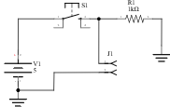

Our plan is to implement a scanning grid for the switches as used in CPE322 for FPGAs.

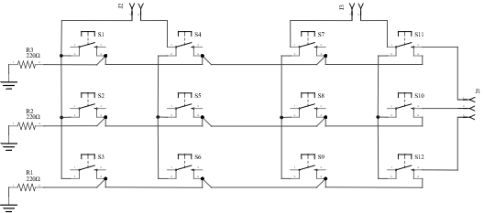

For testing our firmware and hardware approach, we constructed a set of twelve isolated switches which can be wired into breadboards. The tradeoff here is ease of configuration in exchange for a lot of tidiness.

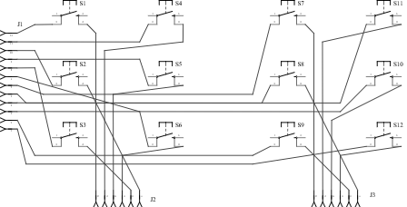

**Material breakdown for both keyboards**

We’re following Design Analysis from the University of Delaware’s [*Nonprofit Management Certificate Course*](http://www.udel.edu/ccrs/NPMCC_2006_Materials/Tradeoff_Analysis_Example.pdf).

For our design decisions, we hold the brailling keyboard and sliding keyboard to have similar enough hardware qualities as to occupy the same space of design approaches. Hardware approaches were based on components that we have had previous experience with, could easily source, and knew to have high availability in common makerspaces (PLA printing, 30W laser CNC bed).

**Design Scenario A**

* MSP430F5529 processor
* Cherry Corp. MX switches
* Thermoplastic case

**Design Scenario B**

* MSP430F5529 processor
* Gatereon switches
* Laser cut case

**Design Scenario C**

* ATmega328p processor
* Cherry Corp. MX switches
* Thermoplastic case

**Design Scenario D**

* ATmega328p processor
* Gatereon switches
* Laser cut case

Each approach’s set of decision criteria is given an importance magnitude 1-5 and instance rating 1-5. The resulting grade ( = importance * rating) is assigned and reviewed alongside functional or behavioral decompositions.

|  |  |  |  |
| --- | --- | --- | --- |
| **Scenario A - Decision Criteria** | **Importance** | **Rating** | **Grade** |
| Production Cost | 5 | 3 | 15 |
| Component Availability | 4 | 2 | 8 |
| Assembly Skill/Time | 4 | 3 | 12 |
| System Durability | 3 | 4 | 12 |
| Design Complexity | 2 | 3 | 6 |
| Grade total |  |  | 53 |

|  |  |  |  |
| --- | --- | --- | --- |
| **Scenario B - Decision Criteria** | **Importance** | **Rating** | **Grade** |
| Production Cost | 5 | 5 | 25 |
| Component Availability | 4 | 4 | 16 |
| Assembly Skill/Time | 4 | 4 | 16 |
| System Durability | 3 | 2 | 6 |
| Design Complexity | 2 | 4 | 8 |
| Grade total |  |  | 71 |

|  |  |  |  |
| --- | --- | --- | --- |
| **Scenario C - Decision Criteria** | **Importance** | **Rating** | **Grade** |
| Production Cost | 5 | 2 | 10 |
| Component Availability | 4 | 3 | 12 |
| Assembly Skill/Time | 4 | 4 | 16 |
| System Durability | 3 | 4 | 12 |
| Design Complexity | 2 | 4 | 8 |
| Grade total |  |  | 58 |

|  |  |  |  |
| --- | --- | --- | --- |
| **Scenario D - Decision Criteria** | **Importance** | **Rating** | **Grade** |
| Production Cost | 5 | 4 | 20 |
| Component Availability | 4 | 5 | 20 |
| Assembly Skill/Time | 4 | 5 | 20 |
| System Durability | 3 | 2 | 6 |
| Design Complexity | 2 | 4 | 8 |
| Grade total |  |  | 74 |

Analysis factors

* Cherry Corp. products are often difficult to source, are more expensive than Gatereon compliments.
* Grading thermoplastic and laser laminate cases is difficult due to the vast plethora of available systems and operator knowledge. We settled on as unbiased a format as possible, with plastic cases offering better system durability and longevity with a higher complexity and design cost.
* The two microcontrollers compared here were chosen either for their popularity in crowd-designed keyboards (such as the Kiibohd Infinity) or their use in previous UAH courses (CPE323).
* We tried to favor availability and assembly factors heavily in this stage, as a durable and cheap system is unhelpful if nobody is willing or capable to generate them for people in need.

Although the Atmel/Gatereon solution provided the best score by our criteria, our team did not have a “will fetch a good grade” section. This unfortunately ended up being the deciding factor, and we chose to investigate the msp430/cherry/thermoplastic option as it used microcontrollers presented in a previous UAH class and promised a higher level of complexity. We wonder how often this happens in the real world.

**Response to Feedback**

As a result of the CPE 495 Project Proposal Presentation to our peers and instructors, we received valuable feedback. We outlined and addressed each of the comments and concerns below.  
 **Sounds like a useful/feasible project. But is it Valuable to the impaired customer?**

We can draw some confidence of the project value from the presence of existing items on the market. Our sliding keyboard is not a new concept, but we are working to make a key-less keyboard easier to obtain.

Value is difficult to determine. Take for example voice input and output; voice recognition and synthesis software has become quite capable lately and we have witnessed a lot of similar comments to yours online about the need to physical AT devices. To clarify our stance, imagine an office setting in which a voice system is the only method available for someone to interact with a computer. Not only does eight hours of talking sound appallingly strenuous, but the situation may also be distracting for others working nearby. The need for a variety of options exists because there is not a single best solution to aiding a person living with disability in using a computer.

**Suggested additions - audio shortcuts - or some other non-tactile method, may add large value at small costs.**

Thank you for your input, we have reviewed it as a component of prospective designs. Refer to the above question for our reasoning for not pursuing this.

**The idea of reducing the cost of current keyboard is nice and suitable. However, I was not able to recognize how the cost will actually be reduced. The proposal presentation looks to be vague. It would be better to present more specifically the cost reduction.**

Please see *Introduction* (page 1) in which we discuss our plan to use consumer grade materials with existing manufacturing infrastructure to generate an affordable alternative.

We recognize the comment on a vague proposal. This was in part due to our ongoing research for solutions and existing systems, as we did not wish to commit to something that would be usurped the next day. We will strive to make all future correspondence and presentations as well balanced in details available to us and time.

**Very informative presentation. I was able to follow everything without any prior knowledge in the field. My only suggestion would be to see about locating a working pre-existing solution (braille keyboard) that you can access to be able to test against. Perhaps contact one of your disability advocates and see if they have a disabled-accessible computer lab with some of the hardware available so no one has to purchase a new one.**

We agree and wish to pursue this. Our customer, UCP, has a few solutions which we can request access to, although we have yet to locate a brailling keyboard or RFB to borrow.

**How will you make the determination that the product you produce is easy to use by the customer? Need a specific plan and customer.**

Please see *Test Plan* (page 10) in which we discuss our intent to perform a case study and see if our affordable solution measure desirably against market solutions. Thanks for bringing the need of a customer to our attention, we have since located one.

**Global and Societal Impact of Project**

We have reviewed the environmental impact of this project to be negligible. Components of the system are all readily available for purchase in the United States and have passed all pertinent consumer regulations. Hardware, when discarded, should be disposed of based on the relevant regulations.

Security vulnerabilities can be introduced when a person decides to build our design with modifications to the microcontroller firmware. Since many existing keyboard kits available on the market use similar microcontrollers and firmware approaches, this keyboard is adequately secure in respect to the scope of modern keyboards. Our project is open source, and if another person was to use our design and implement a key logger into the source code for the keyboard, they could potentially steal information inputted by another user. We plan to counteract this possibility by providing source and binary checksums while requesting all potential developers build the project directly from source or from a trusted authority.

We are designing our hardware to be interoperable to conform to existing standards (USB 1.1, 2.1 CDC and HID). Legacy and emerging computer systems should allow for the keyboard to be operational via the USB interface.

With respect to personal privacy, our prospective desktop software design plans be a learning program that will remember most commonly used phrases in order to help predict the user’s word input and sentences. We will have to take ethical measures to ensure the raw or generated data taken is with consent and not distributed to unauthorized parties. We will also review later designs to implement fuzzing techniques which prevent the extraction of valid writings and communique of the user.

Health and safety concerns are minimal, the keyboard is constructed of nontoxic material. As far as the development of our product, we are prototyping with a chemical laser bed and we have to ensure proper ventilation and eye protection is used during operation. The 3D printers are printing with polylactic acid (PLA) thermoplastics that are food grade, thus posing limited risk and no noxious fumes during extrusion. Furthermore, we are soldering with leadless solder and are ensuring that proper safety measures are taken in the lab.

In regard to regulatory and legal issues, we are using MSP430 TI USB API Stack which includes the driverlib package. Both are clearly licensed under BSD compliant licenses via the following [[http://software-dl.ti.com/msp430/msp430_public_sw/mcu/msp430/MSP430_USB_Developers_‌Package/latest/index_FDS.html](http://software-dl.ti.com/msp430/msp430_public_sw/mcu/msp430/MSP430_USB_Developers_Package/latest/index_FDS.html)]. MSP430 hardware is subject to export restrictions for certain packages, but we are not crossing state or country lines and are not mailing the hardware systems.

In the end, systems are often victim to aging technology because the rapid innovations in technology for able bodied people—for example, systems developed a decade ago were not modified for high speed USB connections or flat panel monitors. Many of these old technologies are still in use today because they have no replacement or are prohibitively expensive to exchange. While the US does have programs that allow people who need AT, not everyone around the world has access to proper government programs and health insurance that will offset the costs. The project will aim to prioritize the safety and affordability of the users.

**Test Plan**

Primary testing will be dependent on the cooperation of outside organizations. Optimally we would like to allow several people from our target audience to try several of our prototypes so we can determine values such as words per minute and get feedback on the system for improvements. Our proposed test plan includes unit tests on each of the essential hardware elements. This includes testing the hardware for durability during operation. Additional tests will be the software’s predictive text ability.

Integration tests will be performed to observe the hardware and software modules as a group. For example, to ensure a proper data sync we must compare switch input versus the data output. Extensive integration tests must also be qualitative based on customer response. The device will be tested based on the ease of use and comfort.

Acceptance tests will use the feedback from the customers at UCP of Huntsville. With the help of outside organizations we would like to allow users in need of our device to actually try the device themselves and return their feedback for the majority of our testing. Without this support we will still be running similar tests but with group members instead.

**CPE 495 Go/No Go Milestone(s)**

We have successfully met our milestone that was set forth and approved by instructor. We were able to identify UCP of Huntsville as a valid customer that was willing to evaluate the effectiveness of the project. We had made substantial research and provided documentation on what approaches worked well and would be worth further investigation in future projects. We managed to create a physical input device as a proof of concept that will be further improved upon in the upcoming month. Finally, we broke ground on our software package with prospective solutions.

**CPE 496 Course Team-Specific Deliverables**

Our course deliverables are twofold. We are providing our instructor with the systems designed during the class, along with our case study on the viability of this approach to manufacturing. This includes working prototypes of input devices for the handicapped. We will include a collection of software enhancing prototypes from a simple I/O peripheral to a more useful tool such as predictive text. Additionally, we are providing the physical systems to a local benefactor, either UCP or NFB of Huntsville. Ultimately, the goal is to have other people become interested in creating Adaptive Technology.

**CPE 496 Project Work Breakdown Structure and Base Line Project Schedule**

We have outlined the project schedule using the GanntProject. For this semester we have been on time with each step in the development process and plan to remain on track for Spring 2016.

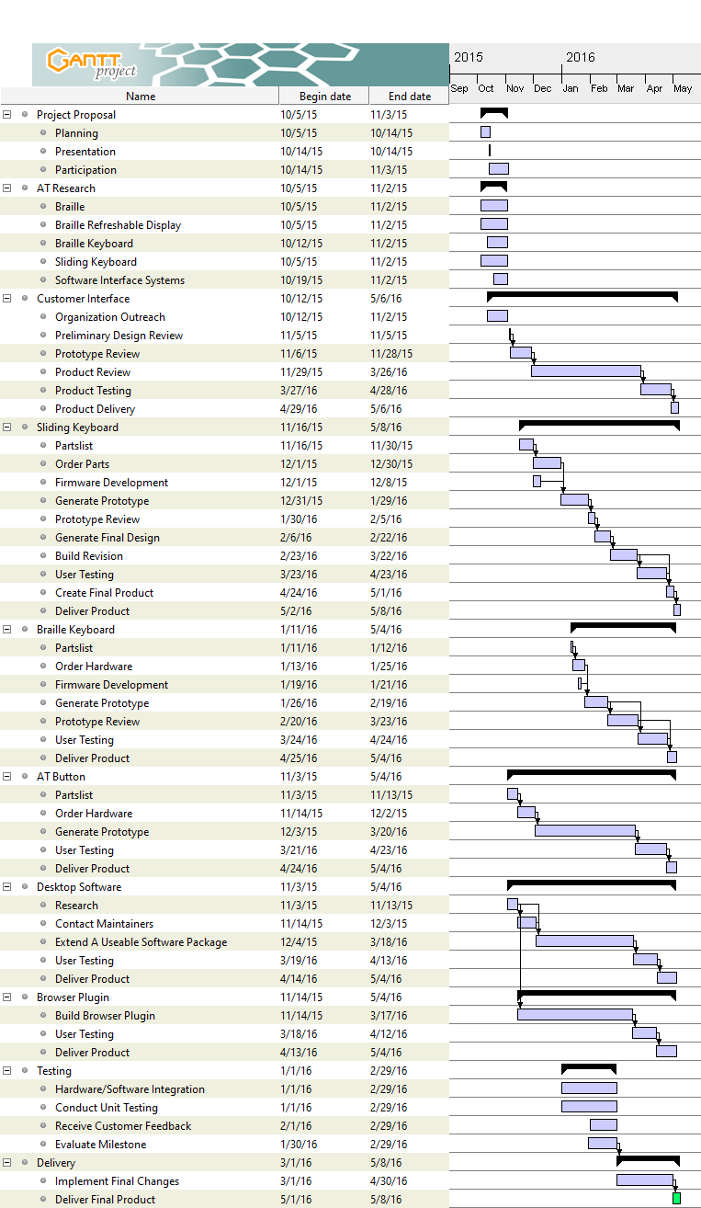

**CPE Professional and Ethical Statements of Responsibility**

Each student within the Adaptive H.I.D project team (Christopher Bero, Michael Baldwin, Bryant Johnson, and John Gould) hereby reaffirm our commitment to the common good of the Adaptive H.I.D. team. Additionally, we will continue to adhere to the policies of UAH and the ethical responsibilities assumed by adherence, as well as throughout the scope of the CPE 496 project.

**CPE 496 Project Cost Evaluation**

We do not anticipate the need to purchase any additional components for CPE 496. Any additional items we may need will either be 3D printed, of minimal cost, or already available through the makerspace available resources.

**Conclusions**

Our CPE 495 design experience was extensive in researching the pros and cons of developing each system. We were able to select what specific parts and designs we would pursue for the following Spring 2016 semester. The primary obstacle for CPE 496 will be product testing and optimizations after the initial prototype. We will have to coordinate multiple sessions with our customer in order to deliver the best possible product on time.

Regarding individual technical strengths and weaknesses, our group’s core proficiencies allow us to bond each essence of project development. Each team member provides knowledge from their area of expertise. The primary weakness of our group is time management. The responsibility of a job, compounded by the demands of a class schedule, created stress and feelings of being overwhelmed while making the group as a whole feel awkward when meeting schedules are discussed. We utilized options which include online instant messengers, such as Google Hangouts, to offset the problem in order to facilitate communication. For the remainder of the project, we do not foresee any technical difficulties. If we to adhere to the schedule that we have developed, we will be able to successfully deliver our product.

**Appendix A: Copy of Progress Reports**

**Progress Report 1**

| **Class** | **Week** |
| --- | --- |
| CPE 495 | 5 Oct. 2015 - 9 Oct. 2015 |

**Adaptive H.I.D.**

* Christopher Bero
* Bryant Johnson
* John Gould
* Michael Baldwin

**Project Status**

Since the course launch, we have:

* Formed a team
* Reviewed candidate projects.
* Selected a project for milestone 1 attempt.
* Begun initial research on necessary background and design.

**Difficulties Encountered**

As a team we've struggled to decide on a primary project. After several iterative reviews we've adjusted the initial keyboard project to increase scope of research and design.

**Next Sprint**

For the next reporting period we intend to

* Complete and present a project proposal.
* Continue research on hardware and software design requirements.
* Begin construction of a parts list for hardware designs.
* Triage hardware designs to choose a spearhead for milestone 1's prototype.
* Begin setup of a hardware workbench to include a machine with adaptive programs installed for testing.

## Progress Report 2

| **Class** | **Week** |
| --- | --- |
| CPE 495 | 12 Oct. 2015 - 16 Oct. 2015 |

**Adaptive H.I.D.**

* Christopher Bero
* Bryant Johnson
* John Gould
* Michael Baldwin

**Project Status**

* Attempted to contact organizations that are relevant to our product for testing and feedback (UCP NFB UAH DSS ADIB).
* We have gotten response from UCP and UAHDSS.
* Prepared purchasing guidelines for prototype materials.
* Gave project presentation to the class.
* Updated scope of projected, adjusted long term goals in case of difficulty.

**Difficulties Encountered**

Firmly establishing contact has been slower than anticipated. The biggest criticism from the presentation was our lack of contact with potential customers. We have increased efforts of contact, with mixed results.

**Next Sprint**

For the next reporting period we intend to:

-Begin investigation into the software aspect of the project. -Order materials for construction of the prototype. -Assess any changes to project details based on presentation

**Progress Report 3**

| **Class** | **Week** |
| --- | --- |
| CPE 495 | 19 Oct. 2015 - 23 Oct. 2015 |

**Adaptive H.I.D.**

* Christopher Bero
* Bryant Johnson
* John Gould
* Michael Baldwin

**Project Status**

We are currently waiting feedback from our presentation in order to move forward. We are creating our purchase order and continuing our attempt to contact groups who have already done relevant research in Adaptive Technology.

**Difficulties Encountered**

Two of our team members are in the Honors College, which requires a Project Director: "Whether you write a thesis or do a project, you must have somebody with whom you can work closely and who is an expert in your chosen field. You may wish to work with a professor with whom you previously took a class, your major advisor, or someone with whom you have been working in a lab, studio, or in clinical practice ... Generally the director should have at least a graduate degree in her or his field, and preferably the terminal degree in the relevant field."

Difficulties include finding a person that fits this criteria.

**Next Sprint**

For the next reporting period we intend to

* Continue research on hardware and software design requirements.
* Triage hardware designs to choose a spearhead for milestone 1's prototype.
* Begin setup of a hardware workbench to include a machine with adaptive programs installed for testing.

## Progress Report 4

| **Class** | **Week** |
| --- | --- |
| CPE 495 | 26 Oct. 2015 - 30 Oct. 2015 |

### Adaptive H.I.D.

* Christopher Bero
* Bryant Johnson
* John Gould
* Michael Baldwin

### Project Status

This week we were able to schedule a meeting with our customer, UCP. We will be meeting with an Assistive Technology Specialist. While meeting with the customer is our primary concern for the time being, some progress has also been made on software development. We are currently researching existing software for text prediction which can be used to increase functionality of both our product hopefully existing products already owned and used.

### Difficulties Encountered

We are still trying to find a Project Director to meet the requirements for our two team members who are in the Honors College. Prior to the meeting we have planned with UCP we have had no face-to-face contact with any of our customers yet which has severely hindered our understanding of our customer’s needs. This meeting should help resolve this hurdle.

### Next Sprint

For the next reporting period we intend to do the following:

Meet with UCP and finalize our initial requirements on our hardware. Begin building a prototype input device. Continue research and begin trying various open source software applications which predict the intended completion of a fragment of a word.

## Progress Report 5

| **Class** | **Week** |
| --- | --- |
| CPE 495 | 2 Nov. 2015 - 6 Nov. 2015 |

### Adaptive H.I.D.

* Christopher Bero
* Bryant Johnson
* John Gould
* Michael Baldwin

### Project Status

This sprint we conducted a meeting to gather ideas and questions in anticipation of our meeting with UCP. On November 5th we met with Kate Moseley of TASC to receive a presentation on AT systems and initial design feedback for our project.

We've also received our first shipment of hardware to begin building the sliding keyboard prototype.

### Difficulties Encountered

Coordinating team meetings and efforts through this semester’s class schedule of 431/434/435/412 has proved troublesome. We will begin implementing an hour sign off sheet for the next sprint to increase our cohesion with the group's timeline.

### Next Sprint

Tentatively:

* Christopher Bero
  + Get set up with microcontroller hardware and begin circuit designs for sliding keyboard.
* John Gould
  + Work with Christopher Bero and Michael Baldwin to make sure the initial hardware and software systems are compatible from a systems view.
* Bryant Johnson
  + Continue work on tests for both hardware and software prototypes.
* Michael Baldwin
  + Finish software research and begin design phase for program MVP

## Progress Report 6

| **Class** | **Week** |
| --- | --- |
| CPE 495 | 9 Nov. 2015 -- 13 Nov. 2015 |

### Adaptive H.I.D.

* Christopher Bero
* Bryant Johnson
* John Gould
* Michael Baldwin

### Project Status

This week we

* Used the information from our customer meeting to finish the Specifications and Requirements document.
* Began the Go/No Go hardware and software construction.

### Difficulties Encountered

* The MSP430 USB toolkit isn't compiling. We need to check with some dependencies to correct this.
* The open source software that we're investigating are difficult to break ground with. We need to follow up with them on mailing lists to get a scope of tasks involved in compiling current development builds.

### Next Sprint

* Christopher Bero:
  + Install MSP430 USB toolkit. Flash initial firmware tests.
* Michael Baldwin:
  + Work on contacting maintainers of open source projects.
* John Gould:
  + Help with bringing in software to the wiki.
* Bryant Johnson:
  + Continue work on tests for both hardware and software prototypes.

## Progress Report 7

| **Class** | **Week** |
| --- | --- |
| CPE 495 | 16 Nov. 2015 -- 20 Nov. 2015 |

### Adaptive H.I.D.

* Christopher Bero
* Bryant Johnson
* John Gould
* Michael Baldwin

### Project Status

We've completed another hardware purchase order for prototyping materials (PCB and breadboard) and 3.5mm mono audio equipment to match the standards discussed with our customer.

We have an initial MSP-USB firmware demo and are working on the SPI tools to upload it to our experimenter board.

We are still looking for project maintainers to contact for our software research.

### Difficulties Encountered

The MSP430F5529 Experimenter Board has an on-PCB MSP430F2258 that's used for SPI and real time debugging. This chip is also the only way to flash new firmware to the F5529, making the upload process more complicated when using raw firmware rather than Energia sketches. We're pursuing a fix by flashing firmware with a modified version of avrdude.

### Next Sprint

* Christopher Bero:
  + Flash USB firmware demo to MSP430F5529.
  + Create 12-switch prototype circuit.
* Michael Baldwin:
  + Continuation of sprint 7.
* John Gould: Help with bringing in software to the wiki.
* Bryant Johnson:
  + Continue with the interim report
  + Formulate responses for the received presentation feedback

## Cost Summary for CPE 495 November 2015

| **Item** | **Quantity** | **Sum Cost** |
| --- | --- | --- |
| Female Mono Sockets | 10 | $4.66 |
| 3ft Mono Cables | 11 | $14.82 |

**October 2015**

| **Item** | **Quantity** | **Sum Cost** |
| --- | --- | --- |
| Ti USB Developer Board | 2 | $38.90 |
| ATmega328 | 4 | $6.99 |
| Screw Terminal Blocks | 1 | $5.95 |
| PCB proto board | 1 | $7.99 |
| PCB proto board | 1 | $3.57 |
| Breadboard | 1 | $3.58 |
| Cherry MX switches | 24 | $26.74 |

Sum total: $128.22

**Appendix B: Source Code/Schematic Diagrams (as needed)**

Below is a flowchart documenting the interface we plan to develop from the text prediction to the braille output and the text to audio output. More research must be done on existing text prediction software in order to develop an algorithm interfacing the braille input to the text prediction.

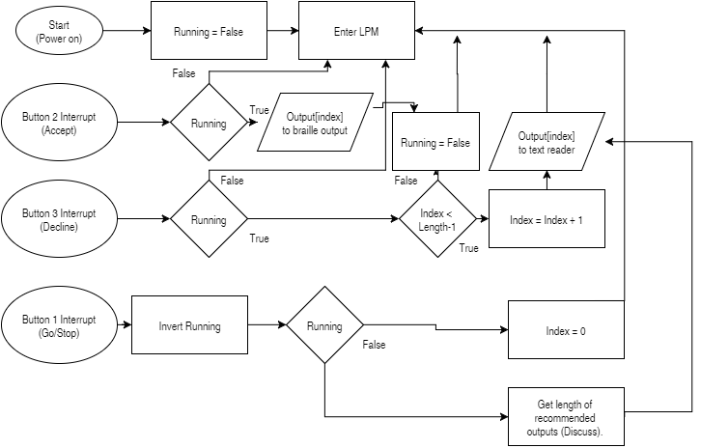

Hardware Model without actuation disks  
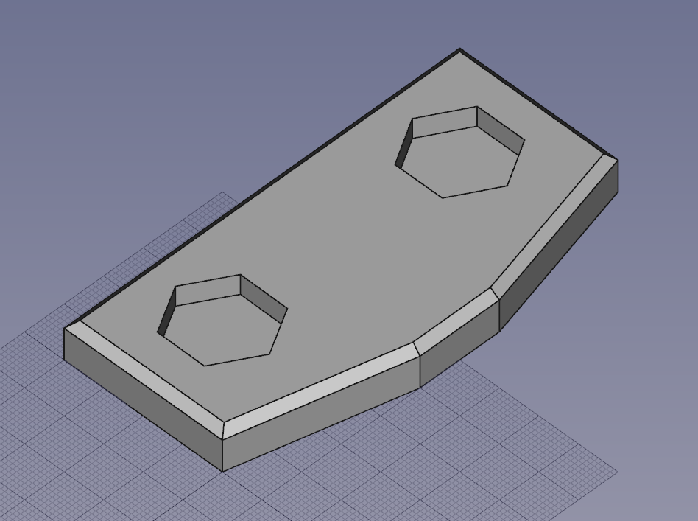

Hardware Model with actuation disks  
