The goal of the Adaptive H.I.D. team was to design a set of adaptive interface devices for modern computers with readily available consumer machinery and products. The product has a focus on affordability, iterative design, and easy operation. We are providing the systems designed during the class, along with our case study on the viability of this approach to manufacturing. This includes working prototypes of input devices for the handicapped and software enhancing prototypes from a simple I/O peripheral to a more useful tool such as predictive text. Additionally, we are providing the physical systems to a local benefactor, United Cerebral Palsy of Huntsville.

**Adaptive H.I.D.**   
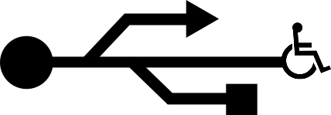  
<https://github.com/ctag/cpe495>  
  
<http://cpe-design.uah.edu/2016/team1/index.html>

CPE 495 Project Review

Spring 2016

University of alabama in huntsville

301 Sparkman Dr. NW, Huntsville, Alabama 35899

Christopher Bero

Bryant Johnson

Michael Baldwin  
John Gould