Group 4A
Chris Bero, Chris McClellan, Michael Bizanis, John Gould
3/30/2015
CPE 453 Bi-Weekly Sprint Report (Sprint 3 (Revision))
Author: Michael Bizanis

Table of Contents

- Cover Page......................................................................................................................Page1

- Table of Contents...........................................................................................................Page2

- Repository Information.................................................................................................Page3
- Equipment used for Testing...........................................................................................Page3
- How to download and run..............................................................................................Page3
- Test Case Descriptions...................................................................................................Page3
- Designed........................................................................................................................Page3
- Completed......................................................................................................................Page3

- Project Repository........................................................................................................Page4
- Issues Concerns and Risks...........................................................................................Page4
- Lessons Learned...........................................................................................................Page4
- Metrics, (User Stories Completed, Lines of Code, Test Cases completed/run Labor Hours by Task/Person, Burn Rate).....................................................................Page4

- Story Backlog...............................................................................................................Page5
- Prioritized List of Tasks................................................................................................Page5

- Proposed Test Cases.....................................................................................................Page6
- Sample Displays...........................................................................................................Page6
- Labor Estimates by Task/Person..................................................................................Page6
- Product Backlog...........................................................................................................Page6
- Prioritized List of Stories.............................................................................................Page6
- Nominal Assignment by Person...................................................................................Page6
- Nominal Labor Estimate..............................................................................................Page6

- Code Listings..........................................................................................................Page7-10
Part I Retrospective
Code Listings: Code Placed at end of Report.

Repository Information: All code still being stored at: https://github.com/ctag/cpe453

Equipment used for Testing: Testing this sprint needed further use of the QT development software. The sprint was focused largely on fixing a major bug in creating track pieces, as well implementing the interface to insert track pieces. Most testing simply required the most recent code and a user to interface it. SQL database interfacing with the track systems underwent further refinement and attempted queueing.

How to download and run: In order to download the code, a user must first go to the github repository located at https://github.com/ctag/cpe453. Under the cpe453 repository, download the folder denoted as "NodeToNode" and open the QT application within the folder. The application within the folder should run the current working model of the layout system. From there, a user can test out the features in question.
To run the SQL bridge code, go to the terminal in any of the computers in the EB linux labs. Once in the terminal, run the following command "home/student/csb0019/train_rec". This will bring up the main program used to interface with the track. To sample manual control of trains, switches, and detection sections, run "home/student/csb0019/train_rec_Sql".

Test Case Descriptions: Test case 1: Testing track placement feature. Goal: Successfully place a piece of track onto the track layout grid. Test Parameters: Open the program (no starting track pieces), select the place track option, and draw a straight piece of track on the screen. Expected Outcome: A straight line with 2 endpoints representing a track piece should be drawn on the screen.
Test case 2: Testing bug fix attempt. Goal: Drag a track piece around without ghost images appearing. Test Parameters: Place a straight track line piece onto the board. Attempt to drag it to a new location. Expected Outcome: If bug fix worked, the track piece should re-locate without any strange imaging issues. Test Case 3: Verify loconet messaging queue. Goal: Confirm if attempted messaging queue in latest loconet code build actually improves speed. Test Parameters: Connect to loconet and attempt to receive and transmit packets. Compare to previous rates. Expected Outcome: If the queue is helpful, the processing time should be reduced and loconet traffic should be faster.

Designed: Test case 1: Testing the track placement feature required running the application on one of the lab computers. Once the code is running, click on the track segment option on the right-hand side of the screen, then, in the main section of space, click on 2 distinct points in the grid to place a track. If all is correct, a straight line of track should appear. Test case 2: Once track piece has been created in test case 1, attempt to select and drag the track piece around. If the bug fix worked, there should be no ghost images as a result of moving the componenet. Test case 3: Load up the sql bridge application and make a connection to loconet on the lab computer in the room with the track. Attempt to query the track for information. Compare speed of response to earlier iterations. A noteworthy increase in response time indicates the queue is working.

Completed: Test case 1: Test was completed successfully. Track pieces can now be added to the layout. Test case 2: Success. Moving the track piece no longer leaves ghost images behind while layout tries to reconfigure. Test case 3: Failure. The loconet messaging queue did not adequately improve the speed of interacting with the track. Messaging queue will be abandonded.

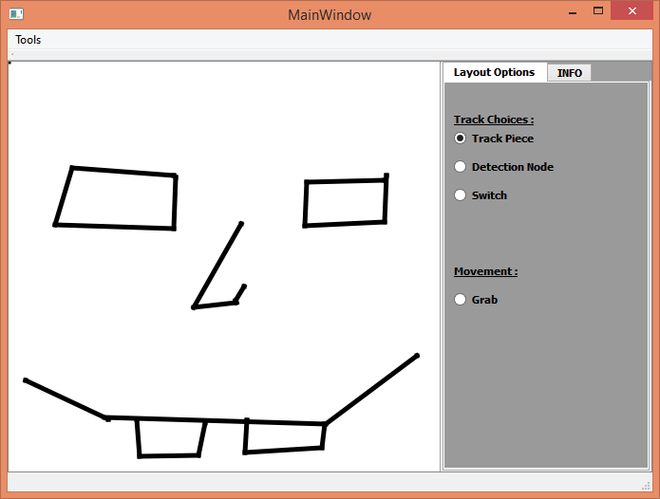

The bug fix issue, though time consuming, was successfully taken care of, and smooth addition of track pieces is now working correctly. The queue system has so far failed, no improvement.

Project Repository: Project repository stored at: https://trello.com/b/8oFdolpq/senior-design-studio (trello link). All sprint information publicly viewable.

Issues, Concerns, Risks: One significant issue issue encountered was with the attempted track data queue. A lot of effort went into making it work, but due to poor documentation on the part of digitracks, the real issue was difficult to discern until testing proved the attempt failed. Implementation of the full track is a noticeable concern, though modification seems fairly stable.

Lessons Learned: The queue attempt was frustrating, but many advancements were made to the overall functionality of the track data interface. The bug fix was difficult, but we now fully understand the limitations of the QLine class that we are using.

Metrics:
*User Stories Completed: As a user, I want an interface to create a track. As a user, I want to be able to make a selection on the interface and enable adding track pieces to my display. BUG FIX: As a user, I want a fluent creation of track pieces (lines).
*Lines of Code: 287 lines of code.
*Test Cases completed/run: 6. 4 separate user interface tests passed. Bug fix test passed. Track data queue failed.
*Labor Hours by Task/Person:
John Gould: 8 hours. Task: Interface Story. BUG FIX. Testing.
Chris Bero: 22+ Task: Loconet detection code, track data queue.
Chris McClellan: 8 hours Task: Interface Story, Track Addition, BIG FIX.
Michael Bizanis: 12 hours Task: BUG FIX, Interface story.
*Burn Rate: (Actual/Projected): Projected hours this sprint: 60 hours. Actual Hours: 50 hours.
This Sprint: 50 hours. Total Project: 117 hours. (Majority devoted to Loconet testing).
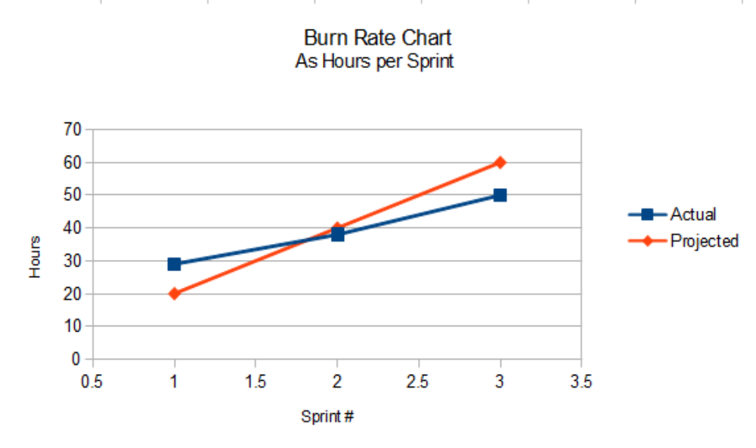

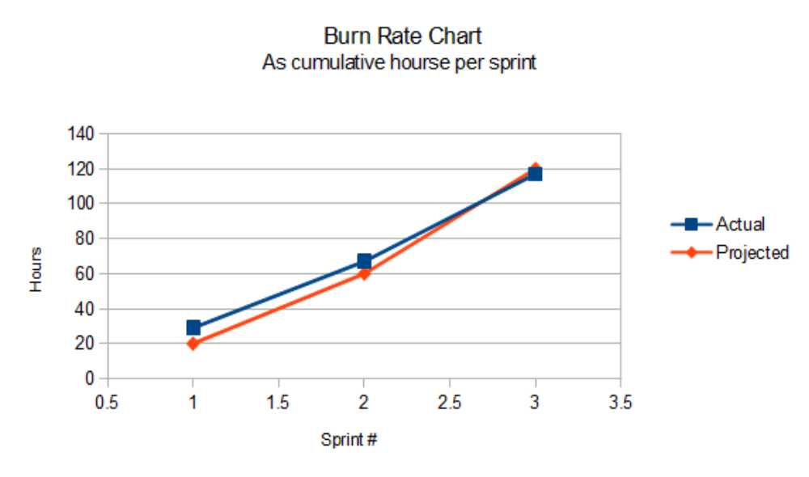

Story Backlog at End of Sprint: As a user, I want to be able to select a switch or piece of track and assign a switch number or sector number to it. As a developer, I want a method to send/receive loconet packets. Extensive work was put forth to these stories, but will likely require more time.

Part II Prospective

Prioritized List of Tasks:
1. Implement a way to create switches in the user interface.
2. Refine methods for interfacing with the SQL tables.
3. Focus on collecting data from the track through Loconet.
5. Ensure future changes do not allow for further track placement bugs.

Proposed Test Cases: Test the functionality of the switch option (once operational) by placing basic track segments and then connecting switch pieces. Check for track detection code. Monitor SQL tables.

Sample Display:

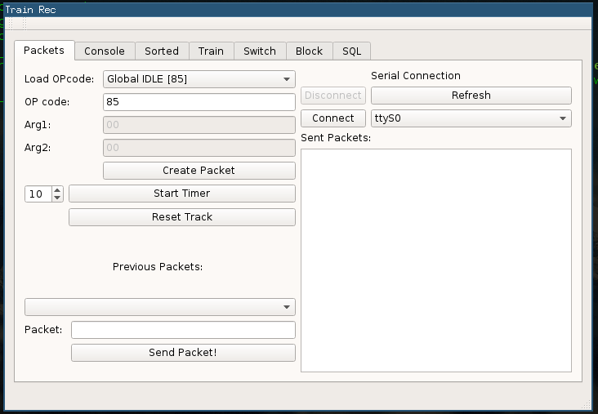

Labor Estimates by Task/Person:
Task: Create a switch as a user (10). Layout GUI be free of persisting track bug (10). Process detection data from track through Loconet (40). Access SQL tables (8).
Person: John Gould: 12 hrs Chris Bero: 32+ hrs Chris McClellan: 6 hrs Michael Bizanis: 10 hrs

Product Backlog: As a developer, I want to establish connection with the environment and be able to retrieve data to update graphical display. As a user, I want an updatable graphical display of the track. As a user, I want to be able to select a switch or piece of track and assign a switch number or sector number to it.

Prioritized List of Stories:
1. As a user, I want to be able to create a switch (Display Only).
2. As a developer, I want to process detection data from the track through Loconet.
3. As a user, I want the layout GUI to be free of the persistent track pieces bug.
4. As a developer, I want to access the SQL tables.

Nominal Assignment by Person: Chris Bero: Developing Loconet, reading SQL data. John Gould: Switch story, testing. Micahel Bizanis: Track layout GUI, Switch story. Chris McClellan: QGrapchics change, Track Layout GUI.

Nominal Labor Estimate: 60 hours.
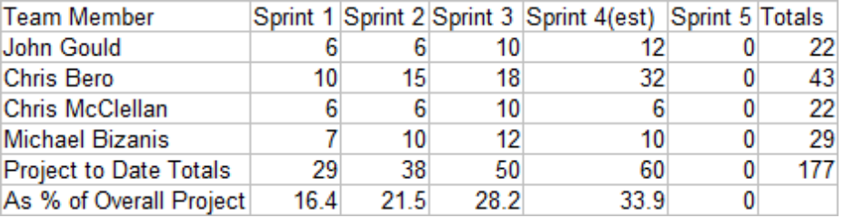

Code Listings:
#endif // MAINWINDOW_H

#ifndef MYWIDGET_H
#define MYWIDGET_H
#include <QLabel>
#include "QLine"
#include "QEvent"
#include "QMoveEvent"
#include "QGraphicsSceneMouseEvent"
#include <QMouseEvent>
#include <QPoint>
#include <QPixmap>
#include <QPainter>
#include <QDebug>
#include <QDialog>
#include <QVBoxLayout>
#include <QLabel>
#include <QAction>
#include <QRadioButton>
//#include "mainwindow.h"
class mywidget : public QLabel
{
Q_OBJECT
public:
explicit mywidget(QWidget *parent = 0);
~mywidget();
private:
QPoint startPos;
QPoint endPos;
QPoint switch_startPos;
QPoint switch_endPos;
bool firstclick;
bool secondclick;
bool originclick;
bool isSwitch;
bool leftDown;
bool rightDown;
bool connectsToPrevious;
QVector<QLine> lines;
bool track_rad_state;
bool detection_rad_state;
bool switch_rad_state;
//QLinkedList<int> mypoints;
public slots:
void get_rad_rad(bool status);
void get_det_rad(bool status);
void get_switch_rad(bool status);
signals:
// void request_rad_status(bool);
};
#endif // MYWIDGET_H

#include "mainwindow.h"
#include "ui_mainwindow.h"
MainWindow::MainWindow(QWidget *parent) :
QMainWindow(parent),
ui(new Ui::MainWindow)
{
ui->setupUi(this);
//Connect Signals to mywidget
connect(ui->rad_track_piece,SIGNAL(clicked()),this,SLOT(check_rad()));//
connect(ui->rad_det_node,SIGNAL(clicked()),this,SLOT(check_rad()));//
connect(ui->rad_switch,SIGNAL(clicked()),this,SLOT(check_rad()));
connect(this,SIGNAL(rad_track_status(bool)),ui->mytraintrack,SLOT(get_rad_rad(bool)));
connect(this,SIGNAL(rad_det_status(bool)),ui->mytraintrack,SLOT(get_det_rad(bool)));
connect(this,SIGNAL(rad_switch_status(bool)),ui->mytraintrack,SLOT(get_switch_rad(bool)));
}
MainWindow::~MainWindow()
{
delete ui;
}
void MainWindow::check_rad(){
if(ui->rad_track_piece->isChecked())
emit rad_track_status(true);
if(ui->rad_det_node->isChecked())
emit rad_det_status(true);
if(ui->rad_switch->isChecked())
emit rad_switch_status(true);
}

#include "mywidget.h"
//#include "mainwindow.h"
mywidget::mywidget(QWidget *parent):QLabel(parent)
{
this->setMouseTracking(true);
this->startPos = QPoint();
this->endPos = QPoint();
leftDown = false;
rightDown = false;
connectsToPrevious = false;
originclick=true;
firstclick=false;
secondclick=false;
}
//click
void mywidget::mousePressEvent(QMouseEvent *event){
if(track_rad_state==true){
if (event->buttons() & Qt::LeftButton)
{
if(!connectsToPrevious){
QLine line = QLine(startPos, endPos);
lines.append(line);
startPos = event->pos();
endPos = event->pos();
update();
}
leftDown = true;
}
else if (event->buttons() & Qt::RightButton){
rightDown = true;
}
}
if(switch_rad_state==true)
{
if (event->buttons() & Qt::LeftButton)
{
if(!connectsToPrevious){
QLine line = QLine(startPos, endPos);
lines.append(line);
startPos = event->pos();
endPos = event->pos();
update();
originclick=true;
}
leftDown = true;
}
else if (event->buttons() & Qt::RightButton){
rightDown = true;
}
}
}
//click & drag
void mywidget::mouseMoveEvent(QMouseEvent *event){
if(track_rad_state==true){
if (leftDown & connectsToPrevious)
{
endPos = event->pos();
update();
}
else if (connectsToPrevious)
{
endPos = event->pos();
update();
}
else if (leftDown){
startPos = event->pos();
endPos = event->pos();
update();
}
}
if(switch_rad_state==true)
{
if (connectsToPrevious)
{
endPos = event->pos();
update();
}
else if (leftDown){
startPos = event->pos();
endPos = event->pos();
update();
}
}
}
//release
void mywidget::mouseReleaseEvent(QMouseEvent *event){
if(track_rad_state==true){
if (leftDown){
leftDown = !leftDown;
endPos = event->pos();
QLine line = QLine(startPos, event->pos());
lines.append(line);
}
else if(rightDown){
//clear selection
rightDown = !rightDown;
endPos = startPos;
connectsToPrevious = false;
}
update();
}
if(switch_rad_state==true){
if (leftDown){
leftDown = !leftDown;
endPos = event->pos();
QLine line = QLine(startPos, event->pos());
lines.append(line);
//begin next line
if(originclick==true)
{
qDebug() <<"Fumborigin";
endPos = event->pos();
connectsToPrevious = true;
originclick=false;
firstclick=true;
}
else if (firstclick)
{
qDebug() << "first";
endPos = event->pos();
firstclick=false;
secondclick=true;
update();
}
else if (secondclick)
{ qDebug() << "second";
secondclick=false;
endPos = event->pos();
update();
connectsToPrevious=false;
}
}
else if(rightDown){
//clear selection
rightDown = !rightDown;
endPos = startPos;
if(firstclick)
connectsToPrevious = false;
else if (secondclick)
connectsToPrevious=true;
}
update();
}
}
void mywidget::drawLines(QPainter *p){
if(track_rad_state==true||switch_rad_state==true){
if (!startPos.isNull() && !endPos.isNull())
{ p->setRenderHint(QPainter::Antialiasing, true);//added
p->drawLine(startPos, endPos);
}
p->drawLines(lines);
}
}

