Group 4A
Chris Bero, Chris McClellan, Michael Bizanis, John Gould
4/6/2015
CPE 453 Bi-Weekly Sprint Report (Sprint 5)
Author: Chris McClellan

Table of Contents

- Cover Page......................................................................................................................Page1

- Table of Contents...........................................................................................................Page2

- Repository Information.................................................................................................Page3
- Equipment used for Testing...........................................................................................Page3
- How to download and run..............................................................................................Page3
- Test Case Descriptions...................................................................................................Page3
- Designed........................................................................................................................Page3
- Completed......................................................................................................................Page3

- Project Repository........................................................................................................Page4
- Issues Concerns and Risks...........................................................................................Page4
- Lessons Learned...........................................................................................................Page4
- Metrics, (User Stories Completed, Lines of Code, Test Cases completed/run Labor Hours by Task/Person, Burn Rate).....................................................................Page4

- Story Backlog...............................................................................................................Page5
- Prioritized List of Tasks................................................................................................Page5
- Proposed Test Cases.....................................................................................................Page5
- Sample Displays...........................................................................................................Page5

- Labor Estimates by Task/Person..................................................................................Page6
- Product Backlog...........................................................................................................Page6
- Prioritized List of Stories.............................................................................................Page6
- Nominal Assignment by Person...................................................................................Page6
- Nominal Labor Estimate..............................................................................................Page6

- Code Listings............................................................................................................Page6-8
Part I Retrospective
Code Listings: Code Placed at end of Report.

Repository Information: All code still being stored at: https://github.com/ctag/cpe453

Equipment used for Testing: Testing this sprint required continued use of the QT development software. The sprint was focused largely on completing all reqruied fields to finish up the layout system. Additional work was devoted to finializing the SQL bridge application. Lab computers, and access to the track were required for verification of changes.

How to download and run: In order to download the code, a user must first go to the github repository located at https://github.com/ctag/cpe453. Under the cpe453 repository, download the folder denoted as "NodeToNode" and open the QT application within the folder. The application within the folder should run the current working model of the layout system. From there, a user can test out the features in question.
To run the SQL bridge code, go to the terminal in any of the computers in the EB linux labs. Once in the terminal, run the following command "home/student/csb0019/train_rec". This will bring up the main program used to interface with the track. To sample manual control of trains, switches, and detection sections, run "home/student/csb0019/train_rec_Sql".

Test Case Descriptions: Test case 1: Point to point track placement. Goal: Place track pieces be sketching a path as a serires of nodes. Test Parameters: Open the program (no starting track pieces), select the place track option, and generate a series of nodes in a path. Expected Outcome: Program should link the nodes together and create a track segment. Test case 2: Switches. Goal: Select a track piece and assert the section as a switch. Test Parameters: Use node to node system to create a track segement. Select the track piece, and select the switch option. Expected Outcome: Program should denote the section as a switch. When layout is converted to SQL database, switch should appear. Test Case 3: Final check on SQL bridge. Goal: Ensure final changes to SQL bridge support communication with track. Test Parameters: Connect to the track using the SQL bridge program. Following the on-screen prompt, query the track status, select a train, and drive the train, togling a few switches along the way. Expected Outcome: SQL bridge should communicate with the track, listing detection sections, trains, and updating the SQL tables accordingly.

Designed: Test case 1: Testing required running the application on one of the lab computers. Once the code is running, click somewhere on the grid, which should create a node. Continue to place a few more nodes, then select the segment option, creating a track section that the program connects. Test case 2: Once track piece has been created in test case 1, select a section and change it to a switch. This should allow the user to create a bypass section, as well as the other section. Once the switch is complete, update SQL tables using the option in the prgram and verify if track section (including switch) was added successfully. Test case 3: Using a computer in the track room, load the SQL bridge program and establish a connection to the track. Once track communication is established, check the track status, listing the track segements and switches. Connect to a train, and attmept to drive it using the SQL bridge. Once train is driving, toggle switches using the SQL bridge.

Completed: Test case 1: Success. Adding nodes in sequence will create a track section. Test case 2: Success. Track piceces can be selected, and then converted to switches. Uploading to SQL tables works. Test case 3: Success. SQL bridge can connect to the track and fully control trains, as well as monitor detection sections and affect switches.

Project Repository: Project repository stored at: https://trello.com/b/8oFdolpq/senior-design-studio (trello link). All sprint information publicly viewable.

Issues, Concerns, Risks: There is a potential bug when converting track layout data into the SQL data. One suggested method was a brute-force attempt that when lengthen conversion time, but could ensure proper list coverage with each iteration. SQL bridge has requested functionality to bypass slots, but is slighlty lsoppy and somewhat slow.

Lessons Learned: Converting to switches was somewhat challenging, but it succesfully covers all needed track segments when used in correct methods. SQL bridge is fully functional and capable of interfacing with all other groups. Making DINST to aid comprehension was quite useful.

Metrics:
*User Stories Completed: As a user, I want an interface to create a track. As a user, I want to be able to make a selection on the interface and convert to switch status. As a developer, I want a stable and functional release of the SQL bridge.
*Lines of Code: 116 lines of code.
*Test Cases completed/run: 3. 2 tests on layout functionality, 1 large test on SQL bridge. All passed.
*Labor Hours by Task/Person:
John Gould: 15 hours. Task: Interface Story. BUG FIX. Testing.
Chris Bero: 40+ Task: Loconet detection code, track data queue.
Chris McClellan: 5 hours Task: Interface Story, Track Addition, BIG FIX.
Michael Bizanis: 10 hours Task: BUG FIX, Interface story.
*Burn Rate: (Actual/Projected): Projected hours this sprint: 50 hours. Actual Hours: 70 hours.
This Sprint: 70 hours. Total Project: 255 hours.
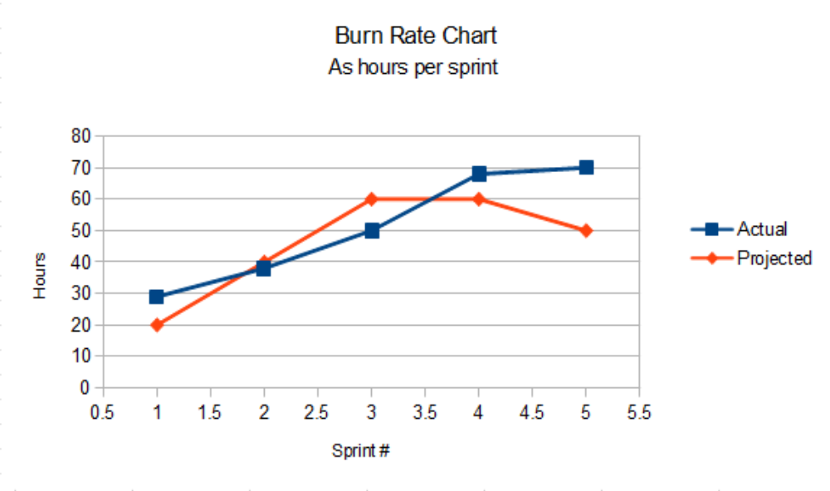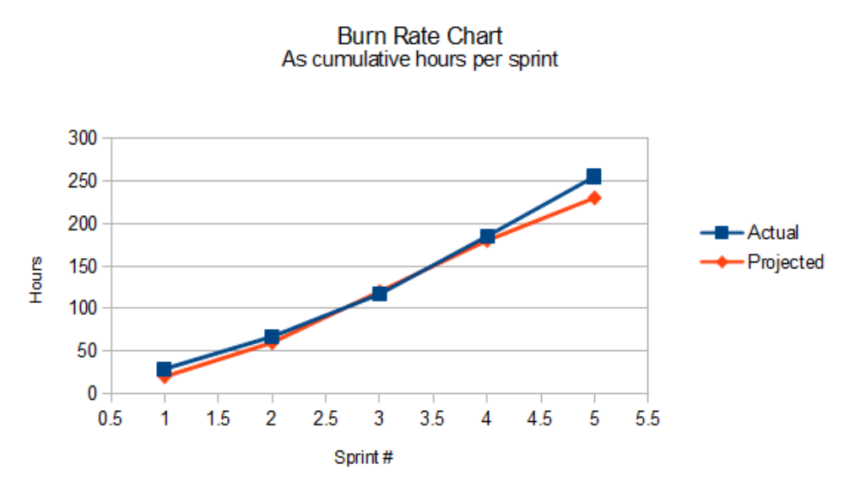

Story Backlog at End of Sprint: As a user, I want to be able to select a switch or piece of track and assign a switch number or sector number to it. As a developer, I want a method to send/receive loconet packets. Extensive work was put forth to these stories, but will likely require more time.

Part II Prospective

Prioritized List of Tasks:
1. Make minor changes to finish product.

Proposed Test Cases: Test overall functionality.

Sample Display:

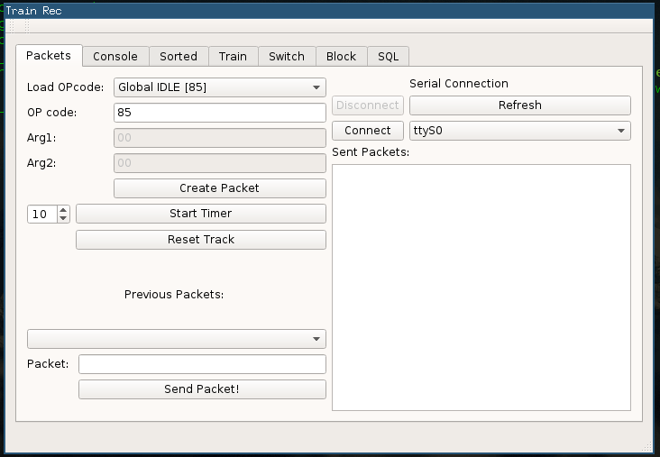

Labor Estimates by Task/Person:
Task: Double check all features (20).
Person: John Gould: 5 hrs Chris Bero: 5 hrs Chris McClellan: 5 hrs Michael Bizanis: 5 hrs

Product Backlog: As a developer, I want to establish connection with the environment and be able to retrieve data to update graphical display. As a user, I want an updatable graphical display of the track. As a user, I want to be able to select a switch or piece of track and assign a switch number or sector number to it.

Prioritized List of Stories: No more stories are really need. All is left is bug fixes.

Nominal Assignment by Person: All personel devoted to bug fixes and refinement.

Nominal Labor Estimate: 10 hours.

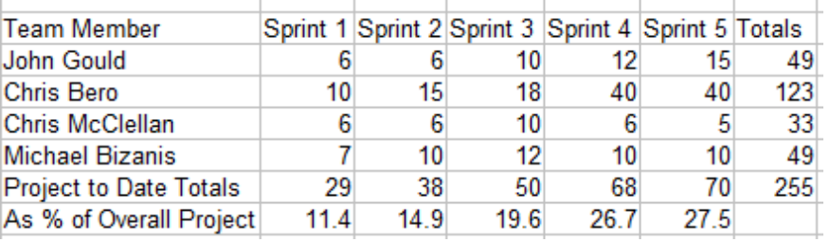

Code Listings:
#include "mainwindow.h"
#include "ui_mainwindow.h"

MainWindow::MainWindow(QWidget *parent) :
QMainWindow(parent),
ui(new Ui::MainWindow)
{
ui->setupUi(this);
// create List

// Declaring thread association
locosql = new SQL;
locosql->moveToThread(&threadSQL);

ui->horizontalLayout_3->setMargin(0);
ui->horizontalLayout->setMargin(0);

// Database Sig/Slots
connect(ui->pushButton_connect_2, SIGNAL(clicked()), this, SLOT(do_connectDB()));
connect(ui->pushButton_disconnect_2, SIGNAL(clicked()), this, SLOT(do_disconnectDB()));
connect(locosql, &SQL::DBopened, this, &MainWindow::handle_DBopened);
connect(locosql, &SQL::DBclosed, this, &MainWindow::handle_DBclosed);
connect(ui->pushButton_sqlUpload, SIGNAL(clicked()), this, SLOT(do_sqlUpload()));
connect(ui->pushButton_sqlClear, SIGNAL(clicked()), locosql, SLOT(do_clearVertices()));

connect(ui->mytraintrack, SIGNAL(connectedVertices(vertex*,QList<vertex*>)), locosql, SLOT(do_uploadVertex(vertex*,QList<vertex*>)));
connect(ui->mytraintrack, SIGNAL(allEdges(QList<edge*>)), locosql, SLOT(do_uploadEdges(QList<edge*>)));

//connect(ui->rad_track_piece,SIGNAL(clicked()),this,SLOT(check_rad()));
//connect(this,SIGNAL(rad_track_status(bool)),ui->mytraintrack,SLOT(get_track_rad(bool)));
connect(ui->connectButton,SIGNAL(clicked()),ui->mytraintrack,SLOT(connect_button_clicked()));
connect(ui->deleteButton,SIGNAL(clicked()),ui->mytraintrack,SLOT(delete_button_clicked()));
connect(ui->switchButton,SIGNAL(clicked()),ui->mytraintrack,SLOT(switch_button_clicked()));
connect(ui->groupButton,SIGNAL(clicked()),this,SLOT(handle_groupButton()));

// Attach arrow buttons to track panning
connect(ui->pushButton_shiftUp, SIGNAL(clicked()), ui->mytraintrack, SLOT(shift_up()));
connect(ui->pushButton_shiftLeft, SIGNAL(clicked()), ui->mytraintrack, SLOT(shift_left()));
connect(ui->pushButton_shiftDown, SIGNAL(clicked()), ui->mytraintrack, SLOT(shift_down()));
connect(ui->pushButton_shiftRight, SIGNAL(clicked()), ui->mytraintrack, SLOT(shift_right()));

// Kickstart thread
threadSQL.start();
locosql->do_run();
}

MainWindow::~MainWindow()
{
// Clean up sub-threads
threadSQL.quit();
threadSQL.wait();

delete ui;
}

/**
* Database Methods
*/

void MainWindow::handle_DBopened()
{
ui->textBrowser_sql_2->append("Database opened. Connection appears successful :)");
ui->pushButton_connect_2->setEnabled(false);
ui->pushButton_disconnect_2->setEnabled(true);
ui->pushButton_sqlUpload->setEnabled(true);
ui->pushButton_sqlClear->setEnabled(true);
}

void MainWindow::handle_DBclosed()
{
ui->textBrowser_sql_2->append("Database closed.");
ui->pushButton_connect_2->setEnabled(true);
ui->pushButton_disconnect_2->setEnabled(false);
ui->pushButton_sqlUpload->setEnabled(false);
ui->pushButton_sqlClear->setEnabled(false);
}

void MainWindow::do_connectDB()
{
// Collect information from window
QString hostname = ui->lineEdit_hostname_2->text();
int port = ui->spinBox_port_2->value();
QString database = ui->lineEdit_database_2->text();
QString username = ui->lineEdit_user_2->text();
QString password = ui->lineEdit_password_2->text();

locosql->do_openDB(hostname, port, database, username, password);
}

void MainWindow::do_disconnectDB()
{
locosql->do_closeDB();
}

void MainWindow::do_sqlUpload()
{
//ui->mytraintrack->get_allConnectedVertices();
ui->mytraintrack->updateVertInches();
ui->mytraintrack->get_allEdges();
}

void MainWindow::handle_groupButton()
{
ui->mytraintrack->group_button_clicked(ui->lineEdit_group->text());
}

/*void MainWindow::check_rad(){

if(ui->rad_track_piece->isChecked())
emit rad_track_status(true);
else
emit rad_track_status(false);

}*/

