Group 4A
Chris Bero, Chris McClellan, Michael Bizanis, John Gould
3/18/2015
CPE 453 Bi-Weekly Sprint Report (Sprint 4)
Author: John Gould

Table of Contents
Cover Page.................................................................................................................................Page1

Table of Contents.......................................................................................................................Page2

1. Repository Information...........................................................................................................Page3
2. Equipment used for Testing.....................................................................................................Page3
3. How to download and run.......................................................................................................Page3
4. Test Case Descriptions............................................................................................................Page3
5. Designed, Completed..............................................................................................................Page3
6. Project Repository...................................................................................................................Page3

9. Issues Concerns and Risks.....................................................................................................Page4
8. Lessons Learned.....................................................................................................................Page4
10. Metrics, (User Stories Completed, Lines of Code, Test Cases completed/run
Labor Hours by Task/Person, Burn Rate)..................................................................................Page4

11. Story Backlog......................................................................................................................Page5
12. Prioritized List of Tasks......................................................................................................Page5
13. Proposed Test Cases............................................................................................................Page5

14. Sample Displays...................................................................................................................Page6
15. Labor Estimates by Task/Person..........................................................................................Page6
16. Product Backlog...................................................................................................................Page6
17. Prioritized List of Stories.....................................................................................................Page6
18. Nominal Assignment by Person...........................................................................................Page6
19. Nominal Labor Estimate......................................................................................................Page6
20. Code Listings....................................................................................................................Page7-12
Part I Retrospective
20. Code Listings: Code Placed at end of Report (starting at page 7, ending on page 12).

1. Repository Information: All code still being stored at: https://github.com/ctag/cpe453

2. Equipment used for Testing: Testing this sprint largely required continued use of QT development software. This sprint focused on refining the layout management system, fixing the switch option, and minor bug solves. Most testing simply required up-to-date code. For managing the SQL database tables and track updates, the board layout for the trains was required. Minor attempts to interface with the SQL databases on pavelow were attempted.

3. How to download and run: 1. In order to download the code, a user must first go to the github repository located at https://github.com/ctag/cpe453. 2. Under the cpe453 repository, download the folder denoted as "NodeToNode" and open the QT application within the folder. 3. Opening the QT application should run the program, allowing a user to initiate the test cases.

To run the SQL bridge code, go to the terminal in any of the computers in the EB linux labs. Once in the terminal, run the following command "home/student/csb0019/train_rec". This will bring up the main program used to interface with the track. To sample manual control of trains, switches, and detection sections, run "home/student/csb0019/train_rec_Sql".

4. Test Case Descriptions: Primary test was to check if switch functionality is properly implemented (visual only, database affects are in the next sprint). Additional testing was devoted to track detection code. Trains were placed onto tracks, and loconet packets were scanned for detection data.

5. Designed: To test switch functionality, program was compiled and run, multiple segements of track were placed as straight pieces, then the “switch” option was selected and used. Testing of the detection sections required going into the lab, setting up the trains, and running the code. Data packets from the track were then examined. Connection to SQL tables attempted.

6. Completed: The switch test (visual only) was completed successfully. Switches can now be made in the layout program. SQL tables were connected to, detection data part way processed.
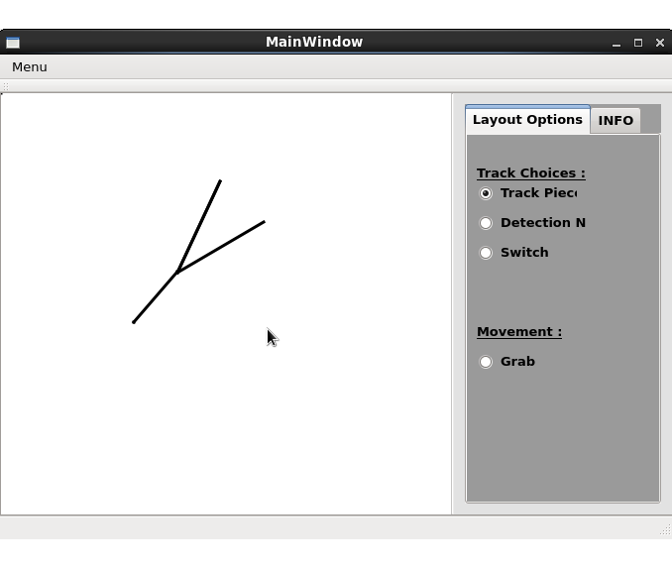

7. Project Repository: Project repository stored at: https://trello.com/b/8oFdolpq/senior-design-studio (trello link). All sprint information publicly viewable.

8. Issues, Concerns, Risks: One major issue was treating the track segments that were created as separate objects for processing into the SQL tables. Our original method worked quite well for making the track pieces, but presents several issues for data tracking.

9. Lessons Learned: Our previous implementation made use of draw line, but in order to interface with the databases, we are likely going to switch to using Qgraphics view to draw track pieces, thus allowing them to be accessed as objects. This will be a major change to project functionality.

10. Metrics:
*User Stories Completed: As a user, I want to be able to create a switch (Display only). As a user, I want the layout GUI to be free of the persistent track pieces bug. As a developer, I want to process detection data from the track through Loconet. As a developer, I want to access the SQL tables.
*Lines of Code: 399 lines of code.
*Test Cases completed/run: 5 (Several different parameters of the switch option were tested). All switch test cases passed. Bug fix test cases passed. Detection data initial test passed. Second test failed (ghost detection sections causing interference).
*Labor Hours by Task/Person:
John Gould: 12 hours. Task: Switch Story. Testing.
Chris Bero: 40+ Task: Loconet detection code
Chris McClellan:6 hours Task: Track Layout GUI, Switch Story, Qgraphics change.
Michael Bizanis:10 hours Task: Track Layout GUI, Switch Story.
*Burn Rate: (Actual/Projected): Projected hours this sprint: 60 hours. Actual Hours: 50 hours.
Totals: Projected by sprint 4: 180 hours. Actual hours: 185. (Majority devoted to Loconet testing).
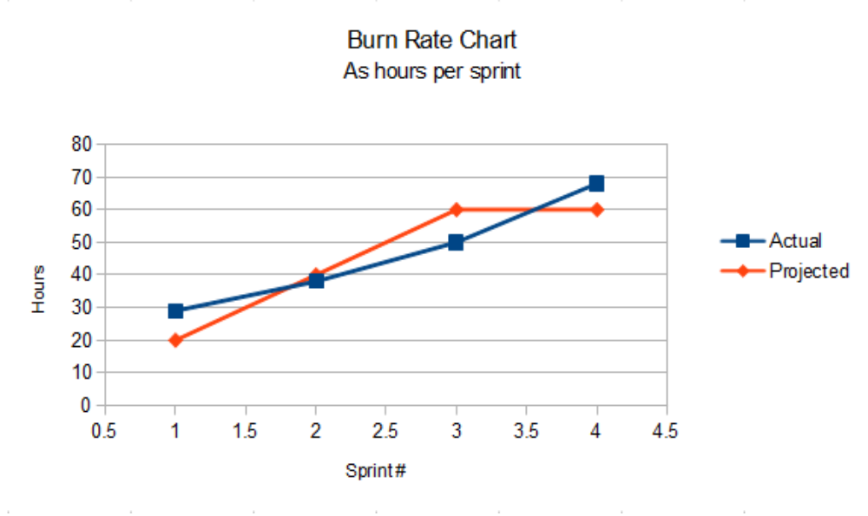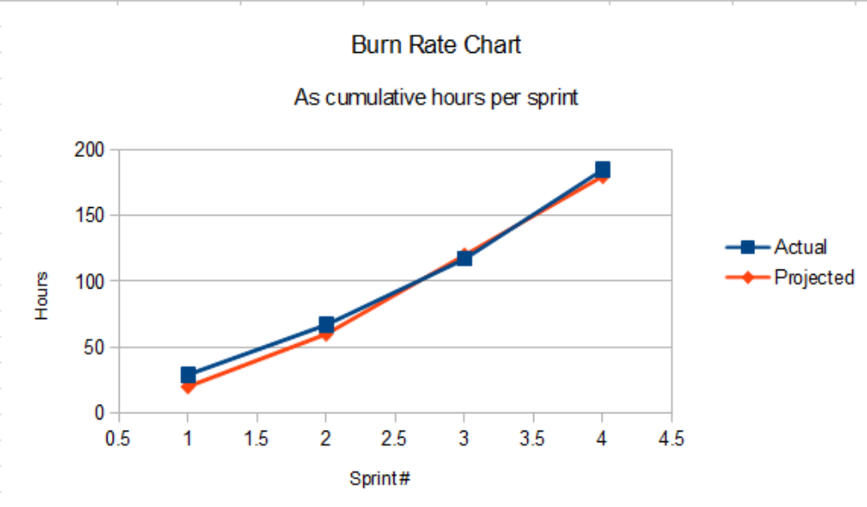

11. Story Backlog at End of Sprint: As a developer, I want a method to send/receive loconet packets. Extensive work was put forth to this story, but it will likely require more time.

Part II Prospective

12. Prioritized List of Tasks:
1. Confirm consistent data collection from the track and placement into SQL data tables.
2. Switch the main drawing mechanic in the layout system from QLabel to QGraphics.
3. Be able to access track pieces and place detection information into SQL tables.
4. Creation of a robust test suite for creating data packets and communicating with the track.
5. Create a user friendly interface for the layout GUI.

13. Proposed Test Cases: Attempt initial tests to confirm successful switch to the QGraphics design. Testing track creation and switch creation. Attempt to make various track piece types. Attempt to grab data from the tracks. Attempt to grab individual track segments and move them around. Check if placed track segments impact the SQL tables.

14. Sample Display:

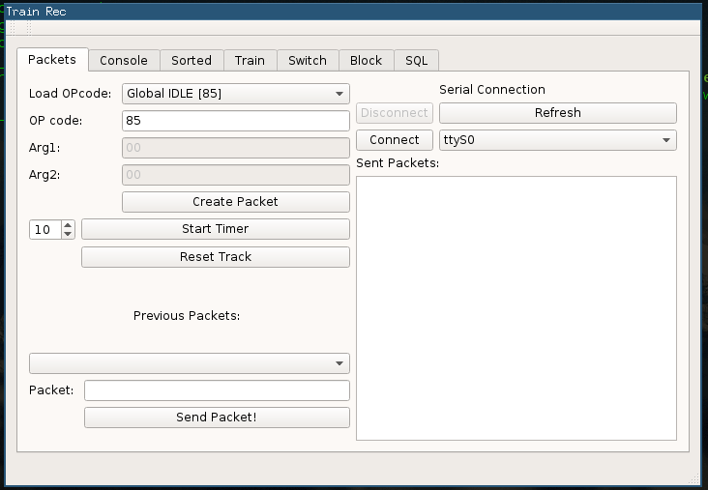

15. Labor Estimates by Task/Person:
Task: Confirm collection of data from track (13 hours). Switch to QGraphics mechanic (13 hours). Accessing track pieces (13 hours). Robust test suite (16 hours). User friendly interface (20 hours).
Person: John Gould: 10 hrs Chris Bero: 20 hrs Chris McClellan: 10 hrs Michael Bizanis: 10 hrs

16. Product Backlog: As a developer, I want to establish connection with the environment and be able to retrieve data to update graphical display. As a user, I want an updatable graphical display of the track. As a user, I want to be able to select a switch or piece of track and assign a switch number or sector number to it.

17. Prioritized List of Stories:
1. As a developer, I want a robust loconet test suite to generate packets and communicate with the track.
2. As a developer, I want to change my QLabel to a QGraphicsScene.
3. As a developer, I want SQL data from the track.
4. As a user, I want to be able to move my objects around.
5. As a developer, I want to bring the loconet test suite to be able to pass more stringent testing.

18. Nominal Assignment by Person: Chris Bero: Developing Loconet, reading SQL data. John Gould: Switching to QGraphics, improving code traceability. Micahel Bizanis: Moving objects around, adjusting QLabel. Chris McClellan: Creating more user friendly interface.

19. Nominal Labor Estimate: As of sprint4, 185 hours have been put into the project. 180 hours were projected by the end of this sprint. Total labor estiame is 230 hours. Therefore, remaining 50 hours of projected labor is devoted to the next sprint. Nominal labor estimate for sprint 5 is 50 hours.
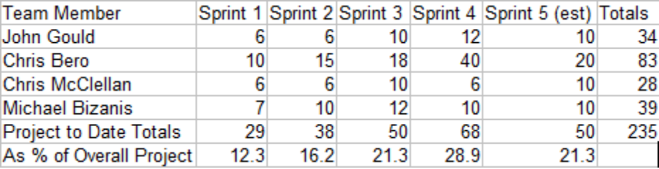

Code Listings:
#ifndef MAINWINDOW_H
#define MAINWINDOW_H
#include <QMainWindow>
#include "QLine"
#include "QEvent"
#include "QMoveEvent"
#include "QGraphicsSceneMouseEvent"
#include <QMouseEvent>
#include <QPoint>
#include <QPixmap>
#include <QPainter>
#include <QDebug>
#include <QDialog>
#include <QVBoxLayout>
#include <QLabel>
#include <QAction>
#include <QRadioButton>
#include "mywidget.h"
namespace Ui {
class MainWindow;
}
class MainWindow : public QMainWindow
{
Q_OBJECT
public:
explicit MainWindow(QWidget *parent = 0);
~MainWindow();
private:
mywidget my;
Ui::MainWindow *ui;
//GUI
protected:
/* void mousePressEvent(QMouseEvent *event);
void mouseMoveEvent(QMouseEvent *event);
void mouseReleaseEvent(QMouseEvent *event);//added
void paintEvent(QPaintEvent *paintEvent);
void drawLines(QPainter *p);
*/
private slots:
void check_rad();
signals:
void rad_track_status(bool status);
void rad_det_status(bool status);
void rad_switch_status(bool status);
};
#endif // MAINWINDOW_H

#ifndef MYWIDGET_H
#define MYWIDGET_H
#include <QLabel>
#include "QLine"
#include "QEvent"
#include "QMoveEvent"
#include "QGraphicsSceneMouseEvent"
#include <QMouseEvent>
#include <QPoint>
#include <QPixmap>
#include <QPainter>
#include <QDebug>
#include <QDialog>
#include <QVBoxLayout>
#include <QLabel>
#include <QAction>
#include <QRadioButton>
#include <QList>
//#include "mainwindow.h"
class mywidget : public QLabel
{
Q_OBJECT
public:
explicit mywidget(QWidget *parent = 0);
~mywidget();
private:
QPoint startPos;
QPoint endPos;
QPoint switch_startPos;
QPoint switch_endPos;
bool firstclick;
bool secondclick;
bool originclick;
bool isSwitch;
bool leftDown;
bool rightDown;
bool connectsToPrevious;
QVector<QLine> lines;
bool track_rad_state;
bool detection_rad_state;
bool switch_rad_state;
//QLinkedList<int> mypoints;
protected:
void mousePressEvent(QMouseEvent *event);
void mouseMoveEvent(QMouseEvent *event);
void mouseReleaseEvent(QMouseEvent *event);
void paintEvent(QPaintEvent *paintEvent);
void drawLines(QPainter *p);
public slots:
void get_rad_rad(bool status);
void get_det_rad(bool status);
void get_switch_rad(bool status);
signals:
// void request_rad_status(bool);
};
#endif // MYWIDGET_H

#include "mainwindow.h"
#include "ui_mainwindow.h"
MainWindow::MainWindow(QWidget *parent) :
QMainWindow(parent),
ui(new Ui::MainWindow)
{
ui->setupUi(this);
//GUI
ui->mytoolbox->setFixedWidth(220);
ui->horizontalLayout_2->setMargin(0);
ui->horizontalLayout_3->setMargin(0);
ui->horizontalLayout->setMargin(0);
ui->tabWidget->setTabText(0,"Layout Options");
//Connect Signals to mywidget
connect(ui->rad_track_piece,SIGNAL(clicked()),this,SLOT(check_rad()));//
connect(ui->rad_det_node,SIGNAL(clicked()),this,SLOT(check_rad()));//
connect(ui->rad_switch,SIGNAL(clicked()),this,SLOT(check_rad()));
connect(this,SIGNAL(rad_track_status(bool)),ui->mytraintrack,SLOT(get_rad_rad(bool)));
connect(this,SIGNAL(rad_det_status(bool)),ui->mytraintrack,SLOT(get_det_rad(bool)));
connect(this,SIGNAL(rad_switch_status(bool)),ui->mytraintrack,SLOT(get_switch_rad(bool)));
}
MainWindow::~MainWindow()
{
delete ui;
}
void MainWindow::check_rad(){
if(ui->rad_track_piece->isChecked())
emit rad_track_status(true);
if(ui->rad_det_node->isChecked())
emit rad_det_status(true);
if(ui->rad_switch->isChecked())
emit rad_switch_status(true);
}

#include "mywidget.h"
//#include "mainwindow.h"
mywidget::mywidget(QWidget *parent):QLabel(parent)
{
this->setMouseTracking(true);
this->startPos = QPoint();
this->endPos = QPoint();
leftDown = false;
rightDown = false;
connectsToPrevious = false;
originclick=true;
firstclick=false;
secondclick=false;
}
mywidget::~mywidget(){
}
//click
void mywidget::mousePressEvent(QMouseEvent *event){
if(track_rad_state==true){
if (event->buttons() & Qt::LeftButton)
{
if(!connectsToPrevious){
QLine line = QLine(startPos, endPos);
lines.append(line);
startPos = event->pos();
endPos = event->pos();
update();
}
leftDown = true;
}
else if (event->buttons() & Qt::RightButton){
rightDown = true;
}
}
if(switch_rad_state==true)
{
if (event->buttons() & Qt::LeftButton)
{
if(!connectsToPrevious){
QLine line = QLine(startPos, endPos);
lines.append(line);
startPos = event->pos();
endPos = event->pos();
update();
originclick=true;
}
leftDown = true;
}
else if (event->buttons() & Qt::RightButton){
rightDown = true;
}
}
}
//click & drag
void mywidget::mouseMoveEvent(QMouseEvent *event){
if(track_rad_state==true){
if (leftDown & connectsToPrevious)
{
endPos = event->pos();
update();
}
else if (connectsToPrevious)
{
endPos = event->pos();
update();
}
else if (leftDown){
startPos = event->pos();
endPos = event->pos();
update();
}
}
if(switch_rad_state==true)
{
if (connectsToPrevious)
{
endPos = event->pos();
update();
}
else if (leftDown){
startPos = event->pos();
endPos = event->pos();
update();
}
}
}
//release
void mywidget::mouseReleaseEvent(QMouseEvent *event){
if(track_rad_state==true){
if (leftDown){
leftDown = !leftDown;
endPos = event->pos();
QLine line = QLine(startPos, event->pos());
lines.append(line);
//begin next line
startPos = event->pos();
endPos = event->pos();
connectsToPrevious = true;
}
else if(rightDown){
//clear selection
rightDown = !rightDown;
endPos = startPos;
connectsToPrevious = false;
}
update();
}
if(switch_rad_state==true){
if (leftDown){
leftDown = !leftDown;
endPos = event->pos();
QLine line = QLine(startPos, event->pos());
lines.append(line);
//begin next line
if(originclick==true)
{
qDebug() <<"Fumborigin";
endPos = event->pos();
connectsToPrevious = true;
originclick=false;
firstclick=true;
}
else if (firstclick)
{
qDebug() << "first";
endPos = event->pos();
firstclick=false;
secondclick=true;
update();
}
else if (secondclick)
{ qDebug() << "second";
secondclick=false;
endPos = event->pos();
update();
connectsToPrevious=false;
}
}
else if(rightDown){
//clear selection
rightDown = !rightDown;
endPos = startPos;
if(firstclick)
connectsToPrevious = false;
else if (secondclick)
connectsToPrevious=true;
}
update();
}
}
void mywidget::drawLines(QPainter *p){
if(track_rad_state==true||switch_rad_state==true){
if (!startPos.isNull() && !endPos.isNull())
{ p->setRenderHint(QPainter::Antialiasing, true);//added
p->drawLine(startPos, endPos);
}
p->drawLines(lines);
}
}
void mywidget::paintEvent(QPaintEvent *event){
QPainter p(this);
QPen pen;
pen.setColor(Qt::black);
pen.setWidth(3);
p.setPen(pen);
drawLines(&p);
}
void mywidget::get_rad_rad(bool status){
track_rad_state=status;
detection_rad_state=false;
switch_rad_state=false;
}
void mywidget::get_det_rad(bool status){
detection_rad_state=status;
track_rad_state=false;
switch_rad_state=false;
}
void mywidget::get_switch_rad(bool status){
detection_rad_state=false;
track_rad_state=false;
switch_rad_state=true;
}

