Group 4A
Chris Bero, Chris McClellan, Michael Bizanis, John Gould
3/30/2015
CPE 453 Bi-Weekly Sprint Report (Sprint 3 (Revision))

Table of Contents:

Page 1:
- Repository Information
- Equipment used for Testing
- How to download and run
- Test Case Descriptions
- Designed
- Completed

Page 2:
- Completed
- Project Repository
- Issues Concerns and Risks
- Lessons Learned
- Metrics, (User Stories Completed, Lines of Code, Test Cases completed/run, Labor Hours by Task/Person, Burn Rate)
- Story Backlog
- Prioritized List of Tasks
- Proposed Test Cases

Page 3:
- Sample Displays
- Labor Estimates by Task/Person
- Product Backlog
- Prioritized List of Stories
- Nominal Assignment by Person
- Code Listings

Pages 3-7:
- Code Listings
Part I Retrospective
Code Listings: Code Placed at end of Report.

Repository Information: All code still being stored at: https://github.com/ctag/cpe453

Equipment used for Testing: Testing this sprint needed further use of the QT development software. The sprint was focused largely on fixing a major bug in creating track pieces, as well implementing the interface to insert track pieces. Most testing simply required the most recent code and a user to interface it. SQL database interfacing with the track systems underwent further refinement and attempted queueing.

How to download and run: To run test cases, simply pull the latest version of the code from the repository and git-hub, compile and run in QT, then attempt to use the interface. Checking the track update functionality requires use of the Digitracks hardware. Current layout code is posted under the “NodeToNode” folder. Grab from the repository, then using QT, open the project file, and run the program.

Test Case Descriptions: Primary test was to see if track placement was implemented properly. Test of the completed portions of the user interface was undertaken, as well as attempting to place track pieces without the bug that was plaguing implementation last sprint. Various attempt were made to try and improve loconet messages with a QT side queue, but progress is uncertain.

Designed: To test the user interface, the code was run, and each team member attempted to place track elements and commented on the layout of the options. For verifying if the bug fix worked, it was a simple matter of executing the code and attempting to place track pieces in a smooth and continuous fashion without unusual errors. Testing the queue involved setting up the trains and monitoring table data output rate.

Completed: The user interface test was completed as we now have a GUI with the options needed to implement most of the requirements for the task. Sample image from repository below:

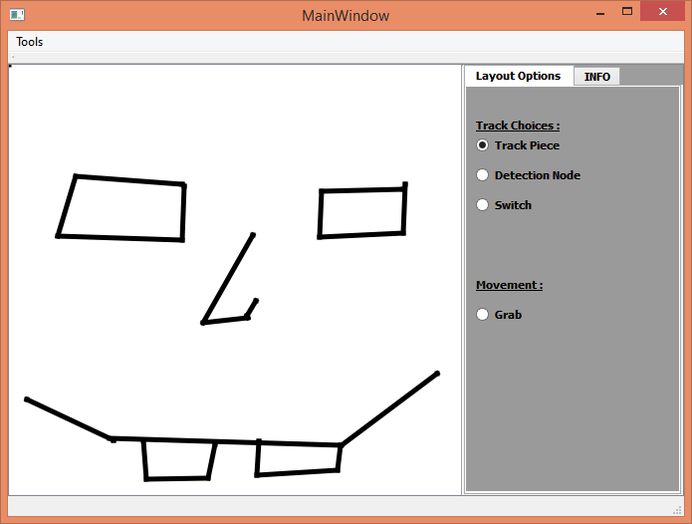

The bug fix issue, though time consuming, was successfully taken care of, and smooth addition of track pieces is now working correctly. The queue system has so far failed, no improvement.

Project Repository: Project repository stored at: https://trello.com/b/8oFdolpq/senior-design-studio

Issues, Concerns, Risks: One significant issue issue encountered was with the attempted track data queue. A lot of effort went into making it work, but due to poor documentation on the part of digitracks, the real issue was difficult to discern until testing proved the attempt failed. Implementation of the full track is a noticeable concern, though modification seems fairly stable.

Lessons Learned: The queue attempt was frustrating, but many advancements were made to the overall functionality of the track data interface. The bug fix was difficult, but we now fully understand the limitations of the QLine class that we are using.

Metrics:
*User Stories Completed: As a user, I want an interface to create a track. As a user, I want to be able to make a selection on the interface and enable adding track pieces to my display. BUG FIX: As a user, I want a fluent creation of track pieces (lines).
*Lines of Code: 287 lines of code.
*Test Cases completed/run: 6. 4 separate user interface tests passed. Bug fix test passed. Track data queue failed.
*Labor Hours by Task/Person:
John Gould: 8 hours. Task: Interface Story. BUG FIX. Testing.
Chris Bero: 22+ Task: Loconet detection code, track data queue.
Chris McClellan: 8 hours Task: Interface Story, Track Addition, BIG FIX.
Michael Bizanis: 12 hours Task: BUG FIX, Interface story.
*Burn Rate: (Actual/Projected): Projected hours this sprint: 68 hours. Actual Hours: 50 hours.
This Sprint: 50 hours. Total Project: 137 hours. (Majority devoted to Loconet testing).

Story Backlog at End of Sprint: As a user, I want to be able to select a switch or piece of track and assign a switch number or sector number to it. As a developer, I want a method to send/receive loconet packets. Extensive work was put forth to these stories, but will likely require more time.

Part II Prospective

Prioritized List of Tasks:
1. Implement a way to create switches in the user interface.
2. Refine methods for interfacing with the SQL tables.
3. Focus on collecting data from the track through Loconet.
5. Ensure future changes do not allow for further track placement bugs.

Proposed Test Cases: Test the functionality of the switch option (once operational) by placing basic track segments and then connecting switch pieces. Check for track detection code. Monitor SQL tables.

Sample Display:

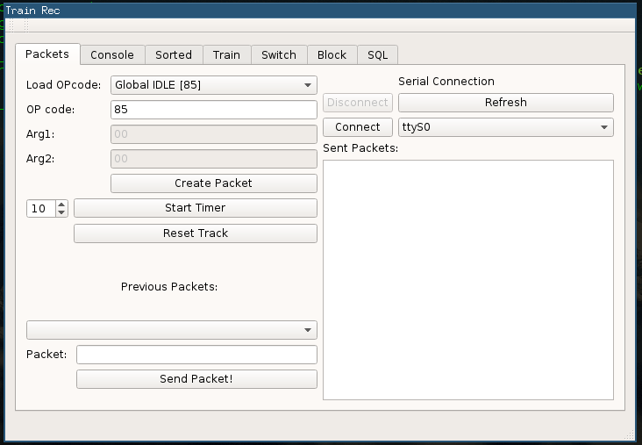

Labor Estimates by Task/Person:
Task: Create a switch as a user (10). Layout GUI be free of persisting track bug (10). Process detection data from track through Loconet (40). Access SQL tables (8).
Person: John Gould: 12 hrs Chris Bero: 40+ hrs Chris McClellan: 6 hrs Michael Bizanis: 10 hrs

Product Backlog: As a developer, I want to establish connection with the environment and be able to retrieve data to update graphical display. As a user, I want an updatable graphical display of the track. As a user, I want to be able to select a switch or piece of track and assign a switch number or sector number to it.

Prioritized List of Stories:
1. As a user, I want to be able to create a switch (Display Only).
2. As a developer, I want ot process detection data from the track through Loconet.
3. As a user, I want the layout GUI to be free of the persistent track pieces bug.
4. As a developer, I want to access the SQL tables.

Nominal Assignment by Person: Chris Bero: Developing Loconet, reading SQL data. John Gould: Switch story, testing. Micahel Bizanis: Track layout GUI, Switch story. Chris McClellan: QGrapchics change, Track Layout GUI.

Nominal Labor Estimate: 68 hours.

Code Listings:
#endif // MAINWINDOW_H

#ifndef MYWIDGET_H
#define MYWIDGET_H
#include <QLabel>
#include "QLine"
#include "QEvent"
#include "QMoveEvent"
#include "QGraphicsSceneMouseEvent"
#include <QMouseEvent>
#include <QPoint>
#include <QPixmap>
#include <QPainter>
#include <QDebug>
#include <QDialog>
#include <QVBoxLayout>
#include <QLabel>
#include <QAction>
#include <QRadioButton>
#include <QList>
//#include "mainwindow.h"
class mywidget : public QLabel
{
Q_OBJECT
public:
explicit mywidget(QWidget *parent = 0);
~mywidget();
private:
QPoint startPos;
QPoint endPos;
QPoint switch_startPos;
QPoint switch_endPos;
bool firstclick;
bool secondclick;
bool originclick;
bool isSwitch;
bool leftDown;
bool rightDown;
bool connectsToPrevious;
QVector<QLine> lines;
bool track_rad_state;
bool detection_rad_state;
bool switch_rad_state;
//QLinkedList<int> mypoints;
public slots:
void get_rad_rad(bool status);
void get_det_rad(bool status);
void get_switch_rad(bool status);
signals:
// void request_rad_status(bool);
};
#endif // MYWIDGET_H

#include "mainwindow.h"
#include "ui_mainwindow.h"
MainWindow::MainWindow(QWidget *parent) :
QMainWindow(parent),
ui(new Ui::MainWindow)
{
ui->setupUi(this);
//Connect Signals to mywidget
connect(ui->rad_track_piece,SIGNAL(clicked()),this,SLOT(check_rad()));//
connect(ui->rad_det_node,SIGNAL(clicked()),this,SLOT(check_rad()));//
connect(ui->rad_switch,SIGNAL(clicked()),this,SLOT(check_rad()));
connect(this,SIGNAL(rad_track_status(bool)),ui->mytraintrack,SLOT(get_rad_rad(bool)));
connect(this,SIGNAL(rad_det_status(bool)),ui->mytraintrack,SLOT(get_det_rad(bool)));
connect(this,SIGNAL(rad_switch_status(bool)),ui->mytraintrack,SLOT(get_switch_rad(bool)));
}
MainWindow::~MainWindow()
{
delete ui;
}
void MainWindow::check_rad(){
if(ui->rad_track_piece->isChecked())
emit rad_track_status(true);
if(ui->rad_det_node->isChecked())
emit rad_det_status(true);
if(ui->rad_switch->isChecked())
emit rad_switch_status(true);
}

#include "mywidget.h"
//#include "mainwindow.h"
mywidget::mywidget(QWidget *parent):QLabel(parent)
{
this->setMouseTracking(true);
this->startPos = QPoint();
this->endPos = QPoint();
leftDown = false;
rightDown = false;
connectsToPrevious = false;
originclick=true;
firstclick=false;
secondclick=false;
}
//click
void mywidget::mousePressEvent(QMouseEvent *event){
if(track_rad_state==true){
if (event->buttons() & Qt::LeftButton)
{
if(!connectsToPrevious){
QLine line = QLine(startPos, endPos);
lines.append(line);
startPos = event->pos();
endPos = event->pos();
update();
}
leftDown = true;
}
else if (event->buttons() & Qt::RightButton){
rightDown = true;
}
}
if(switch_rad_state==true)
{
if (event->buttons() & Qt::LeftButton)
{
if(!connectsToPrevious){
QLine line = QLine(startPos, endPos);
lines.append(line);
startPos = event->pos();
endPos = event->pos();
update();
originclick=true;
}
leftDown = true;
}
else if (event->buttons() & Qt::RightButton){
rightDown = true;
}
}
}
//click & drag
void mywidget::mouseMoveEvent(QMouseEvent *event){
if(track_rad_state==true){
if (leftDown & connectsToPrevious)
{
endPos = event->pos();
update();
}
else if (connectsToPrevious)
{
endPos = event->pos();
update();
}
else if (leftDown){
startPos = event->pos();
endPos = event->pos();
update();
}
}
if(switch_rad_state==true)
{
if (connectsToPrevious)
{
endPos = event->pos();
update();
}
else if (leftDown){
startPos = event->pos();
endPos = event->pos();
update();
}
}
}
//release
void mywidget::mouseReleaseEvent(QMouseEvent *event){
if(track_rad_state==true){
if (leftDown){
leftDown = !leftDown;
endPos = event->pos();
QLine line = QLine(startPos, event->pos());
lines.append(line);
}
else if(rightDown){
//clear selection
rightDown = !rightDown;
endPos = startPos;
connectsToPrevious = false;
}
update();
}
if(switch_rad_state==true){
if (leftDown){
leftDown = !leftDown;
endPos = event->pos();
QLine line = QLine(startPos, event->pos());
lines.append(line);
//begin next line
if(originclick==true)
{
qDebug() <<"Fumborigin";
endPos = event->pos();
connectsToPrevious = true;
originclick=false;
firstclick=true;
}
else if (firstclick)
{
qDebug() << "first";
endPos = event->pos();
firstclick=false;
secondclick=true;
update();
}
else if (secondclick)
{ qDebug() << "second";
secondclick=false;
endPos = event->pos();
update();
connectsToPrevious=false;
}
}
else if(rightDown){
//clear selection
rightDown = !rightDown;
endPos = startPos;
if(firstclick)
connectsToPrevious = false;
else if (secondclick)
connectsToPrevious=true;
}
update();
}
}
void mywidget::drawLines(QPainter *p){
if(track_rad_state==true||switch_rad_state==true){
if (!startPos.isNull() && !endPos.isNull())
{ p->setRenderHint(QPainter::Antialiasing, true);//added
p->drawLine(startPos, endPos);
}
p->drawLines(lines);
}
}
void mywidget::paintEvent(QPaintEvent *event){
QPainter p(this);
QPen pen;
pen.setColor(Qt::black);
}
void mywidget::get_rad_rad(bool status){
track_rad_state=status;
detection_rad_state=false;
switch_rad_state=false;
}
void mywidget::get_det_rad(bool status){
detection_rad_state=status;
track_rad_state=false;
switch_rad_state=false;
}
void mywidget::get_switch_rad(bool status){
detection_rad_state=false;
track_rad_state=false;
switch_rad_state=true;
}

