Lab 03
Christopher Bero
EE384

Problem 1

% 1.a
% Load and plot ECG data
% Replace this path with wherever the SAMPLE_ECG.mat is located
load('/home/berocs/Documents/uah/ee384/lab02/SAMPLE_ECG.mat');
n=1:2000;
subplot(2,2,1);
plot(n,ECG_Data);
title('1.a Raw ECG');
xlabel('Time');
ylabel('Amplitude'); % Likely voltage from ecg sensor?
hold all;
retA=filter([1/3 1/3 1/3],1,ECG_Data);
subplot(2,2,2);
plot(n,retA);
title('1.a Filtered ECG');
xlabel('Time');
ylabel('Amplitude');

% 1.b
h=[1/3 1/3 1/3];
retB=conv(ECG_Data,h);
subplot(2,2,3);
countb=(length(n)+length(h)-1);
nb=1:countb;
plot(nb,retB);
title('1.a Filtered ECG');
xlabel('Time');
ylabel('Amplitude');

% 1.c
h=[1/3 1/3 1/3];
retB=ee384_conv(ECG_Data,h);
subplot(2,2,4);
countb=(length(n)+length(h)-1);
nb=1:countb;
plot(nb,retB);
title('1.a conv.m filetered');
xlabel('Time');
ylabel('Amplitude');

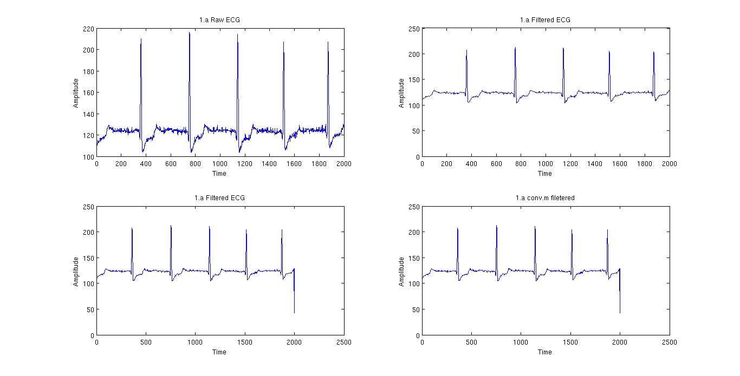

ee384_conv

function [ y, len ] = ee384_conv( x, h )
%ee384_conv generate the convolution of two vectors

% Convolution function:
% y[n] = SUMMATION from j of (x[j]h[n-j+1])
% The plus 1 is to make up for matlab not having zero indexed matrices

% EX:
% x[n] = [1 2 3]; -> M
% h[n] = [4 5]; -> N
% Len = M + N -1

M=length(x);
N=length(h);
len=1:(M+N-1);

if M >= N
subLen=M;
else
subLen=N;
end

y=len;

for n = len
acc=0;
for j = 1:subLen
if (n-j+1)<=0
continue
end
if (n-j+1)>N
continue
end
acc=acc+(x(j)*h(n-j+1));
end
y(n)=acc;
end

end

Problem 2

% 2.a
fs=50;
t1=0:(1/fs):1;
f1=10;
y1=sin(2*pi*f1*t1);
subplot(1,2,1);
plot(t1, y1);
hold all;
title('10Hz Signal');
xlabel('Time');
ylabel('Amplitude');

% 2.b
fs=50
t2=0:(1/fs):1;
f2=60;
y2=sin(2*pi*f2*t2);
subplot(1,2,2);
plot(t2, y2);
title('60Hz Signal');
xlabel('Time');
ylabel('Amplitude');

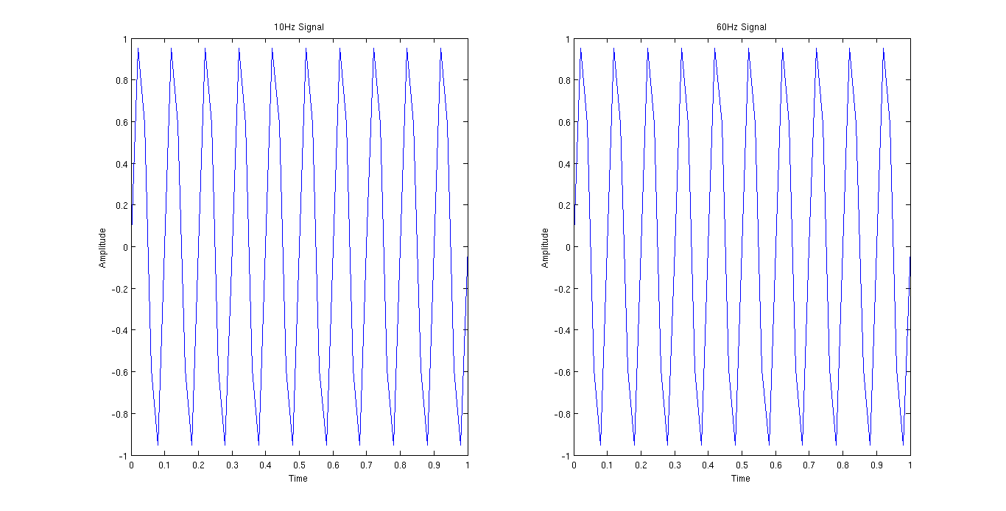
We can't tell the difference between the two signals because the sampling rate doesn't agree with the Nyquist Theorem and the additional information is lost between samples.
Problem 3

% 3.a
t1=0:(1/50000):1;
f1=2000;
y1=sin(2*pi*f1*t1);
subplot(3,1,1);
plot(t1,y1);
title('2kHz Signal');
xlabel('Time');
ylabel('Amplitude');
axis([0 0.01 -1 1]);
sound(y1,50000);

% 3.b
t2=0:(1/50000):1;
f2=6000;
y2=sin(2*pi*f2*t2);
subplot(3,1,2);
plot(t2,y2);
title('6kHz Signal');
xlabel('Time');
ylabel('Amplitude');
axis([0 0.01 -1 1]);
sound(y2,50000);

% b.c
t3=0:(1/50000):1;
f3=25000;
y3=sin(2*pi*f3*t3);
subplot(3,1,3);
plot(t3,y3);
title('25kHz Signal');
xlabel('Time');
ylabel('Amplitude');
axis([0 0.001 -1 1]);
sound(y3,50000);

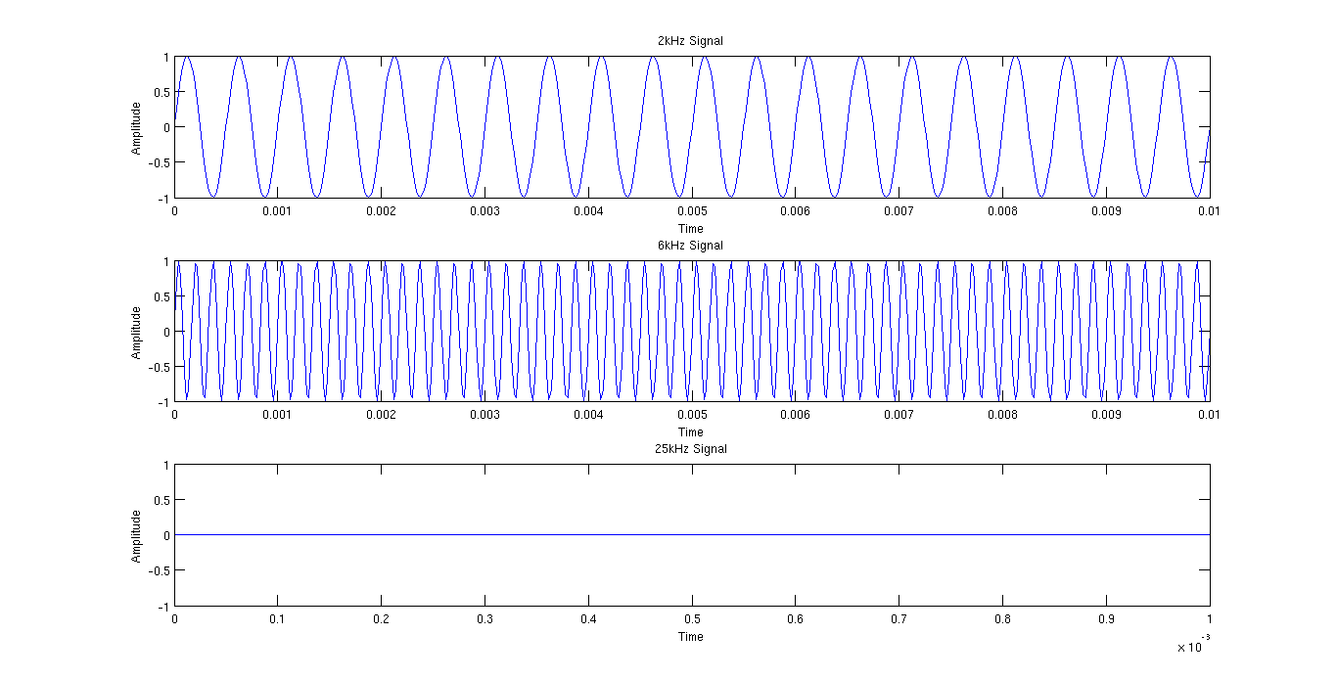
The 6kHz signal sounds much higher in pitch than the 2kHz one, while the 25kHz signal appears silent as it is both out of typical human hearing range, and also out of range of my headphone's rating (20-20,000 Hz).

