Lab 04
Christopher Bero
EE384

1.a
% P1.a
x=[1,2,3,4,5,6,7,8];
Y=fft(x);

1.b
% P1.b
Yi=ifft(Y);

1.c
% P1.c
bero_Y=bero_dft(x);
bero_x=bero_idft(bero_Y);

bero_dft
function [ Y ] = bero_dft( x )
% bero_dft

N=length(x);
Y=zeros(N,1);

for yi = 1:N;
acc=0;
for k = 0:(N-1)
W=( exp( -1i*(2*pi/N)*(yi-1)*k ) );
acc = acc + (x(k+1) * W);
end
Y(yi)=acc;
end

end

bero_idft
function [ x ] = bero_idft( Y )
% bero_idft

N=length(Y);
x=zeros(N,1);

for yi = 1:N;
acc=0;
for k = 0:(N-1)
W=( exp( -1i*(2*pi/N)*-(yi-1)*k ) );
acc = acc + (Y(k+1) * W);
end
x(yi)=(1/N)*acc;
end

end

2.a
% P2.a
fs=8000;
f1=697;
f2=1209;
t=0:(1/fs):1;
y_t=sin(2*pi*f1*t) + sin(2*pi*f2*t);
figure
plot(t,y_t);
title('Combined Sine Waves');
xlabel('Time');
ylabel('Amplitude');
axis([0 0.05 -2 2]);

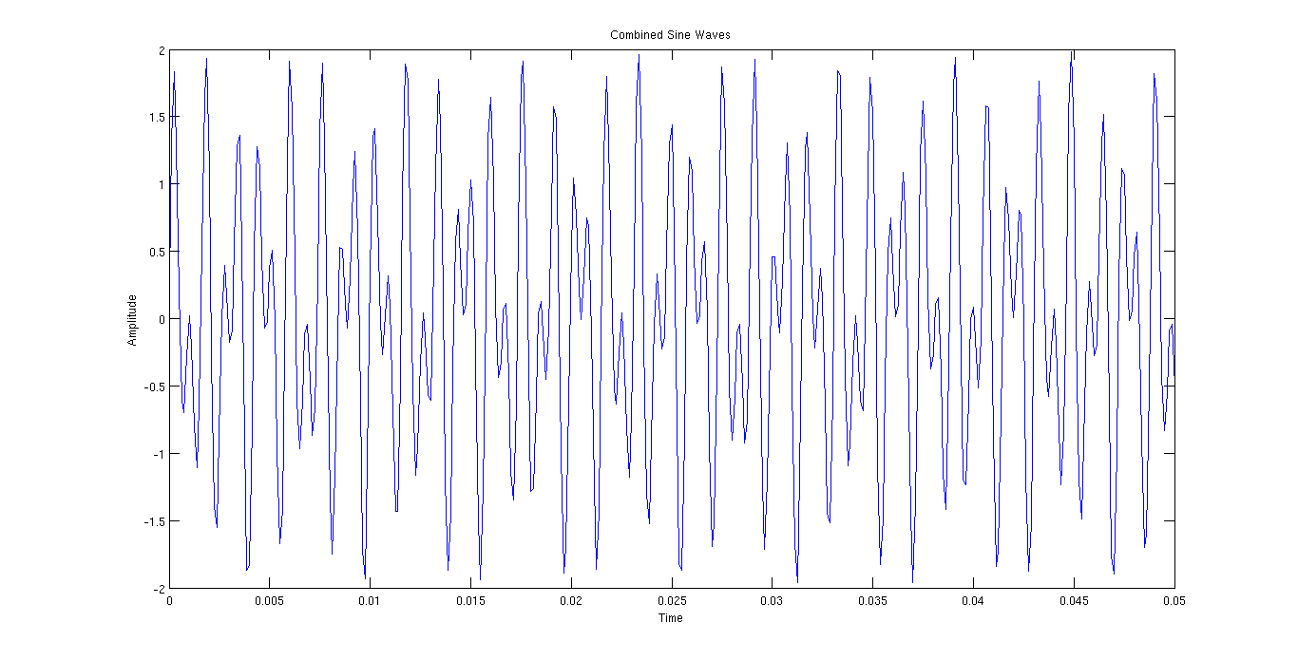

2.c
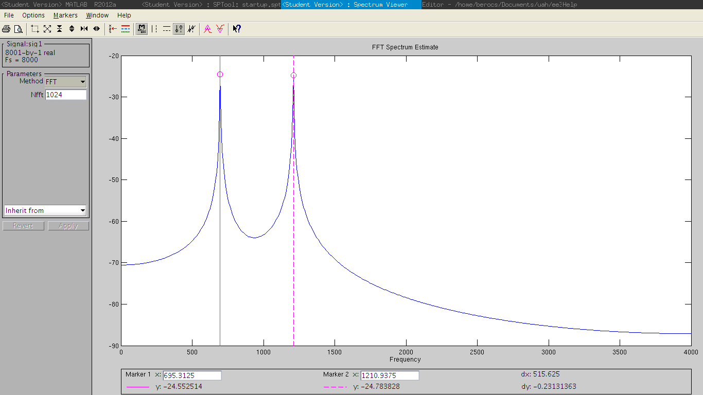

2.d
% P2.c
L=8001;
nfft=2^nextpow2(L);
fq=fft(y_t,nfft)/L;
f=fs/2*linspace(0,1,nfft/2+1);
figure
plot(f,2*abs(fq(1:nfft/2+1)));
title('Signal Spectrum');
xlabel('Frequency');
ylabel('Magnitude');

