Lab 04 Report
Christopher Bero
EE 316

Digital to Analog Converter Using OpAmp

Simulation

In this lab we will be modeling an inverting op amp with a resistor network to represent binary input to the system. Based on our previous experience with OpAmp concepts, we expect to see the output voltage roughly track a higher absolute value with higher binary input.

Model

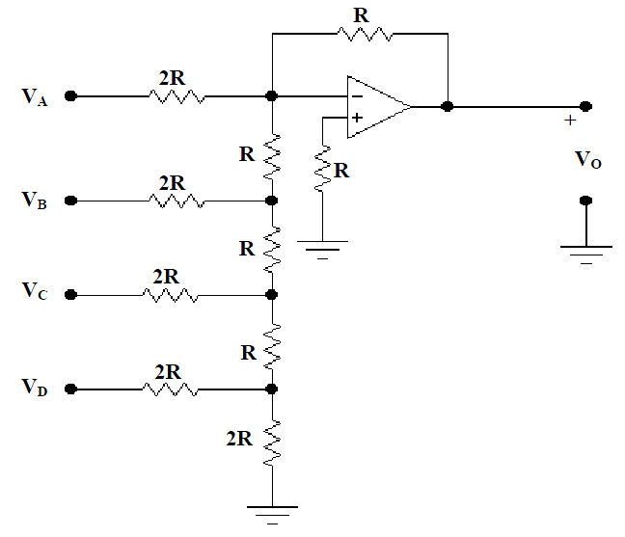

Simulation

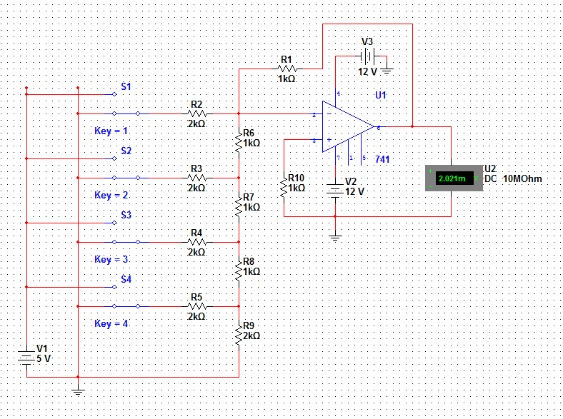

Measurements

# | Bin3 | Bin2 | Bin1 | Bin0 | Voltage(V)
1 | 0 | 0 | 0 | 0 | 0.002
2 | 0 | 0 | 0 | 1 | -0.310
3 | 0 | 0 | 1 | 0 | -0.623
4 | 0 | 0 | 1 | 1 | -0.935
5 | 0 | 1 | 0 | 0 | -1.248
6 | 0 | 1 | 0 | 1 | -1.560
7 | 0 | 1 | 1 | 0 | -1.873
8 | 0 | 1 | 1 | 1 | -2.185
9 | 1 | 0 | 0 | 0 | -2.498
10 | 1 | 0 | 0 | 1 | -2.810
11 | 1 | 0 | 1 | 0 | -3.123
12 | 1 | 0 | 1 | 1 | -3.435
13 | 1 | 1 | 0 | 0 | -3.748
14 | 1 | 1 | 0 | 1 | -4.060
15 | 1 | 1 | 1 | 0 | -4.373
16 | 1 | 1 | 1 | 1 | -4.685

Hardware

We next wired a comparable circuit using a 741 IC and the breadboard kit. The OpAmp was given +/- 12V supply voltage, and logic was set at 0V and 5V for binary values. As gathered by comparing the two sets of measured voltages between simulation and hardware, the physical system works as expected.

Measurements

# | Bin3 | Bin2 | Bin1 | Bin0 | Voltage(V)
1 | 0 | 0 | 0 | 0 | 1.11
2 | 0 | 0 | 0 | 1 | 0.81
3 | 0 | 0 | 1 | 0 | 0.50
4 | 0 | 0 | 1 | 1 | 0.21
5 | 0 | 1 | 0 | 0 | -0.14
6 | 0 | 1 | 0 | 1 | -0.39
7 | 0 | 1 | 1 | 0 | -0.74
8 | 0 | 1 | 1 | 1 | -1.02
9 | 1 | 0 | 0 | 0 | -1.44
10 | 1 | 0 | 0 | 1 | -1.59
11 | 1 | 0 | 1 | 0 | -1.91
12 | 1 | 0 | 1 | 1 | -2.12
13 | 1 | 1 | 0 | 0 | -2.53
14 | 1 | 1 | 0 | 1 | -2.65
15 | 1 | 1 | 1 | 0 | -2.99
16 | 1 | 1 | 1 | 1 | -3.19

