Christopher Bero
10-2-2015
CPE 322

Simulation Assignment 01

“RTL & Post FPGA Layout Timing Simulation of two an [sic] 8-bit Subtractor/Adder”

Stimulus

#
# Stimulus for Behavioral Model
# [0] is LSB
# SUB_ADD: 0=add (A+B), 1=subtract (A-B)
# Library: cycloneive_ver
#

force {sim:/eight_bit_sub_add/B_CIN} 0 0ns, 0 50ns, 1 100ns, 1 150ns, 1 200ns, 1 250ns, 1 300ns, 0 350ns, 0 400ns

force {sim:/eight_bit_sub_add/A[0]} 0 0ns, 1 50ns, 1 100ns, 1 150ns, 1 200ns, 1 250ns, 1 300ns, 1 350ns, 1 400ns
force {sim:/eight_bit_sub_add/A[1]} 0 0ns, 1 50ns, 0 100ns, 1 150ns, 1 200ns, 1 250ns, 1 300ns, 0 350ns, 1 400ns
force {sim:/eight_bit_sub_add/A[2]} 0 0ns, 1 50ns, 0 100ns, 1 150ns, 1 200ns, 1 250ns, 1 300ns, 0 350ns, 0 400ns
force {sim:/eight_bit_sub_add/A[3]} 0 0ns, 1 50ns, 0 100ns, 1 150ns, 1 200ns, 1 250ns, 1 300ns, 0 350ns, 0 400ns
force {sim:/eight_bit_sub_add/A[4]} 0 0ns, 0 50ns, 0 100ns, 0 150ns, 1 200ns, 1 250ns, 1 300ns, 1 350ns, 0 400ns
force {sim:/eight_bit_sub_add/A[5]} 0 0ns, 0 50ns, 0 100ns, 0 150ns, 1 200ns, 1 250ns, 1 300ns, 1 350ns, 0 400ns
force {sim:/eight_bit_sub_add/A[6]} 0 0ns, 0 50ns, 0 100ns, 0 150ns, 1 200ns, 1 250ns, 1 300ns, 1 350ns, 0 400ns
force {sim:/eight_bit_sub_add/A[7]} 0 0ns, 0 50ns, 0 100ns, 0 150ns, 0 200ns, 0 250ns, 1 300ns, 1 350ns, 0 400ns
F
force {sim:/eight_bit_sub_add/B[0]} 0 0ns, 1 50ns, 0 100ns, 1 150ns, 1 200ns, 1 250ns, 1 300ns, 1 350ns, 1 400ns
force {sim:/eight_bit_sub_add/B[1]} 0 0ns, 0 50ns, 1 100ns, 1 150ns, 1 200ns, 1 250ns, 1 300ns, 0 350ns, 0 400ns
force {sim:/eight_bit_sub_add/B[2]} 0 0ns, 0 50ns, 1 100ns, 0 150ns, 1 200ns, 1 250ns, 1 300ns, 0 350ns, 0 400ns
force {sim:/eight_bit_sub_add/B[3]} 0 0ns, 0 50ns, 1 100ns, 0 150ns, 1 200ns, 1 250ns, 1 300ns, 0 350ns, 0 400ns
force {sim:/eight_bit_sub_add/B[4]} 0 0ns, 0 50ns, 0 100ns, 0 150ns, 1 200ns, 1 250ns, 1 300ns, 0 350ns, 0 400ns
force {sim:/eight_bit_sub_add/B[5]} 0 0ns, 0 50ns, 0 100ns, 0 150ns, 1 200ns, 1 250ns, 1 300ns, 0 350ns, 0 400ns
force {sim:/eight_bit_sub_add/B[6]} 0 0ns, 0 50ns, 0 100ns, 0 150ns, 1 200ns, 1 250ns, 1 300ns, 1 350ns, 0 400ns
force {sim:/eight_bit_sub_add/B[7]} 0 0ns, 0 50ns, 0 100ns, 0 150ns, 1 200ns, 0 250ns, 1 300ns, 1 350ns, 0 400ns

force {sim:/eight_bit_sub_add/SUB_ADD} 0 0ns, 1 50ns, 0 100ns, 1 150ns, 0 200ns, 1 250ns, 0 300ns, 1 350ns, 0 400ns

run 500ns

#
# Stimulus for Structural Model
# [0] is LSB
# SUB_ADD: 0=add (A+B), 1=subtract (A-B)
# Library: cycloneive_ver
#

force {sim:/eight_bit_sub_add/B_CIN} 0 0ns, 0 50ns, 1 100ns, 1 150ns, 1 200ns, 1 250ns, 1 300ns, 0 350ns, 0 400ns

force {sim:/eight_bit_sub_add/A[0]} 0 0ns, 1 50ns, 1 100ns, 1 150ns, 1 200ns, 1 250ns, 1 300ns, 1 350ns, 1 400ns
force {sim:/eight_bit_sub_add/A[1]} 0 0ns, 1 50ns, 0 100ns, 1 150ns, 1 200ns, 1 250ns, 1 300ns, 0 350ns, 1 400ns
force {sim:/eight_bit_sub_add/A[2]} 0 0ns, 1 50ns, 0 100ns, 1 150ns, 1 200ns, 1 250ns, 1 300ns, 0 350ns, 0 400ns
force {sim:/eight_bit_sub_add/A[3]} 0 0ns, 1 50ns, 0 100ns, 1 150ns, 1 200ns, 1 250ns, 1 300ns, 0 350ns, 0 400ns
force {sim:/eight_bit_sub_add/A[4]} 0 0ns, 0 50ns, 0 100ns, 0 150ns, 1 200ns, 1 250ns, 1 300ns, 1 350ns, 0 400ns
force {sim:/eight_bit_sub_add/A[5]} 0 0ns, 0 50ns, 0 100ns, 0 150ns, 1 200ns, 1 250ns, 1 300ns, 1 350ns, 0 400ns
force {sim:/eight_bit_sub_add/A[6]} 0 0ns, 0 50ns, 0 100ns, 0 150ns, 1 200ns, 1 250ns, 1 300ns, 1 350ns, 0 400ns
force {sim:/eight_bit_sub_add/A[7]} 0 0ns, 0 50ns, 0 100ns, 0 150ns, 0 200ns, 0 250ns, 1 300ns, 1 350ns, 0 400ns
F
force {sim:/eight_bit_sub_add/B[0]} 0 0ns, 1 50ns, 0 100ns, 1 150ns, 1 200ns, 1 250ns, 1 300ns, 1 350ns, 1 400ns
force {sim:/eight_bit_sub_add/B[1]} 0 0ns, 0 50ns, 1 100ns, 1 150ns, 1 200ns, 1 250ns, 1 300ns, 0 350ns, 0 400ns
force {sim:/eight_bit_sub_add/B[2]} 0 0ns, 0 50ns, 1 100ns, 0 150ns, 1 200ns, 1 250ns, 1 300ns, 0 350ns, 0 400ns
force {sim:/eight_bit_sub_add/B[3]} 0 0ns, 0 50ns, 1 100ns, 0 150ns, 1 200ns, 1 250ns, 1 300ns, 0 350ns, 0 400ns
force {sim:/eight_bit_sub_add/B[4]} 0 0ns, 0 50ns, 0 100ns, 0 150ns, 1 200ns, 1 250ns, 1 300ns, 0 350ns, 0 400ns
force {sim:/eight_bit_sub_add/B[5]} 0 0ns, 0 50ns, 0 100ns, 0 150ns, 1 200ns, 1 250ns, 1 300ns, 0 350ns, 0 400ns
force {sim:/eight_bit_sub_add/B[6]} 0 0ns, 0 50ns, 0 100ns, 0 150ns, 1 200ns, 1 250ns, 1 300ns, 1 350ns, 0 400ns
force {sim:/eight_bit_sub_add/B[7]} 0 0ns, 0 50ns, 0 100ns, 0 150ns, 1 200ns, 0 250ns, 1 300ns, 1 350ns, 0 400ns

force {sim:/eight_bit_sub_add/SUB_ADD} 0 0ns, 1 50ns, 0 100ns, 1 150ns, 0 200ns, 1 250ns, 0 300ns, 1 350ns, 0 400ns

run 500ns

Behavioral:RTL:Waveform

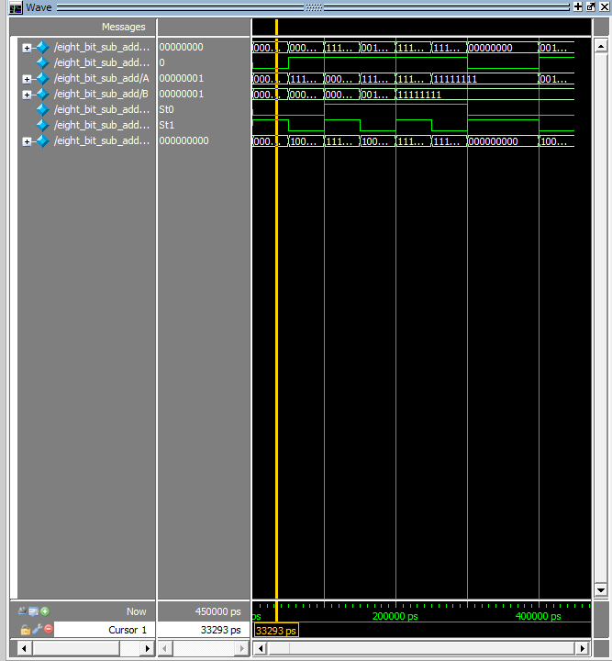

Behavioral:RTL:List

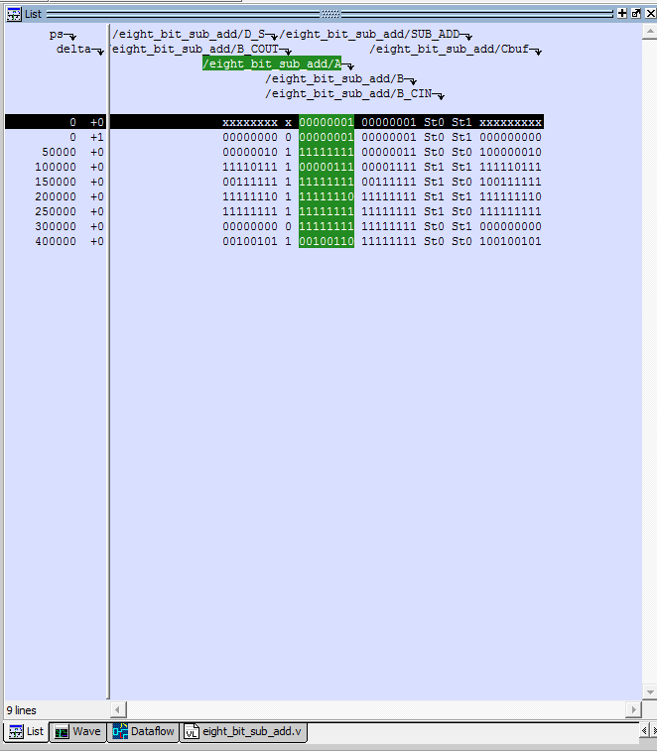
Behavioral:Gate:Slow:85:Waveform
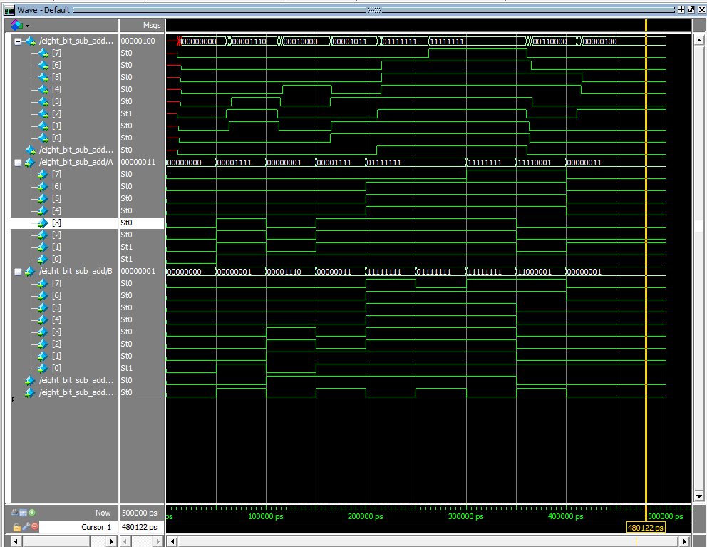
Behavioral:Gate:Slow:85:List
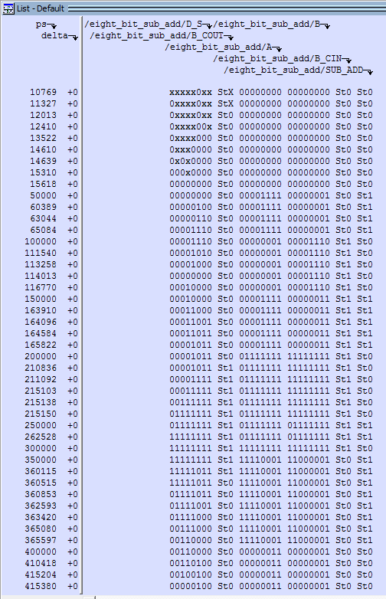

Behavioral:Gate:Slow:0:Waveform
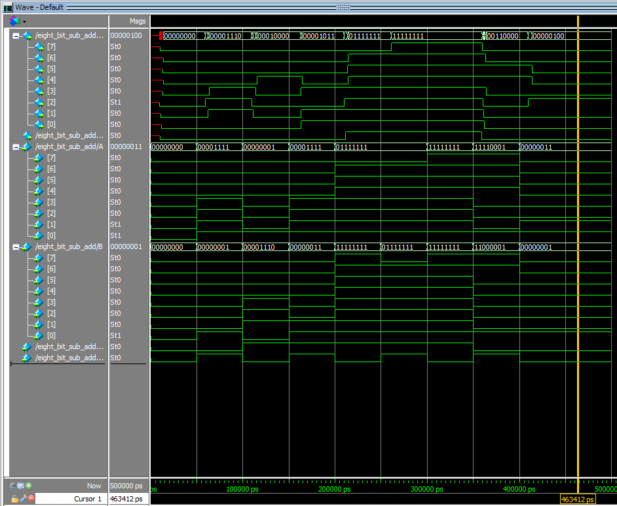
Behavioral:Gate:Slow:0:List
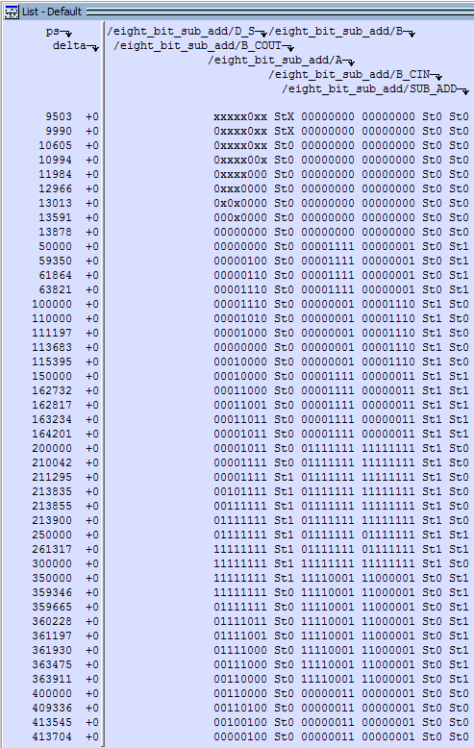

Behavioral:Gate:Fast:0:Waveform
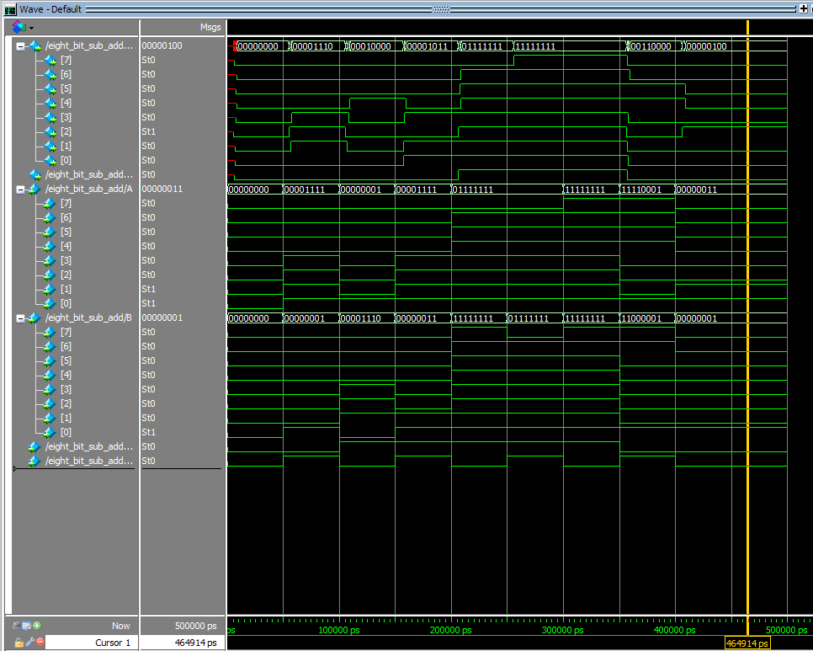
Behavioral:Gate:Fast:0:List
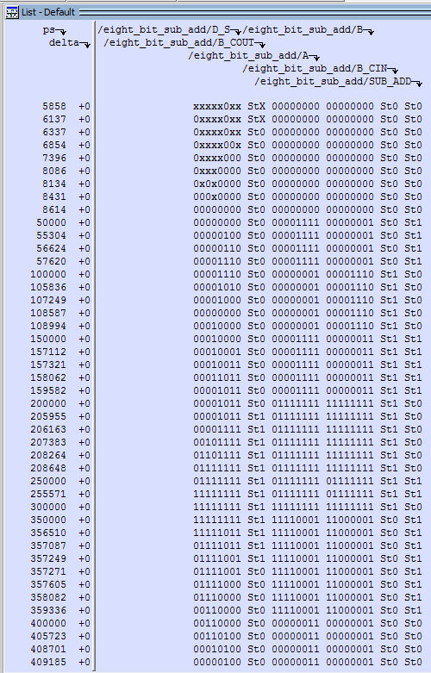

Structural:RTL:Waveform

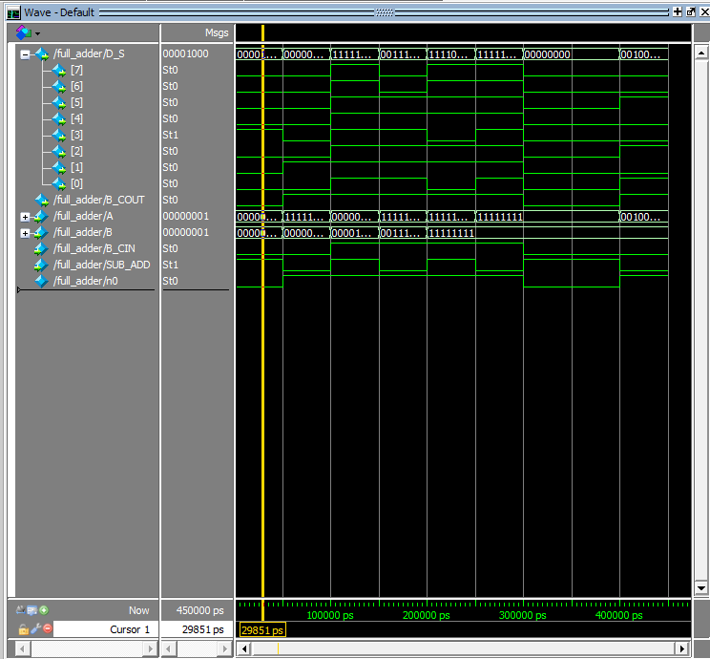
Structural:RTL:List

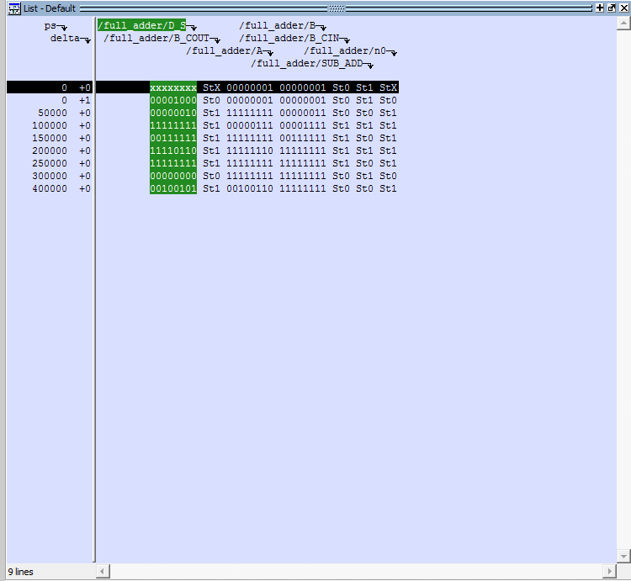
Structural:Gate:Slow:85:Waveform
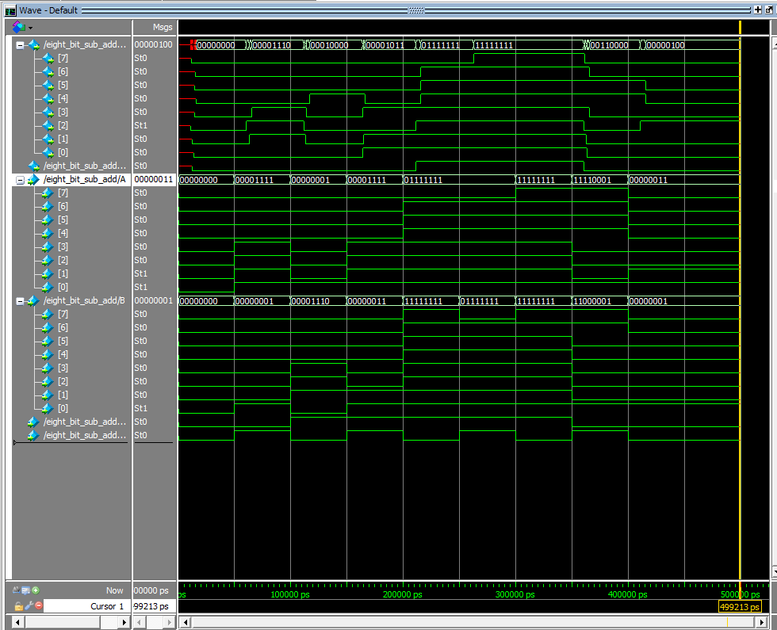

Structural:Gate:Slow:85:List
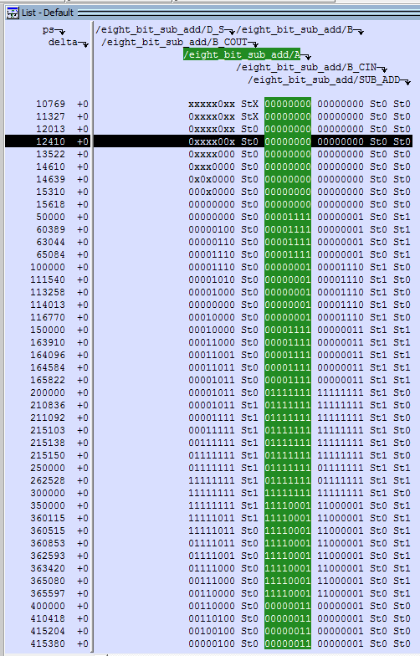

Structural:Gate:Slow:0:Waveform
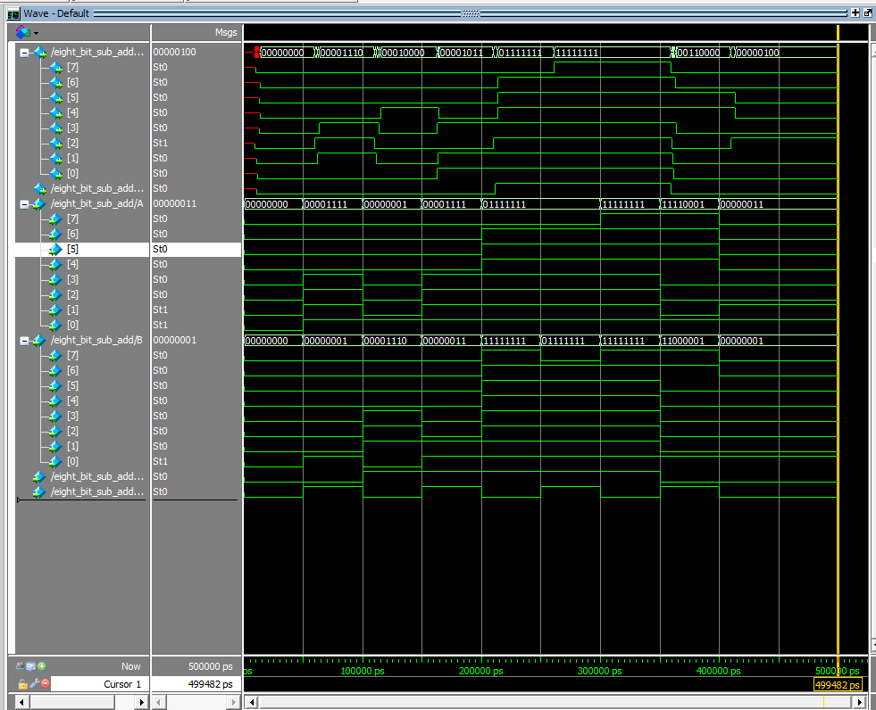

Structural:Gate:Slow:0:List
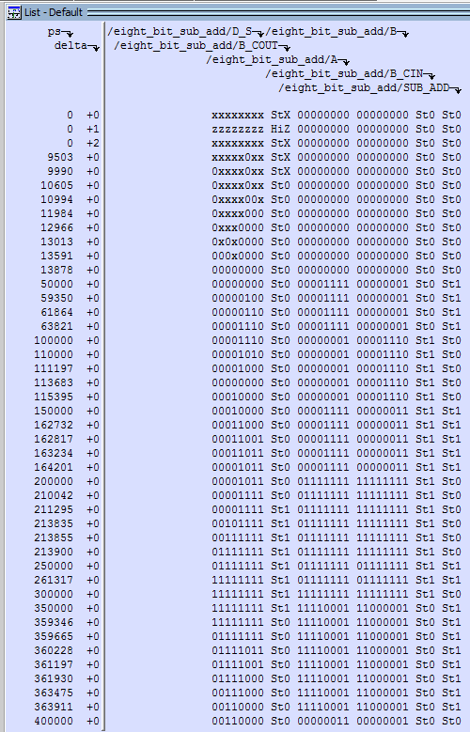

Structural:Gate:Fast:0:Waveform
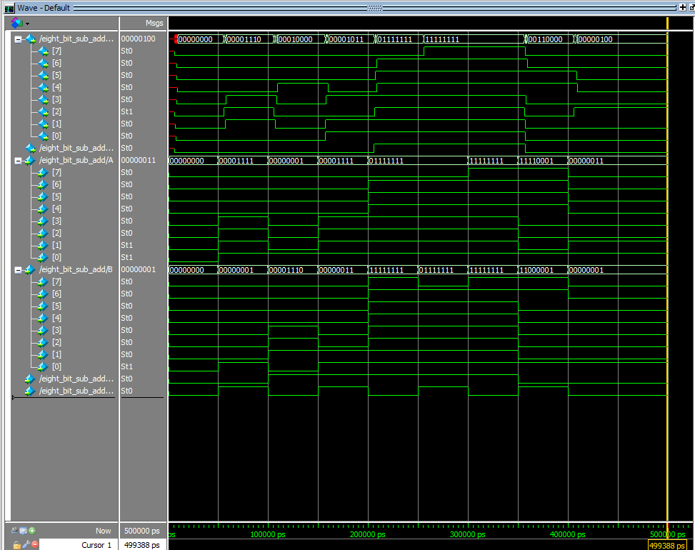

Structural:Gate:Fast:0:List
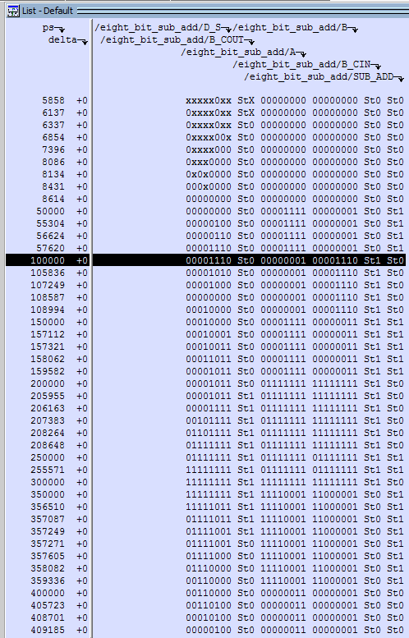

Discussion

Without a definition for glitch to act as a basis for the assignment, pinpointing one is a nontrivial task. As observed, we did not notice anything worthy of a glitch, as the system appeared to operate correctly after troubleshooting to start Model-Sim was successful. Again, significant is not described to us, and the models appeared to have very similar output which leads us to believe that there is not a significant difference between behavioral and structural representations of the system in verilog. Since we have not implemented any activity based on the output of the simulation, determining the merits of waveform and list output is a dubiously wasteful and unadvantageous exercise. Nevertheless, it is this student's stance that the waveform view makes understanding the progression of the combinational circuit easier, while the list output makes immediate instantaneous analysis and debugging faster.

