LABORATORY # 1
Circuits Review
Part 1: Resistive Circuits, Linear Scale Ohmmeter
Part 2: Thevenin and Norton Circuits

Purpose

The goals of this laboratory are to verify Ohm’s Law, Kirchhoff’s Voltage Law, Kirchhoff’s Current Law, Thevenin and Norton Theorems.

Part 1: KVL, KCL and Ohm’s Law

Kirchhoff's Voltage Law (KVL)

Kirchhoff's Voltage Law states the algebraic sum of the voltages around any closed path or loop in a circuit must be equal to zero. That is for the circuit below:
Vs = V1 + V2

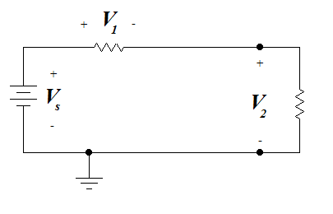
Figure 1.1

Kirchhoff’s Current Law (KCL)

Kirchhoff’s Current Law states that the algebraic sum of the currents entering a node must be equal to the algebraic sum of the currents leaving the node.

Mathematically:
I1 = I2 + I3

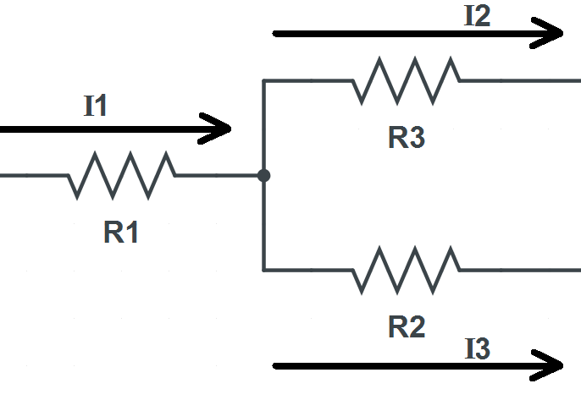
Figure 1.2

Theoretical Analysis
Referring to Figure 1.1, calculate the circuit’s Branch Voltages, Branch Currents, Node Voltages, and Loop Currents with the following assumptions. (Note: Mesh Analysis may be useful here.)
- First assume all the resistors are exact (i.e. a 10 ohm resistor is exactly 10 ohms).
- Then assume all resistors are 10% above the exact values.
- Then assume all resistors are 10% below the exact values.

Record all your data in tabular format similar to Table 1.1.

Vs = 5V

R1 = R2 = R3 =100

R4 = R5 =1 K

R6 = R7 =2.2 K

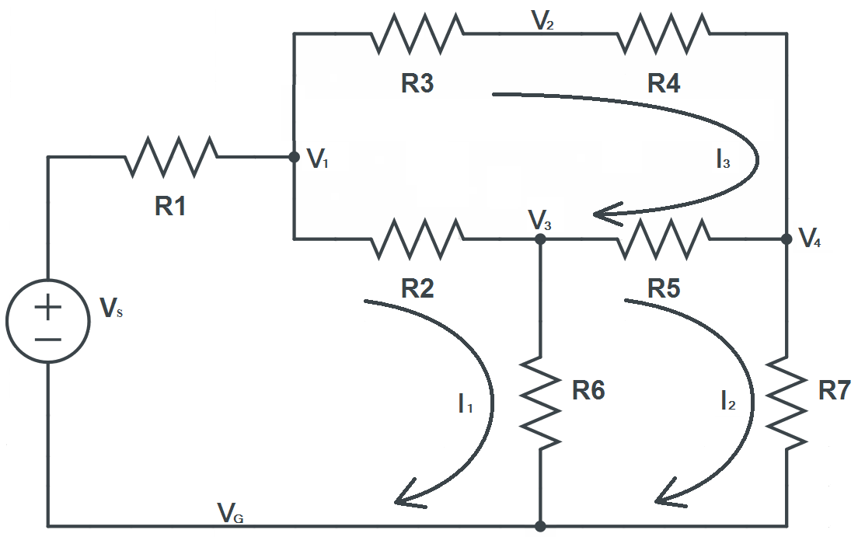
Figure 1.3

Simulation

Build the circuit using the Electronics Workbench (Multisim 11.0). Then place virtual Voltmeters and Ammeters in the circuit to find all required voltages and currents that you found in the theoretical analysis section. Print out the schematic showing all the readings before moving on to the next section.

Laboratory Procedure

Using the Analog/Digital trainer or available lab equipments, build the circuit and re-measure all Branch Voltages, Branch Currents, Node Voltages, and Loop Currents using a digital multimeter (DMM).

Record all the specified measurements in a table similar to Table 1.1.

Table 1.1

Branch Voltages | Branch Currents | Node Voltages | Loop Currents
VR1 = | iR1 = | V1 = | I1 =
VR2 = | iR2 = | V2 = | I2 =
VR3 = | iR3 = | V3 = | I3 =
VR4 = | iR4 = | V4 =
VR5 = | iR5 =
VR6 = | iR6 =
VR7 = | iR7 =

Ohm’s Law Verification

Ohm’s Law states that the voltage across a linear resistor is directly proportional to the current flowing through the resistor. Mathematically, the voltage, current, and resistance are related by

V = I*R

Build the circuit shown in Figure 1.4.
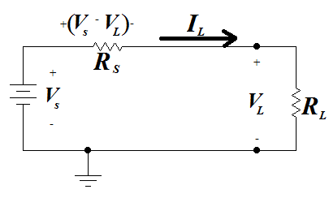
Figure 1.4

Set your source voltage and resistance values as follows; let Vs = 5.0 Volt and Rs = 100 ohm. It does not matter if these values are exact as long as they remain consistent throughout the experiment.
- Measure and record the values of load voltages and currents for various values of RL (load resistance) as specified in Table 1.2. Use a variable resistor to vary the load resistance.
- Using your data, plot VL vs. IL.

Table 1.2
RL (Ohms) | VL (V) | IL (mA)
10
30
70
100
150
200
300
500
1000

Part 2: Norton and Thevenin Equivalent Circuits

Purpose

The goals of this laboratory are to demonstrate the equivalence between a multiple resistive network and its’ Thevenin or Norton equivalent circuits. The concepts of load line and power transfer will also be introduced.

Theoretical Background

Thevenin and Norton’s Theorems can be employed at any load terminal. The advantage of applying these theorems is that a complex circuit can easily be reduced to a simpler one. This is very effective in simplifying the process of determining the current, voltage and power at the load.

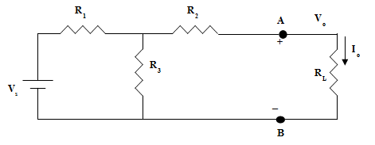
Figure 1.5

Thevenin Theorem

Thevenin’s theorem states that an entire network can be replaced, exclusive of the load, by an equivalent circuit that contains only two components. They consist of an independent voltage source in series with a resistor in such a way that the current-voltage relationship at the load remains unchanged.

Method for finding a Thevenin’s equivalent circuit. Refer to Figure 1.5
- Disconnect the load RL to open the terminal A-B. Find the Voltage at the terminal. This is called open circuit voltage Voc. Voc is the independent voltage source for the Thevenin’s equivalent circuit (Vth).
- Next, short-circuit the terminal A-B by adding a wire.
- Find the current at the terminal. This is called short circuit current Isc.
- Find RTh by short circuiting Vs and calculating resistance between terminal A-B.
- Alternatively, calculate the Thevenin equivalent resistance RTh, where RTh = Voc/Isc.
- Draw the Thevenin equivalent circuit using Voc in series with RTh, as demonstrated in Figure 1.6. Re-calculate I₀ using digital multimeter and verify the results.
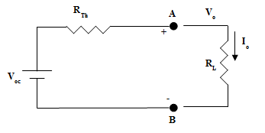

Figure 1.6

Norton’s Theorem

Norton’s theorem is similar to Thevenin’s theorem with the exception that the equivalent circuit is an independent current source in parallel with a resistor.

Method for finding a Norton equivalent circuit (Refer to Figure 1.5):
1. To begin use the same steps 1-4 that you applied in the Thevenin method. But, you will draw the Norton’s equivalent circuit using I₀ (Isc) in parallel with RTh. (See Figure 1.7)

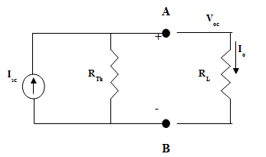

Figure 1.7

Vs = 5.0 V, R1 = R2 = R3 = 1K Ohm.

Calculate Thevenin’s equivalent resistance RTh. Recall RTh = Voc/Isc.

Simulation

Draw the circuit in Figure 1.3 using Electronics Workbench (Multisim 11.0). Repeat steps 1 to 3 of Theoretical Analysis using virtual Amperage & Volt meters to determine the currents and voltages. Print out your schematic diagram before moving on to the next section.

Laboratory Procedure

- Build a circuit as shown in the Figure 1.5. Letting: Vs = 5.0 V, R1 = R2 = R3 = 1K Ohm.
- Measure Voc, Isc, and calculate RTh at the terminal A-B.
- Build a circuit using your Thevenin’s equivalent circuit and calculate Isc.

