Lab 02 Report
Christopher Bero
EE 316

Inverting and Noninverting OP-Amp Circuits

Introduction

In this lab we continued to practice using MultiSim while creating and analyzing the impact of resistance values on standard OpAmp circuits.

Inverting OpAmp

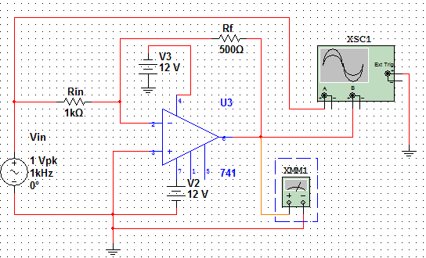Illustration 1: Inverting Circuit Design

V_{in} = 2V; 1KHz; Inverting; R_{in} = 1K
R_{f} (k) | V_{out} (V) | Gain | V_{rms} (V) | Current (mA)
0.5 | 0.998 | 0.499 | 0.354 | 24.46
1 | 1.995 | 1.003 | 0.707 | 24.73
2 | 3.996 | 1.998 | 1.414 | 24.86
3 | 5.999 | 2.999 | 2.121 | 24.9
4 | 7.997 | 3.999 | 2.828 | 24.91

V_{in} = 2V; 100Hz; Inverting; R_{in} = 1K
R_{f} (k) | V_{out} (V) | Gain | V_{rms} (V) | Current (mA)
0.5 | 0.997 | 0.498 | 0.356 | 24.63
1 | 1.997 | 0.998 | 0.707 | 24.8
2 | 3.979 | 1.989 | 1.414 | 24.936
3 | 5.999 | 2.999 | 2.121 | 24.997
4 | 8 | 4 | 2.828 | 25.037

Noninverting OpAmp

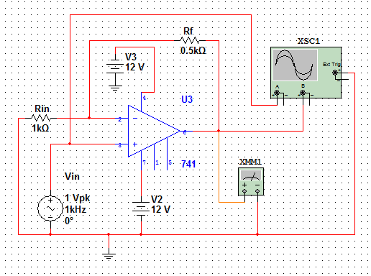Illustration 2: Noninverting Circuit Design

V_{in} = 2V; 1KHz; Noninverting; R_{in} = 1K
R_{f} (k) | V_{out} (V) | Gain | V_{rms} (V) | Current (mA)
0.5 | 2.997 | 1.498 | 1.061 | 25.08
1 | 3.999 | 1.999 | 1.414 | 25.03
2 | 5.994 | 2.997 | 2.121 | 25.03
3 | 7.988 | 3.994 | 2.828 | 25.032
4 | 9.995 | 4.997 | 3.535 | 25.042

V_{in} = 2V; 100Hz; Noninverting; R_{in} = 1K
R_{f} (k) | V_{out} (V) | Gain | V_{rms} (V) | Current (mA)
0.5 | 2.994 | 1.497 | 1.061 | 25.177
1 | 3.996 | 1.998 | 1.414 | 25.179
2 | 5.999 | 2.999 | 2.121 | 25.18
3 | 8.036 | 4.018 | 2.828 | 25.173
4 | 9.994 | 4.997 | 3.535 | 25.18

Inverting OpAmp 1KHz – Oscilloscope

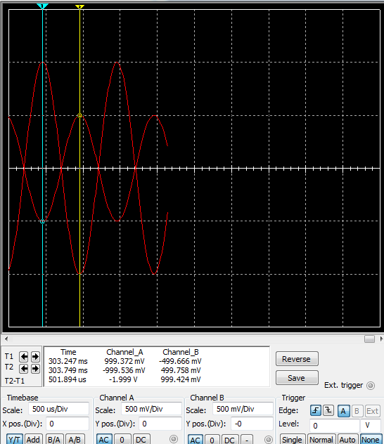f = 1khz, Rf = 0.5k
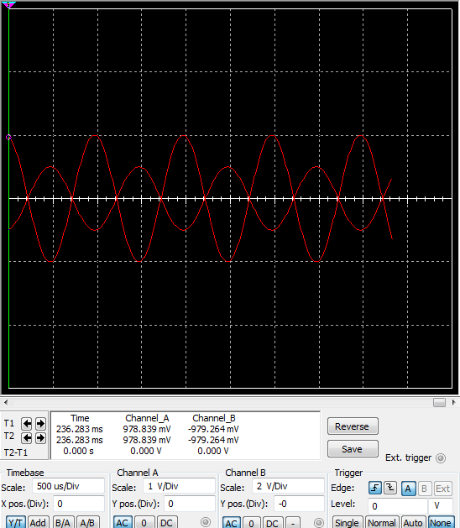f = 1khz, Rf = 1k
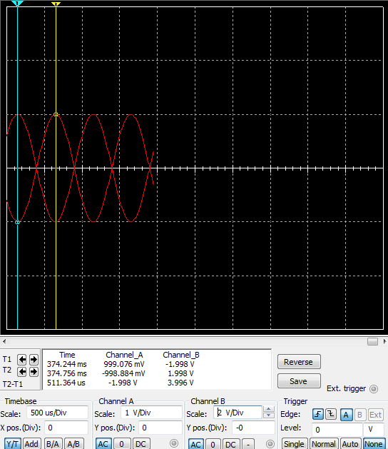f = 1khz, Rf = 2k
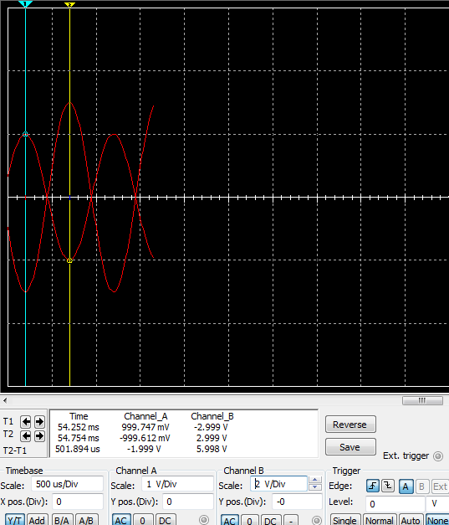f = 1khz, Rf = 3k
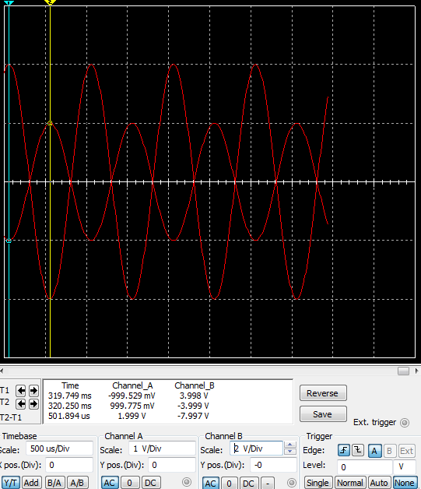f = 1khz, Rf = 4k

Inverting OpAmp 100Hz – Oscilloscope

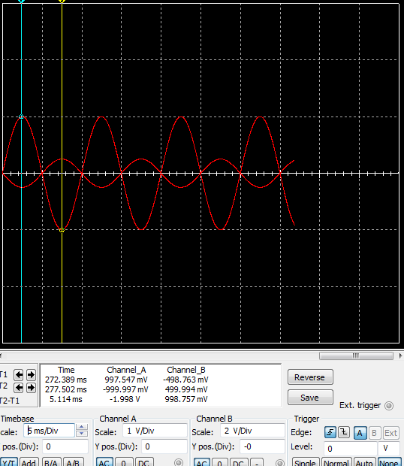f = 100hz, Rf = 0.5k
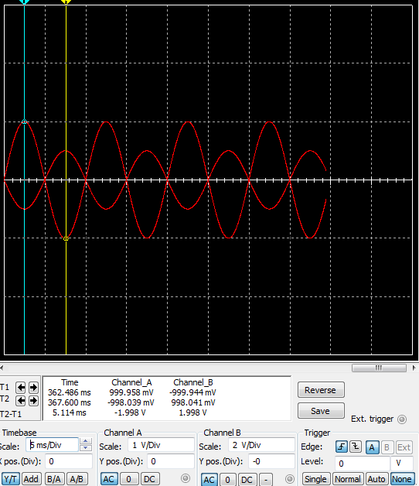f = 100hz, Rf = 1k
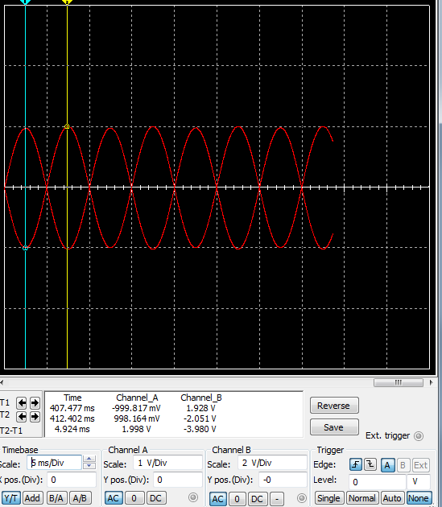f = 100hz, Rf = 2k
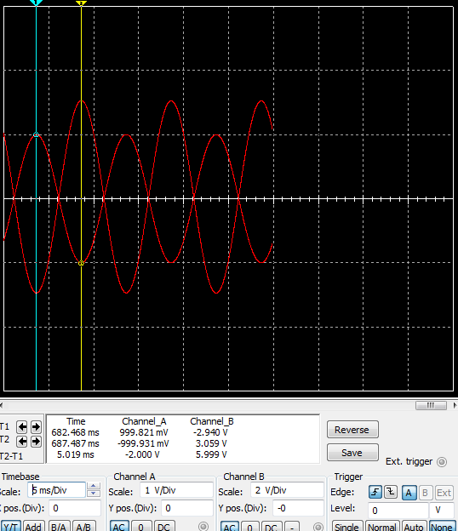f = 100hz, Rf = 3k
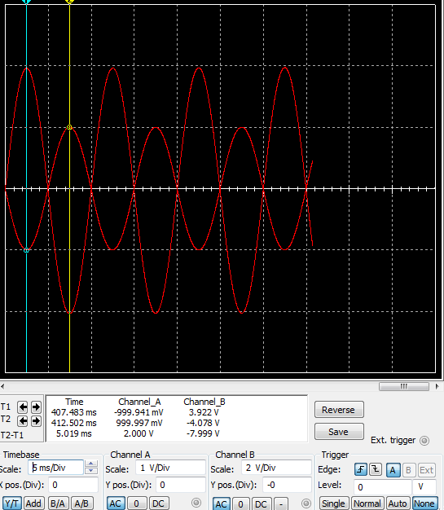f = 100hz, Rf = 4k

Noninverting OpAmp 1KHz – Oscilloscope

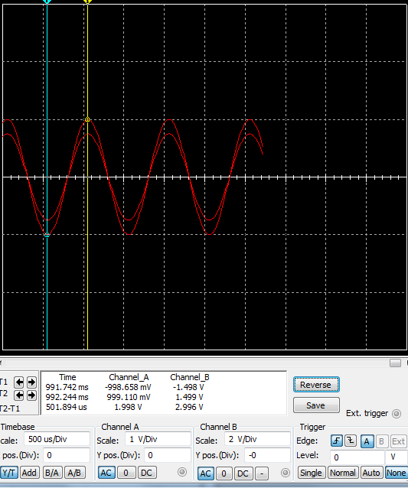f = 1khz, Rf = 0.5k
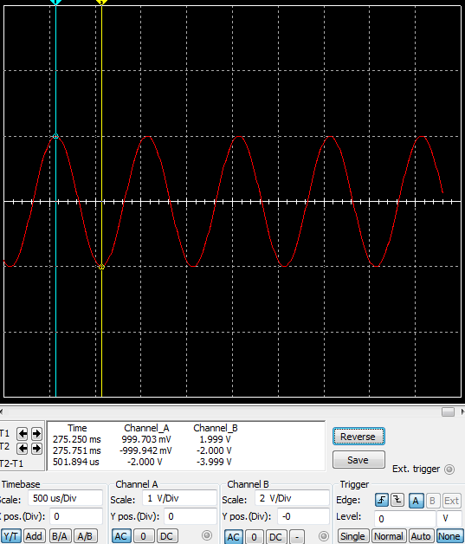f = 1khz, Rf = 1k
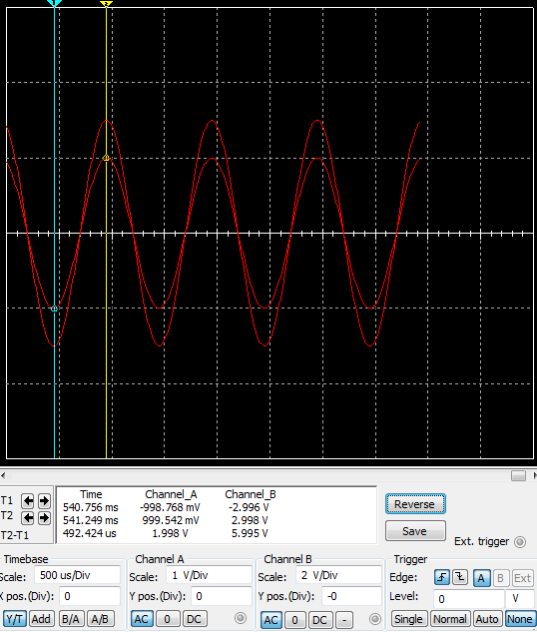f = 1khz, Rf = 2k
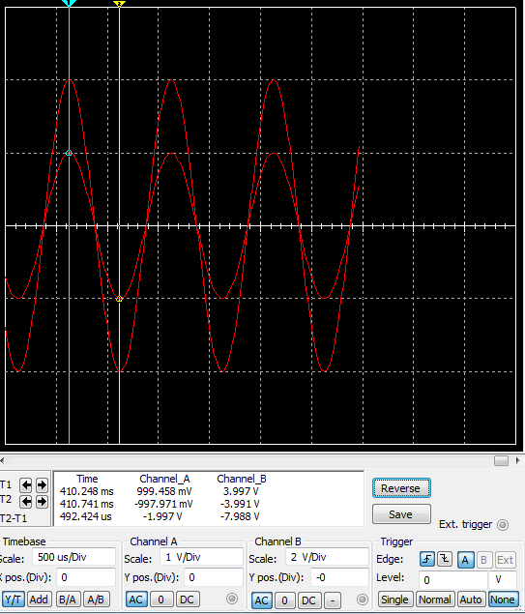f = 1khz, Rf = 3k
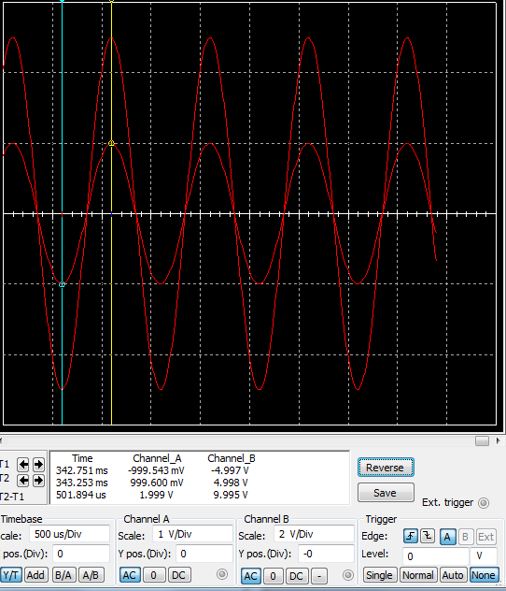f = 1khz, Rf = 4k

Inverting OpAmp 100Hz – Oscilloscope

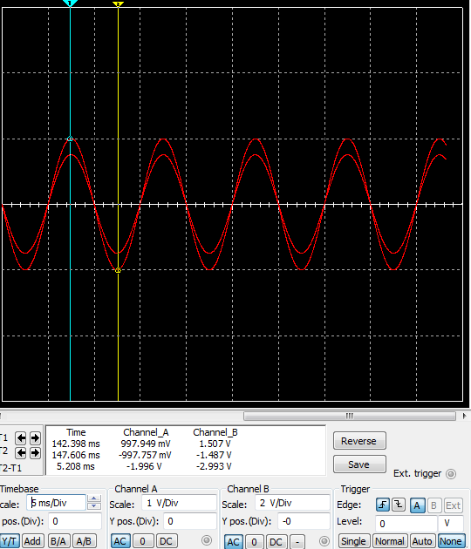f = 100hz, Rf = 0.5k
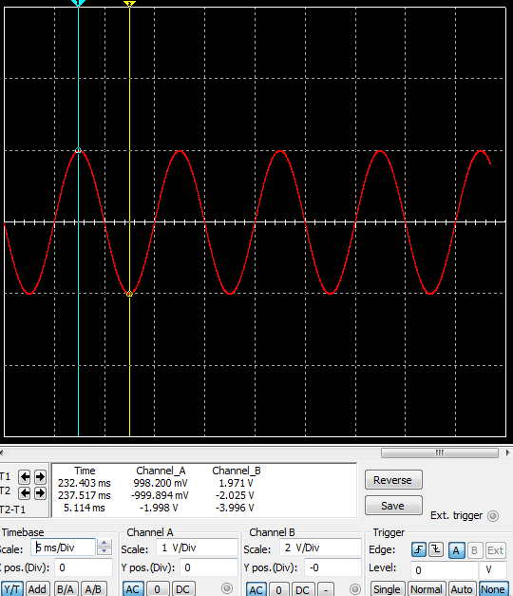f = 100hz, Rf = 1k
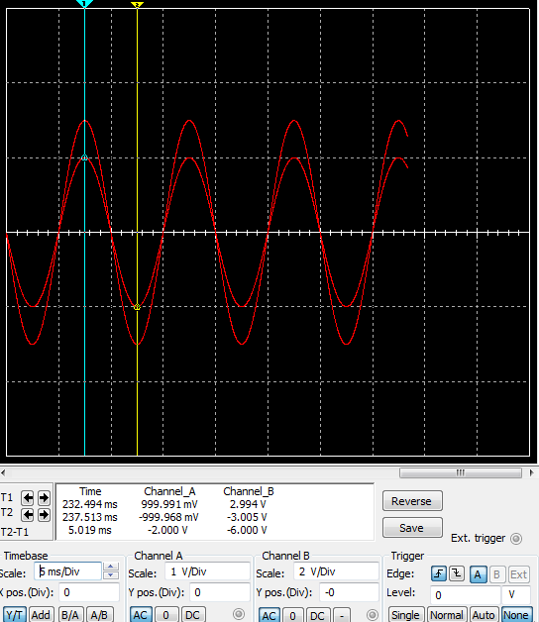f = 100hz, Rf = 2k
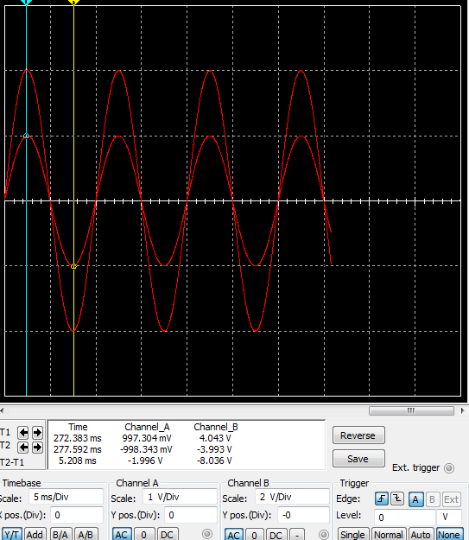f = 100hz, Rf = 3k
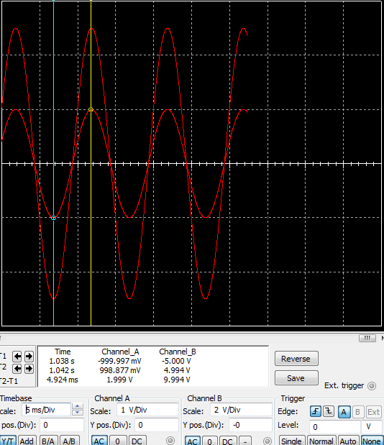f = 100hz, Rf = 4k

Simulation Results

Overall, the circuits behaved very much as expected based on our previous experience with the topic in class. We can see from the manipulation of Rf in both circuit designs that gain can be controlled very precisely to define this most important aspect of the system. Resistance had a very small impact on current, and input voltage frequency had negligible affect. Looking back at gain for both inverting and noninverting circuits, we can see that it is not changed by input voltage frequency. This leads us to conclude that the OpAmp 741 is capable of a wide range of input voltage frequencies as we have modulated ours by an order of magnitude.

Hardware

Our team (I paired with another student for this section) attempted to wire the first inverting configuration. We believe the design was correct, but were unable to get reasonable output from the OpAmp. The voltage supply is suspected of either incorrect configuration or insufficient supply.

